Operating Systems 2026 Spring
Lab 01
Goals:
Learn to work with Linux system calls related to process creation and control.
Policies:
It should go without saying that all the work that you will turn in for this lab will be yours. Do not surf the web to get inspiration for this assignment, do not include code that was not written by you. You should try your best to debug your code on your own, but it’s fine to get help from a colleague as long as that means getting assistance to identify the problem and doesn’t go as far as receiving source code to fix it (in writing or orally).
Set up:
- Creates a text file in a proper folder, such as ~OSLab1
- Write your C code to the text file.
- Start the Linux terminal
- Locate your text file in terminal:
cd OSLab1
ls
- Compile & link your program:
gcc -o fork1 fork1.c
ls
- Run your program:
./fork1
Contents:
- fork()
In this lab, we start experimenting with a few Unix system calls. The first one, we will look at is fork, which is used by a process to spawn an identical copy of itself. When the fork system call is executed, a new process is created which consists of a copy of the address space of the parent.
The fork call:
- Returns a value of type pid_t (essentially, an integer), and
- Does not take any input parameters, what is indicated by the formal parameter void.
- The return code for fork is 0 for the child process and the process identifier of child is returned to the parent process.
- On success, both processes continue execution at the instruction after the fork call.
- On failure, -1 is returned to the parent process.

- Example 1: fork1.c
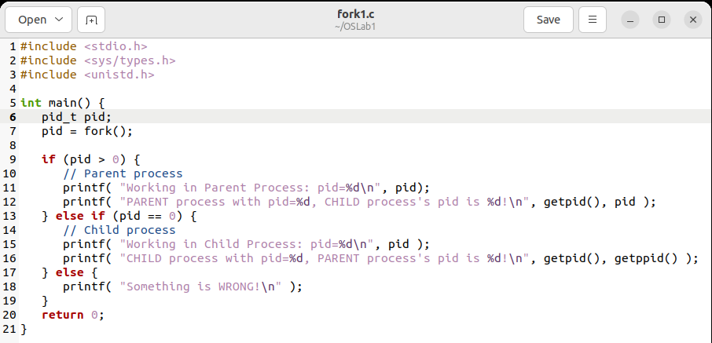
运行结果：
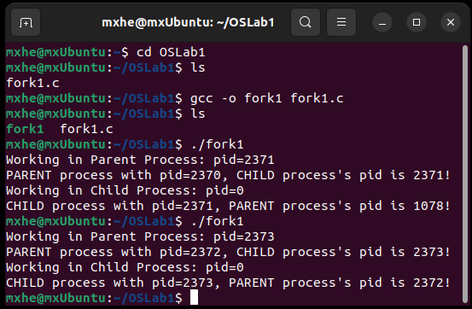

- Example 2: fork2.c
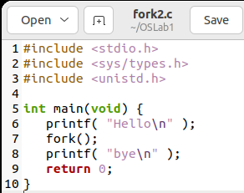
运行结果：
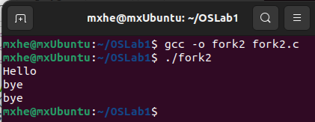

- wait()
When a process creates a child process, sometimes it becomes necessary that the parent process should execute only after the child has finished. wait() system call does exactly this. It makes the parent process wait for child process to finish and then the parent continues its working from the statement after the wait().
To be exact wait makes the parent wait for the child to change state. The state change can be: the child terminated; the child was stopped by a signal; or the child was resumed by a signal.
wait() system call takes only one parameter which stores the status information of the process. Pass NULL as the value if you do not want to know the exit status of the child process and are simply concerned with making the parent wait for the child. On success, wait returns the PID of the terminated child process while on failure it returns -1.

- Example 3: fork3.c
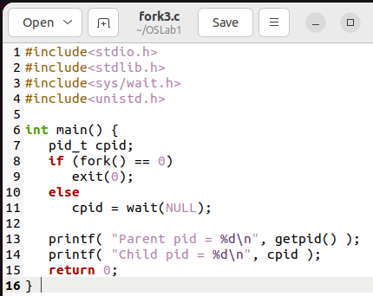
运行结果：
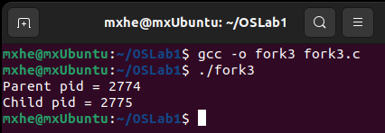
- Example 4: fork4.c
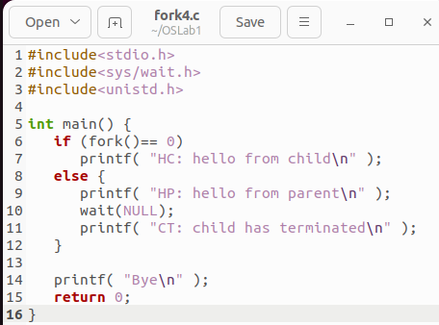

运行结果：
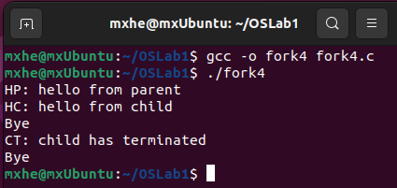
- Example 5: fork5.c
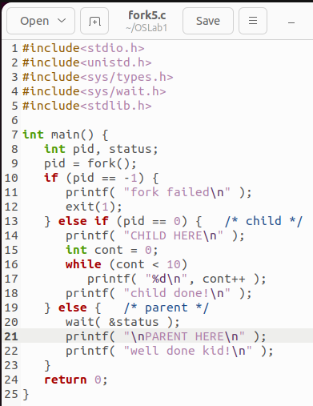
运行结果：
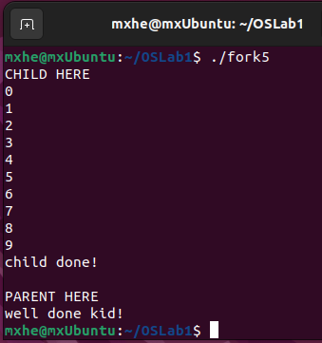

- What should you do in this lab?
Task 1:
Write a C program to create 4 processes where first process is the parent of the second one and the second process is the parent of the third one and the third process is the parent of the fourth one. Your program should be capable of:
- checking if the processes is forked with success,
- printing the pid and parent pid of each process,
- printing the parent pid of the first process.
Expected results:
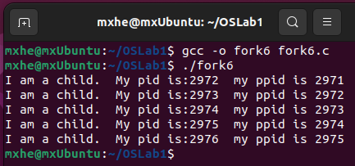

Task 2:
Write a C program to create a fan of processes. That is, process 1 is the parent of processes 2, 3, 4, 5, 6.
Expected results:
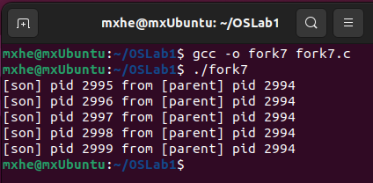

What should you submit:
- Please submit a zip file which includes the C code for these two tasks: with name: task1.c, task2.c
- A short report to show: your idea, your code structure, and execution results.
- Your zip file should be named as: “学号+姓名+ OS26S-Lab1.zip”，e.g.: 1234567-何明昕-OS26S-Lab1.zip
- Please submit your zip file by sending email to Mr. He as attachment with an email subject like “OS26S-Lab1 from 1234567-何明昕” before (including) April 7. My email address for the OS & SE courses is: c.max@yeah.net

