Operating Systems 2026 Spring
Lab 02 李荣耀 2024103975
Goals:
Master the use of signal-related system calls, the use of command line pipe | and anonymous pipes. Learn the logic of signal communication and pipe communication in Linux.
Contents:
- Operations on Signals
- signal(): void (*signal(int sig, void (*func)(int)))(int);
After the process receives the signal defined by the argument sig, the process pauses the default operations and access the self-defined function func. If succeed, it will return the last handle function of this signal; if not, it will return SIG_ERR

- sigaction(): int sigaction(int sig, const struct_sigaction *act, struct_sigaction *oact);
More secure and stable version to handle signal-related system calls similar to signal().

- kill(): int kill(pid_t pid, int sig);
Send the signal sig to the process with the PID pid. If succeed, it will return 0. Otherwise, return -1.

- Working with |
The pipe symbol connects two or more programs, taking the output of former program as the input of the next program.
- job1 | job2 | job3
- randoms 1000 | statistics

- Working with pipes
The anonymous pipes is the mechanism of interprocess communication. It is used for parent and child process or bible processes. It is anonymous since it communicates by file descriptor.
- #include <unistd.h>
- int pipe(int file_descriptor[2]);
Create an anon pipe and return two file descriptors. The first descriptor is used to read while the second descriptor is used to write. If succeed, return 0. Otherwise return -1.
- Write to pipe：write(file_descriptor[1], buf, size);
- Read from pipe：read(file_descriptor[0], buf, size);

Tasks
Task 1: Test Signals
- Test test2_1.c
- Remove signal() statement and the MyCtrlC function, recompile the program and see what will happen.
Programming Task 1:
Write a program that exit after 3 Ctrl+C entered.
Task 2: Test Signals
- Test test2_2.c
Programming Task 2:
Modify test2_2.c to test2_2a.c，the Parent Process creates a child process p1 and display “How are you!\n”3 times；The child process display “I’m a child!” in a conditional loop; The Parent process send a signal 12 to p1 and try to pass a parameter number (such as 15) and a conditional loop variable; The child process sensored the loop exit condition, then calculate and display the square of the parameter, finally exit.
Task 3: Test randoms.c and statistics.c with | in CLI
- Test randoms.c
- Test statistic.c
- Test them together with | in CLI
Task 4: Test anonymous pipes with test_pipe1.c
- The parent Process create a child process and an anonymous pipe fd; The child process write “Just a message :-)” to the pipe and exit；The parent process received the exit signal of the child process by wait() and read the message from the pipe and display the message, finally exit。
- Pay attention to the creation of the pipe, reading & writting with pipes.

Programming Task 3:
- Parent process (p0) create 2 children processes p1, p2 and a pipe fd[2]
- p1 write a string “Message from process p1!” to the pipe
- p2 read the message from the pipe and display it; and p2 write a string “Message from process p2!” to the pipe
- p0 read the message from the pipe and display it

Ideas and Code Structures
Programming Task 1:
Set a counter as a global variable. For each input of Ctrl + C, increment the counter until it reaches three. Then set the flag as 0 and the process exits.
/**
* test2_1a.c
* exit after receiving 3 Ctrl-C signals
*/
#include <stdio.h> // printf
#include <stdlib.h> // exit
#include <signal.h> // signal, #define SIGINT 2
#include <unistd.h> // sleep

int goOnFlag = 1, cnt = 0; // global varaible

void MyExit(int sig) {
if (cnt < 3){
cnt++;
}
printf("%d in MyExit\n", cnt);
if (cnt == 3){
printf("OK!\n");
goOnFlag = 0;
}
}

int main(){
signal( SIGINT, MyExit );

while (goOnFlag){
printf("Hello...\n");
sleep(1);
}

exit(0);
}

Programming Task 2:
For parent process, print the corresponding messages and then use kill() to send the signal 12 to the child process. Then wait for the child process.
For child process, initially print the status before receiving the signal and print repeatedly corresponding message. Then after receiving the signal from parent process, the self-defined function set global parameter and flag. The child process break the loop and print the status after receiving the signal.
/**
* test2_2a.c
* Parent process displays "How are you!" for 3 times, then sends signal and parameter to child process, wait and exit.
* Child process displays "I am child" until receives signal from parent process
* Child process displays the parameter and its square.
*/

#include <stdio.h>
#include <stdlib.h>
#include <signal.h>
#include <unistd.h>
#include <sys/wait.h>

int goOnFlag = 1, x = 0;
void MyFunc(int sig){
x = 15;
goOnFlag = 0;
}

int main(){
int p1;
while ((p1=fork()) == -1) /*!*/ ;
if (p1 > 0){ // parent process
for (int i=1; i <= 3; i++){
printf("How are you!\n");
sleep(1);
}
kill(p1, 12); // send signal 12 to child process
wait(0);
printf("Parent process exited!\n");
exit(0);
} else{ // child process
signal(12, MyFunc);
printf("Child: Parameter before signal 12: %d\n", x);
goOnFlag = 1;

while (goOnFlag == 1){
printf("I am child!\n");
sleep(1);
}

printf("Child: Parameter after signal 12: %d\n", x);
printf("Child exited!\n");
printf("%d\n", x * x);
exit(0);
}
}

Programming Task 3:
Create reading and writing buffer for each process (p0, p1, p2) and the anonymous pipe for IPC. After create p1, p0 waits. p1 writes the message in its buffer to the pipe and exits. Then p0 creates p2 and waits. p2 receives the message of p1 in the pipe, reads it in the buffer and displays it. Then p2 writes the message in its buffer to the pipe and exits. p0 receives the message of p2 in the pipe, reads it in the buffer and displays it. Then exits.
/**
* test_pipe2.c
* Parent process creates two child processes
* Child process 1 sends message to child process 2 through pipe, then exits
* Child process 2 receives message from child process 1, displays it, then sends message to parent process through pipe, then exits
* Parent process receives message from child process 2, displays it, then exits
*/
#include <stdio.h>
#include <stdlib.h>
#include <unistd.h>
#include <sys/wait.h>

int main(int argc, char* argv[]){
int p1, p2, fd[2];
char inp0str[50], outp0str[50];
char inp1str[50] = "[Message from process p1!]", outp1str[50];
char inp2str[50] = "[Message from process p2!]", outp2str[50];
if (pipe(fd) == -1){
perror("cannot create the IPC pipe!");
return 1;
}

while ((p1=fork()) == -1) /*!*/ ;
if (p1 == 0){ // process 1
write(fd[1], inp1str, 50);
exit(0);
}else{
wait(0);
while ((p2=fork()) == -1) /*!*/ ;
if (p2 == 0){ // process 2
read(fd[0], outp2str, 50);
printf("Message received from p1 in p2:\n%s\n", outp2str);
write(fd[1], inp2str, 50);
exit(0);
}else { // process 0(parent process)
wait(0);
read(fd[0], outp0str, 50);
printf("Message received from p2 in p0:\n%s\n", outp0str);
exit(0);
}
}

}

Execution Results
Task 1:
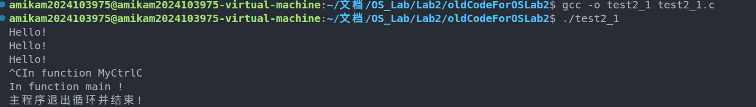
After removal:
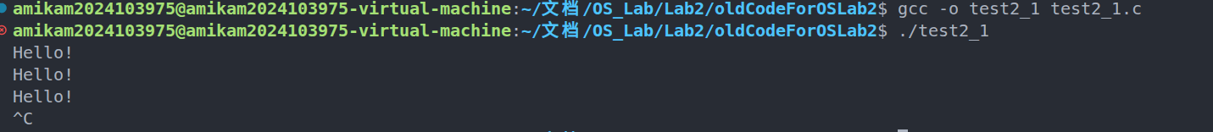
Task 2:
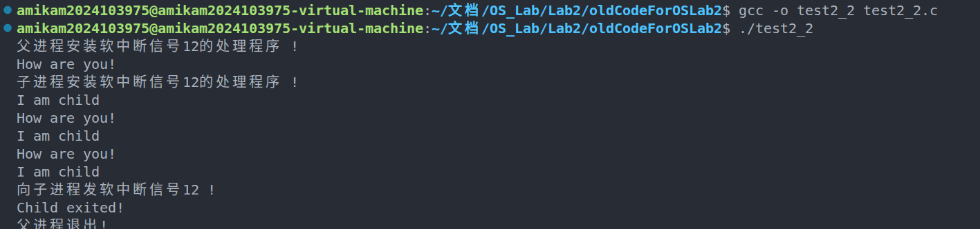
Task 3:
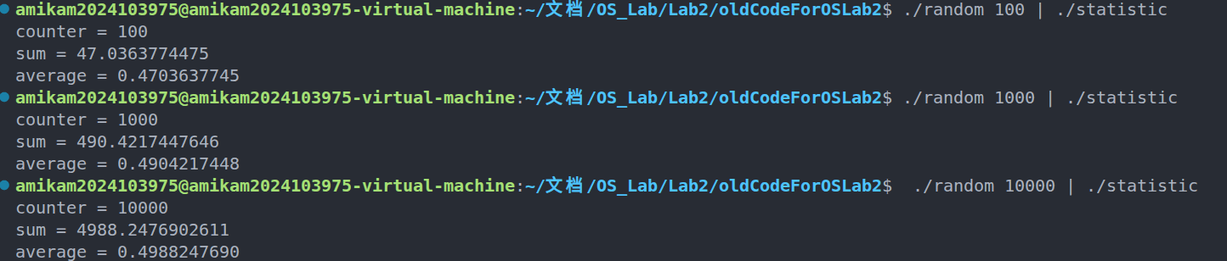
Task 4:
Programming Task 1:
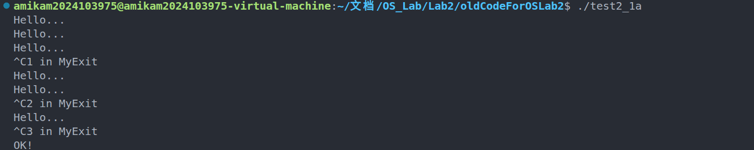
Programming Task 2:
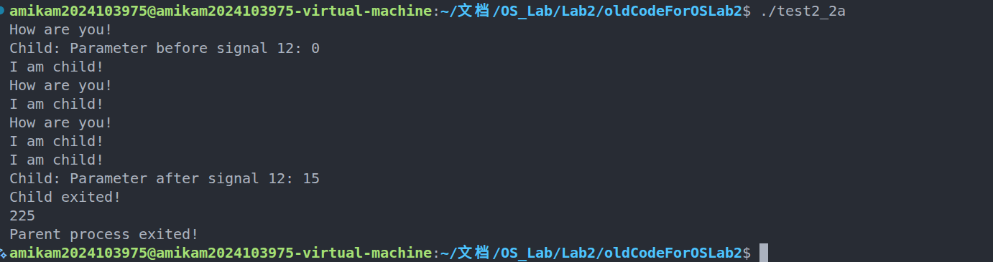
Programming Task 3:
