Operating Systems 2026 Spring
Lab 03 李荣耀 2024103975
Goals:
Learn to work with message queue to implement inter-process communication by using message queue, IPC to implement sending and receiving messages.
Contents:
- msgget(): int msgget(key_t key, int msgflag);
Create a message queue to implement IPC. key is the unique key value of queue and msgflag is the creation flag and access. Return queue id if succeed otherwise return -1.

- msgsnd: int msgsnd(int msgid, struct msgbuf *msgp, int size, int flag); (there is a mistake in PPT about the prototype of the function)
Send message to the specified message queue. The first parameter is the id returned from msgget(). The second parameter is the pointer to the self-defined message struct. The third parameter is the size of user’s data. (not includes the first eight bytes, that is, long my_type). The fourth parameter is the flag to send. Return 0 if succeed. Otherwise return -1.

- msgrcv(): int msgrcv(int msgid, struct msgbuf *msgp, int size, int type, int flag);
Receive message from the specified message queue. The first parameter is the id which is the same as sender. The second parameter is the pointer to the buffer to receive the message. The third parameter is the largest data length to receive. The fourth parameter is the type of message to receive.(0 for the first element in the queue) The fifth parameter is the flag. Return the actually received data size if succeed. Otherwise return -1.

- msgctl(): int msgctl(int msgid, int cmd, struct msgid_ds *buf);
Control message queue: state query, modify and remove queue. The first parameter is the id of queue to be operated. The second parameter is the control command. (IPC_RMID for deleting queue). The third is the pointer to the state struct. (NULL for deleting queue).

Tasks
Task 1: IPC with Message Queues
- Use Message Queue, IPC, to implement sending & receive messages
  - Sending Process sndfile.c gets messages (line by line) inputed from keybord, and send to the message que, end with a “end”
  - Receiving Process rcvfile.c read and display messages one by one from the message queue, until reach a “end”
  - The key of the message queue is set to 1234
- Objective：Learn to work with message queue to implement inter-process communication.
- Key Points：
  - struct my_msg is the struct of msgbuf, need to be definedby users
  - Learn to use msgget()、msgsnd()、msgrcv()
  - Try to execute the two processes in diferrent order and see the results
- Run ./sndfile and ./rsvfile

Task 2: Programming with Message Queues, IPC
  - Modify sndfile.c & rcvfile.c to sender.c & receiver.c
  - sender.c
    - Repeat to read a record from stdin with following info:
name, gender, age, mobile
    - Send the record to the message buffer msgid
    - Continue to read next record from stdin until to read a name “end”，then exit.
    - There should have some tips displayed for inputs.
  - receiver.c
    - Repeat to receive person info from the message queue
    - Display each person info in a line, better with a header
    - When receive a person info named “end”，then exit.

Ideas and Code Structures
Task 2:
For sender.c, we first modify the self-defined struct.
#define MAXMSG 50
struct my_msg{
long int my_msg_type;
struct stdmsg{
char name[MAXMSG];
char gender[MAXMSG];
char age[MAXMSG];
char mobil[MAXMSG];
} std;
} msg;
According to situation, we set MAXMSG as 50.
Then we should remove the newline character in the buffer to ensure correctly exiting and receiving.
void remove_newline(char *str){
str[strcspn(str, "\n")] = '\0';
}
And we should also note the size to send.
Complete code:
// sender.c
#include <stdio.h>
#include <stdlib.h>
#include <string.h>
#include <unistd.h>
#include <sys/types.h>
#include <sys/msg.h> // <linux/msg.h> for old versions

#define MAXMSG 50
struct my_msg{
long int my_msg_type;
struct stdmsg{
char name[MAXMSG];
char gender[MAXMSG];
char age[MAXMSG];
char mobil[MAXMSG];
} std;
} msg;

// remove \n from the end of string
void remove_newline(char *str){
str[strcspn(str, "\n")] = '\0';
}

int main(){
int msgid;
char buffer[BUFSIZ];

msgid = msgget(1234, 0666|IPC_CREAT);
msg.my_msg_type = 1;

while (1){
puts("Please Enter a person info.");

// receive each member in the struct and remove \n
puts("Name:");
fgets(buffer, BUFSIZ, stdin);
remove_newline(buffer);
strcpy(msg.std.name, buffer);

// end and set an empty object
if (strncmp(msg.std.name, "end", 3) == 0){
msg.std.gender[0] = '\0';
msg.std.age[0] = '\0';
msg.std.mobil[0] = '\0';
msgsnd(msgid, &msg, sizeof(msg.std), 0);
break;
}

puts("Gender:");
fgets(buffer, BUFSIZ, stdin);
remove_newline(buffer);
strcpy(msg.std.gender, buffer);

puts("Age:");
fgets(buffer, BUFSIZ, stdin);
remove_newline(buffer);
strcpy(msg.std.age, buffer);

puts("Number:");
fgets(buffer, BUFSIZ, stdin);
remove_newline(buffer);
strcpy(msg.std.mobil, buffer);

// more accurate size to send
msgsnd(msgid, &msg, sizeof(msg.std), 0);
}

exit(0);
}

For receiver.c, we just need to modify the size to receive, print the head of the table and format the output.
Complete code:
// receiver.c
#include <stdio.h>
#include <stdlib.h>
#include <string.h>
#include <unistd.h>
#include <sys/types.h>
#include <sys/msg.h> // <linux/msg.h> for old versions

#define MAXMSG 50
struct my_msg{
long int my_msg_type;
struct stdmsg{
char name[MAXMSG];
char gender[MAXMSG];
char age[MAXMSG];
char mobil[MAXMSG];
} std;
} msg;

int main(){
int msgid;
long int msg_to_receive=0;

msgid = msgget(1234, 0666|IPC_CREAT);

// the head of the table
printf("Person Info as Follows:\n");
printf("Name Gender Age Mobile\n");
printf("-------------------------\n");

while (1){
// receive the message from queue
msgrcv(msgid, &msg, sizeof(msg.std), msg_to_receive, 0);

// break if end
if (strncmp(msg.std.name, "end", 3) == 0){
break;
}

// format output
printf("%-8s", msg.std.name);
printf("%-8s", msg.std.gender);
printf("%-5s", msg.std.age);
printf("%-15s\n", msg.std.mobil);

}

// close the queue
msgctl(msgid, IPC_RMID, 0);
exit(0);
}

Execution Results
Task 1:
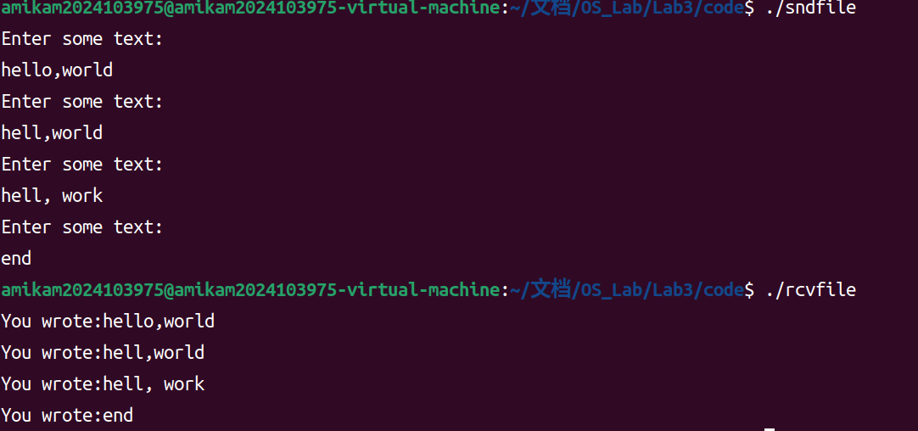
And we can know the size of BUFSIZ on Ubuntu 22.04 with ISO C99 Standard: 7.19 Input/output <stdio.h> is
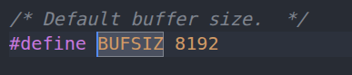
Task 2:
