Operating Systems 2026 Spring
Lab 04 李荣耀 2024103975
Goals:
Learn to work with pthread and to program with Producer-Consumer Synchronization.
Contents:
- POSIX thread libraries:
  - The POSIX (Portable Operating System Interface) thread libraries are a standards-based thread API.
  - The purpose of using the POSIX thread library in your software is to execute software faster.
- Create a thread – pthread_create():
int pthread_create(
pthread_t *thread,
const pthread_attr_t *attr,
void *(*start_routine)(void *),
void *arg
);

• thread: pointer to an unsigned integer value that returns the thread id of the thread created.
• attr: pointer to a structure that is used to define thread attributes like detached state, scheduling policy, stack address, etc. Set to NULL for default thread attributes.
• start_routine: pointer to a subroutine that is executed by the thread. The return type and parameter type of the subroutine must be of type void *. The function has a single attribute but if multiple values need to be passed to the function, a struct must be used.
• arg: pointer to void that contains the arguments to the function defined in the earlier argument.
• Return: return 0 on success; If an error occurs, the error number is returned.

- Used to wait for the termination of thread - pthread_join():
int pthread_join(pthread_t *thread, void **thread_return);
• thread: thread id of the thread for which the current thread waits.
• thread_return: pointer to the location where the exit status of the thread mentioned in thread is stored.

• Return: Returns 0 on success and an error code on failure

- Thread collaboration:
  - Multiple threads can collaborate if they do not depend on each other and are done in parallel while main thread waits for subthreads.
  - Multiple threads may encounter mistakes if they are done concurrently and share the same code segment.

- Pthread_Mutex – Thread synchronization:
It is the mechanism that ensures that two or more concurrent processes or threads do not simultaneously execute some shared program segment, known as critical section. When one thread starts executing critical sections, the other threads should wait until the first thread finishes.

Mutex: A mutex is a lock that we set before using a shared resource and release after using it.
  - Define a mutex:
pthread_mutex_t mutex;
  - Initialize a mutex:
int pthread_mutex_init(
pthread_mutex_t *restrict mutex,
const pthread_mutexattr_t *restrict attr
)；
    - mutex: creates a mutex, referenced by mutex.
    - attr: with attributes specified by attr, can be NULL.
    - Returned value: if successful, returns 0, and the state of the mutex becomes initialized and unlocked. If unsuccessful, returns -1.
  - Lock a mutex:
int pthread_mutex_lock(pthread_mutex_t *mutex);
- Function: If the mutex is already locked by another thread, the thread waits for the mutex to become available.
- Function: The thread that has locked a mutex becomes its current owner and remains the owner until the same thread has unlocked it.
- Returned value: If successful, returns 0. If unsuccessful, returns -1.
  - Unlock a mutex:
int pthread_mutex_unlock(pthread_mutex_t *mutex);
    - Returned value: If successful, returns 0. If unsuccessful, returns -1.
  - Deletes a mutex:
int pthread_mutex_destroy(pthread_mutex_t *mutex);
    - Returned value: If successful, returns 0. If unsuccessful, returns -1.
- Producer-Consumer Problem:
  - Condition variable:
When a thread accesses a variable mutually exclusively, it can do nothing until the other thread changes state. In this case, the condition variable is needed.
    - Define a condition variable:
pthread_cond_t cond;
    - Initialize a condition variable:
pthread_cond_init(
pthread_cond_t *cond,
const pthread_condattr_t *restrict attr
)；
cond：condition variable
attr：variable attribute: NULL
    - Wait a condition variable:
int pthread_cond_wait(
pthread_cond_t *restrict cond,
pthread_mutex_t *restrict mutex
);
cond：wait on this condition
mutex：mutex
    - Release a condition variable:
int pthread_cond_signal(pthread_cond_t *cond);
cond：signal on this condition
    - Delete a condition variable:
int pthread_cond_ destroy(pthread_cond_t *cond);
cond：destroy on this condition

  - Why does pthread_cond_wait need a mutex:
int pthread_cond_wait(cond, mutex);
    - Conditional waiting is a means of synchronization between threads. There must be a thread through some operations to change the shared variable so that the original unmet condition becomes satisfied to avoid deadlock.
    - The shared data must be changed to make some threads continue. And it cannot be safely obtained or modified without a mutex.
    - Cannot unlock the mutex before calling pthread_cond_wait() to avoid missing the signal after the call is unlocked and before pthread_cond_wait, which causing permanently block on the pthread_cond_wait.
Tasks
Write code to solve the producer-consumer synchronization problem. Partial of the code have been given in pc.c.
The expected execution results:

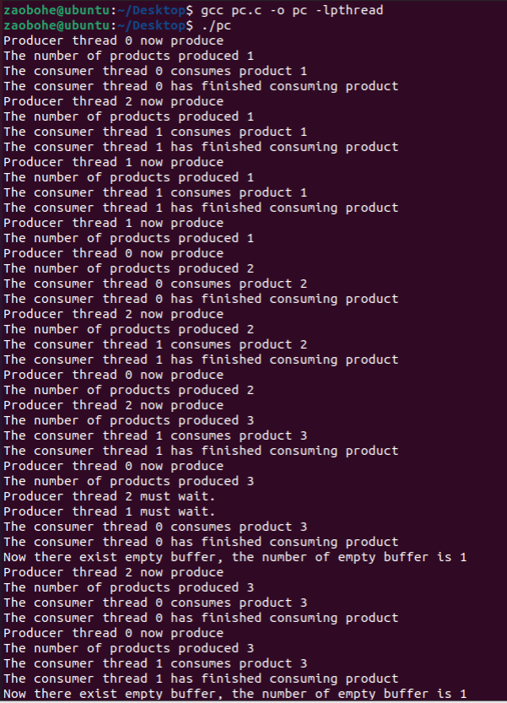
Ideas and Code Structures
  - To ensure only one thread occupies the shared at the time, we use pthread_mutex_t to ensure proper synchronization. And it is put in the inner of infinite loop to ensure each iteration can be protected by the lock.
  - To achieve the communication between producer and consumer, we use condition variables. Producer waits for n_empty if the buffer is full while Consumer waits for n_full if the buffer is empty.
The code structure is like:
  - Producer: loop -> lock -> wait if the buffer full -> produce -> update shared variables -> signal consumers -> unlock -> sleep
  - Consumer: loop -> lock -> wait if the buffer empty -> consume -> update shared variables -> signal producers -> unlock -> sleep
Complete code segments:
// producer
void* pro_route(void* arg) {
// get the id of thread
int id = *(int *)arg;

while (1){
// lock
pthread_mutex_lock(&mutex);
// check whether the buffer is full.
while (empty_num == 0){
// unlock if so and block until the buffer is not full.
printf("Producer thread %d must wait.\n", id);
pthread_cond_wait(&n_empty, &mutex);
}

printf("Producer thread %d now produce.\n", id);
// produce the product
g_num++;
empty_num--;
printf("The number of products produced %d.\n", g_num);

// set the signal to consumer and unlock
pthread_cond_signal(&n_full);
pthread_mutex_unlock(&mutex);

// sleep to switch the thread clearly
sleep(rand() % 3);
}

return NULL;
}

// consumer
void *con_route(void* arg) {
// get the id of thread
int id = *(int *)arg;

while(1){
// lock
pthread_mutex_lock(&mutex);
// chech whether the buffer is empty
while (g_num == 0){
// unlock if so and block until the buffer is not empty
pthread_cond_wait(&n_full, &mutex);
}

printf("The consumer thread %d consumes product %d.\n", id, g_num);
// consume the product
g_num--;
empty_num++;
printf("The consumer thread %d has finished consuming product\n", id);
printf("Now there exist empty buffer, the number of empty buffer is %d\n", empty_num);

// set the signal to producer and unlock
pthread_cond_signal(&n_empty);
pthread_mutex_unlock(&mutex);

// sleep to switch the thread clearly
sleep(rand() % 3);
}

return NULL;
}

Execution Results
