Operating Systems
Lab 05: Dining-Philosophers Problem
Goals:
Learn to use semaphores to solve the classic Dining-Philosophers Problem.
Contents:
The Dining-Philosophers problem is a classic OS problem, as shown in Fig 1. There are N philosophers sitting around a circular table and spending their lives alternating thinking and eating:
- From time to time, a philosopher gets hungry and tries to pick up the two chopsticks that are closest to her (the chopsticks that are between her and her left and right neighbors).
- A philosopher may pick up only one chopstick at a time.
- Obviously, she cannot pick up a chopstick that is already in the hand of a neighbor.
- When a hungry philosopher has both her chopsticks at the same time, she eats without releasing the chopsticks.
- When she is finished eating, she puts down both chopsticks and starts thinking again.

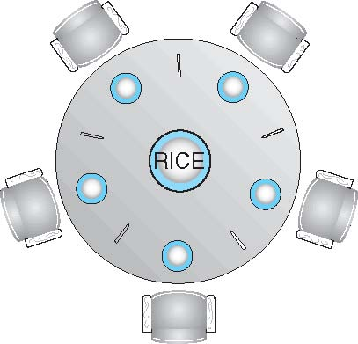

Figure 1 The Dining-Philosophers Problem

- What should you do:

Design an algorithm to solve the Dining-Philosophers Problem based on semaphores such that
- No starvation;
- No deadlock;
- Maximum concurrency (i.e., if many philosophers try to eat simultaneously, please make sure the number of philosophers who can eat simultaneously is maximum).

Write code to implement the designed algorithm and test it in details (Refer the test results of TicTacToe_Derby V3.89 attached).

- What should you submit:
- Please submit a zip file which includes the C code and your test results (in text files ONLY).
- A short report to show: your idea, your code structure, and sophisticated execution results.
- Your zip file should be named as: “学号+姓名+ OS26S-Lab5.zip”，e.g.: 1234567-何明昕-OS26S-Lab5.zip
- Please submit your zip file by sending email to Mr. He as attachment with an email subject like “OS26S-Lab5 from 1234567-何明昕” before (including) May 24. My email address for the OS & SE courses is: c.max@yeah.net

