Operating Systems 2026 Spring
Lab 06 李荣耀 2024103975
Goals:
Learn to use Banker‘s Algorithm to avoid deadlock and implement a dynamic resource request evaluator in C. The program must load an initial system snapshot, process resource-request commands, and decide whether each request can be safely granted based on the safety test (reference Sec. 8.6.3 of the textbook).
Contents:
Banker’s algorithm is a classic deadlock-avoidance method. The system has n processes and m resource types. Each process declares its maximum demand (Max) beforehand. The system records currently allocated (Allocation) and still available (Available) resources. When a process requests additional resources, the system pretends to grant the request and then runs the safety algorithm to see whether there exists a safe sequence (an order in which all processes can eventually finish). If yes, the request is accepted; otherwise, it is rejected, and the state is unchanged.
Tasks
Write a program banker.c that:
- Loads an initial system snapshot (number of processes n, number of resource types m, the Max and Allocation matrices, and the Available vector).
- Continuously reads resource‑request commands of the form RQ pid r1 r2 … rm and termination commands quit from stdin.
- For each request, runs the Banker’s safety test:
- If the request is unsafe, reject it and explain why.
- If safe, update the state and print the resulting safe sequence.
- Prints the full state (Available, Allocation, Need) after every accepted request.
Input Format:
Write a program banker.c that:
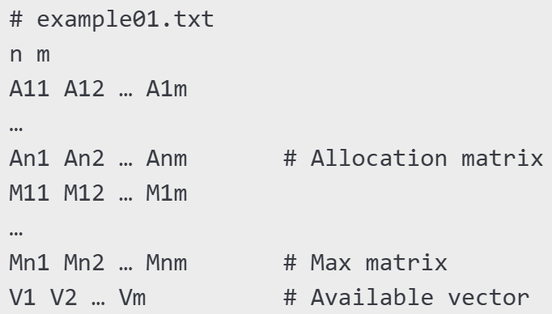
After loading, the program accepts commands interactively, e.g.
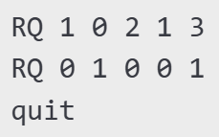

Output Specification:
For each RQ line, print either
State would be unsafe – request denied.

or
State is safe. Grant request.
Safe sequence: P2 → P4 → P0 → P1 → P3

After an accepted request, print the matrices in neat tabular form.
Implementation Requirements:
- Data limits: maximum n ≤ 10, m ≤ 8 (but avoid hard-coding; allocate dynamically).
int is_safe(
int n, int m,
int Available[], int Max[][MAXM], int Allocation[][MAXM],
int safeSeq[]
);

int request_resources(int pid, int request[], ...)

- Functions to implement (minimum):
  - is_safe()
  - request_resources()
Skeleton Code:
#include <stdio.h>
#include <stdlib.h>
#include <stdbool.h>

// Read n, m, and matrices…
// Compute Need = Max – Allocation
// Implement is_safe() here
// Implement request_resources() here

int main(void) {
// 1. Load snapshot
// 2. Event loop reading commands
// if (strcmp(cmd, "RQ") == 0) { … }
// 3. Clean up and exit
return 0;
}

Example Test Case & Run:
Input file example01.txt:
5 3
0 1 0
2 0 0
3 0 2
2 1 1
0 0 2
7 5 3
3 2 2
9 0 2
2 2 2
4 3 3
3 3 2

Interactive session (extract):
$ ./banker example01.txt
RQ 1 1 0 2
State is safe. Grant request.
Safe sequence: P1 → P3 → P4 → P0 → P2

Available: 1 0 0
Allocation:
P0 0 1 0
P1 3 0 2
P2 3 0 2
P3 2 1 1
P4 0 0 2
Need:
P0 7 4 3
P1 0 2 0
P2 6 0 0
P3 0 0 0
P4 4 3 1

Ideas and Code Structures
The safety algorithm (is_safe) works as follows:
- Create a Work array (copy of Available) and a Finish boolean array (all false).
- Repeatedly find an unfinished process i such that Need[i] <= Work (vector-wise). If found, add Allocation[i] to Work, mark Finish[i]=true, and record i in the safe sequence.
- If all processes are finished, safe; otherwise unsafe.
The request handling (request_resources):
- Validate request <= Need[pid] and request <= Available.
- Temporarily subtract the request from Available, add to Allocation[pid], subtract from Need[pid].
- Call is_safe on the temporary state.
- If safe, keep the changes and return 1; otherwise roll back and return 0.
Maximum concurrency is implicitly achieved because the safety test accepts any request that leads to a safe state, i.e., no artificial limit is added, but the algorithm naturally allows as many concurrent allocations as possible while keeping the system safe.
The code structures:
- Header files: standard input and output, library, Boolean, string.
- Macro definition: MAXN and MAXM.
- Functions: vector comparison, vector addition and subtraction, safety test, process a request and output tables.
- Main function: Parse command line argument, read argument, compute in the loop, safely exit.
Execution Results
example01.txt:
5 3
0 1 0
2 0 0
3 0 2
2 1 1
0 0 2
7 5 3
3 2 2
9 0 2
2 2 2
4 3 3
3 3 2
Interactive Session:
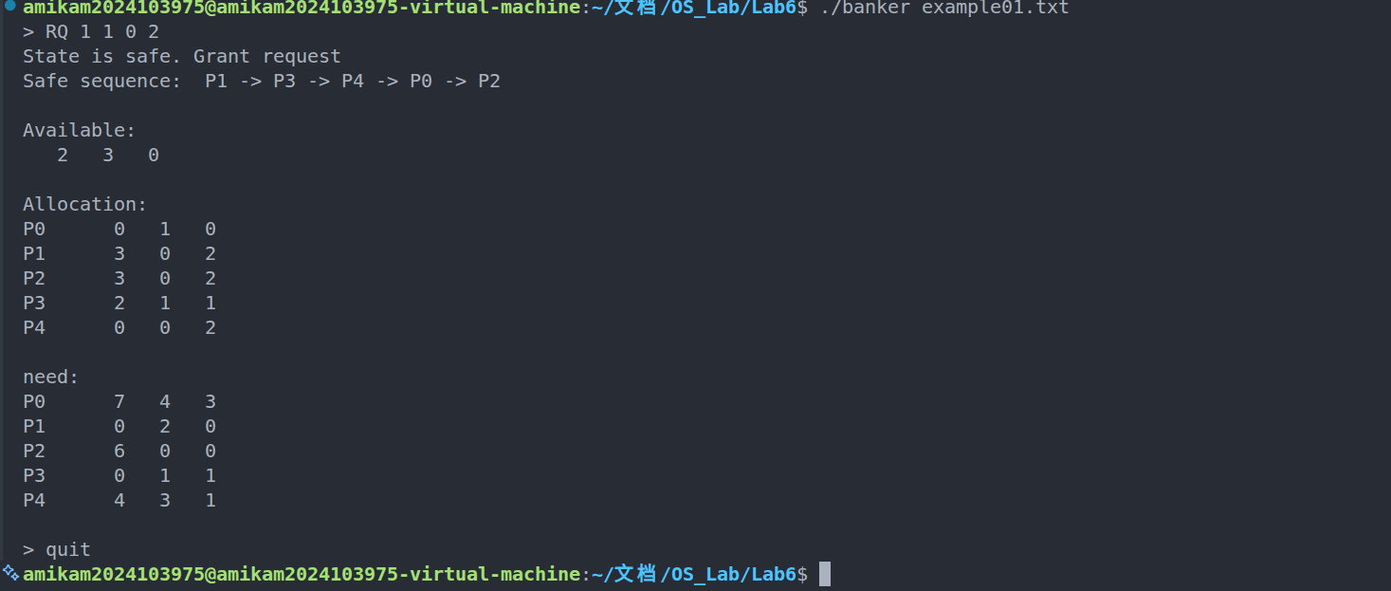
Test1.txt – multiple steps of safe request.
4 2
0 1
2 0
3 0
2 1
4 2
3 2
5 2
2 2
2 2
Interactive Session:
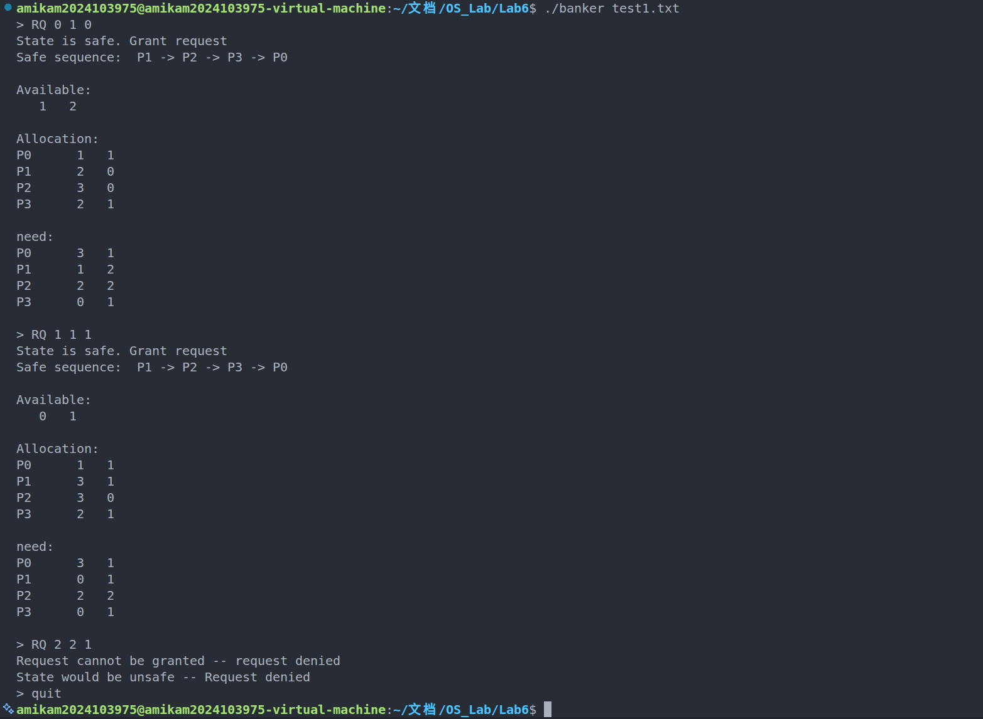
Test2.txt – deny the unsafe request and ensure sequent safe request:
4 4
0 0 0 0
1 0 0 0
0 1 0 0
0 0 1 0
1 1 1 1
1 0 0 0
0 1 0 0
0 0 1 0
0 0 0 1
Interactive Session:
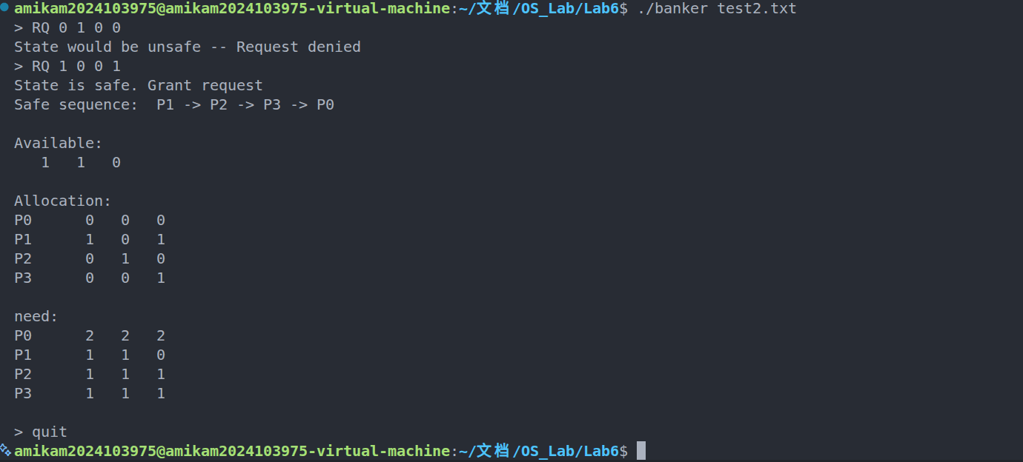
Test3.txt – more type of resources and currently reach bound
4 4
0 0 0 0
1 0 0 0
0 1 0 0
0 0 1 0
1 1 1 1
1 0 0 0
0 1 0 0
0 0 1 0
0 0 0 1
Interactive Session:
