Operating Systems, 2026 Spring
Lab 6: Deadlock Avoidance with the Banker’s Algorithm
Goals:
Implement Banker’s Algorithm in C and use it to decide at run‑time whether a resource‑allocation request can be safely granted. (Reference Sec. 8.6.3, especially 8.6.3.3 on page 336-337 in the textbook!)
Task Overview:
You will write a program banker.c that:
- Loads an initial system snapshot (number of processes n, number of resource types m, the Max and Allocation matrices, and the Available vector).
- Continuously reads resource‑request commands of the form RQ pid r1 r2 … rm and termination commands quit from stdin.
- For each request, runs the Banker’s safety test:
- If the request is unsafe, reject it and explain why.
- If safe, update the state and print the resulting safe sequence.
- Prints the full state (Available, Allocation, Need) after every accepted request.
Input Format:
You will write a program banker.c that:
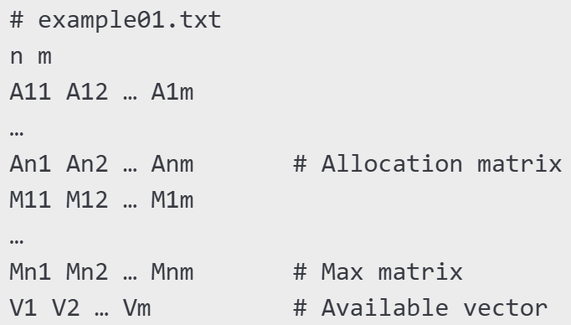
After loading, the program accepts commands interactively, e.g.
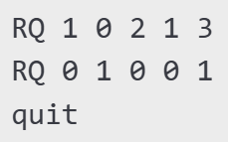

Output Specification:
For each RQ line, print either
State would be unsafe – request denied.

or
State is safe. Grant request.
Safe sequence: P2 → P4 → P0 → P1 → P3

After an accepted request, print the matrices in neat tabular form.
Implementation Requirements:
- Data limits: maximum n ≤ 10, m ≤ 8 (but avoid hard-coding; allocate dynamically).
int is_safe(
int n, int m,
int Available[], int Max[][MAXM], int Allocation[][MAXM],
int safeSeq[]
);

int request_resources(int pid, int request[], ...)

- Functions to implement (minimum):
Skeleton Code (代码框架):
#include <stdio.h>
#include <stdlib.h>
#include <stdbool.h>

// Read n, m, and matrices…
// Compute Need = Max – Allocation
// Implement is_safe() here
// Implement request_resources() here

int main(void) {
// 1. Load snapshot
// 2. Event loop reading commands
// if (strcmp(cmd, "RQ") == 0) { … }
// 3. Clean up and exit
return 0;
}

Example Test Case & Run:
Input file example01.txt:
5 3
0 1 0
2 0 0
3 0 2
2 1 1
0 0 2
7 5 3
3 2 2
9 0 2
2 2 2
4 3 3
3 3 2

Interactive session (extract):
$ ./banker example01.txt
RQ 1 1 0 2
State is safe. Grant request.
Safe sequence: P1 → P3 → P4 → P0 → P2

Available: 1 0 0
Allocation:
P0 0 1 0
P1 3 0 2
P2 3 0 2
P3 2 1 1
P4 0 0 2
Need:
P0 7 4 3
P1 0 2 0
P2 6 0 0
P3 0 0 0
P4 4 3 1

What should you submit:
- banker.c ;
- At least 3 .txt test cases and your test results.
- A short report to show: your idea, your code structure, and your execution results.
- Your zip file should be named as: “学号+姓名+ OS26S-Lab6.zip”，e.g.: 1234567-何明昕-OS26S-Lab6.zip
- Please submit your zip file by sending email to Mr. He as attachment with an email subject like “OS26S-Lab6 from 1234567-何明昕” before (including) June 7. My email address for the OS & SE courses is: c.max@yeah.net

