LAB REPORT
Lab Title | Functions | Lab No. | 04
Student Name | Li Rongyao | Student ID | 2024103975
Date | 2025/3/24
Lab description/objectives:
- Demonstrate understanding of function implementation, random number generation, loop structures in C programming.
- Implement a simple guessing game using the rand() function and write functions to calculate the greatest common divisor (GCD) and least common multiple (LCM) of two integers as defined in the lab tasks.
- Analyze critical aspect.
Source code:
Task 1:
#include <stdio.h>
#include <stdlib.h>
#include <time.h>
void guessgame(int n,int target){
if (n > target){
printf("Too high! Try again.\n");
}else if(n < target){
printf("Too low! Try again.\n");
}else {
printf("Congratulations! You guessed it right.\n");
}
}
int main(){
srand(time(0));
int upperbound = 100;
int target = 1 + (int)rand() % upperbound;
int n;
printf("Please Enter your guess.\n");
do {
scanf("%d", &n);
guessgame(n, target);
} while (n != target);
return 0;
}
Task 2:
#include <stdio.h>
int gcd(int a, int b){
int temp;
if (a < b){
temp = a;
a = b;
b = temp;
}
while (b != 0){
temp = b;
b = a % b;
a = temp;
}
return a;
}
int lcm(int a, int b){
if (a*b == 0){
return 0;
}else {
return (a * b) / gcd(a, b);
}

}
int main(){
int a, b;
printf("Please Enter the two number you want to find the GCD and LCM.\n");
scanf("%d%d", &a, &b);
printf("The gcd of %d and %d is %d.\n", a, b, gcd(a, b));
printf("The lcm of %d and %d is %d.\n", a, b, lcm(a, b));
return 0;
}
Program output:
Task 1:
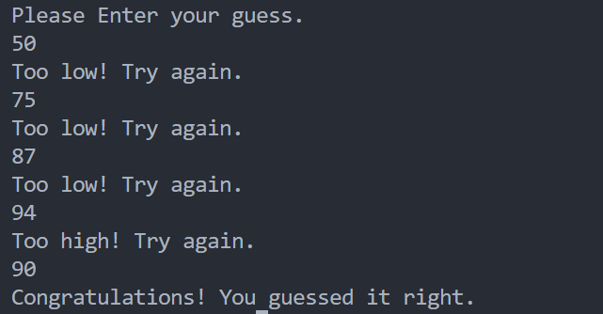
Task 2:
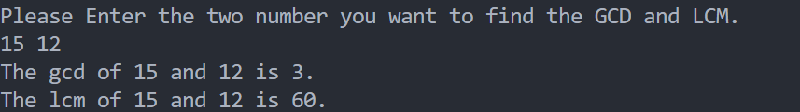
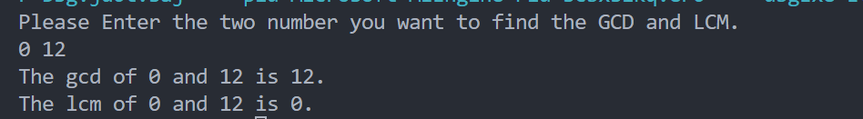
Analysis:
- Guess game
- Learn about the function of producing random number and corresponding head file.
- Cope with the random number in the appropriate scape.
- Write a function and loop to perform the guess game.
- GCD and LCM
- Use the right algorithm in the function to find the GCD.
- Note the order of the two number and the two function to find GCD and LCM.
- Be cautious about the 0 in the function.
Conclusion：
For the functions, we need to have the ability to learn about the functions in the standard library and to write the functions by ourselves to produce some results or perform some operations. And we should master the elements in the function like the name, parameters and so on.

