Jinan University

Java Programming Lab Report

Major: Computer Science & Technology
School: International School

Student name : _________李荣耀___________

Student number : ______2024103975________

Date of Submission (mm-dd-yyyy): _06/08/2026_

Instructor: Yuxia Sun

Table of Content
LAB 1 DATE: 3/31/2026 4
Problem 1. (1.5) 4
Problem 2. (1.9) 4
Problem 3. (1.11) (optional) 6
Problem 4. (2.5) 8
Problem 5. (2.17) 9
Problem 6. (2.19) (optional) 11
LAB 2 DATE: 4/07/2026 13
Problem 1. (3.5) 14
Problem 2. (3.31) 15
Problem 3. (3.15) (optional) 18
Problem 4. (4.9) 22
Problem 5. (4.11) 23
Problem 6. (4.17) (optional) 25
LAB 3 DATE: 4/14/2026 27
Problem 1. (5.9) 27
Problem 2. (5.29) (optional) 30
Problem 3. (6.5) 33
Problem 4. (6.11) 35
Problem 5. (6.19) (optional) 37
LAB 4 DATE: 4/21/2026 39
Problem 1. (7.13) 39
Problem 2. (7.23) (Optional) 41
Problem 3. (8.5) 42
Problem 4. (8.27) 45
Problem 5. (8.37) (Optional) 48
LAB 5 DATE: 4/28/2026 53
Problem 1. (9.1) 53
Problem 2. (9.5) 56
Problem 3. (9.11) 57
Problem 4. (9.9) (Optional) 61
Problem 5. (9.13) (Optional) 66
LAB 6 DATE: 5/12/2026 69
Problem 1. (10.1) 69
Problem 2. (10.3) 73
Problem 3. (10.7) 79
Problem 4. (10.9) (Optional) 85
Problem 5. (10.13) (Optional) 87
LAB 7 DATE: 5/16/2026 93
Problem 1. (11.1) 93
Problem 2. (11.5) 97
Problem 3. (11.11) 99
Problem 4. (11.13) (Optional) 101
Problem 5. (11.17) (Optional) 103
LAB 8 DATE: 5/19/2026 105
Problem 1. (12.3) 105
Problem 2. (12.7) 107
Problem 3. (12.11) 109
Problem 4. (12.27) (Optional) 112
Problem 5. (12.33) (Optional) 116
Problem 6. (13.1) 118
Problem 7. (13.7) 122
Problem 8. (13.17) (Optional) 126
...................

LAB 1 DATE: 3/31/2026

Student Name: __李荣耀____ Student ID: 2024103975___

Problem 1. (1.5)
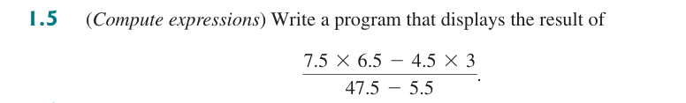

* Source Code / Solution :
public class ComputeExpression {
public static void main(String[] args) {
System.out.printf("%.3f", compute());
}

// compute the expression
public static double compute() {
return (7.5 * 6.5 - 4.5 * 3) / (47.5 - 5.5);
}
}

* Output:

* Debugging/Testing:
Bug1: The digits after dot are too many.
Fix:
System.out.printf("%.3f", compute());
Use format output.

Problem 2. (1.9)
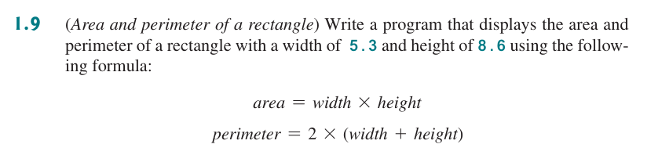

* Source Code / Solution :
public class AreaAndPerimeterOfRactangles {
// class of ractangle
public static class Ractangle {
// members of ractangle
private double height;
private double width;

// constructor to initiaize height and width
public Ractangle(double height, double width) {
this.height = height;
this.width = width;
}

// compute area
public double computeArea() {
return height * width;
}

// compute perimeter
public double computePerimeter() {
return 2.0 * (height + width);
}
}

public static void main(String[] args) {
// calcultate the area and perimeter of a certain ractangle
Ractangle rac = new Ractangle(8.6, 5.3);
System.out.println("Area: " + rac.computeArea());
System.out.println("Perimeter: " + rac.computePerimeter());
}
}

* Output:

* Debugging/Testing:
Bug1: Informal formula when calculate perimeter.
Fix:
return 2.0 * (height + width);
Use 2.0 as parameter rather than 2 to avoid possible type conflict.

Problem 3. (1.11) (optional)
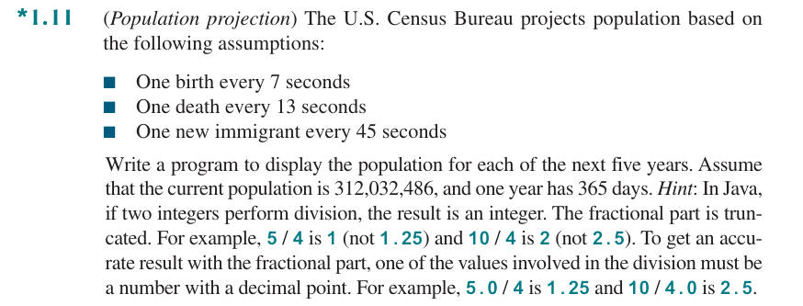

* Source Code / Solution :
public class PopulationProjection {
// model of population question
public static class PopulationModel {
private long popu;
private double increRate;
private double decreRate;
private double time;

// conductor to initialize population
public PopulationModel(long iniPopu) {
popu = iniPopu;
}

// get Popu
public long getPopu() {
return popu;
}

// compute increasing rate
public void setIncreRate(double birthRate, double immiRate) {
increRate = birthRate + immiRate;
}

// compute decrease rate
public void setDecreRate(double deathRate) {
decreRate = deathRate;
}

// set certain time(seconds)
public void setTime(double time) {
this.time = time;
}

// compute the population after certain time(seconds)
public void computePopu() {
popu = (long) (popu + ((increRate - decreRate) * time));
}
}

public static void main(String[] args) {
// initialize the model
long iniPop = 312_032_486;
double birthRate = 1.0 / 7;
double deathRate = 1.0 / 13;
double immiRate = 1.0 / 45;
long gap = 365 * 24 * 60 * 60;
PopulationModel USPopulation = new PopulationModel(iniPop);
USPopulation.setIncreRate(birthRate, immiRate);
USPopulation.setDecreRate(deathRate);

// compute the poplation of each year in next five years
for (int years = 1; years <= 5; years++) {
USPopulation.setTime(gap);
USPopulation.computePopu();
System.out.println("The population after "
+ years
+ " years is :"
+ USPopulation.getPopu());
}
}
}

* Output:
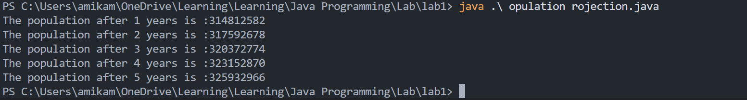

* Debugging/Testing:
Bug1: The result is wrong.
Fix:
private long popu;
private double increRate;
private double decreRate;
private double time;
For population, use type long rather than int to avoid overflow.

Problem 4. (2.5)
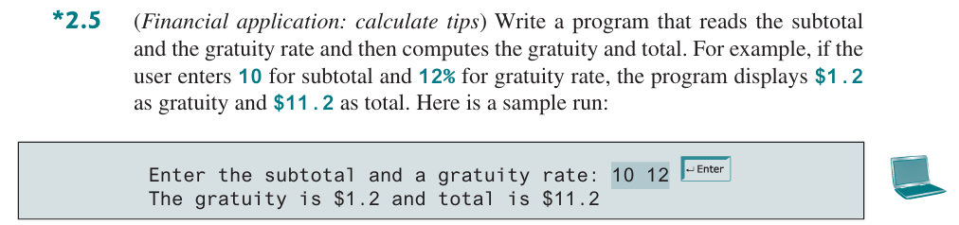

* Source Code / Solution :
import java.util.Scanner;

public class CalculateTips {
public static class TipCalculator {
private double subtotal;
private double gratuityRate;

// get subtotal
public double getSubtotal() {
return subtotal;
}

// conductor to initialize subtotal and gratuityRate
public TipCalculator(double subtotal, double gratuityRate) {
this.subtotal = subtotal;
this.gratuityRate = gratuityRate;
}

// calculate tip
public double calculateTip() {
double tip = subtotal * gratuityRate / 100;
subtotal += tip;
return tip;
}

}

public static void main(String[] args) {
// create a Scanner object to read input from the user
Scanner input = new Scanner(System.in);

System.out.println("Enter the subtotal and a gratuity rate:");
// read the subtotal and gratuity rate from the user
double subtotal = input.nextDouble();
double gratuityRate = input.nextDouble();

// create a TipCalculator object and calculate the tip and total
TipCalculator calculator = new TipCalculator(subtotal, gratuityRate);
System.out.println("The gratuity is $" + calculator.calculateTip()
+ " and total is $" + calculator.getSubtotal());
input.close();
}
}

* Output:
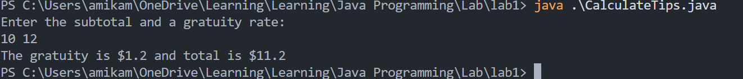

* Debugging/Testing:
Bug1: The format of output.
Fix:
System.out.println("The gratuity is $" + calculator.calculateTip()
+ " and total is $" + calculator.getSubtotal());
Ensure the correct space around parameters.

Problem 5. (2.17)
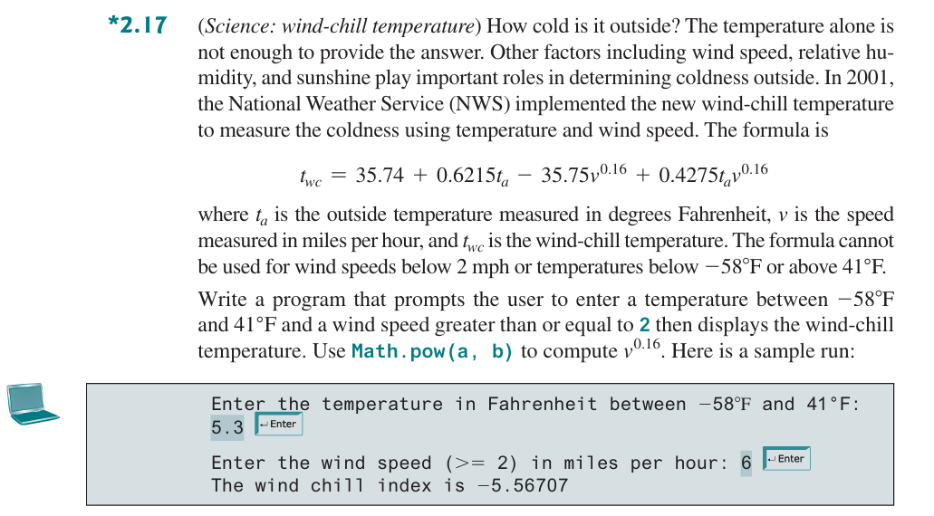

* Source Code / Solution :
import java.util.Scanner;

public class WindChillTemperature {

public static class WindChillTemperatureCalculator {
private double outsideTemperature;
private double speed;
private double windChillTemperature;

// conductor to initialize outside temperature and wind speed
public WindChillTemperatureCalculator(double outsideTemperature, double speed) {
this.outsideTemperature = outsideTemperature;
this.speed = speed;
}

// get wind chill temperature
public double getWindChillTemperature() {
return windChillTemperature;
}

// calculate wind chill temperature
public void calculateWindTemperature() {
windChillTemperature = 35.74 + 0.6215 * outsideTemperature - 35.75 * Math.pow(speed, 0.16) + 0.4275 * outsideTemperature * Math.pow(speed,0.16);
}

}

public static void main(String[] args) {
// create a scanner object to read user input
Scanner input = new Scanner(System.in);
System.out.println("Enter the temperature in Fahrenheit between -58°F and 41°F:");
double outsideTemperature = input.nextDouble();
System.out.println("Enter the wind speed (>= 2) in miles per hour:");
double speed = input.nextDouble();

// calculate wind chill temperature
WindChillTemperatureCalculator result = new WindChillTemperatureCalculator(outsideTemperature, speed);
result.calculateWindTemperature();
System.out.printf("The wind chill index is %.5f", result.getWindChillTemperature());

input.close();
}

}

* Output:
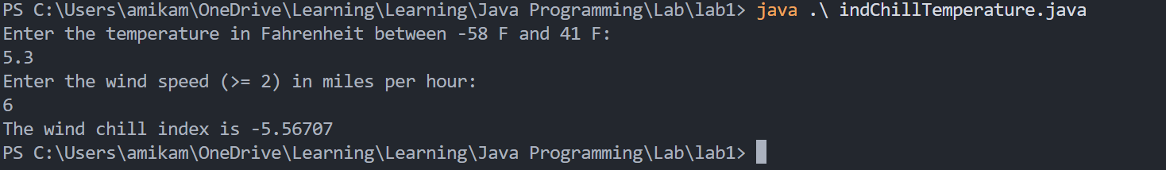

* Debugging/Testing:
Bug1: The format of fractional part
Fix:
System.out.printf("The wind chill index is %.5f", result.getWindChillTemperature());
Use format output to ensure the digits.

Problem 6. (2.19) (optional)
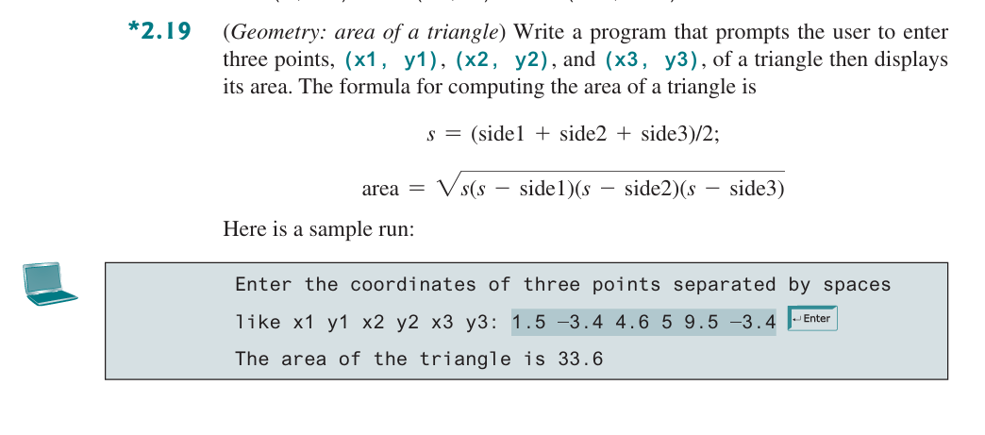

* Source Code / Solution :
import java.util.Scanner;

public class AreaOfTriangles {
public static class TrianglesAreaCalculator {
private double side1, side2, side3;
private double area;

// initialize sides by passing x and y coordinates of each vertex
public TrianglesAreaCalculator(double x1, double y1, double x2, double y2, double x3, double y3) {
side1 = Math.sqrt(Math.pow(x2 - x1, 2) + Math.pow(y2 - y1, 2));
side2 = Math.sqrt(Math.pow(x3 - x2, 2) + Math.pow(y3 - y2, 2));
side3 = Math.sqrt(Math.pow(x1 - x3, 2) + Math.pow(y1 - y3, 2));
}

// get area of the triangle
public double getArea() {
return area;
}

// calculate the area of the triangle
public void calculateArea() {
double s = (side1 + side2 + side3) / 2;
area = Math.sqrt(s * (s - side1) * (s - side2) * (s - side3));
}
}

public static void main(String[] args) {
// create a scanner object to read input
Scanner input = new Scanner(System.in);
System.out.println("Enter the coordinates of three points separated by spaces\r\n" +
"like x1 y1 x2 y2 x3 y3:");
double x1 = input.nextDouble();
double y1 = input.nextDouble();
double x2 = input.nextDouble();
double y2 = input.nextDouble();
double x3 = input.nextDouble();
double y3 = input.nextDouble();

// calculate the area of the triangle
TrianglesAreaCalculator result = new TrianglesAreaCalculator(x1, y1, x2, y2, x3, y3);
result.calculateArea();
System.out.printf("The area of the triangle is: %.1f", result.getArea());

input.close();
}
}

* Output:
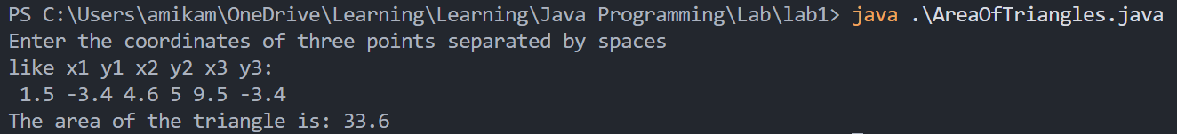

* Debugging/Testing:
Bug1: The incorrect format of output.
Fix:
System.out.printf("The area of the triangle is: %.1f", result.getArea());
Use format output to ensure only one digit after dot.

LAB 2 DATE: 4/07/2026

Student Name: ___李荣耀____ Student ID: 2024103975__

Problem 1. (3.5)
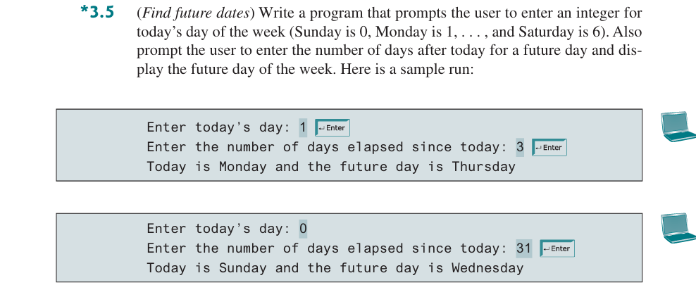

* Source Code / Solution :
package Lab2;

import java.util.Scanner;

public class FindFutureDate {
/**
* print the day according to today and the days after today
* @param today the day of today
* @param days the days
*/
public static void printFutureDay(int today, int days) {
// error check
if (today < 0) {
System.out.println("Error input of today");
return;
}

if (days < 0) {
System.out.println("Error input of days");
}

// calculate the future day
String[] dayStrings = { "Sunday", "Monday", "Tuesday", "Wednesday", "Thusday", "Friday", "Saturday" };
int futureDay = (today + days) % 7;
System.out.println("Today is " + dayStrings[today] + " and the future day is " + dayStrings[futureDay]);
}
public static void main(String[] args) {
Scanner sc = new Scanner(System.in);
System.out.println("Enter today's day:");
int today = sc.nextInt();
System.out.println("Enter the number of days elapsed since today:");
int days = sc.nextInt();

printFutureDay(today, days);

sc.close();
}
}

* Output:
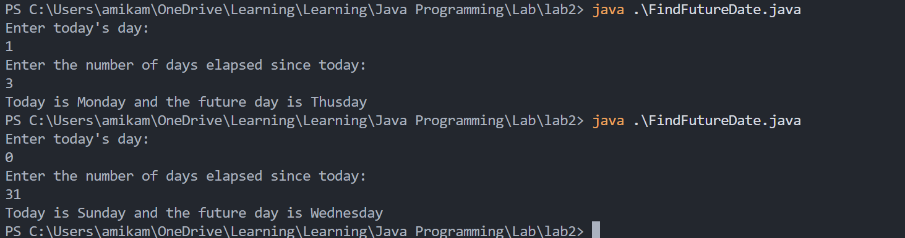

* Debugging/Testing:
Bug1: The incorrect index to the days in a week and.
Fix:
int futureDay = (today + days) % 7;
Modify the corresponding relation.

Problem 2. (3.31)
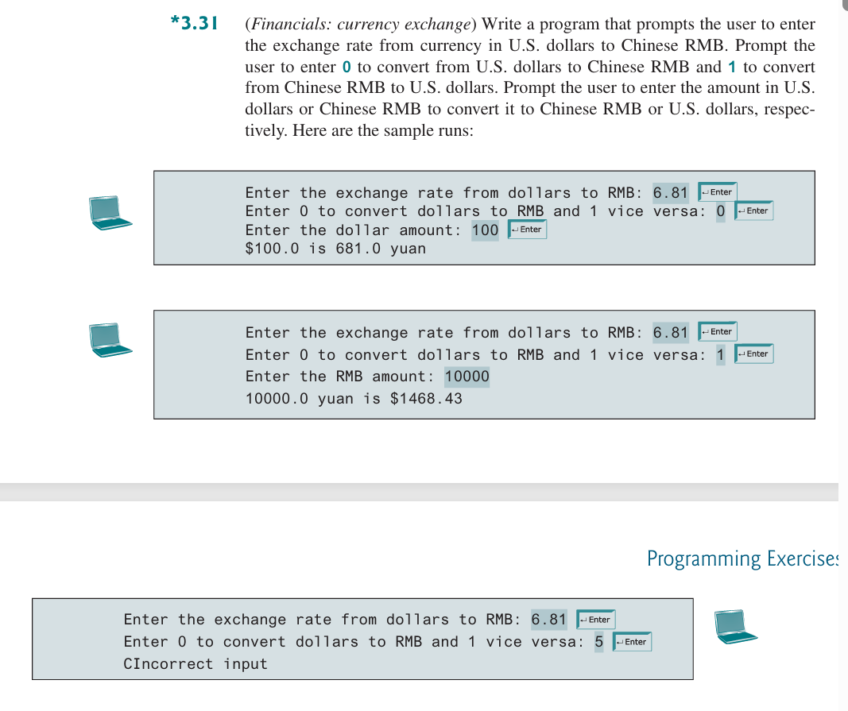

* Source Code / Solution :
package Lab2;

import java.util.Scanner;

public class CurrencyExchange {
/**
* print the result of currency exchange
* @param rate the rate from dollor to yuan
* @param type the conversion type
* @param amount the amount of currency
*/
public static void printCurrencyExchange(double rate, int type, double amount) {
// check the input
if (type != 0 && type != 1) {
System.out.println("Incorrect input");
return;
}

if (rate <= 0) {
System.out.println("Incorrect input of rate");
return;
}

if (amount < 0) {
System.out.println("Incorrect input of amount");
return;
}

// calculate the result according to type
double target;
if (type == 0) {
target = amount * rate;
System.out.println("$" + amount + " is " + String.format("%.2f", target) + " yuan");
} else {
target = amount / rate;
System.out.println(amount + " yuan is $" + String.format("%.2f", target));
}
}
public static void main(String[] args) {
Scanner sc = new Scanner(System.in);
System.out.println("Enter the exchange rate from dollars to RMB:");
double rate = sc.nextDouble();
if (rate <= 0) {
System.out.println("Incorrect input of rate");
sc.close();
return;
}

System.out.println("Enter 0 to convert dollars to RMB and 1 vice versa:");
int type = sc.nextInt();
if (type != 0 && type != 1) {
System.out.println("Incorrect input");
sc.close();
return;
}

System.out.println("Enter the RMB amount:");
double amount = sc.nextDouble();
if (amount < 0) {
System.out.println("Incorrect input of amount");
sc.close();
return;
}

printCurrencyExchange(rate, type, amount);

sc.close();
}
}

* Output:
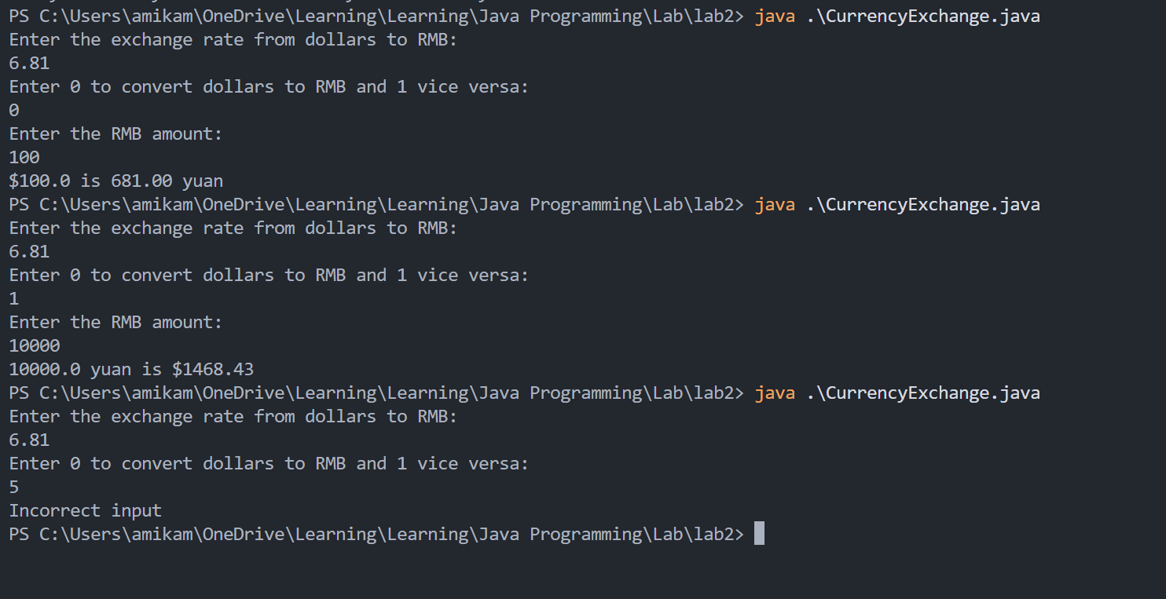

* Debugging/Testing:
Bug1: The sc is not close if the input is valid.
Fix: Add sc.close() in each incorrect situation.

Problem 3. (3.15) (optional)
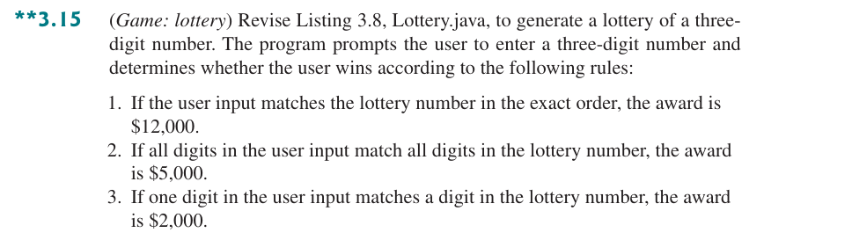

* Source Code / Solution :
package Lab2;

import java.util.Scanner;

public class Lottery {
/**
* sort the integers in non-decreasing order
* @param arr the array storing integers
*/
public static void sortIntegers(int[] arr) {
int tmp;
if (arr[0] < arr[1]) {
tmp = arr[0];
arr[0] = arr[1];
arr[1] = tmp;
}
if (arr[1] < arr[2]) {
tmp = arr[1];
arr[1] = arr[2];
arr[2] = tmp;
}
}

/**
* Generate the lottery and print the matching result
* @param input the input number
*/
public static void lotteryMatch(int input) {
if (input < 0 || input > 999) {
System.out.println("Incorrect input");
System.exit(1);
}
// generate the result(0~999) randomly
int result = (int) (Math.random() * 1000);

// separate three digits
int resHundred = result / 100;
int resTen = (result % 100) / 10;
int resOne = (result % 10);

int inputHundred = input / 100;
int inputTen = (input % 100) / 10;
int inputOne = (input % 10);

System.out.println("The result of the lottery is " + String.format("%03d", result));

// match in the exact order
if (resHundred == inputHundred && resTen == inputTen && resOne == inputOne) {
System.out.println("Match in exact order, the award is $12000.");
}
// match
else {
int[] res = { resHundred, resTen, resOne };
int[] inp = { inputHundred, inputTen, inputOne };

sortIntegers(res);
sortIntegers(inp);

int digitLen = 3;
// the number of number matches
int match = 0;

for (int i = 0; i < digitLen; i++) {
if (res[i] == inp[i]) {
match++;
}
}

if (match == 3) {
System.out.println("Match all digits in the lottery number, the award is $5,000");
} else if (match != 0) {
System.out.println("Match a digit in the lottery number, the award is $2,000");
} else {
System.out.println("No match");
}
}
}

public static void main(String[] args) {
Scanner sc = new Scanner(System.in);
System.out.println("Enter a three-digit number:");
int input = sc.nextInt();
if (input < 0 || input > 999) {
System.err.println("Incorrect input");
sc.close();
return;
}

lotteryMatch(input);

sc.close();
}
}

* Output:
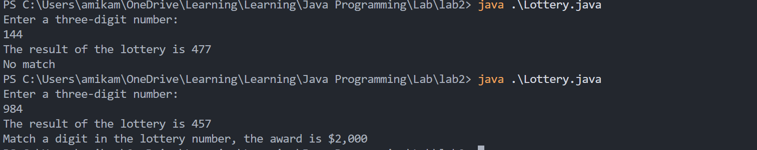

* Debugging/Testing:
Bug1: The scale of random number is wrong.
Fix:
int result = (int) (Math.random() * 1000);
Modify the algorithm to get random. Understand the difference between random() in C and Math.random().
Bug2: The situation of two number match is not handled.
Fix:
if (match == 3) {
System.out.println("Match all digits in the lottery number, the award is $5,000");
} else if (match != 0) {
System.out.println("Match a digit in the lottery number, the award is $2,000");
} else {
System.out.println("No match");
}
Let two matches be the second situation. The award is $2000.

Problem 4. (4.9)
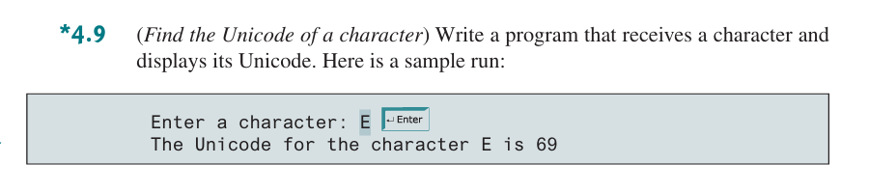

* Source Code / Solution :
package Lab2;

import java.util.Scanner;

public class UnicodeOfCharacters {
/**
* print the unicode of a character
* @param ch the character
*/
public static void printUnicode(char ch) {
//force type cast
int Unicode = (int) ch;
System.out.println("The Unicode for the character " + ch + " is " + Unicode);
}

public static void main(String[] args) {
Scanner sc = new Scanner(System.in);
System.out.println("Enter a character:");
char ch = sc.next().charAt(0);
printUnicode(ch);

sc.close();
}
}

* Output:
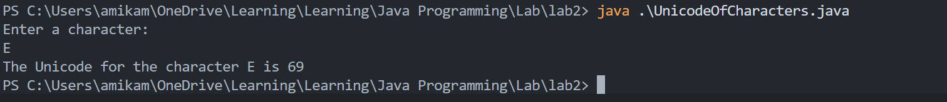

* Debugging/Testing:
Bug1: Error method to obtain the character.
Fix:
char ch = sc.next().charAt(0);
Understand the difference of the performance between C and Java.

Problem 5. (4.11)
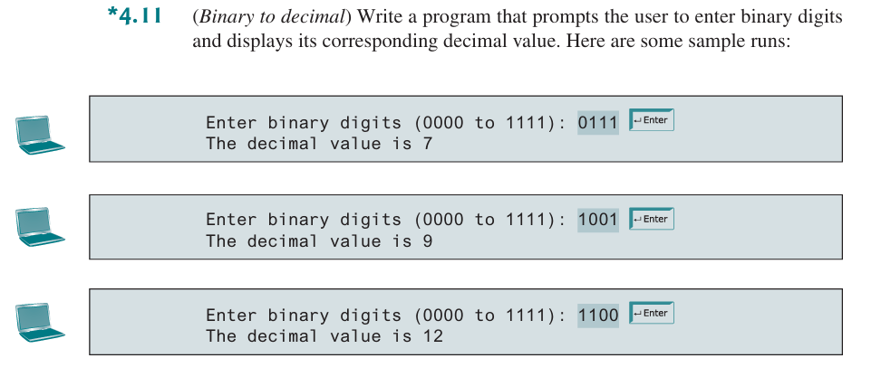

* Source Code / Solution :
package Lab2;

import java.util.Scanner;

public class BinaryToDecimal {
/**
* transform the binary to decimal(unsigned)
* @param bitString binary string
* @return decimal of binary string
*/
public static int B2U(String bitString) {
int len = bitString.length();
// check illegal length
if (len > 4) {
System.out.println("Error length of bit string");
System.exit(1);
}

int decimal = 0;
int mul = 1;

// multiple corresponding digit and add to result
for (int i = len - 1; i >= 0; i--) {
char ch = bitString.charAt(i);
if (ch != '0' && ch != '1') {
System.out.println("Incorrect input of binary string");
System.exit(1);;
}
decimal += (ch - '0') * mul;
mul *= 2;
}

return decimal;
}
public static void main(String[] args) {
Scanner sc = new Scanner(System.in);
System.out.println("Enter binary digits (0000 to 1111):");
String bitString = sc.next();

System.out.println("The decimal value is " + B2U(bitString));

sc.close();
}
}

* Output:
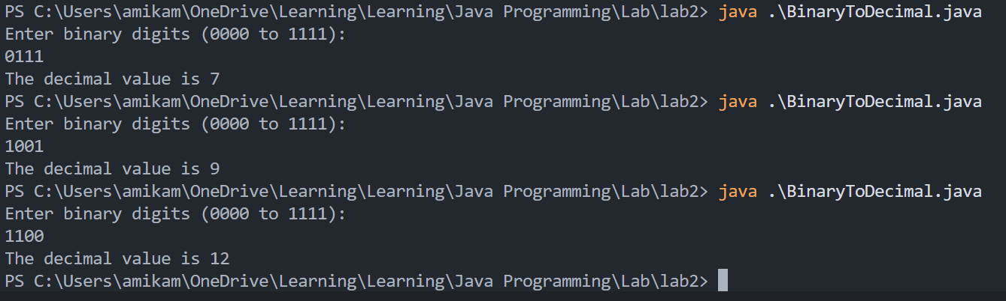

* Debugging/Testing:
Bug1: The result is incorrect.
Fix:
decimal += (ch - '0') * mul;
The transformation between the character to its corresponding integer should be ch – ‘0’ rather than type cast(Unicode).

Problem 6. (4.17) (optional)
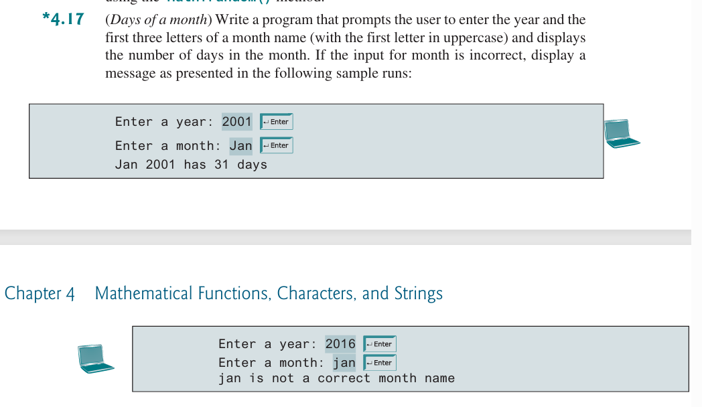

* Source Code / Solution :
package Lab2;

import java.util.Scanner;

public class DaysOfAMonth {

/**
* find the days of month in corresponding year
* @param year
* @param month
* @return the days of month in corresponding year
*/
public static int findDaysOfMonth(int year, String month) {
int ret = 0;
// map month to corresponding days
int[] days = { 31, 28, 31, 30, 31, 30, 31, 31, 30, 31, 30, 31 };
// check whether is leap year
if (((year % 100 != 0) && (year % 4 == 0)) || (year % 400 == 0)) {
days[1] = 29;
}

// map string to corresponding index
String[] months = { "Jan", "Feb", "Mar", "Apr", "May", "Jun", "Jul", "Aug", "Sep", "Oct", "Nov", "Dec" };
int monthsLen = months.length;
boolean isMonth = false;

for (int i = 0; i < monthsLen; i++) {
if (month.equals(months[i])) {
ret = days[i];
isMonth = true;
}
}

if (isMonth == false) {
System.out.println(month + " is not a correct month name");
System.exit(1);
}

return ret;
}
public static void main(String[] args) {
Scanner sc = new Scanner(System.in);
System.out.println("Enter a year:");
int year = sc.nextInt();
System.out.println("Enter a month:");
String month = sc.next();

int days = findDaysOfMonth(year, month);
System.out.println(month + " " + year + " has " + days + " days");

sc.close();
}
}

* Output:
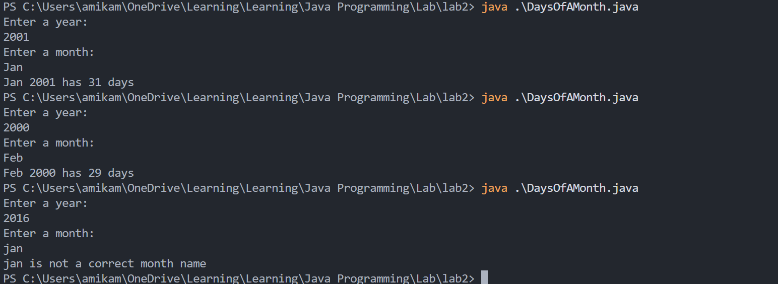

* Debugging/Testing:
Bug1: The comparison between strings.
Fix:
if (month.equals(months[i])) {
The comparison between strings should use compareTo() or equals() rather than directly use ‘==’

LAB 3 DATE: 4/14/2026

Student Name: __李荣耀____ Student ID: 2024103975___

Problem 1. (5.9)
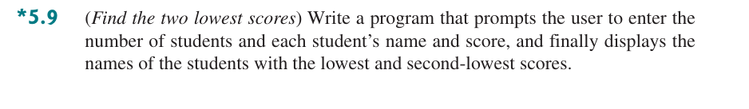

* Source Code / Solution :
import java.util.Scanner;

public class FindTwoLowestScores {
// class of a single student
public static class Student {
private String name;
private double score;

public Student(String name, double score) {
this.name = name;
this.score = score;
}

public String getName() {
return name;
}

public double getScore() {
return score;
}

public void setName(String name) {
this.name = name;
}

public void setScore(double score) {
this.score = score;
}
}

/**
* find two lowest scores and print them and corresponding name
* @param s the array of students
*/
public static void printTwoLowestScores(Student[] s, int num) {
double[] scores = new double[num];
int idx1 = 0, idx2 = 0;
for (int i = 0; i < num; i++) {
scores[i] = s[i].getScore();
}

// find the lowest score
for (int i = 0; i < num; i++) {
if (scores[i] < scores[idx1]) {
idx1 = i;
}
}

// find the second lowest score
for (int i = 0; i < num; i++) {
if (scores[i] < scores[idx2] && i != idx1) {
idx2 = i;
}
}

// print the two lowest scores and corresponding name
System.out.println("The lowest student: " + s[idx1].getName() + "; Score: " + scores[idx1]);
System.out.println("The second lowest student: " + s[idx2].getName() + "; Score: " + scores[idx2]);
}

public static void main(String[] args) {
Scanner sc = new Scanner(System.in);
System.out.println("Please enter the number of students.");
int num = sc.nextInt();

System.out.println("Please enter the name and score of each student. Like \"Leon 11037\"");
Student[] s = new Student[num];
for (int i = 0; i < num; i++) {
String name = sc.next();
double score = sc.nextDouble();
s[i] = new Student(name, score);
}

printTwoLowestScores(s, num);
sc.close();
}
}

* Output:
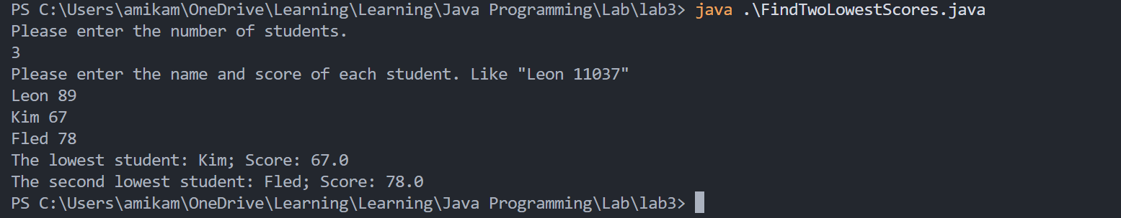

* Debugging/Testing:
Bug1: The lowest student and the second lowest student is the same one.
Fix:
for (int i = 0; i < num; i++) {
if (scores[i] < scores[idx2] && i != idx1) {
idx2 = i;
}
}
Modify the condition. It should be `i != idx1` rather than `idx2 != idx1`.

Problem 2. (5.29) (optional)
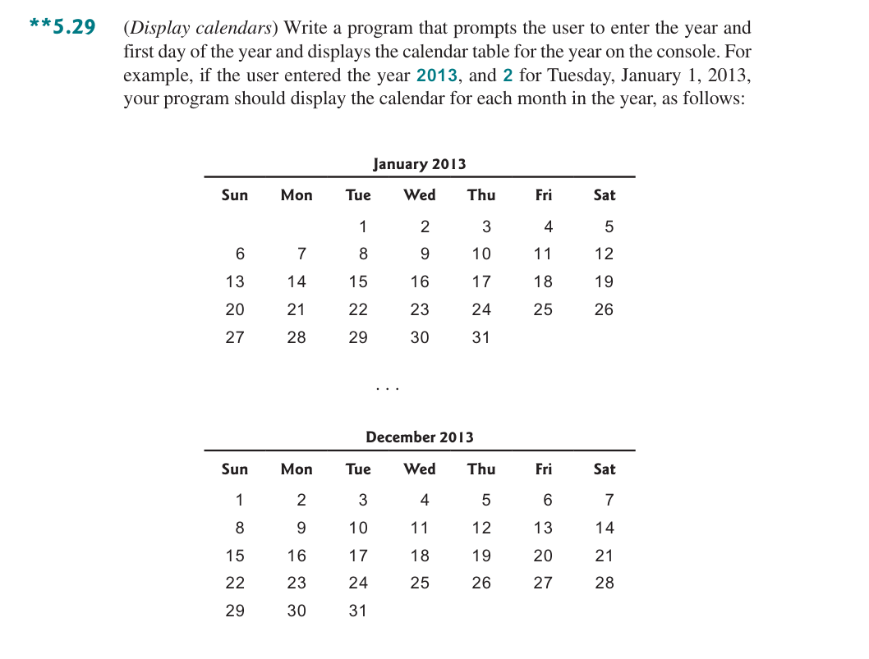

* Source Code / Solution :
import java.util.Scanner;

public class DisplayCalendars {
/**
* display the calendar by the year and the first day
* @param year the year
* @param firstDay the first day
*/
public static void displayCalendars(int year, int firstDay) {
final String[] months = { "January", "February", "March", "April", "May", "June", "July", "August", "September",
"October", "November", "December" };
int[] daysInMonth = { 31, 28, 31, 30, 31, 30, 31, 31, 30, 31, 30, 31 };

if ((year % 4 == 0 && year % 100 != 0) || (year % 400 == 0)) {
daysInMonth[1] = 29;
}

int currentFirstDay = firstDay;

for (int m = 0; m < 12; m++) {
// print the head of the table
System.out.println("\n" + String.format("%-10s", months[m] + " " + year));
System.out.println("-".repeat(28));
System.out.printf("%-4s%-4s%-4s%-4s%-4s%-4s%-4s\n", "Sun", "Mon", "Tue", "Wed", "Thu", "Fri", "Sat");

// print the former space
for (int i = 0; i < currentFirstDay; i++) {
System.out.printf(" ".repeat(4));
}

// print dates
int dayOfWeek = currentFirstDay;
for (int day = 1; day <= daysInMonth[m]; day++) {
System.out.printf("%-4d", day);

if (dayOfWeek == 6) {
System.out.println();
}
dayOfWeek = (dayOfWeek + 1) % 7;
}

System.out.println();

currentFirstDay = (currentFirstDay + daysInMonth[m]) % 7;
}
}

public static void main(String[] args) {
Scanner sc = new Scanner(System.in);
System.out.println("Please enter the year:");
int year = sc.nextInt();
System.out.println("Please enter the first day of the year (0-6 for Sunday-Saturday):");
int firstDay = sc.nextInt();
displayCalendars(year, firstDay);

sc.close();
}
}

* Output:
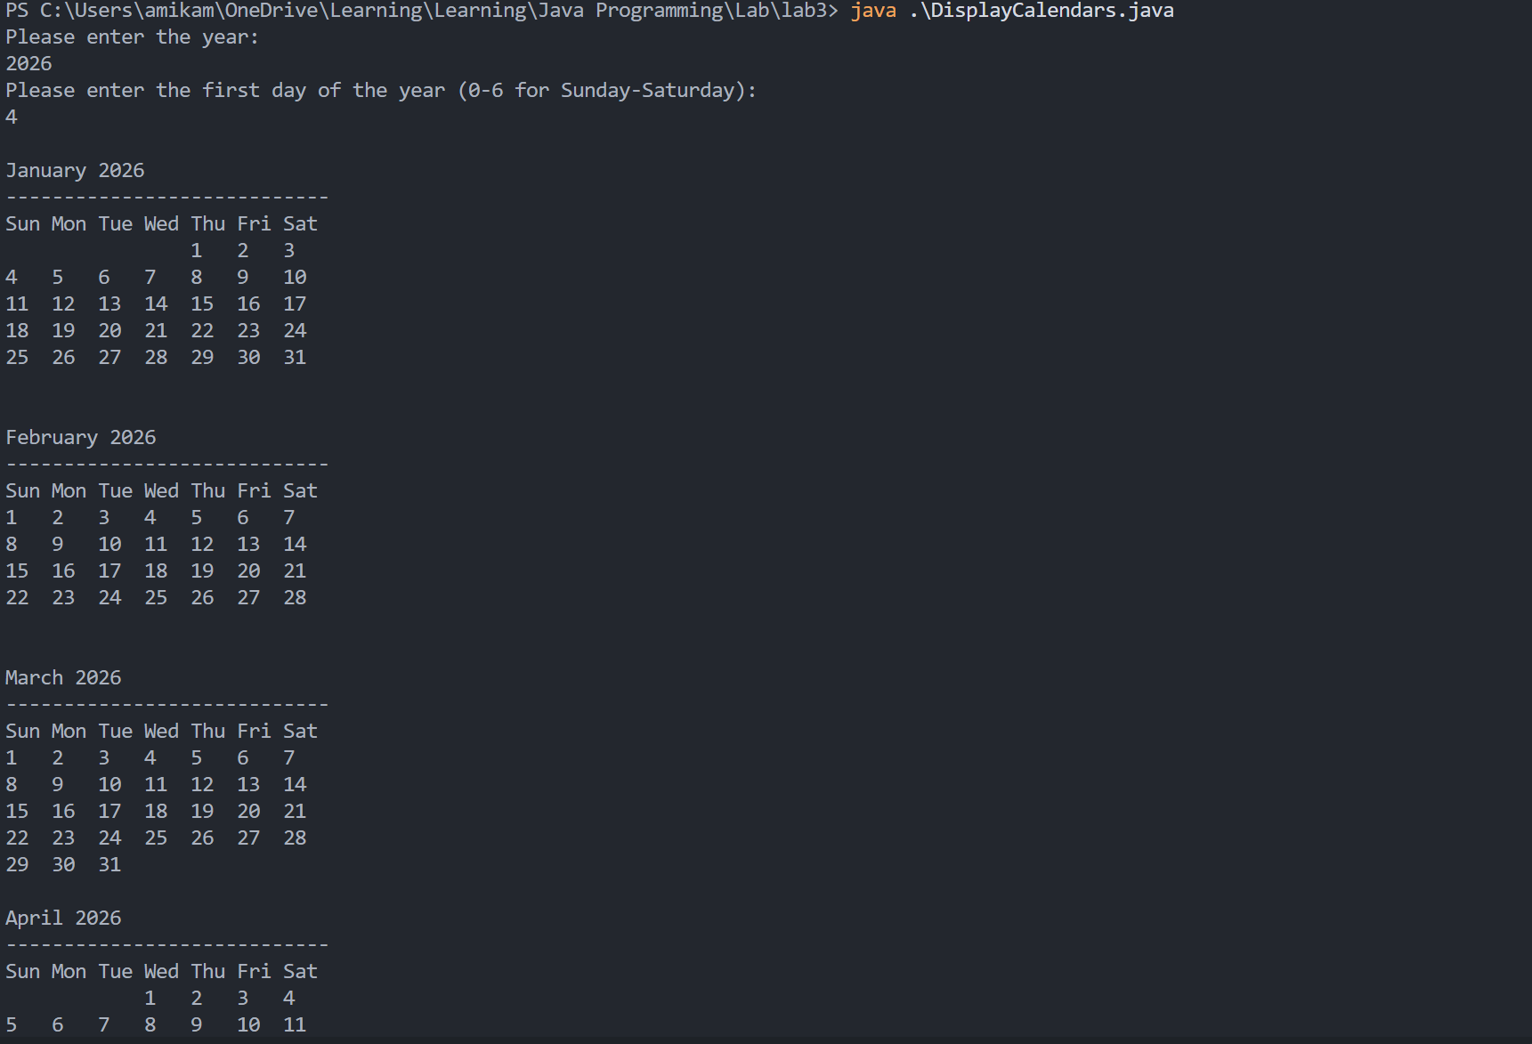
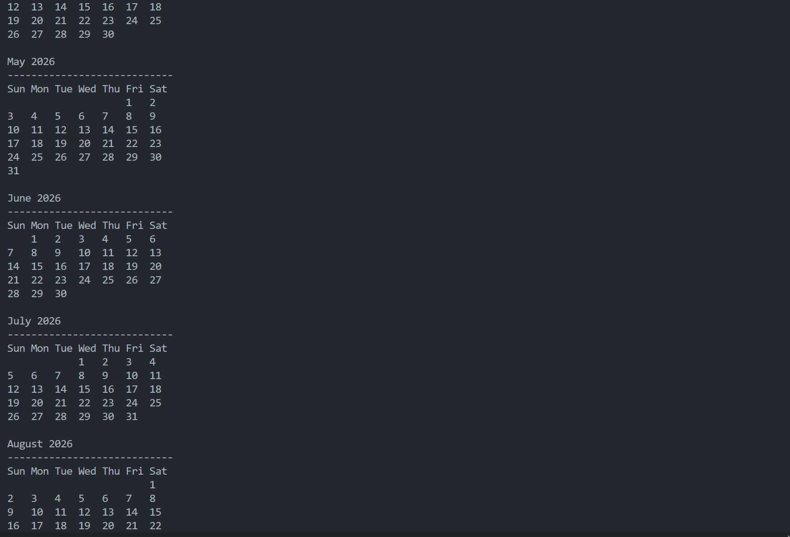
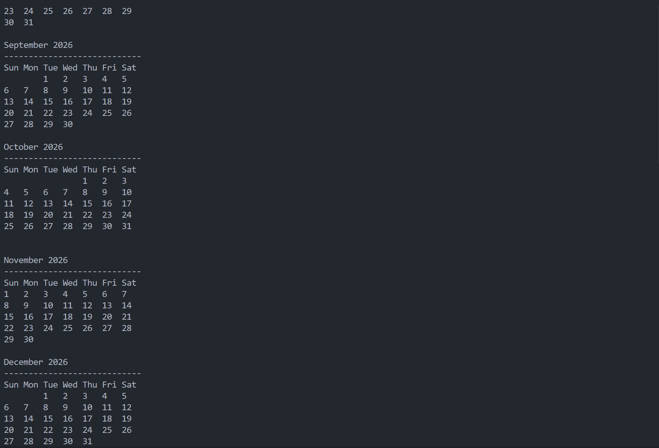

* Debugging/Testing:
Bug1: The first day of each month is the same.
Fix:
currentFirstDay = (currentFirstDay + daysInMonth[m]) % 7;
Add a new variable to record the first day of current month.

Problem 3. (6.5)
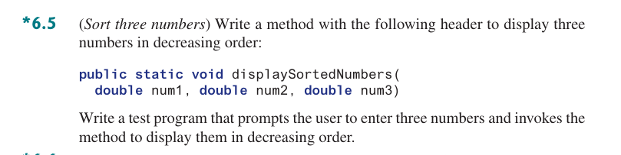

* Source Code / Solution :
import java.util.Scanner;

public class SortThreeNumbers {
/**
* display three numbers in decreasing order
* @param num1 the first number
* @param num2 the second number
* @param num3 the third number
*/
public static void displaySortedNumbers(double num1, double num2, double num3) {
double temp;
if (num1 < num2) {
temp = num1;
num1 = num2;
num2 = temp;
}
if (num1 < num3) {
temp = num1;
num1 = num3;
num3 = temp;
}
if (num2 < num3) {
temp = num2;
num2 = num3;
num3 = temp;
}

System.out.println(num1);
System.out.println(num2);
System.out.println(num3);
}
public static void main(String[] args) {
Scanner sc = new Scanner(System.in);
System.out.println("Please enter three numbers: ");
double num1 = sc.nextDouble();
double num2 = sc.nextDouble();
double num3 = sc.nextDouble();

System.out.println();
displaySortedNumbers(num1, num2, num3);

sc.close();
}
}

* Output:
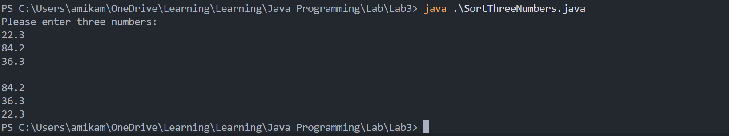

* Debugging/Testing:
Bug1: The output and the input are connect.
Fix:
System.out.println();
Print a new line.

Problem 4. (6.11)
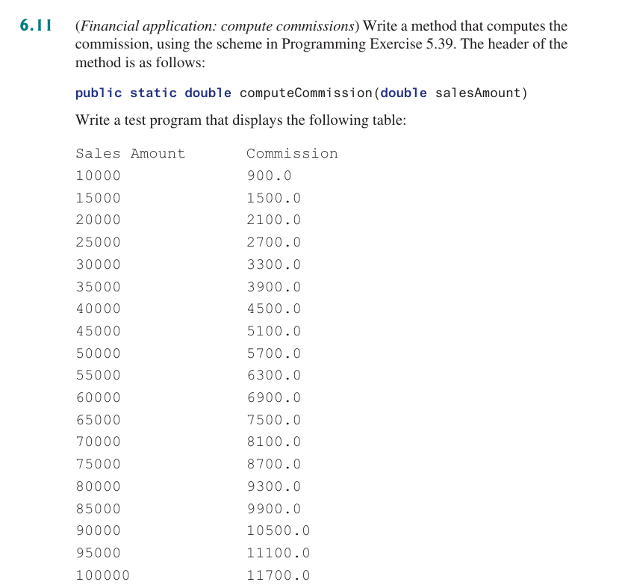

* Source Code / Solution :
public class ComputeCommissions {
/**
* Compute the commission based on the sales amount
* @param salesAmount
* @return the commission
*/
public static double computeCommission(double salesAmount) {
final double stg1 = 5000.0;
final double stg2 = 10000.0;
final double rt1 = 0.06;
final double rt2 = 0.08;
final double rt3 = 0.1;
double commission = 0.0;
if (salesAmount > 0.0 && salesAmount < stg1) {
commission = salesAmount * rt1;
} else if (salesAmount < stg2) {
commission = stg1 * rt1 + (salesAmount - stg1)
* rt2;
} else {
commission = stg1 * rt1 + (stg2 - stg1) * rt2 + (salesAmount - stg2) * rt3;
}

return commission;
}
public static void main(String[] args) {
// print the head of the table
System.out.printf("%-15s %-20s\n", "Sales Amount", "Commission");

//test the function with some sample sales amounts
double[] salesAmount = {10000, 15000, 20000, 25000, 30000, 35000, 40000, 45000, 50000, 55000, 60000, 65000,
70000, 75000, 80000, 85000, 90000, 95000, 100000 };

// print the commission for each sales amount
for (double ele : salesAmount) {
System.out.printf("%-15.0f %-20.1f\n", ele, computeCommission(ele));
}
}
}

* Output:
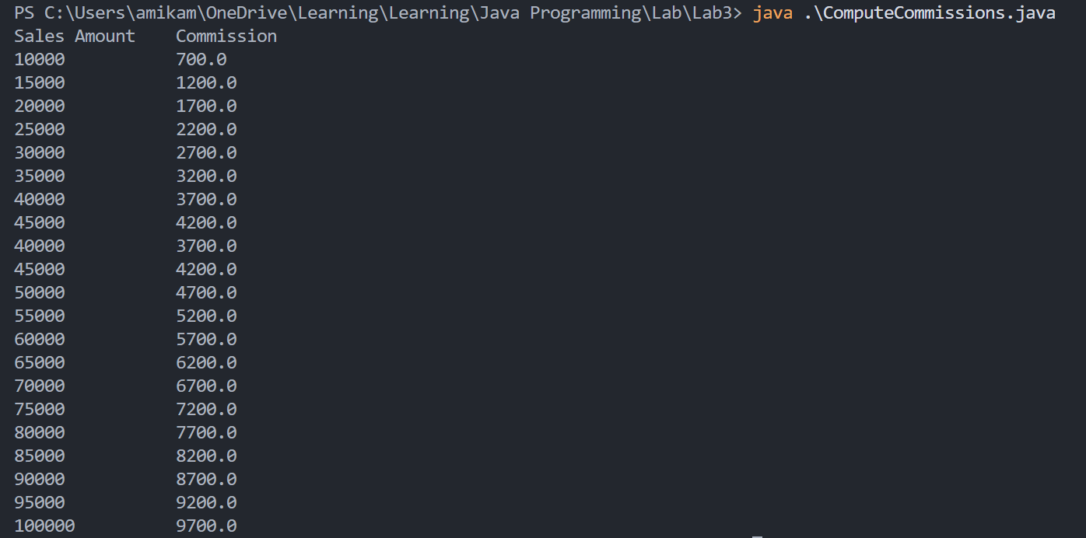

* Debugging/Testing:
Bug1: The format of output.
Fix:
System.out.printf("%-15.0f %-20.1f\n", ele, computeCommission(ele));
Ensure the fixed size and left justifying.

Problem 5. (6.19) (optional)
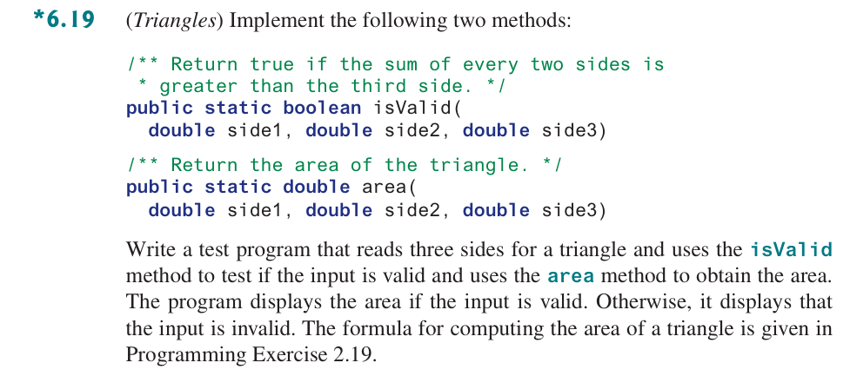

* Source Code / Solution :
import java.util.Scanner;

public class Triangles {
/**
* Return true if the sum of every two sides greater than the third side.
* @param side1
* @param side2
* @param side3
* @return true or false
*/
public static boolean isValid(double side1, double side2, double side3) {
return (side1 + side2 > side3) && (side2 + side3 > side1) && (side1 + side3 > side2);
}

/**
* Return the area of the triangle.
* @param side1
* @param side2
* @param side3
* @return the area of the triangle
*/
public static double area(double side1, double side2, double side3) {
if (!isValid(side1, side2, side3)) {
System.out.println("The input is invalid.");
return 0;
}

double s = (side1 + side2 + side3) / 2;
return Math.sqrt(s * (s - side1) * (s - side2) * (s - side3));
}

public static void main(String[] args) {
Scanner sc = new Scanner(System.in);
System.out.println("Please enter the sides of the triangle, separate by space:");
double side1 = sc.nextDouble();
double side2 = sc.nextDouble();
double side3 = sc.nextDouble();

if (!isValid(side1, side2, side3)) {
System.out.println("Invalid input");
sc.close();
return;
}

System.out.printf("The area of the triangle is: %.2f\n", area(side1, side2, side3));

sc.close();
}
}

* Output:
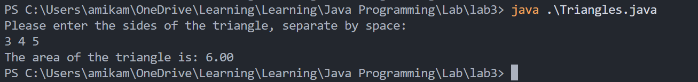

* Debugging/Testing:
Bug1: The format of output.
Fix:
System.out.printf("The area of the triangle is: %.2f\n", area(side1, side2, side3));
Use %.2f to ensure the number of digits.

LAB 4 DATE: 4/21/2026

Student Name: __李荣耀____ Student ID: 2024103975___

Problem 1. (7.13)
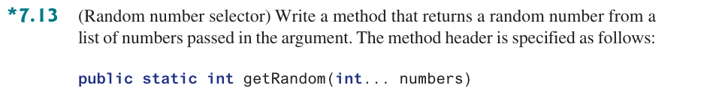

* Source Code / Solution :
package Lab4;

public class RandomNumberSelector {
/**
* return a random number from a list of numbers
* @param numbers
* @return a random number in a list of numbers
*/
public static int getRandom(int... numbers) {
// handle argument exception
if (numbers == null || numbers.length == 0) {
throw new IllegalArgumentException("Empty array.");
}
// generate random index
int idx = (int) (Math.random() * numbers.length);
return numbers[idx];
}

public static void main(String[] args) {
int[] numbers = { 34, 13, 78, 29, 91, 114, 514, 1919, 810, 11037 };
System.out.println("The elements in the array are:");
for (int ele : numbers) {
System.out.print(ele + " ");
}
System.out.println();

System.out.println("A random number from the array:");
System.out.println(getRandom(numbers));
}
}

* Output:
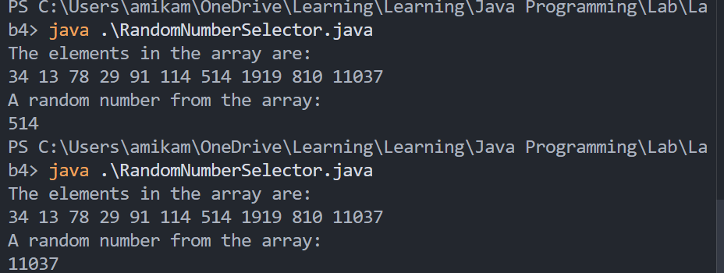

* Debugging/Testing:
Bug1: There is no check for array.
Fix:
if (numbers == null || numbers.length == 0) {
throw new IllegalArgumentException("Empty array.");
}
Throw argument exception if the array is empty. Enhance the robustness of the program.

Problem 2. (7.23) (Optional)
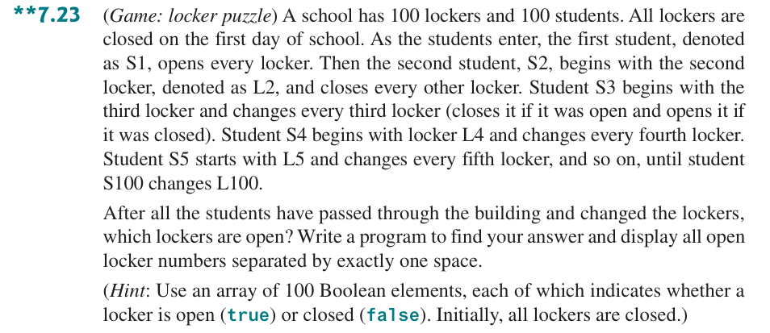

* Source Code / Solution :
package Lab4;

public class LockerPuzzle {
/**
* solve the locker puzzle
* @param lockers the array to denote the situation of lockers, false is close and true is open
*/
public static void solveLockerPuzzle(boolean[] lockers){
int len = lockers.length;
// i represents i+1-th student
for (int i = 0; i < len; i++) {
for (int j = i; j < len; j++) {
// reverse the situation if satisfying the condition
if ((j + 1) % (i + 1) == 0) {
lockers[j] = !lockers[j];
}
}
}
}

public static void main(String[] args) {
// initialize 100 lockers as false
final int SIZE = 100;
boolean[] lockers = new boolean[SIZE];

solveLockerPuzzle(lockers);
System.out.println("All indices of open lockers are:");

int len = lockers.length;
for (int i = 0; i < len; i++) {
if (lockers[i]) {
System.out.print(i + 1 + " ");
}
}
}
}

* Output:
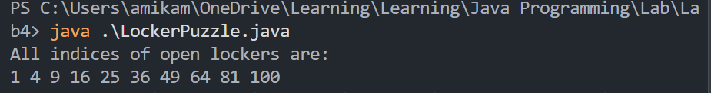

* Debugging/Testing:
Bug1: Null pointer exception.
Fix: Confuse the primitive data type ‘boolean’ and the class ‘Boolean’. Boolean will be initialized as null whereas boolean will be initialized as false in default. If use Boolean, the conditional judgment will throw the null pointer exception.

Problem 3. (8.5)
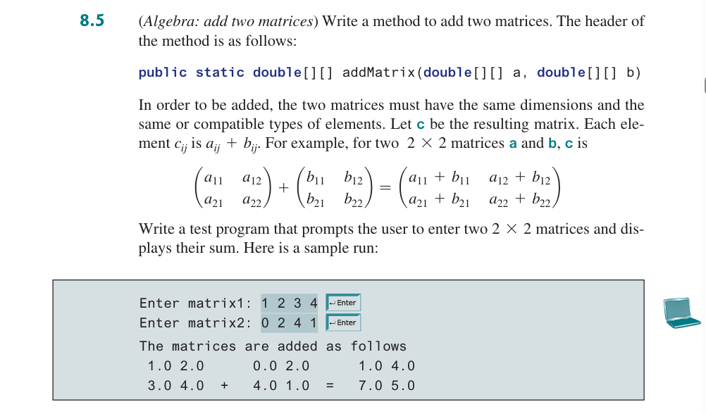

* Source Code / Solution :
package Lab4;

import java.util.Scanner;

public class AddTwoMatrices {
/**
* add two matrices
* @param a the first matrix
* @param b the second matrix
* @return the result matrix
*/
public static double[][] addMatrix(double[][] a, double[][] b) {
// check whether two matrices have the same DIMensions
if (a.length != b.length) {
throw new IllegalArgumentException("Different DIMentions for matrices.");
}

// check whether the matrix is empty
if (a == null || b == null || a.length == 0 || b.length == 0 || a[0] ==null || b[0] == null || a[0].length == 0 || b[0].length == 0) {
throw new IllegalArgumentException("Invalid matrix.");
}

// obtain the row and col length
int row = a.length;
int col = a[0].length;

double[][] res = new double[row][col];

// add two matrices
for (int i = 0; i < row; i++) {
for (int j = 0; j < col; j++) {
res[i][j] = a[i][j] + b[i][j];
}
}

return res;
}
public static void main(String[] args) {
Scanner sc = new Scanner(System.in);
final int DIM = 2;
double[][] matrix1 = new double[DIM][DIM];
double[][] matrix2 = new double[DIM][DIM];

// scan two matrices
System.out.println("Enter matrix1 (2x2):");
for (int i = 0; i < DIM; i++) {
for (int j = 0; j < DIM; j++) {
matrix1[i][j] = sc.nextDouble();
}
}

System.out.println("Enter matrix2 (2x2):");
for (int i = 0; i < DIM; i++) {
for (int j = 0; j < DIM; j++) {
matrix2[i][j] = sc.nextDouble();
}
}

double[][] res = addMatrix(matrix1, matrix2);

System.out.println("The matrices are added as follows");
for (int i = 0; i < DIM; i++) {
// print the same row of each matrix
for (int j = 0; j < DIM; j++) {
System.out.printf("%4.1f", matrix1[i][j]);
}

if (i == DIM - 1) {
System.out.print(" + ");
} else {
System.out.print(" ".repeat(4));
}

for (int j = 0; j < DIM; j++) {
System.out.printf("%4.1f", matrix2[i][j]);
}

if (i == DIM - 1) {
System.out.print(" = ");
} else {
System.out.print(" ".repeat(4));
}

for (int j = 0; j < DIM; j++) {
System.out.printf("%4.1f", res[i][j]);
}

System.out.println();
}

sc.close();
}
}

* Output:
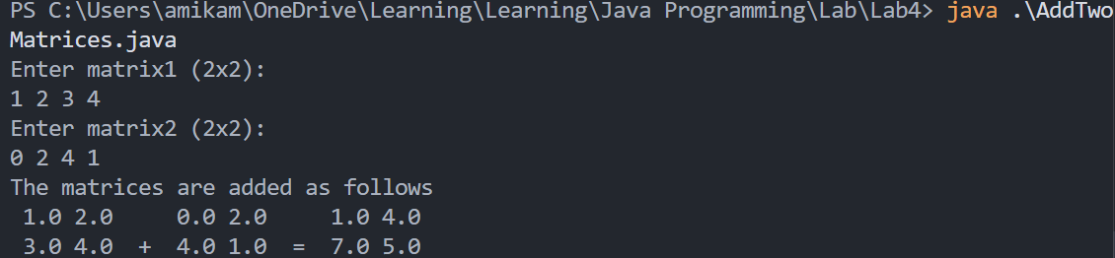

* Debugging/Testing:
Bug1: The format of output.
Fix: Use three inner loops to respectively print one row of each matrix. Use format output to ensure correct spaces and symbol.

Problem 4. (8.27)
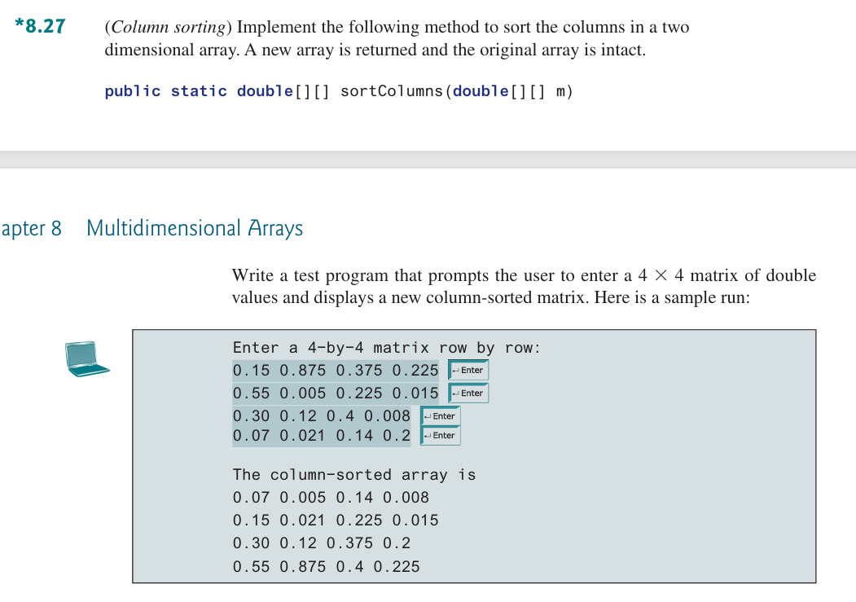

* Source Code / Solution :
package Lab4;

import java.util.Scanner;
import java.util.ArrayList;

public class ColumnSorting {
/**
* sort the columns of a matrix
* @param m
* @return sorted matrix
*/
public static double[][] sortColumns(double[][] m) {
if (m == null || m.length == 0 || m[0] == null || m[0].length == 0) {
throw new IllegalArgumentException("Invalid matrix.");
}

// obtain row and column length
int row = m.length;
int col = m[0].length;
double[][] res = new double[row][col];

for (int j = 0; j < col; j++) {
// create ArrayList to easily sort
ArrayList<Double> elements = new ArrayList<Double>();
for (int i = 0; i < row; i++) {
elements.add(m[i][j]);
}

// sort increasingly
elements.sort(null);

// set value to res[i][j]
for (int i = 0; i < row; i++) {
res[i][j] = elements.get(i);
}
}

return res;
}
public static void main(String[] args) {
Scanner sc = new Scanner(System.in);
final int DIM = 4;
double[][] matrix = new double[DIM][DIM];

// scan the matrix
System.out.println("Enter a 4-by-4 matrix row by row:");
for (int i = 0; i < DIM; i++) {
for (int j = 0; j < DIM; j++) {
matrix[i][j] = sc.nextDouble();
}
}

double[][] res = sortColumns(matrix);

// output the sorted matrix
System.out.println("The column-sorted array is");
for (int i = 0; i < DIM; i++) {
for (int j = 0; j < DIM; j++) {
System.out.print(res[i][j] + " ");
}
System.out.println();
}

sc.close();
}
}

* Output:
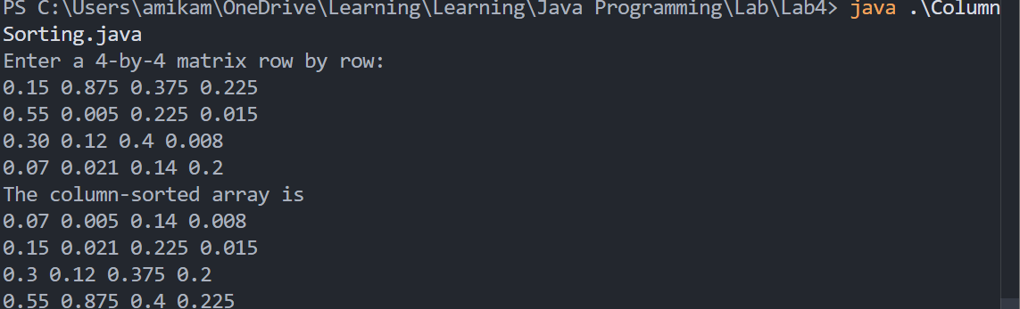

* Debugging/Testing:
Bug1: ArrayList cannot be resolved as a type
Fix: Import the package for ArrayList. Use the inner method sort() to sort the array. null as a parameter represents increasing order.

Problem 5. (8.37) (Optional)
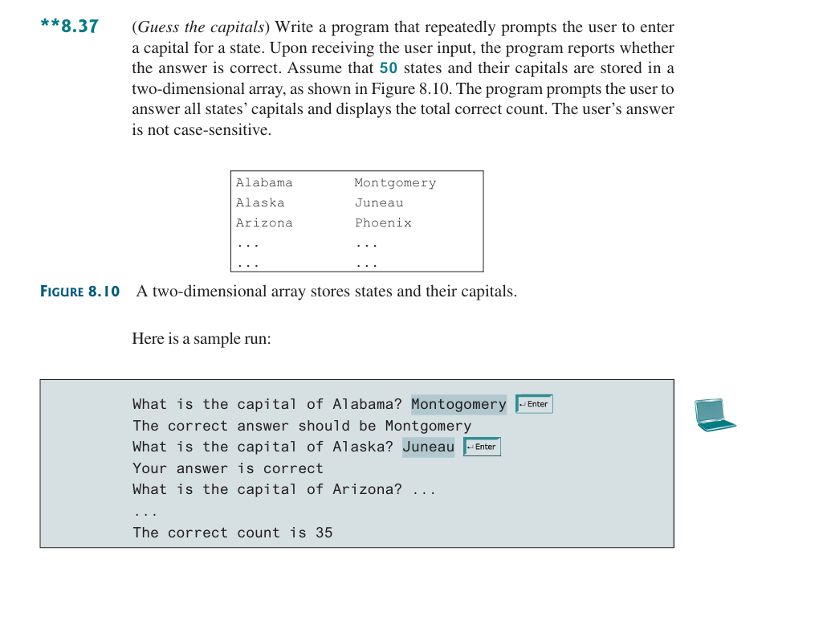

* Source Code / Solution :
package Lab4;

import java.util.Scanner;

public class GuessTheCapitals {
public static void main(String[] args) {
// two-dimensional array to store states and capitals
String[][] list =
{
{"Alabama", "Montgomery"},
{"Alaska", "Juneau"},
{"Arizona", "Phoenix"},
{"Arkansas", "Little Rock"},
{"California", "Sacramento"},
{"Colorado", "Denver"},
{"Connecticut", "Hartford"},
{"Delaware", "Dover"},
{"Florida", "Tallahassee"},
{"Georgia", "Atlanta"},
{"Hawaii", "Honolulu"},
{"Idaho", "Boise"},
{"Illinois", "Springfield"},
{"Indiana", "Indianapolis"},
{"Iowa", "Des Moines"},
{"Kansas", "Topeka"},
{"Kentucky", "Frankfort"},
{"Louisiana", "Baton Rouge"},
{"Maine", "Augusta"},
{"Maryland", "Annapolis"},
{"Massachusetts", "Boston"},
{"Michigan", "Lansing"},
{"Minnesota", "St. Paul"},
{"Mississippi", "Jackson"},
{"Missouri", "Jefferson City"},
{"Montana", "Helena"},
{"Nebraska", "Lincoln"},
{"Nevada", "Carson City"},
{"New Hampshire", "Concord"},
{"New Jersey", "Trenton"},
{"New Mexico", "Santa Fe"},
{"New York", "Albany"},
{"North Carolina", "Raleigh"},
{"North Dakota", "Bismarck"},
{"Ohio", "Columbus"},
{"Oklahoma", "Oklahoma City"},
{"Oregon", "Salem"},
{"Pennsylvania", "Harrisburg"},
{"Rhode Island", "Providence"},
{"South Carolina", "Columbia"},
{"South Dakota", "Pierre"},
{"Tennessee", "Nashville"},
{"Texas", "Austin"},
{"Utah", "Salt Lake City"},
{"Vermont", "Montpelier"},
{"Virginia", "Richmond"},
{"Washington", "Olympia"},
{"West Virginia", "Charleston"},
{"Wisconsin", "Madison"},
{"Wyoming", "Cheyenne"}
};

Scanner sc = new Scanner(System.in);
int cnt = 0;

// tranverse each state and prompt
for (String[] ele : list) {
String state = ele[0];
String capital = ele[1];
String ans;

System.out.println("What is the capital of " + state + " ?");
ans = sc.nextLine().trim();

if (ans.equalsIgnoreCase(capital)) {
System.out.println("Your answer is correct");
cnt++;
} else {
System.out.println("The correct answer should be " + capital);
}
}

// output the final result
System.out.println("The correct count is " + cnt);

sc.close();
}
}

* Output:
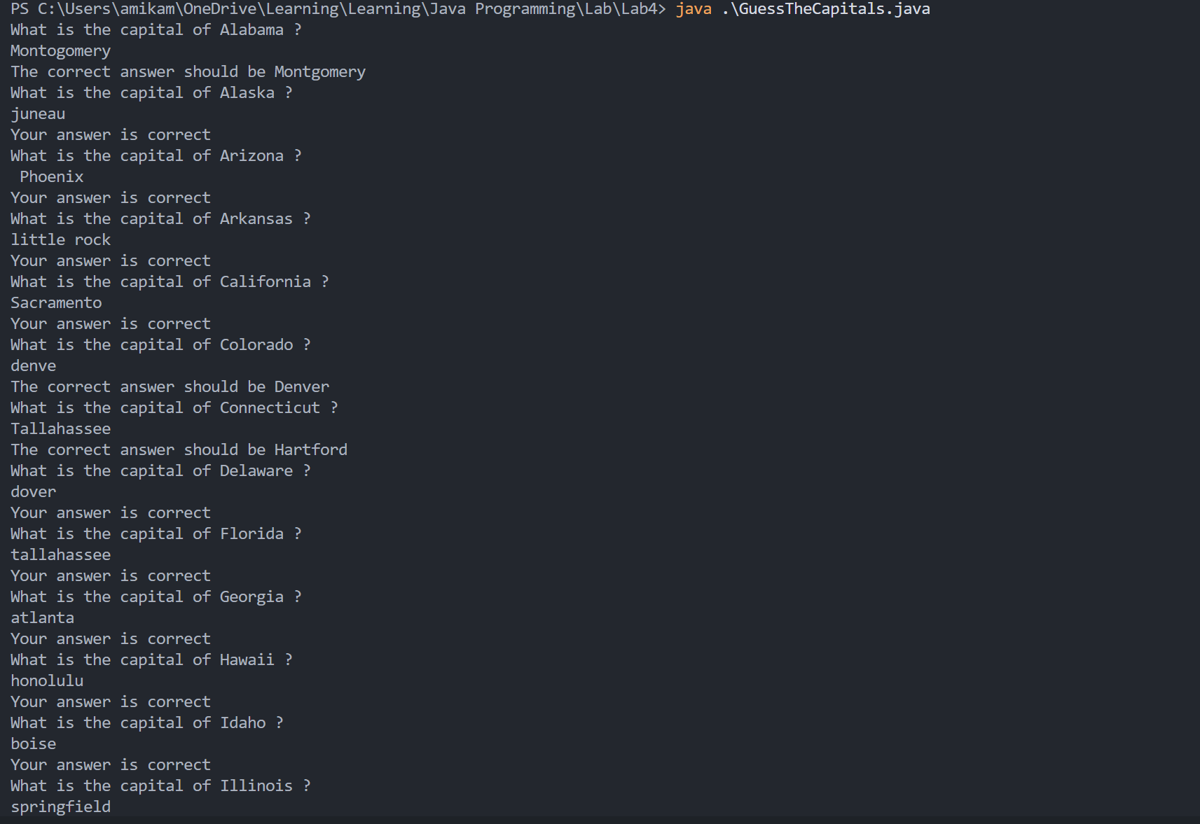
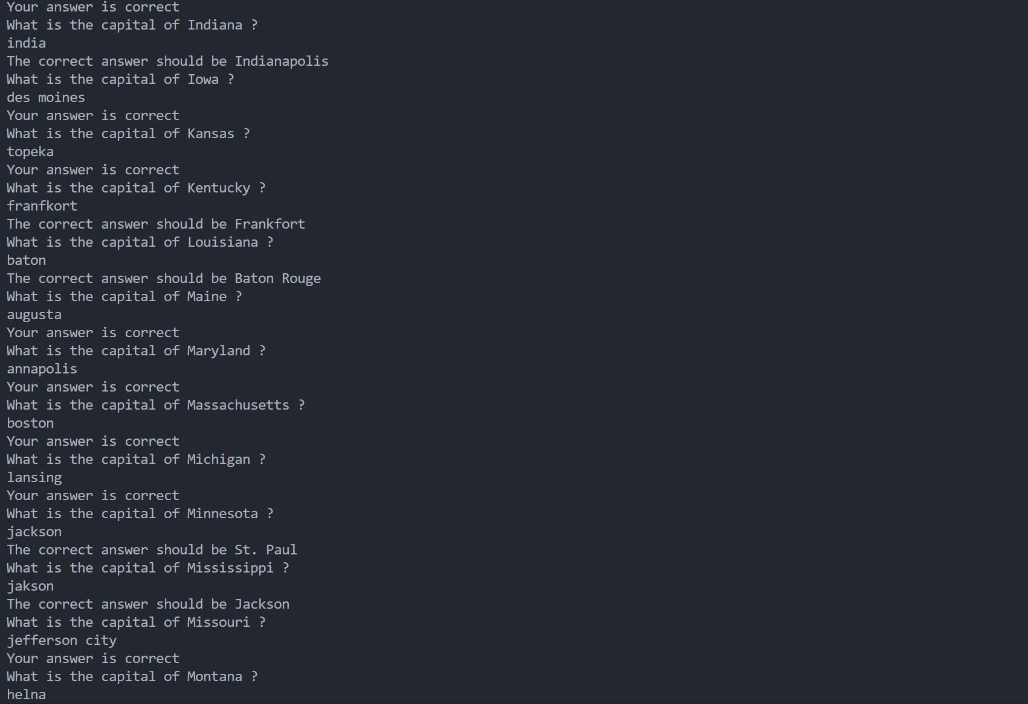
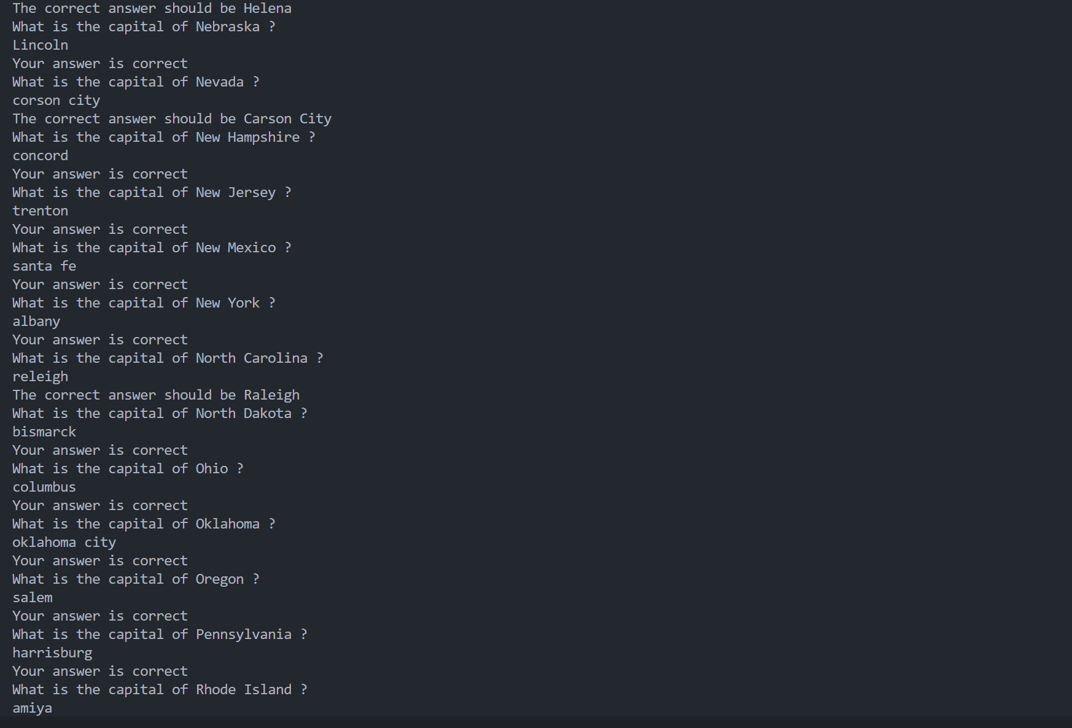
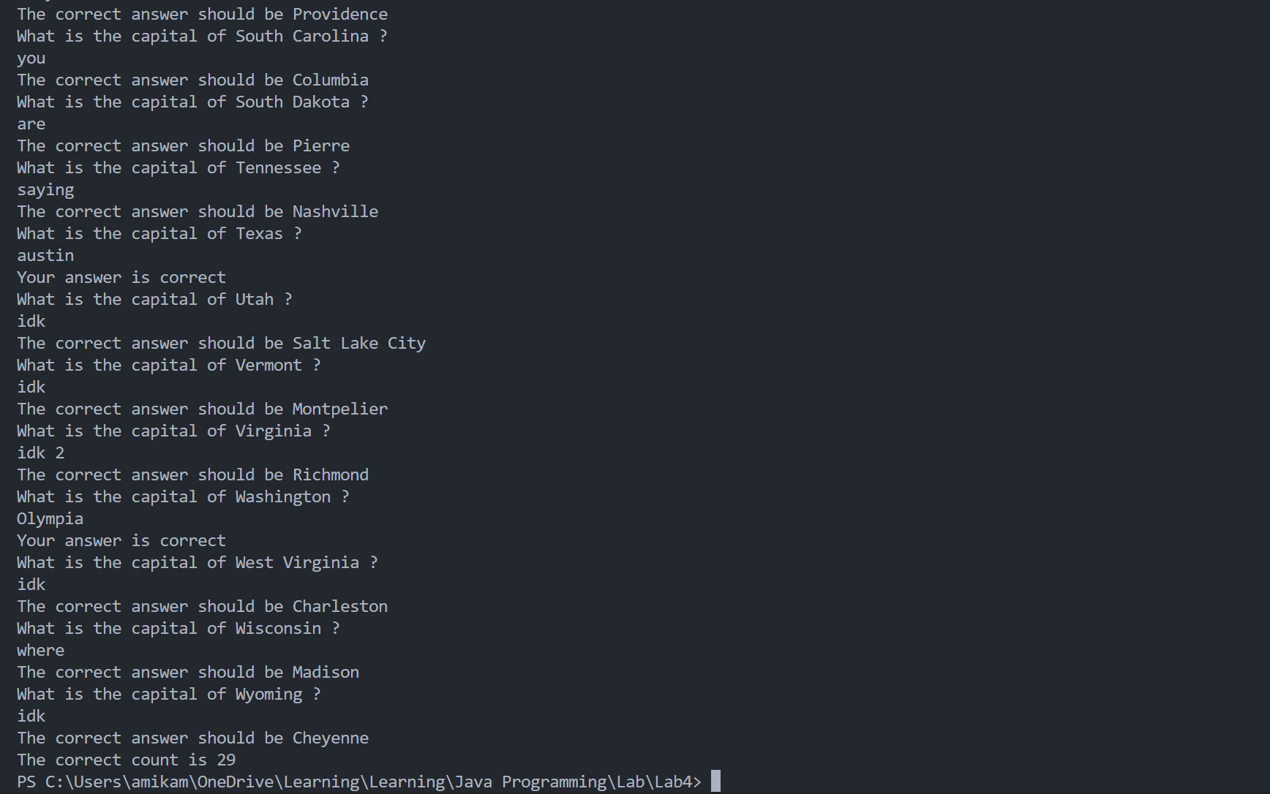

* Debugging/Testing:
Bug1: Jump over the next input when the string of capital includes space.
Fix: Use nextLine() rather than next() to avoid the input separated by the space. And use trim() to eliminate the control characters in the head and tail.

LAB 5 DATE: 4/28/2026

Student Name: __李荣耀____ Student ID: 2024103975___

Problem 1. (9.1)
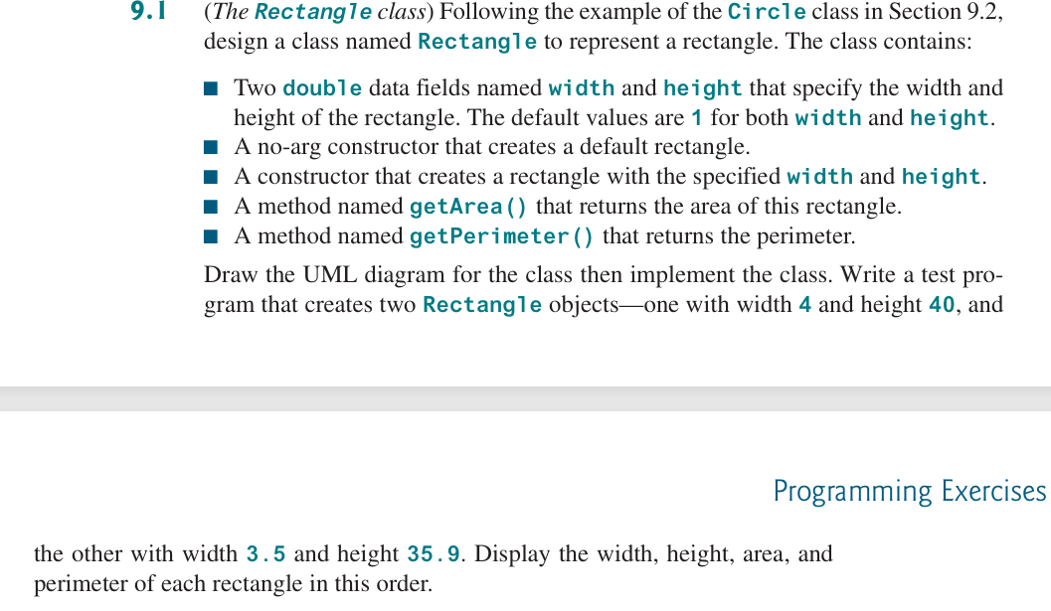

* Source Code / Solution :
package Lab5;

public class TheRectangleClass {
public static class Rectangle {
private double width = 1;
private double height = 1;

// no-arg constructor to create a default rectangle
public Rectangle() {
};

// constructor with specified width and height
public Rectangle(double width, double height) {
this.width = width;
this.height = height;
}

public void setWidth(double width) {
this.width = width;
}

public void setHeight(double height) {
this.height = height;
}

public double getWidth() {
return width;
}

public double getHeight() {
return height;
}

// method to get area
public double getArea() {
return width * height;
}

// method to get perimeter
public double getPerimeter() {
return 2 * (width + height);
}

}
public static void main(String[] args) {
Rectangle rec1 = new Rectangle(4, 40);
Rectangle rec2 = new Rectangle(3.5, 35.9);

System.out.println("The width, height, area, and perimeter"
+ "of the first rectangle are "
+ rec1.getWidth() + " "
+ rec1.getHeight() + " "
+ rec1.getArea() + " "
+ rec1.getPerimeter());

System.out.println("The width, height, area, and perimeter"
+ "of the first rectangle are"
+ rec2.getWidth() + " "
+ rec2.getHeight() + " "
+ rec2.getArea() + " "
+ rec2.getPerimeter());
}
}

* Output:
The UML graph:
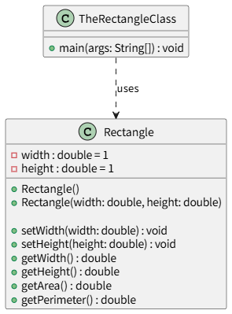

* Debugging/Testing:
Bug1: The output format is incorrect.
Fix: Add the space after each parameter.

Problem 2. (9.5)
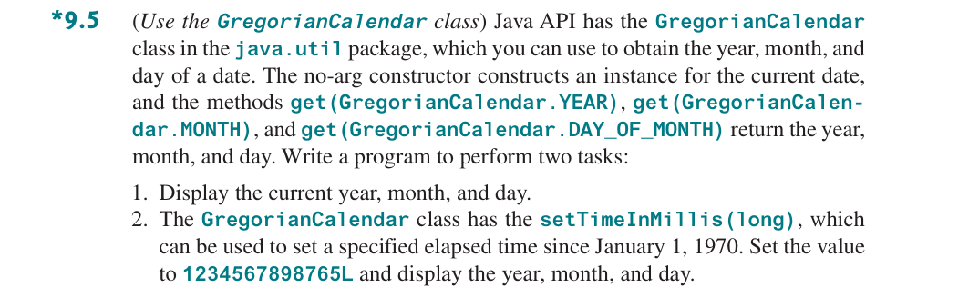

* Source Code / Solution :
package Lab5;

import java.util.GregorianCalendar;

public class UseGregorianCalendar {
public static void main(String[] args) {
// create object of current time
GregorianCalendar current = new GregorianCalendar();

System.out.println("Current year, month and day:");
System.out.println((current.get(GregorianCalendar.MONTH) + 1) + "/"
+ current.get(GregorianCalendar.DAY_OF_MONTH) + "/"
+ current.get(GregorianCalendar.YEAR));

// create object of the time after 1234567898765 millis
GregorianCalendar obj = new GregorianCalendar();
obj.setTimeInMillis(1234567898765L);
System.out.println("The time after 1234567898765 millis from 1/1/1970 is:");
System.out.println((obj.get(GregorianCalendar.MONTH) + 1) + "/"
+ obj.get(GregorianCalendar.DAY_OF_MONTH) + "/"
+ obj.get(GregorianCalendar.YEAR));
}
}

* Output:

* Debugging/Testing:
Bug1: The incorrect order of year, month and day.
Fix: Modify the order of parameters.
Bug2: The month is smaller one month than actual month.
Fix: The GregorainCalendar return the month based on 0. So the correct output should add 1.

Problem 3. (9.11)
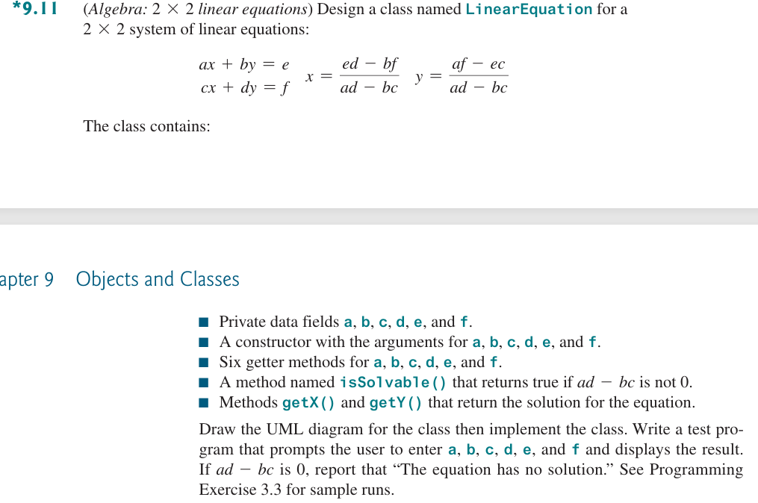

* Source Code / Solution :
package Lab5;

import java.util.Scanner;

public class LinearEquations {
public static class LinearEquation {
private double a, b, c, d, e, f;

// constructor with arguments
public LinearEquation(double a, double b, double c, double d, double e, double f) {
this.a = a;
this.b = b;
this.c = c;
this.d = d;
this.e = e;
this.f = f;
}

// getter methods
public double getA() {
return a;
}

public double getB() {
return b;
}

public double getC() {
return c;
}

public double getD() {
return d;
}

public double getE() {
return e;
}

public double getF() {
return f;
}

// return true if ad-bc is not 0
public boolean isSolvable() {
return (a * d - b * c != 0);
}

// get x if it is solvable
public double getX() {
if (isSolvable()) {
return (e * d - b * f) / (a * d - b * c);
} else {
throw new ArithmeticException("The equation has no solution.");
}
}

// get y if it is solvable
public double getY() {
if (isSolvable()) {
return (a * f - e * c) / (a * d - b * c);
} else {
throw new ArithmeticException("The equation has no solution.");
}
}
}
public static void main(String[] args) {
System.out.println("Please enter the parameters of 2x2 system of linear equations.");
Scanner sc = new Scanner(System.in);

double a = sc.nextDouble();
double b = sc.nextDouble();
double c = sc.nextDouble();
double d = sc.nextDouble();
double e = sc.nextDouble();
double f = sc.nextDouble();

LinearEquation obj = new LinearEquation(a, b, c, d, e, f);

System.out.println("The solution of the linear equations:");
System.out.println("x: " + obj.getX());
System.out.println("y: " + obj.getY());

sc.close();
}
}

* Output:
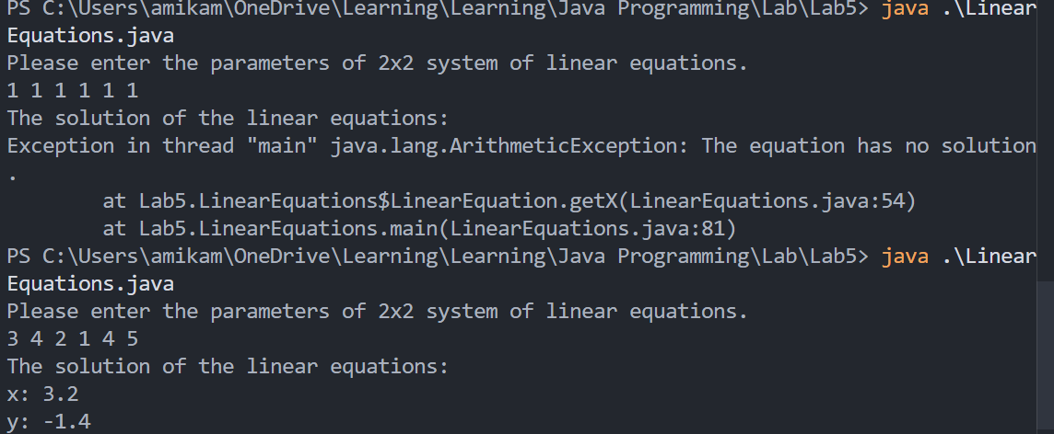
The UML graph:
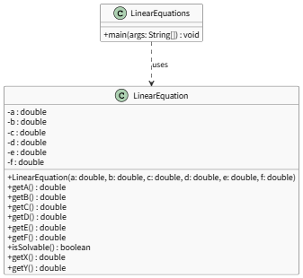

* Debugging/Testing:
Bug1: No exception handling in getX() and getY() if it is not solvable.
Fix: Throw arithmetic exception when it is not solvable.

Problem 4. (9.9) (Optional)
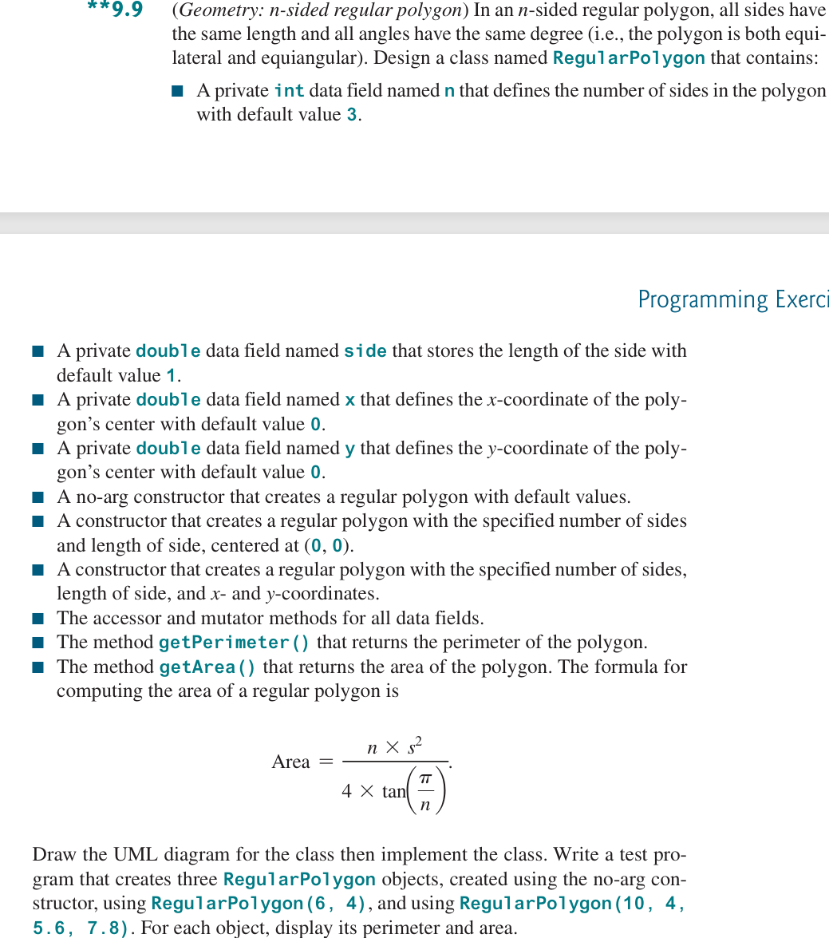

* Source Code / Solution :
package Lab5;

public class NsideRegularPolygon {
public static class RegularPolygon {
private int n = 3;
private double side = 1;
private double x = 0;
private double y = 0;

// no-arg constructor
public RegularPolygon() {
}

// constructor to create a regular polygon with specified n, side and default x, y
public RegularPolygon(int n, double side) {
this.n = n;
this.side = side;
}

// constructor to create a regular polygon with specified n, side, x and y
public RegularPolygon(int n, double side, double x, double y) {
this.n = n;
this.side = side;
this.x = x;
this.y = y;
}

// accessors and mutators for all data fields
public int getN() {
return n;
}

public double getSide() {
return side;
}

public double getX() {
return x;
}

public double getY() {
return y;
}

public void setN(int n) {
this.n = n;
}

public void setSide(double side) {
this.side = side;
}

public void setX(double x) {
this.x = x;
}

public void setY(double y) {
this.y = y;
}

// return the perimeter of the polygon
public double getPerimeter() {
return n * side;
}

// return the area of the polygon
public double getArea() {
return (n * side * side) / (4 * Math.tan(Math.PI / n));
}
}

public static void main(String[] args) {
RegularPolygon obj1 = new RegularPolygon();
RegularPolygon obj2 = new RegularPolygon(6, 4);
RegularPolygon obj3 = new RegularPolygon(10, 4, 5.6, 7.8);

System.out.println("The parimeter and area of the first regular polygon");
System.out.printf("Perimeter: %.2f; Area: %.3f\n", obj1.getPerimeter(), obj1.getArea());

System.out.println("The parimeter and area of the second regular polygon");
System.out.printf("Perimeter: %.2f; Area: %.3f\n", obj2.getPerimeter(), obj2.getArea());

System.out.println("The parimeter and area of the third regular polygon");
System.out.printf("Perimeter: %.2f; Area: %.3f\n", obj3.getPerimeter(), obj3.getArea());
}
}

* Output:
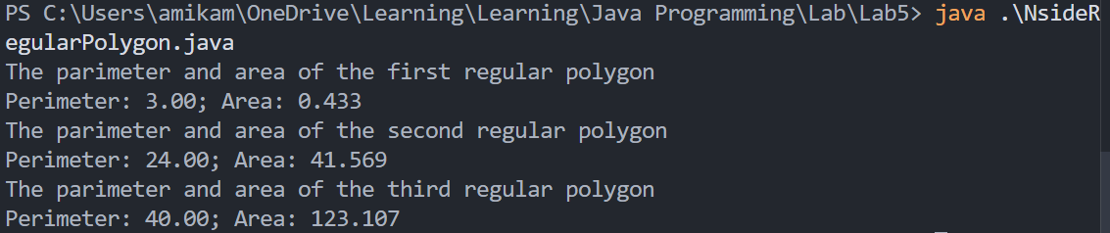
The UML graph:
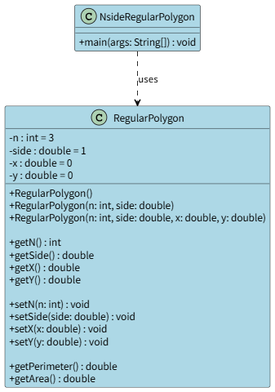

* Debugging/Testing:
Bug1: Ignore the type of return value of Math.tan() and the result of perimeter and area are double, causing too many digits in results.
Fix: Optimize the format of output.

Problem 5. (9.13) (Optional)
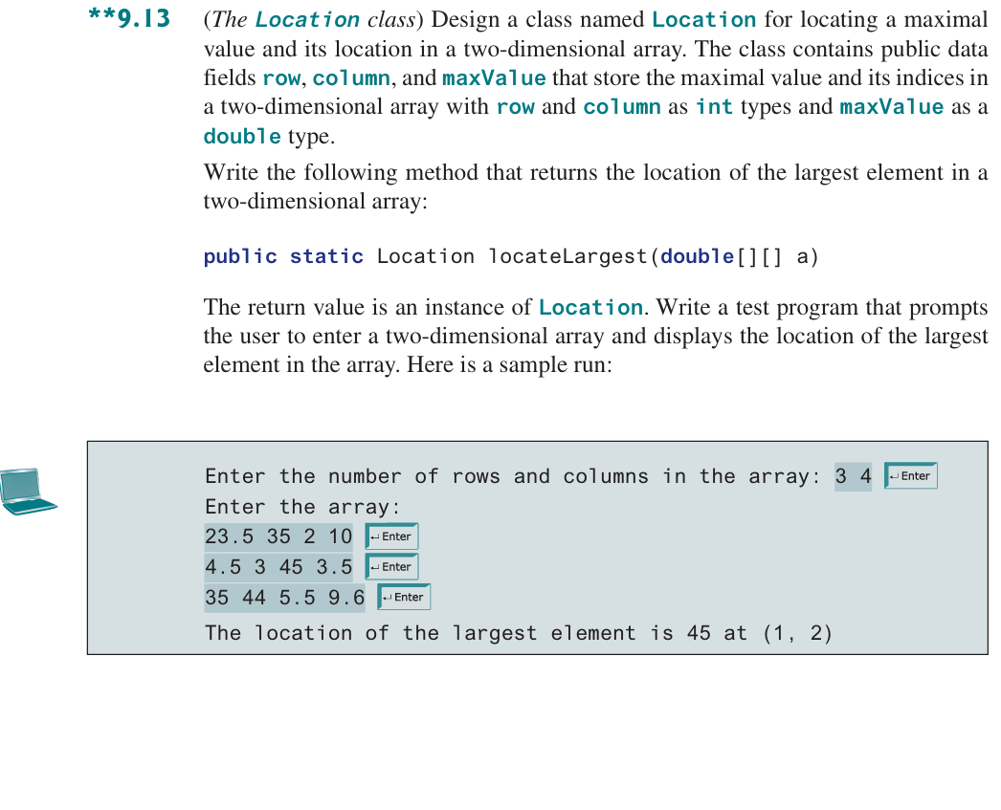

* Source Code / Solution :
package Lab5;

import java.util.Scanner;

public class TheLocationClass {
public static class Location {
public int row;
public int column;
public double maxValue;

// default constructor
public Location() {
}

// constructor to set row and column
public Location(int row, int column) {
this.row = row;
this.column = column;
}
}

// return the location of the largest element
public static Location locateLargest(double[][] a) {
if (a.length == 0 || a[0].length == 0 || a == null || a[0] == null) {
throw new IllegalArgumentException("Error two-dimensional array.");
}
Location ret = new Location();

int row = a.length;
int col = a[0].length;

int i = 0, j = 0;
int maxRow = 0, maxCol = 0;
double max = a[0][0];

// find the max value
for (i = 0; i < row; i++) {
for (j = 0; j < col; j++) {
if (a[i][j] > max) {
max = a[i][j];
maxRow = i;
maxCol = j;
}
}
}

// assign row, column and maxvalue to
ret.row = maxRow;
ret.column = maxCol;
ret.maxValue = max;

return ret;
}

public static void main(String[] args) {
System.out.println("Enter the number of rows and columns in the array");

Scanner sc = new Scanner(System.in);
int row = sc.nextInt();
int column = sc.nextInt();
double[][] arr = new double[row][column];

System.out.println("Enter the array:");
for (int i = 0; i < row; i++) {
for (int j = 0; j < column; j++) {
arr[i][j] = sc.nextDouble();
}
}

Location maxLocation = new Location();
maxLocation = locateLargest(arr);
System.out.println("The location of the largest element is " + maxLocation.maxValue + " at (" + maxLocation.row
+ ", " + maxLocation.column + ")");

sc.close();
}
}

* Output:
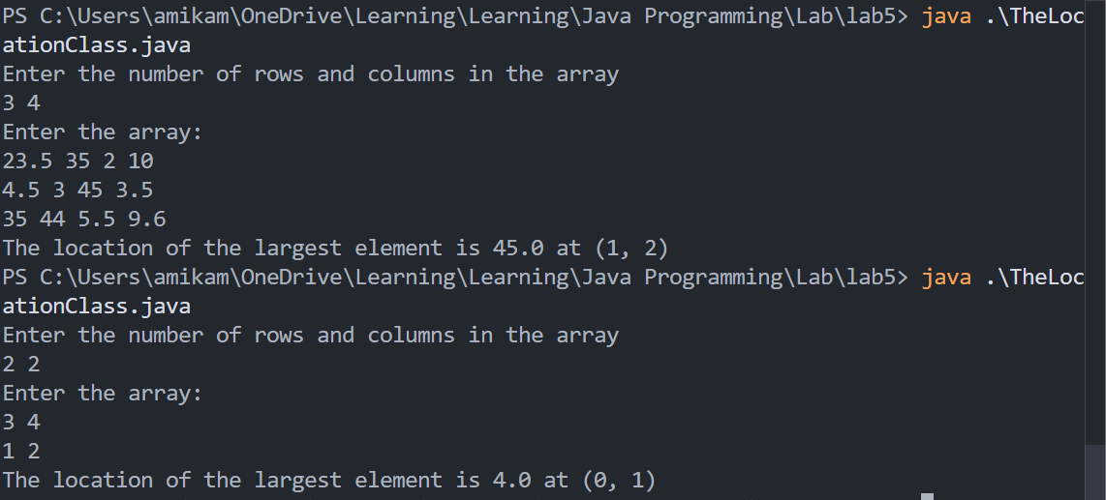
The UML graph:
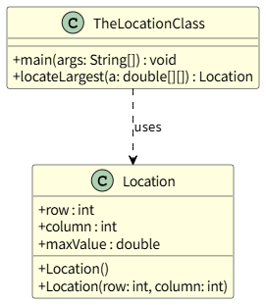

* Debugging/Testing:
Bug1: The max position is always (0,0)
Fix: We incorrectly use ‘break’ in the inner loop and the total loop will continue. Thus we use two more varaibles ‘maxRow’ and ‘maxCol’ to record the max position.

Bug2: The max position is still always (0,0)
Fix: We incorrectly set row and col in locateLargest(double[][] a), which causes the loop to find the largest terminates directly. Thus we correctly assign a.length and a[0].length to row and col.

LAB 6 DATE: 5/12/2026

Student Name: __李荣耀____ Student ID: 2024103975___

Problem 1. (10.1)
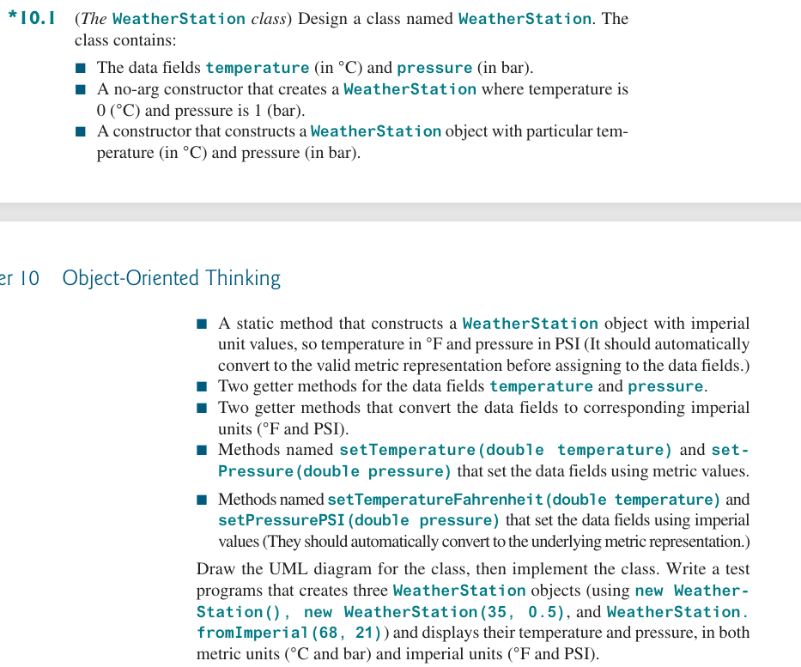

* Source Code / Solution :
package Lab6;

public class WeatherStationTest {
public static class WeatherStation {

private double temperature;
private double pressure;

// no-arg constructor
public WeatherStation() {
temperature = 0;
pressure = 1;
}

// constructor with temperature and pressure
public WeatherStation(double temperature, double pressure) {
this.temperature = temperature;
this.pressure = pressure;
}

// static method to construct WeatherStation
public static WeatherStation ImperialUnitConstructor(double temperature, double pressure) {
double temp = temperature * 9 / 5 + 32;
double pres = pressure / 14.5037738;
return new WeatherStation(temp, pres);
}

// Metric getters
public double getTemperature() {
return temperature;
}

public double getPressure() {
return pressure;
}

// Imperial getters
public double getTemperatureFahrenheit() {
return temperature * 9 / 5 + 32;
}

public double getPressurePSI() {
return pressure * 14.5037738;
}

// Metric setters
public void setTemperature(double temperature) {
this.temperature = temperature;
}

public void setPressure(double pressure) {
this.pressure = pressure;
}

// Imperial setters
public void setTemperatureFahrenheit(double temperature) {
this.temperature = (temperature - 32) * 5.0 / 9.0;
}

public void setPressurePSI(double pressure) {
this.pressure = pressure / 14.5037738;
}
}

/**
* display the data of WeatherStation
* @param1
* @param2 the object
*/
public static void DisplayWeatherStaton(WeatherStation station) {
System.out.printf("Metric: %.2f, %.4f\n",
station.getTemperature(), station.getPressure());
System.out.printf("Imperial: %.2f, %.2f\n",
station.getTemperatureFahrenheit(), station.getPressurePSI());
System.out.println();
}
public static void main(String[] args) {
WeatherStation station1 = new WeatherStation();
WeatherStation station2 = new WeatherStation(35, 0.5);
WeatherStation station3 = WeatherStation.ImperialUnitConstructor(68, 21);

System.out.println("The data of these stations are:");
System.out.println("Station 1:");
DisplayWeatherStaton(station1);
System.out.println("Station 2:");
DisplayWeatherStaton(station2);
System.out.println("Station 3:");
DisplayWeatherStaton(station3);
}
}

* Output:
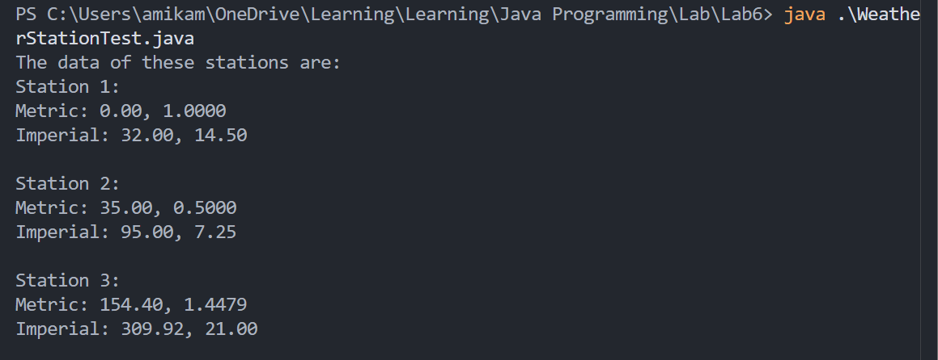
UML graph:
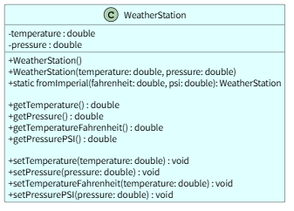

* Debugging/Testing:
Bug1:
WeatherStation station3 = ImperialUnitConstructor(68, 21);
Directly invoke the static method to construct an object.
Fix: Use correct syntax to invoke the static constructor. It must be invoked by clearing the class. That is, className.staticConstructor().
Bug2: Repetitive rate is too high when displaying the weather station
Fix: Use a method to display weather station.

Problem 2. (10.3)
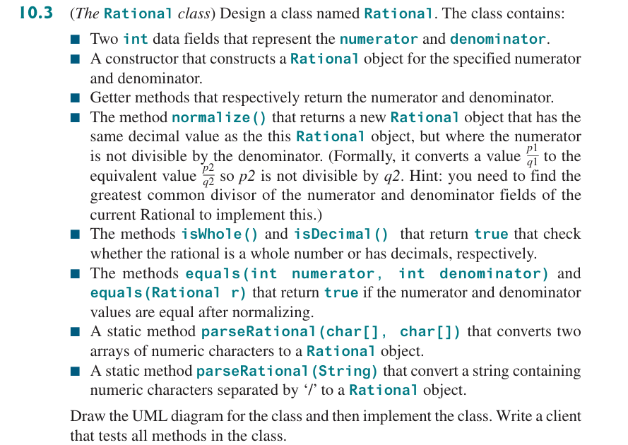

* Source Code / Solution :
package Lab6;

public class Rational {
private int numerator;
private int denominator;

// constructor
public Rational(int numerator, int denominator) {
if (denominator == 0) {
throw new IllegalArgumentException("Denomitor cannot be zero.");
}
this.numerator = numerator;
this.denominator = denominator;
}

// getters
public int getNumerator() {
return numerator;
}

public int getDenominator() {
return denominator;
}

// return rational object after reduction of a fraction
public Rational normalize() {
int gcd = findGCD(numerator, denominator);
int newDeno = denominator / gcd;
int newNume = numerator / gcd;

// put the minus on the numerator
if (newDeno < 0) {
newNume *= -1;
newDeno *= -1;
}

return new Rational(newNume, newDeno);
}

// auxiliary method to find the gcd
private static int findGCD(int a, int b) {
a = Math.abs(a);
b = Math.abs(b);

while (b != 0) {
int tmp = b;
b = a % b;
a = tmp;
}

return a;
}

// judge whether it is integer
public boolean isWhole() {
Rational newRational = this.normalize();
return newRational.getDenominator() == 1;
}

// judge whether it is decimal
public boolean isDecimal() {
return !isWhole();
}

// judge whether two rationals are equivalent
public boolean equals(int numerator, int denominator) {
Rational newRat = new Rational(numerator, denominator).normalize();

Rational thisRat = this.normalize();

return newRat.numerator == thisRat.numerator && newRat.denominator == thisRat.denominator;
}

// override: receive the object
public boolean equals(Rational r) {
return equals(r.numerator, r.denominator);
}

// convert two arrays of numeric characters to a Rational object
public static Rational parseRational(char[] numerator, char[] denominator) {
int nume = Integer.parseInt(new String(numerator));
int deno = Integer.parseInt(new String(denominator));

return new Rational(nume, deno);
}

// override: receive string seperated by '/' to a Rational object
public static Rational parseRational(String r) {
String[] s = r.split("/");
int nume = Integer.parseInt(s[0].trim());
int deno = Integer.parseInt(s[1].trim());

return new Rational(nume, deno);
}
}

RationalTest.java
package Lab6;

public class RationalTest {
public static void main(String[] args) {
System.out.println("1. Test constructors and normalization");
Rational r1 = new Rational(4, 8);
System.out.println("Original: " + r1.getNumerator() + "/" + r1.getDenominator());
System.out.println("Normalized: " + r1.normalize().getNumerator() + "/" + r1.normalize().getDenominator());
// test positive
Rational r2 = new Rational(-2, -3);
System.out.println("Original: " + r2.getNumerator() + "/" + r2.getDenominator());
System.out.println("Normalized: " + r2.normalize().getNumerator() + "/" + r2.normalize().getDenominator());

System.out.println("2. Test isWhole() and isDecimal()");
Rational r3 = new Rational(6, 3);
System.out.println(r1.isWhole() ? "r1 is whole." : "r1 is decimal.");
System.out.println(r3.isDecimal() ? "r3 is decimal." : "r3 is whole.");

System.out.println("3. Test equal()");
Rational r4 = new Rational(2, 4);
System.out.println(r4.equals(r1) ? "r4 are equal to r1" : "r4 are not equal to r1");
System.out.println(r4.equals(3, 4) ? "r4 are equal to 3/4" : "r4 are not equal to 3/4");

System.out.println("4. Test parseRational()");
char[] nume = { '1', '2' };
char[] deno = { '6' };
Rational r5 = Rational.parseRational(nume, deno);
System.out.println("r5: " + r5.getNumerator() + '/' + r5.getDenominator());
Rational r6 = Rational.parseRational("8/31");
System.out.println("r6: " + r6.getNumerator() + '/' + r6.getDenominator());
}
}

UML graph:
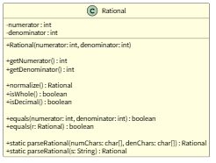

* Output:
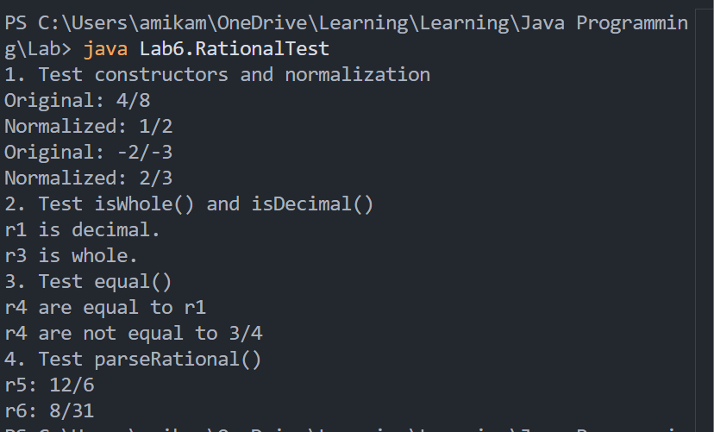

* Debugging/Testing:
Bug1: Ignore the situation that the denominator and numerator are positive.
Fix: Add the handling of positive numbers in findGCD() and normalize() to make the result more precise.
Bug2:
PS C:\Users\amikam\OneDrive\Learning\Learning\Java Programming\Lab> java Lab6.RationalTest
1. Test constructors and normalization
Original: Lab6.Rational@c387f44
Normalized: Lab6.Rational@73d16e93
Original: Lab6.Rational@659e0bfd
Normalized: Lab6.Rational@2a139a55
…
4. Test parseRational()
Exception in thread "main" java.lang.NumberFormatException: For input string: "[C@15db9742"
at java.base/java.lang.NumberFormatException.forInputString(NumberFormatException.java:67)
at java.base/java.lang.Integer.parseInt(Integer.java:565)
at java.base/java.lang.Integer.parseInt(Integer.java:662)
at Lab6.Rational.parseRational(Rational.java:81)
at Lab6.RationalTest.main(RationalTest.java:27)
Fix: First, directly print object will use default toString() function, which will return className@hashcode. So we modify the output format:
System.out.println("Original: " + r1.getNumerator() + "/" + r1.getDenominator());
Then, modify the method when converting
int nume = Integer.parseInt(new String(numerator));
int deno = Integer.parseInt(new String(denominator));

Problem 3. (10.7)
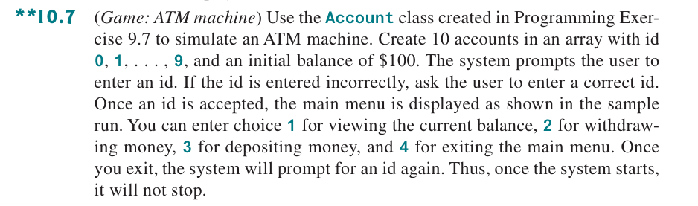

* Source Code / Solution :
ATMMachine.java:
package Lab6;

import java.util.Scanner;

public class ATMMachine {

public static void main(String[] args) {
Account[] accounts = new Account[10];
for (int i = 0; i < 10; i++) {
accounts[i] = new Account(i, 100);
}

Scanner sc = new Scanner(System.in);

while (true) {
int id = 0;
System.out.println("Please enter an id.");
try {
id = sc.nextInt();
if (id < 0 || id >= 10) {
System.out.println("Invalid id");
continue;
}
} catch (java.util.InputMismatchException e) {
System.out.println("Please enter a correct id.");
sc.next();
}
while (true) {
int choice = 0;
System.out.println("Please enter the choice");
System.out.println("1: check balance");
System.out.println("2. withdraw money");
System.out.println("3: deposit money");
System.out.println("4: exit the main menu");

try {
choice = sc.nextInt();
if (choice < 1 || choice > 4) {
System.out.println("Invalid choice number");
continue;
}
} catch (java.util.InputMismatchException e) {
System.out.println("Please enter a correct choice");
sc.next();
}

if (choice == 1) {
System.out.println("The balance is " + accounts[id].getBalance());
} else if (choice == 2) {
System.out.println("Enter amount to withdraw");
double amount = sc.nextDouble();
accounts[id].withdraw(amount);
System.out.println("Current balance: " + accounts[id].getBalance());
} else if (choice == 3) {
System.out.println("Enter amount to deposit");
double amount = sc.nextDouble();
accounts[id].deposit(amount);
System.out.println("Current balance: " + accounts[id].getBalance());
} else {
System.out.println("Exiting...");
break;
}
}
}
}
}

Account.java:
package Lab6;

import java.util.Date;

public class Account {
private int id = 0;
private double balance = 0;
private double annualInterestRate = 0;
private Date dateCreated;

// no-arg constructor
public Account() {
id = 0;
balance = 0;
annualInterestRate = 0;
dateCreated = new Date();
}

// constructor with specific id and initial balance
public Account(int id, double balance) {
this.id = id;
this.balance = balance;
this.dateCreated = new Date();
}

// accessors
public int getID() {
return id;
}

public double getBalance() {
return balance;
}

public double getAnnualInterestRate() {
return annualInterestRate;
}

public Date getDateCreated() {
return dateCreated;
}

// mutators
public void setID(int id) {
this.id = id;
}

public void setBalance(double balance) {
this.balance = balance;
}

public void setAnnualInterestRate(double annualInterestRate) {
this.annualInterestRate = annualInterestRate;
}

// return the monthly interest
public double getMonthlyInterestRate() {
return annualInterestRate / 12;
}

// return the monthly interest
public double getMonthlyInterest() {
double monthlyInterestRate = getMonthlyInterestRate();
return balance * monthlyInterestRate / 100;
}

// withdraws a specified amount, return the account after withdrawing
public double withdraw(double amount) {
if (amount > 0 && amount <= balance) {
balance -= amount;
return balance;
} else {
throw new IllegalArgumentException("No enough balance");
}
}

// deposit a specified amount, return the account after deposit
public double deposit(double amount) {
if (amount > 0) {
balance += amount;
return balance;
} else {
throw new IllegalArgumentException("Error deposit amount");
}
}
}

* Output:
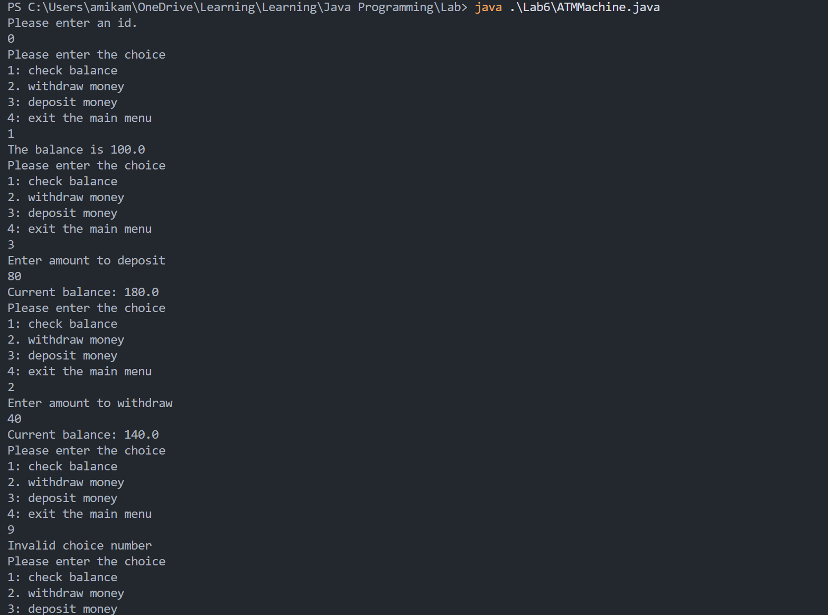
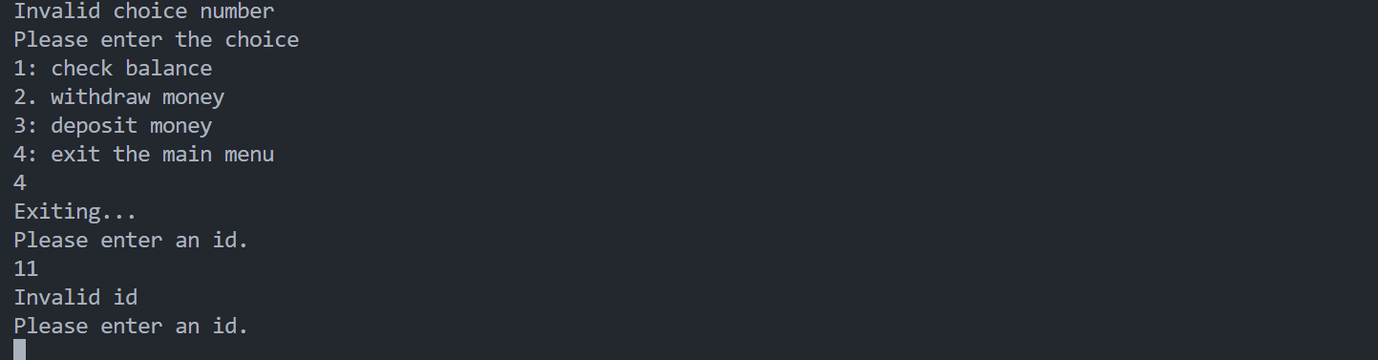

* Debugging/Testing:
Bug1:
System.out.println("Please enter an id.");
try{
id = sc.nextInt();
} catch (ExceptionInInitializerError e) {
System.out.println("Please enter a correct id.");
}
The code page cannot catch the exception correctly.
Fix: The exception is java.util.InputMismatchException. And after receive the error input, clear the buffer.

Bug2:
Account[] accounts = new Account[10];
for (int i = 0; i < 10; i++) {
accounts[i].setID(i);
accounts[i].setBalance(100);
}
Exception of Null pointer. The array initially is all null pointer. It should be instantiated.
Fix:
Account[] accounts = new Account[10];
for (int i = 0; i < 10; i++) {
accounts[i] = new Account(i, 100);
}

Problem 4. (10.9) (Optional)
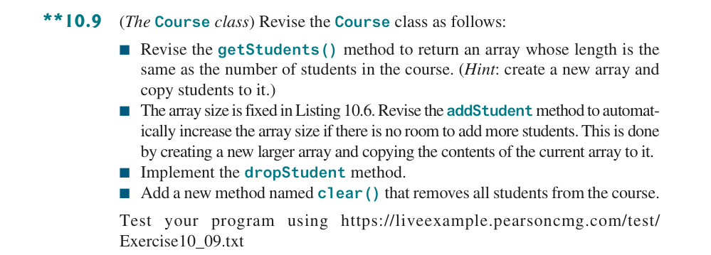

* Source Code / Solution :
package Lab6;

public class Course {
private String courseName;
private String[] students = new String[100];
private int numberOfStudents;

public Course(String courseName) {
this.courseName = courseName;
}

public void addStudent(String student) {
int len = students.length;
if (numberOfStudents >= len) {
String[] newStudents = new String[2 * len];
for (int i = 0; i < len; i++) {
newStudents[i] = students[i];
}

students = newStudents;
}

students[numberOfStudents] = student;
numberOfStudents++;
}

public String[] getStudents() {
int length = numberOfStudents;
String[] students = new String[length];

for (int i = 0; i < length; i++) {
students[i] = this.students[i];
}

return students;
}

public int getNumberOfStudents() {
return numberOfStudents;
}

public String getCourseName() {
return courseName;
}

public void dropStudent(String student) {
int index = -1;
for (int i = 0; i < numberOfStudents; i++) {
if (student.equals(students[i])) {
index = i;
break;
}
}

if (index == -1) {
System.out.println(student + "does not exist");
return;
}

for (int i = index; i < numberOfStudents - 1; i++) {
students[i] = students[i + 1];
}

students[numberOfStudents - 1] = null;
numberOfStudents--;
}

public void clear() {
for (int i = 0; i < numberOfStudents; i++) {
students[i] = null;
}

numberOfStudents = 0;
}
}

* Output:
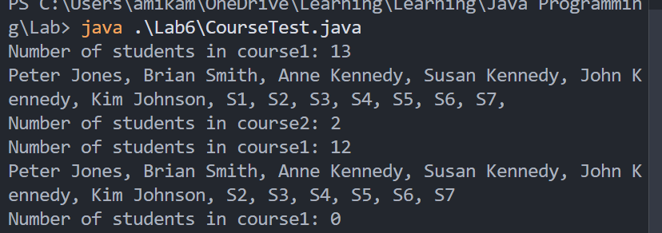

* Debugging/Testing:
Bug1: After drop student, the element at students[numberOfStudents - 1] still records the information of last student.
Fix: Let the last element of students[] points at null.

Problem 5. (10.13) (Optional)
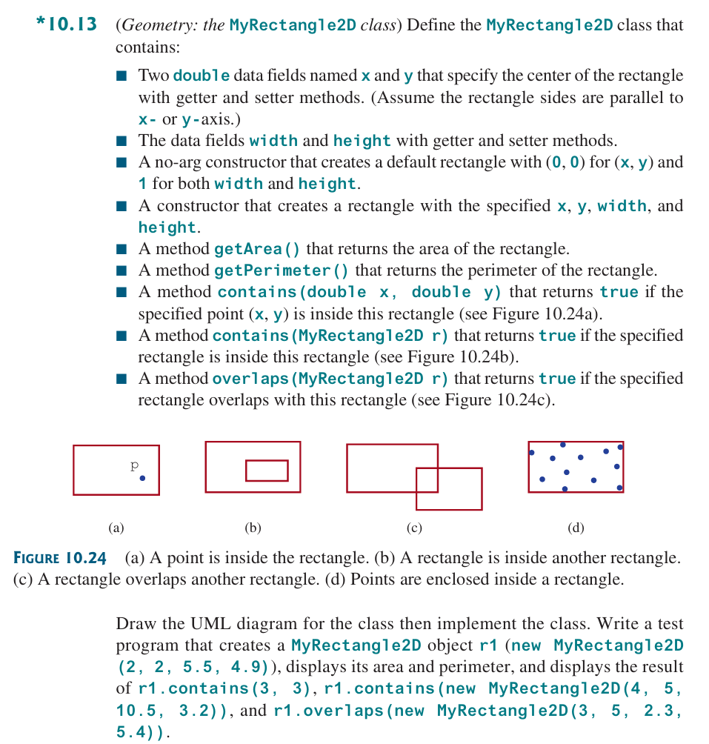

* Source Code / Solution :
MyRectangle2D.java:
package Lab6;

public class MyRectangle2D {
private double x;
private double y;
private double width;
private double height;

// getters
public double getWidth() {
return width;
}

public double getHeight() {
return height;
}

// setters
public void setWidth(double width) {
this.width = width;
}

public void setHeight(double height) {
this.height = height;
}

// no-arg constructor
public MyRectangle2D() {
x = 0;
y = 0;
width = 1;
height = 1;
}

// specified constructor
public MyRectangle2D(double x, double y, double width, double height) {
this.x = x;
this.y = y;
this.width = width;
this.height = height;
}

// return the area
public double getArea() {
return width * height;
}

// return the parimeter
public double getParimeter() {
return 2 * (width + height);
}

public boolean contains(double x, double y) {
double dx = width / 2;
double dy = height / 2;

double thisLeftLimit = x - dx;
double thisRightLimit = x + dx;
double thisDownLimit = y - dy;
double thisUpLimit = y + dy;

return (x < thisRightLimit && x > thisLeftLimit && y < thisUpLimit + dy && y > thisDownLimit);
}

public boolean contains(MyRectangle2D r) {
double xRightLimit = r.x + r.width /
2;
double xLeftLimit = r.x - r.width / 2;
double yRightLimit = r.y + r.height / 2;
double yLeftLimit = r.y - r.height / 2;

double dx = this.width / 2;
double dy = this.height / 2;

double thisLeftLimit = x - dx;
double thisRightLimit = x + dx;
double thisDownLimit = y - dy;
double thisUpLimit = y + dy;

return (xRightLimit < thisRightLimit && xLeftLimit > thisLeftLimit && yRightLimit < thisUpLimit
&& yLeftLimit > thisDownLimit);
}

public boolean overlaps(MyRectangle2D r) {
double xRightLimit = r.x + r.width /
2;
double xLeftLimit = r.x - r.width / 2;
double yRightLimit = r.y + r.height / 2;
double yLeftLimit = r.y - r.height / 2;

double dx = this.width / 2;
double dy = this.height / 2;

double thisLeftLimit = x - dx;
double thisRightLimit = x + dx;
double thisDownLimit = y - dy;
double thisUpLimit = y + dy;

boolean noOverlap = (thisRightLimit < xLeftLimit) || (thisLeftLimit > xRightLimit) || (thisUpLimit < yLeftLimit)
|| (thisDownLimit > yRightLimit);

return !noOverlap;
}
}

MyRectangle2DTest.java:
package Lab6;

public class MyRectangle2DTest {
public static void main(String[] args) {
MyRectangle2D r1 = new MyRectangle2D(2, 2, 5.5, 4.9);
System.out.println("The area of r1: " + r1.getArea());
System.out.println("The parimeter of r1: " + r1.getParimeter());

System.out.println(r1.contains(3, 3)
? "r1 contains (3,3)"
: "r1 does not contain (3,3)");
System.out.println(r1.contains(new MyRectangle2D(4, 5, 10.5, 3.2))
? "r1 contains rectangle with 10.5 width and 3.2 height, centered (4,5)"
: "r1 does not contain rectangle with 10.5 width and 3.2 height, centered (4,5)");

System.out.println(r1.overlaps(new MyRectangle2D(3, 5, 2.3, 5.4))
? "r1 overlaps rectangle with 2.3 width and 5.4 height, centered (3,5)"
: "r1 does not overlap rectangle with 2.3 width and 5.4 height, centered (3,5)");
}
}

UML graph:
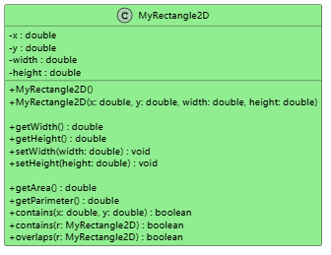

* Output:
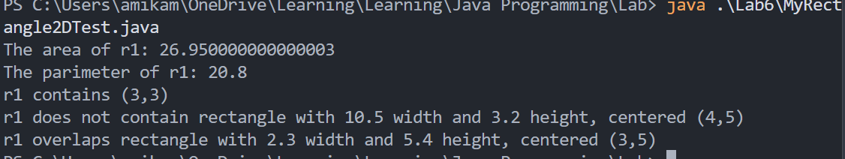

* Debugging/Testing:
Bug1:
public boolean overlaps(MyRectangle2D r) {
double xRightLimit = r.x + r.width /
2;
double xLeftLimit = r.x - r.width / 2;
double yRightLimit = r.y + r.height / 2;
double yLeftLimit = r.y - r.height / 2;

boolean isLeftUpIn = contains(xLeftLimit, yRightLimit);
boolean isLeftDownIn = contains(xLeftLimit, yLeftLimit);
boolean isRightUpIn = contains(xRightLimit, yRightLimit);
boolean isRightDownIn = contains(xRightLimit, yLeftLimit);

return (isLeftDownIn || isLeftUpIn || isRightDownIn || isRightUpIn);
}
Only judge four corners, ignore the situation that four corners are all not in the rectangle but they still overlap.
Fix: Use the four edge limit to judge.

LAB 7 DATE: 5/16/2026

Student Name: __李荣耀____ Student ID: 2024103975___

Problem 1. (11.1)
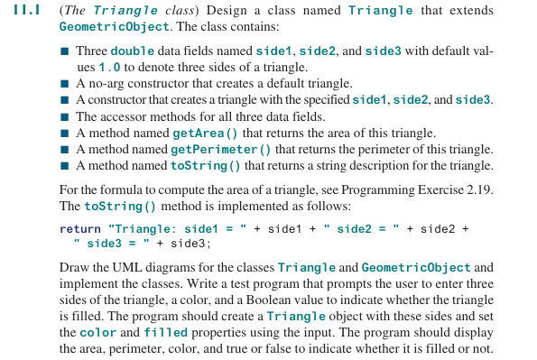

* Source Code / Solution :
Triangle.java:
package Lab7;

public class Triangle extends GeometricObject {
private double side1;
private double side2;
private double side3;

// no-arg constructor
public Triangle() {
side1 = 1.0;
side2 = 1.0;
side3 = 1.0;
}

// constructor with specific side1, side2 and side3
public Triangle(double side1, double side2, double side3) {
this.side1 = side1;
this.side2 = side2;
this.side3 = side3;
}

// accessor methods
public double getSide1() {
return side1;
}

public double getSide2() {
return side2;
}

public double getSide3() {
return side3;
}

// mutator methods
public void setSide1(double side1) {
this.side1 = side1;
}

public void setSide2(double side2) {
this.side2 = side2;
}

public void setSide3(double side3) {
this.side3 = side3;
}

// return the area of the triangle
public double getArea() {
double s = (side1 + side2 + side3) / 2.0;
return Math.sqrt(s * (s - side1) * (s - side2) * (s - side3));
}

// return the perimeter of the triangle
public double getPerimeter() {
return side1 + side2 + side3;
}

// return a string description of the triangle
public String toString() {
return "Triangle: side1 = " + side1 + " side2 = " + side2 + " side3 = " + side3;
}
}
Triangle Test.java:
package Lab7;

import java.util.Scanner;

public class TriangleTest {
public static void main(String[] args) {
Scanner sc = new Scanner(System.in);
Triangle t = new Triangle();

System.out.println(
"Please enter three sides, a color and a Boolean value to indicate whether the triangle is filled.");

double side1 = sc.nextDouble();
double side2 = sc.nextDouble();
double side3 = sc.nextDouble();

if (side1 <= 0 || side2 <= 0 || side3 <= 0) {
System.out.println("Invalid input. Please enter positive values for all sides.");
sc.close();
return;
}

String color = sc.next();
boolean filled = sc.nextBoolean();

t.setSide1(side1);
t.setSide2(side2);
t.setSide3(side3);
t.setColor(color);
t.setFilled(filled);

System.out.println("Area: " + t.getArea());
System.out.println("Perimeter: " + t.getPerimeter());
System.out.println("Color: " + t.getColor());
System.out.println("Filled: " + t.isFilled());

sc.close();
}
}

* Output:
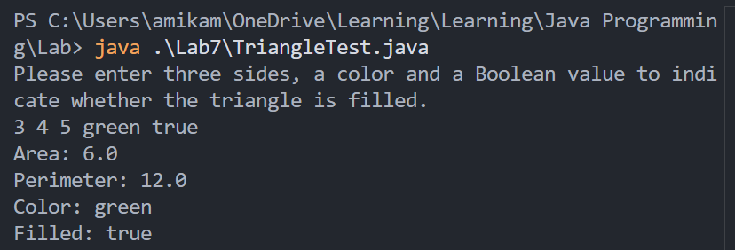
UML Graph:
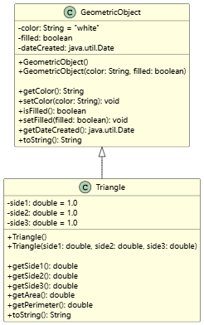

* Debugging/Testing:
Bug1: The requests do not include the mutators in the class Triangle, which might affect receiving arguments.
Fix: Add three mutator methods for three sides.
Bug2: The area may encounter negative values.
Fix: Limit the sides when entering the arguments.

Problem 2. (11.5)
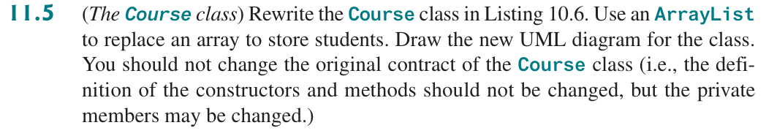

* Source Code / Solution :
Course.java:
package Lab7;

import java.util.ArrayList;

public class Course {
private String courseName;
private ArrayList<String> students = new ArrayList<String>();
private int numberOfStudents;

public Course(String courseName) {
this.courseName = courseName;
}

public void addStudent(String student) {
students.add(student);
numberOfStudents++;
}

public ArrayList<String> getStudents() {
return students;
}

public int getNumberOfStudents() {
return numberOfStudents;
}

public String getCourseName() {
return courseName;
}

public void dropStudent(String student) {
students.remove(student);
numberOfStudents--;
}
}

CourseTest.java
package Lab7;

import java.util.ArrayList;

public class CourseTest {
public static void main(String[] args) {
Course course1 = new Course("Data Structures");
Course course2 = new Course("Database Systems");

course1.addStudent("Peter Jones");
course1.addStudent("Brian Smith");
course1.addStudent("Anne Kennedy");
course1.addStudent("Susan Kennedy");
course1.addStudent("John Kennedy");
course1.addStudent("Kim Johnson");
course1.addStudent("S1");
course1.addStudent("S2");
course1.addStudent("S3");
course1.addStudent("S4");
course1.addStudent("S5");
course1.addStudent("S6");
course1.addStudent("S7");

course2.addStudent("Peter Jones");
course2.addStudent("Steve Smith");

System.out.println("Number of students in course1: "
+ course1.getNumberOfStudents());
ArrayList<String> students = course1.getStudents();
for (int i = 0; i < students.size(); i++)
System.out.print(students.get(i) + ", ");

System.out.println();
System.out.println("Number of students in course2: "
+ course2.getNumberOfStudents());

course1.dropStudent("S1");
System.out.println("Number of students in course1: "
+ course1.getNumberOfStudents());
students = course1.getStudents();
for (int i = 0; i < course1.getNumberOfStudents(); i++)
System.out.print(students.get(i) + (i < course1.getNumberOfStudents() - 1 ? ", " : " "));

}
}

* Output:
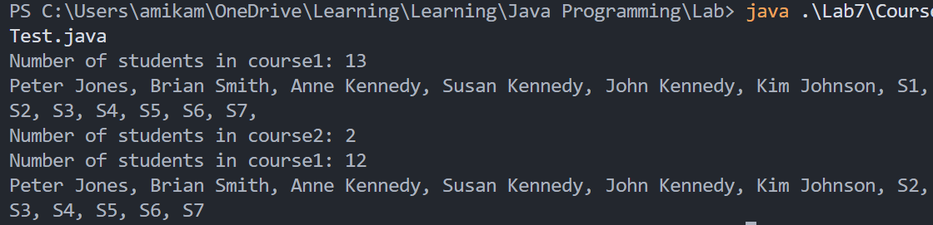
UML Graph:
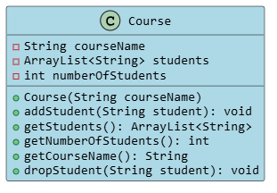

* Debugging/Testing:
Bug1: When compiling and running CourseTest.java, it cannot specify the ArrayList type.
Fix: Add the import statement in CourseTest.java. In the same package, the class can directly use but the package imported in one class will not be shared in other class.

Problem 3. (11.11)
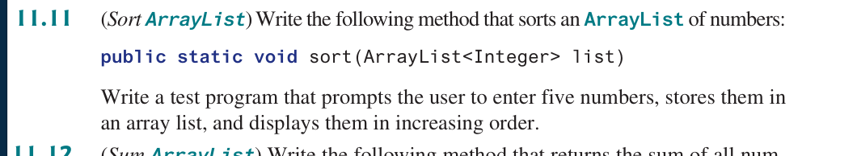

* Source Code / Solution :
package Lab7;

import java.util.ArrayList;
import java.util.Scanner;

public class SortArrayList {
public static void sort(ArrayList<Integer> list) {
// sort the list by increasing order
list.sort(null);
}

public static void main(String[] args) {
Scanner sc = new Scanner(System.in);
ArrayList<Integer> numbers = new ArrayList<Integer>();

System.out.println("Please enter five numbers, separated by space:");
int cnt = 5;
while (cnt > 0) {
numbers.add(sc.nextInt());
cnt--;
}

sort(numbers);

System.out.println("Sorted list:");
for (int num : numbers) {
System.out.print(num + " ");
}

System.out.println();

sc.close();
}
}

* Output:
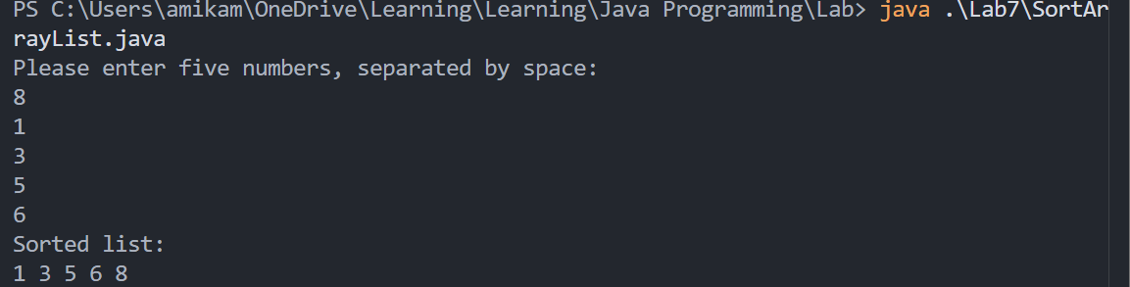

* Debugging/Testing:
Bug1: Syntax error when creating objects in type of Arraylist.
Fix:
ArrayList<Integer> numbers = new ArrayList<Integer>();

ArrayList<E>, the type can only be the reference type. We should use the corresponding reference type if using base type.
And we use the method in the ArrayList class to make the code clear and efficient.

Problem 4. (11.13) (Optional)
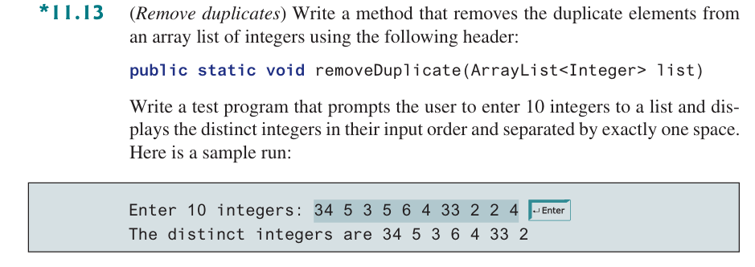

* Source Code / Solution :
package Lab7;

import java.util.Scanner;
import java.util.ArrayList;

public class RemoveDuplicates {
public static void removeDuplicate(ArrayList<Integer> list) {
int len = list.size();
for (int i = 0; i < len; i++) {
for (int j = i + 1; j < len; j++) {
if (list.get(i) == list.get(j)) {
list.remove(j);
len--;
}
}
}
}

public static void main(String[] args) {
Scanner sc = new Scanner(System.in);
ArrayList<Integer> list = new ArrayList<Integer>();
System.out.println("Enter 10 integers: ");
int len = 10;
for (int i = 0; i < len; i++) {
list.add(sc.nextInt());
}

removeDuplicate(list);
len = list.size();
System.out.println("The distinct integers are: ");
for (int i = 0; i < len; i++) {
System.out.print(list.get(i) + " ");
}

sc.close();
}
}

* Output:
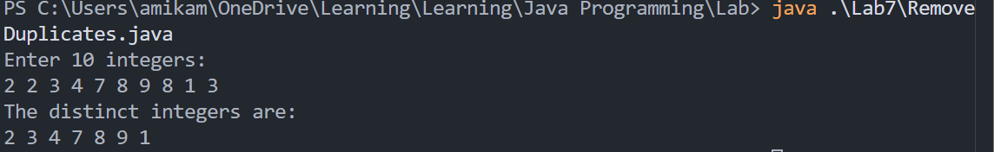

* Debugging/Testing:
Bug1: The iterator is out of the bound of the array.
Fix:
if (list.get(i) == list.get(j)) {
list.remove(j);
len--;
}
Add the len—in the method to correct the logic.

Problem 5. (11.17) (Optional)
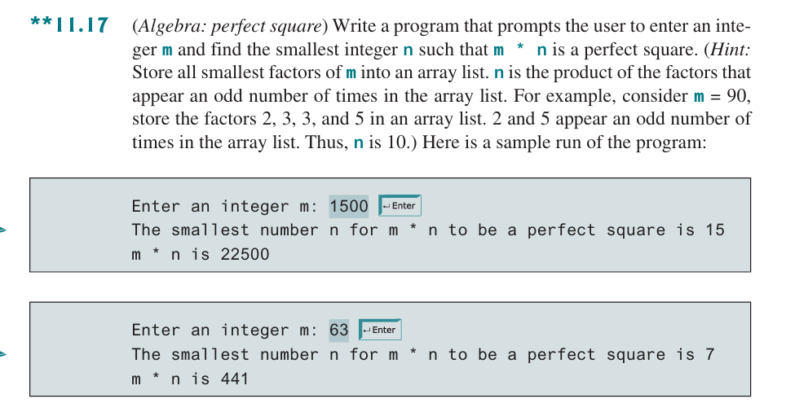

* Source Code / Solution :
package Lab7;

import java.util.ArrayList;
import java.util.Scanner;

public class PerfectSquare {
public static int findPerfectSquare(int m) {
ArrayList<Integer> factors = new ArrayList<Integer>();

// store all smallest factors of m in factors array list
for (int i = 2; i * i <= m; i++) {
while (m % i == 0) {
factors.add(i);
m /= i;
}
}

if (m > 1) {
factors.add(m);
}

// find all factors appearing in odd numbers
factors.sort(null);
int len = factors.size();
int n = 1;
int cnt = 1;
for (int i = 0; i < len; i++) {
if (i + 1 < len && factors.get(i) == factors.get(i + 1)) {
cnt++;
} else {
if (cnt % 2 == 1) {
n *= factors.get(i);
}

cnt = 1;
}
}

return n;
}

public static void main(String[] args) {
Scanner sc = new Scanner(System.in);
System.out.println("Enter an integer m: ");
int m = sc.nextInt();
int n = findPerfectSquare(m);
System.out.println("The smallest number n for m * n to be a perfect square is " + n);
System.out.println("m * n is " + m * n);

sc.close();
}
}

* Output:
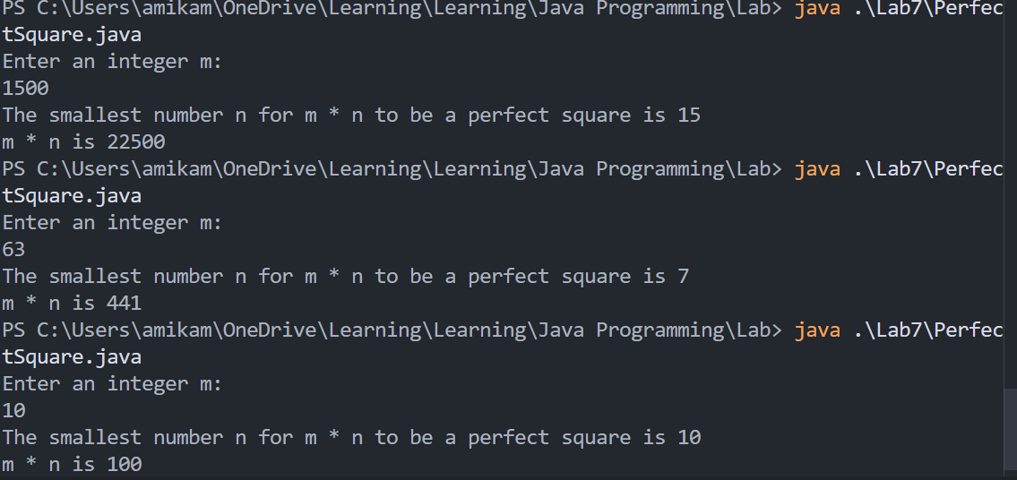

* Debugging/Testing:
Bug1: The result is incorrect for n.
Fix:
while (m % i == 0) {
factors.add(i);
m /= i;
}
Correct the logic that use loop rather than one judgment.

LAB 8 DATE: 5/19/2026

Student Name: __李荣耀____ Student ID: 2024103975___

Problem 1. (12.3)
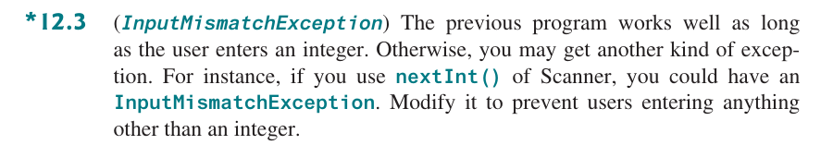

* Source Code / Solution :
package Lab8;

import java.util.InputMismatchException;
import java.util.Scanner;

public class MonthAndDays {
public static void main(String[] args) {
String[] months = { "January", "February", "March", "April",
"May", "June", "July", "August", "September", "October",
"November", "December" };
int[] dom = { 31, 28, 31, 30, 31, 30, 31, 31, 30, 31, 30, 31 };
Scanner sc = new Scanner(System.in);
int idx;
String month;
int days;

System.out.println("Please enter an integer between 1 and 12: ");

try{
idx = sc.nextInt() - 1;
} catch (InputMismatchException e) {
System.err.println("Invalid input. Please enter an integer between 1 and 12.");
sc.close();
return;
}

try{
month = months[idx];
days = dom[idx];
} catch (ArrayIndexOutOfBoundsException e) {
System.err.println("Wrong number. Please enter an integer between 1 and 12.");
sc.close();
return;
}

System.out.println("Month :" + month);
System.out.println("The number of days in the month: " + days);

sc.close();
}
}

* Output:
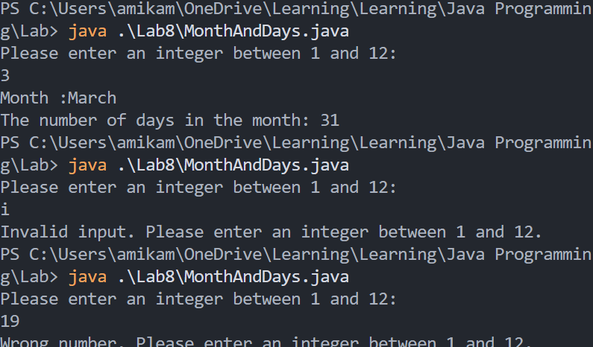

* Debugging/Testing:
Bug1: The variables defined in the try block cannot be used outside.
Fix: Define the variable outside the try_catch block. The domain of those variables defined in the block does not include the outside.

Problem 2. (12.7)
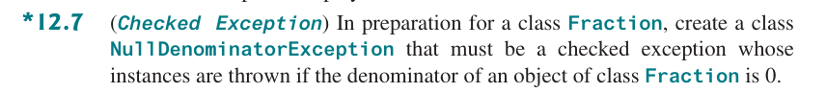

* Source Code / Solution :
Fraction:
package Lab8;

public class Fraction {
private int numerator;
private int denominator;

public Fraction(int numerator, int denominator) throws NullDenominatorException {
if (denominator == 0) {
throw new NullDenominatorException("The denominator cannot be zero.");
}

this.numerator = numerator;
this.denominator = denominator;

}

// accessor methods
public int getNumerator() {
return numerator;
}

public int getDenominator() {
return denominator;
}

// mutator methods
public void setNumerator(int numerator) {
this.numerator = numerator;
}

public void setDenominator(int denominator) throws NullDenominatorException {
if (denominator == 0){
throw new NullDenominatorException("The denominator cannot be zero.");
}

this.denominator = denominator;
}

public class NullDenominatorException extends Exception {
public NullDenominatorException() {
super();
}

public NullDenominatorException(String message) {
super(message);
}
}
}

FractionTest:
package Lab8;

import Lab8.Fraction.NullDenominatorException;

public class FractionTest {
public static void main(String[] args) {
try{
Fraction f = new Fraction(2, 0);
} catch (NullDenominatorException e) {
System.out.println(e.getMessage());
}
}
}

* Output:
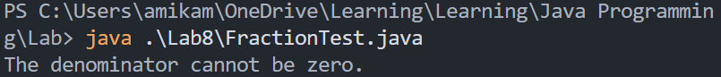

* Debugging/Testing:
Bug1: After creating the class NullDenominatorException and invoking by
if (denominator == 0) {
throw new NullDenominatorException("The denominator cannot be zero.");
}
The compiler reports error when compiling.
Fix: If a method throw out exceptions, there must be throws statement in the method signature. So state throws when constructing and setting.
Bug2: In test program, it occurs the same situation.
Fix: The mechanism of throw will find the first matching catch until main function. If no catch the program will crash.

Problem 3. (12.11)
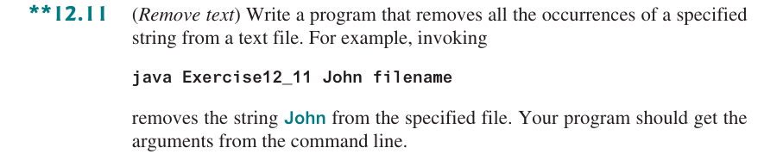

* Source Code / Solution :
package Lab8;

import java.io.FileNotFoundException;
import java.io.IOException;
import java.nio.file.*;

public class RemoveText {
public static void main(String[] args) {
if (args.length < 2) {
System.out.println("Please enter: java RemoveText <target> <filename>.");
return;
}

String target = args[0];
String filename = args[1];

try {
// read the file
Path path = Paths.get(filename);
String content = new String(Files.readAllBytes(path));

// remove the target text
String newContent = content.replace(target, "");

// rewrite the modified file
Files.write(path, newContent.getBytes());

System.out.println("Finished.");
} catch (FileNotFoundException e) {
System.err.println("Not Found the file " + filename);
} catch (IOException e) {
System.err.println("Error when reading and writing the file. " + e.getMessage());
}
}
}

* Output:
test.txt:
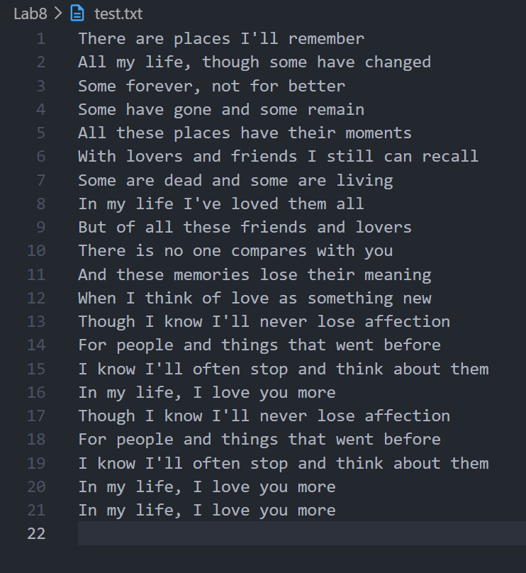
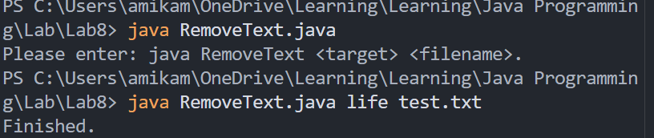
After running:
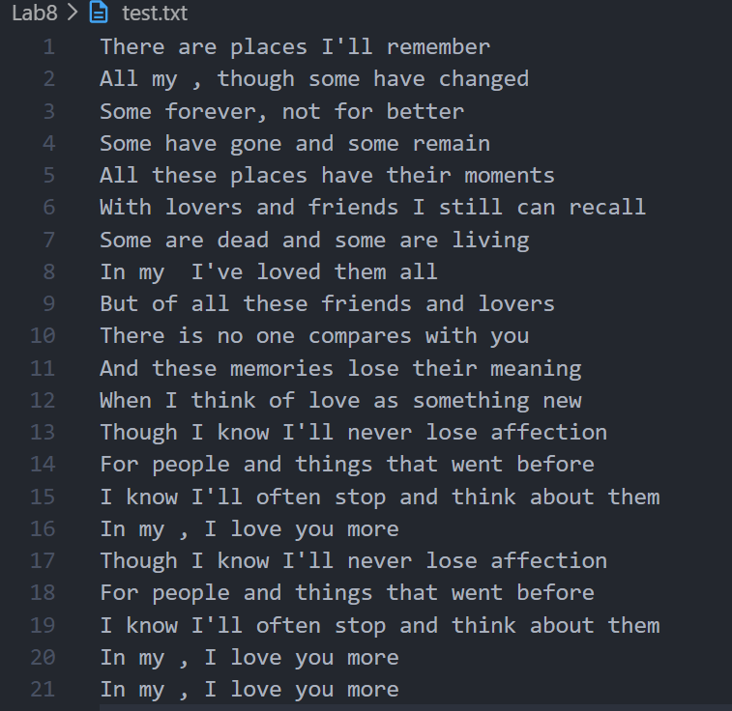

* Debugging/Testing:
Bug1: No exception handling when the arguments in the command line is less than 2.
Fix:
if (args.length < 2) {
System.out.println("Please enter: java RemoveText <target> <filename>.");
return;
}

Problem 4. (12.27) (Optional)
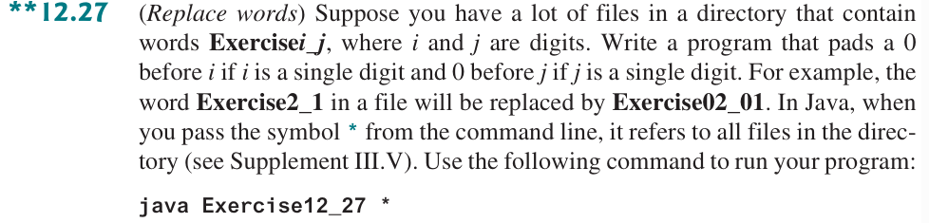

* Source Code / Solution :
package Lab8;

import java.io.FileNotFoundException;
import java.io.IOException;
import java.nio.file.*;
import java.util.regex.Pattern;
import java.util.regex.Matcher;

public class ReplaceWords {
public static void main(String[] args) {
if (args.length < 1) {
System.out.println("Usage: java RenameFiles *");
return;
}

Pattern pattern = Pattern.compile("Exercise(\\d+)_(\\d+)");

for (String filename : args) {
Path path = Paths.get(filename);
if (Files.isDirectory(path)) {
continue;
}

try {
String content = new String(Files.readAllBytes(path));
StringBuffer sb = new StringBuffer();
Matcher matcher = pattern.matcher(content);

// replace words for all matches
while (matcher.find()) {
String i = matcher.group(1);
String j = matcher.group(2);
// pad a 0 before single digit numbers
String paddedI = i.length() == 1 ? "0" + i : i;
String paddedJ = j.length() == 1 ? "0" + j : j;
String newWord = "Exercise" + paddedI + "_" + paddedJ;
matcher.appendReplacement(sb, newWord);
}

matcher.appendTail(sb);
String newContent = sb.toString();

if (!newContent.equals(content)) {
Files.write(path, newContent.getBytes());
System.out.println("Updated :" + filename);
}
} catch (FileNotFoundException e) {
System.err.println("Not Found the file " + filename);
} catch (IOException e) {
System.err.println("Error when handling file: " + filename + " - " + e.getMessage());
}
}
}
}

* Output:
ReplaceWordsTest1.txt:
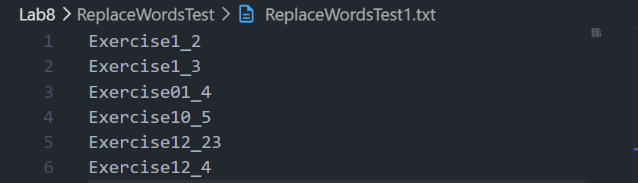
ReplaceWordsTest2.txt:
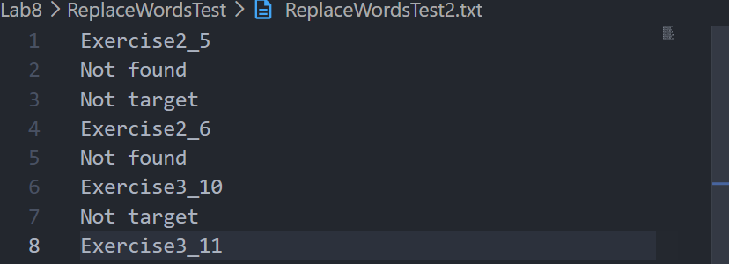
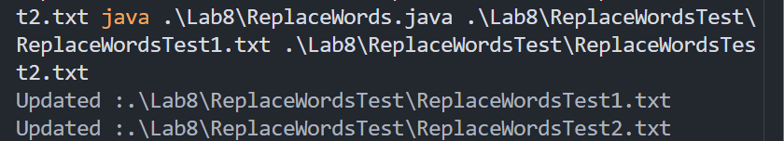
After running:
ReplaceWordsTest1.txt:
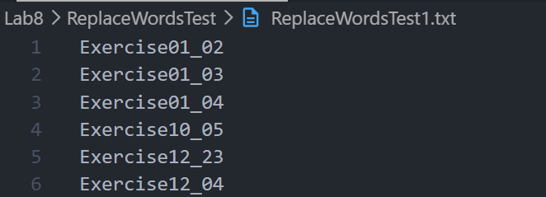
ReplaceWordsTest2.txt:
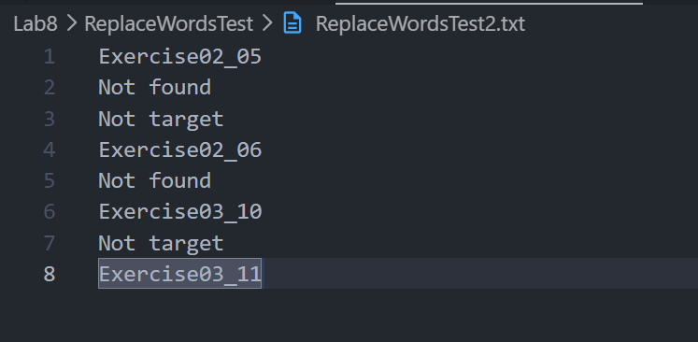

* Debugging/Testing:
Bug1: Unreachable catch block for FileNotFoundException.
Fix: Modify the order of IOException and FileNotFoundException.

Bug2: Incorrect input in the command line.
Fix: In Windows powershell and cmd, the wildcard character cannot be ignored correctly sometimes. So I have to enter all file names.

Problem 5. (12.33) (Optional)
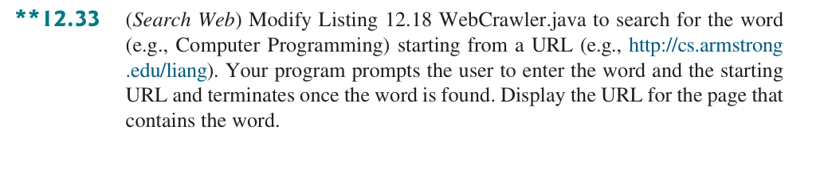

* Source Code / Solution :
package Lab8;

import java.util.Scanner;
import java.util.ArrayList;

public class WebCrawler {
public static void main(String[] args) {
Scanner input = new Scanner(System.in);
System.out.print("Enter a word to search: ");
String word = input.nextLine();
System.out.print("Enter a URL: ");
String url = input.nextLine();
crawler(url, word); // Traverse the Web from the starting url
}

public static void crawler(String startingURL, String word) {
ArrayList<String> listOfPendingURLs = new ArrayList<>();
ArrayList<String> listOfTraversedURLs = new ArrayList<>();

listOfPendingURLs.add(startingURL);
while (!listOfPendingURLs.isEmpty() &&
listOfTraversedURLs.size() <= 100) {
String urlString = listOfPendingURLs.remove(0);
if (!listOfTraversedURLs.contains(urlString)) {
listOfTraversedURLs.add(urlString);
System.out.println("Crawl " + urlString);

// check whether currect page includes searching word
if (pageContainsWord(urlString, word)) {
System.out.println("Word found at: " + urlString);
return;
}

for (String s : getSubURLs(urlString)) {
if (!listOfTraversedURLs.contains(s))
listOfPendingURLs.add(s);
}
}
}
System.out.println("Word not found within the crawled pages.");
}

public static boolean pageContainsWord(String urlString, String word) {
try {
java.net.URL url = new java.net.URL(urlString);
Scanner input = new Scanner(url.openStream());

StringBuilder pageContent = new StringBuilder();
while (input.hasNextLine()) {
pageContent.append(input.nextLine()).append("\n");
}
input.close();

return pageContent.toString().toLowerCase()
.contains(word.toLowerCase());
} catch (Exception ex) {
System.out.println("Error reading page: " + ex.getMessage());
return false;
}
}

public static ArrayList<String> getSubURLs(String urlString) {
ArrayList<String> list = new ArrayList<>();

try {
java.net.URL url = new java.net.URL(urlString);
Scanner input = new Scanner(url.openStream());
int current = 0;
while (input.hasNext()) {
String line = input.nextLine();
current = line.indexOf("http:", current);
while (current > 0) {
int endIndex = line.indexOf("\"", current);
if (endIndex > 0) { // Ensure that a correct URL is found
list.add(line.substring(current, endIndex));
current = line.indexOf("http:", endIndex);
} else
current = -1;
}
}
} catch (Exception ex) {
System.out.println("Error: " + ex.getMessage());
}

return list;
}
}

* Output:
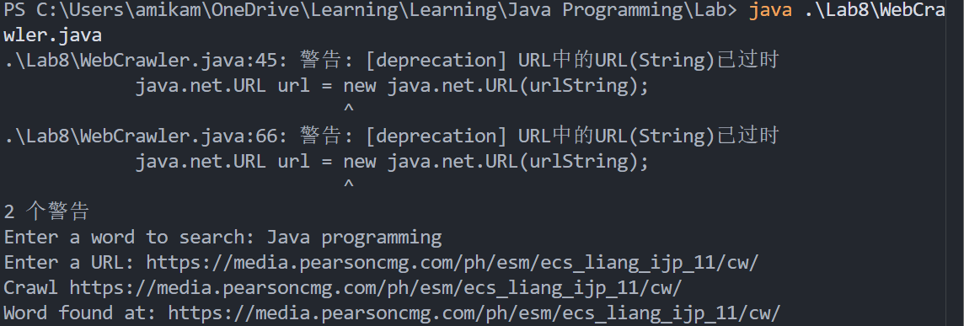

* Debugging/Testing:
Bug1: The example web URL cannot be accessed.
Fix: The URL cannot be accessed due to the cause of region. So, I replace it by another web URL.

Problem 6. (13.1)
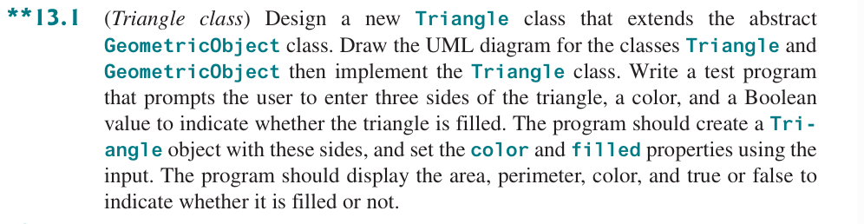

* Source Code / Solution :
Triangle.java:
package Lab8;

public class Triangle extends GeometricObject{
private double side1;
private double side2;
private double side3;

//accessor methods
public double getSide1() {
return side1;
}

public double getSide2() {
return side2;
}

public double getSide3() {
return side3;
}

// mutator methods
public void setSide1(double side1) {
this.side1 = side1;
}

public void setSide2(double side2) {
this.side2 = side2;
}

public void setSide3(double side3) {
this.side3 = side3;
}

//constructor
public Triangle() {
this(1.0, 1.0, 1.0);
}

public Triangle(double side1, double side2, double side3) {
this.side1 = side1;
this.side2 = side2;
this.side3 = side3;
}

public Triangle(double side1, double side2, double side3, String color, boolean filled) {
super(color, filled);
this.side1 = side1;
this.side2 = side2;
this.side3 = side3;
}

@Override
public double getArea() {
double s = (side1 + side2 + side3) / 2;
return Math.sqrt(s * (s - side1) * (s - side2) * (s - side3));
}

@Override
public double getPerimeter() {
return side1 + side2 + side3;
}

@Override
public String toString() {
return "Triangle: side1 = " + side1 + ", side2 = " + side2 + ", side3 = " + side3 + "\n" + super.toString();
}
}

TriangleTest.java:
package Lab8;

import java.util.Scanner;

public class TriangleTest {
public static void main(String[] args) {
Scanner sc = new Scanner(System.in);
double side1 = 1.0;
double side2 = 1.0;
double side3 = 1.0;
String color = "white";
boolean filled = false;

try{
System.out.println("Enter three sides of the triangle: ");
side1 = sc.nextDouble();
side2 = sc.nextDouble();
side3 = sc.nextDouble();

System.out.println("Enter a color: ");
color = sc.next();

System.out.println("Enter filled or not (true/false): ");
filled = sc.nextBoolean();
} catch (Exception e) {
System.err.println("Invalid input format!");
sc.close();
return;
}
Triangle t = new Triangle(side1, side2, side3, color, filled);

System.out.println("Area of the triangle is: " + t.getArea());
System.out.println("Perimeter of the triangle is: " + t.getPerimeter());
System.out.println("Color of the triangle is: " + t.getColor());
System.out.println("Filled or not: " + t.isFilled());

sc.close();
}
}

* Output:
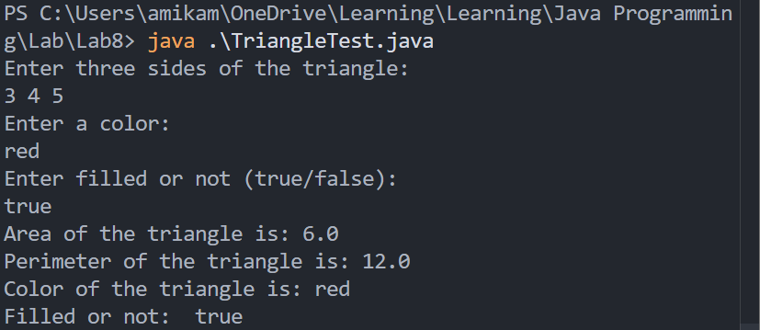

* Debugging/Testing:
Bug1: No Exception handling when entering incorrect format.
Fix:
try{
...
} catch (Exception e) {
System.err.println("Invalid input format!");
sc.close();
return;
}

Problem 7. (13.7)
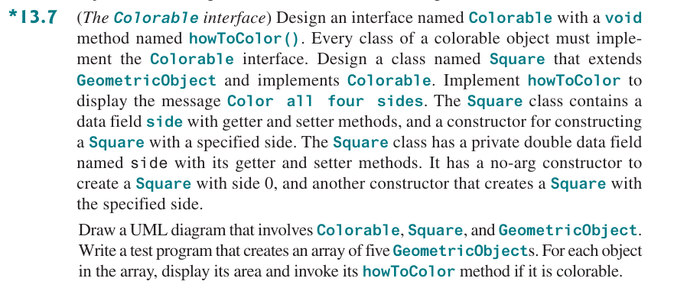

* Source Code / Solution :
Colorable.java:
package Lab8;

public interface Colorable {
void howToColor();
}
Square.java
package Lab8;

public class Square extends GeometricObject implements Colorable {
private double side;

// constructor
public Square() {
this(0);
}

public Square(double side) {
super();
this.side = side;
}

// setter
public void setSide(double side) {
this.side = side;
}

// getter
public double getSide() {
return side;
}

@Override
public void howToColor() {
System.out.println("Color all four sides");
}

public double getArea() {
return side * side;
}

public double getPerimeter() {
return 4 * side;
}

@Override
public String toString() {
return "Square: side = " + side + ", area = " + getArea() + ", perimeter = " + getPerimeter()
+ super.toString();
}

}

* Output:
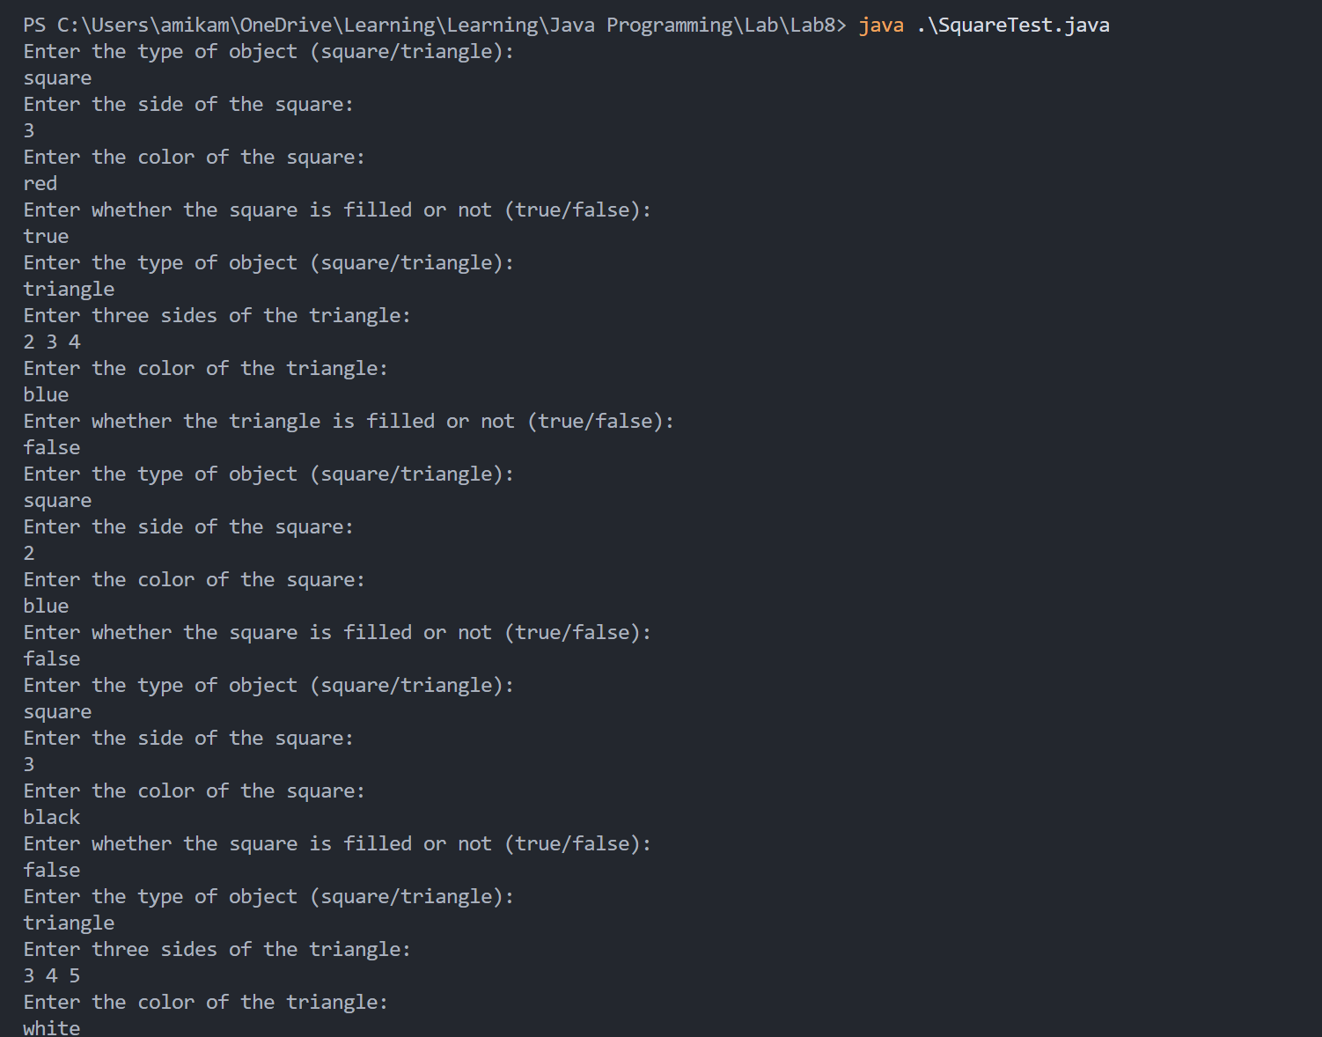
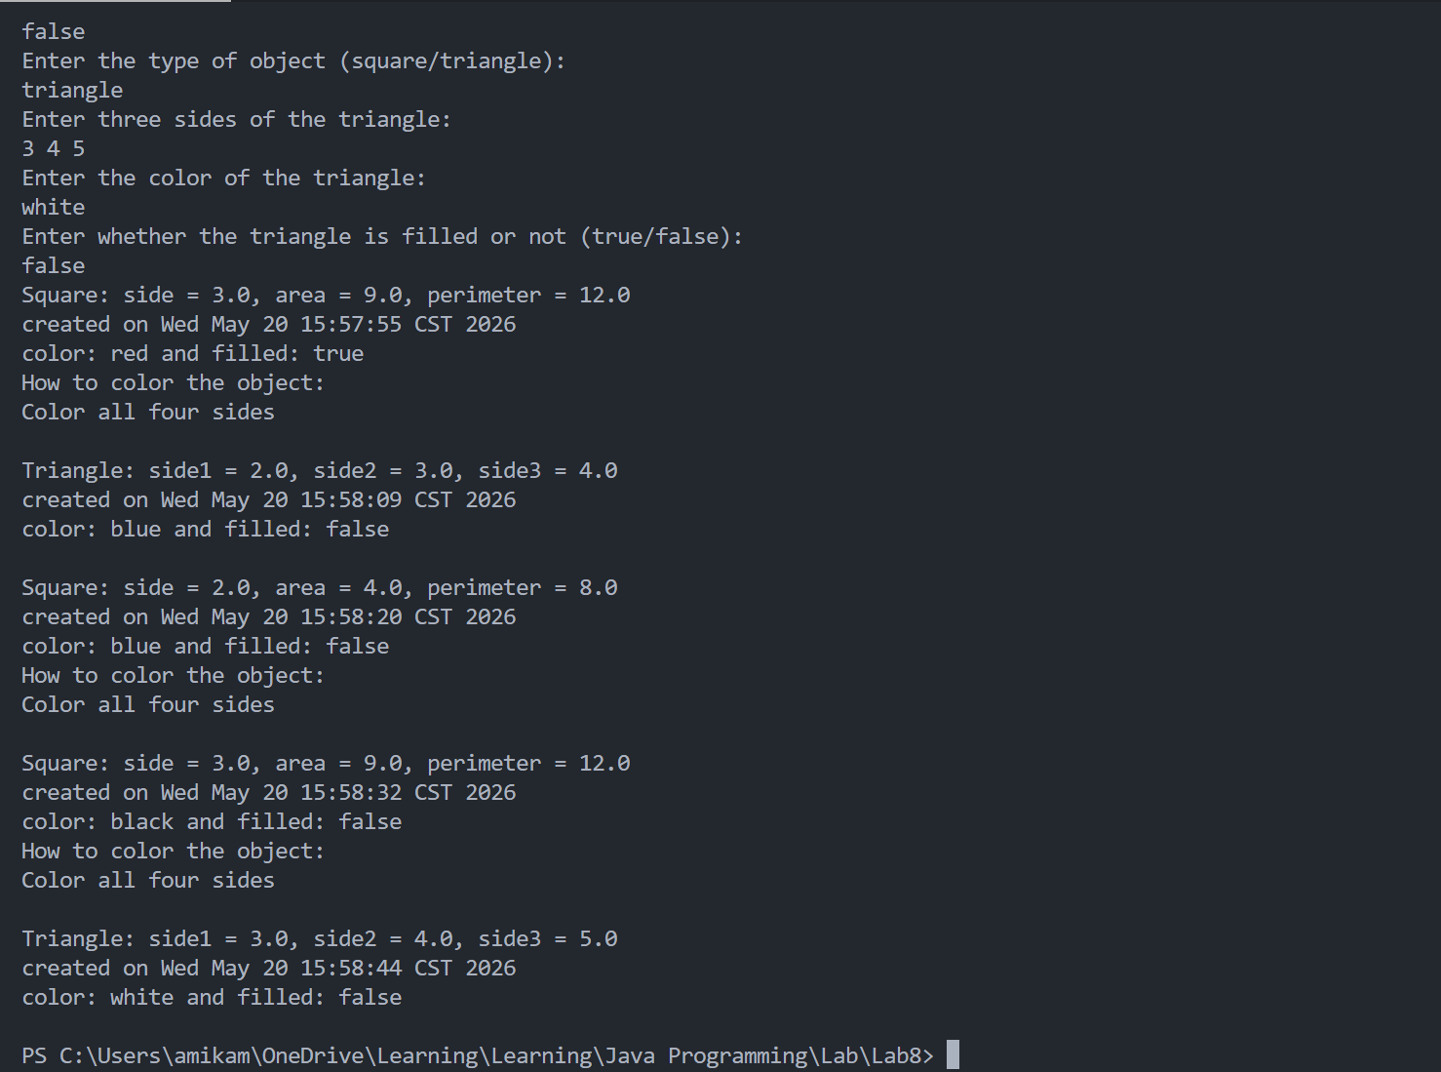
UML graph:
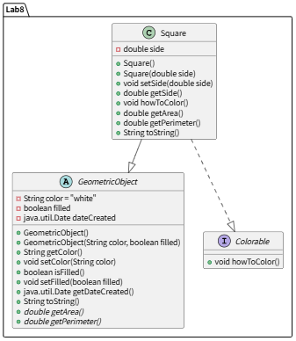

* Debugging/Testing:
Bug1: The for statement cannot be recognized by the compiler.
Fix: Forget the main function in the test program.
Bug2: Sometimes the type input will be jumped over.
Fix: The nextline character is stored in the buffer and will be read by sc.nextline(). So we add sc.nextline() after other reading.

Problem 8. (13.17) (Optional)
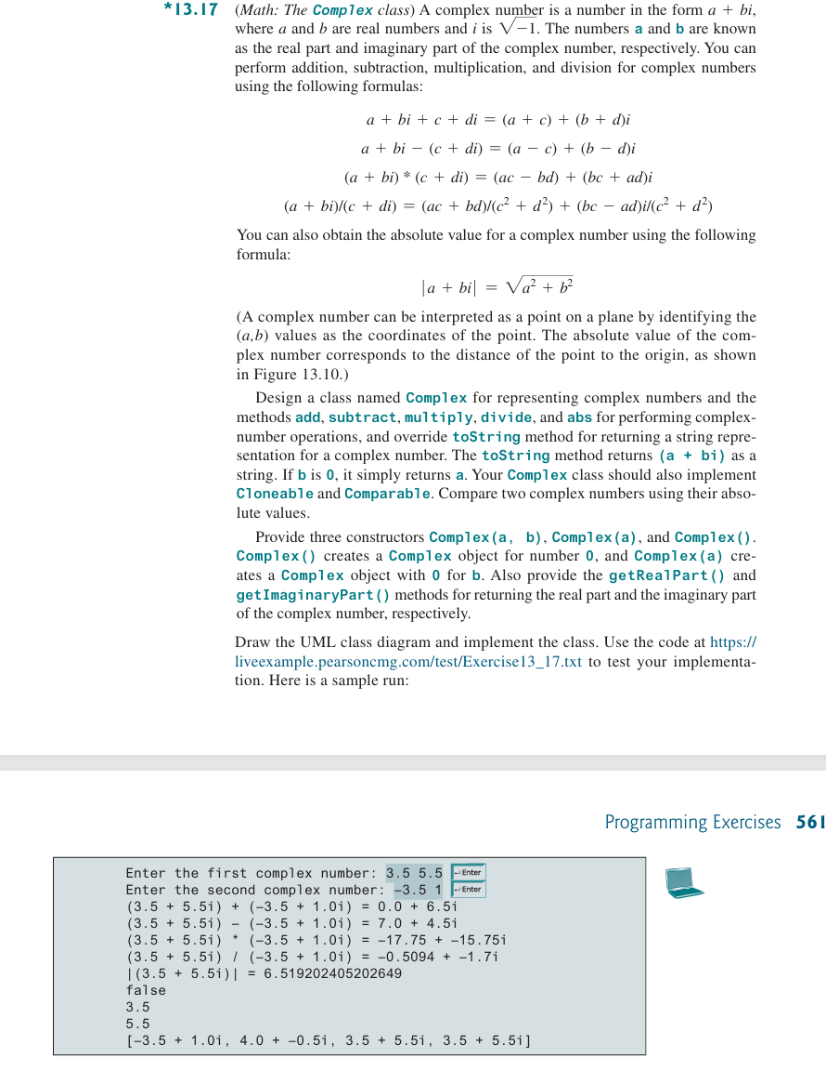

* Source Code / Solution :
package Lab8;

public class Complex implements Cloneable, Comparable<Complex>{
private double a;
private double b;

// constructors
public Complex(double a, double b) {
this.a = a;
this.b = b;
}

public Complex(double a) {
this(a, 0);
}

public Complex() {
this(0, 0);
}

// Getter methods
public double getRealPart() {
return a;
}

public double getImaginaryPart() {
return b;
}

// Arithmetic operations
public Complex add(Complex other) {
return new Complex(this.a + other.a, this.b + other.b);
}

public Complex subtract(Complex other) {
return new Complex(this.a - other.a, this.b - other.b);
}

public Complex multiply(Complex other) {
double real = this.a * other.a - this.b * other.b;
double imag = this.b * other.a + this.a * other.b;
return new Complex(real, imag);
}

public Complex divide(Complex other) {
double denom = other.a * other.a + other.b * other.b;
if (denom == 0)
throw new ArithmeticException("Division by zero");
double real = (this.a * other.a + this.b * other.b) / denom;
double imag = (this.b * other.a - this.a * other.b) / denom;
return new Complex(real, imag);
}

public double abs() {
return Math.sqrt(a * a + b * b);
}

@Override
public String toString() {
if (b == 0) {
return Double.toString(a);
}

return "(" + a + " + " + b + "i)";
}

// implement Cloneable
@Override
public Complex clone() {
try {
return (Complex) super.clone();
} catch (CloneNotSupportedException e) {
return new Complex(this.a, this.b);
}
}

// implement Comparable
@Override
public int compareTo(Complex other) {
return Double.compare(this.abs(), other.abs());
}
}

* Output:
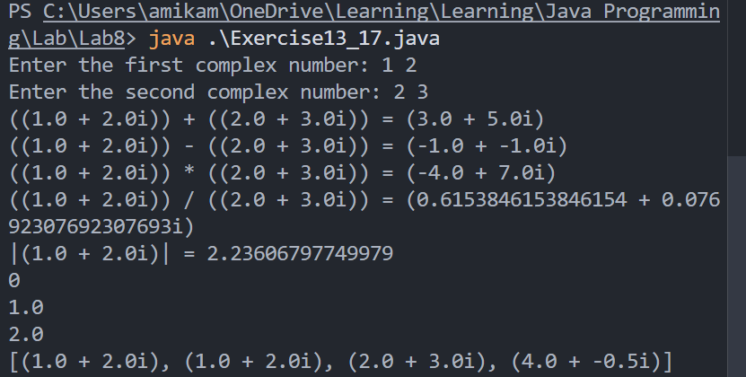

* Debugging/Testing:
Bug1: Conflict occurs because Complex class occurs two times.
Fix: Delete the commission part in the Exercise13_17.java to ensure unique Complex.java in the package.
Bug2: The code in the Exercise13_17.java to judge whether two complex is equal has mistaken.
Complex c3 = (Complex) c1.clone();
System.out.println(c1 == c3);
It compares the reference rather than the two complexes.
Fix:
Complex c3 = (Complex) c1.clone();
System.out.println(c1.compareTo(c3));

