LAB REPORT
Lab Title | STL map container | Lab No. | 15
Student Name | Li Rongyao | Student ID | 2024103975
Date | 2025/6/16
Lab description/objectives:
1. Demonstrate understanding of the STL map container and its function in cpp.
2. Implement the steps of fruit price management as defined in the lab tasks/requirements.
3. Analyze critical functions and performance about map container.
Source code:
#include <iostream>
#include <map>
using namespace std;
void Insertingfruit(map<string, double>& fruitPrices){
string tmpname;
double tmpprices;
cout << "Enter fruit name: ";
cin >> tmpname;
cout << "Enter price: ";
cin >> tmpprices;
fruitPrices.insert({tmpname, tmpprices});
}
void Printingfruit(map<string, double>& fruitPrices){
for (auto i = fruitPrices.begin(); i != fruitPrices.end(); i++){
cout << i->first
<< " : "
<< i->second
<< endl;
}
}
void Searchingfruit(map<string, double>& fruitPrices){
string name;
cout << "Please enter the name of the fruit you want to search."
<< endl;
cin >> name;
auto tmp = fruitPrices.find(name);
if (tmp != fruitPrices.end()){
cout << "The price of "
<< name
<< " is "
<< tmp->second
<< "."
<< endl;
}else{
cout << "The fruit is not in the list."
<< endl;
}
}
void ModifyingPrice(map<string, double>& fruitPrices){
string name;
double newprice;
cout << "Please enter the fruit you want to modify the price and its new price."
<< endl;
cin >> name >> newprice;
auto tmp = fruitPrices.find(name);
if (tmp != fruitPrices.end()){
tmp->second = newprice;
cout << "The price has been successfully modified."
<< endl;
}else{
cout << "Error. The fruit cannot be found for price modification."
<< endl;
}
}
void Deletingfruit(map<string, double>& fruitPrices){
string name;
cout << "Please enter the fruit you want to delete."
<< endl;
cin >> name;
auto tmp = fruitPrices.find(name);
if (tmp != fruitPrices.end()){
fruitPrices.erase(tmp);
cout << "The fruit has been successfully deleted."
<< endl;
}else{
cout << "Error. The fruit cannot be found for deletion."
<< endl;
}
}
int main(){
map<string, double> fruitPrices;
int num;
cout << "Please enter the number of initial elements in the fruit list."
<< endl;
cin >> num;
for (int i = 0; i < num; i++){
Insertingfruit(fruitPrices);
}
cout << "The fruit list is:"
<< endl;
Printingfruit(fruitPrices);
Searchingfruit(fruitPrices);
ModifyingPrice(fruitPrices);
Deletingfruit(fruitPrices);
cout << "The modified fruit list is:"
<< endl;
Printingfruit(fruitPrices);
return 0;
}
Program output:
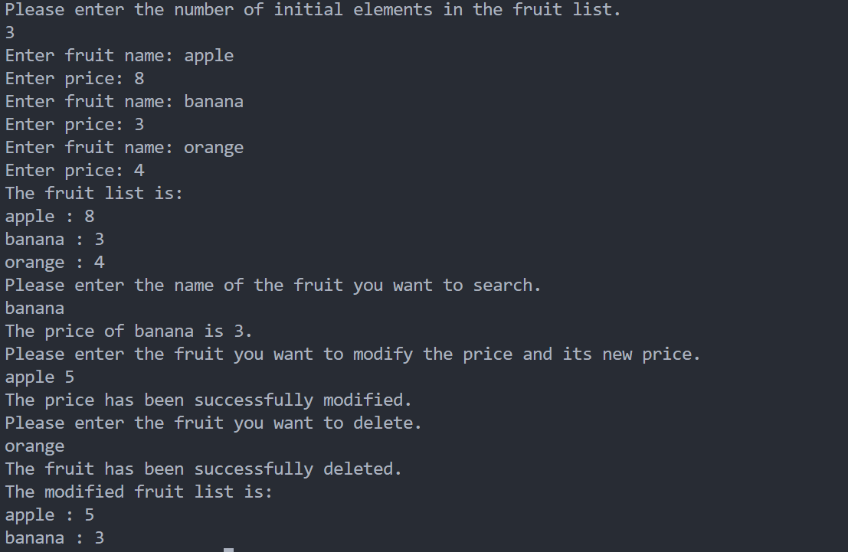
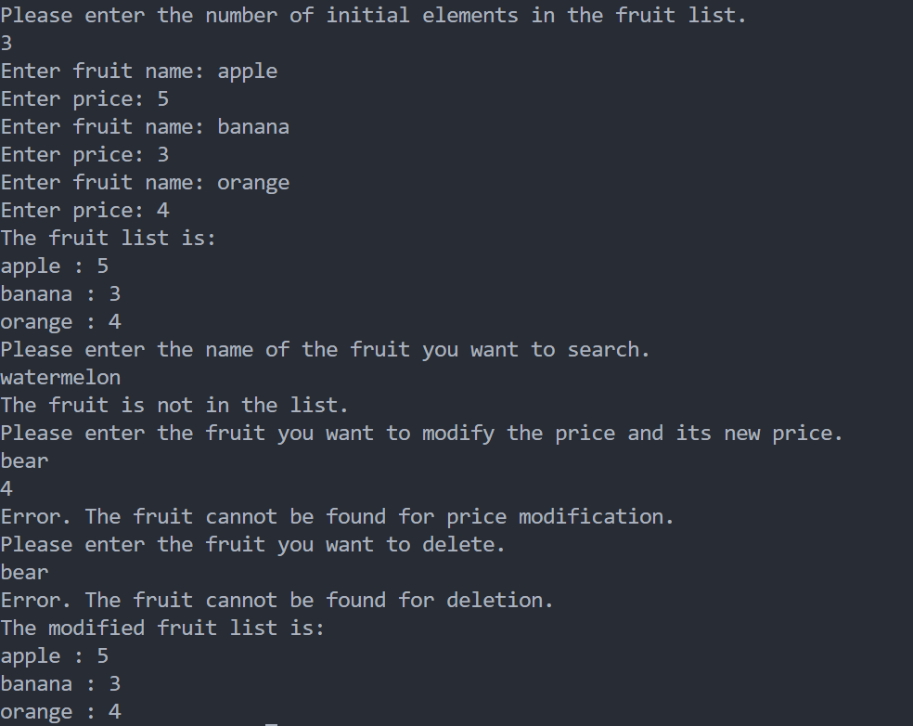
Analysis:
- Key Challenges & Solutions
- Understand the various functions in the map container and their corresponding usage.
- Use appropriate iterator to iterate through the container and use the type auto to perform.
- Result Validation
- Confirm passing reference to the function so that the map in the main function can be modified correctly.
- Print the error message when the fruit is not in the list.
- Improvement Suggestions
- Can check the data type when entering the number of initial elements.
Conclusion：
In cpp, the map container can be used to correspond key to the value and provides various function to insert, delete, modify, search in the container.

