

Undergraduate Lab Report

Course Title: Experiment of Computer Organization
Course No: 60080014
Student Name: 李荣耀
Student No: 2024103975
School: International School
Department:
Major: CST
Instructor： SUN Heng

Academic Year:2025~2026, Semester : 1st [√ ] 2nd[ ]

Academic Affairs Office of Jinan University
Date (dd/mm/yyyy) 2025/10/15
Computer Organization Lab List
Student Name: Li Rongyao Student No: 2024103975

ID | Lab Name | Type
1 | Number Storage Lab | Individual
2 | Manipulating Bits | Individual
3 | A Simple Real-life Control System Lab | Team
4 | System I/O | Individual
5 | Simulating Y86-64 Program | Individual
6 | Performance Lab | Team
Undergraduate Lab Report of Jinan University
Course Title Experiment of computer organization Evaluation
Lab Name Number Storage Lab Instructor Sun Heng
Lab Address Room 116
Student Name Li Rongyao
Student No 2024103975
College International School
Department Major CST
Date 2025/10/15 Afternoon
- Introduction

This lab extends the section Information Storage (chapter 2) in the textbook. It will immerse us in a problem context, which will require us to apply the theoretical concepts taught in the C language course. This will help us to develop basic skills needed to become a device level system developers and digital system designer. While going through this lab concentrate on developing a good understanding of the problem context, as it is a fundamental requirement for becoming a skilled system designer or application developer.
- Lab Instructions or Steps

a) Using less than 4 sentences, explain what function/action, the two statements marked with “Tag 1” and “Tag 2” perform.

b) Compile and run this program with “gcc” on the Linux machine.

c) When you ran your code, did you get the time executed to be negative? If yes, why did that happen? (Since time cannot be negative). How could you fix this? Figure out how to fix it and do the necessary modifications.

d) Change the data type of the variable time_stamp from double to long int. Is there a change in the values reported? If so, which of the values is the correct value? Why is there a difference?

e) Find out the structure of type “timeval”. Is it a standard C data type or is it platform specific?

f) Print the output files for all runs in the report. (and the fixed versions if necessary).
g) Write a C program to get bit and byte lengths for all the following C numerical data types according to the following table. The new C code file should have name “lab1_2.c” and it should generate an output file named “lab1_2_out.txt”.
- Lab Device or Environment
Ubuntu 16.04 (64-bit) on virtual machine (VMware workstation 17 Pro)
- Results and Analysis
- Tag 1 is to create a variable named int_var with the data type int. And Tag 2 is to output the data size of int data type in bytes and bits respectively through the variable int_var.

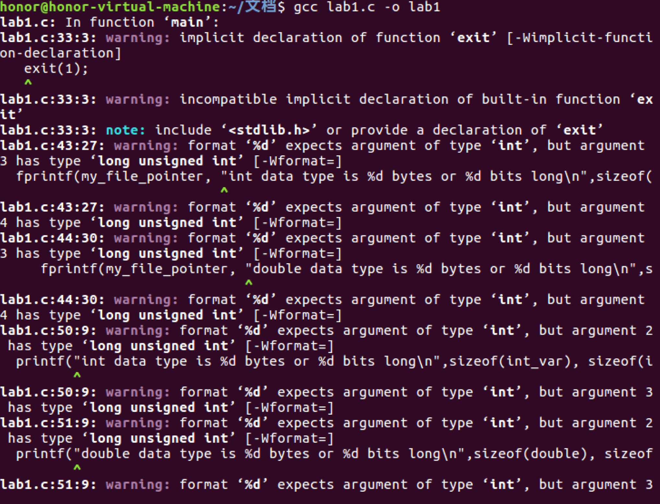
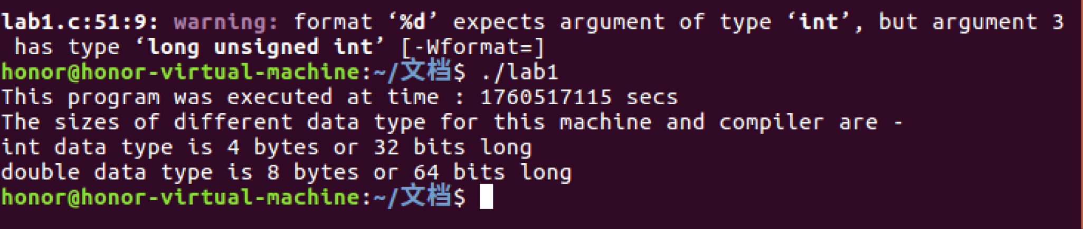
When compile, there exists warning since the function exit() in stdlib.h is declaration and the ouput format %d for the type `int` cannnot match the data type `long unsigned int` of arguments. And we can know the data type `double` and `int` converse implicitly.
- No. The time is positive. Because the data type `double` converse implicity to `long unsigned int`, which is type cast rather than truncation on bits in C language. And the type `long unsigned int`, which is 8-byte long on the 64-bit machime, is enough to store the time from 1970/01/01 to now. Even if it is the type `int`, its upper bound 2^31-1 is still enough to store the time from 1970/01/01 to now.
If the output is negative, it may occur the truncation of lower 32 bits when outputing with the format %d. That will lead to an error negative put.
- After modifying the data type of theet variable `time_stamp` from double to long int, the result is as:
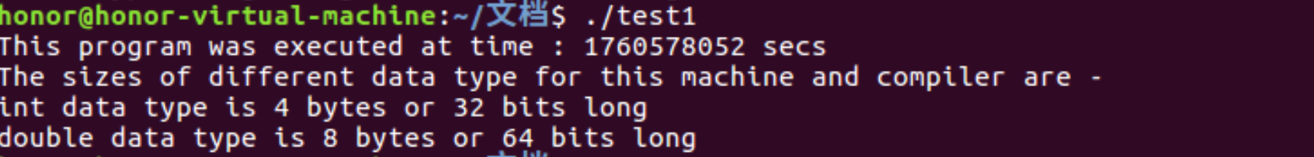
There are no exciplit changes because before modifying the data type has been conversed implicity into long unsigned int, which even can store more numbers than long int for positive.
- Find the struct timeval in the function gettimeofday():

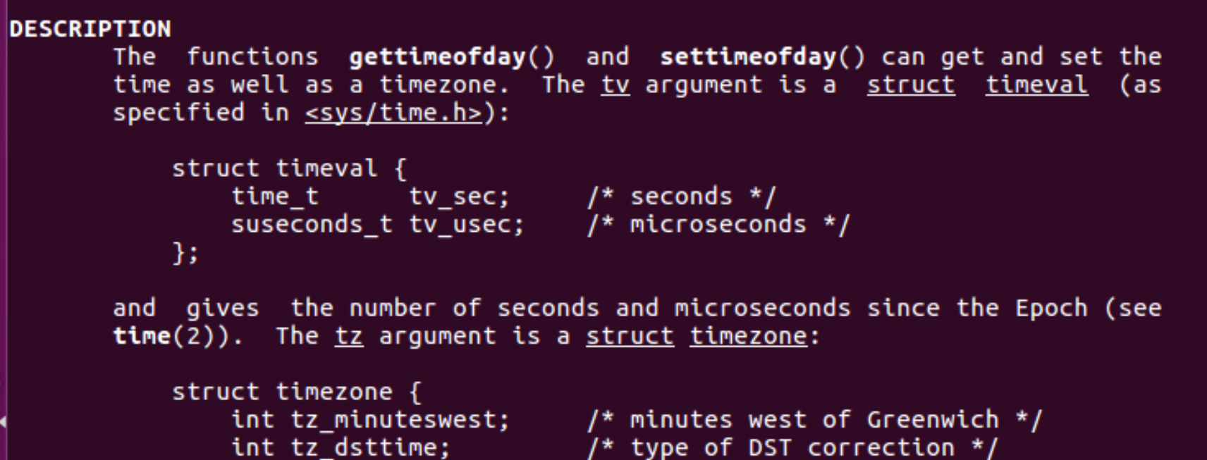
It consists of two elements tv_sec and tv_usec, which are with the data type time_t and susecond_t respectively.
Find the description of time_t and susecond_t in types.h:
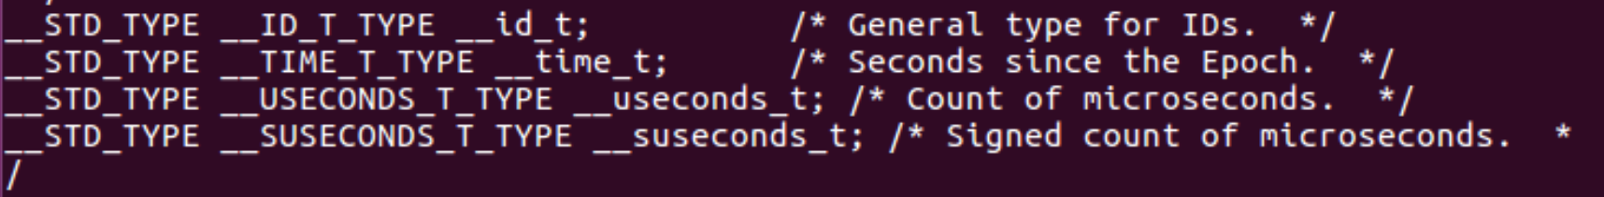
And in typesizes.h:
And in types.h again:
So we can know the struct timeval has two elements with the same data type of long int.
And in the description of time.h:
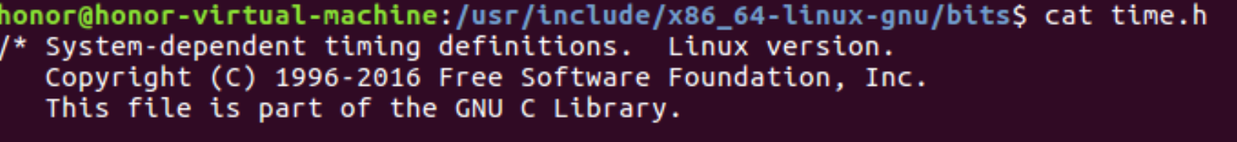
So we can know it is platform specific.
- The output of lab1.c and its fixed version by modifying the data type of time_stamp from double to long int:
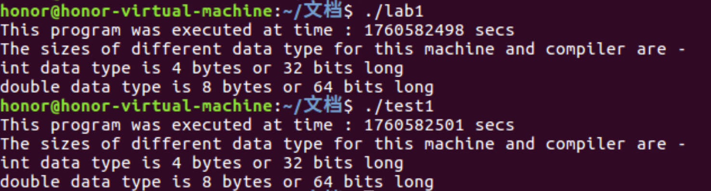
- For 32-bit machine and 64-bit machine:
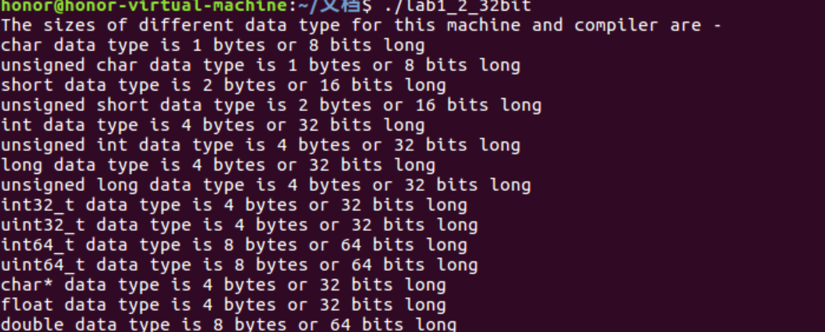
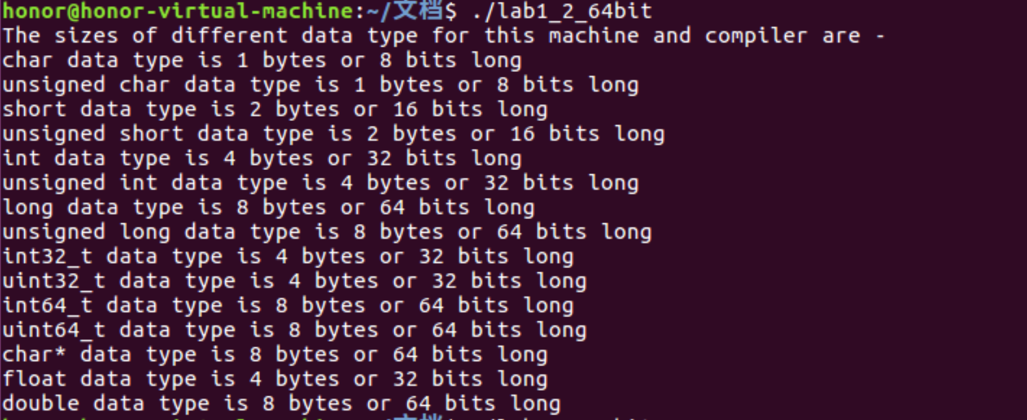
- Appendix (Program Code)
Lab1_2.c:
#include <stdio.h> //For input/output
#include <stdint.h> //For int32_t
#include <stdlib.h> //For exit() function

int main()
{

FILE *my_file_pointer;
if ((my_file_pointer = fopen("lab1_2_out.txt", "w")) == NULL)
{
printf("Error opening the file, so exiting\n");
exit(1);
}

// Code segment for file I/O

fprintf(my_file_pointer, "The sizes of different data type for this machine and compiler are -\n");
fprintf(my_file_pointer, "char data type is %d bytes or %d bits long\n", sizeof(char), sizeof(char) * 8);
fprintf(my_file_pointer, "unsigned char data type is %d bytes or %d bits long\n", sizeof(unsigned char), sizeof(unsigned char) * 8);
fprintf(my_file_pointer, "short data type is %d bytes or %d bits long\n", sizeof(short), sizeof(short) * 8);
fprintf(my_file_pointer, "unsigned short data type is %d bytes or %d bits long\n", sizeof(unsigned short), sizeof(unsigned short) * 8);
fprintf(my_file_pointer, "int data type is %d bytes or %d bits long\n", sizeof(int), sizeof(int) * 8);
fprintf(my_file_pointer, "unsigned int data type is %d bytes or %d bits long\n", sizeof(unsigned int), sizeof(unsigned int) * 8);
fprintf(my_file_pointer, "long data type is %d bytes or %d bits long\n", sizeof(long), sizeof(long) * 8);
fprintf(my_file_pointer, "unsigned long data type is %d bytes or %d bits long\n", sizeof(unsigned long), sizeof(unsigned long) * 8);
fprintf(my_file_pointer, "int32_t data type is %d bytes or %d bits long\n", sizeof(int32_t), sizeof(int32_t) * 8);
fprintf(my_file_pointer, "uint32_t data type is %d bytes or %d bits long\n", sizeof(uint32_t), sizeof(uint32_t) * 8);
fprintf(my_file_pointer, "int64_t data type is %d bytes or %d bits long\n", sizeof(int64_t), sizeof(int64_t) * 8);
fprintf(my_file_pointer, "uint64_t data type is %d bytes or %d bits long\n", sizeof(uint64_t), sizeof(uint64_t) * 8);
fprintf(my_file_pointer, "char* data type is %d bytes or %d bits long\n", sizeof(char*), sizeof(char*) * 8);
fprintf(my_file_pointer, "float data type is %d bytes or %d bits long\n", sizeof(float), sizeof(float) * 8);
fprintf(my_file_pointer, "double data type is %d bytes or %d bits long\n", sizeof(double), sizeof(double) * 8);

// Code segment for console I/O, this can be used instead of the file I/O

printf("The sizes of different data type for this machine and compiler are -\n");
printf("char data type is %d bytes or %d bits long\n", sizeof(char), sizeof(char) * 8);
printf("unsigned char data type is %d bytes or %d bits long\n", sizeof(unsigned char), sizeof(unsigned char) * 8);
printf("short data type is %d bytes or %d bits long\n", sizeof(short), sizeof(short) * 8);
printf("unsigned short data type is %d bytes or %d bits long\n", sizeof(unsigned short), sizeof(unsigned short) * 8);
printf("int data type is %d bytes or %d bits long\n", sizeof(int), sizeof(int) * 8);
printf("unsigned int data type is %d bytes or %d bits long\n", sizeof(unsigned int), sizeof(unsigned int) * 8);
printf("long data type is %d bytes or %d bits long\n", sizeof(long), sizeof(long) * 8);
printf("unsigned long data type is %d bytes or %d bits long\n", sizeof(unsigned long), sizeof(unsigned long) * 8);
printf("int32_t data type is %d bytes or %d bits long\n", sizeof(int32_t), sizeof(int32_t) * 8);
printf("uint32_t data type is %d bytes or %d bits long\n", sizeof(uint32_t), sizeof(uint32_t) * 8);
printf("int64_t data type is %d bytes or %d bits long\n", sizeof(int64_t), sizeof(int64_t) * 8);
printf("uint64_t data type is %d bytes or %d bits long\n", sizeof(uint64_t), sizeof(uint64_t) * 8);
printf("char* data type is %d bytes or %d bits long\n", sizeof(char *), sizeof(char *) * 8);
printf("float data type is %d bytes or %d bits long\n", sizeof(float), sizeof(float) * 8);
printf("double data type is %d bytes or %d bits long\n", sizeof(double), sizeof(double) * 8);

fclose(my_file_pointer); // To close the output file, mandatory to actually get an output !

return 0;
}

Lab1.c(Fixed)
/*
Instructions -

To run this program - first compile to crete an executable,
then run the executable code.

Type the following in the Linux console/shell to compile and make an executable using the gcc complier-

gcc lab1.c -o lab1

To run the executable named "lab1", type the following-

./lab1
*/

#include <stdio.h> //For input/output
#include <stdint.h> //For int32_t
#include <sys/time.h> //For gettimeofday() function

int main()
{
int int_var; //Tag 1

struct timeval this_instant;
long int time_stamp;

FILE *my_file_pointer;
if ( (my_file_pointer = fopen("lab1_out.txt", "w")) == NULL)
{
printf("Error opening the file, so exiting\n");
exit(1);
}

gettimeofday(&this_instant,0);
time_stamp = this_instant.tv_sec;

//Code segment for file I/O
fprintf(my_file_pointer, "This program was executed at time : %d secs\n", (int)time_stamp);

fprintf(my_file_pointer, "The sizes of different data type for this machine and compiler are -\n");
fprintf(my_file_pointer, "int data type is %d bytes or %d bits long\n",sizeof(int_var), sizeof(int_var)*8 );
fprintf(my_file_pointer, "double data type is %d bytes or %d bits long\n",sizeof(double), sizeof(double)*8 );

//Code segment for console I/O, this can be used instead of the file I/O
printf("This program was executed at time : %d secs\n", (int)time_stamp);

printf("The sizes of different data type for this machine and compiler are -\n");
printf("int data type is %d bytes or %d bits long\n",sizeof(int_var), sizeof(int_var)*8 ); //Tag 2
printf("double data type is %d bytes or %d bits long\n",sizeof(double), sizeof(double)*8 );

fclose(my_file_pointer); //To close the output file, mandatory to actually get an output !

return 0;
}

