

Undergraduate Lab Report

Course Title: Experiment of Computer Organization
Course No: 60080014
Student Name: 李荣耀
Student No: 2024103975
School: International School
Department:
Major: CST
Instructor： SUN Heng

Academic Year:2025~2026, Semester : 1st [√ ] 2nd[ ]

Academic Affairs Office of Jinan University
Date (dd/mm/yyyy) 2025/11/05
Computer Organization Lab List
Student Name: Li Rongyao Student No: 2024103975

ID | Lab Name | Type
1 | Number Storage Lab | Individual
2 | Manipulating Bits | Individual
3 | A Simple Real-life Control System Lab | Team
4 | System I/O | Individual
5 | Simulating Y86-64 Program | Individual
6 | Performance Lab | Team
Undergraduate Lab Report of Jinan University
Course Title Experiment of computer organization Evaluation
Lab Name A Simple Real-life Control System Lab Instructor Sun Heng
Lab Address Room 116
Student Name Li Rongyao
Student No 2024103975
College International School
Department Major CST
Date 2025/11/05 Afternoon
- Introduction
The purpose of this lab is to understand I/O of chapter 10 and to perform a simple real-life control system lab.
- Lab Instructions or Steps

The total goal is to develop an embedded software to the new model of cars, focusing on sensor input processing and actuator control (i/p i/f and o/p i/f subsystems are pre-configured to convert signals between physical and digital forms).
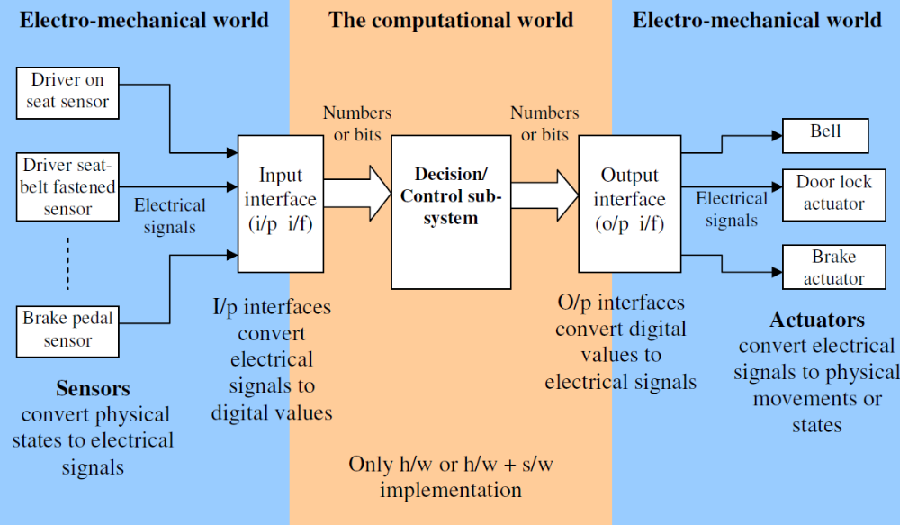

Available sensors -

Each hardware sensor provides a “high” (1) or “low” (0) output. The input interface sub-system sets the value of the corresponding global integer variable to the respective value. The decision/control logic sub-system will read this integer to take the right decision. It is assumed that this integer is available for C programming. The i/p i/f sub-system keeps monitoring the sensor hardware outputs and takes action (changes value of the integer variable) as soon as the sensor output state changes.

1. DOS – driver on seat. This sensor indicates whether a driver is present. This sensor provides logical “high” (1) as output when a person is sitting on the driver’s seat and “low” (0) if he is not on the seat.

2. DSBF – driver seat belt fastened. This sensor indicates whether the driver seat belt is fastened or not. The sensor hardware provides “high” when driver’s seat belt is fastened, “low” otherwise. The corresponding integer variable that reflects the physical states inside the computer and programming world is “driver_seat_belt_fastened”. The i/p i/f sub-system sets this integer to 1 when DSBF output is high and to 0 when DSBF is low, and the decision/control sub-system code reads/uses it.

3. ER – engine running. This sensor indicates whether engine is running or not. It provides “true” when engine is running, false otherwise. The corresponding integer variable to read and use is “engine_running”.

4. DC- doors closed. Indicates whether all doors are closed or not. The corresponding integer is “doors_closed”.

5. KIC – key in car. Indicates that the keys are still inside the key hole, the corresponding integer variable is “key_in_car”.

6. DLC – door lock lever. This indicates whether the door lock lever is closed or not. To close the electronic door locks the driver has to close this door lock lever. When the car’s computer finds that door lock lever is closed it checks all other variables to assess the situation and finally decides whether to activate the electronic door locks to lock the doors or not. For example if the car keys are still inside but the driver is not on seat (has gone out of car) then the doors should never be locked even though the driver has closed the door lock lever.

7. BP – brake pedal. This indicates that the brake pedal is pressed by the driver.

8. CM – car moving. This sensor indicates the car is moving and atleast one of its wheels is turning. The corresponding integer variable “car_moving” has value 1 when the car is moving, and has value 0 if the car is not moving.

Available actuators -

1. BELL - A beeper/chime that sounds/plays to alert the driver of any abnormal/hazardous situation. A global integer variable named “bell” is provided in the computer, if your code that implements the decision/control sub-system sets this variable to 1, then the output interface sub-system will read this value and turn the on the voltage on the electrical wire that feeds the beeper/chime. As a result the beeper/chime will start beeping. The beeper will stop when the decision/control subsystem code sets the value of “bell” to 0, because then the o/p i/f will turn down the electrical voltage feeding the beeper hence it will stop. The o/p i/f keeps on monitoring the integer variable and takes action (change the voltage) when the integer changes its value.

2. DLA – door lock actuator. This actuator locks the doors. A corresponding global integer variable named “door_lock” is provided in the computer, if you set this integer to 1 all the doors are locked, it unlocks all doors when you set the value of “door_lock” to 0.

3. BA – brake actuator. This actuator will actually activate the disk brakes in each of the four wheels if the global integer variable “brake” is set to 1. The brake will be released when this variable is set to 0 by the code that implements the decision/control logic sub-system.

Requirements -

1. The BELL should chime/sound when the driver starts the engine without fastening his seatbelt.

2. The BELL should sound when the driver starts the car without closing all the doors.

3. The BELL should be off as soon as the conditions change to normal.

4. The doors should not lock when the driver has got out of the car but the keys are still inside the engine, even though the driver has closed the door lock lever. Note: If the driver is on the seat and requests the doors to be locked, the doors must lock.

5. The brake should be engaged when the driver presses the brake pedal. Brakes should disengage when the brake pedal is released. The brake should engage only when the car is moving, when the car is stationary the brake should not unnecessarily engage to reduce mechanical wear and tear of the brake’s hydraulic system.

Activities to do -

a) For each requirement, separately provide the Boolean expressions that you decided to use.

b) Create a single combined truth table with all the available sensor inputs and actuator outputs for all the five requirements together. Some of the truth table entries will be don’t-care states (represented by an X) instead of true or false. For this sub-problem assume that these five requirements together constitute a complete system.

c) Write a C program using the Boolean logic concepts and tools learnt in class to materialize these five requirements. Use if-then-else structure to do this. Submit the C code and your executable. A basic code framework (file name “lab5.c”) for a general control system has been provided. This is available in the lab files that you downloaded. Use this code to learn how to develop C program for a real-life control system.
- Lab Device or Environment
Ubuntu 16.04 (64-bit) on virtual machine (VMware workstation 17 Pro)
- Results and Analysis
Analysis:
The truth table is as following:
DOS | DSBF | ER | DC | KIC | DLC | BP | CM | BELL | DLA | BA
 | 0 | 1 |  |  |  |  |  | 1
 |  | 1 | 0 |  |  |  |  | 1
 | 1 |  | 1 |  |  |  |  | 0
0 |  |  |  | 1 | X |  |  |  | 0
0 |  |  |  | 0 | 1 |  |  |  | 1
1 |  |  |  |  | 1 |  |  |  | 1
 |  |  |  |  |  | 1 | 1 |  |  | 1
 |  |  |  |  |  | X | 0 |  |  | 0
All blanks also represent X (don’t-care states).
For requirement 1, 2 and 3, we use the Boolean expression ER && ( !DSBF || !DC ). For requirement 4, we use the Boolean expression DLC && ( DOS || !KIC ). For requirement 5, we use the Boolean expression BP && CM.
Results:
Test Input:
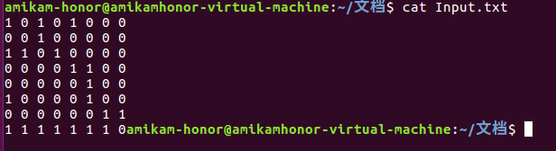
Test Output:
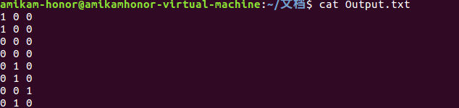
- Appendix (Program Code and Snapshot)
- /*
- This program sounds the bell when driver is on seat AND haven't closed the doors. Use the general framework and the function shells, replace the code inside the control_action() function with your own code.

- Note: This code is designed to run in an infinite loop to mimic a real control system.
- If you prefer to read the inputs from a file, modify the code appropriately to terminate the loop when all the inputs have been processed.

- run this file as : gcc filename.c -o executableName

- */

- #include <stdio.h> //This is useful to do i/o to test the code
- #include <stdlib.h> // This is useful to use exit() function

- // sensors
- unsigned int driver_on_seat;
- unsigned int driver_seat_belt_fastened;
- unsigned int engine_running;
- unsigned int doors_closed;
- unsigned int key_in_car;
- unsigned int door_lock_lever;
- unsigned int brake_pedal;
- unsigned int car_moving;

- // actuators
- unsigned int bell;
- unsigned int door_lock_actuator;
- unsigned int brake_actuator;

- // operators to control file
- FILE *input = NULL;
- FILE *output = NULL;
- int IsEOF = 0;

- void read_inputs_from_ip_if(){

- //open the file storing state of sensors at beginning for first reading
- if (!input){
- input = fopen("./Input.txt", "r");
- }

- //mark if EOF and close input file
- if (fscanf(input, "%u", &driver_on_seat) == EOF){
- IsEOF = 1;
- fclose(input);
- return;
- }
- // to read the current state of the available sensors
- fscanf(input, "%u", &driver_seat_belt_fastened);
- fscanf(input, "%u", &engine_running);
- fscanf(input, "%u", &doors_closed);
- fscanf(input, "%u", &key_in_car);
- fscanf(input, "%u", &door_lock_lever);
- fscanf(input, "%u", &brake_pedal);
- fscanf(input, "%u", &car_moving);

- return;
- }

- void write_output_to_op_if(){

- //exit if the input file reached EOF
- if (IsEOF){
- fclose(output);
- exit(0);
- }

- if (!output){
- output = fopen("./Output.txt", "w");
- }

- //to display/print the state of the 3 actuators (DLA/BELL/BA)
- fprintf(output, "%u ", bell);
- fprintf(output, "%u ", door_lock_actuator);
- fprintf(output, "%u\n", brake_actuator);

- return;
- }

- //The code segment which implements the decision logic
- void control_action(){

- /*
- The code given here sounds the bell when driver is on seat
- AND hasn't closed the doors. (Requirement-2)
- Replace this code segment with your own code.
- */

- //control bell
- if (engine_running && (!driver_seat_belt_fastened || !doors_closed))
- {
- bell = 1;
- }
- else
- {
- bell = 0;
- }

- //control door lock actuator
- if (door_lock_lever && (driver_on_seat || !key_in_car))
- {
- door_lock_actuator = 1;
- }
- else
- {
- door_lock_actuator = 0;
- }

- //control brake actuator
- if (brake_pedal && car_moving)
- {
- brake_actuator = 1;
- }
- else
- {
- brake_actuator = 0;
- }

- }

- /* --- You should not have to modify anything below this line ---------*/

- int main(int argc, char *argv[])
- {

- /*The main control loop which keeps the system alive and responsive forever,
- until the system is powered off */
- for (; ; )
- {
- read_inputs_from_ip_if();
- control_action();
- write_output_to_op_if();
- }

- return 0;
- }

