

Undergraduate Lab Report

Course Title: Experiment of Computer Organization
Course No: 60080014
Student Name: 李荣耀
Student No: 2024103975
School: International School
Department:
Major: CST
Instructor： SUN Heng

Academic Year:2025~2026, Semester : 1st [√ ] 2nd[ ]

Academic Affairs Office of Jinan University
Date (dd/mm/yyyy) 2025/11/19
Computer Organization Lab List
Student Name: Li Rongyao Student No: 2024103975

ID | Lab Name | Type
1 | Number Storage Lab | Individual
2 | Manipulating Bits | Individual
3 | A Simple Real-life Control System Lab | Team
4 | System I/O | Individual
5 | Simulating Y86-64 Program | Individual
6 | Performance Lab | Team
Undergraduate Lab Report of Jinan University
Course Title Experiment of computer organization Evaluation
Lab Name System I/O
Instructor Sun Heng
Lab Address Room 116
Student Name Li Rongyao
Student No 2024103975
College International School
Department Major CST
Date 2025/11/19 Afternoon
- Introduction

The purpose of this lab is to become more familiar with the Unix-I/O by modifying the file to handle different problems of Unix-I/O.
- Lab Instructions or Steps

The C programs are provided. These codes are available from the lab materials. Related concepts can be found in the file 04.ppt of our theoretical course.

Activities to do-

a) Modify the cpfile program so that it uses the Rio unbuffered functions Rio_readn and Rio_writen to copy standard input to standard output, 10 bytes at a time. Use $ make to compile, and then use $ ./main.out to run. Remember to use & make again after modifying cpfile.c;
b) Modify the original cpfile program so that it takes an optional command line argument infile, such as: $ ./main.out infile.txt; If infile is given, then copy infile to standard output; otherwise, copy standard input (STDIN_FILENO) to standard output as before. The twist is that your program must use the original copy loop (lines 13–15) for both cases. You are only allowed to insert code, and you are not allowed to change any of the existing code.
- Lab Device or Environment
Ubuntu 16.04 (64-bit) on virtual machine (VMware workstation 17 Pro)
- Results and Analysis
Activity a):
Results:
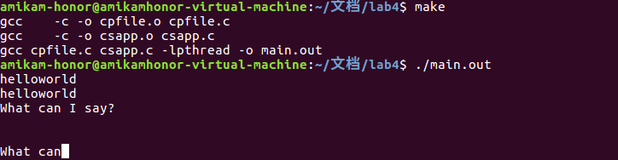
Analysis:
First, we know the prototype of Rio_readn and Rio_writen are:
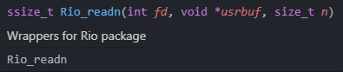
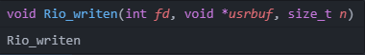
fd is the descriptor of file, usrbuf is the pointer at the buffer of users, and n is the size of read or write. It performs the ability to read data directly from file without buffer.
So, to modify cpfile, we need to modify the read function as Rio_readn and let size equals to 10 as the argument of the function.
In my example, the first line have 11 bytes “helloworld\n”, then the output is “helloworld” as 10 bytes at a time. Then my input is “\nWhat can I say?\n”, the program continue to output the rest byte in the standard input and then read more bytes until 10 bytes. Thus the second output is “\n\nWhat can”. That verifies the correctness of my program.
Activity b):
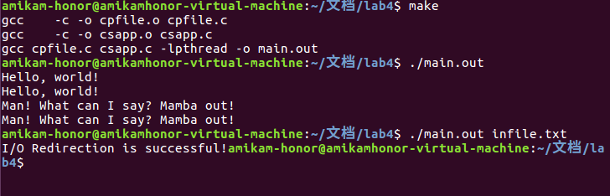
Analysis:
We need to handle the situation that the command line containing the infile.txt, which is the second element of argv. So we need a condition judgment to handle this situation.
First, we need to open the infile.txt by open and get a file descriptor. Then handle the error situation. The core operation is to use dup2 to let the STDIN_FILENO points at the same destination of fd, which points at infile.txt, then we can use the same loop to perform that copy the infile.txt to standard output. Remember to use close free the file descriptor of fd.
We can also re-initialize the buffer rio by Rio_readinitb to the infile.txt. But it not matches the idea of redirection. So we use dup2 rather than re-initialize.
In my example, first just test main.out in command line. The output is the same as before from the standard input. Then takes the input infile.txt, the output is correct.
- Appendix (Program Code)
cpfile_1.c (for activity a)
/* All of rio function implementations are obtained from csapp.c */
/* Please note the usage of wrapper function */

/* $begin cpfile */
#include "csapp.h"

int main(int argc, char **argv)
{
int n;
int size = 10;
char buf[MAXLINE];

while((n = Rio_readn(STDIN_FILENO, buf, size)) != 0)
Rio_writen(STDOUT_FILENO, buf, n);
exit(0);
}
/* $end cpfile */

cpfile_2.c (for activity b)
/* All of rio function implementations are obtained from csapp.c */
/* Please note the usage of wrapper function */

/* $begin cpfile */
#include "csapp.h"

int main(int argc, char **argv)
{
int n;
rio_t rio;
char buf[MAXLINE];

Rio_readinitb(&rio, STDIN_FILENO);

if (argc == 2)
{
int fd = open(argv[1], O_RDONLY);
if (fd == -1){
exit(0);
}
Dup2(fd, STDIN_FILENO);
close(fd);
}

while ((n = Rio_readlineb(&rio, buf, MAXLINE)) != 0)
Rio_writen(STDOUT_FILENO, buf, n);

exit(0);
}
/* $end cpfile */

