

Undergraduate Lab Report

Course Title: Experiment of Computer Organization
Course No: 60080014
Student Name: 李荣耀
Student No: 2024103975
School: International School
Department:
Major: CST
Instructor： SUN Heng

Academic Year:2025~2026, Semester : 1st [√ ] 2nd[ ]

Academic Affairs Office of Jinan University
Date (dd/mm/yyyy) 2025/12/3
Computer Organization Lab List
Student Name: Li Rongyao Student No: 2024103975

ID | Lab Name | Type
1 | Number Storage Lab | Individual
2 | Manipulating Bits | Individual
3 | A Simple Real-life Control System Lab | Team
4 | System I/O | Individual
5 | Simulating Y86-64 Program | Individual
6 | Performance Lab | Team
Undergraduate Lab Report of Jinan University
Course Title Experiment of computer organization Evaluation
Lab Name Simulating Y86-64 Program
Instructor Sun Heng
Lab Address Room 116
Student Name Li Rongyao
Student No 2024103975
College International School
Department Major CST
Date 2025/12/3 Afternoon
- Introduction
- To learn about the implementation of a Y86-64 processor.
- To have a keen appreciation for the interactions between instruction and hardware that affect the programs.
- To run two simple Y86-64 programs and become familiar with the Y86-64 tools.
- Lab Instructions or Steps
- Find Sources List:
Make sure the link in sources.list match your ubuntu version:
For Ubuntu 16.04 xenial:
模板:16.04source - Ubuntu中文
- Backup: sources.list.bak
# sudo cp /etc/apt/sources.list /etc/apt/sources.list.bak
- Modify: Rewrite sources.list using source from the website.
# sudo gedit /etc/apt/sources.list
- Update:
# sudo apt-get update (upgrade / -f install)
# sudo apt-get install flex bison
For Ubuntu16.04:
# sudo apt-get install tcl8.5 tcl8.5-dev tk8.5 tk8.5-dev
For Ubuntu16.04:
In sim and seq directory, find Makefile, and modify it:
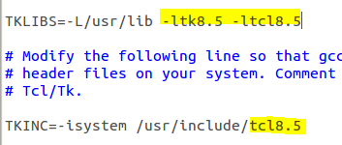
- Start by copying this lab to a directory in which you plan to do your work.
- Unpacked the file using:
# tar xvf sim.tar (Or just double click and choose extract)
The directory sim contains the following subdirectories:
misc Source code files for utilities such as YAS (the Y86-64 assembler), and YIS (the Y86-64 instruction set simulator). It also contains the isa.c source file that is used by all of the processor simulators.
y86-code Y86-64 assembly code for many of the example programs. As a running example, we will use the program asum.ys in this subdirectory. The compiled version of the program is shown in Figure 1.
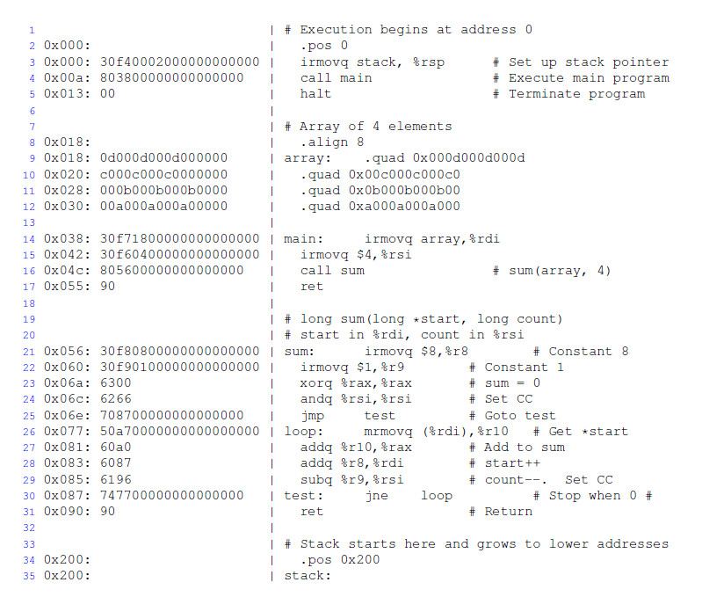
Figure 1 Sample object code file. This code is in the file asum.yo in the y86-code subdirectory.
- Change to the sim directory and build the Y86-64 tools:
# make clean
# make
- For the Y86-64processor, the simulator can be run in TTY or GUI mode:
TTY mode Uses a minimalist, terminal-oriented interface. Prints everything on the terminal output. Not very convenient for debugging but can be installed on any system and can be used for automated testing. The default mode for all simulators.
GUI mode Has a graphic user interface, to be described shortly. Very helpful for visualizing the processor activity and for debugging modified versions of the design. Requires installation of Tcl/Tk on your system. Invoked with the -g command line option. Running in GUI mode is only possible from within the directory (seq) in which the executable simulator program is located.
Several options from the command line:
-h Prints a summary of all of the command line options.
-g Run the simulator in GUI mode (the default is TTY mode).
-t (TTY mode only) Runs both the processor and the ISA simulators, comparing the resulting values of the memory, register file, and condition codes. If no discrepancies are found, it prints the message ‘ISA Check Succeeds.’ Otherwise, it prints information about the words of the register file or memory that differ.
-l m (TTY mode only) Sets the instruction limit, executing at most m instructions before halting (the default limit is 10000 instructions).
-v n (TTY mode only) Sets the verbosity level to n, which must be between 0 and 2 with a default value of 2.
If running in GUI mode, It need to install Tcl/Tk alongwith the Tcl and Tk developer's packages.
(5) In seq directory, use following command to open GUI:
# make clean
# make ssim VERSION=std
# ./ssim -g ../y86-code/asum.yo
This code runs SSIM in GUI mode, executing the instructions in object code file asum.yo from the y86-code subdirectory.
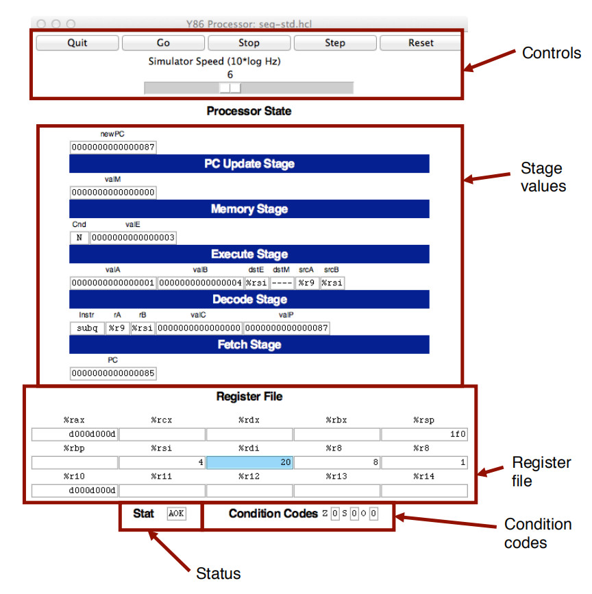
Figure 2 Main control panel for SEQ simulator
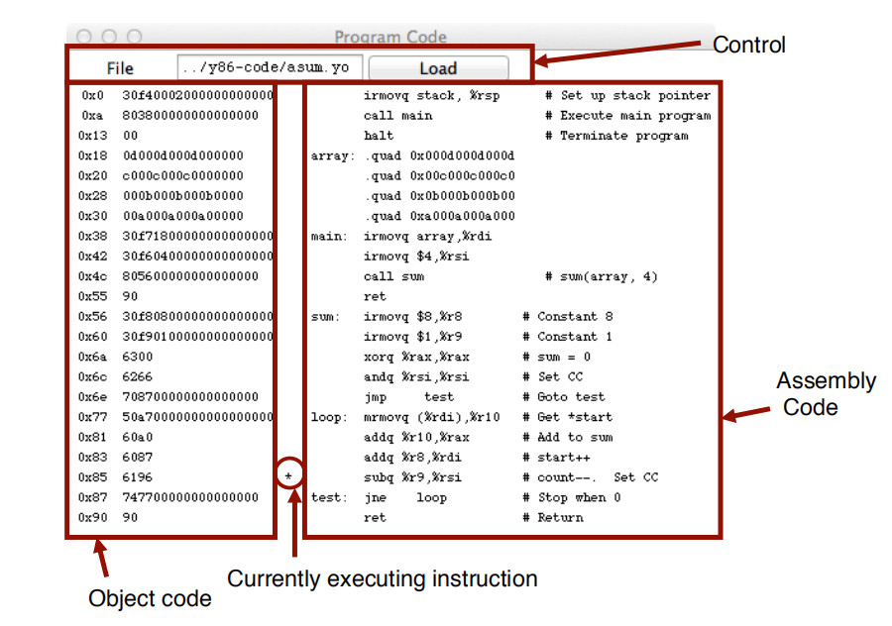
Figure 3 Code display window for SEQ simulator

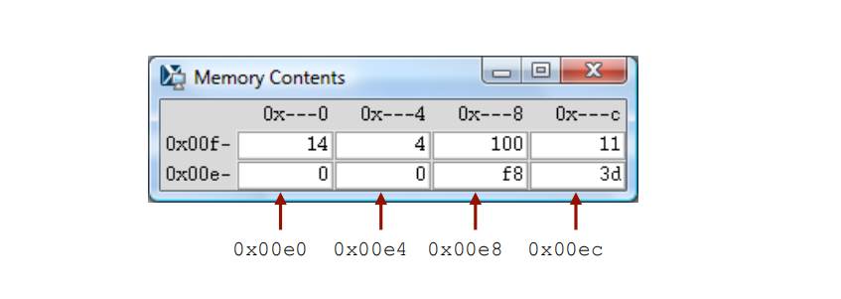
Figure 4 Memory display window for SEQ simulator
The main control window (Figure 2) contains buttons to control the simulator as well as status information about the state of the processor. The different parts of the window are labeled in the figure:
Control: The buttons along the top control the simulator. Clicking the Quit button causes the simulator to exit. Clicking the Go button causes the simulator to start running. Clicking the Stop button causes the simulator to stop temporarily. Clicking the Step button causes the simulator to execute one instruction and then stop. Clicking the Reset button causes the simulator to return to its initial state.
The slider below the buttons controls the speed of the simulator when it is running. Moving it to the right makes the simulator run faster.
Stage values: This part of the display shows the values of the different processor signals during the current instruction evaluation. The main difference is that the simulator displays the name of the instruction in a field labeled Instr, rather than the numeric values of icode and ifun. Similarly, all register identifiers are shown using their names, rather than their numeric values, with “----” indicating that no register access is required.
Register file: This section displays the values of the 15 program registers. The register that has been updated most recently is shown highlighted in light blue. Register contents are not displayed until after the first time they are set to non-zero values.
Remember that when an instruction writes to a program register, the register file is not updated until the beginning of the next clock cycle. This means that you must step the simulator one more time to see the update take place.
Stat: This shows the status of the current instruction being executed. The possible values are:
AOK: No problem encountered.
ADR: An addressing error has occurred either trying to read an instruction or trying to read or write data. Addresses cannot exceed 0x0FFF.
INS: An illegal instruction was encountered.
HLT: A halt instruction was encountered.
Condition codes: These show the values of the three condition codes: ZF, SF, and OF.
Remember that when an instruction changes the condition codes, the condition code register is not updated until the beginning of the next clock cycle. This means that you must step the simulator one more time to see the update take place.
Example:
The processor state illustrated in Figure 2 is for the first execution of line 29 of the asum.yo program shown in Figure 1. We can see that the program counter is at 0x085, that it has processed the instruction addq %r8, %rdi, that register %rax holds 0xd000d000d, the sum of the first array element, and %rsi holds 4, the count that is about to be decremented. Register %rdi holds 0x020, the address of these cond array element. There is a pending write of 0x03 to register %rsi (since dstE is set to %rsi and valE is set to 0x03). This write will take place at the start of the next clock cycle.
The window depicted in Figure 3 shows the object code file that is being executed by the simulator. The editbox identifies the file name of the program being executed. You can edit the file name in this window and click the Load button to load a new program. The left hand side of the display shows the object code being executed, while the right hand side shows the text from the assembly code file. The center has an asterisk(*) to indicate which instruction is currently being simulated. This corresponds to line 29 of the asum.yo program shown in Figure 1.
The window shown in Figure 4 shows the contents of the memory. It shows only those locations between the minimum and maximum addresses that have changed since the program began executing. Each row shows the contents of two memory words. Thus, each row shows 16 bytes of the memory, where the addresses of the bytes differ in only their least significant hexadecimal digits. To the left of the memory values is the“root” address, where the least significant digit is shown as “-”. Each column then corresponds to words with least significant address digits 0x0, and 0x8. The example shown in Figure 4 has arrows indicating memory locations 0x01f0 and 0x01f8.
The memory contents illustrated in the figure show the stack contents of the asum.yo program shown in Figure 1 during the execution of the sum procedure. Looking at the stack operations that have taken place so far, we see that %rsp was initialized to 0x200 (line 3). The call to main on line 4 pushes the return pointer 0x013, which is written to address 0x01f8. Procedure main calls sum (line 16), causing the return pointer 0x055 to be written to address 0x01f0. That accounts for all of the words shown in this memory display, and for the stack pointer being set to 0x01f0.
(6) The work should be done in directory sim/misc in this part. The task is to simulate the following two Y86-64 programs. The required behavior of these programs is defined by the example C functions in sim\misc\examples.c.
(6.1) sum.ys: Iteratively sum linked list elements
Simulate a Y86-64 program sum.ys that iteratively sums the elements of a linked list. It consists of some code that sets up the stack structure, invokes a function, and then halts. In this case, the function should be Y86-64 code for a function (sum list) that is functionally equivalent to the C sum list function in Figure 1.
(6.2) rsum.ys: Recursively sum linked list elements
Simulate a Y86-64 program rsum.ys that recursively sums the elements of a linked list. It is similar to the code in sum.ys, except that it uses a function rsum list that recursively sums a list of numbers.
(7) Testing the program. The Y86-64 assembler takes a Y86-64 assembly code file with extension .ys and generates a file with extension .yo. Put rsum.ys and sum.ys into misc directory. Use command:
# make sum.yo
# make rsum.yo
And then run the program in seq directory using:
# ./ssim -g ../misc/sum.yo
# ./ssim -g ../misc/rsum.yo
(8) For the programs sum.ys and rsum.ys, the result will be shown in register %rax with the sum of 0xcba.
(9) Explain the function and processor state of each step in the source file of sum.ys and rsum.ys according to your snapshot.

- Lab Device or Environment
Ubuntu 16.04 (64-bit) on virtual machine (VMware workstation 17 Pro).
- Results and Analysis
- Preparation
The modified sources.list (from website in section 3) and its backups are as following:
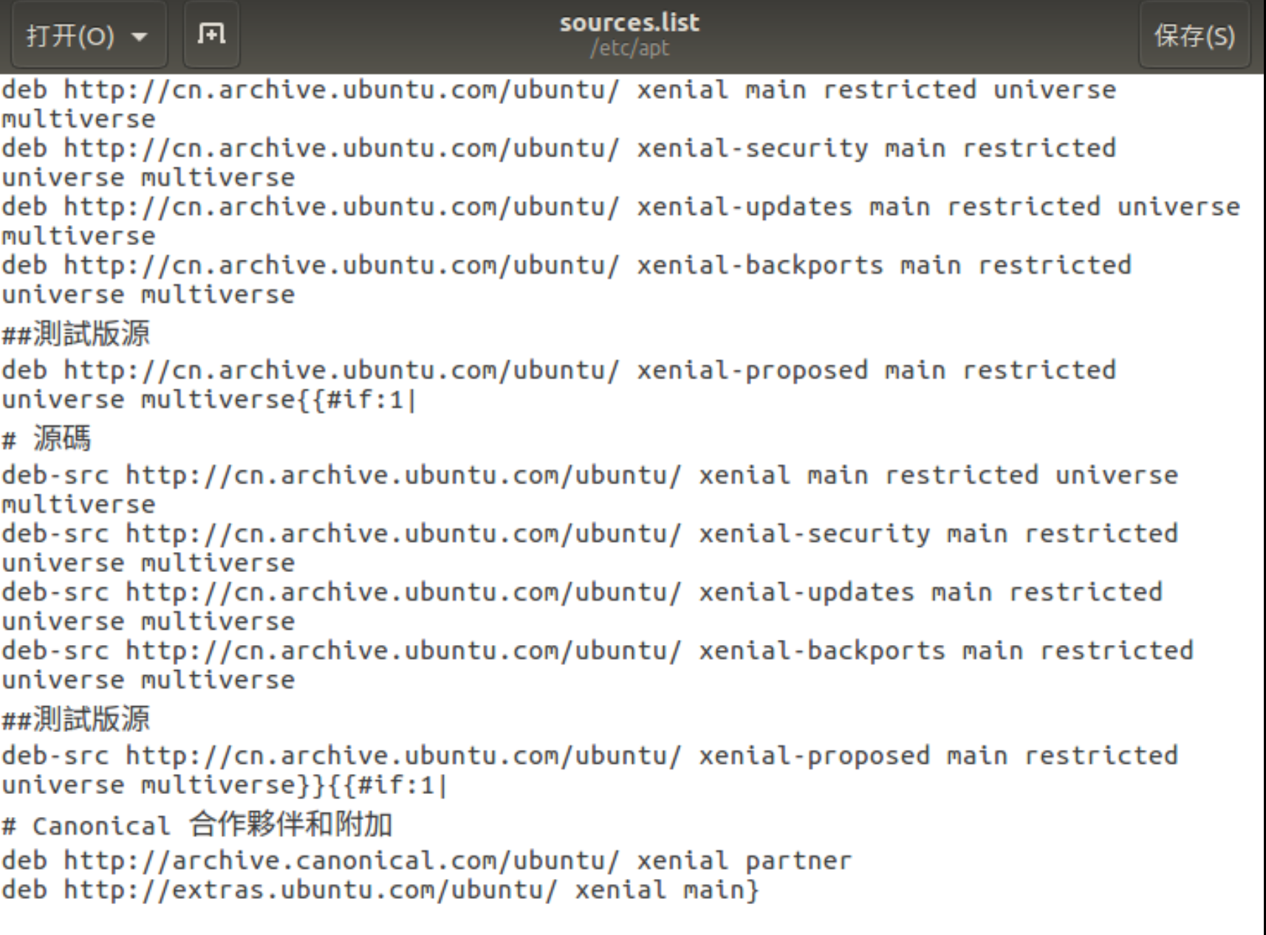
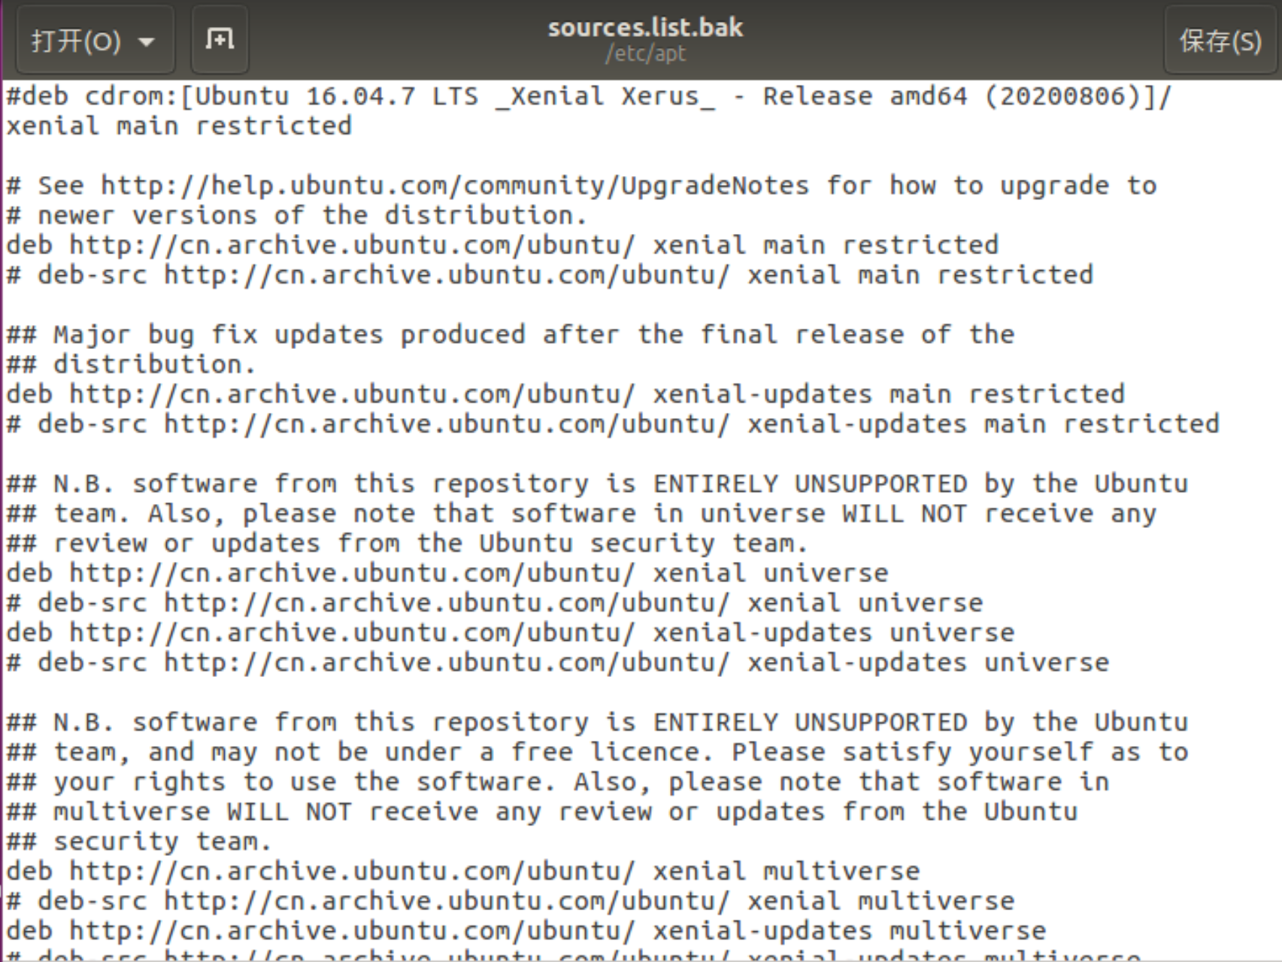
Installation of corresponding tools:
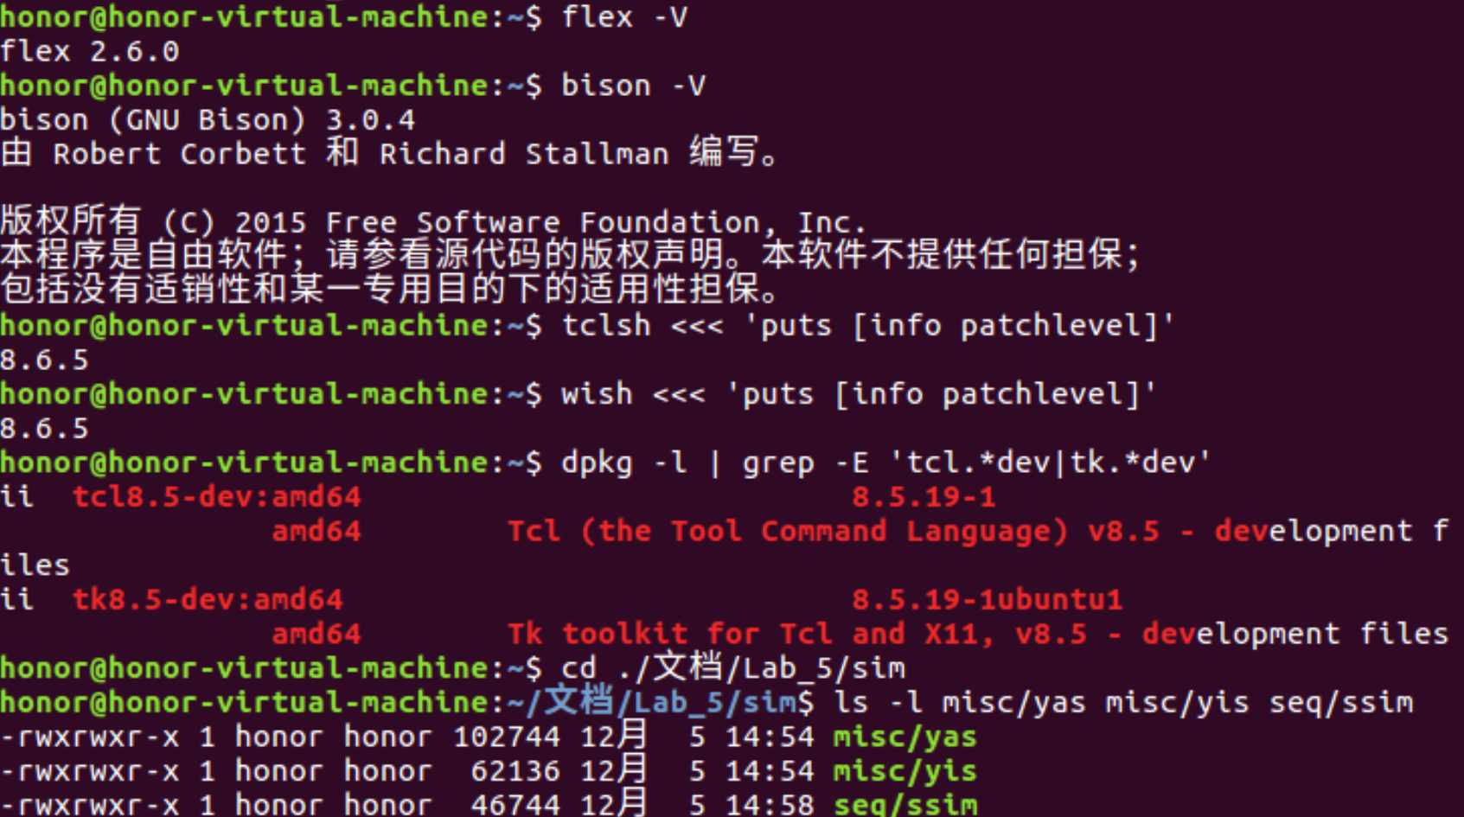
Modification of Makefile in sim and seq:
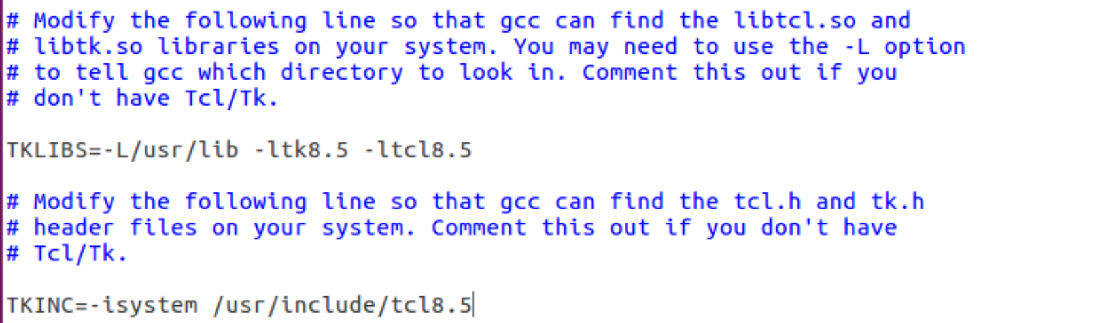
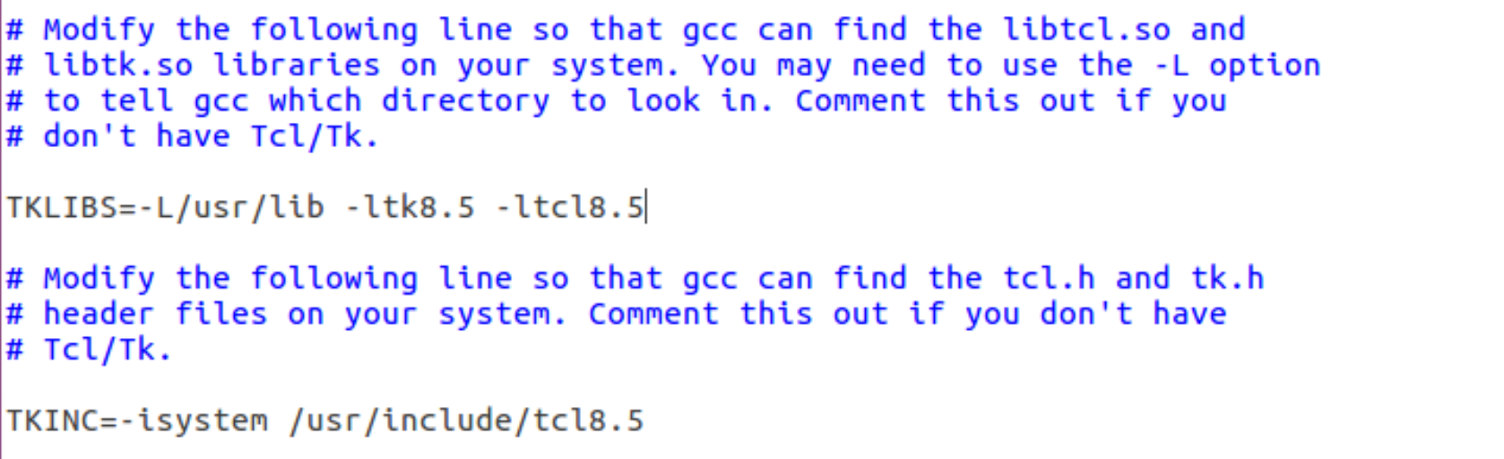
- Building of Y86-64 Tools
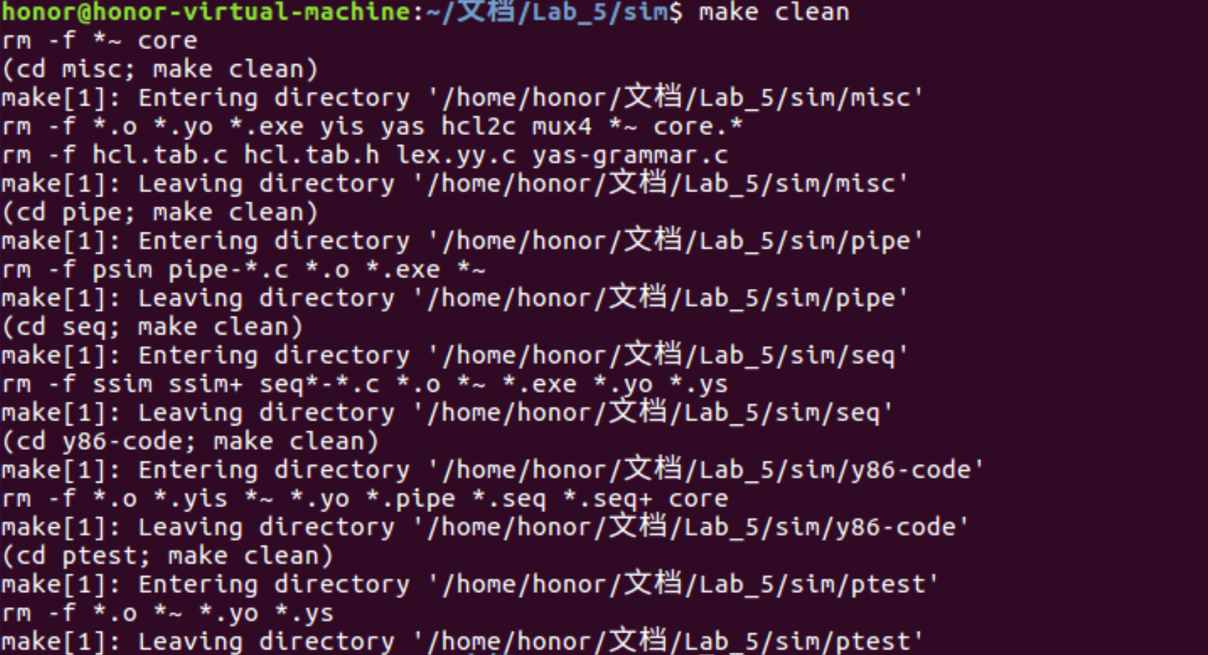
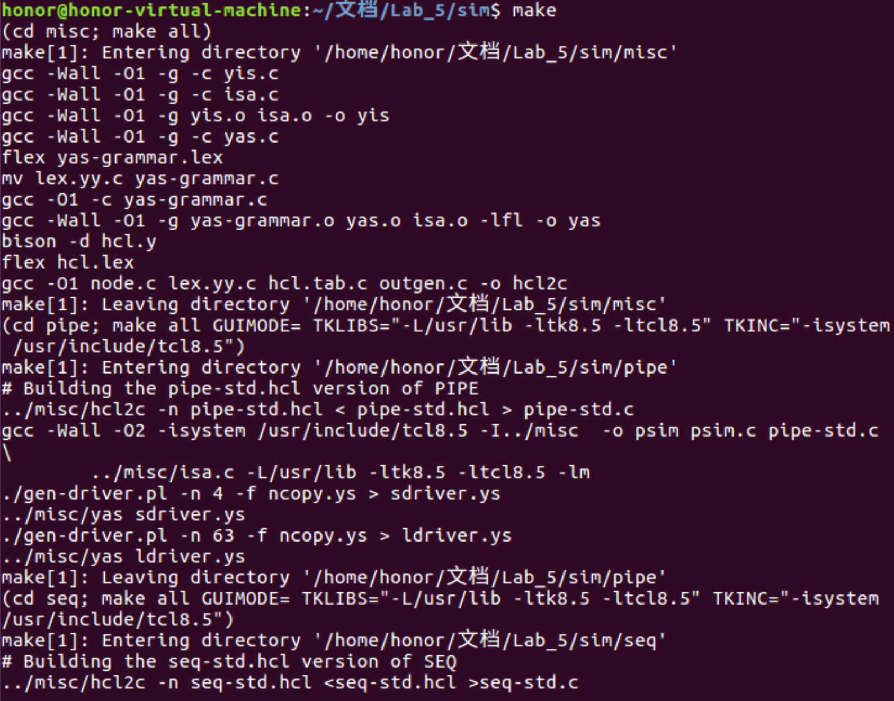
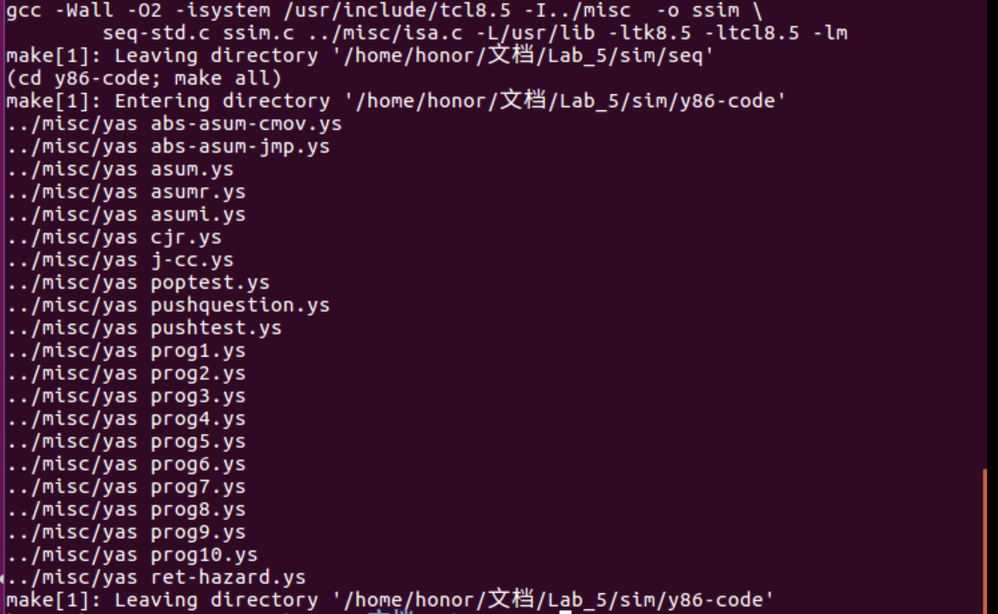
- Explanation of sum.yo
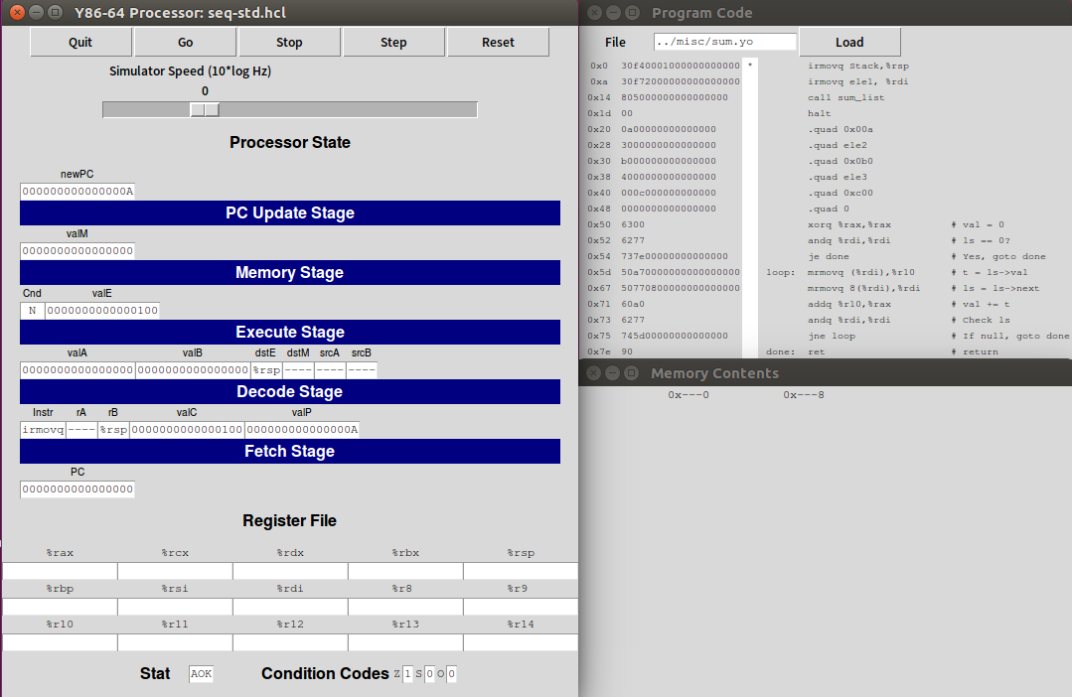
Initially, the command irmovq Stack,%rsp stores the immediate number Stack into the stack pointer %rsp. Then the stack pointer points to 0x100.
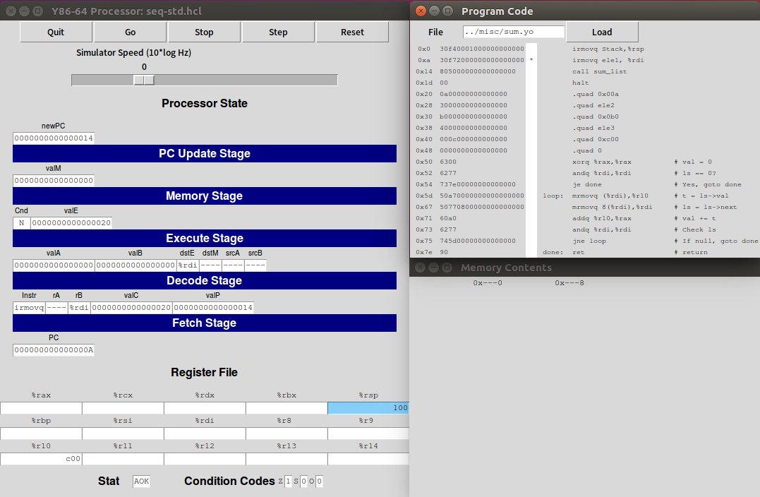
Then, irmovq ele1 %rdi stores the immediate number, the address of the first node, ele1 into the register %rdi.
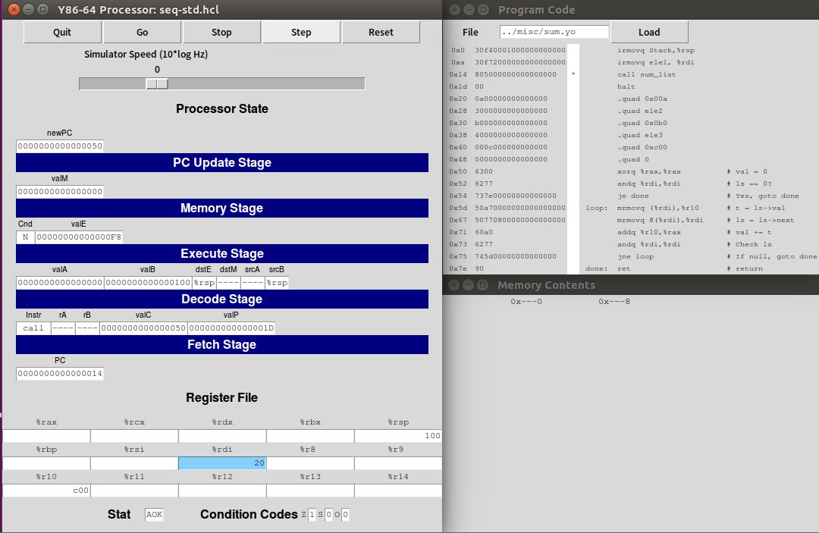
call sum_list calles the function sum, and store the data of linked list nodes including address and corresponding values by commands .quad. Each command increases the PC by 1 byte. And %rsp decreases by 1 byte to store the address 0x1d to return and points to the entry of the function. Here the compiler optimizes the process of leaf function sum_list so that there is no more operations related to stack.
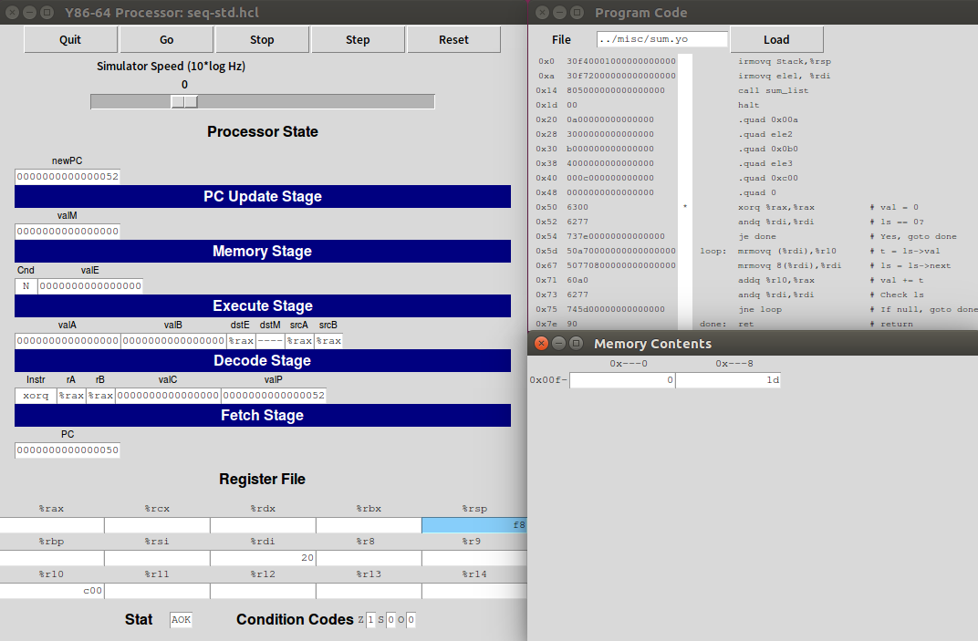
The command xorq %rax %rax initialize the local variable val stored in %rax to 0.
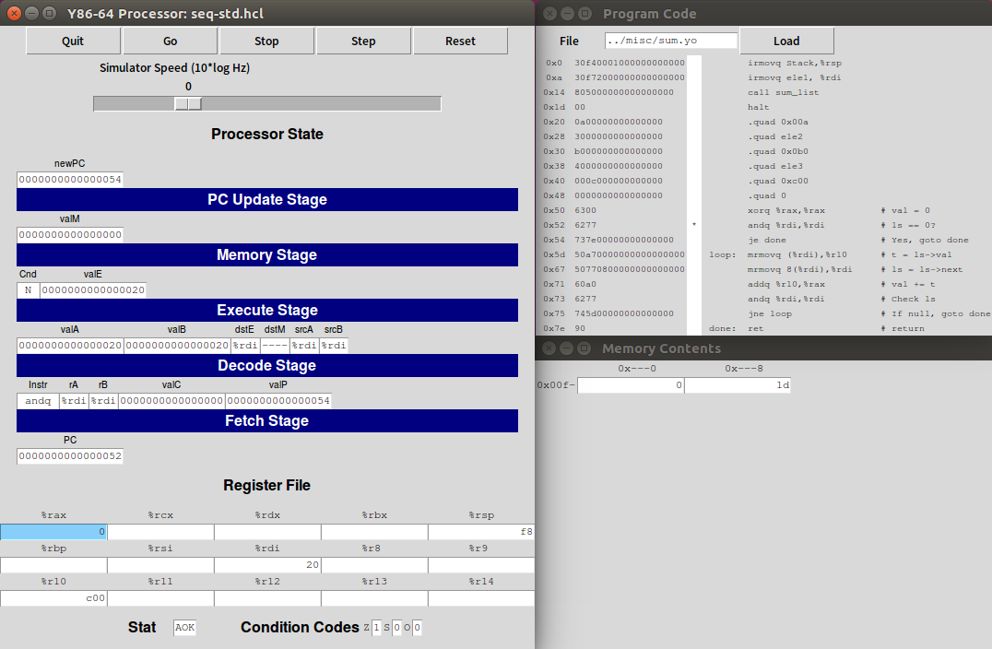
The command andq %rdi %rdi judges whether ele1, or ls, the address of the first node, is zero and correspondingly adjust the condition codes ZF. Here it is not NULL thus ZF is zero.
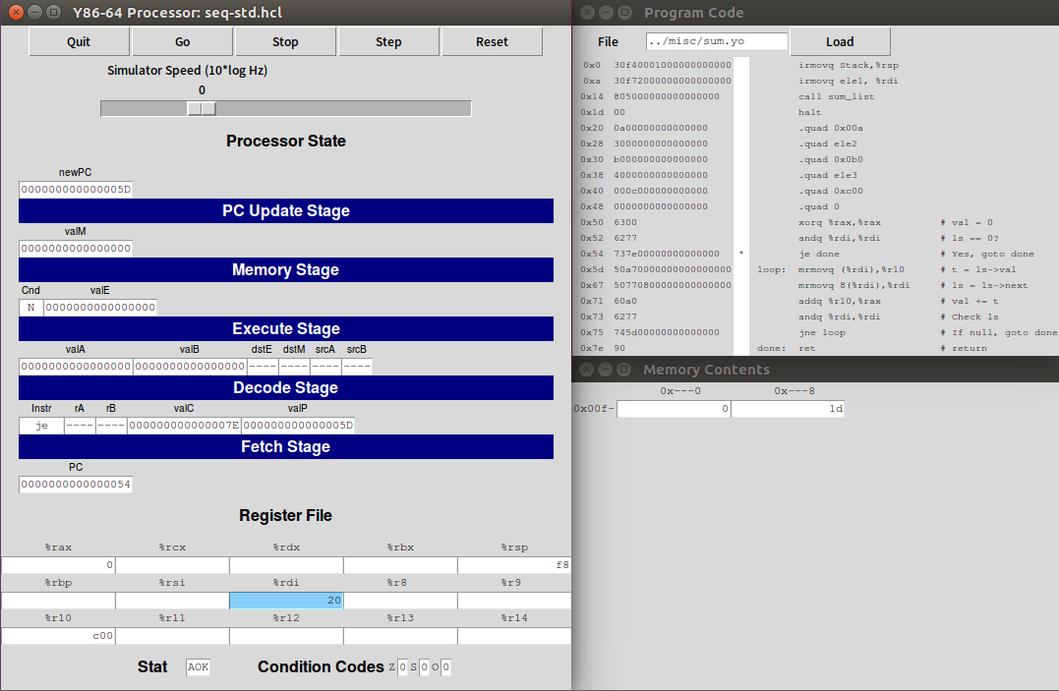
je done operates jumps to the operation done if the condition code ZF is 1. Here it is zero thus it does not jump.
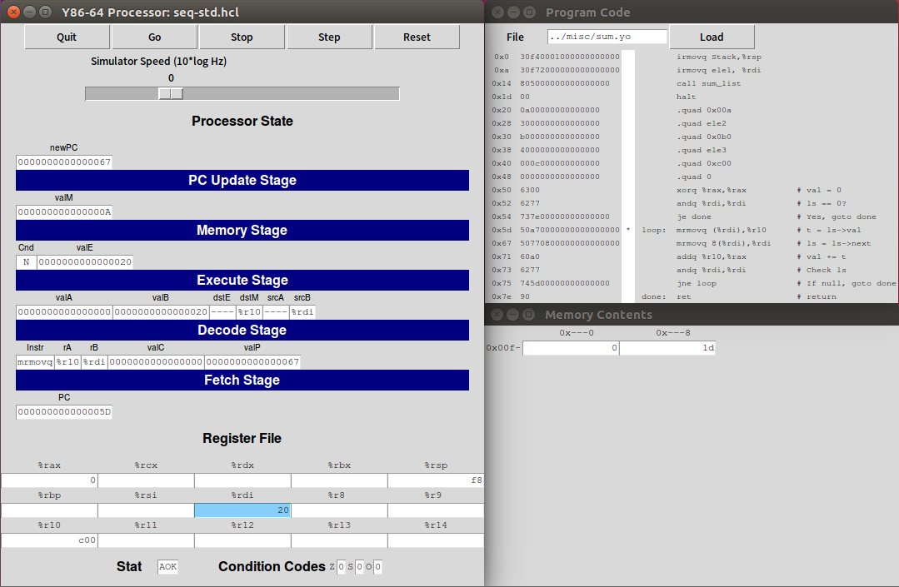
The first command in loop moves the value (%rdi), the value of ele1 stored in memory into register %r10.
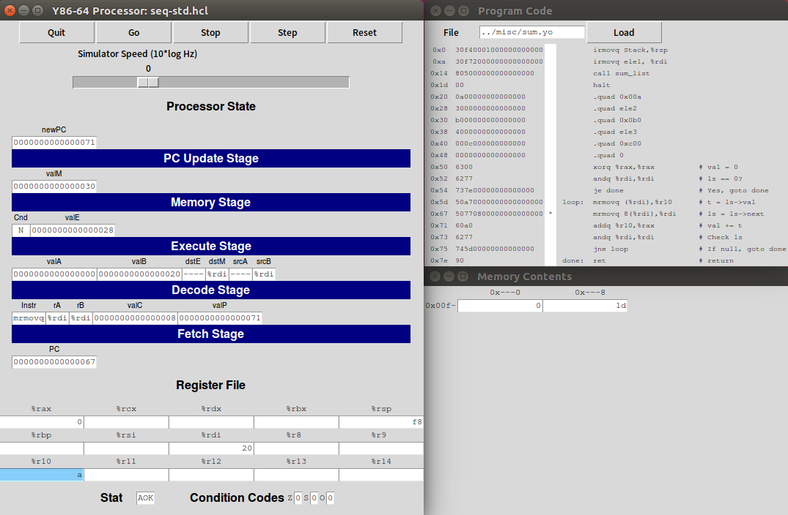
The next command moves the value Mem[reg[%rdi]+8] into the register %rbi, that is, move the address of next node, ele2 into %rbi, ls.
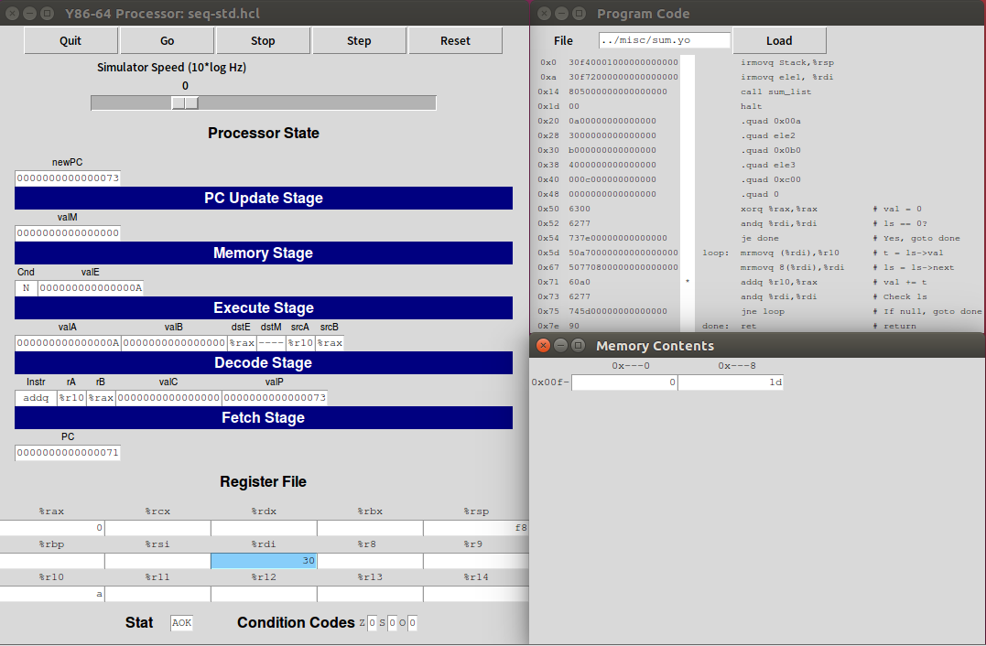
Then the add command add the value in %r10 and the value in %rax, that is the value of ele1 and val, and store the value after addition into %rax, that is to renew the value of val.
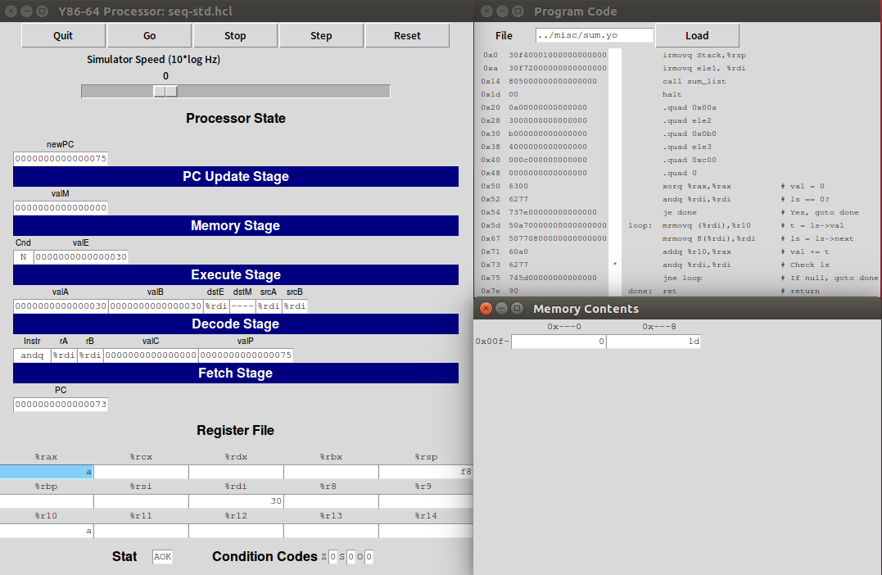
The next command check whether ls is NULL again and to set the condition code ZF. Here ele2 is not NULL thus ZF is 0.
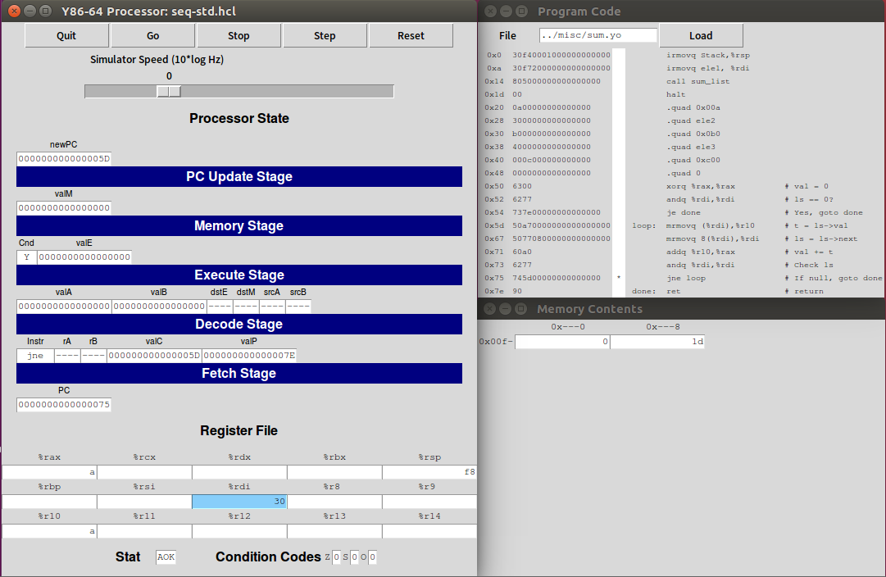
jne loop jumps to loop if the condition code ZF is 0. Here ZF is zero thus the loop continues. After one loop val equals to a.
The loop of handling ele2 and ele3 is similar thus omiting the process of ele2 and ele3 is omitted.
When the third loop will end, that is, the next of ele3 is NULL, the andq sets ZF as 1. Then the jne loop are done and return the value. The stack pointer points to 0x100 again. Then execute halt ends the programme.
The result val is stored in %rax as 0xcba, consistent with expected result.
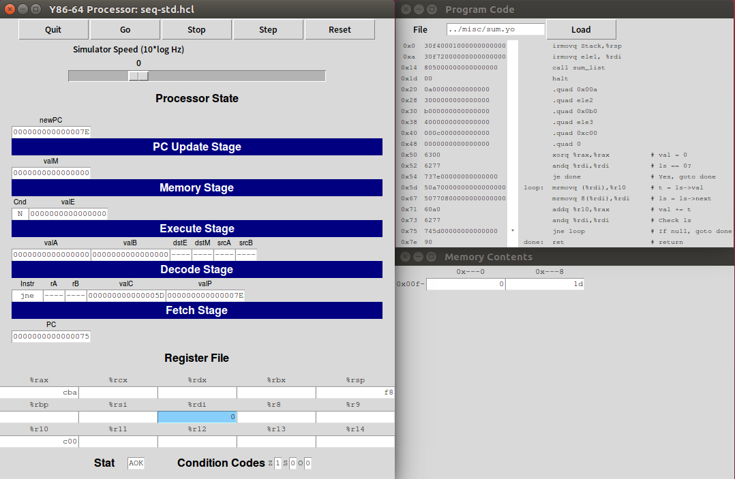
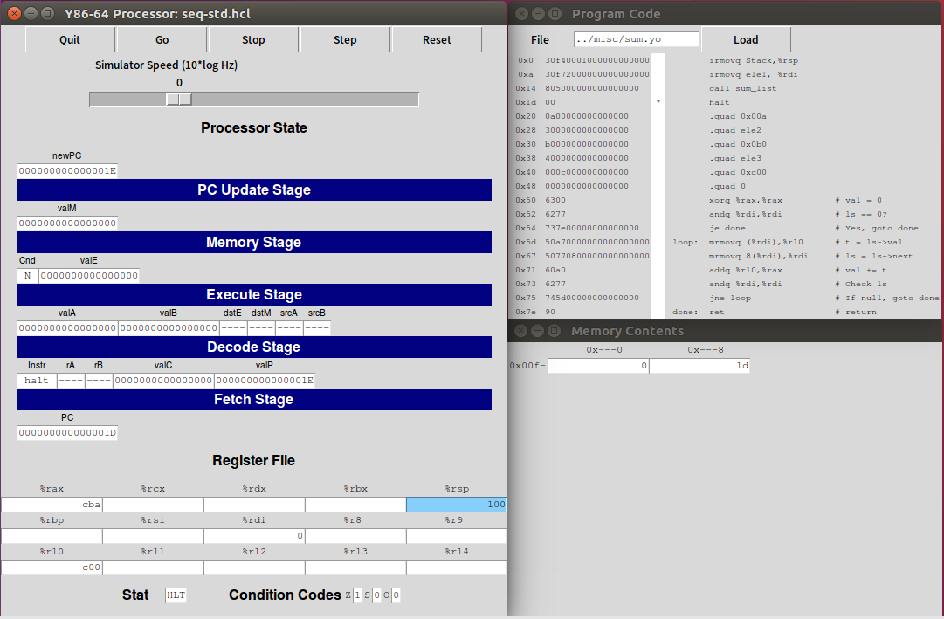
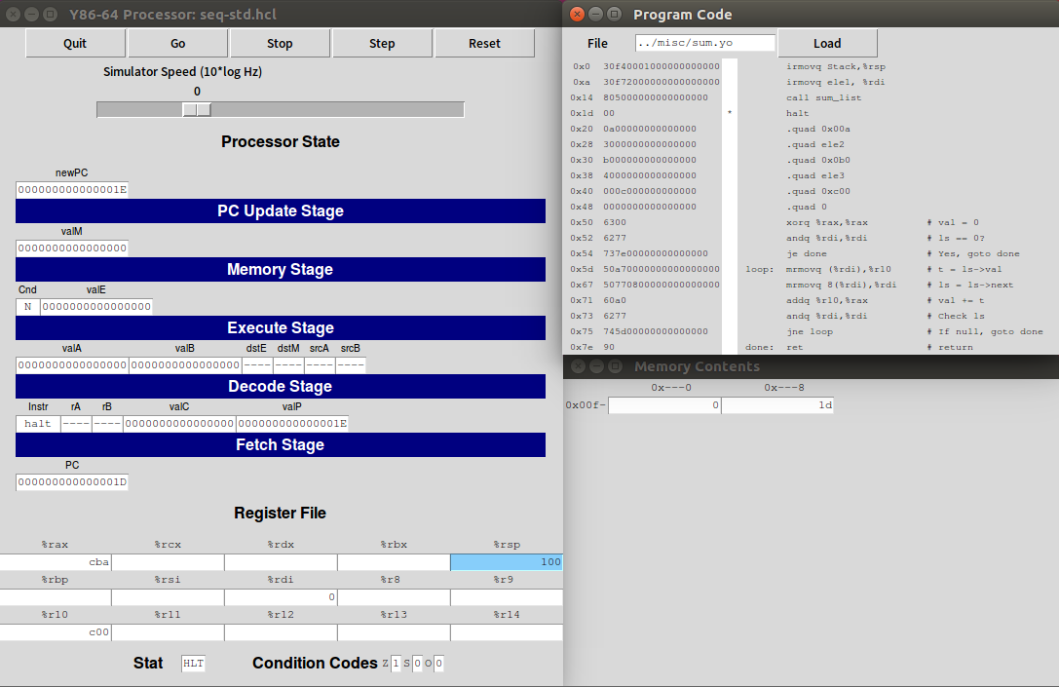
- Explanation of rsum.yo
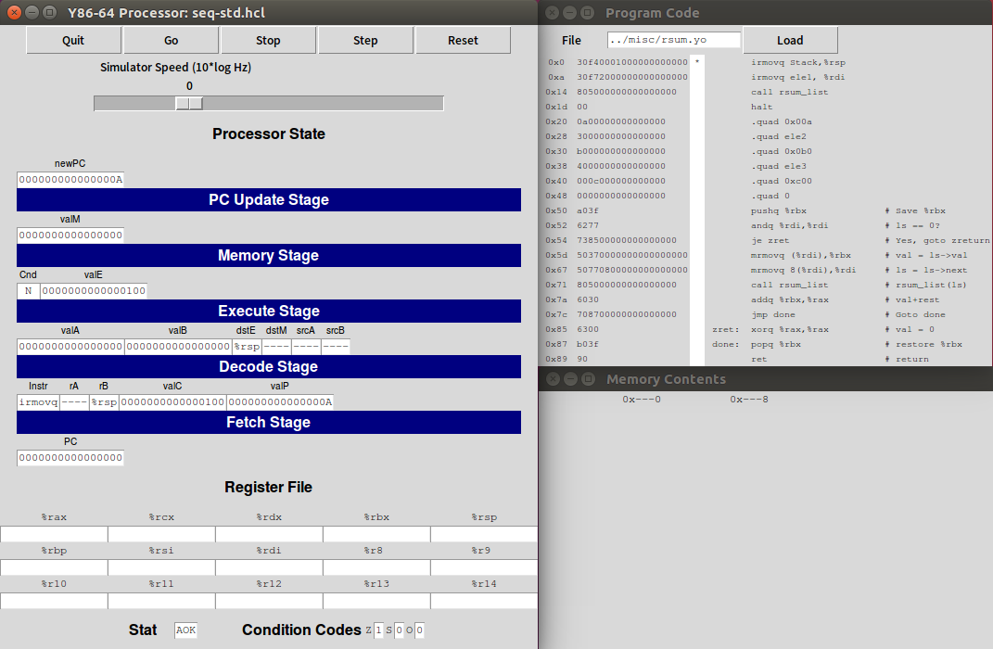
Similar to sum.yo, initially the command irmovq Stack,%rsp stores the immediate number Stack into the stack pointer %rsp. Then the stack pointer points to 0x100. Then, irmovq ele1 %rdi stores the immediate number, the address of the first node, ele1 into the register %rdi.
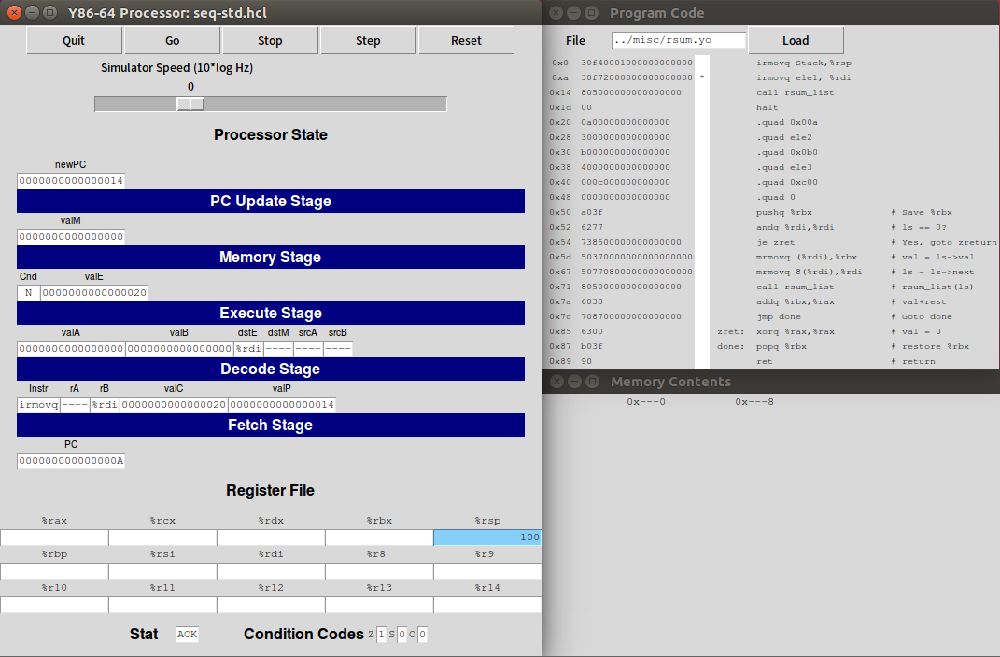
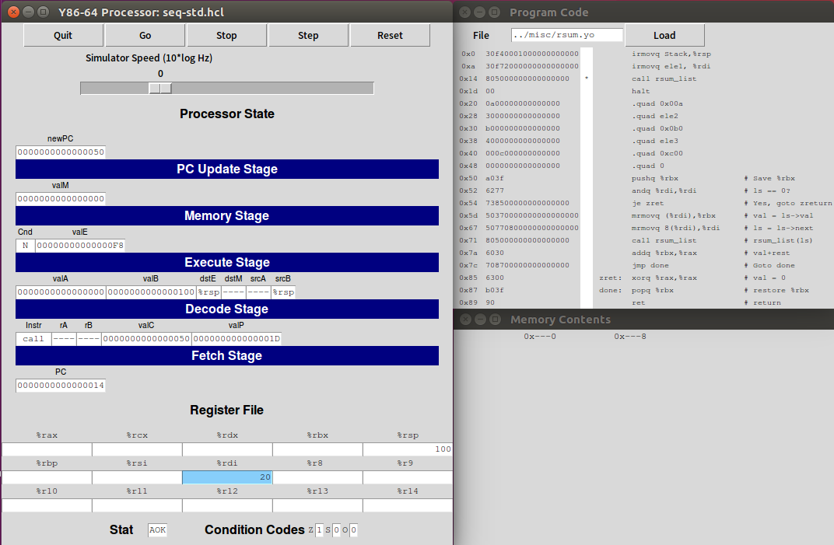
When calling the function rsum_list, the data of linked list nodes including address and corresponding values are stored by commands .quad. Each command increases the PC by 1 byte. And %rsp decreases by 1 byte to store the address 0x1d to return and points to the entry of the function.
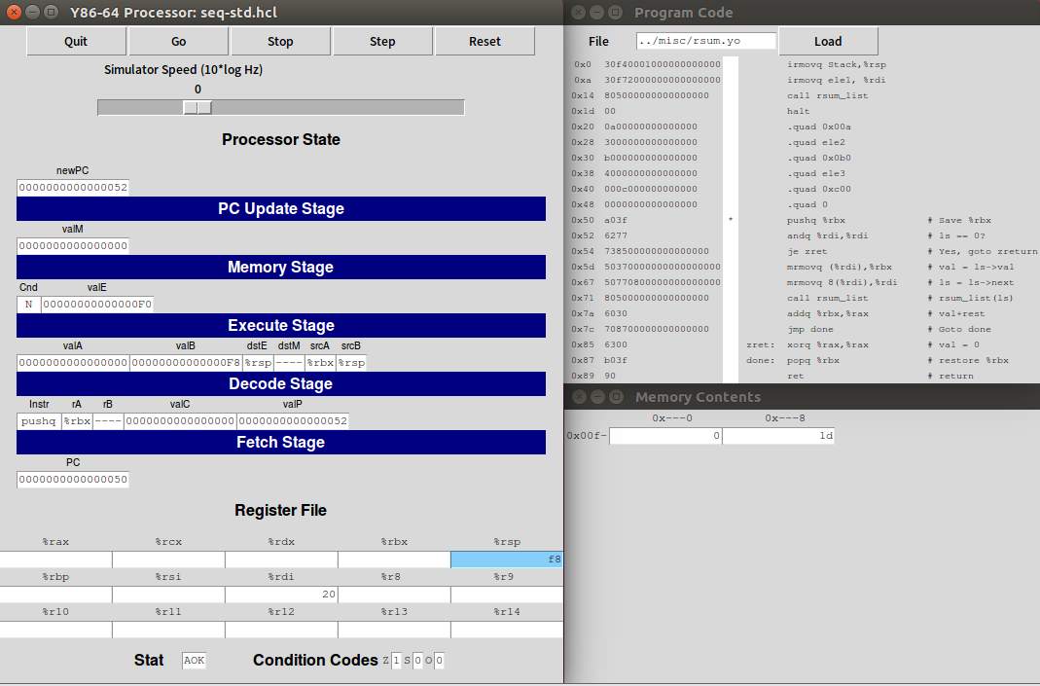
Then the next command push current %rbx into stack, the register storing val in callee. The stack pointer %rsp decreases by 1 byte.
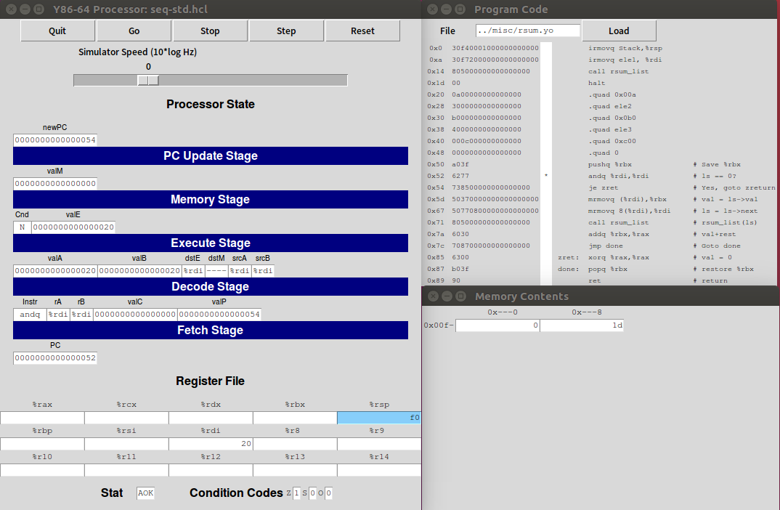
andq judges whether ls stored in %rdi is NULL and set corresponding condition code ZF. Here it is not NULL thus ZF is 0.
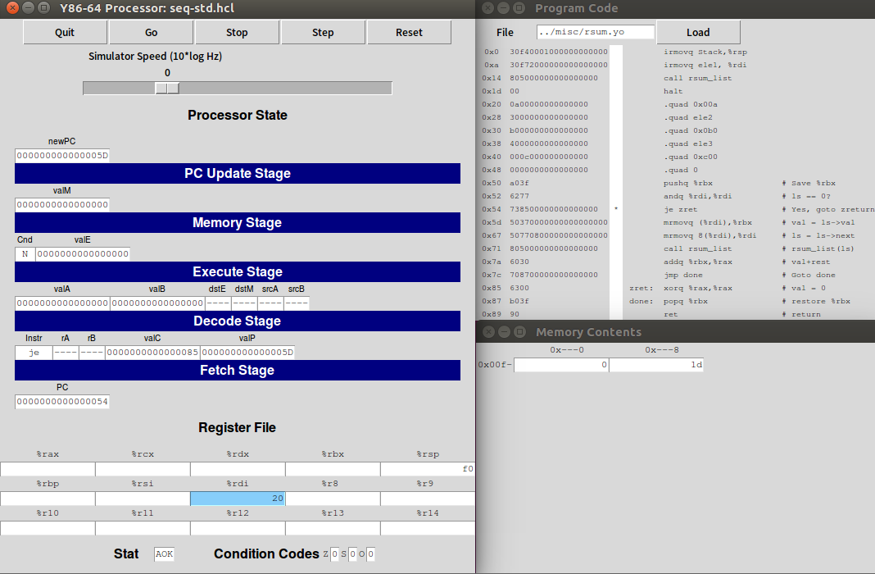
The je jumps to zret when ZF is 1. Here it is zero thus the programme continue sequentially.
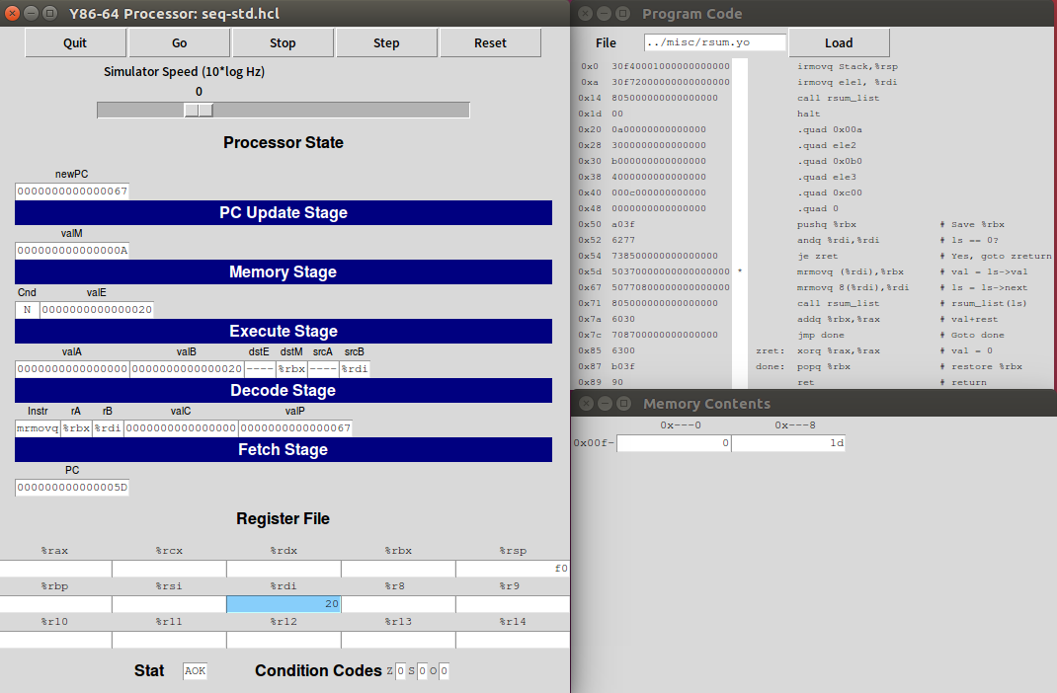
Then the command move the value in memory pointed by %rdi, that is ls->val, into the register %rbx, that is val.
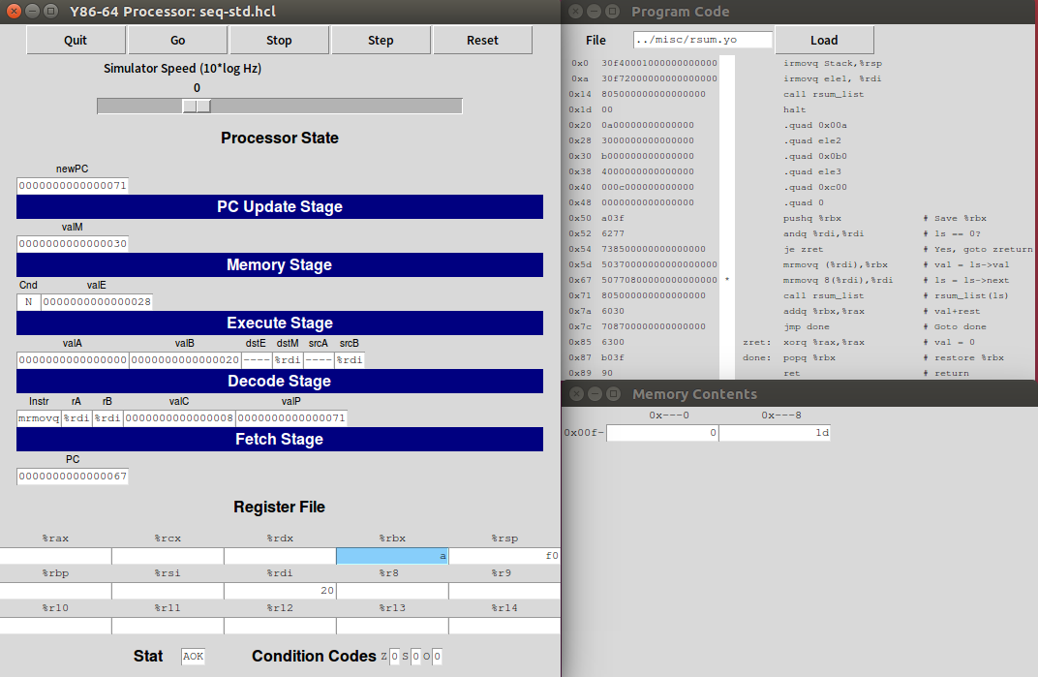
The next command moves the next of ls into %rbi. That is to renew ls to its next.
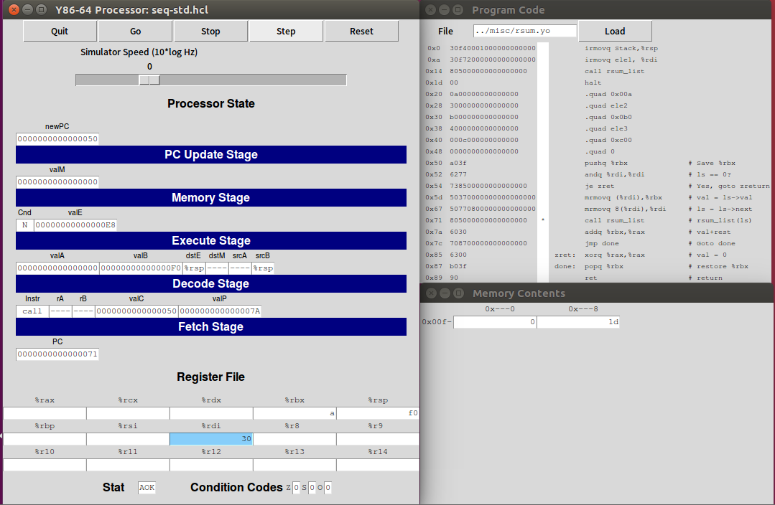
Then the programme calles the rsum_list function recursively. Decrease the %rsp by 1 byte to store the return address 0x7a of this recursion. Then the PC is updated to the starting address of rsum_list function.
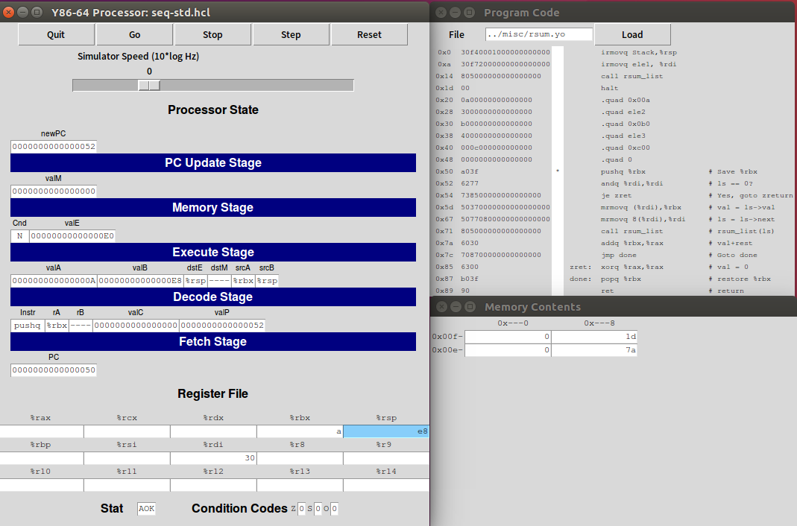
Then the next steps are similar to former steps, push current %rbx, or val into stack to store the state of caller, check whether the node is NULL, take the value of this node, renew ls to its next, call the function again, renew the stack pointer and then store return address until the node is NULL. And the stack pointer is updated to 0xc0.
At the last invoking, the andq set ZF as 1 since the node is NULL.
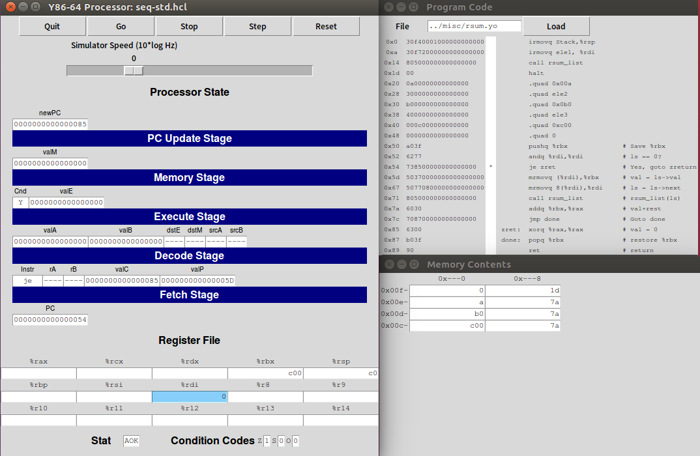
Then, the command je zret jumps to zret since ZF is 1.
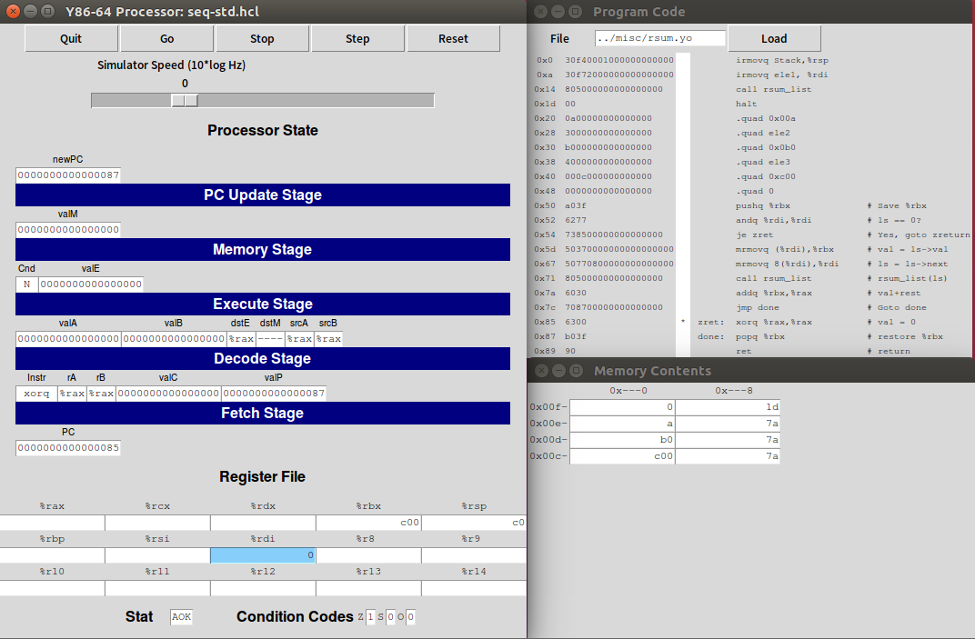
The next command return the %rax, val of callee, as 0.
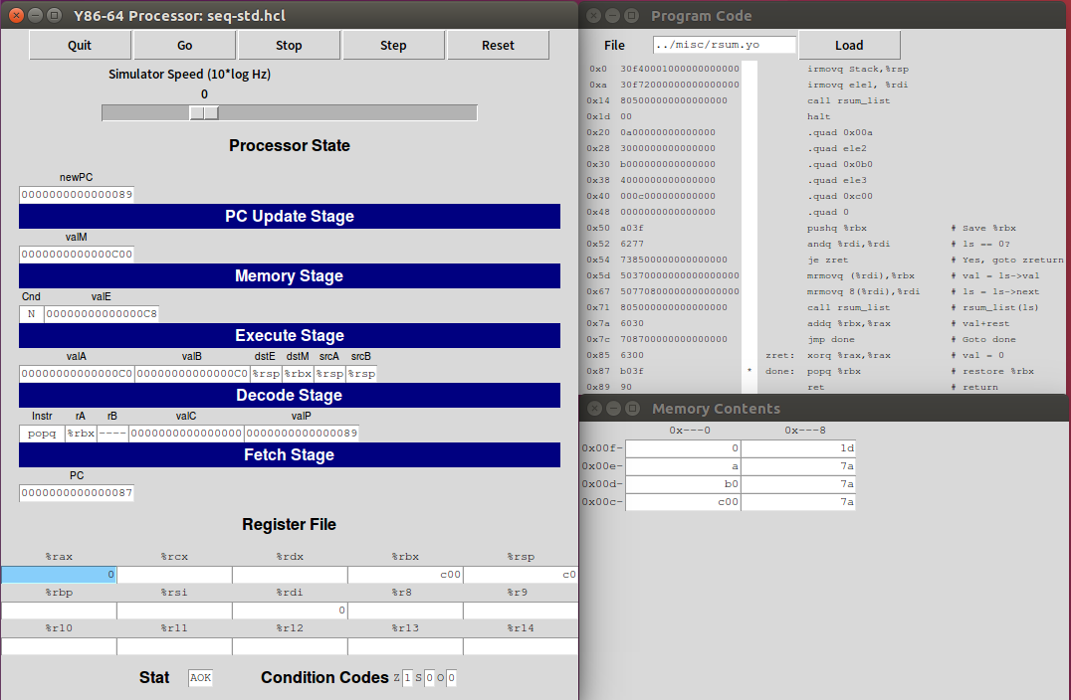
Then the programme pops the value, that is the val of caller storing in %rbx, in the stack and then store it into %rbx. Then the stack pointer is updated to 0xc8 by increasing 1 byte.
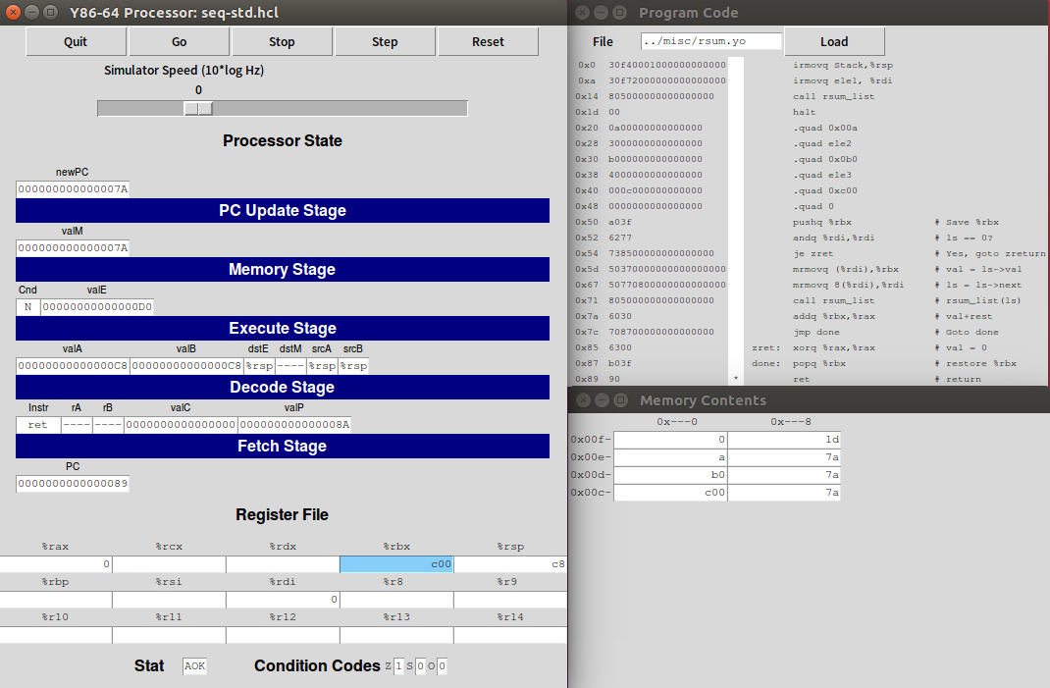
Then ret ends the process of this function and the stack pointer increases to 0xd0. The PC returns to 0x7a, the address to be returned stored in the stack.
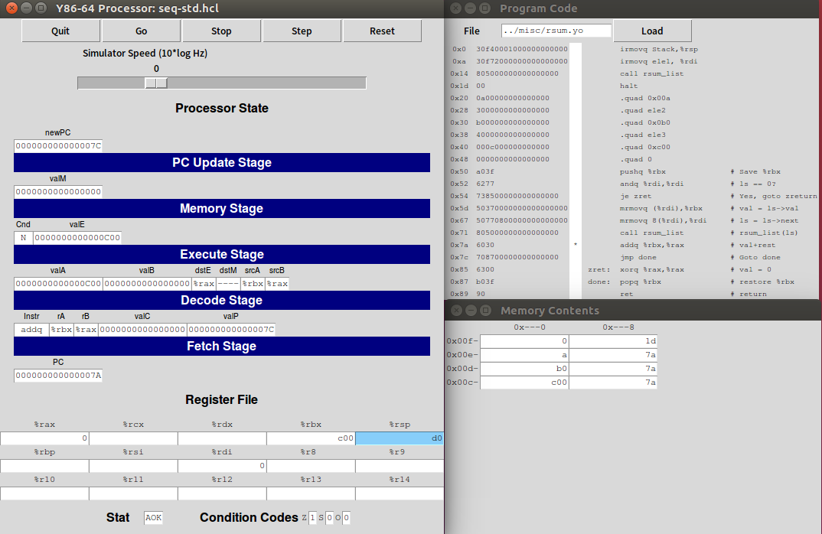
Then the addq adds the sum of return value of callees, that is rest, storing in %rax and the value of current node storing in %rbx. Then store the result into %rax.
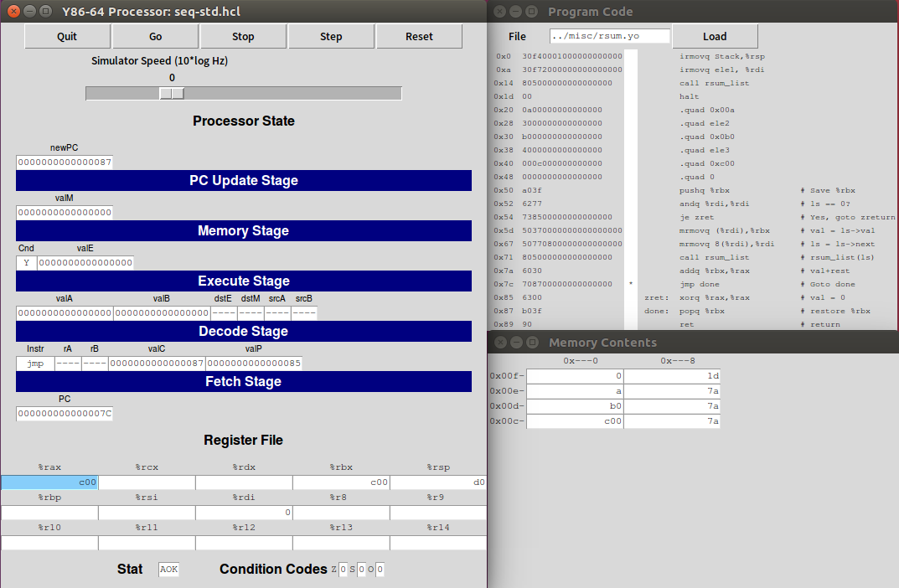
Then jump to done again.
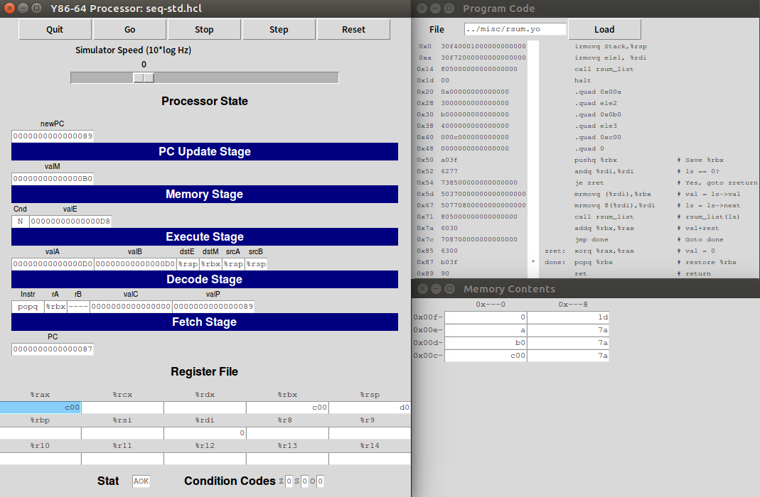
Then the command pops the stack, the val of caller storing in %rbx, and stores it into %rbx again. The stack pointer is updated to 0xd8.
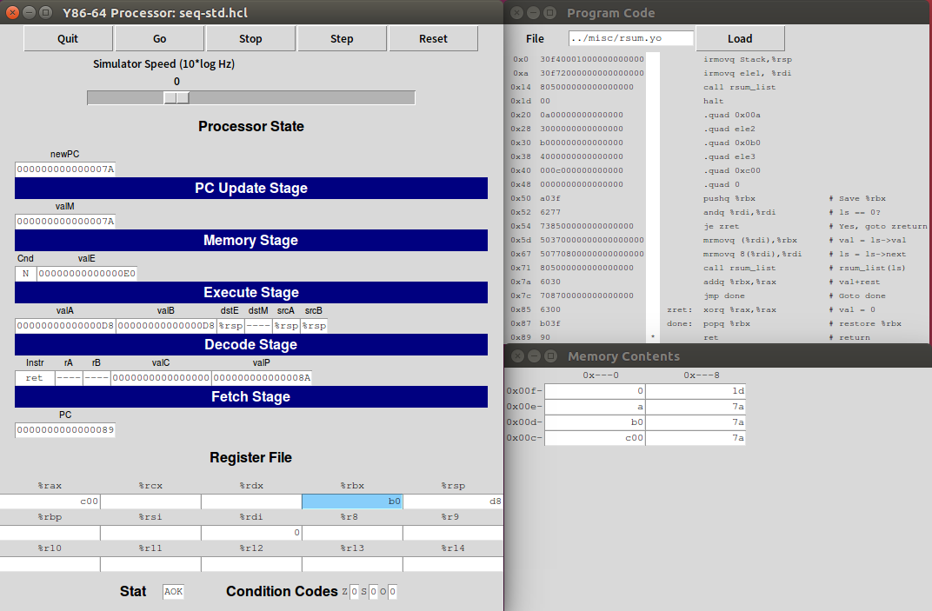
Then return and updates the stack pointer.
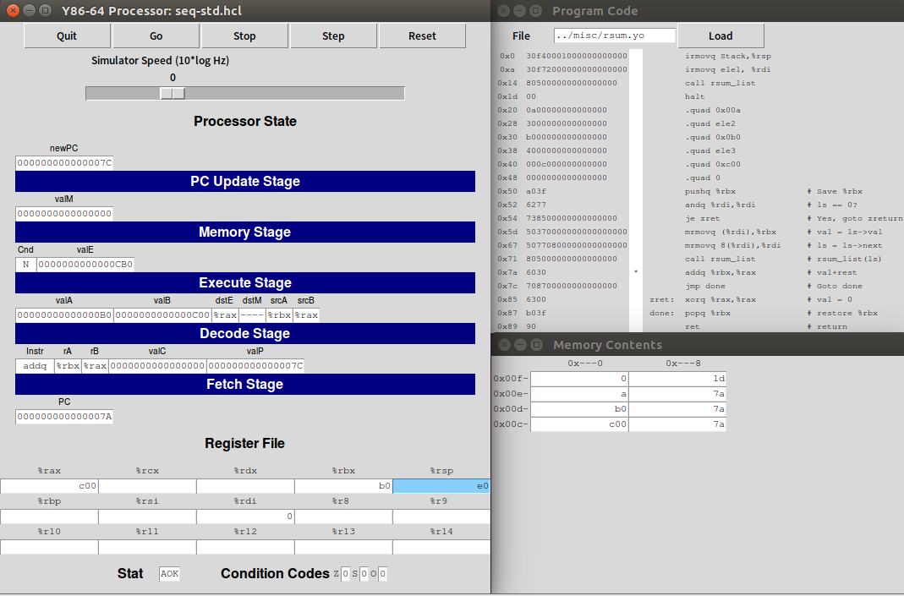
Add the value of the sum of callees stored in %rax and the val of current node stored in %rbx. Store the result into %rax.
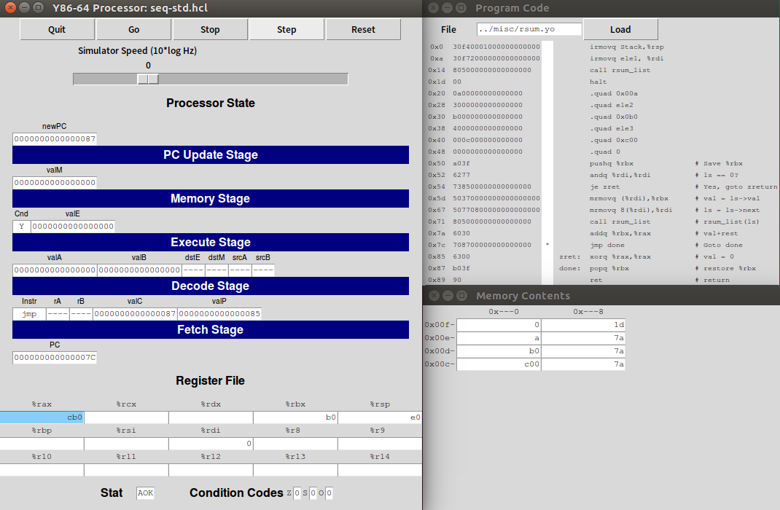
Jump to done again and repeat similar steps to add the values recursively until the stack pointer points to 0xf8.
Then, the last ret is operated and then the PC is updated to 0x1d and the stack pointer is updated to 0x100. The program halts.
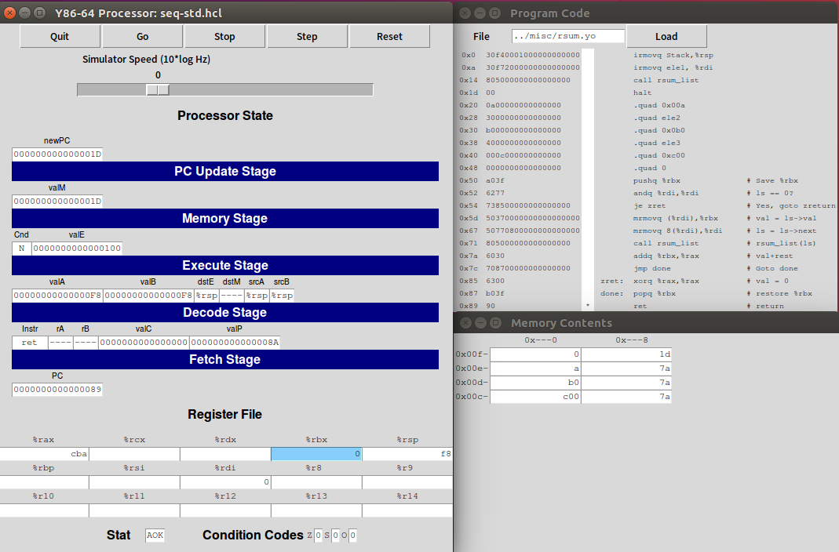
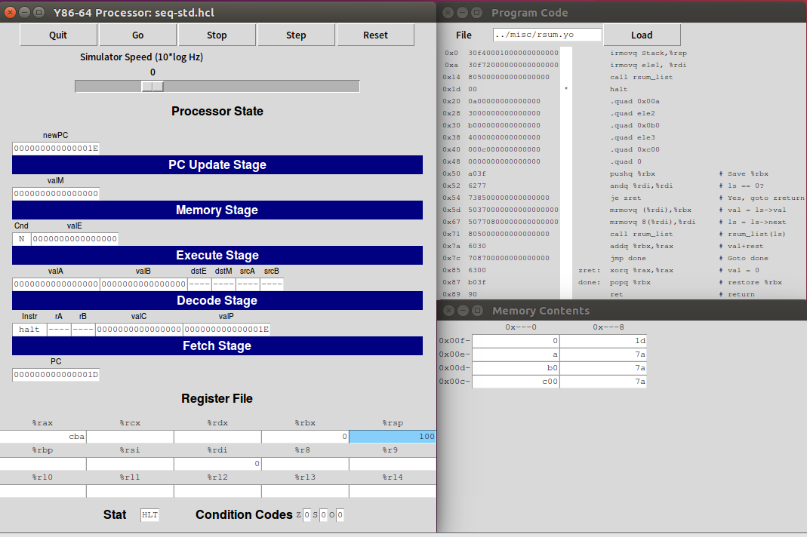
The result value is stored in %rax as 0xcba, consistent with expected result.
- Appendix (Program Code)
sum.c:
/* sum_list - Sum the elements of a linked list */
long sum_list(list_ptr ls)
{
long val = 0;
while (ls)
{
val += ls->val;
ls = ls->next;
}
return val;
}

rsum.c:
/* rsum_list - Recursive version of sum_list */
long rsum_list(list_ptr ls)
{
if (!ls)
return 0;
else
{
long val = ls->val;
long rest = rsum_list(ls->next);
return val + rest;
}
}
sum.yo:
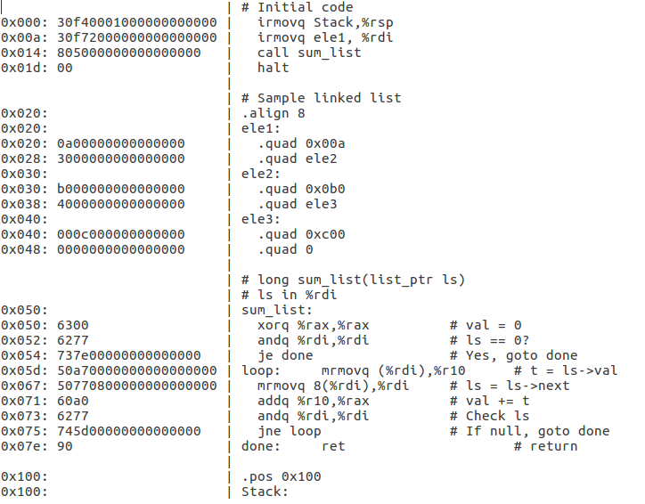
rsum.yo:
