

Undergraduate Lab Report

Course Title: Experiment of Computer Organization
Course No: 60080014
Student Name: 李荣耀
Student No: 2024103975
School: International School
Department:
Major: CST
Instructor： SUN Heng

Academic Year:2025~2026, Semester : 1st [√ ] 2nd[ ]

Academic Affairs Office of Jinan University
Date (dd/mm/yyyy) 2025/11/05
Computer Organization Lab List
Student Name: Li Rongyao Student No: 2024103975

ID | Lab Name | Type
1 | Number Storage Lab | Individual
2 | Manipulating Bits | Individual
3 | A Simple Real-life Control System Lab | Team
4 | System I/O | Individual
5 | Simulating Y86-64 Program | Individual
6 | Performance Lab | Team
Undergraduate Lab Report of Jinan University
Course Title Experiment of computer organization Evaluation
Lab Name Performance Lab
Instructor Sun Heng
Lab Address Room 116
Student Name Li Rongyao
Student No 2024103975
College International School
Department Major CST
Date 2025/12/17 Afternoon
- Introduction

In this lab, optimize the performance of an application kernel function such as convolution or matrix transposition. It provides a clear demonstration of the properties of cache memories and gives them experience with low-level program optimization.
- Lab Instructions or Steps
  - Image processing problem

This lab deals with optimizing memory intensive code. Image processing offers many examples of functions that can benefit from optimization. In this lab, we will consider two image processing operations: rotate, which rotates an image counter-clockwise by 90。, and smooth, which “smooths” or “blurs” an image.

For this lab, we will consider an image to be represented as a two-dimensional matrix M, where M_{i,j} denotes the value of (i, j)th pixel of M. Pixel values are triples of red, green, and blue (RGB) values. We will only consider square images. Let N denote the number of rows (or columns) of an image. Rows and columns are numbered, in C-style, from 0 to N-1.

Given this representation, the rotate operation can be implemented quite simply as the combination of the following two matrix operations:

• Transpose: For each (i, j) pair, M_{i,j} and M_{j,i} are interchanged.

• Exchange rows: Row i is exchanged with row N-1-i.

This combination is illustrated in Figure 1.

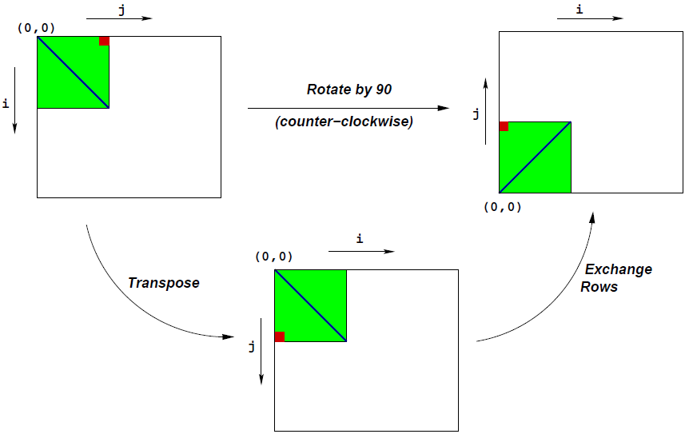
Figure 1 Rotation of an image by 90。counterclockwise

The smooth operation is implemented by replacing every pixel value with the average of all the pixels around it (in a maximum of 3×3 window centered at that pixel). Consider Figure 2. The values of pixels M2[1][1] and M2[N-1][N-1] are given below:

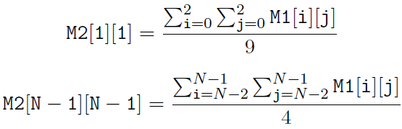

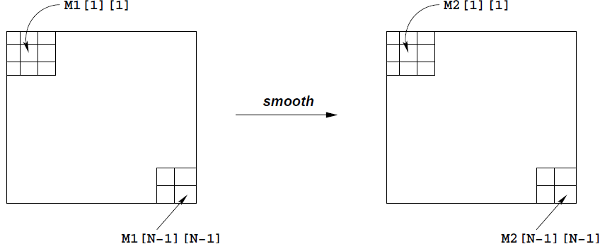

Figure 2 Smoothing an image
  - Source code

The only file you will be modifying is kernels.c. Insert the requested identifying information about the one or two individuals comprising programming team.
  - Data structures

The core data structure deals with image representation. A pixel is a struct as shown below:

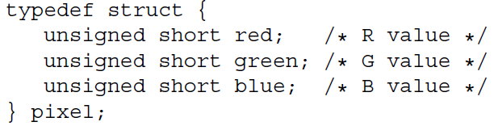

As can be seen, RGB values have 16-bit representations (“16-bit color”). An image I is represented as a one-dimensional array of pixels, where the (i, j)th pixel is I[RIDX(i,j,n)]. Here n is the dimension of the image matrix, and RIDX is a macro defined as follows:

#define RIDX(i,j,n) ((i)*(n)+(j))

See the file defs.h for this code.
  - Rotate operation

The following C function computes the result of rotating the source image src by 90◦ and stores the result in destination image dst. dim is the dimension of the image.

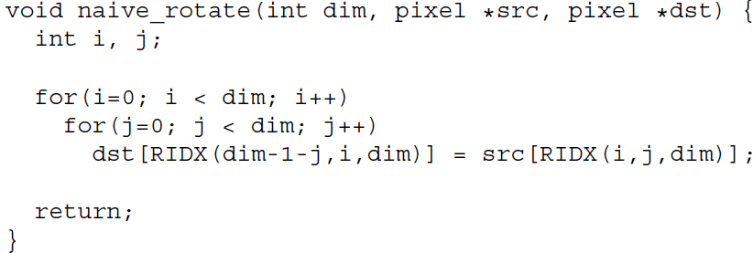

The above code scans the rows of the source image matrix, copying to the columns of the destination image matrix. The task is to discuss the reasons of performance improvement from the functions rotate_c、rotate_b8、rotate_b4、rotate_b16_u2、rotate_b32_u2、rotate_b8_u4_c、rotate_b8_u4、rotate_b16_u4、rotate_b16_u4_c、rotate_b32_u4、rotate_b32_u4_c.

See the file kernels.c for this code.
  - Smooth operation

The smoothing function takes as input a source image src and returns the smoothed result in the destination image dst. Here is part of an implementation:

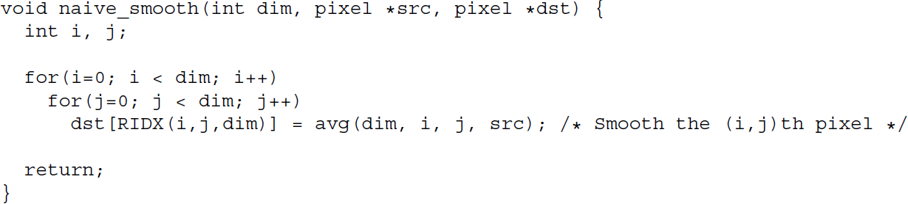

The function avg returns the average of all the pixels around the (i,j)th pixel. The task is to optimize smooth (and avg) to run as fast as possible.

This code (and an implementation of avg) is in the file kernels.c.
The task is to discuss the reasons of performance improvement.
  - Performance measures

Main performance measure is CPE (Cycles per Element). If a function takes C cycles to run for an image of size N×N, the CPE value is C/N². Performance is shown for 5 different values of N.

The ratios (speedups) of the optimized implementation over the naive one will constitute a score of your implementation. To summarize the overall effect over different values of N, we will compute the geometric mean of the results for these 5 values. That is, if the measured speedups for N = {32, 64, 128, 256, 512} are R₃₂, R₆₄, R₁₂₈, R₂₅₆, and R₅₁₂ then we compute the overall performance as
  - Running
Install the gcc-multilib to compile the source code
unix> sudo apt-get install gcc-multilib

The source code to write will be linked with object code. To create this binary, execute the command

unix> make driver

Re-make driver each time you change the code in kernels.c. To test the implementations, run the command:

unix> ./driver
- Lab Device or Environment
Ubuntu 16.04 (64-bit) on virtual machine (VMware workstation 17 Pro)
- Results and Analysis
Rotate Operations:
- rotate_c
The accession of memory matches the sequence of preloading caches. Before modifying, src strictly increases and accesses successive memory in cache according to row while dst accesses discrete memory. After modifying, although src accesses discrete memory, it might read in preloading cache and dst also accesses successive memory in a row. I.e., sacrifice the continuity of read to obtain the continuity of write. Generally, the cost of writing is more than reading and the reading might be optimized by preloading cache. Thus, the performance of rotate_c is better than naïve_rotate.s
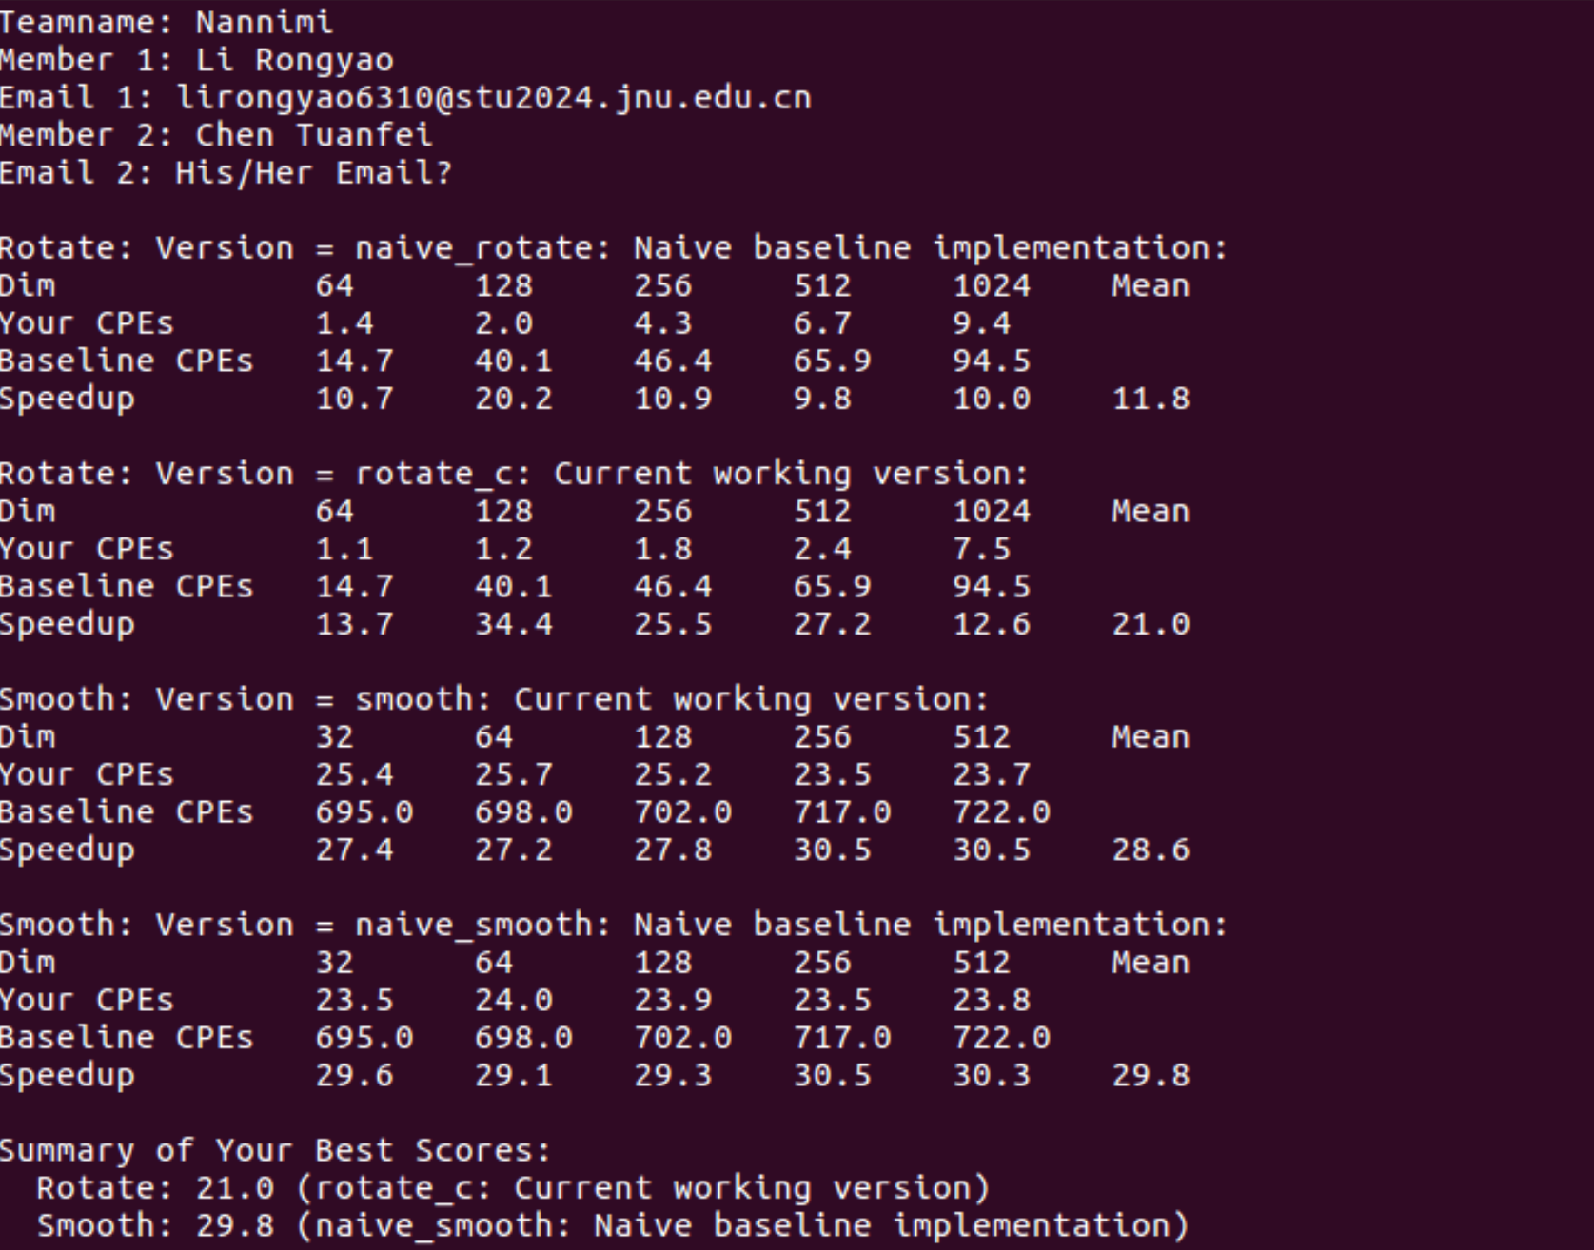
- rotate_b8
This version split large dim into small 8x8 blocks. When dim of matrix becomes larger than 512, the cache cannot accommodate all pixels no matter naïve_rotate or rotate_c. Thus, this version can handle the 8x8 blocks step by step in caches, improving the use ratio of cache and the space locality of the program.
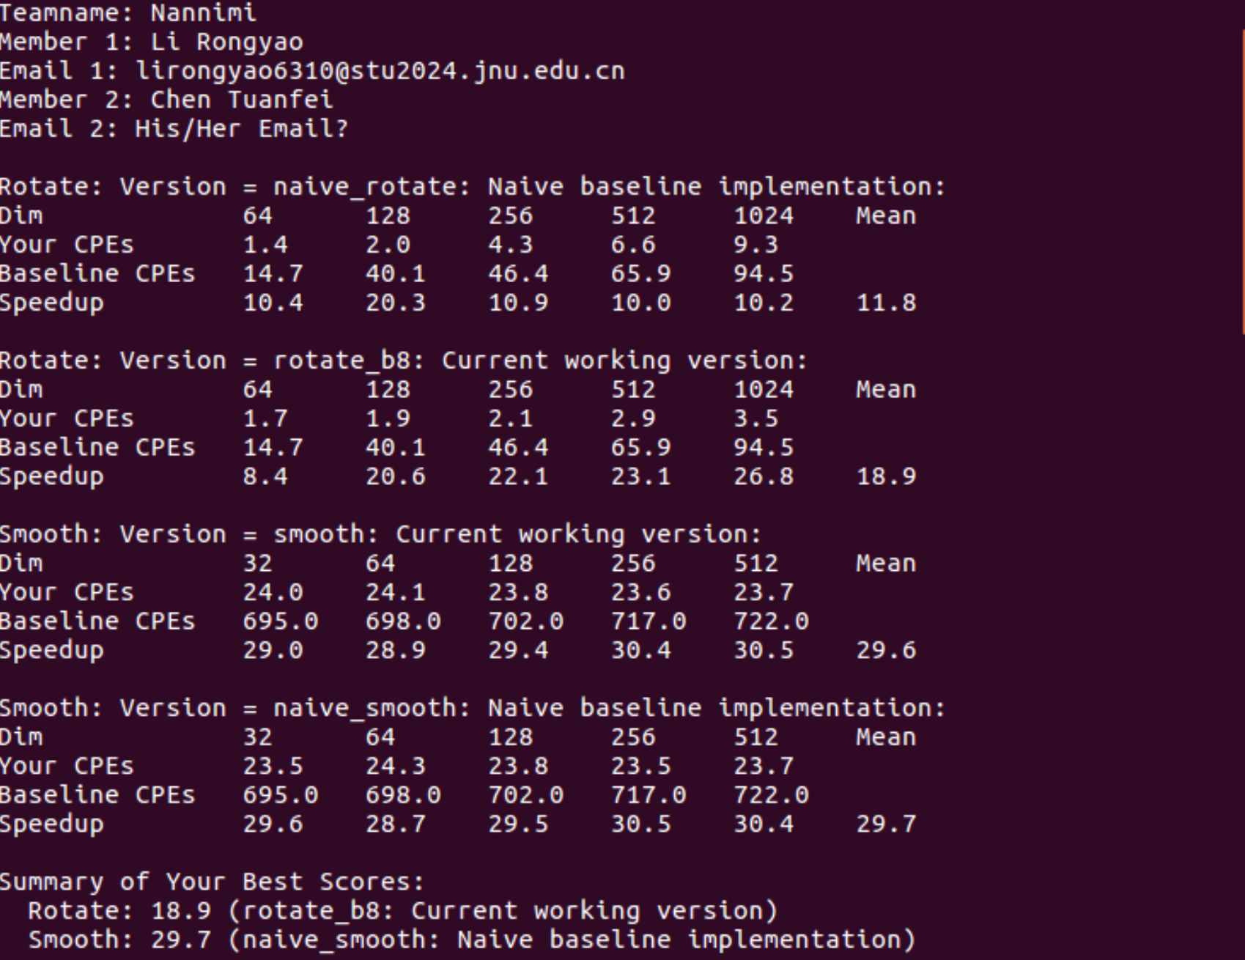
- rotate_b4
The fundamental logic of this optimization is similar to rotate_b8 but 4x4 blocks. However, according to the test, when dim is smaller than 512, the design of block are unnecessary so it is slower than rotate_c. When dim is larger than 512, the size of blocks are too small such that increases the times of reading from memory to caches so it is slower than rotate_b8.
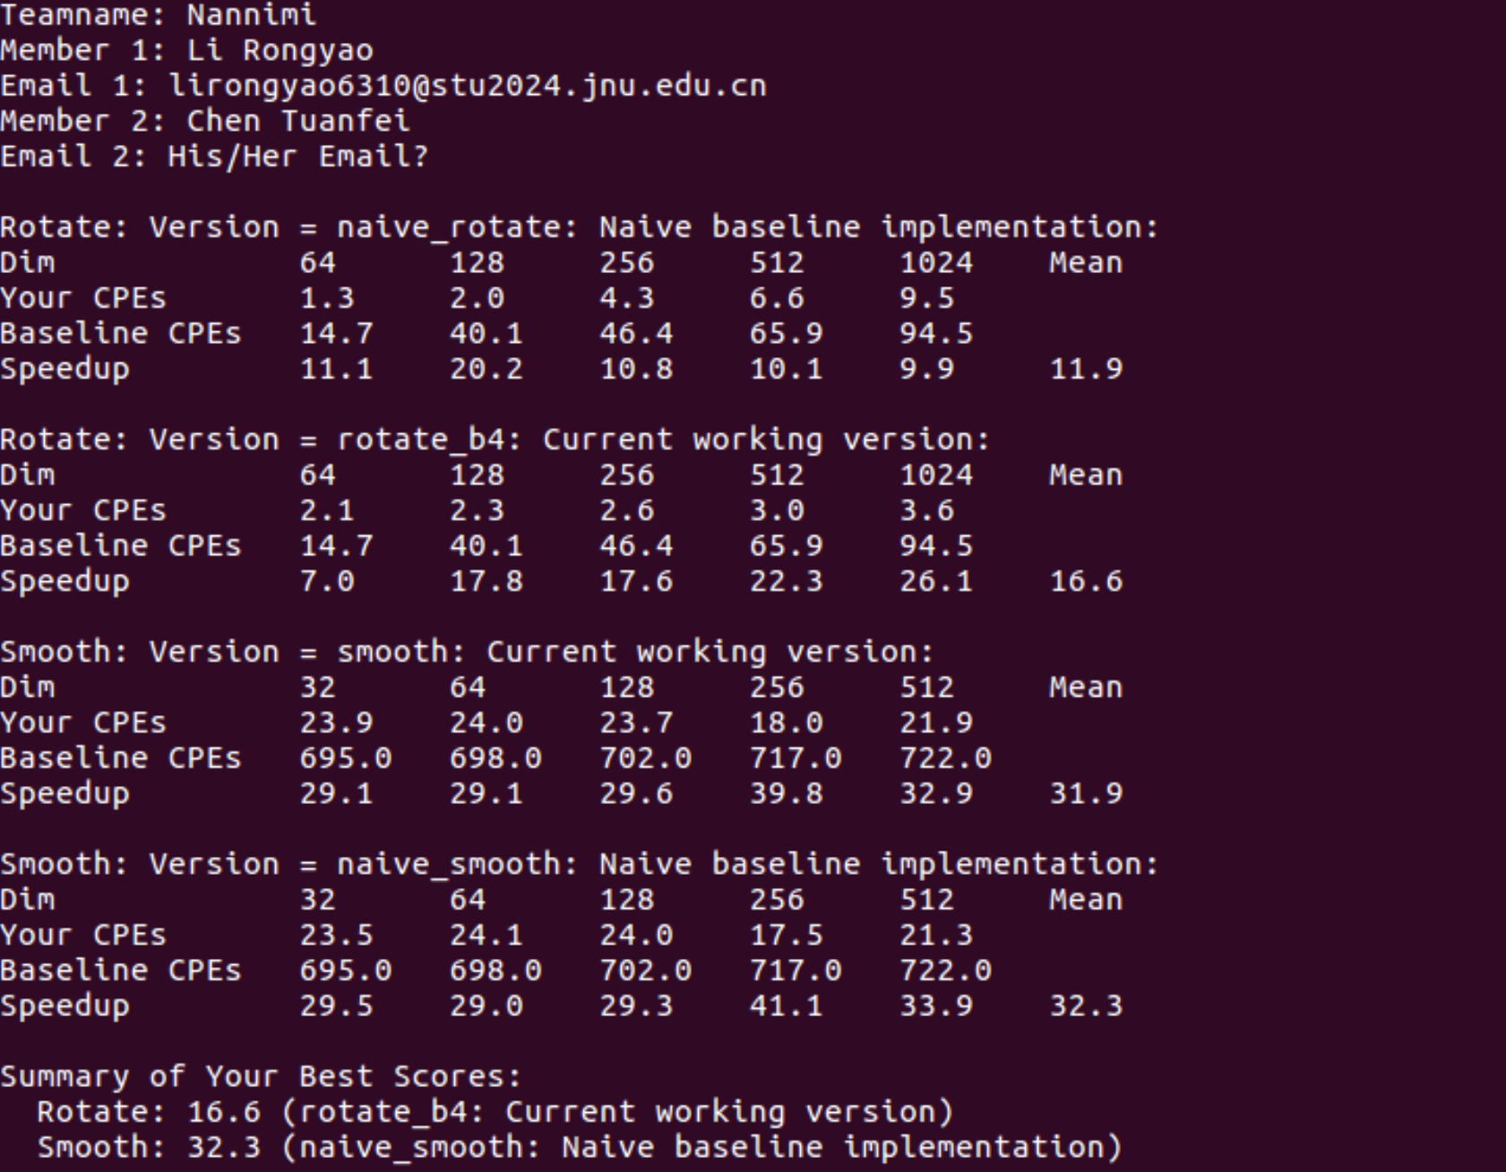
- rotate_b16_u2
This version divide the matrix into 16x16 blocks and unroll the blocks with the step size of two. The implement of two instructions in inner loops improves the efficiency for CPU to parallelly process. However, the size of block is too large to be contained by cache thus the performance is not better than rotate_b8 even than rotate_b4.
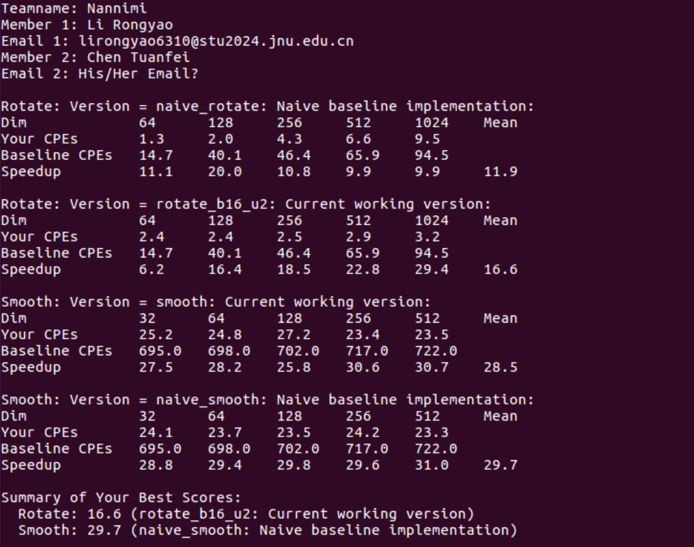
- rotate_b32_u2
The fundamental logic of this version is similar to rotate_b16_u2 while the size of blocks is much larger. Thus, the performance of this version is even worse than rotate.
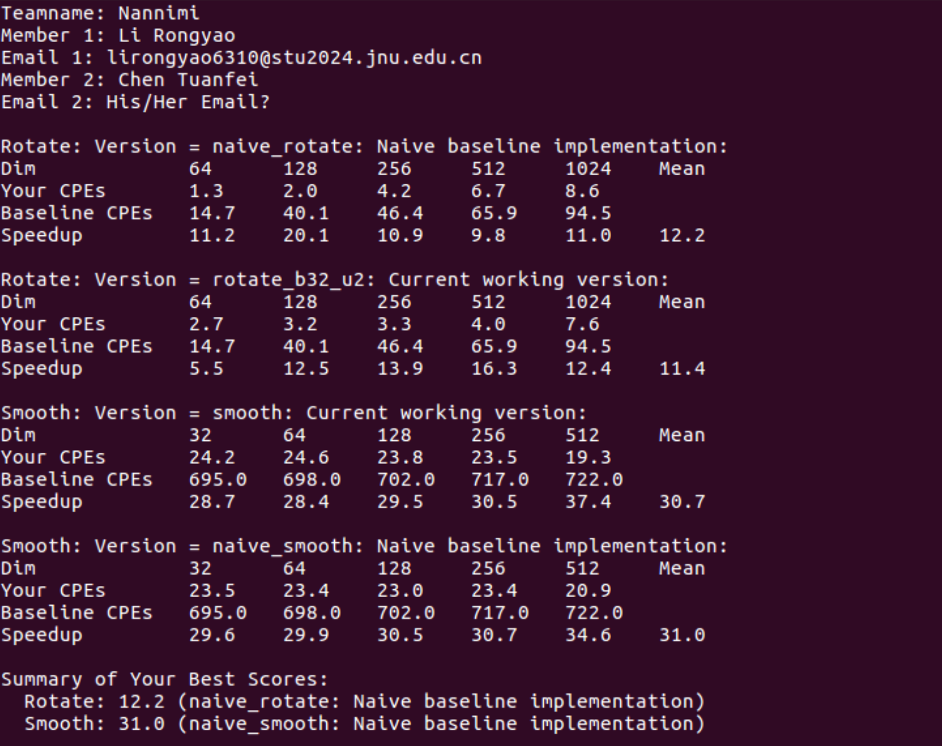
- rotate_b8_u4
This version implements four instruction in one loop to improve the performance by parallel processing. But the improvement than rotate_b8 is not apparent due to performance bottleneck.
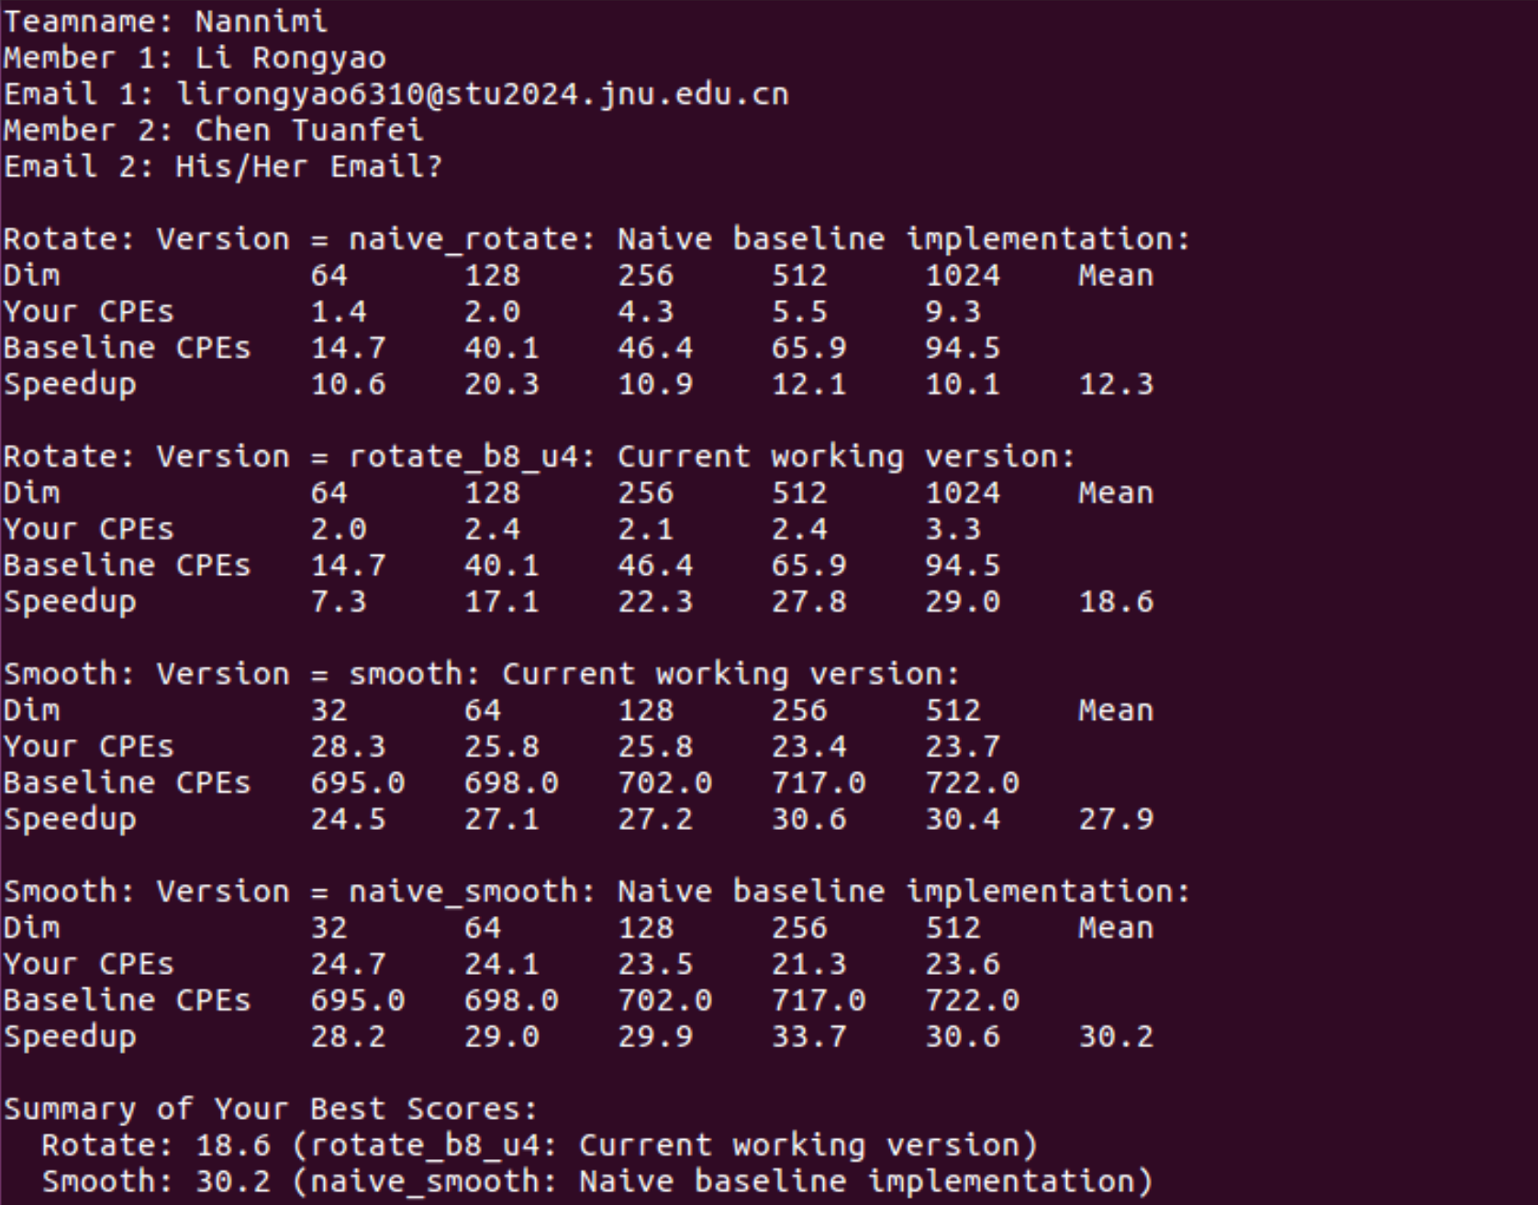
- rotate_b8_u4_c
This version try to modify the loops to sacrifice reading ratio to obtain writing ratio as before. But in 8x8 blocks, the elements may be all in cache and the sequence cannot affect the performance too much.
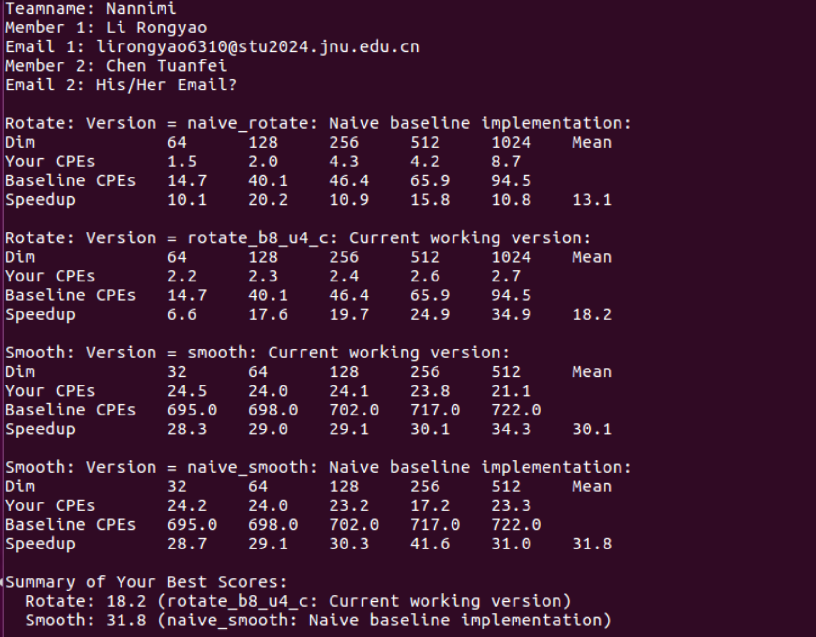
- rotate_b16_u4
This version increases step size by two and has better performance than rotate_b16_u2.
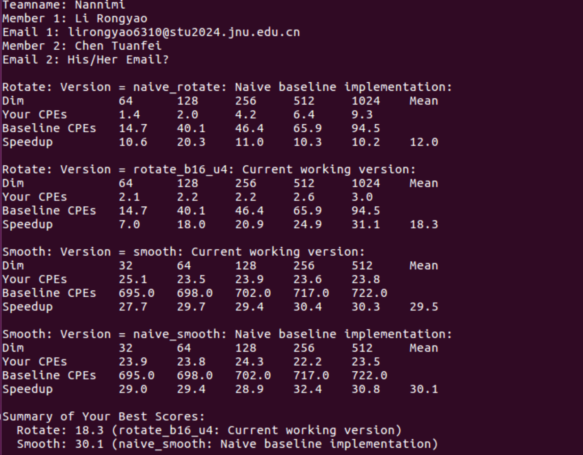
- rotate_b16_u4_c
It is similar to rotate_b8_u4_c and the performance cannot improve too much than rotate_b16_u4.
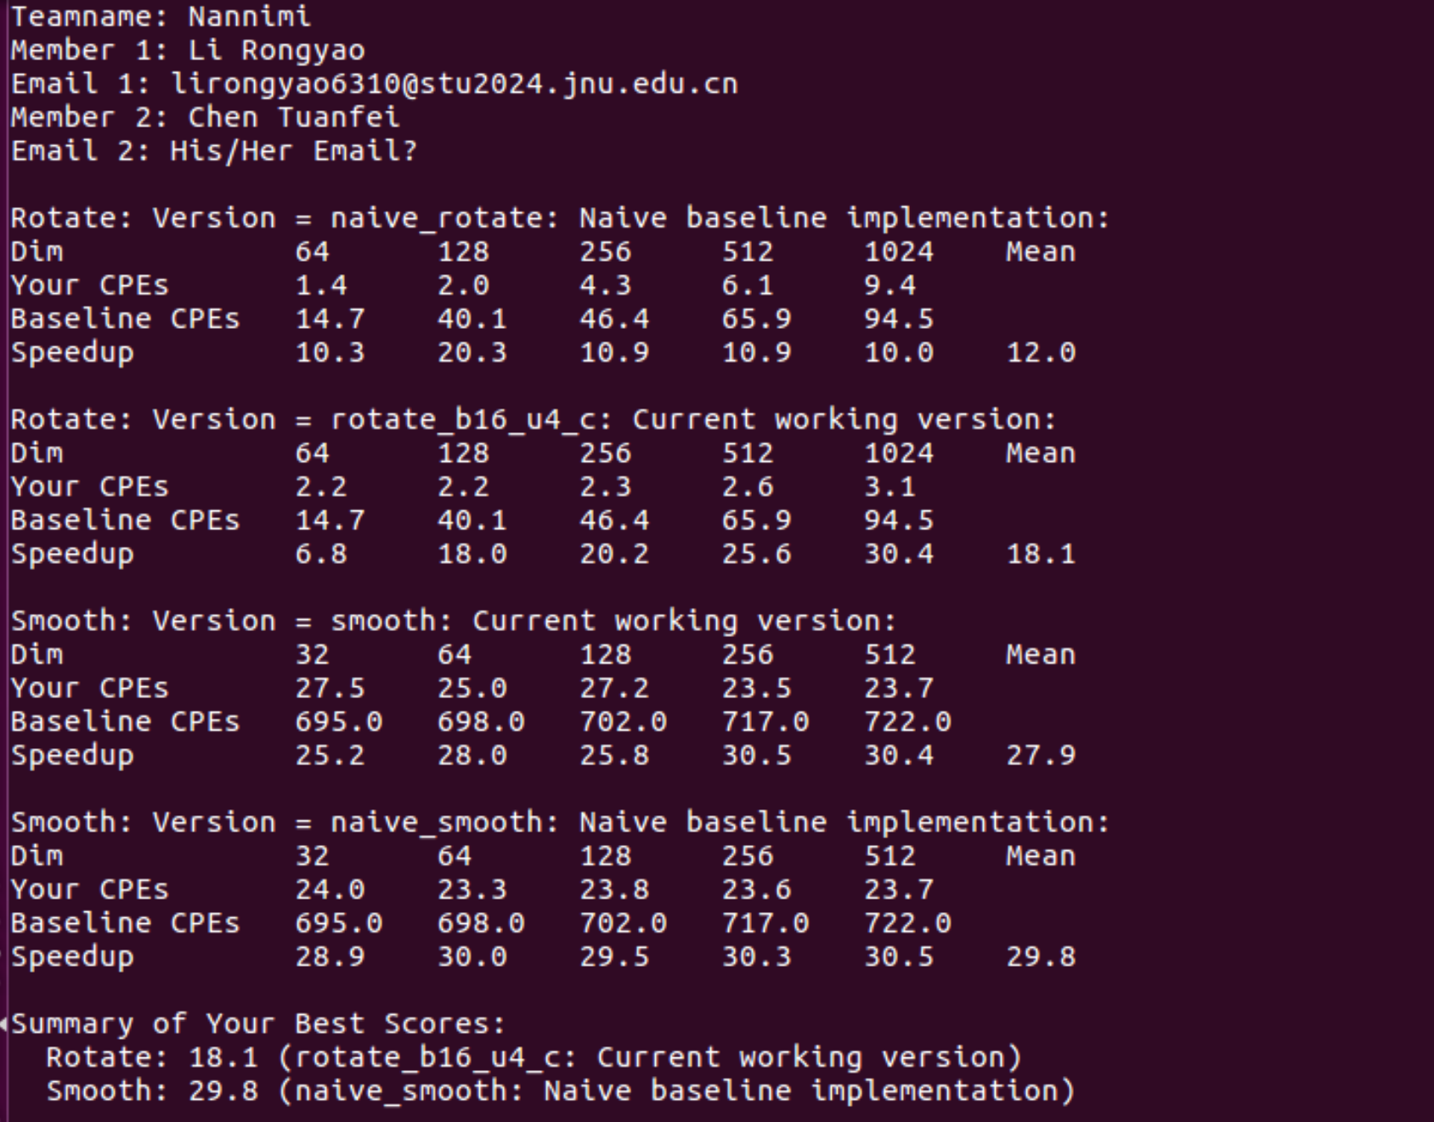
- rotate_b32_u4
Because of the size of blocks is larger, the increment of parallel process improves the performance more apparently.
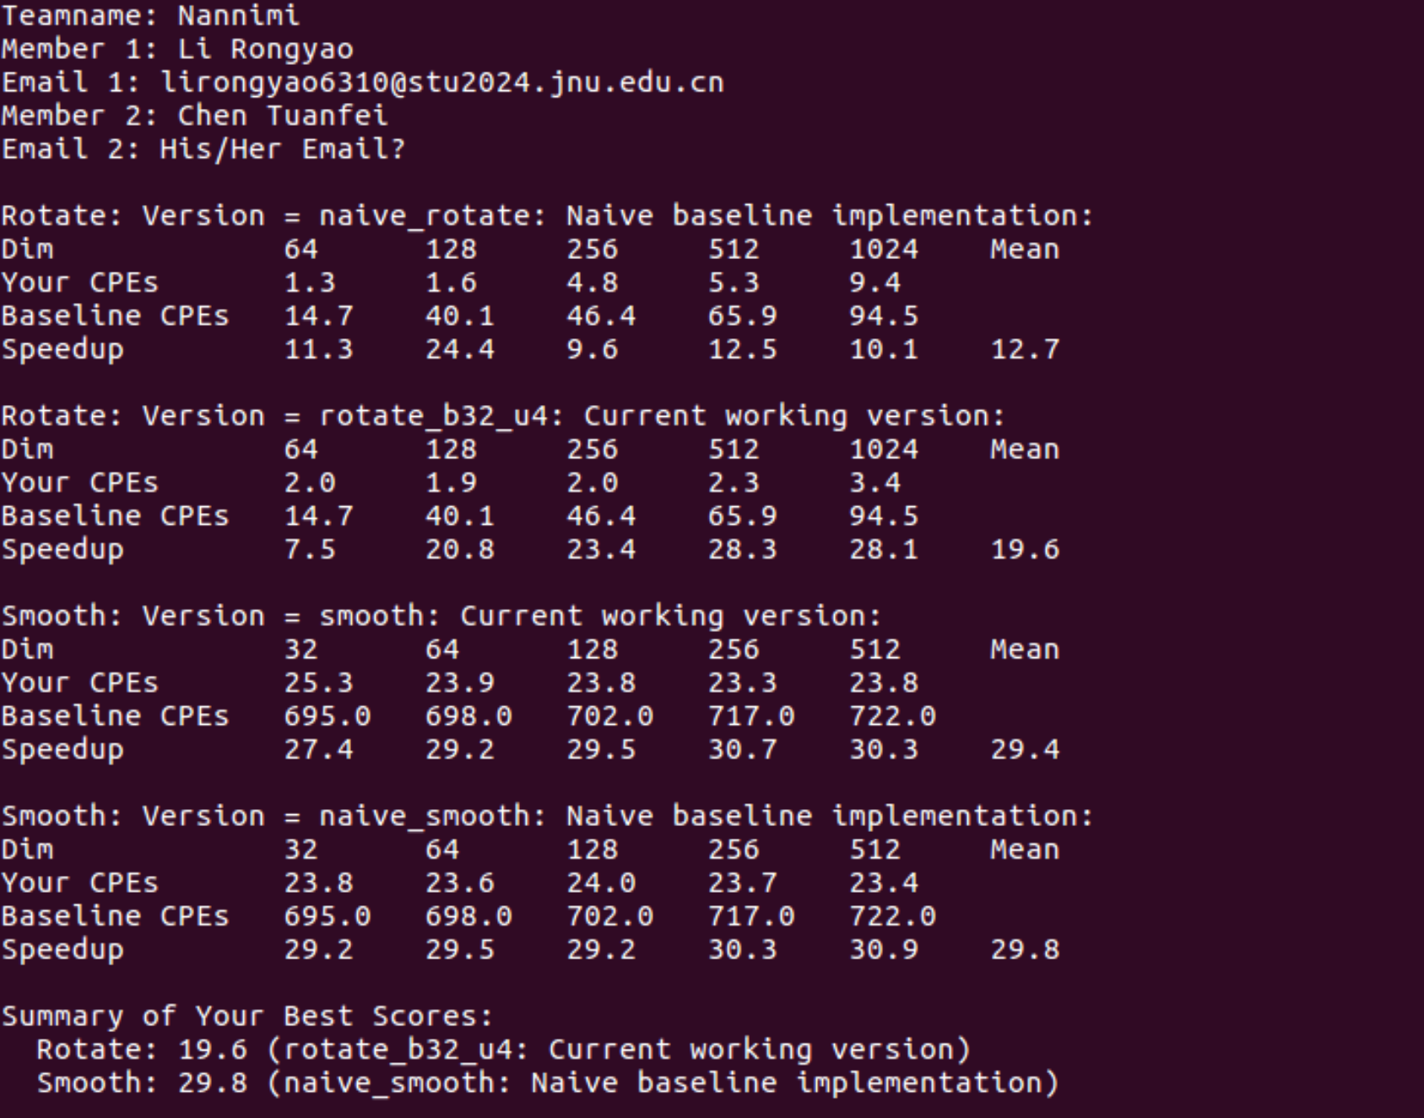
- rotate_b32_u4_c
Similar to previous three groups, the sequence cannot affect the performance too much.
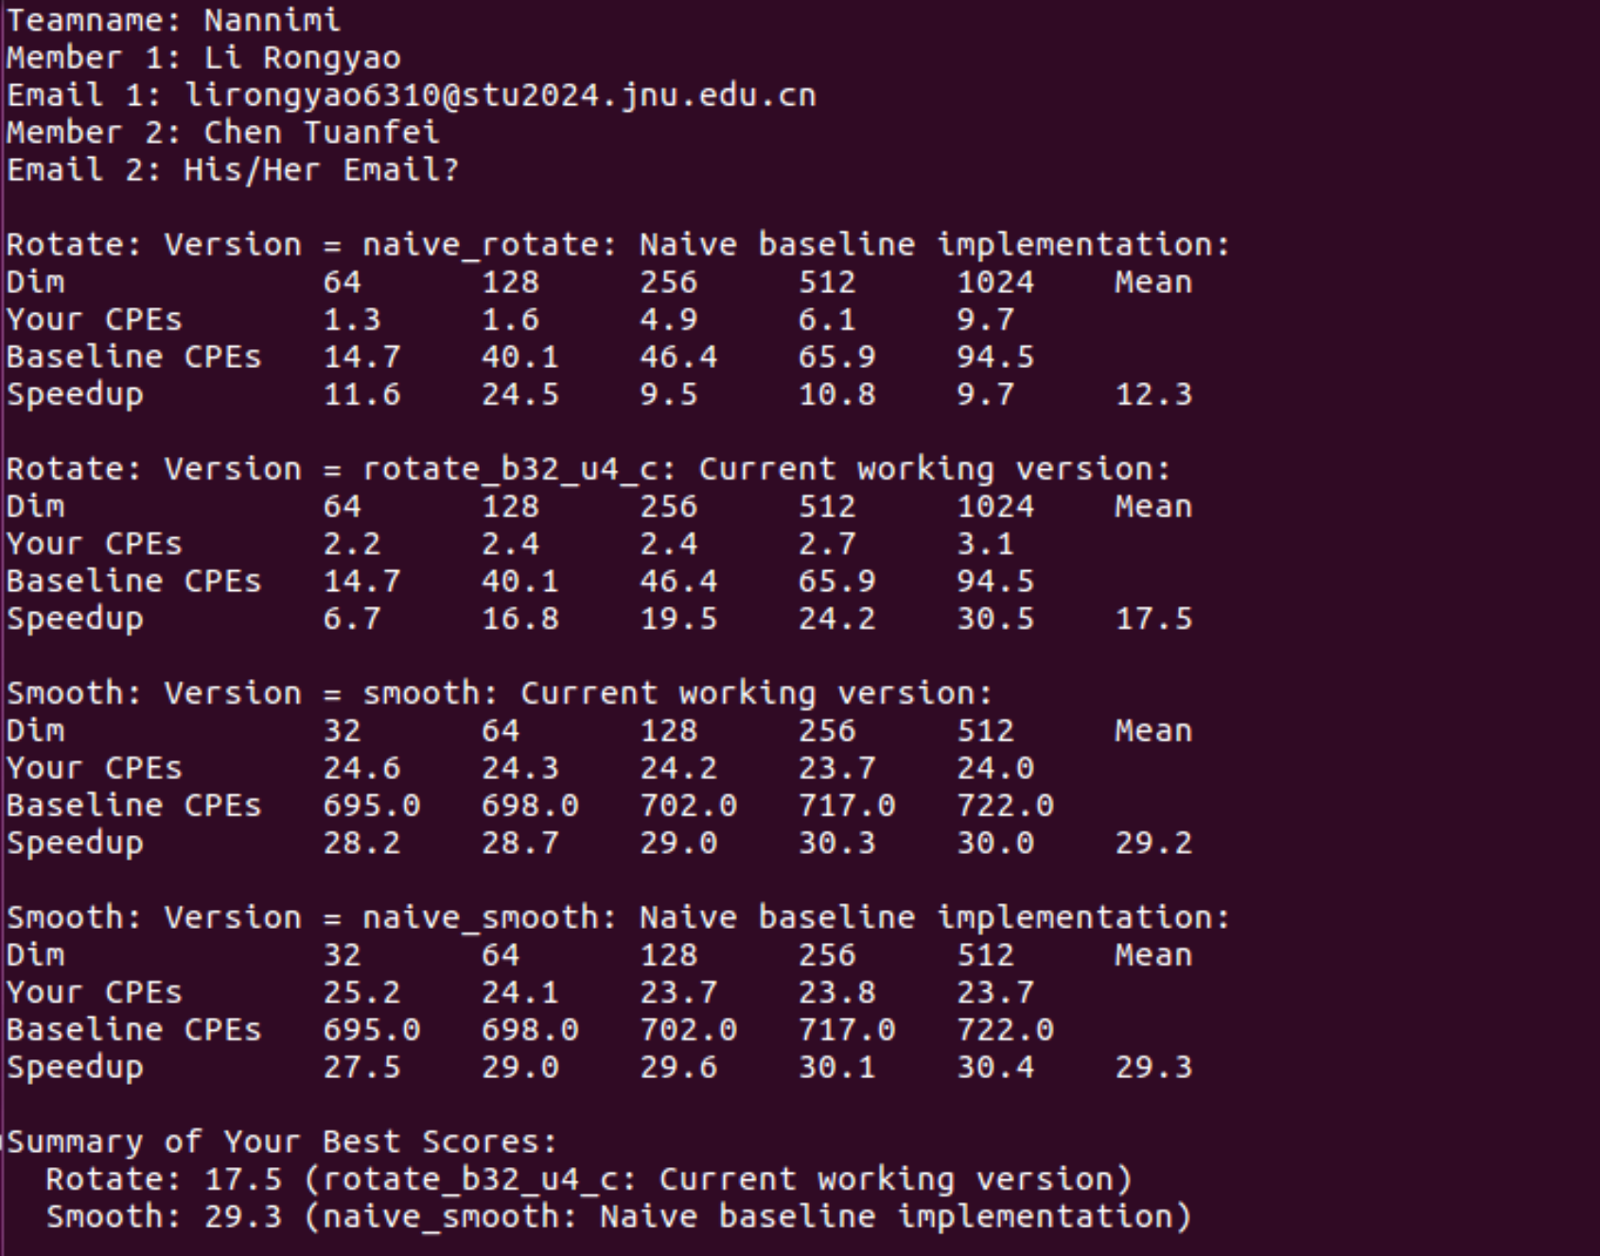
Summary of rotation:
When the size of matrix is small (in our experiments), the best performance is rotate_c. However, with the size of matrix increasing, the performance of blocks will be better. And with the size of blocks increasing, the performance of parallel processing will be better.
Smooth Operations:
- Corner hardcoding for dim == 1 and dim == 2 to avoid other complicated logic.
- Remove all function calls to improve the performance.
- Directly handle the corners and edges to avoid specific situations in center.
- Center incremental update to reduce the times of addition. (9n^2 to 3n^2 + 6n).
- Edge contiguous access improves the space locality and incremental in blocks improves time locality.
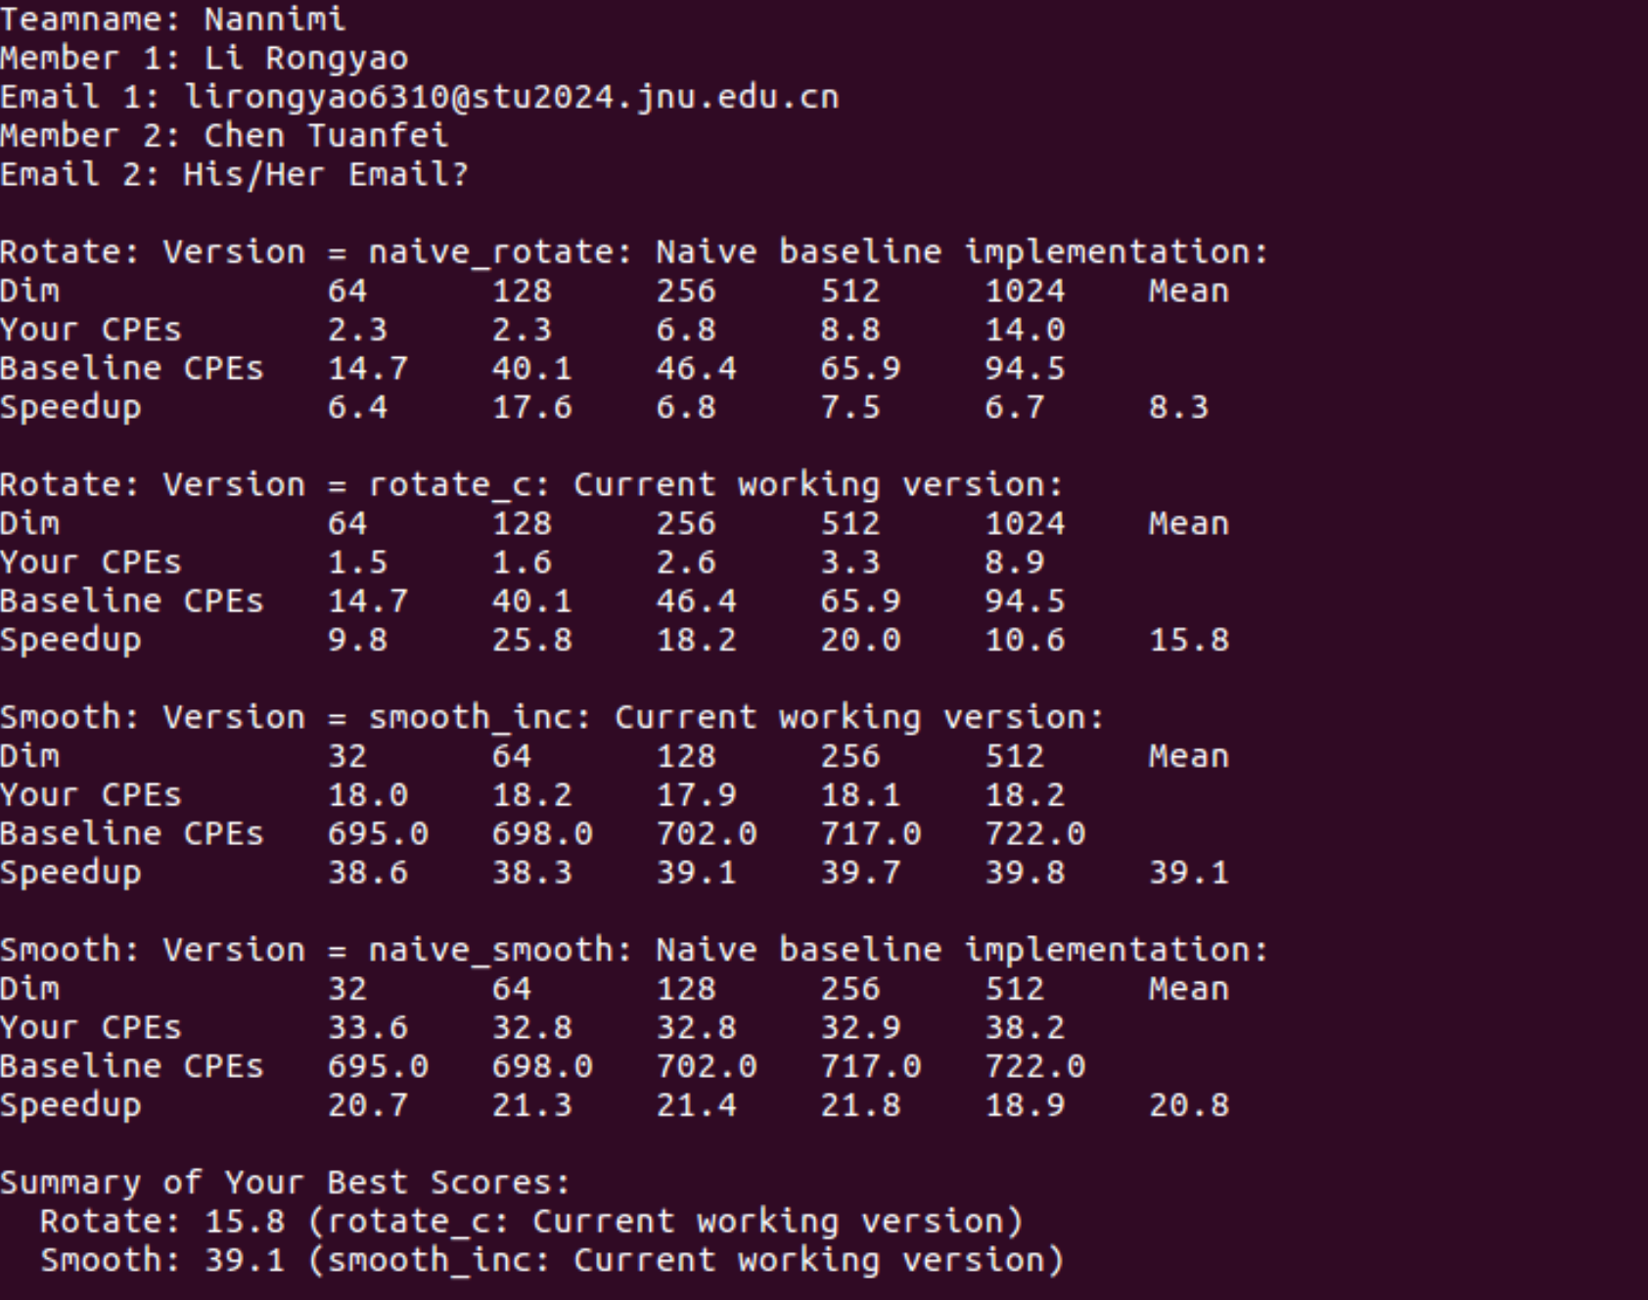
- Appendix (Program Code and Snapshot)
#include <stdio.h>
#include <stdlib.h>
#include "defs.h"

/*
* Please fill in the following team struct
*/
team_t team = {
"Nannimi", /* Team name */

"Li Rongyao", /* First member full name */
"lirongyao6310@stu2024.jnu.edu.cn", /* First member email address */

"Chen Tuanfei", /* Second or third member full name (leave blank if none) */
"His/Her Email?" /* Second or third member email addr (leave blank if none) */
};

/***************
* ROTATE KERNEL
***************/

/******************************************************
* Your different versions of the rotate kernel go here
******************************************************/

/*
* naive_rotate - The naive baseline version of rotate
*/
char naive_rotate_descr[] = "naive_rotate: Naive baseline implementation";
void naive_rotate(int dim, pixel *src, pixel *dst)
{
int i, j;

for (i = 0; i < dim; i++)
for (j = 0; j < dim; j++)
dst[RIDX(dim - 1 - j, i, dim)] = src[RIDX(i, j, dim)];
}

/*
* rotate_c - Optimize the loop sequence to match memory access
*/
char rotate_c_descr[] = "rotate_c: Optimize the loop sequence to match accession";
void rotate_c(int dim, pixel *src, pixel *dst)
{
for (int j = 0; j < dim; j++)
{
for (int i = 0; i < dim; i++)
{
dst[RIDX(dim - 1 - j, i, dim)] = src[RIDX(i, j, dim)];
}
}
}

/*
* rotate_b8 - Handle successive 8 x 8 block of matrix
*/

char rotate_b8_descr[] = "rotate_b8 : Handle successive 8 x 8 block of matrix";
void rotate_b8(int dim, pixel *src, pixel *dst)
{
for (int i = 0; i < dim; i += 8)
{
for (int j = 0; j < dim; j += 8)
{
for (int bi = i; bi < i + 8 && bi < dim; bi++)
{
for (int bj = j; bj < j + 8 && bi < dim; bj++)
{
dst[RIDX(dim - 1 - bj, bi, dim)] = src[RIDX(bi, bj, dim)];
}
}
}
}
}

/*
* rotate_b4 - Handle successive 4 x 4 block of matrix
*/

char rotate_b4_descr[] = "rotate_b4 : Handle successive 4 x 4 block of matrix";
void rotate_b4(int dim, pixel *src, pixel *dst)
{
for (int i = 0; i < dim; i += 4)
{
for (int j = 0; j < dim; j += 4)
{
for (int bi = i; bi < i + 4 && bi < dim; bi++)
{
for (int bj = j; bj < j + 4 && bj < dim; bj++)
{
dst[RIDX(dim - 1 - bj, bi, dim)] = src[RIDX(bi, bj, dim)];
}
}
}
}
}

/*
* rotate_b16_u2 - Handle successive 16 x 16 block of matrix and unroll the block with the step size of 2
*/

char rotate_b16_u2_descr[] = "rotate_b16_u2 : Handle successive 16 x 16 block of matrix and unroll the block with the step size of 2";
void rotate_b16_u2(int dim, pixel *src, pixel *dst)
{
for (int i = 0; i < dim; i += 16)
{
for (int j = 0; j < dim; j += 16)
{
for (int bi = i; bi < i + 16 && bi < dim; bi += 2)
{
int bi1_valid = (bi + 1 < i + 16) && (bi + 1 < dim);

for (int bj = j; bj < j + 16 && bj < dim; bj++)
{
dst[RIDX(dim - 1 - bj, bi, dim)] = src[RIDX(bi, bj, dim)];

if (bi1_valid)
{
dst[RIDX(dim - 1 - bj, bi + 1, dim)] = src[RIDX(bi + 1, bj, dim)];
}
}
}
}
}
}

/*
* rotate_b32_u2 - Handle successive 32 x 32 block of matrix and unroll the block with the step size of 2
*/

char rotate_b32_u2_descr[] = "rotate_b32_u2 : Handle successive 32 x 32 block of matrix and unroll the block with the step size of 2";
void rotate_b32_u2(int dim, pixel *src, pixel *dst)
{
for (int i = 0; i < dim; i += 32)
{
for (int j = 0; j < dim; j += 32)
{
for (int bi = i; bi < i + 32 && bi < dim; bi += 2)
{
int bi1_valid = (bi + 1 < i + 32) && (bi + 1 < dim);
for (int bj = j; bj < j + 32 && bj < dim; bj++)
{
dst[RIDX(dim - 1 - bj, bi, dim)] = src[RIDX(bi, bj, dim)];

if (bi1_valid)
{
dst[RIDX(dim - 1 - bj, bi + 1, dim)] = src[RIDX(bi + 1, bj, dim)];
}
}
}
}
}
}

/*
* rotate_b8_u4 - Handle successive 8 x 8 block of matrix, unroll the block with the step size of 4
*/

char rotate_b8_u4_descr[] = "rotate_b8_u4 - Handle successive 8 x 8 block of matrix, unroll the block with the step size of 4";
void rotate_b8_u4(int dim, pixel *src, pixel *dst)
{
for (int i = 0; i < dim; i += 8)
{
for (int j = 0; j < dim; j += 8)
{
for (int bi = i; bi < i + 8 && bi < dim; bi += 4)

{
int bi1_valid = (bi + 1 < i + 8) && (bi + 1 < dim);
int bi2_valid = (bi + 2 < i + 8) && (bi + 2 < dim);
int bi3_valid = (bi + 3 < i + 8) && (bi + 3 < dim);
for (int bj = j; bj < j + 8 && bj < dim; bj++)
{
dst[RIDX(dim - 1 - bj, bi, dim)] = src[RIDX(bi, bj, dim)];
if (bi1_valid)
{
dst[RIDX(dim - 1 - bj, bi + 1, dim)] = src[RIDX(bi + 1, bj, dim)];
}

if (bi2_valid)
{
dst[RIDX(dim - 1 - bj, bi + 2, dim)] = src[RIDX(bi + 2, bj, dim)];
}

if (bi3_valid)
{
dst[RIDX(dim - 1 - bj, bi + 3, dim)] = src[RIDX(bi + 3, bj, dim)];
}
}
}
}
}
}

/*
* rotate_b8_u4_c - Handle successive 8 x 8 block of matrix, unroll the block with the step size of 4 and optimize the loop sequence to match memory access
*/

char rotate_b8_u4_c_descr[] = "rotate_b8_u4_c - Handle successive 8 x 8 block of matrix, unroll the block with the step size of 4 and optimize the loop sequence to match memory access";
void rotate_b8_u4_c(int dim, pixel *src, pixel *dst)
{
for (int j = 0; j < dim; j += 8)
{
for (int i = 0; i < dim; i += 8)
{
for (int bi = i; bi < i + 8 && bi < dim; bi += 4)

{
int bi1_valid = (bi + 1 < i + 8) && (bi + 1 < dim);
int bi2_valid = (bi + 2 < i + 8) && (bi + 2 < dim);
int bi3_valid = (bi + 3 < i + 8) && (bi + 3 < dim);
for (int bj = j; bj < j + 8 && bj < dim; bj++)
{
dst[RIDX(dim - 1 - bj, bi, dim)] = src[RIDX(bi, bj, dim)];
if (bi1_valid)
{
dst[RIDX(dim - 1 - bj, bi + 1, dim)] = src[RIDX(bi + 1, bj, dim)];
}

if (bi2_valid)
{
dst[RIDX(dim - 1 - bj, bi + 2, dim)] = src[RIDX(bi + 2, bj, dim)];
}

if (bi3_valid)
{
dst[RIDX(dim - 1 - bj, bi + 3, dim)] = src[RIDX(bi + 3, bj, dim)];
}
}
}
}
}
}

/*
* rotate_b16_u4 - Handle successive 16 x 16 block of matrix, unroll the block with the step size of 4
*/

char rotate_b16_u4_descr[] = "rotate_b16_u4 - Handle successive 16 x 16 block of matrix, unroll the block with the step size of 4";
void rotate_b16_u4(int dim, pixel *src, pixel *dst)
{
for (int i = 0; i < dim; i += 16)
{
for (int j = 0; j < dim; j += 16)
{
for (int bi = i; bi < i + 16 && bi < dim; bi += 4)
{
int bi1_valid = (bi + 1 < i + 16) && (bi + 1 < dim);
int bi2_valid = (bi + 2 < i + 16) && (bi + 2 < dim);
int bi3_valid = (bi + 3 < i + 16) && (bi + 3 < dim);
for (int bj = j; bj < j + 16 && bj < dim; bj++)
{
dst[RIDX(dim - 1 - bj, bi, dim)] = src[RIDX(bi, bj, dim)];
if (bi1_valid)
{
dst[RIDX(dim - 1 - bj, bi + 1, dim)] = src[RIDX(bi + 1, bj, dim)];
}

if (bi2_valid)
{
dst[RIDX(dim - 1 - bj, bi + 2, dim)] = src[RIDX(bi + 2, bj, dim)];
}

if (bi3_valid)
{
dst[RIDX(dim - 1 - bj, bi + 3, dim)] = src[RIDX(bi + 3, bj, dim)];
}
}
}
}
}
}

/*
* rotate_b16_u4_c - Handle successive 16 x 16 block of matrix, unroll the block with the step size of 4 and optimize the loop sequence to match memory access
*/

char rotate_b16_u4_c_descr[] = "rotate_b16_u4_c - Handle successive 16 x 16 block of matrix, unroll the block with the step size of 4 and optimize the loop sequence to match memory access";
void rotate_b16_u4_c(int dim, pixel *src, pixel *dst)
{
for (int j = 0; j < dim; j += 16)
{
for (int i = 0; i < dim; i += 16)
{
for (int bi = i; bi < i + 16 && bi < dim; bi += 4)

{
int bi1_valid = (bi + 1 < i + 16) && (bi + 1 < dim);
int bi2_valid = (bi + 2 < i + 16) && (bi + 2 < dim);
int bi3_valid = (bi + 3 < i + 16) && (bi + 3 < dim);
for (int bj = j; bj < j + 16 && bj < dim; bj++)
{
dst[RIDX(dim - 1 - bj, bi, dim)] = src[RIDX(bi, bj, dim)];
if (bi1_valid)
{
dst[RIDX(dim - 1 - bj, bi + 1, dim)] = src[RIDX(bi + 1, bj, dim)];
}

if (bi2_valid)
{
dst[RIDX(dim - 1 - bj, bi + 2, dim)] = src[RIDX(bi + 2, bj, dim)];
}

if (bi3_valid)
{
dst[RIDX(dim - 1 - bj, bi + 3, dim)] = src[RIDX(bi + 3, bj, dim)];
}
}
}
}
}
}

/*
* rotate_b32_u4 - Handle successive 32 x 32 block of matrix, unroll the block with the step size of 4
*/

char rotate_b32_u4_descr[] = "rotate_b32_u4 - Handle successive 32 x 32 block of matrix, unroll the block with the step size of 4";
void rotate_b32_u4(int dim, pixel *src, pixel *dst)
{
for (int i = 0; i < dim; i += 32)
{
for (int j = 0; j < dim; j += 32)
{
for (int bi = i; bi < i + 32 && bi < dim; bi += 4)

{
int bi1_valid = (bi + 1 < i + 32) && (bi + 1 < dim);
int bi2_valid = (bi + 2 < i + 32) && (bi + 2 < dim);
int bi3_valid = (bi + 3 < i + 32) && (bi + 3 < dim);
for (int bj = j; bj < j + 32 && bj < dim; bj++)
{
dst[RIDX(dim - 1 - bj, bi, dim)] = src[RIDX(bi, bj, dim)];
if (bi1_valid)
{
dst[RIDX(dim - 1 - bj, bi + 1, dim)] = src[RIDX(bi + 1, bj, dim)];
}

if (bi2_valid)
{
dst[RIDX(dim - 1 - bj, bi + 2, dim)] = src[RIDX(bi + 2, bj, dim)];
}

if (bi3_valid)
{
dst[RIDX(dim - 1 - bj, bi + 3, dim)] = src[RIDX(bi + 3, bj, dim)];
}
}
}
}
}
}

/*
* rotate_b32_u4_c - Handle successive 32 x 32 block of matrix, unroll the block with the step size of 4 and optimize the loop sequence to match memory access
*/

char rotate_b32_u4_c_descr[] = "rotate_b32_u4_c - Handle successive 32 x 32 block of matrix, unroll the block with the step size of 4 and optimize the loop sequence to match memory access";
void rotate_b32_u4_c(int dim, pixel *src, pixel *dst)
{
for (int j = 0; j < dim; j += 32)
{
for (int i = 0; i < dim; i += 32)
{
for (int bi = i; bi < i + 32 && bi < dim; bi += 4)

{
int bi1_valid = (bi + 1 < i + 32) && (bi + 1 < dim);
int bi2_valid = (bi + 2 < i + 32) && (bi + 2 < dim);
int bi3_valid = (bi + 3 < i + 32) && (bi + 3 < dim);
for (int bj = j; bj < j + 32 && bj < dim; bj++)
{
dst[RIDX(dim - 1 - bj, bi, dim)] = src[RIDX(bi, bj, dim)];
if (bi1_valid)
{
dst[RIDX(dim - 1 - bj, bi + 1, dim)] = src[RIDX(bi + 1, bj, dim)];
}

if (bi2_valid)
{
dst[RIDX(dim - 1 - bj, bi + 2, dim)] = src[RIDX(bi + 2, bj, dim)];
}

if (bi3_valid)
{
dst[RIDX(dim - 1 - bj, bi + 3, dim)] = src[RIDX(bi + 3, bj, dim)];
}
}
}
}
}
}

/*
* rotate - Your current working version of rotate
* IMPORTANT: This is the version you will be graded on
*/
char rotate_descr[] = "rotate: Current working version";
void rotate(int dim, pixel *src, pixel *dst)
{
naive_rotate(dim, src, dst);
}

/*********************************************************************
* register_rotate_functions - Register all of your different versions
* of the rotate kernel with the driver by calling the
* add_rotate_function() for each test function. When you run the
* driver program, it will test and report the performance of each
* registered test function.
*********************************************************************/

void register_rotate_functions()
{
add_rotate_function(&naive_rotate, naive_rotate_descr);
add_rotate_function(&rotate, rotate_descr);
/* ... Register additional test functions here */
}

/***************
* SMOOTH KERNEL
**************/

/***************************************************************
* Various typedefs and helper functions for the smooth function
* You may modify these any way you like.
**************************************************************/

/* A struct used to compute averaged pixel value */
typedef struct
{
int red;
int green;
int blue;
int num;
} pixel_sum;

/* Compute min and max of two integers, respectively */
static int min(int a, int b) { return (a < b ? a : b); }
static int max(int a, int b) { return (a > b ? a : b); }

/*
* initialize_pixel_sum - Initializes all fields of sum to 0
*/
static void initialize_pixel_sum(pixel_sum *sum)
{
sum->red = sum->green = sum->blue = 0;
sum->num = 0;
return;
}

/*
* accumulate_sum - Accumulates field values of p in corresponding
* fields of sum
*/
static void accumulate_sum(pixel_sum *sum, pixel p)
{
sum->red += (int)p.red;
sum->green += (int)p.green;
sum->blue += (int)p.blue;
sum->num++;
return;
}

/*
* assign_sum_to_pixel - Computes averaged pixel value in current_pixel
*/
static void assign_sum_to_pixel(pixel *current_pixel, pixel_sum sum)
{
current_pixel->red = (unsigned short)(sum.red / sum.num);
current_pixel->green = (unsigned short)(sum.green / sum.num);
current_pixel->blue = (unsigned short)(sum.blue / sum.num);
return;
}

/*
* avg - Returns averaged pixel value at (i,j)
*/
static pixel avg(int dim, int i, int j, pixel *src)
{
int ii, jj;
pixel_sum sum;
pixel current_pixel;

initialize_pixel_sum(&sum);
for (ii = max(i - 1, 0); ii <= min(i + 1, dim - 1); ii++)
for (jj = max(j - 1, 0); jj <= min(j + 1, dim - 1); jj++)
accumulate_sum(&sum, src[RIDX(ii, jj, dim)]);

assign_sum_to_pixel(&current_pixel, sum);
return current_pixel;
}

/******************************************************
* Your different versions of the smooth kernel go here
******************************************************/

/*
* naive_smooth - The naive baseline version of smooth
*/
char naive_smooth_descr[] = "naive_smooth: Naive baseline implementation";
void naive_smooth(int dim, pixel *src, pixel *dst)
{
int i, j;

for (i = 0; i < dim; i++)
for (j = 0; j < dim; j++)
dst[RIDX(i, j, dim)] = avg(dim, i, j, src);
}

/*
* smooth - Your current working version of smooth.
* IMPORTANT: This is the version you will be graded on
*/

char smooth_inc_descr[] = "smooth_inc: Incremental sum update";
void smooth_inc(int dim, pixel *src, pixel *dst)
{
pixel_sum sum;
int i, j;

// dim == 1
if (dim == 1)
{
dst[0] = src[0];
return;
}

// dim == 2
if (dim == 2)
{
sum.red = src[0].red + src[1].red + src[2].red + src[3].red;
sum.green = src[0].green + src[1].green + src[2].green + src[3].green;
sum.blue = src[0].blue + src[1].blue + src[2].blue + src[3].blue;
dst[0].red = dst[1].red = dst[2].red = dst[3].red = (unsigned short)(sum.red >> 2);
dst[0].green = dst[1].green = dst[2].green = dst[3].green = (unsigned short)(sum.green >> 2);
dst[0].blue = dst[1].blue = dst[2].blue = dst[3].blue = (unsigned short)(sum.blue >> 2);
return;
}

// left top
sum.red = src[0].red + src[1].red + src[dim].red + src[dim + 1].red;
sum.green = src[0].green + src[1].green + src[dim].green + src[dim + 1].green;
sum.blue = src[0].blue + src[1].blue + src[dim].blue + src[dim + 1].blue;
dst[0].red = (unsigned short)(sum.red >> 2);
dst[0].green = (unsigned short)(sum.green >> 2);
dst[0].blue = (unsigned short)(sum.blue >> 2);

// right top
sum.red = src[dim - 2].red + src[dim - 1].red + src[2 * dim - 2].red + src[2 * dim - 1].red;
sum.green = src[dim - 2].green + src[dim - 1].green + src[2 * dim - 2].green + src[2 * dim - 1].green;
sum.blue = src[dim - 2].blue + src[dim - 1].blue + src[2 * dim - 2].blue + src[2 * dim - 1].blue;
dst[dim - 1].red = (unsigned short)(sum.red >> 2);
dst[dim - 1].green = (unsigned short)(sum.green >> 2);
dst[dim - 1].blue = (unsigned short)(sum.blue >> 2);

// left bottom
int last_row = (dim - 1) * dim;
sum.red = src[last_row - dim].red + src[last_row - dim + 1].red + src[last_row].red + src[last_row + 1].red;
sum.green = src[last_row - dim].green + src[last_row - dim + 1].green + src[last_row].green + src[last_row + 1].green;
sum.blue = src[last_row - dim].blue + src[last_row - dim + 1].blue + src[last_row].blue + src[last_row + 1].blue;
dst[last_row].red = (unsigned short)(sum.red >> 2);
dst[last_row].green = (unsigned short)(sum.green >> 2);
dst[last_row].blue = (unsigned short)(sum.blue >> 2);

// right bottom
sum.red = src[last_row - 2].red + src[last_row - 1].red + src[last_row + dim - 2].red + src[last_row + dim - 1].red;
sum.green = src[last_row - 2].green + src[last_row - 1].green + src[last_row + dim - 2].green + src[last_row + dim - 1].green;
sum.blue = src[last_row - 2].blue + src[last_row - 1].blue + src[last_row + dim - 2].blue + src[last_row + dim - 1].blue;
dst[last_row + dim - 1].red = (unsigned short)(sum.red >> 2);
dst[last_row + dim - 1].green = (unsigned short)(sum.green >> 2);
dst[last_row + dim - 1].blue = (unsigned short)(sum.blue >> 2);

// handle the first row
for (j = 1; j < dim - 1; j++)
{
sum.red = src[j - 1].red + src[j].red + src[j + 1].red +
src[dim + j - 1].red + src[dim + j].red + src[dim + j + 1].red;
sum.green = src[j - 1].green + src[j].green + src[j + 1].green +
src[dim + j - 1].green + src[dim + j].green + src[dim + j + 1].green;
sum.blue = src[j - 1].blue + src[j].blue + src[j + 1].blue +
src[dim + j - 1].blue + src[dim + j].blue + src[dim + j + 1].blue;
dst[j].red = (unsigned short)(sum.red / 6);
dst[j].green = (unsigned short)(sum.green / 6);
dst[j].blue = (unsigned short)(sum.blue / 6);
}

// handle the first column
for (i = 1; i < dim - 1; i++)
{
int idx = i * dim;
sum.red = src[idx - dim].red + src[idx - dim + 1].red +
src[idx].red + src[idx + 1].red +
src[idx + dim].red + src[idx + dim + 1].red;
sum.green = src[idx - dim].green + src[idx - dim + 1].green +
src[idx].green + src[idx + 1].green +
src[idx + dim].green + src[idx + dim + 1].green;
sum.blue = src[idx - dim].blue + src[idx - dim + 1].blue +
src[idx].blue + src[idx + 1].blue +
src[idx + dim].blue + src[idx + dim + 1].blue;
dst[idx].red = (unsigned short)(sum.red / 6);
dst[idx].green = (unsigned short)(sum.green / 6);
dst[idx].blue = (unsigned short)(sum.blue / 6);
}

// handle the last row
int last = (dim - 1) * dim;
for (j = 1; j < dim - 1; j++)
{
sum.red = src[last - dim + j - 1].red + src[last - dim + j].red + src[last - dim + j + 1].red +
src[last + j - 1].red + src[last + j].red + src[last + j + 1].red;
sum.green = src[last - dim + j - 1].green + src[last - dim + j].green + src[last - dim + j + 1].green +
src[last + j - 1].green + src[last + j].green + src[last + j + 1].green;
sum.blue = src[last - dim + j - 1].blue + src[last - dim + j].blue + src[last - dim + j + 1].blue +
src[last + j - 1].blue + src[last + j].blue + src[last + j + 1].blue;
dst[last + j].red = (unsigned short)(sum.red / 6);
dst[last + j].green = (unsigned short)(sum.green / 6);
dst[last + j].blue = (unsigned short)(sum.blue / 6);
}

// handle the last column
for (i = 1; i < dim - 1; i++)
{
int idx = i * dim + dim - 1;
sum.red = src[idx - dim - 1].red + src[idx - dim].red +
src[idx - 1].red + src[idx].red +
src[idx + dim - 1].red + src[idx + dim].red;
sum.green = src[idx - dim - 1].green + src[idx - dim].green +
src[idx - 1].green + src[idx].green +
src[idx + dim - 1].green + src[idx + dim].green;
sum.blue = src[idx - dim - 1].blue + src[idx - dim].blue +
src[idx - 1].blue + src[idx].blue +
src[idx + dim - 1].blue + src[idx + dim].blue;
dst[idx].red = (unsigned short)(sum.red / 6);
dst[idx].green = (unsigned short)(sum.green / 6);
dst[idx].blue = (unsigned short)(sum.blue / 6);
}

// handle other rows by sliding blocks and renewing increment
for (int i = 1; i < dim - 1; i++)
{
// initialize the start of each row
sum.red = sum.green = sum.blue = 0;
int num = 0;
for (int ii = i - 1; ii <= i + 1; ii++)
{
for (int jj = 0; jj <= 2; jj++)
{
sum.red += src[RIDX(ii, jj, dim)].red;
sum.green += src[RIDX(ii, jj, dim)].green;
sum.blue += src[RIDX(ii, jj, dim)].blue;
num++;
}
}
dst[RIDX(i, 1, dim)].red = (unsigned short)(sum.red / num);
dst[RIDX(i, 1, dim)].green = (unsigned short)(sum.green / num);
dst[RIDX(i, 1, dim)].blue = (unsigned short)(sum.blue / num);

// slide the block and renew increment
for (j = 2; j < dim - 1; j++)
{
// minus left column
for (int ii = i - 1; ii <= i + 1; ii++)
{
sum.red -= src[RIDX(ii, j - 2, dim)].red;
sum.green -= src[RIDX(ii, j - 2, dim)].green;
sum.blue -= src[RIDX(ii, j - 2, dim)].blue;
}
num -= 3;

// add right column
for (int ii = i - 1; ii <= i + 1; ii++)
{
sum.red += src[RIDX(ii, j + 1, dim)].red;
sum.green += src[RIDX(ii, j + 1, dim)].green;
sum.blue += src[RIDX(ii, j + 1, dim)].blue;
}
num += 3;

dst[RIDX(i, j, dim)].red = (unsigned short)(sum.red / num);
dst[RIDX(i, j, dim)].green = (unsigned short)(sum.green / num);
dst[RIDX(i, j, dim)].blue = (unsigned short)(sum.blue / num);
}
}
}

char smooth_descr[] = "smooth: Current working version";
void smooth(int dim, pixel *src, pixel *dst)
{
smooth_inc(dim, src, dst);
}

/*********************************************************************
* register_smooth_functions - Register all of your different versions
* of the smooth kernel with the driver by calling the
* add_smooth_function() for each test function. When you run the
* driver program, it will test and report the performance of each
* registered test function.
*********************************************************************/

void register_smooth_functions()
{
add_smooth_function(&smooth, smooth_descr);
add_smooth_function(&naive_smooth, naive_smooth_descr);
/* ... Register additional test functions here */
}

