Final project : Histogram

1. Running the CPU version of the code :

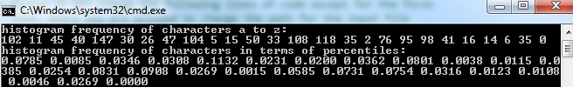

b) Code after modification :

#include "J:\ami\ami\common\book.h"

#include <cuda_runtime_api.h>

#include "device_launch_parameters.h"

#include <stdio.h>

#include <cuda.h>

#include <stdlib.h>

#include <time.h>

#include "..\..\ami\ami\common\cpu_bitmap.h"

#include<math.h>

#include "J:\ami\ami\common\cpu_anim.h"

/*

*

* Author: Brady Chen 4/12/2017

* Modified By:

* <Amikar Divij> <5/5/2017>

*

* This is a C code for the computation of a histogram of data from an input text file. The

* text file contains multiple lines of characters. The code generate the frequency histogram

* of characters from the input file.

*/

/*

*

* Definition of important values:

* MAX_TEXT_LINES -- maximum number of lines for the input file. We initially set to 1000

* If your file contains more than 1000, just change the value

* MAX_LINE_LENGTH -- the length of each line. You change the value

* NUMBER_OF_CHARS -- this the total number of characters used in the input file. We set

* the number to 128 which could include all the standard characters in

* the ASCII code table. If your input file contains more than 128 standard

* characters, please increase the number. For example, you should use 256

* for extended ASCII code.

* TOTAL_SIZE -- this is the total number of characters in the input file.

*

* NOTE: You can change the values of the varibales if necessary but please don't change the variable

* names themselves

*/

#define MAX_TEXT_LINES 4400

#define MAX_LINE_LENGTH 75

#define NUMBER_OF_CHARS 128

#define TOTAL_SIZE (MAX_TEXT_LINES + 10)*(MAX_LINE_LENGTH + 10)

/*

* Declaraion of the arrays of characters

* aTextData -- this is a two dimensional array of char. It contains all the characters

* inputted from the input file. The first index record the lines and the

* second index record the columns in each line. We add 10 on MAX_TEXT_LINES

* and MAX_LINE_LENGTH as safety spaces to crash on off-by-one errors.

*

* NOTE: No need to change this part

*/

char aTextData[MAX_TEXT_LINES + 10][MAX_LINE_LENGTH + 10];

char aFlattenedData[(MAX_TEXT_LINES + 10)*(MAX_LINE_LENGTH + 10)];

/*

*

* Declaration of function

* histogram() -- This function takes two arguments

* aText -- a two dimensional array of char.

* histo -- a one dimensional array which returns the frequency histogram

* of the characrers in the array aText

*/

__global__ void gpu_histogram(unsigned char *aText, unsigned int *histo);

int main(void)

{

/*

* Declaration of variables

* histo -- contains the frequency histogram of the characters

* lineBuffer -- line buffer for reading

* iTextSize -- how large is the array

* iTextUsed -- how many lines contained

*/

unsigned int histo[NUMBER_OF_CHARS];

char lineBuffer[MAX_LINE_LENGTH + 10];

int iTextSize = MAX_TEXT_LINES;

int iTextUsed = 0;

// clean the memory with zeros

memset(aTextData, 0, sizeof(aTextData));

memset(lineBuffer, 0, sizeof(lineBuffer));

/*

* Data read and conversion: The following lines of code do the following

* 1. Find the input file (in this case "input.txt)

* 2. Read the data from the input file and store it in a two dimensional

* array of char

*

*

*/

char *inputFile = "J:/FSD/FSD/input_test.txt"; // you may need to change the path depending on

// where you put the input file

// read input file into the array. use binary mode "rb"

FILE *fin = fopen(inputFile, "rb");

if (!fin) {

printf("cannot read %s\n", inputFile);

return 1;

}

// while not end of file, read another line

while (fgets(lineBuffer, sizeof(lineBuffer)-10, fin) != 0)

{

// check if array has space for another line

if (iTextUsed >= iTextSize)

{

printf("overflow: too many text lines\n");

return 1;

}

// strip CR/LF from line endings so we get pure text

char *psz = strchr(lineBuffer, '\r'); if (psz) *psz = '\0';

psz = strchr(lineBuffer, '\n'); if (psz) *psz = '\0';

// store the line

strncpy(aTextData[iTextUsed], lineBuffer, MAX_LINE_LENGTH);

aTextData[iTextUsed][MAX_LINE_LENGTH - 1] = '\0'; // safety

iTextUsed++;

}

fclose(fin);

/* end of the Data read and conversion */

/*

* Function call to compute the frequency histogram of the data

* 1. declare’s the blocks and threads

* 2. call’s the implemented kernel function gpu_histogram() .

* Please note that the kernel function DOES NOT take array as argument,

* not to mention two dimensional array in this case.

*/

unsigned int *histo1;

unsigned char *aText;

cudaMalloc((void**)&aText, TOTAL_SIZE);

cudaMemcpy(aText, aTextData, TOTAL_SIZE,

cudaMemcpyHostToDevice);

cudaMalloc((void**)&histo1,

NUMBER_OF_CHARS * sizeof(int));

cudaMemset(histo1, 0,

NUMBER_OF_CHARS * sizeof(int));

// kernel launch - 2x the number of mps gave best timing

cudaDeviceProp prop;

cudaGetDeviceProperties(&prop, 0);

unsigned int blocks = prop.multiProcessorCount;

gpu_histogram << <blocks * 2, NUMBER_OF_CHARS >> >(aText, histo1);

cudaMemcpy(histo, histo1,

NUMBER_OF_CHARS * sizeof(int),

cudaMemcpyDeviceToHost);

/*

*

* Output of histogram results

* the following is the output of the histogram frequency of characters in

* the order of ASCII code. the array histo[] contains the frequency histogram

* of 128 characters defined in ASCII.

* 1. The decimal values for the letters are

* A to Z -- 65 to 90

* a to z -- 97 to 122

* 2. the following lines of code print the histogram results for a to z, A to * Z. and both lower and upper case a to z with their percentiles.

*

*

*/

unsigned int histocount = 0; // total character count

printf("histogram frequency of characters a to z: \n");

for (int i = 97; i < 97 + 26; i++) {

histocount += histo[i];

printf("%d ", histo[i]);

}

printf("\n");

printf("histogram frequency of characters in terms of percentiles: \n");

for (int i = 97; i < 97 + 26; i++) {

printf("%.4f ", (float)histo[i] / (float)histocount);

}

printf("\n");

unsigned int histocount1 = 0; // total character count

printf("histogram frequency of characters A to Z: \n");

for (int i = 65; i < 65 + 26; i++) {

histocount1 += histo[i];

printf("%d ", histo[i]);

}

printf("\n");

printf("histogram frequency of characters in terms of percentiles for A to Z: \n");

for (int i = 65; i < 65 + 26; i++) {

printf("%.4f ", (float)histo[i] / (float)histocount1);

}

printf("\n");

unsigned int histocount2 = 0;

printf("histogram frequency of characters A to Z and a to z: \n");

for (int i = 0; i < 0 + 26; i++) {

histocount2 += histo[65 + i];

printf("%d ", histo[65+i]+histo[97+i]);

}

printf("\n");

unsigned int histocount3 = 0;

histocount3 = histocount + histocount1;

printf("histogram frequency of characters in terms of percentiles for A to Z and a to z: \n");

for (int i = 0; i < 0 + 26; i++) {

printf("%.4f ", ((float)histo[65 + i] + (float)histo[97 + i] ) / (float)histocount3);

}

/* code above here for computing the frequency histogram for all letters

* regardless low or up cases.

*

*/

cudaFree(histo);

cudaFree(aText);

cudaFree(aTextData);

return 0;

}

/*

*

* Implementation of function

* histogram() -- This function takes two pointer arguments

* aText -- a two dimensional array of char.

* histo -- a one dimensional array which returns the frequency histogram

* of the characrers in the array aText

*it used atomicadd to perform the increment function without causing any error due to *different threads accessing the same variable

*/

__global__ void gpu_histogram(unsigned char *aText, unsigned int *histo)

{

int i = threadIdx.x + blockIdx.x * blockDim.x;

int stride = blockDim.x * gridDim.x;

while (i < TOTAL_SIZE){

atomicAdd(&(histo[aText[i]]), 1);

i += stride;

}

}

c ) Result of GPU histogram on input_test

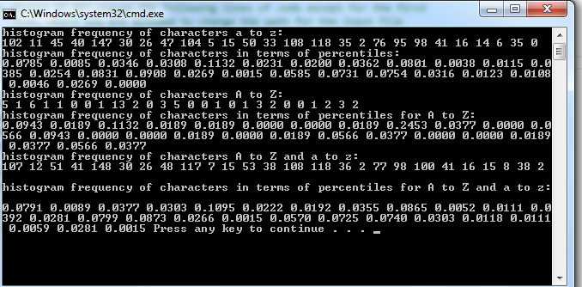

d) Result of GPU histogram on input_data

