# Investeeringud

### Klassid

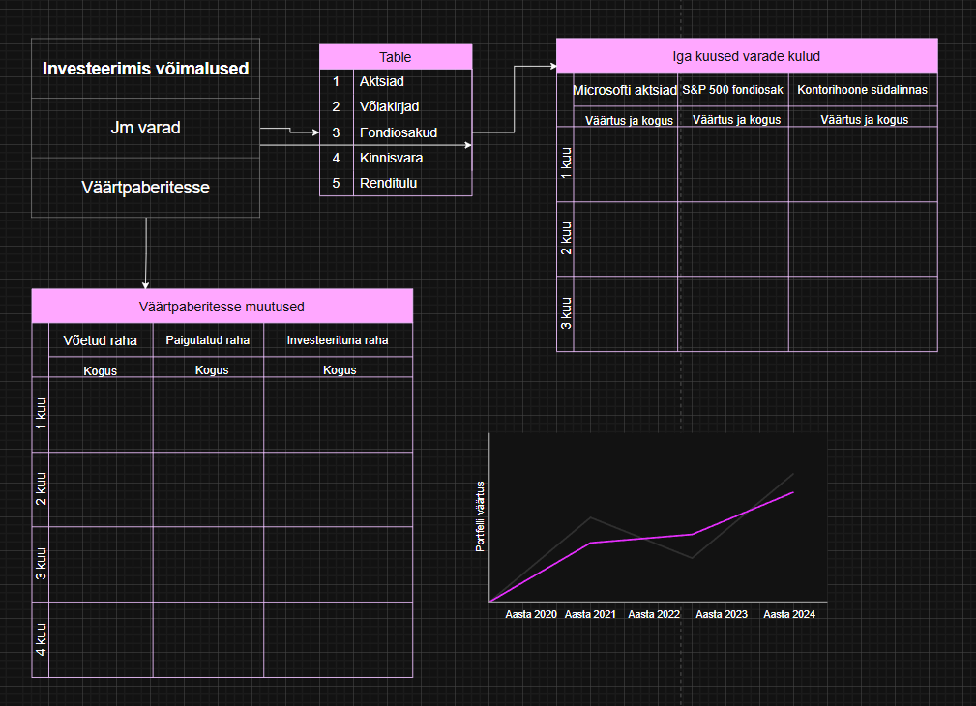 Omadused

|  |  |  |  |  |
| --- | --- | --- | --- | --- |
| Omadus | Tüüp | Pikkus | Kohustuslik | Unikaalne |
| Customer | | | | |
| Id | int | 1 | + | + |
| Name | string | Amilia | + |  |
| Address | string | Westwood 5 | + |  |
| Email | string | Midagi@gmail.com | + |  |
| Phone | string | + 909-390-0003 |  |  |
| Discount | decimal | 0.3 | + |  |
| Invoice | | | | |
| Id | int | 2 | + | + |
| Invoice No | string |  | + | + |
| Invoice Date | DateTime | 23.12.2026 | + |  |
| Due Date | DateTime | 23.12.2026 | + |  |
| Subtotal | decimal | 0.2 | + |  |
| Shipping | decimal | 0.4 | + |  |
| GrandTotal | decimal | 0.6 |  |  |
| Discount | decimal | 0.8 | + |  |
| Invoice line | | | | |
| Id | int | 3 | + | + |
| Line item | string | 255 | + |  |
| Unit price | decimal | 0.3 | + |  |
| Quantity | decimal | 0.5 | + |  |
| VatRate | decimal | 0.9 | + |  |
| Total | decimal | 0.9 | + |  |