

Functional Safety Concept Lane Assistance

**Document Version: [Version]**

**Template Version 1.0, Released on 2017-06-21**



# Document history

**[Instructions: Fill in the date, version and description fields. You can fill out the Editor field with your name if you want to do so. Keep track of your editing as if this were a real world project.**

**For example, if this were your first draft or first submission, you might say version 1.0. If this is a second submission attempt, then you'd add a second line with a new date and version 2.0]**

|  |  |  |  |
| --- | --- | --- | --- |
| Date | Version | Editor | Description |
| 2019-02-01 | 1.0 | Amilendra Kodithuwakku | Initial draft |
|  |  |  |  |
|  |  |  |  |
|  |  |  |  |
|  |  |  |  |

# Table of Contents

**[Instructions: We have provided a table of contents. If you change the document structure, please update the table of contents accordingly. The table of contents should show each section of the document and page numbers or links. Most word processors can do this for you. In** [**Google Docs**](https://support.google.com/docs/answer/116338?co=GENIE.Platform%3DDesktop&hl=en)**, you can use headings for each section and then go to Insert > Table of Contents.** [**Microsoft Word**](https://support.microsoft.com/en-us/help/285059/how-to-create-a-table-of-contents-by-marking-text-in-word) **has similar capabilities]**

Document history

Table of Contents

Purpose of the Functional Safety Concept

Inputs to the Functional Safety Analysis

Safety goals from the Hazard Analysis and Risk Assessment

Preliminary Architecture

Description of architecture elements

Functional Safety Concept

Functional Safety Analysis

Functional Safety Requirements

Refinement of the System Architecture

Allocation of Functional Safety Requirements to Architecture Elements

Warning and Degradation Concept

# Purpose of the Functional Safety Concept

**[Instructions: Answer what is the purpose of a functional safety concept?]**

The functional safety concept attaches attributes such as the ASIL level, fault tolerant time interval. safe state into each item in the system architecture that implements the safety requirements of the system, by looking at the general functionality of each item. The verification and validation steps needed to prove that each item meets the safety requirements are also included in the functional safety concept.

# Inputs to the Functional Safety Concept

## Safety goals from the Hazard Analysis and Risk Assessment

**[Instructions:**

**REQUIRED:**

**Provide the lane departure warning and lane keeping assistance safety goals as discussed in the lessons and derived in the hazard analysis and risk assessment.**

**OPTIONAL:**

**If you expanded the hazard analysis and risk assessment to include other safety goals, include them here.**

**]**

|  |  |
| --- | --- |
| **ID** | **Safety Goal** |
| Safety_Goal_01 | The oscillating steering torque from the lane departure warning function shall be limited. |
| Safety_Goal_02 | The lane keeping assistance function shall be time limited and the additional steering torque shall end after a given time interval so that the driver cannot misuse the system for autonomous  driving. |

## Preliminary Architecture

**[Instructions: Provide a preliminary architecture for the lane assistance item. Hint: See Lesson 3: Item Definition]**

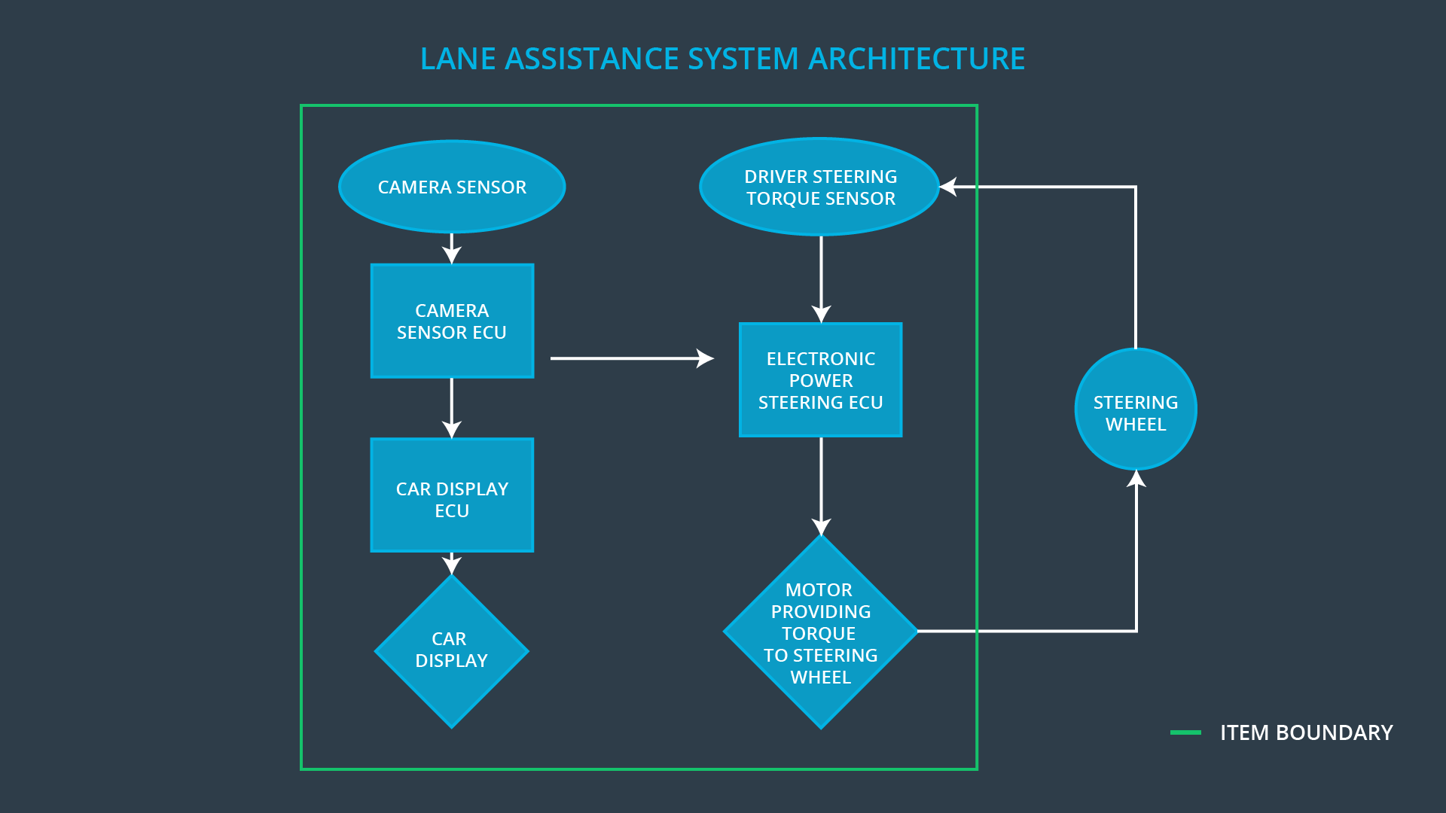

### Description of architecture elements

**[Instructions: Provide a description for each of the item elements; what is each element's purpose in the lane assistance item? ]**

|  |  |
| --- | --- |
| **Element** | **Description** |
| Camera Sensor | The camera sensor reads in images from the road and surroundings |
| Camera Sensor ECU | The Camera sensor ECU identifies when the vehicle has accidentally departed its lane, and sends the appropriate messages to the Car Display ECU and the Electronic Power Steering ECU. |
| Car Display | The car display shows visual feedback to the driver |
| Car Display ECU | Receives messages from the Camera Sensor ECU and creates and sends the visual feedback shown by the Car Display. |
| Driver Steering Torque Sensor | Reads the torque applied to the Steering wheel and sends messages to the Electronic Power Steering ECU |
| Electronic Power Steering ECU | Identifies when to deactivate the Lane Keep Assistance functionality. Also identifies the torque that needs to be applied to the Steering Wheel, and sends appropriate messages to the Motor. |
| Motor | Receives messages from the Electronic Power Steering ECU and applies the required torque to the Steering wheel. |

# Functional Safety Concept

The functional safety concept consists of:

* Functional safety analysis
* Functional safety requirements
* Functional safety architecture
* Warning and degradation concept

## Functional Safety Analysis

**[Instructions: Fill in the functional safety analysis table below.]**

|  |  |  |  |
| --- | --- | --- | --- |
| **Malfunction ID** | **Main Function of the Item Related to Safety Goal Violations** | **Guidewords (NO, WRONG, EARLY, LATE, MORE, LESS)** | **Resulting Malfunction** |
| Malfunction_01 | Lane Departure Warning (LDW) function shall apply an oscillating steering torque to provide the driver a haptic feedback | MORE | The lane departure warning function applies an oscillating torque with very high torque amplitude (above limit) |
| Malfunction_02 | Lane Departure Warning (LDW) function shall apply an oscillating steering torque to provide the driver a haptic feedback | MORE | The lane departure warning function applies an oscillating torque with very high torque frequency (above limit) |
| Malfunction_03 | Lane Keeping Assistance (LKA) function shall apply the steering torque when active in order to stay in ego lane | NO | The lane keeping assistance function is not limited in time duration which leads to misuse as an autonomous driving function. |

## Functional Safety Requirements

**[Instructions: Fill in the functional safety requirements for the lane departure warning ]**

Lane Departure Warning (LDW) Requirements:

|  |  |  |  |  |
| --- | --- | --- | --- | --- |
| **ID** | **Functional Safety Requirement** | **ASIL** | **Fault Tolerant Time Interval** | **Safe State** |
| Functional  Safety  Requirement  01-01 | The Electronic Power Steering ECU shall ensure that the lane departure oscillating torque amplitude is below Max_Torque_Amplitude | C | 50 ms | ZERO |
| Functional  Safety  Requirement  01-02 | The Electronic Power Steering ECU shall ensure that the lane departure oscillating torque frequency is below Max_Torque_Frequency | C | 50 ms | ZERO |

Lane Departure Warning (LDW) Verification and Validation Acceptance Criteria:

|  |  |  |
| --- | --- | --- |
| **ID** | **Validation Acceptance**  **Criteria and Method** | **Verification Acceptance**  **Criteria and Method** |
| Functional  Safety  Requirement  01-01 | Test how drivers react to different torque amplitudes and validate that we have chosen an appropriate value for Max_Torque_Amplitude | Verify that if the torque amplitude exceeds Max_Torque_Amplitude for 50 ms, the Lane Departure Warning (LDW) System output is set to zero |
| Functional  Safety  Requirement  01-02 | Test how drivers react to different torque frequencies and validate that we have chosen an appropriate value for Max_Torque_Frequency | Verify that if the torque frequency exceeds Max_Torque_Frequency for 50 ms, the Lane Departure Warning (LDW) System output is set to zero |

**[Instructions: Fill in the functional safety requirements for the lane keeping assistance]**

Lane Keeping Assistance (LKA) Requirements:

|  |  |  |  |  |
| --- | --- | --- | --- | --- |
| **ID** | **Functional Safety Requirement** | **ASIL** | **Fault Tolerant Time Interval** | **Safe State** |
| Functional  Safety  Requirement  02-01 | The electronic power steering ECU shall ensure that the lane keeping assistance torque is applied for only Max_Duration | C | 500 ms | OFF |

Lane Keeping Assistance (LKA) Verification and Validation Acceptance Criteria:

|  |  |  |
| --- | --- | --- |
| **ID** | **Validation Acceptance**  **Criteria and Method** | **Verification Acceptance**  **Criteria and Method** |
| Functional  Safety  Requirement  02-01 | Test how drivers react to different time limits and validate that it is more likely to keep their hands on the wheel at all times when Max_Duration is used. | Verify that the Lane Keeping Assistance (LKA) System output switches off after being active for Max_Duration. |

## Refinement of the System Architecture

**[Instructions: Include the refined system architecture. Hint: The refined system architecture should include the system architecture from the end of the functional safety lesson including all of the ASIL labels.]**

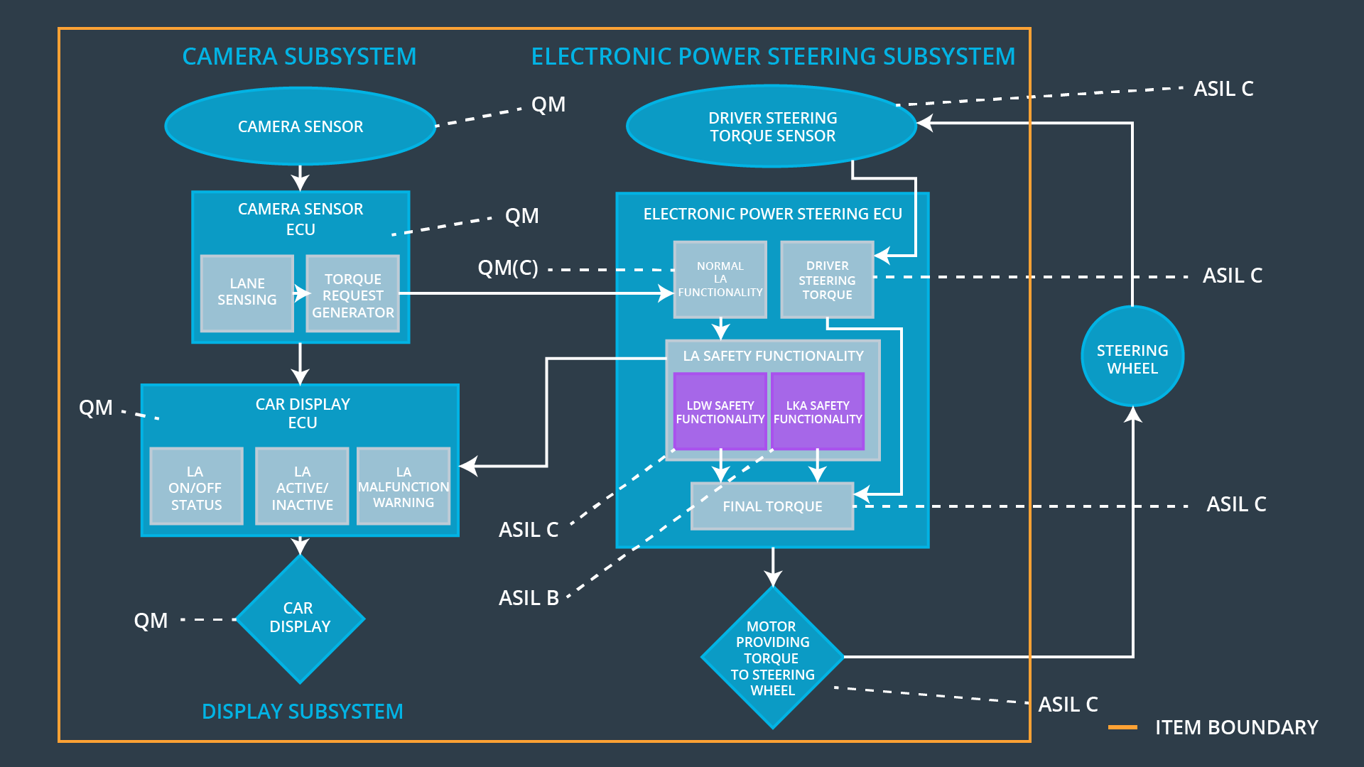

## Allocation of Functional Safety Requirements to Architecture Elements

**[Instructions: Mark which element or elements are responsible for meeting the functional safety requirement. Hint: Only one ECU is responsible for meeting all of the requirements.]**

|  |  |  |  |  |
| --- | --- | --- | --- | --- |
| **ID** | **Functional Safety Requirement** | **Electronic Power Steering ECU** | **Camera ECU** | **Car Display ECU** |
| Functional  Safety  Requirement  01-01 |  | **X** |  |  |
| Functional  Safety  Requirement  01-02 |  | **X** |  |  |
| Functional  Safety  Requirement  02-01 |  | **X** |  |  |

## Warning and Degradation Concept

**[Instructions: Fill in the warning and degradation concept.]**

|  |  |  |  |  |
| --- | --- | --- | --- | --- |
| **ID** | **Degradation Mode** | **Trigger for Degradation Mode** | **Safe State invoked?** | **Driver Warning** |
| WDC-01 | Turn Off | Malfunction_01  Malfunction_02 | Yes | No Warning needed. |
| WDC-02 | Turn Off | Malfunction_02 | Yes | Warning Light |