The US should have a law that prevents content providers from paying ISPs for any type of preferential treatment (e.g. paid prioritization, zero rating).

“people see life as a central service” lmao

Arguments:

1. The internet is not broken
   1. “The internet wasn’t broken in 2015,” when net neutrality was implemented and “it certainly wasn’t heavy-handed government regulation” that was responsible for the “phenomenal development of the internet.”[1]
      1. There aren’t widespread infrastructure/peering relationship issues that have an undue effect on one's ability to use the internet
   2. “We have had a decade of experience with broadband ISPs with little evidence of wrongdoing.”[2]
      1. Before NE became a hot button issue under Obama, and since NE laws have been repealed under Trump, ISPs haven’t engaged in systematic throttling or censoring, as people fear will happen in a world without NE
2. What, then, is Net Neutrality (NE) and why is it needed?
   1. NE is needed to respond to fears of censorship and throttling by ISPs with political views and economic incentive.
      1. i.e. Comcast is going to stop me from watching Netflix at reliable speeds, so I use their content platforms instead
   2. It is supposed to alleviate these fears by mandating neutrality in the peering relationships that describe the larger internet.
      1. This means that ISPs wouldn't be able to prioritize some types of traffic over others, or some sources of traffic over other
   3. This argument has been voiced and supported by a number of large web-based tech companies like Google, Amazon, Facebook, and Netflix
3. In conversations about Net Neutrality in 2014, Netflix and its CEO Reed Hastings featured prominently. This is due to the drop in service preceding 2014, represented in the graph:
   1. 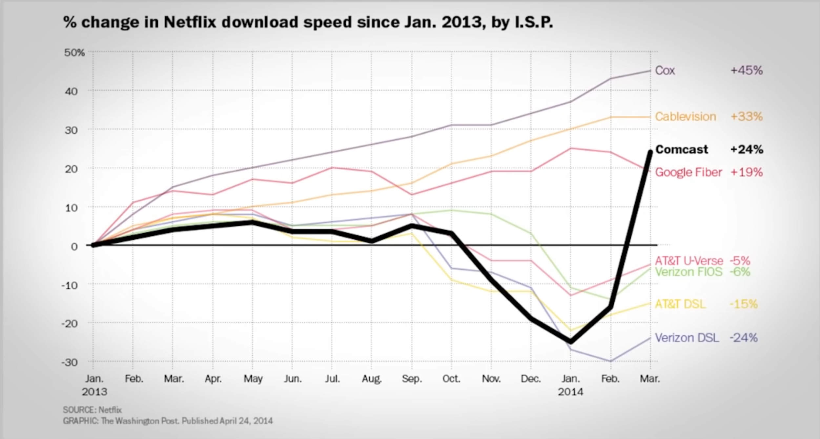
   2. Netflix ended up having to pay Comcast an undisclosed sum to prioritize their service in order to meet customer needs, as shown in the graph.
   3. This case was widely seen as a powerful example of the dangers of an internet without NE.
   4. However, such arguments ignore the fact that the drop in service wasn’t due to Comcast not being a cooperative business partner – rather, performance drops occurred due to Comcast’s infrastrucuture not being able to handle the massive increase in High Defintion vidoe data moving though its networks
   5. The point is that our fears about the internet shouldnt be directed at peering policies -- the issue is infrastructure, and the uproar caused by concerns of Net Nuetrality are historically unsubstanitated
4. Questioning Net Neutrality
   1. Doesn't address primary issue of infrastructure
      1. ISPs don’t want to invest in infrastructure to handle more traffic, if they can’t capitalize or otherwise manage
         1. Between 2011 and 2015, when neutrality rules were being debated by the FCC, the mere threat of implementing them reduced ISPs investments in network upgrades by 20-30%, a $150-$200 billion reduction in investment. [[13](https://www.procon.org/headlines/should-net-neutrality-be-restored-top-3-pros-and-cons/#13)]
         2. During the years that net neutrality rules were in place (2015-2017), investment in broadband fell for the first time ever in a non-recession period. [[10](https://www.procon.org/headlines/should-net-neutrality-be-restored-top-3-pros-and-cons/#10)][[28](https://www.procon.org/headlines/should-net-neutrality-be-restored-top-3-pros-and-cons/#28)]
      2. Companies shouldn’t be able to pay baseline amounts for internet access, even though they generate a majority of traffic, and make their livelihoods on the connectivity guaranteed by ISPs infrastructure
         1. We should be suspicious of giant tech companies trying to lobby for net neutrality, or denying their role in investing in broadband infrastructure
         2. Essentially, they are advocating for passing costs onto other consumers, who end up footing the bill through higher costs
   2. Can't optimize user experience/It doesn't describe the type of behavior we should want
      1. Traffic is not created equal -> NE would limit our ability to optimize user experience by outlawing packet discriminiation
         1. We should want ISPs to discriminate on types of traffic anyway, which would be disposed of under NE
         2. Packets for downloading files should not be given the same priority as packets meant for streaming
   3. It represents an overstep by the FCC, and an unnecessary burden on ISPs
   4. If the problem is infrastructure, then the solution is not NE
   5. Net neutrality will have feedback effects, and worsen infrastructure gaps
5. Conclusion
   1. Net Neutrality is an overstep in relation to the issue it is trying to solve
      1. Net Neutrality adds no small amount of regulation and extra paperwork; extra costs passed to the consumer
         1. In 2017, the FCC reported that neutrality rules imposed significant and “unnecessary” reporting burdens on ISPs to prove they were in compliance. For example, the ISP CenturyLink estimated that meeting the net neutrality rules created over 5,000 hours of extra paperwork, costing over $134,000 each year. [[10](https://www.procon.org/headlines/should-net-neutrality-be-restored-top-3-pros-and-cons/#10)]
   2. In addition to being burdensome for ISPs, net neutrality regulations exceed the FCC’s authority.
      1. According to the editors of the *National Review*, the net neutrality rules exceeded “the agency’s statutory mandate,” and “there is no title or provision in the *Federal Communication Act* that gives the agency a clear mandate to impose pricing and content-management rules on Internet providers, which is what net neutrality does.” [[31](https://www.procon.org/headlines/should-net-neutrality-be-restored-top-3-pros-and-cons/#31)]
   3. The extension of the conversation into peering represents an overstep
6. Extra stuff:
   1. companies already pay for prioritized access with CDNs

1. Ajit Pai, “Oral Statement of Chairman Ajit Pai,” fcc.gov, Dec. 14, 2017
2. Gerald R. Faulhaber, “Economics of Net Neutrality: A Review,” Communications & Convergence Review, 2011