Longitudinal Data Analysis for the Clinical Sciences

# Introduction

In this document, I introduce the tools and methods for conducting longitudinal data analysis in R.

# Importing data and Quality Assurance (QA)

First, we will check to which folder the working directory is set. You can think of the working directory as the folder on the computer in which R will look for files and in which R will store files that you create. Running the "get working directory" command should return the My Documents folder (or similar).

getwd()

## [1] "C:/Users/u6015231/Documents"

Outside of R, we created a project folder called "LMER_Clinical_Science". Let's now set our working directory to that folder. The exact code will be different on your computer, but it should be something like:

setwd("C:/Users/u6015231/Documents/GitHub/LMER_Clinical_Science/")

Now that we have set the working directory to our project folder. We can see what files are inside. We can also see what files are inside the "data" sub-folder by including the "./" characters in our code. Including the "." means to append all of the characters that follow to the address of the working directory. This can be a big time saver, because we don't want to be retyping the working directory all of the time.

list.files()

## [1] "data" "lohse ACRM 2017 workshop.pptx"  
## [3] "READ_ME.txt" "scripts"

# These are all of the files/folders in the working directory.  
list.files("./data/")

## [1] "data_DIFF_UNIQUE.txt" "data_DIFFICULTY.txt"   
## [3] "data_LOHSE_EXAMPLE.csv" "data_LOHSE_EXAMPLE.xlsx"  
## [5] "data_UNIQUE.csv" "individual_slopes.csv"   
## [7] "long_3_missing_data.txt" "MPLS.LS.csv"   
## [9] "MPLS.LS.Rdata" "MPLS.Rdata"   
## [11] "MPLS.W.Rdata" "MPLScomp1.txt"   
## [13] "MPLScomp2.txt" "MPLSdata.txt"   
## [15] "MPLSdata_Chapt1.csv" "MPLSdata_Chapt1.txt"   
## [17] "MPLSdata_Chapt8.txt"

# These are all of the files in the data sub-folder of the working directory.

Next, we will want to open several packages whose functions we will want to use. Packages contain custom written functions that allow you perform tasks beyond the basic capabilities of R. All of the packages we will use have validated and peer-reviewed documentation, so we can be sure these functions are working correctly.

We will need to install these packages the very first time we want to use them. After a package is installed, you can import its functions into R using the library() function. Because I already have these packages installed on my machine, I have "commented out" the installation code using a "#". To install these packages, simply delete the "#" and run the code as written.

If you are new to coding, comments are an author's way of telling the computer that everything that comes after the symbol is not code to run. Thus, by using comments, you can leave useful notes to yourself and others!

# install.packages("ggplot2"); install.packages("lme4");   
# install.packages("dplyr"); install.packages("AICcmodavg")  
library("ggplot2");library("lme4");library("dplyr");library("AICcmodavg")

## Warning: package 'ggplot2' was built under R version 3.4.2

## Warning: package 'lme4' was built under R version 3.4.2

## Loading required package: Matrix

## Warning: package 'dplyr' was built under R version 3.4.2

##   
## Attaching package: 'dplyr'

## The following objects are masked from 'package:stats':  
##   
## filter, lag

## The following objects are masked from 'package:base':  
##   
## intersect, setdiff, setequal, union

##   
## Attaching package: 'AICcmodavg'

## The following object is masked from 'package:lme4':  
##   
## checkConv

Next, we will read in a "dummy" dataset that I created. This data emulates data structures in the Brain Recovery Core Database. See Lang et al. *J Neurologic Physical Therapy*. 2011 and Lohse et al. *Arch Phys Med Rehabil*. 2016.

DATA<-read.csv("./data/data_LOHSE_EXAMPLE.csv", header = TRUE)   
DATA[1:20,c(1,2,4,5,6,8,10,12)]

## subID time IRF DPS Age BERG X10mSpeed ARAT  
## 1 p01 -1 1 67 58 7 0.0000000 NA  
## 2 p01 0 1 67 58 6 0.0000000 57  
## 3 p01 1 1 67 58 21 0.0000000 58  
## 4 p01 2 1 67 58 22 NA 58  
## 5 p01 3 1 67 58 26 0.1294666 58  
## 6 p01 4 1 67 58 23 0.1214329 58  
## 7 p02 -1 0 680 50 NA NA NA  
## 8 p02 0 0 680 50 3 0.0000000 34  
## 9 p02 1 0 680 50 NA NA 41  
## 10 p02 2 0 680 50 NA NA 44  
## 11 p02 3 0 680 50 4 0.0000000 40  
## 12 p02 4 0 680 50 NA NA 45  
## 13 p02 5 0 680 50 4 0.0000000 45  
## 14 p02 6 0 680 50 5 0.0000000 46  
## 15 p03 -1 0 55 63 3 NA NA  
## 16 p03 0 0 55 63 33 0.1954652 0  
## 17 p03 1 0 55 63 38 0.2687450 0  
## 18 p03 2 0 55 63 40 0.3092146 0  
## 19 p03 3 0 55 63 44 0.4189359 3  
## 20 p03 4 0 55 63 47 0.4878049 7

# Note that I am calling the dataframe "DATA", but you can call it anything.  
# For the ease of reading, I am also only printing select columns and the   
# first 20 rows of the data frame.

Clearly the raw data is a bit of a mess, but notice NAs in multiple rows and columns. Some participants are missing data for entire assessments, others are missing data for individual timepoints.

Even though this dataset is relatively small, it can be good for us to get a quick summary of the data by using either the head() function (which lets us look at the first six rows) or the str() function (which tells us the structure of the dataframe variable by variable).

# Note that now I am looking at all of the columns, but only the first six rows.  
head(DATA)

## subID time event_name IRF DPS Age Sex BERG BERG_ACUTE_AD  
## 1 p01 -1 00_acuteadmission 1 67 58 Male 7 7  
## 2 p01 0 01_admission_arm_1 1 67 58 Male 6 7  
## 3 p01 1 05_onemonths_evalu_arm_1 1 67 58 Male 21 7  
## 4 p01 2 06_twomonths_evalu_arm_1 1 67 58 Male 22 7  
## 5 p01 3 07_threemonths_eva_arm_1 1 67 58 Male 26 7  
## 6 p01 4 08_fourmonths_eval_arm_1 1 67 58 Male 23 7  
## X10mSpeed X10mWT_ACUTE_AD ARAT  
## 1 0.0000000 0 NA  
## 2 0.0000000 0 57  
## 3 0.0000000 0 58  
## 4 NA 0 58  
## 5 0.1294666 0 58  
## 6 0.1214329 0 58

# The structure function does not show data, but instead shows properties of   
# the different columns/variables.  
str(DATA)

## 'data.frame': 60 obs. of 12 variables:  
## $ subID : Factor w/ 12 levels "p01","p02","p03",..: 1 1 1 1 1 1 2 2 2 2 ...  
## $ time : int -1 0 1 2 3 4 -1 0 1 2 ...  
## $ event_name : Factor w/ 10 levels "00_acuteadmission",..: 1 2 3 4 5 7 1 2 3 4 ...  
## $ IRF : int 1 1 1 1 1 1 0 0 0 0 ...  
## $ DPS : int 67 67 67 67 67 67 680 680 680 680 ...  
## $ Age : int 58 58 58 58 58 58 50 50 50 50 ...  
## $ Sex : Factor w/ 2 levels "Female","Male": 2 2 2 2 2 2 1 1 1 1 ...  
## $ BERG : int 7 6 21 22 26 23 NA 3 NA NA ...  
## $ BERG_ACUTE_AD : int 7 7 7 7 7 7 NA NA NA NA ...  
## $ X10mSpeed : num 0 0 0 NA 0.129 ...  
## $ X10mWT_ACUTE_AD: num 0 0 0 0 0 0 NA NA NA NA ...  
## $ ARAT : int NA 57 58 58 58 58 NA 34 41 44 ...

# Creating Basic Plots

We are now ready to create some basic plots using the ggplot2 package. In these visualizations, we will be plotting Berg Balance Scale scores over time with a separate panel for each subject. We will get into all of the details of how to generate this kind of plot later, but in brief, this plot is composed of several different elements:

* Our x- and y-axes are always time from outpatient admission and *Berg Balance Scale* (BBS) scores, respectively.
* In each plot, we have separate data points and lines connecting them (ggplot refers to these objects as *geoms*).
* Over the top of these data points, we plot the linear model for the line of best fit.
* Finally, all of these elements are *faceted* so that each facet plots the data for a different participant.

myX<-scale_x_continuous(name = "Time (Months from Outpatient Admission)")  
myY<-scale_y_continuous(name = "Berg Balance Scale")  
g1<-ggplot(data=DATA, aes(x = time, y = BERG, group = subID))+geom_line()  
g2<-g1+geom_point()+facet_wrap(~subID)+myX+myY  
g3<-g2 + stat_smooth(method=lm, se=FALSE)  
plot(g3)

## Warning: Removed 12 rows containing non-finite values (stat_smooth).

## Warning: Removed 6 rows containing missing values (geom_path).

## geom_path: Each group consists of only one observation. Do you need to  
## adjust the group aesthetic?

## Warning: Removed 12 rows containing missing values (geom_point).

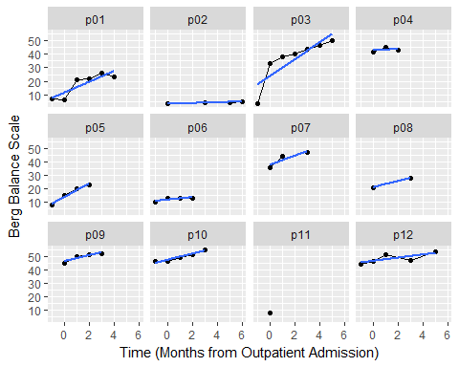

Note that participants have different amounts of data collected at different time points. This is one of the strengths of the linear mixed-effects regression (LMER) approach. If we were using RM ANOVA, we would need to throw out any participants with missing data! Using LMER, however, we can include participants with missing data and participants whose data were collected at different times.

These visualizations are obviously important for publications, but they also help us understand our data better throughout our analysis. As such, sometimes we will spend a lot of time creating a publication quality visualization, whereas other times we will want some quick and simple visualizations that help us understand the data better.

There are also some basic functions that help us understand our data better and get summary statistics quickly. Specifically, we will use the head(), tail(), and summary() functions.

head(DATA) # Peak at the top rows.

## subID time event_name IRF DPS Age Sex BERG BERG_ACUTE_AD  
## 1 p01 -1 00_acuteadmission 1 67 58 Male 7 7  
## 2 p01 0 01_admission_arm_1 1 67 58 Male 6 7  
## 3 p01 1 05_onemonths_evalu_arm_1 1 67 58 Male 21 7  
## 4 p01 2 06_twomonths_evalu_arm_1 1 67 58 Male 22 7  
## 5 p01 3 07_threemonths_eva_arm_1 1 67 58 Male 26 7  
## 6 p01 4 08_fourmonths_eval_arm_1 1 67 58 Male 23 7  
## X10mSpeed X10mWT_ACUTE_AD ARAT  
## 1 0.0000000 0 NA  
## 2 0.0000000 0 57  
## 3 0.0000000 0 58  
## 4 NA 0 58  
## 5 0.1294666 0 58  
## 6 0.1214329 0 58

tail(DATA) # Peak at the bottom rows.

## subID time event_name IRF DPS Age Sex BERG  
## 55 p11 0 01_admission_arm_1 1 334 65 Male 8  
## 56 p12 -1 00_acuteadmission 0 10 71 Female 44  
## 57 p12 0 01_admission_arm_1 0 10 71 Female 46  
## 58 p12 1 05_onemonths_evalu_arm_1 0 10 71 Female 51  
## 59 p12 3 07_threemonths_evalu_arm_1 0 10 71 Female 47  
## 60 p12 5 09_fivemonths_eva_arm_1 0 10 71 Female 53  
## BERG_ACUTE_AD X10mSpeed X10mWT_ACUTE_AD ARAT  
## 55 8 0.120 0.12 45  
## 56 44 0.110 0.11 NA  
## 57 44 0.610 0.11 57  
## 58 44 0.840 0.11 58  
## 59 44 0.885 0.11 58  
## 60 44 0.795 0.11 58

summary(DATA$time) # Using the summary function on a numeric variable

## Min. 1st Qu. Median Mean 3rd Qu. Max.   
## -1.000 0.000 1.000 1.383 3.000 6.000

summary(DATA$event_name) # Using the summary function on a factor variable

## 00_acuteadmission 01_admission_arm_1   
## 11 12   
## 05_onemonths_evalu_arm_1 06_twomonths_evalu_arm_1   
## 13 10   
## 07_threemonths_eva_arm_1 07_threemonths_evalu_arm_1   
## 5 1   
## 08_fourmonths_eval_arm_1 09_fivemonths_eva_arm_1   
## 3 1   
## 09_fivemonths_eval_arm_1 10_sixmonths_evalu_arm_1   
## 2 2

# Creating Tidy Data

The goal of *tidy* data is to structure our data in such a way that the data are easy for a computer to work with. In general, this means that our data are in "long" format, where every row is a separate observation and every column is a unique dependent variable (see Wickham, *J Stat Soft*, 2014). Our practice dataset already adheres to these principles. For your own data (or other data you might encounter "in the wild"), you will want to start collecting data in this long format or learn how to transform data from wide to long format. (Note that long format is also often referred to as "person-period" format because each row is a unique time-point for each person, whereas wide format is also referred to as "person" format because each row is a unique person, but the time-points are in different columns.)

Next, we are going to filter out data to remove some unwanted observations. Specifically, we can create a new dataset that removes the row for the acute admission time-point from each participant. We are doing this because we already have separate columns in our dataset that give the acute admission scores. These variables are *static* variables, meaning that they do not change overtime for our individuals. All acute admission time points are coded as -1 in the *time* variable, so we can remove those data points like this:

DAT2<-subset(DATA, time != -1)  
head(DAT2)

## subID time event_name IRF DPS Age Sex BERG  
## 2 p01 0 01_admission_arm_1 1 67 58 Male 6  
## 3 p01 1 05_onemonths_evalu_arm_1 1 67 58 Male 21  
## 4 p01 2 06_twomonths_evalu_arm_1 1 67 58 Male 22  
## 5 p01 3 07_threemonths_eva_arm_1 1 67 58 Male 26  
## 6 p01 4 08_fourmonths_eval_arm_1 1 67 58 Male 23  
## 8 p02 0 01_admission_arm_1 0 680 50 Female 3  
## BERG_ACUTE_AD X10mSpeed X10mWT_ACUTE_AD ARAT  
## 2 7 0.0000000 0 57  
## 3 7 0.0000000 0 58  
## 4 7 NA 0 58  
## 5 7 0.1294666 0 58  
## 6 7 0.1214329 0 58  
## 8 NA 0.0000000 NA 34

Note that in our new dataset (*DAT2*) the time variable only ranges from 0 to 6 months.

summary(as.factor(DAT2$time))

## 0 1 2 3 4 5 6   
## 12 11 10 8 3 3 2

# We are using the as.factor() funtion to treat time as a factor even though it  
# is numeric. As such, the summary function returns the different categories of   
# time (top row) and the number of observations in each category (bottom row).

# Visualizing Longitudinal Data

## Spaghetti Plots

Longitudinal data analysis is all about seeing how our data change over time. As such, most of the time we will be plotting our dependent variable on the y-axis and time on the x-axis and using different symbols/colors to denote different groups of participants. One of the most common plots for achieving this function is the *spaghetti plot* which plots the dependent variable over time with a separate line for each participant (in a shape vaguely reminiscent of spaghetti!). We will create these plots for all of our dependent variables: the *Berg Balance Scale* (BBS), the *10-meter Walk Test* (10mWT), and the *Action Research Arm Test* (ARAT).

### Berg Balance Scale

myX<-scale_x_continuous(name = "Time (Months from Outpatient Admission)")  
myY<-scale_y_continuous(name = "Berg Balance Scale")  
g1<-ggplot(data=DAT2, aes(x=time, y = BERG, group=subID))+geom_line()+myX+myY  
g2<-g1+theme_bw()  
print(g2)

## Warning: Removed 1 rows containing missing values (geom_path).

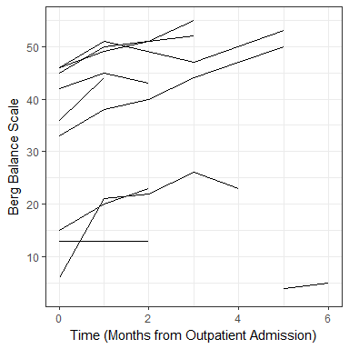

### 10 Meter Walk Test

myX<-scale_x_continuous(name = "Time (Months from Outpatient Admission)")  
myY<-scale_y_continuous(name = "Ten Meter Walk Test (m/s)")  
g1<-ggplot(data=DAT2, aes(x=time, y = X10mSpeed, group=subID))+geom_line()+myX+myY  
g2<-g1+theme_bw()  
print(g2)

## Warning: Removed 2 rows containing missing values (geom_path).

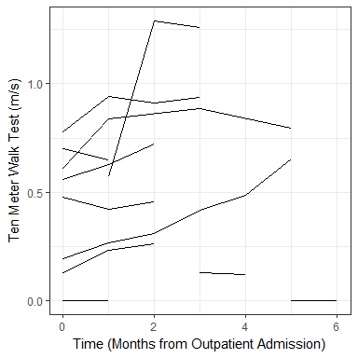

### Action Research Arm Test

myX<-scale_x_continuous(name = "Time (Months from Outpatient Admission)")  
myY<-scale_y_continuous(name = "Action Research Arm Test")  
g1<-ggplot(data=DAT2, aes(x=time, y = ARAT, group=subID))+geom_line()+myX+myY  
g2<-g1+theme_bw()  
print(g2)

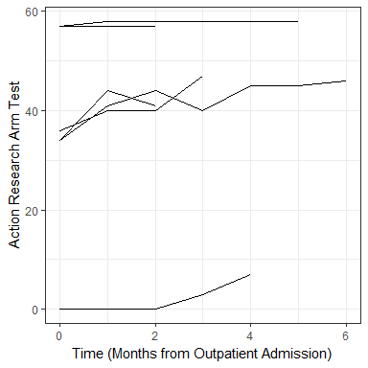

## Faceted/Lattice Plots

Similar to the spaghetti plot, we can create *faceted* plots (also known as *lattice* plots) in which different participants or groups are shown in different facets of the same plot. Grouping our data into facets can be a very effective way to visualize data, especially when our datasets are large (which can make spaghetti plots very hard to interpret). In the plots below, we will create facets for individual participants. These plots can be great, because they show individual participant data very clearly... but these plots are also limited because it can be difficult to meaningfully plot data from a lot of participants at once. As such, in large datasets, we will sometimes select a subset of participants and then create a facet plot for that subset.

### Berg Balance Scale

myX<-scale_x_continuous(breaks = 0:12,   
 name = "Time (Months from OutPatient Admission)")  
myY<-scale_y_continuous(name = "Berg Balance Scale")  
g5<-ggplot(data=DAT2, aes(x = time, y = BERG, group = subID))+geom_line()  
g6<-g5+geom_point()+facet_wrap(~subID)+myX+myY  
plot(g6)

## Warning: Removed 1 rows containing missing values (geom_path).

## Warning: Removed 7 rows containing missing values (geom_point).

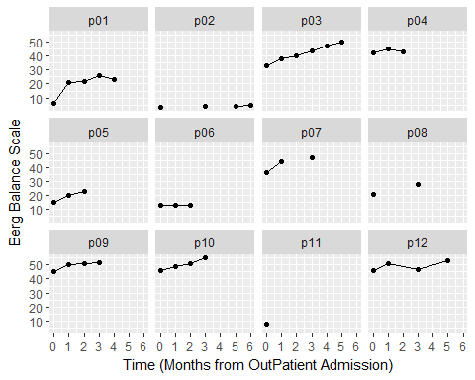

### Action Research Arm Test

myX<-scale_x_continuous(breaks = 0:12,   
 name = "Time (Months from OutPatient Admission)")  
myY<-scale_y_continuous(name = "ARAT")  
g1<-ggplot(data=DAT2, aes(x = time, y = ARAT, group = subID))+geom_line()  
g2<-g1+geom_point()+facet_wrap(~subID)+myX+myY  
plot(g2)

## Warning: Removed 12 rows containing missing values (geom_point).

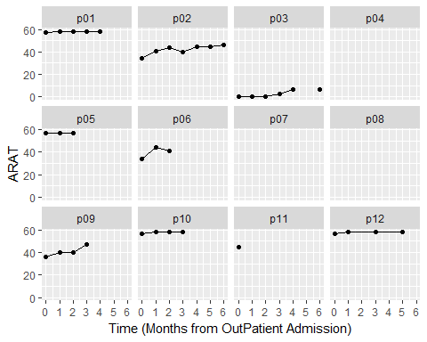

### 10 Meter Walk Test

myX<-scale_x_continuous(breaks = 0:12,   
 name = "Time (Months from OutPatient Admission)")  
myY<-scale_y_continuous(name = "10m Walk Test")  
g7<-ggplot(data=DAT2, aes(x = time, y = X10mSpeed, group = subID))+geom_line()  
g8<-g7+geom_point()+facet_wrap(~subID)+myX+myY  
plot(g8)

## Warning: Removed 2 rows containing missing values (geom_path).

## Warning: Removed 9 rows containing missing values (geom_point).

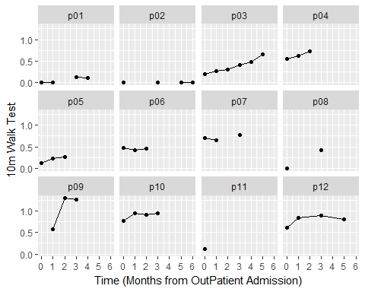

## Conditional Plots

We can also make aspects of our plots conditional on some properties of the data. For instance, we can make the shape of our data-points conditional on whether or not a participant went to an inpatent rehabilitation facility (IRF).

In this case, we can do this by adding an additional "shape" argument to our graphing code.

# First we will create a factor out of the IRF variable (which is coded as   
# 1s and 0s).  
DAT2$IRF_Category<-factor(DAT2$IRF)  
# Note the the additional shape argument in aes()  
myX<-scale_x_continuous(name = "Time (Months from Outpatient Admission)")  
myY<-scale_y_continuous(name = "Berg Balance Scale Score", limits=c(0,60))  
g1 <- ggplot(data = DAT2, aes(x = time, y = BERG, group=subID,   
 shape = IRF_Category)) + geom_point()  
# We now specify that the linear fit for each participant is conditional on   
# on whether or not that participant went to an IRF previously.  
g2 <- g1 + geom_smooth(method=lm, se=FALSE, aes(color=IRF_Category)) + myX + myY  
g3 <- g2 + theme_bw()  
print(g2)

## Warning: Removed 7 rows containing non-finite values (stat_smooth).

## Warning: Removed 7 rows containing missing values (geom_point).

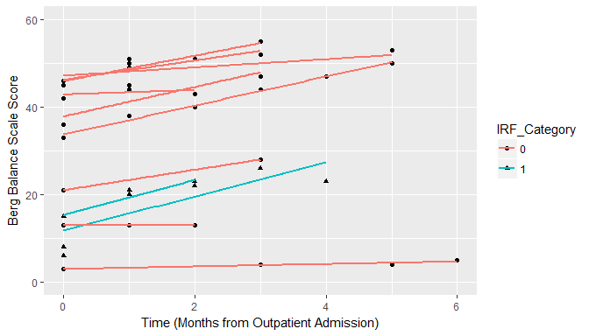

# Building Statistical Models

In this section, we will start building statistical models using the BBS data as our example. The best way to think about these statistical models is as a way of formalizing what we see in the visualizations. Ideally, statistical output should be confirming patterns that we can see in the figures! But first, a word about the technical details of longitudinal data analysis...

## Comparing Linear Mixed-Effect Regression to Traditional Linear Models

In a traditional *general linear models* (GLM), all of our data are independent (i.e., one data point per person). Statistically, we can write this as a linear model like:

$$y_{i}=B_{0}+B_{1}(TIME_{i})+ϵ_{i}$$

Each subject's actual score ($y_{i}$) is the result of an intercept ($B_{0}$) and that constant is modified based on their grade (the slope, $B_{1}$ multiplied by their grade). The intercept and slope are collectively referred to as our statistical *MODEL*. Our model is not going to be perfect, however, so we need to include an error term ($ϵ_{i}$). Good models will have small errors and thus be a better approximation of our *DATA*. As such, we can more generally say that:

$$DATA=MODEL+ERROR$$

The code for LMER is essentially the same as GLM, except that we will be using lmer() instead of lm(). (Note that you need lme4 installed to have access to the lmer() function.) Conceptually, LMER is a lot like GLM but we need to 'partition' our variance into different sources.

$$y_{ij}=B_{0}+U_{0j}+B_{1}(TIME_{ij})+U_{1j}+ϵ_{ij}$$

In LMER, we now have data indexed by time point (i) and by participant (j). Each datapoint, $y_{ij}$, can still be described by the overall intercept and slope, $B_{0}$ and $B_{1}$, plus a random effect for each subject, $U_{0j}$ and $U_{1j}$.

Note that these random-effects could be positive or negative, because they represent how this participant deviates from the norm. Thus, in LMER our *MODEL* is the combination of our fixed-effects (all of the $B$'s) and the random-effects (all of the $U_{j}$'s). However, *DATA = MODEL + ERROR* still applies, so we need to include a random-error term for each data point, $ϵ_{ij}$.

In summary, we have the following terms in our DATA:

* The *MODEL* includes fixed effects and random effects.
* *Fixed-Effects* are the group-level $B$'s, these effects parallel the traditional main-effects and interactions that you have probably encountered in other statistical analyses.
* *Random-Effects* are the participant-level $U_{j}$'s that remove statistical dependency from our data. (This is bit of a simplification, but you can think of not including the appropriate random-effects like running a between-subjects ANOVA when you should be running a repeated-measures ANOVA.)
* The *ERRORS*, or more specifically *Random Errors*, are the difference between our *MODEL*'s predictions and the actual *DATA*.

We can write this as:

$$y_{ij}=B_{0}+U_{0j}+(B_{1}+U_{1j})*(TIME_{ij})+E_{ij}$$

Or in the equivalent form:

$$y_{ij}=B_{0}+B_{1}(TIME_{i})+(U_{0}+U_{1}(TIME_{i})|Subject)$$

This second form more closely resembles the R syntax. Note that we are not including the $j$ subscript here anymore, but it is still implied by the model because we are saying that there are different random-effects ( $U_{0}$ and $U_{1}$) for a given subject.

## Building Linear Mixed-Effect Models

### The "Random Intercepts" Model

In our Random Intercepts model, we estimate a constant (intercept) for each participant and the overall constant. This overall constant is the *fixed-effect*, and individual deviations away from this constant are our *random-effects*. (In writing up a study, we would refer to this as a random-effect of subject/participant.)

$$y_{ij}=B_{0}+U_{0j}+ϵ_{ij}$$

True to it's name, the Random Intercepts model is going to estimate a flat line for each person. Each line will be different, however, because our random-effect of subject means that we are estimating a unique intercept for each person. This intercept will be equal to mean for each participant, because the mean is the value that will produce the smallest errors.

B0<-lmer(BERG~1+(1|subID),data=DAT2, REML=FALSE)  
summary(B0)

## Linear mixed model fit by maximum likelihood ['lmerMod']  
## Formula: BERG ~ 1 + (1 | subID)  
## Data: DAT2  
##   
## AIC BIC logLik deviance df.resid   
## 300.0 305.2 -147.0 294.0 39   
##   
## Scaled residuals:   
## Min 1Q Median 3Q Max   
## -2.90995 -0.38353 0.03968 0.46555 1.72257   
##   
## Random effects:  
## Groups Name Variance Std.Dev.  
## subID (Intercept) 268.91 16.398   
## Residual 22.42 4.735   
## Number of obs: 42, groups: subID, 12  
##   
## Fixed effects:  
## Estimate Std. Error t value  
## (Intercept) 30.549 4.802 6.362

### Plot of Random-Intercepts Model for the Berg Balance Scale

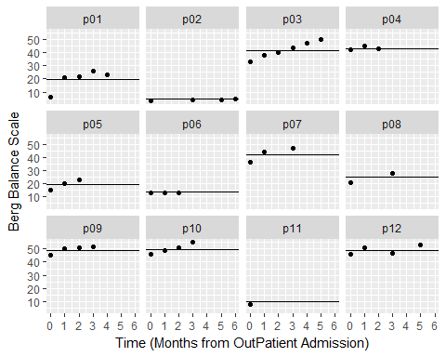 Note that in the plot above, each dot represents the actual data for each participant. The lines in each panel, conversely, represent the model's predictions for each participant. Because *B0* is the random-intercepts model, our model is predicting a different flat line for each participant.

### The "Random Intercept - Fixed Slope" Model

In our Random Intercept - Fixed Slope model, we estimate an intercept for each participant and an overall slope, but **the slope is the same for each person**. The overall intercepts and slopes are the fixed-effects. The prediction lines for each participant can have different heights (due to the random-intercepts), but all of these lines have the same slope (because there is no random-effect for the slope).

$$y_{ij}=B_{0}+U_{0j}+B_{1}*(TIME_{ij})+ϵ_{ij}$$

B1<-lmer(BERG~1+time+(1|subID),data=DAT2, REML=FALSE)  
summary(B1)

## Linear mixed model fit by maximum likelihood ['lmerMod']  
## Formula: BERG ~ 1 + time + (1 | subID)  
## Data: DAT2  
##   
## AIC BIC logLik deviance df.resid   
## 279.4 286.4 -135.7 271.4 38   
##   
## Scaled residuals:   
## Min 1Q Median 3Q Max   
## -2.98346 -0.38528 0.05064 0.54454 1.76134   
##   
## Random effects:  
## Groups Name Variance Std.Dev.  
## subID (Intercept) 274.81 16.577   
## Residual 10.54 3.246   
## Number of obs: 42, groups: subID, 12  
##   
## Fixed effects:  
## Estimate Std. Error t value  
## (Intercept) 27.2915 4.8486 5.629  
## time 2.0017 0.3446 5.808  
##   
## Correlation of Fixed Effects:  
## (Intr)  
## time -0.113

### Plot of Random-Intercepts Fixed Slope Model for the Berg Balance Scale

## subID Intercepts Slopes  
## p01 p01 15.685644 2.0017  
## p02 p02 -2.718155 2.0017  
## p03 p03 36.934149 2.0017  
## p04 p04 41.154404 2.0017  
## p05 p05 17.457350 2.0017  
## p06 p06 11.203960 2.0017  
## p07 p07 39.508225 2.0017  
## p08 p08 21.606475 2.0017  
## p09 p09 46.315060 2.0017  
## p10 p10 47.057937 2.0017  
## p11 p11 8.712515 2.0017  
## p12 p12 44.580436 2.0017

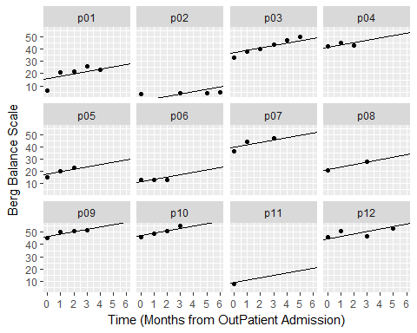 Note that in the plot above, each dot represents the actual data for each participant. The lines in each panel, conversely, represent the model's predictions for each participant. Because *B1* is the random-intercepts fixed slope model, our model is predicting a different intercept for each participant, but each participant has the same slope.

### The "Random Slopes" Model

In our Random Slopes model, we estimate an overall intercept and slope and a unique intercept and slope for each participant. These overall intercepts and slopes are the fixed-effects ($B$'s), and deviations away from these values are random-effects ($B+U$'s).

$$y_{ij}=B_{0}+U_{0j}+(B_{1}+U_{1j})*(TIME_{ij})+ϵ_{ij}$$

B2<-lmer(BERG~1+time+(1+time|subID),data=DAT2, REML=FALSE)  
summary(B2)

## Linear mixed model fit by maximum likelihood ['lmerMod']  
## Formula: BERG ~ 1 + time + (1 + time | subID)  
## Data: DAT2  
##   
## AIC BIC logLik deviance df.resid   
## 276.7 287.2 -132.4 264.7 36   
##   
## Scaled residuals:   
## Min 1Q Median 3Q Max   
## -2.9245 -0.2786 0.0650 0.3125 1.6897   
##   
## Random effects:  
## Groups Name Variance Std.Dev. Corr  
## subID (Intercept) 250.714 15.834   
## time 1.065 1.032 0.23  
## Residual 6.690 2.586   
## Number of obs: 42, groups: subID, 12  
##   
## Fixed effects:  
## Estimate Std. Error t value  
## (Intercept) 27.1662 4.6148 5.887  
## time 2.1606 0.4481 4.821  
##   
## Correlation of Fixed Effects:  
## (Intr)  
## time 0.085

### Plot of Random Slopes Model for the Berg Balance Scale

## subID Intercepts time  
## p01 p01 13.564121 3.0654644  
## p02 p02 2.122334 0.5754571  
## p03 p03 34.383588 3.0388763  
## p04 p04 41.206360 1.9889862  
## p05 p05 17.007389 2.4305898  
## p06 p06 11.683921 1.4372448  
## p07 p07 38.532319 2.7863482  
## p08 p08 21.348696 2.1553786  
## p09 p09 45.768934 2.4039091  
## p10 p10 46.073869 2.7042603  
## p11 p11 8.498068 1.8758309  
## p12 p12 45.804802 1.4648542

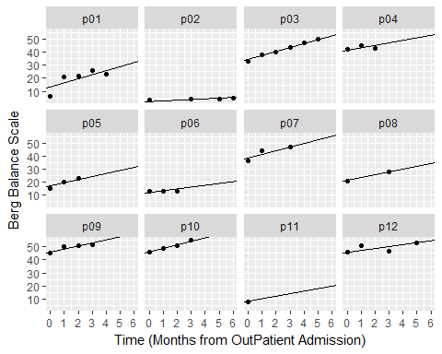 Note that in the plot above, each dot represents the actual data for each participant. The lines in each panel, conversely, represent the model's predictions for each participant. Because *B2* is the random-slopes model, our model predicts different intercepts and slopes for each participant.

### Conditional Models

These three models (Random Intercepts, Fixed Slopes, and Random Slopes) are our starting models that you will probably end up building in most LMER analyses that you run. These models contain valuable information about the variation within and between participants and essentially become the "models to beat" as you add other variables to your model. For instance, the Random Slopes model accounts for how participants change over time but I might be interested in much more than that. (However, sometimes we might also be interested in testing nonlinear effects of time and random slopes are not enough! You definitely can model time non-linearly, but it is an advanced topic that we will not discuss here.) Below are several types on hypotheses you might be interested in testing in your models:

* Do participants who went to an IRF start with worse BBS scores at admission than participants who did not go to an IRF? (The hypothesis asks about the effects of a *categorical* variable on the *intercepts*.)
* Do participants who went to an IRF show more rapid improvement in BBS scores over time compared to participants who did not go to an IRF? (The hypothesis asks about the effects of a *categorical* variable on the *slopes*.)
* Do older participants show show more rapid improvement in BBS scores over time compared to younger participants? (The hypothesis asks about the effects of a *continuous* variable on the *slopes*.)

And naturally there are many more hypotheses that you might be interested in testing! In general, however, when we are talking about data with two-levels (i.e., time nested within participants) we are usually interested in the effects that other variables have on the intercepts (i.e., does this variable affect where someone starts) and on the slopes (i.e., does this variable affect how someone changes over time). In the code below, we will walk through how to build these models using an example of a categorical predictor (IRF stay or not) to see how this variable affects the intercepts and slopes (but the same procedure could be done with a continuous predictor as well).

## The Effects of an Inpatient Rehabilitation Facility

### Does IRF affect the intercept?

First, we want to see if going to an inpatient rehabilitation facility (IRF) has a significant effect on where people begin outpatient rehabilitation. Because Time = 0 is the start of outpatient rehab in our data, this is equivalent to asking about the effect of IRF status on the *intercept* of model. Note that IRF is a *Fixed-Effect* in this model.

$$y_{ij}=B_{0}+U_{0j}+(B_{1}+U_{1j})*(TIME_{ij})+B_{3}*(IRF_{j})+ϵ_{ij}$$

B3<-lmer(BERG~1+time+IRF+(1+time|subID),data=DAT2, REML=FALSE)  
summary(B3)

## Linear mixed model fit by maximum likelihood ['lmerMod']  
## Formula: BERG ~ 1 + time + IRF + (1 + time | subID)  
## Data: DAT2  
##   
## AIC BIC logLik deviance df.resid   
## 272.6 284.8 -129.3 258.6 35   
##   
## Scaled residuals:   
## Min 1Q Median 3Q Max   
## -2.87156 -0.34699 0.05951 0.28275 1.76697   
##   
## Random effects:  
## Groups Name Variance Std.Dev. Corr  
## subID (Intercept) 178.182 13.348   
## time 1.080 1.039 0.66  
## Residual 6.527 2.555   
## Number of obs: 42, groups: subID, 12  
##   
## Fixed effects:  
## Estimate Std. Error t value  
## (Intercept) 33.4941 4.4495 7.528  
## time 2.2083 0.4389 5.031  
## IRF -25.3773 8.5767 -2.959  
##   
## Correlation of Fixed Effects:  
## (Intr) time   
## time 0.356   
## IRF -0.480 -0.075

The estimate for the effect of IRF is -25.38 and as you might recall from the raw data, people who went to an IRF were coded as 1 and people who did not go to an IRF are coded as 0. Just like in a traditional multiple regression model, the values of these slope estimates are the predicted change in Y for a one unit change in X. In this case, a one unit change in X is going from the "no IRF" group to the IRF group and thus the IRF group scored about 25 points lower at baseline. If we want to see what the actual predict values are, we can just put the relevant values for our fixed-effects into our mixed-effect regression:

No IRF Stay

$$=33.49+(2.21*0)+(−25.38*0)=33.49$$

Yes IRF Stay

$$=33.49+(2.21*0)+(−25.38*1)=8.11$$

But remember this model assumes that the going to an IRF has no effect on the rate at which people improve during outpatient therapy. To see if IRF affects the rate at which people change, we will need to add an interaction between IRF and time to our models.

### Does IRF affect the rate of change?

Similar to our previous model, we are going to include an effect of IRF on the intercept (although technically speaking we wouldn't need to do this, we could assume that IRF has not effect on the intercept *but* does have an effect on the slope). In order to model the effect that IRF has on the rate of change (i.e., the effect that IRF has on the time parameter) we need to include an ineraction between the fixed-effect of time and the fixed-effect of IRF.

$$y_{ij}=B_{0}+U_{0j}+(B_{1}+U_{1j})*(Time_{ij})+B_{3}*(IRF_{j})+B_{4}*(Time_{ij}*IRF_{j})+ϵ_{ij}$$

B4<-lmer(BERG~1+time*IRF+(1+time|subID),data=DAT2, REML=FALSE)  
summary(B4)

## Linear mixed model fit by maximum likelihood ['lmerMod']  
## Formula: BERG ~ 1 + time * IRF + (1 + time | subID)  
## Data: DAT2  
##   
## AIC BIC logLik deviance df.resid   
## 271.2 285.1 -127.6 255.2 34   
##   
## Scaled residuals:   
## Min 1Q Median 3Q Max   
## -2.31601 -0.29828 -0.02569 0.38126 2.11982   
##   
## Random effects:  
## Groups Name Variance Std.Dev. Corr  
## subID (Intercept) 173.5347 13.1733   
## time 0.6794 0.8242 0.69  
## Residual 6.2588 2.5018   
## Number of obs: 42, groups: subID, 12  
##   
## Fixed effects:  
## Estimate Std. Error t value  
## (Intercept) 32.2659 4.4456 7.258  
## time 1.8575 0.4197 4.426  
## IRF -20.5454 8.9002 -2.308  
## time:IRF 2.0430 1.0389 1.967  
##   
## Correlation of Fixed Effects:  
## (Intr) time IRF   
## time 0.359   
## IRF -0.500 -0.179   
## time:IRF -0.145 -0.404 0.283

You can see that including the interaction term influences numerous fixed effects in our model, the reason for this is that the effect of time now depends on IRF and IRF depends on time. That is, the parameter estimate for *Time* = 1.86, which is the effect of Time when IRF = 0 (i.e., in the no IRF group). Similarly, the parameter estimate for *IRF* = -20.54, which is the difference between no IRF and IRF groups when Time = 0 (i.e., the difference between groups at baseline). We can see the differences a little more clearly when we see that there are now two separate regression equations in our model, one for the IRF group and one for the no IRG group.

Overall Model

$$=32.27+(1.86*Time_{ij})+(−20.55*IRF_{j})+(2.04*Time_{ij}*IRF_{j})$$

Which can be simplified to two separate sets of predictions:

No IRF Stay

$$=(32.27−(20.55*0)+(1.86+(2.04*0)*Time_{i})=32.27+1.86*Time_{i}$$

Yes IRF Stay

$$=(32.27−(20.55*1)+(1.86+(2.04*1)*Time_{i})=11.72+3.90*Time_{i}$$

### Plot of Conditional Predictions for the Berg Balance Scale

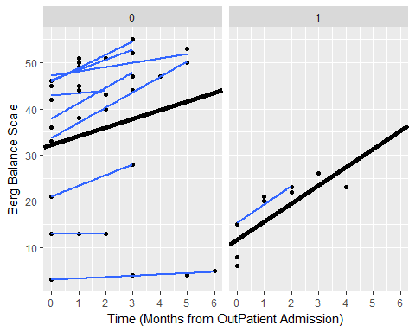

## Comparing between Different Models

Now that we have created a number of different models, how do we decide which models are the best? How do we decide which parameters to include and which parameters are "statistically significant"? When it comes to mixed-effect linear models (or other forms of "multi-level" models) we used a similar criterion to traditional regression. That is, we still rely on the general idea that

$$DATA=MODEL+ERROR$$

and if the error is reduced by a large enough magnitude, then we will call that effect statistically significant (i.e., the parameter reduced error by an unusually larger amount under the null-hypothesis.). However, there are some differences between mixed-effect models and traditional *Ordinary Least Squares* regression.

For instance, you might have noticed that p-values are conspicuously absent from the LME4 output. The reasons for this are complicated, but it has to do with the fact that these models can have statistical dependencies and unbalanced/missing data that do not make the calculation of traditional p-values tenable. In short, your *denominator* degrees of freedom can get a little crazy. (You can also read Doug Bates' explanation, author of the lme4 package, here: <https://stat.ethz.ch/pipermail/r-help/2006-May/094765.html>). **However**, the main things that you should know are:

1. If you really, really want p-values for individual parameters, you can get them from packages that implement the Welch-Satterthwaite approximation to estimate the appropriate degrees of freedom, like the "lmerTest"" package.
2. We are really most interested in comparisons between models and less so the individual parameters within a model. All of the models are fit using *Maximum Likelihood Estimation* (explained below) and we judge models based on a reduction in *Error* that we call *Deviance*. Fortunately, there are a number of quantitative and objective methods for evaluating the change in deviance. We will focus on two of these methods, the *Wald Test* for the change in Deviance and the *Akaike Information Criterion (AIC)*.

You can read more about Maximum Likelihood Estimation from other resources, but conceptually the idea of ML estimation is that our computer tests a series of parameters until it arrives at the specific set of parameters that leads to the smallest error in our data. This is why it is referred to as "maximum likelihood" because we arrive at the set of values (for the given parameters) that are "most likely" to have produced the data we observed. The goodness of fit for these parameter estimate is quantified in something called the *Deviance*, which is a transformation of the likelihood.

$$Deviance=−2*log(Likelihood)$$

Where *Likelihood* is defined by the amount of error () left behind by our estimates. Thus if we delve a little deeper, the Deviance is:

$$Deviance=N*log(2πσ_{ϵ}^{2})+(1/sigma_{ϵ}^{2})*(\sum_{i=1}^{n}{ϵ_{i}})$$

This formula is kind of scary, but there are two things you need to notice about it:

1. Looking at the right side of the equation, notive that the deviance is still largely determined by the sum of errors. **Thus, everything else being equal, smaller errors are going to lead to a smaller deviance.**
2. Notice that size our sample shows up in two different places (the N at the beginning and the fact that we are summing over N on the right hand size). This means that the deviance is senstiive to amount of data we are using. **Thus, if we want to compare models based on their deviance, those models need to be based on the same amount of data.**

### Wald Test for the Change in Deviance

Now we are ready to actually make a comparison between some of our different statistical models by comparing the change in the Deviance. For instance let's start by comparing the Random Intercepts, Fixed Slopes, and Random Slopes models using the anova() function in R.

anova(B0,B1,B2)

## Data: DAT2  
## Models:  
## B0: BERG ~ 1 + (1 | subID)  
## B1: BERG ~ 1 + time + (1 | subID)  
## B2: BERG ~ 1 + time + (1 + time | subID)  
## Df AIC BIC logLik deviance Chisq Chi Df Pr(>Chisq)   
## B0 3 300.00 305.22 -147.00 294.00   
## B1 4 279.43 286.38 -135.72 271.43 22.5727 1 2.023e-06 ***  
## B2 6 276.73 287.16 -132.37 264.73 6.6986 2 0.03511 *   
## ---  
## Signif. codes: 0 '***' 0.001 '**' 0.01 '*' 0.05 '.' 0.1 ' ' 1

The anova() function gives a number of valuable pieces of information. First, it explicitly lists the models that are being tested. Below, it gives us the model name and the degrees of freedom for each model. It then gives us the AIC, the related Bayesian Information Criterion (or BIC), the log of the Likelihood (or logLik), and the Deviance.

The Random Intercepts model acts as our "benchmark" against which other models can be compared. For instance, the reduction in deviance from the Random Intercepts (Deviance = 294.00) to the Fixed Slopes model (Deviance = 271.43) is 22.57. The change in deviance follows a $χ^{2}$ distribution, which allows us to test the statistical significance of the difference between these two models using a classic null hypothesis significance test.

The Fixed Effect model (df = 4) has one more parameter than the Random Intercepts model (df =3) so the degrees are freedom for the $χ^{2}=1$ and the p-value for $χ^{2}(1)=22.57$ is < 0.001. Thus, we would conclude that the Fixed Effect model is **significantly** better than the Random Intercepts model. Similarly, the Random Slopes model reduces the deviance by 6.70 compared to the Fixed-Slopes model and the p-value for $χ^{2}(2)=6.70$ is 0.035. Thus, we would conclude that the Random Slopes model is also a **significantly** better model than the Fixed Slopes model (assuming = 0.05).

### The Akaike Information Criterion (AIC) Test for the Change in Deviance

The AIC is another method to evaluating model fit that is based on the Deviance. Although we won't get into the details of the math behind it, the importance of the AIC is in the name "Information Criterion". That is, the AIC is all about *informativeness* which is slightly different from just being the model that produces the smallest deviance. For a model to be informative, the parameters need to generalize to other new datasets, not just provide the best explanation of the current data. Therefore, the AIC introduces a penalty to reduce **ovef-fitting** of the the model:

$$AIC=Deviance+2(k)$$

In the formula above, k = number of parameters in the model. Thus, for a parameter to actually improve the AIC it has to reduce the deviance by >2 times the number of parameters. As I mentioned above, we won't get into why the magic number of 2(k) seems to work so well, but key thing to know is that **the AIC imposes a penalty based on the number of parameters and is thus a more conservative test than the Wald Test of the change in Deviance**.

We can see this in action by comparing our two conditional models to the Random Slopes model. As a word of caution, there are no fixed cut-offs for a "statistically significant" change in the AIC although some research has been done exploring how the $δAIC$ relates to other measures of effect-size (see Long, 2012). In general, it is a good idea to declare you minimum $δAIC$ in advance and I usually use a value of 2. That is, if an additional parameter reduces the AIC by >2 points, then I will stick with the more complex model. If the additional parameter reduces the AIC by </=2 points, then I will stick with the simpler model. As before, we will use the anova() function in R to get our AICs.

anova(B2,B3,B4)

## Data: DAT2  
## Models:  
## B2: BERG ~ 1 + time + (1 + time | subID)  
## B3: BERG ~ 1 + time + IRF + (1 + time | subID)  
## B4: BERG ~ 1 + time * IRF + (1 + time | subID)  
## Df AIC BIC logLik deviance Chisq Chi Df Pr(>Chisq)   
## B2 6 276.73 287.16 -132.37 264.73   
## B3 7 272.61 284.78 -129.31 258.61 6.1194 1 0.01337 *  
## B4 8 271.22 285.12 -127.61 255.22 3.3899 1 0.06560 .  
## ---  
## Signif. codes: 0 '***' 0.001 '**' 0.01 '*' 0.05 '.' 0.1 ' ' 1

The anova() function starts by explicitly listing the models that are being tested. Below, it gives us the model name and the degrees of freedom for each model. It then gives us the AIC, the related Bayesian Information Criterion (or BIC), the log of the Likelihood (or logLik), and the Deviance. It looks like the model testing the effect of IRF on the intercept (B3) is an improvement above the Random Slopes model (B2), as $δAIC=4.12$ and $χ^{2}$ (1) = 6.11, p = 0.01.

However, there is not a statistically significant effect of IRF status on the change over time (i.e., no IRF by Time interaction) as seen in the comparison between models B3 and B4, $δAIC=1.39$ and $χ^{2}$ (1) = 3.39, p = 0.07. As such, we would conclude that model B3 is the best explanation of the data and the IRF by Time interaction was not statistically significant.