Pruebas:

Métodos en netbeans 7.2.1

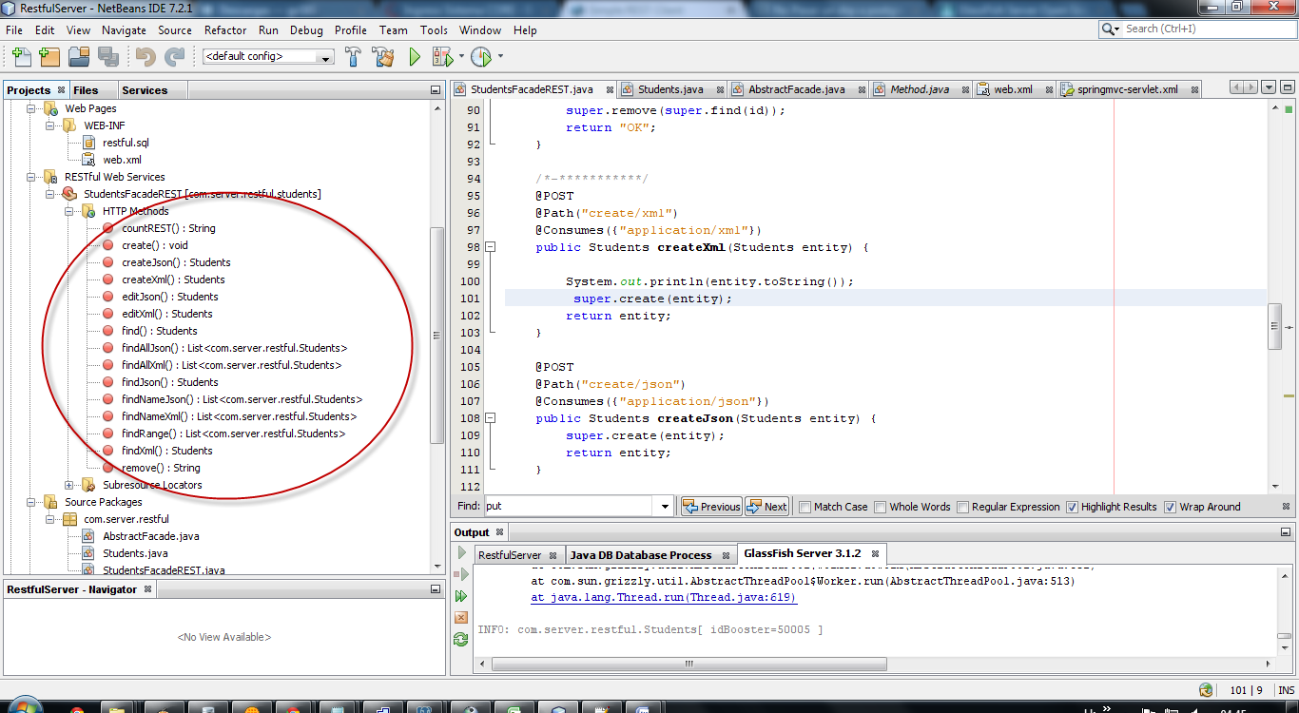

Ejecutar archivo en MYSQL

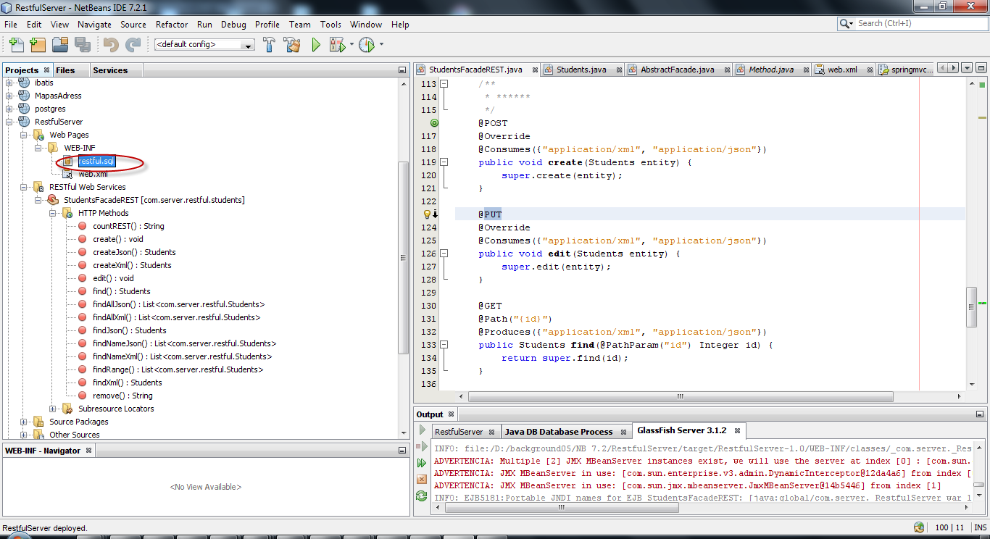

Instalar

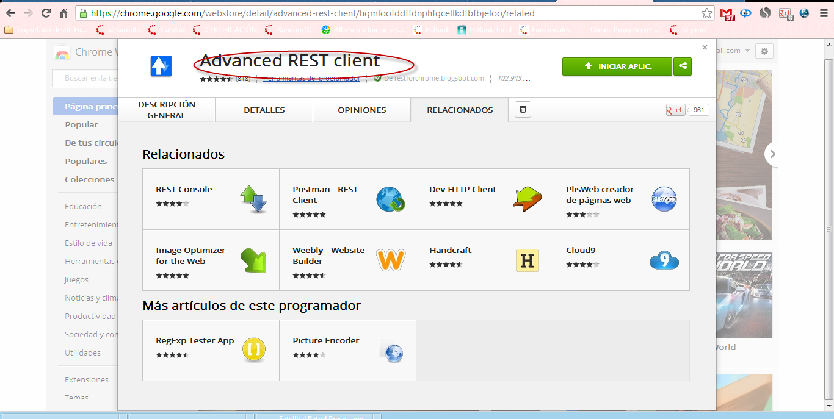

**GET /students**

XML

<http://localhost:8080/RestfulServer/webresources/com.server.restful.students/xml>

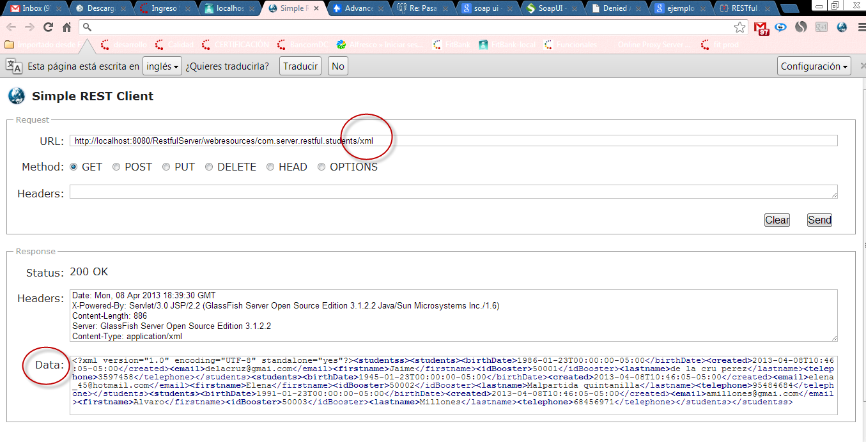

Json:

<http://localhost:8080/RestfulServer/webresources/com.server.restful.students/json>

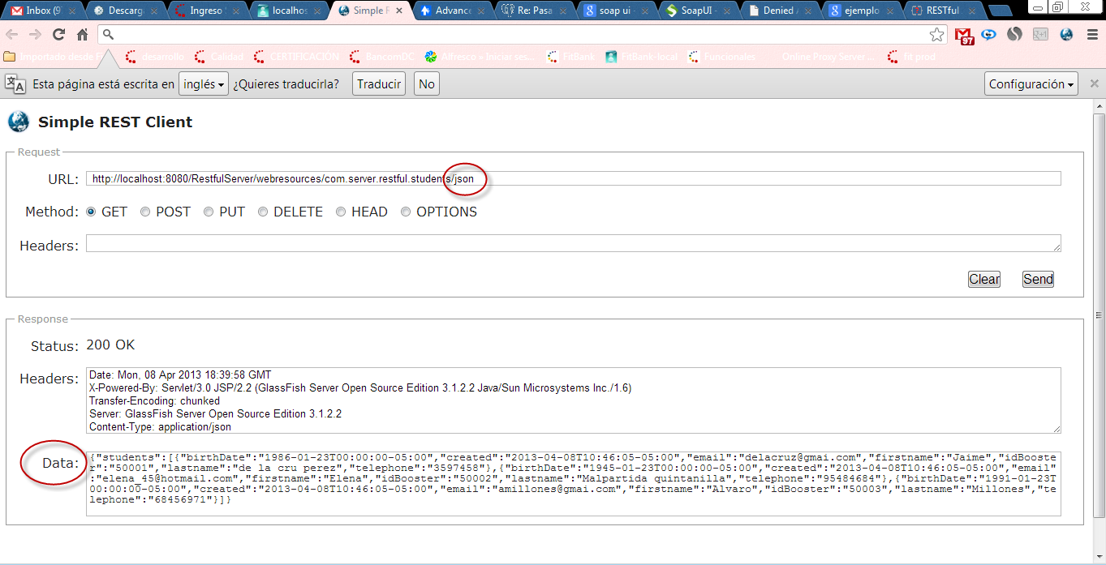

**POST /students**

[**http://localhost:8080/RestfulServer/webresources/com.server.restful.students/create/xml**](http://localhost:8080/RestfulServer/webresources/com.server.restful.students/create/xml)

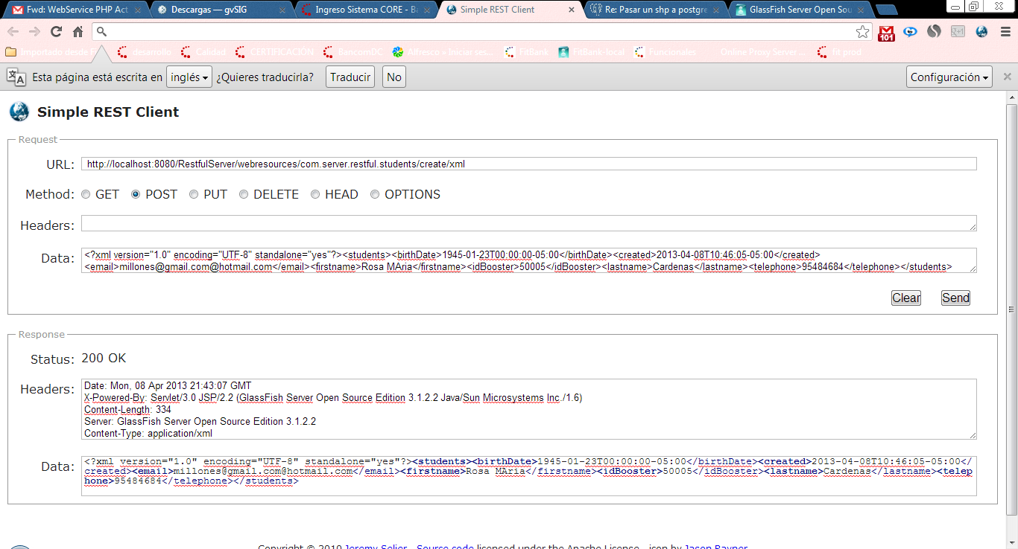

GET /students/{id}

XML

<http://localhost:8080/RestfulServer/webresources/com.server.restful.students/xml/50003>

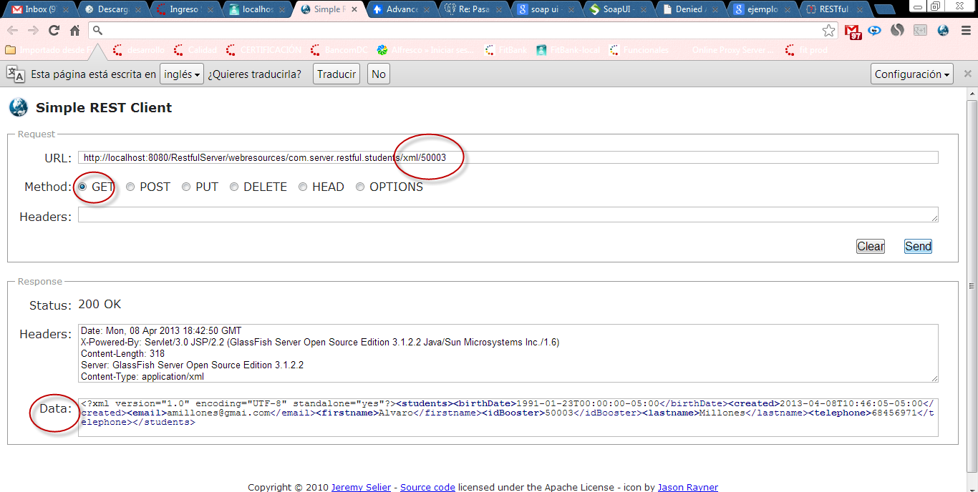

JSON

<http://localhost:8080/RestfulServer/webresources/com.server.restful.students/json/50003>

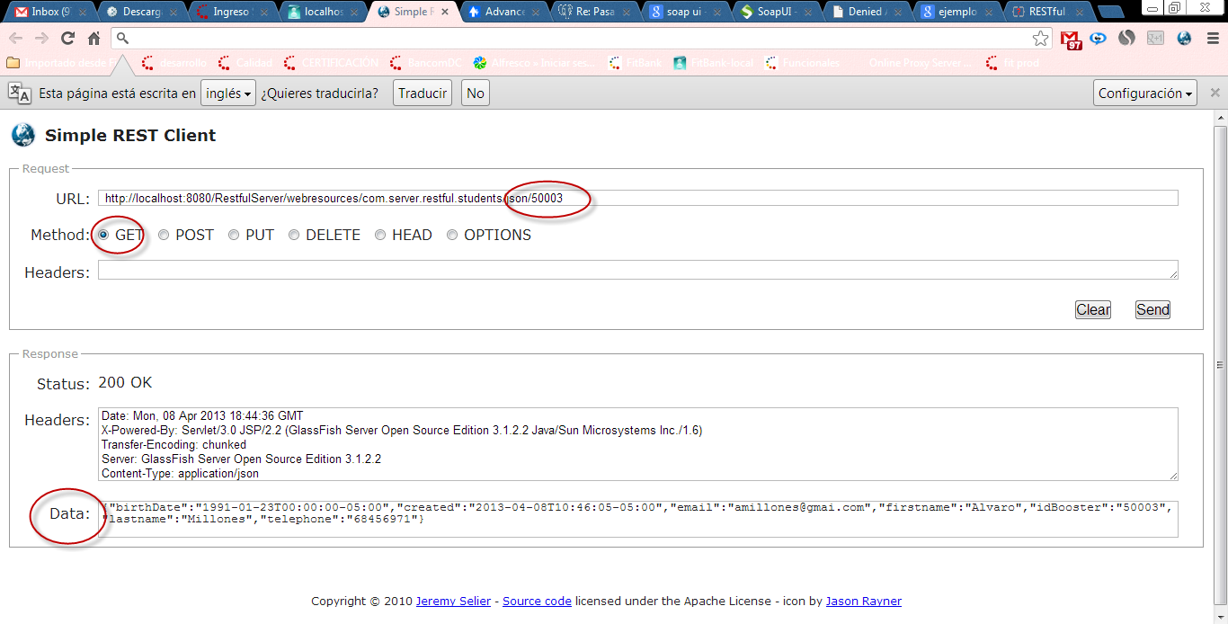

PUT /students/{id}

Xml

<http://localhost:8080/RestfulServer/webresources/com.server.restful.students/update/xml>

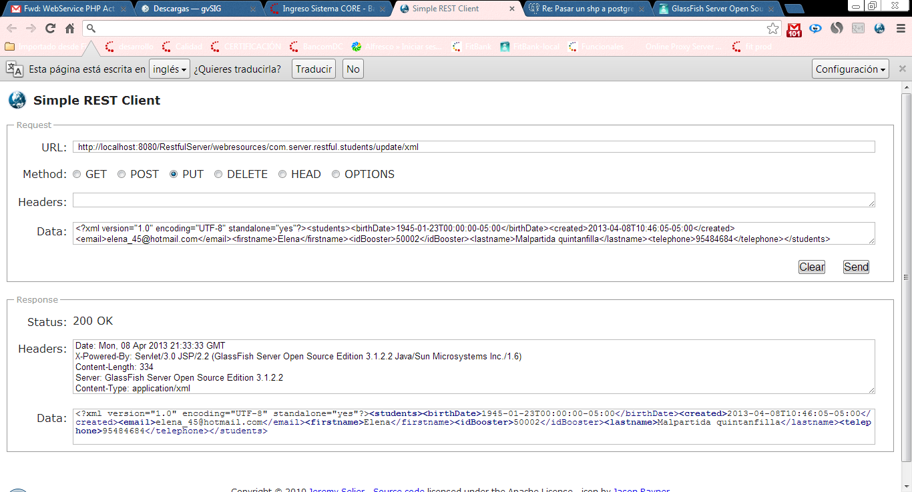

DELETE /students/{id}

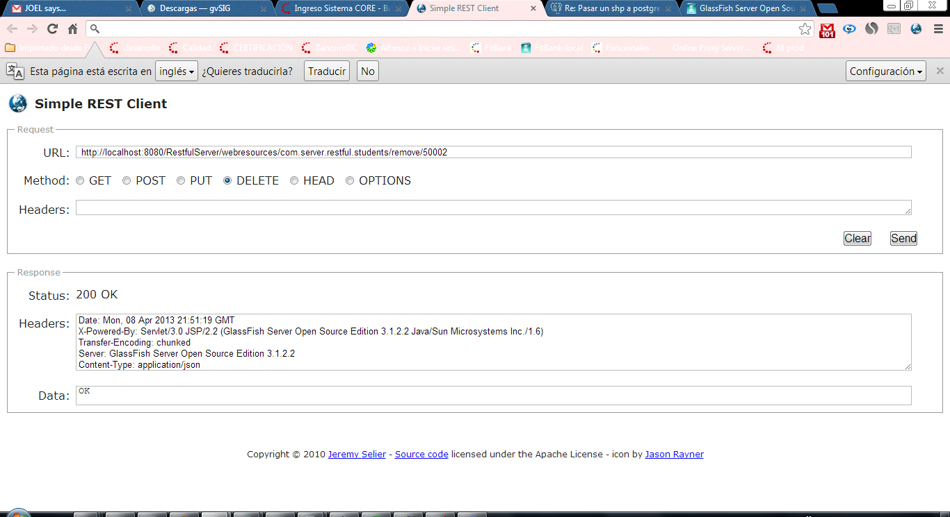

GET /students/search/{query}

XML

<http://localhost:8080/RestfulServer/webresources/com.server.restful.students/search/xml/millones>

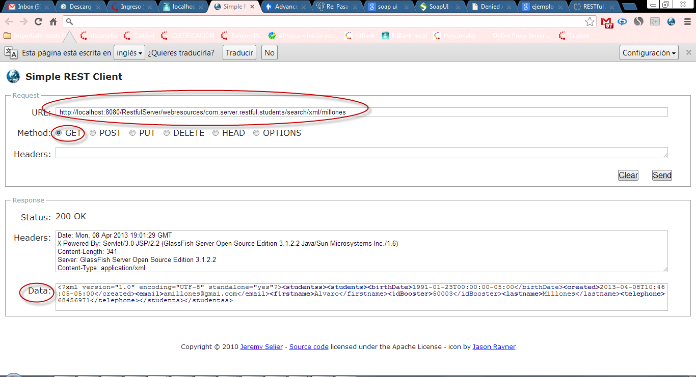

JSON

<http://localhost:8080/RestfulServer/webresources/com.server.restful.students/search/json/millones>

