

Software Test Report

Contents

Overview 3

Testing phases 3

Planning 3

Method 3

Results 4

Analysis and conclusions 4

Software approval 5

# Overview

This document is the Software Test Report of the testing phase of the Calculate and average marks software development project.

The initial script has been supplied, and errors have been seen. They are commented with TODO, and what needs to be corrected to ensure the running of the script as required.

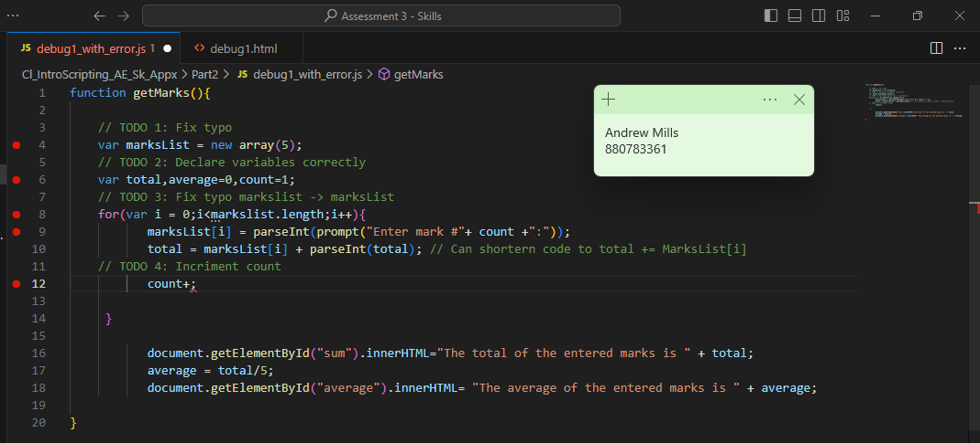

When we try and run the script in its current form we get the following output from the browser console.

We experience that error due to a missing + in line 12 from the first figure. So once we have adjusted the code with the errors reflected above we can now see that script can function to the input stage.

# Testing phases

## Planning

Per the request of the client brief below is the data set we will use to test the script.

Table 1 – Test plan

|  |  |  |  |
| --- | --- | --- | --- |
| Test ID | Test name | Summary | Expected result |
| Test 1 | Testing with numbers | Numbers to use: 10, 12, 16, 14, 18 | Results should be: Sum 70  Average 14 |
| Test 2 | Testing with Grades (Letters A – E) | Letters to use: A, B, D, A, C | The expected results are Not a Number. We are unable to perform math to letters |
| Test 3 | Testing with other numbers | Numbers to use: 17, 17, 19, 20, 17 | Results should be:  Sum 90  Average 18 |

## Method

The data sets in the table above will be loaded into the webpage as each individual testing. The test should be carried out from the webpage debug1.html and the JavaScript file is called from the HTML file.

## Results

Complete the table below with the test results. Include the Test ID (as listed in the Test planning), the actual results from the testing, screenshots of the testing and any relevant comments or information (where required), and the outcome of the test (did it pass or fail?).

Table 2 – Test results

|  |  |  |  |
| --- | --- | --- | --- |
| Test ID | Test results | Screenshots of testing/ relevant comments | Test outcome  (pass/fail) |
| Test 1 |  | See below | Pass |
| Test 2 |  | See below | Fail |
| Test 3 |  | See below | Pass |

## 

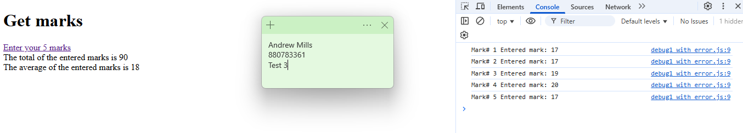

## Analysis and conclusions

After the errors have been corrected and the test above performed the script is tested and moved to the next stage of deployment. With the test data set tested and the expected results as a pass.

# Software approval

Software is approved for installation by:

Name

[Name of appropriate person approving the software]

Role

[Click/tap to select role]

Signature Date

[Click/tap to select date]