

Software Test Report

Contents

Overview 3

Testing phases 3

Planning 3

Method 3

Results 4

Analysis and conclusions 4

Software approval 5

# Overview

This document is the Software Test Report of the testing phase of the ABBA Fan redirection website software development project.

At a user prompt the user is asked to enter a name. If the name entered is one of the members of the pop music band ABBA then the user is redirectored to the abba fan site, else if any other name is entered the user is taken to a Beatles band page.

Upon initial inspection of the script a few errors have been identified. Within the <script> tag these are the errors spotted:

Line 11: there are extra inverted commas. They are not required, so removing them will not affect the outcome.

Lines 13 & 14: The names of the ABBA band names are needed to be inside inverted commas.

Line 23: is missing closing parentensis to close the script.

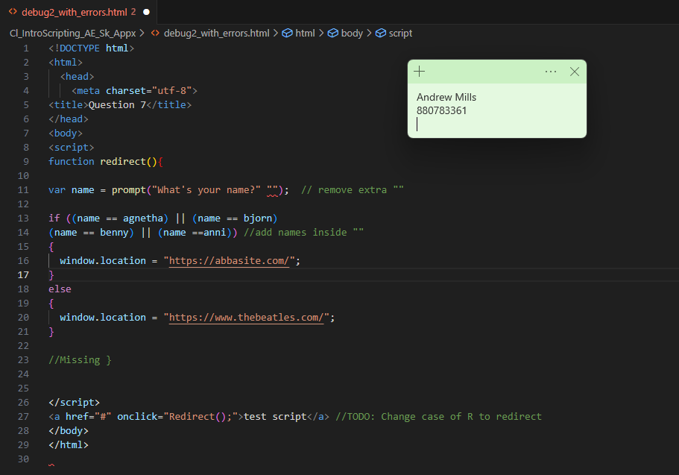

# Testing phases

## Planning

Plan the testing by completing the table below.

Table 1 – Test plan

|  |  |  |  |
| --- | --- | --- | --- |
| Test ID | Test name | Summary | Expected result |
| Test 1 | ABBA member names | Names to test: agnetha, bjorn, benny, anni | Redirect to ABBA site |
| Test 2 | Random names | Names to test:  John, Susan, Jessica | Redirect to Beatles website |
| Test 3 | Empty Name | Not enter a name | Redirect to Beatles website |

## Method

The way the testing will be performed is by entering the names above in the website and see if the redirect function is called. If the testing is sucessful you will end up a the the website listed in the expected results collum.

## Results

Table 2 – Test results

|  |  |  |  |
| --- | --- | --- | --- |
| Test ID | Test results | Screenshots of testing/ relevant comments | Test outcome  (pass/fail) |
| Test 1 | ABBA Names | All ABBA names correctly redirect. Screenshots attached | Pass |
| Test 2 | Other Names | Other names correctly redirect to The Beatles. Screenshots attached | Pass |
| Test 3 | No name or entry | Nothing entered in the prompt correctly redirect to the Beatles.  Screenshots attached | Pass |

## 

## Test 1 results:

## Test 2 results:

## Test 3 Results:

## Analysis and conclusions

After rectification of the script with the errors, the redirection of the website to the correct website is achieved. The testing performed passed all of the tests and meets the client brief. The script has now been fixed and is ready to be signed off and placed into production.

# Software approval

Software is approved for installation by:

Name

[Name of appropriate person approving the software]

Role

[Click/tap to select role]

Signature Date

[Click/tap to select date]