Paper’s figure: A dynamic fleet model of U.S light-duty vehicle lightweighting and associated greenhouse gas emissions from 2016-2050

*Alexandre Milovanoffa, Hyung Chul Kimb, Robert De Kleineb, Timothy J. Wallingtonb, I. Daniel Posena, Heather L. MacLeana,c*  
*a: Department of Civil & Mineral Engineering, University of Toronto, 35 St. George Street, Toronto, Ontario, M5S 1A4 Canada*  
*b: Materials & Manufacturing R&A Department, Ford Motor Company, Dearborn, Michigan 48121-2053, United States*  
*c: Department of Chemical Engineering & Applied Chemistry, University of Toronto, 200 College Street, Toronto, Ontario, M5S 3E5 Canada*  
*Corresponding Author:* [*alexandre.milovanoff@mail.utoronto.ca*](mailto:alexandre.milovanoff@mail.utoronto.ca)

# TOC

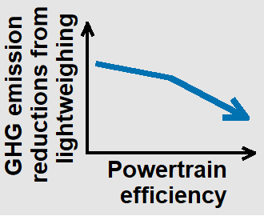

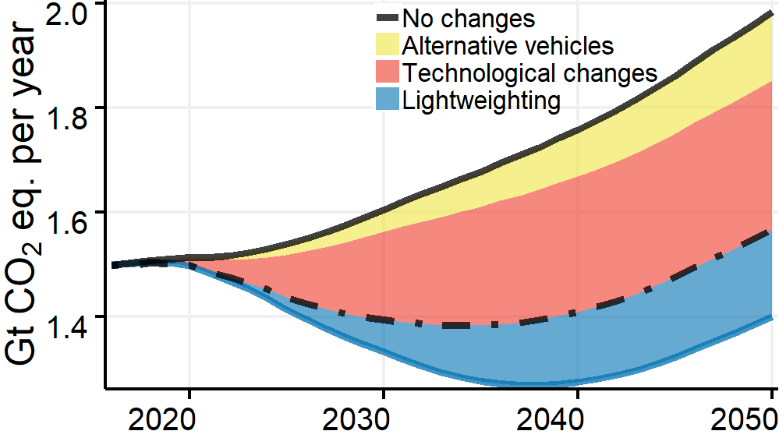

# Paper

## Material composition

ICEV-G Car

|  |  |  |  |  |  |
| --- | --- | --- | --- | --- | --- |
| Material | Steel Intensive | Aluminum Intensive | Aluminum Maximum | BAU | BAU 2016 |
| Cast Aluminum | 117 | 153 | 181 | 121 | 117 |
| Cast Iron | 116 | 109 | 50 | 121 | 117 |
| HSS/AHSS | 486 | 280 | 97 | 298 | 291 |
| Mild steel and other steels | 341 | 327 | 255 | 602 | 589 |
| Other | 504 | 493 | 484 | 512 | 461 |
| Wrought Aluminum | 42 | 136 | 310 | 44 | 42 |
| Total | 1606 | 1498 | 1376 | 1698 | 1617 |
| Weight savings (kg) | 92 | 199 | 321 | NA | NA |
| Weight savings (%) | 5 | 12 | 19 | NA | NA |

## Fleet GHGs emissions

### Panel (a)

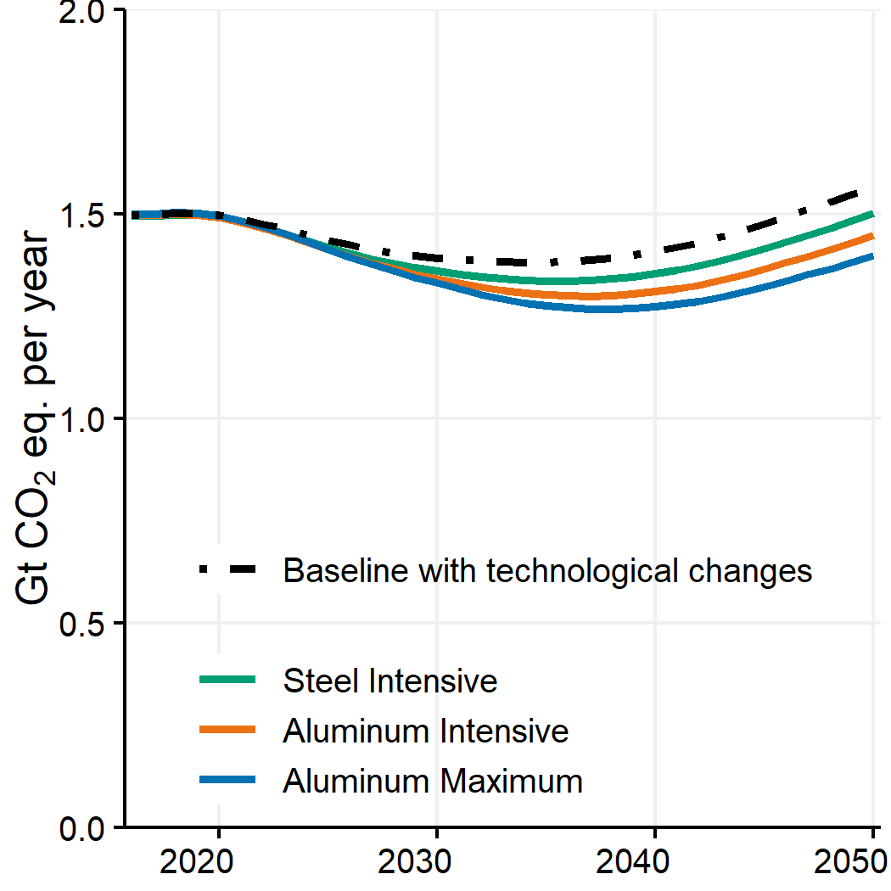 ###Panel (b)

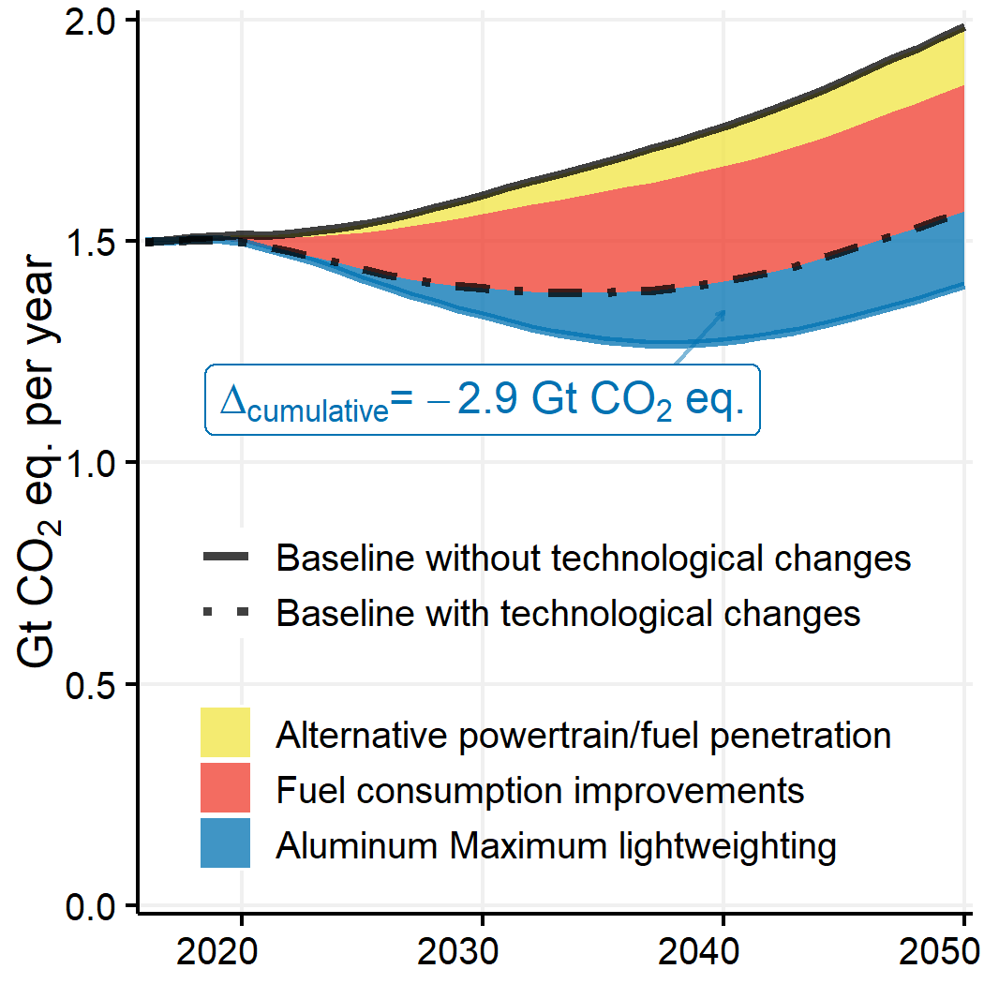

### Panel (c)

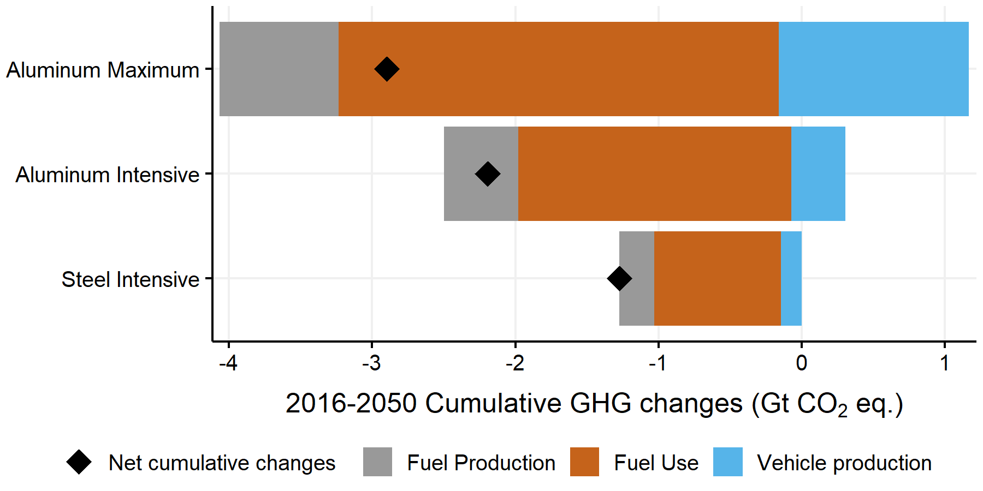

Table

## Impact of External factors on GHG emissions changes due to lightweighting

### Panel (a)

## [1] "Fuel consumption improvements"   
## [2] "Alternative powertrain/fuel penetration"  
## [3] "Oil prices"   
## [4] "Automotive material recovery"

### Panels (b) and (c)

## Timing and pace in ligthweighting

### Panel (a) - Absolute for entire period

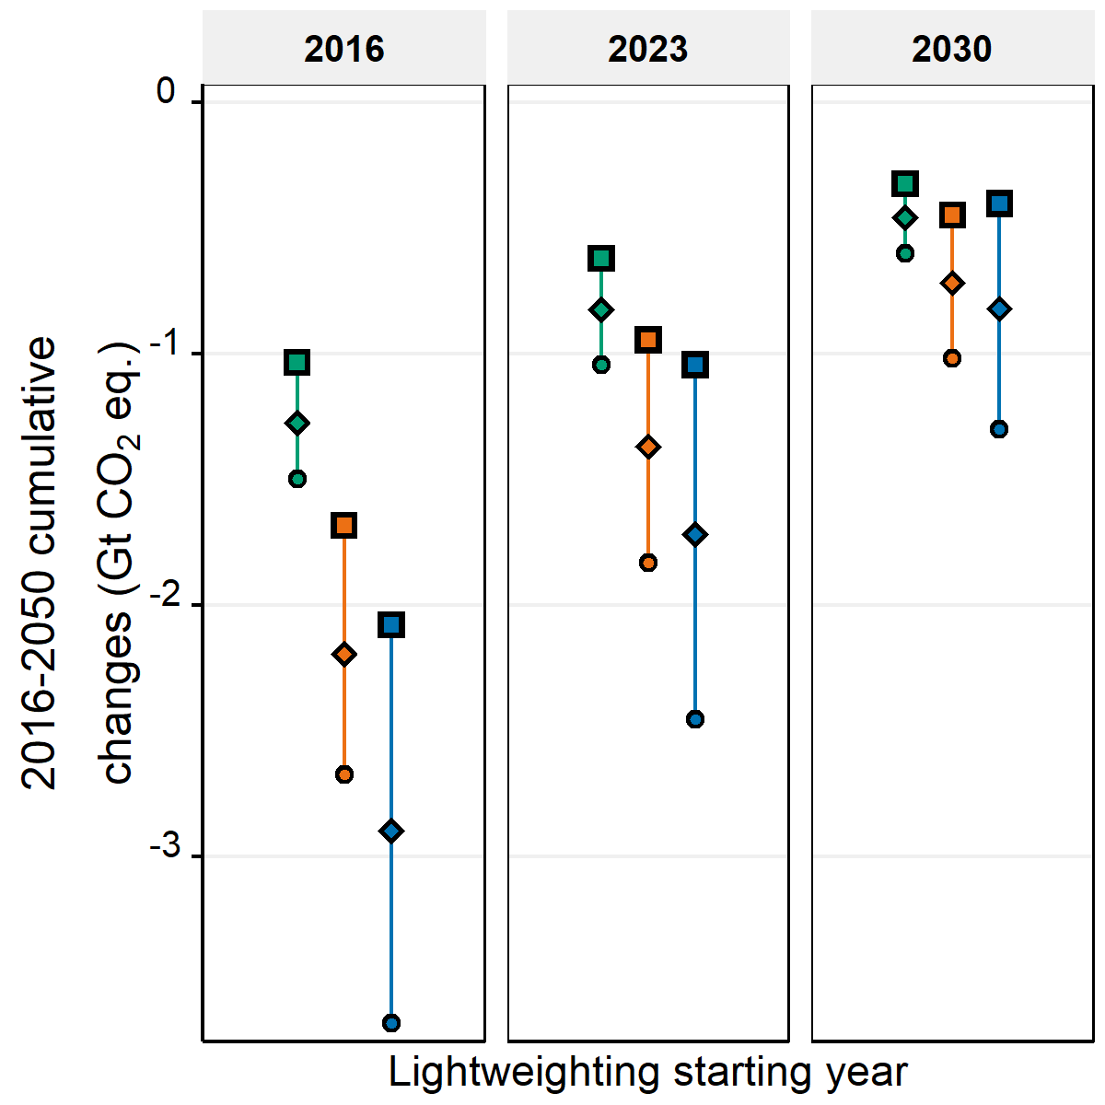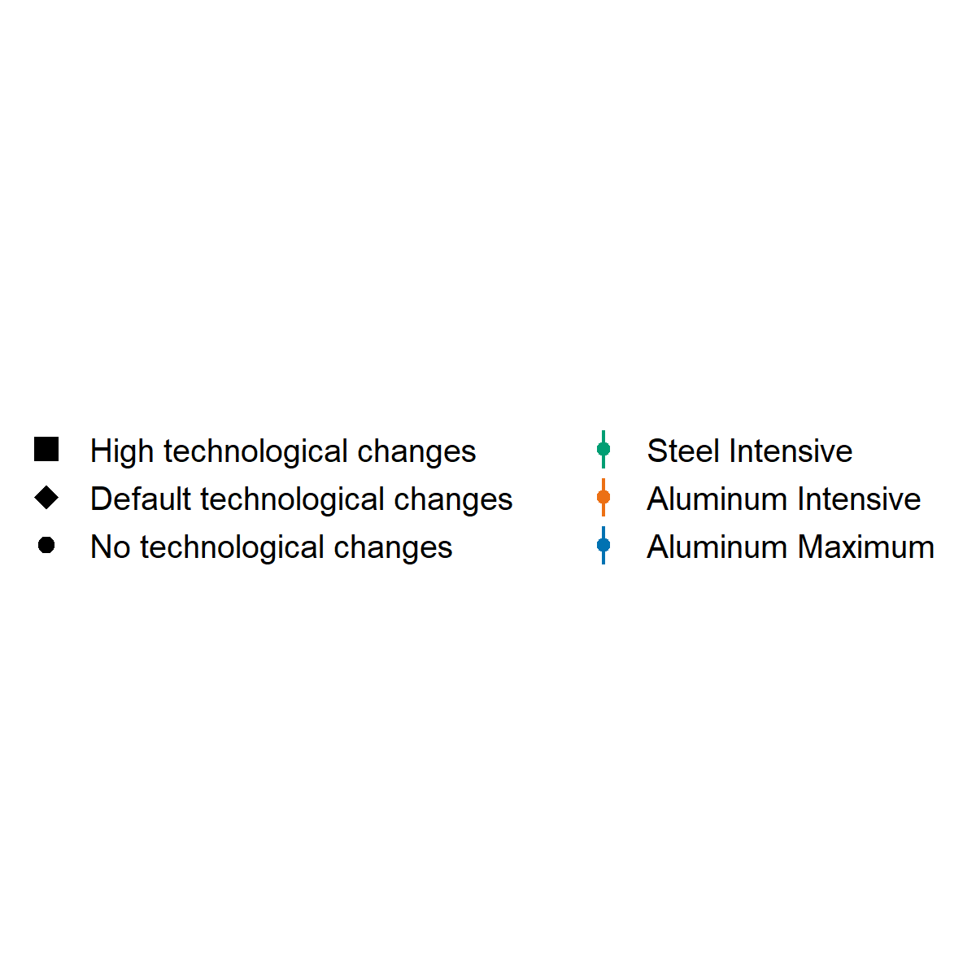

### Per VKT

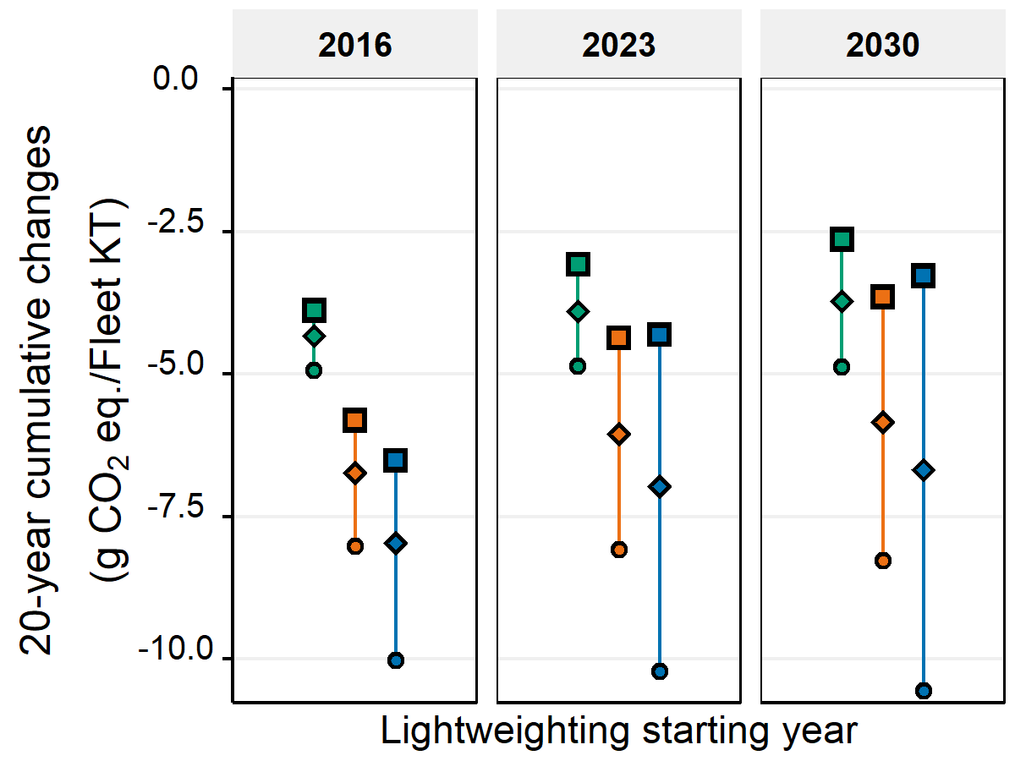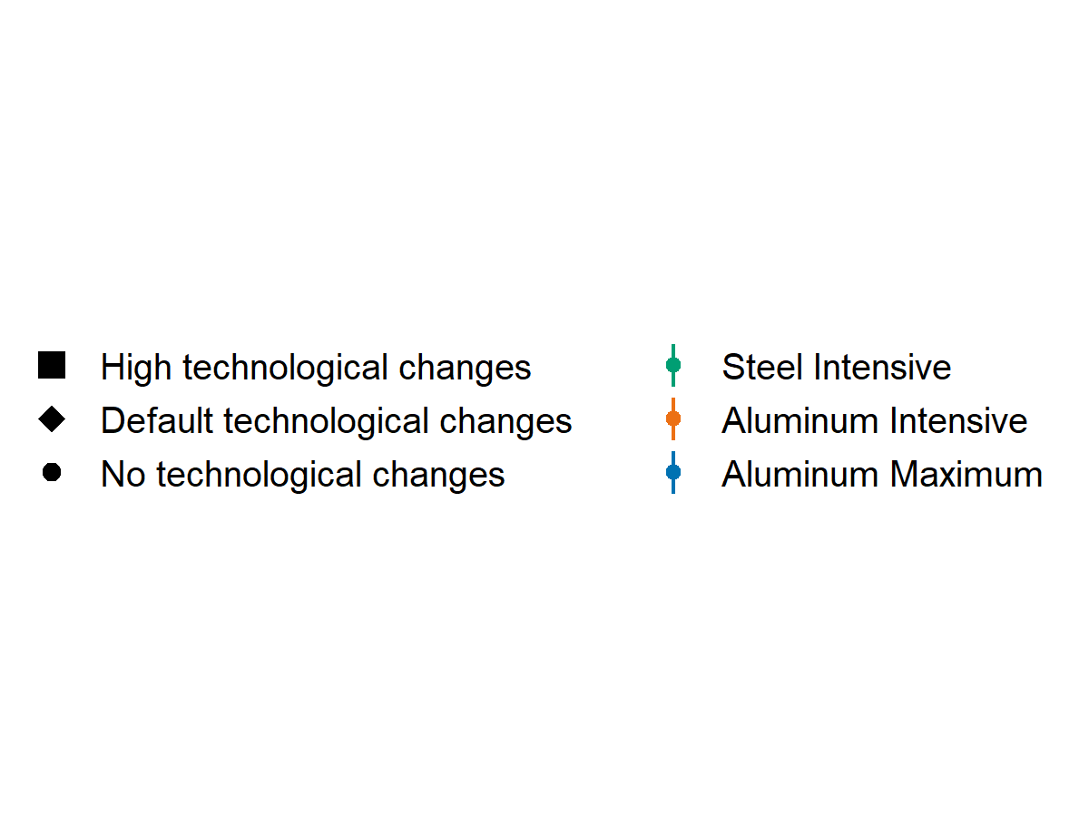

# Discussion

## 4.1

## 4.2