1.When to use (Rapid Application Development) RAD model. When not to use (Rapid Application Development) RAD model.
Ans:

when RAD model used:
- Need to produce the system in short time span.
- When the system can be delivered in incremental manner.
- if there is a high availability of designers for modelling.
- Project budget is high, which allow use of automated code generating tools.
- domain experts are available.
- requirements are well-known.
- user will be involved through the life cycle.

when RAD model not used:
- Designers for modelling are not allowed.
- if the project budget is low.
- Domain experts are not available.
- System can not be modularized.
- if the user can not involve through life cycle.

2. Define an ER diagram of a Software Organization with all the relationship
model that was discussed in the classroom.

DEPARTMENT
PROJECT
CUSTOMER
EMPLOYEE
Dept_ID
Phone
Name
EmpId
Name
Lname
Fname
Address
ProId
Name
technology
work_for
work_on
Control
Request
Location
Id
Name
Address

3. Describe the Entity Relationships for the following diagram

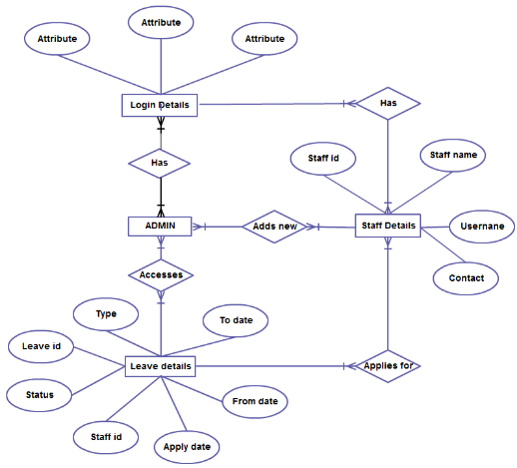

Ans:

Entity:
- Admin
- Leave details
- Staff details
- Login details

Attributes:
- Admin: no attributes given
- Login details : 3 attributes
- staff details :staff Id, staff name,username, contact
- Leave details: Leave id, type, status,staff Id,Apply date, From date, To date,

Relations:
- Has
- Accesses
- Add new
- Applies for

all given relations are many to many.
- Admin has many to many relation to Login deatils
- staff has many to many relation to Login deatils
- Admin has Add New realtion to the staff details.ith is also many to many relation.
- Admin has Accesses relation to Leave details. It is many to many relation.
- Staff has Applies for realtion to leave details, many to many realtion.

logically
- there have many admin and each have their own Login details
- staff has their own Login details
- admin has accesses to Leave details
- Many or 1 staff can apply for many or one leaves
- many admin can add many employees

