Reimagining Psychiatric Care with Physical AI: Multiscale Simulation Stress Tests of Benefit, Burden, and Break-Even Conditions
[AUTHOR INPUT REQUIRED: author names, affiliations, ORCID IDs, corresponding author email]
Article | Original Research — Simulation Study

Abstract
Physical artificial intelligence (AI) may improve engagement in psychiatric care but adds operational and safety burdens. We compared a matched screen with embodied pathways in two complementary, uncoupled simulations: 12-week outpatient monitoring and clinic intake. All model parameters were transparent, uncalibrated assumptions. Across 200 paired replications, human-gated robots increased modeled response by 6.29 percentage points and reduced missed high-acuity cases by 10.85 points, but reduced completion by 5.42 points, added 4.38 clinician-review minutes per participant, and increased waiting by 34.41 working minutes. When hypothesized embodiment advantages were removed, response fell 1.38 points below screen; under skeptical assumptions, response fell 8.83 points. A 1,024-base-point global sensitivity analysis using synchronized random streams showed response sensitivity to the assumed symptom increment and waiting sensitivity to demand. These are model-internal stress-test consequences, not clinical efficacy estimates. Physical AI should demonstrate both benefit and operational acceptability before deployment.
Keywords: physical AI; digital psychiatry; socially assistive robots; microsimulation; discrete-event simulation; global sensitivity; patient safety

Introduction
Physical artificial intelligence extends digital psychiatry from software-only interaction to systems that perceive, reason, communicate, and act through a body. Socially assistive robots have been proposed as coaching, companionship, assessment, and structured-intervention interfaces in mental health care [1-7]. Human-robot interaction research also indicates that physical copresence can alter persuasion, trust, personal space, social salience, and task performance relative to screen-displayed agents, although physical presence should not be conflated with embodiment as an isolated mechanism [8,9]. These findings provide a plausible rationale for testing embodied psychiatric interfaces, but they do not establish clinical benefit.
The empirical evidence remains early and heterogeneous. Mental-health reviews describe small studies spanning different diagnoses, age groups, robots, comparators, and outcomes [2,3]. Broader systematic reviews and meta-analyses report feasibility and occasional improvements in engagement, interaction, mood, or depressive symptoms, but pooled effects on clinical and quality-of-life outcomes are inconsistent and frequently limited by bias, heterogeneity, and short follow-up [10-12]. Longitudinal home deployments demonstrate that sustained interaction is technically possible in selected populations [13], while a recent content-matched comparison in internet-based cognitive behavioral therapy found higher alliance, adherence, and satisfaction for a physically present robot without a significant mood advantage [5]. A matched screen is therefore essential, and even that contrast remains a complete pathway comparison when acceptance, reliability, alerting, and human oversight also differ.
Parameter uncertainty is especially consequential in an early technology area. Digital-intervention reviews document substantial variation in adherence and dropout, and real-world app engagement is often much lower than trial participation [27-30]. These findings support broad stress ranges for uptake, weekly engagement, and attrition, but they do not identify robot-specific coefficients. Similarly, physical-robot reviews identify heterogeneous technical, organizational, and user antecedents [2,39], while alarm research warns that false-alert burden can change human response and workflow [40]. We therefore distinguish empirical scale anchors, literature-informed directions, operational stress ranges, and explicit placeholders rather than presenting all inputs as equally evidenced.
Good modeling practice requires parameter provenance, separation of stochastic and parameter uncertainty, conceptual and operational validation, and sensitivity methods that can detect nonlinear interactions [19,31-38]. This study therefore reports complete equations and queue rules; exhaustive parameter dictionaries; neutral and skeptical scenarios; and variance-based first-, total-, and second-order Sobol indices. Formal empirical calibration, structured multi-stakeholder elicitation, and independent face validation remain prospective activities and are not claimed as completed.
We study two complementary decision contexts, not a continuous patient trajectory: longitudinal outpatient monitoring and clinic intake triage. The models share pathway constructs and expose the costs of implementation, but no patient-level event feeds dynamically into the queue. Figure 1 specifies this architecture; Table 1 defines the content-matched comparisons. The proposed dual gate requires both additional patient benefit and prespecified non-worsening of access, retention and human workload; it is an evaluation principle, not a validated regulatory threshold.
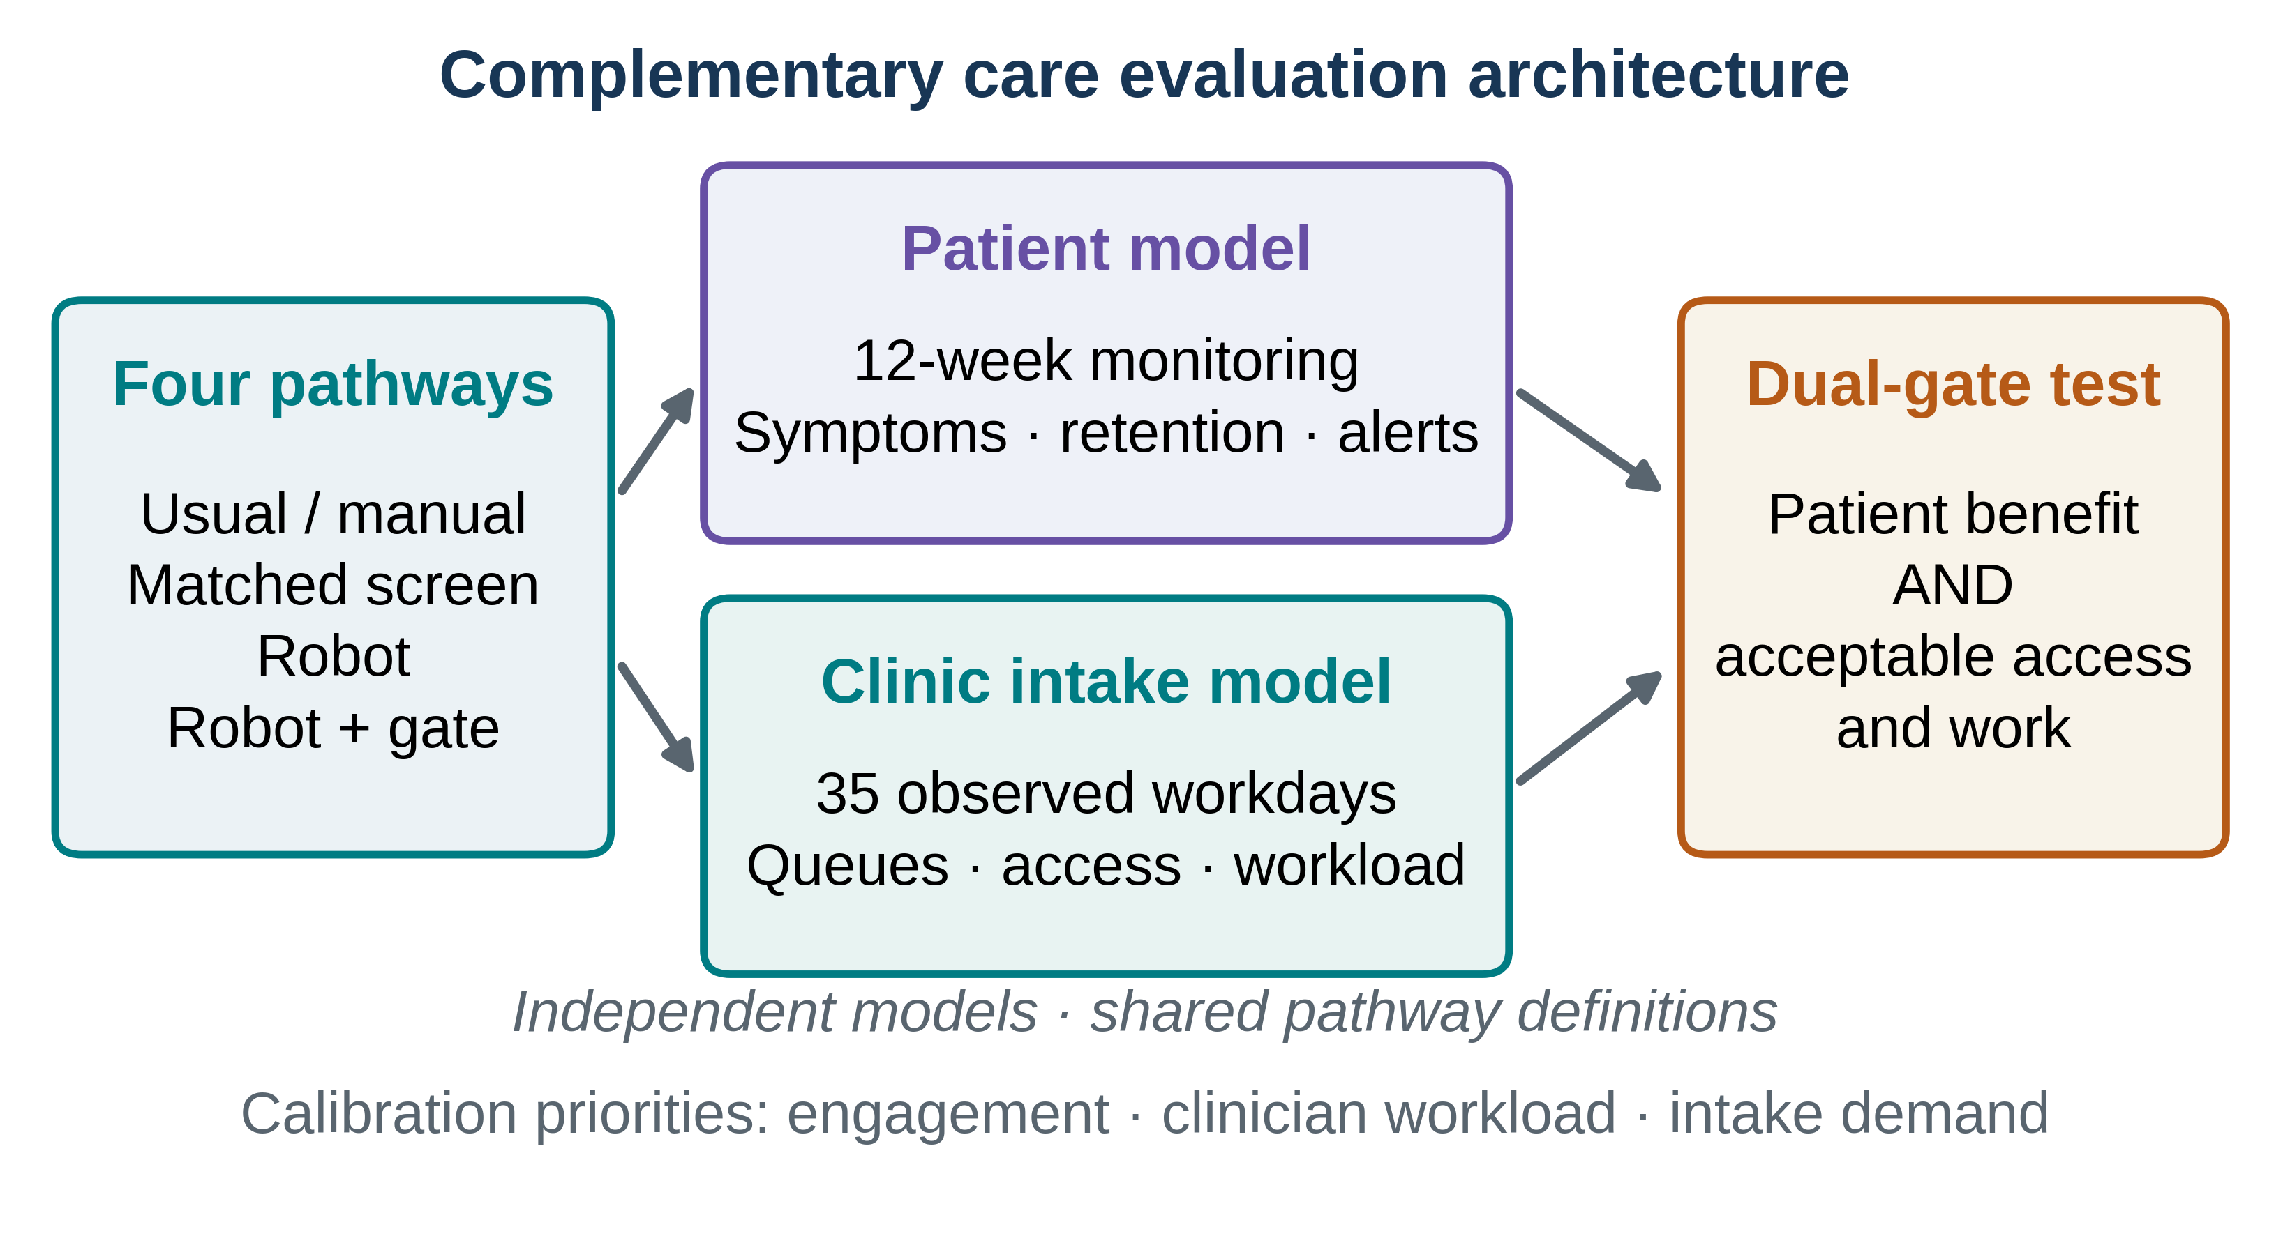
Figure 1. Complementary, independently simulated contexts. The patient microsimulation represents 12-week follow-up and the service model represents intake assessment. Arrows lead to a common decision framework; they do not denote dynamic coupling. Model parameters are illustrative, not empirically fitted.
Table 1 | Comparison pathways and contexts
Pathway | Longitudinal monitoring | Clinic intake | Incremental question
Usual/manual | Measurement-based usual care | Manual assessment | Contextual comparator
Matched screen | Screen agent delivering matched intervention content | Digital kiosk with clinician review | Primary reference
Embodied robot | Same digital content plus physical interface | Robot intake with faults and fallback | Bundled effects of embodiment, reliability and workflow
Robot + human gate | Robot with mandatory risk-relevant review | Robot with mandatory clinician checks | Detection gain versus oversight and access costs
Content was matched in the patient model, but acceptance, engagement dynamics, detection, reliability and oversight also differed. No contrast isolates the physical body as a single randomized component.

Results

Computational checks and model-internal contrasts
Reproduced base-case data files contained 200 independent patient trials with 1,200 synthetic participants per pathway and 200 paired service replications with five warm-up and 35 observed working days. Shared baseline cohorts and paired service demand streams passed structural checks; every service arrival was accounted for as completed or abandoned. Primary-model results below are preserved from the audited base-case run. New global sensitivity results were recomputed using a separate, better-powered input design.
Across the patient trials, mean response was 20.65% (95% bootstrap interval 20.49–20.80) for the screen and 26.94% (26.78–27.11) for the human-gated robot, whereas 12-week completion was 73.43% (73.24–73.62) and 68.00% (67.81–68.19), respectively. Figure 2a–c brings trajectories, endpoint outcomes and paired contrasts together. Patient-level review work and missed risk events, which a threshold-only report would omit, appear in Fig. 2d.
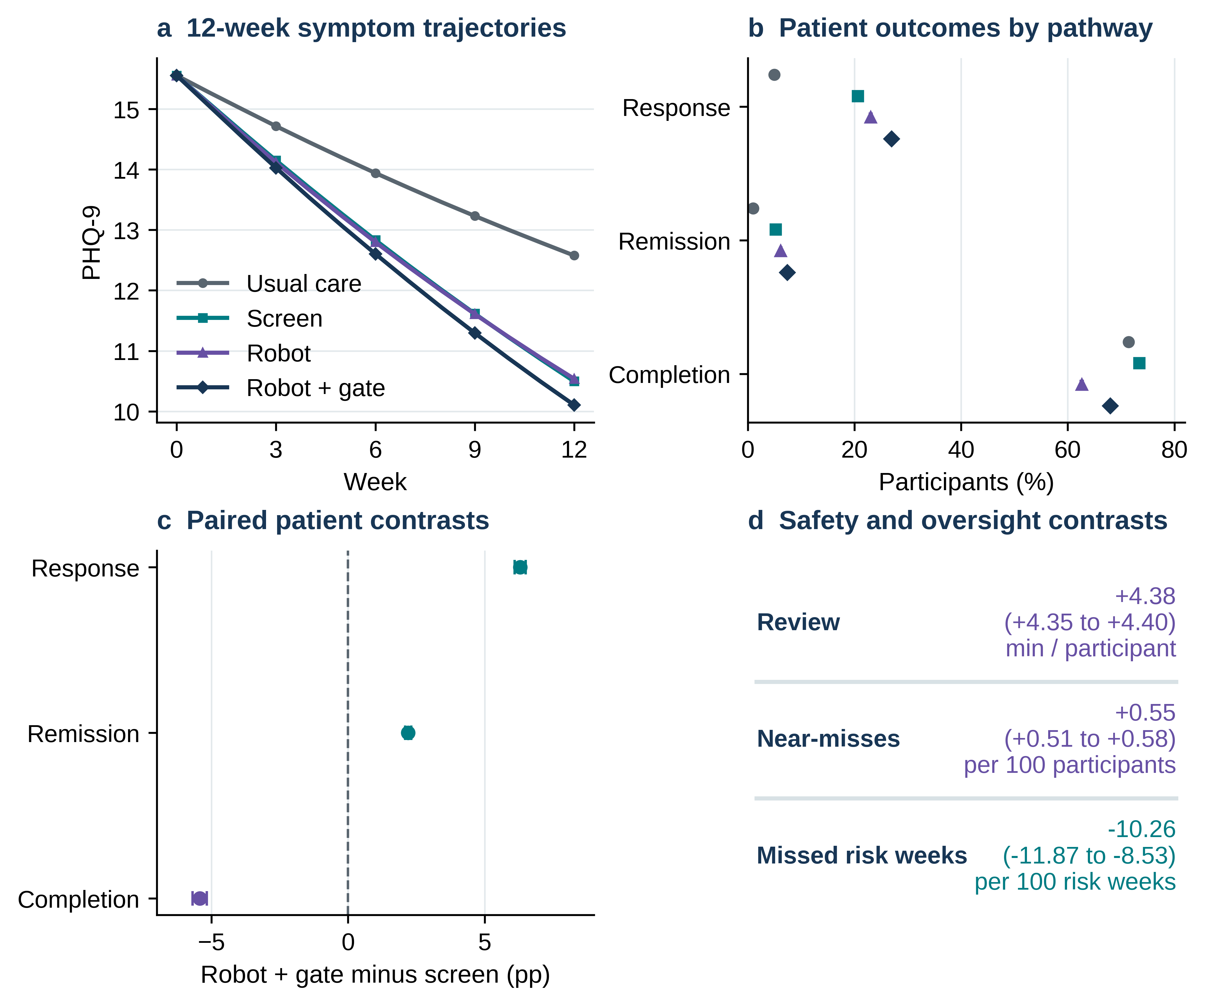
Figure 2. Patient-scale modeled outcomes. a, Mean last-observation-carried-forward PHQ-9 with 95% BCa intervals across 200 independent synthetic replications. b, Mean response, remission and completion by pathway, with 95% BCa intervals. c, Paired mean differences in percentage points between human-gated robot and screen; error bars are 95% BCa intervals. d, Review time, physical near-miss and missed-risk-week paired contrasts with bootstrap intervals; units are stated for each endpoint. Intervals reflect only fixed-model simulation precision.
The complete human-gated pathway improved response by +6.29 (6.09 to 6.50) percentage points and remission by +2.20 (2.09 to 2.31) points, while completion was -5.42 (-5.69 to -5.17) points. Clinician review rose by +4.38 (4.35 to 4.40) minutes per participant and physical near-misses by +0.55 (0.51 to 0.58) per 100 participants. These findings support neither a clinical efficacy claim nor a body-only causal contrast (Table 2).

Access and detection trade-offs at intake
The intake model generated slower queues under both robot configurations, despite near-matched throughput. In the human-gated pathway, mean waiting was 78.75 versus 44.34 working minutes for the screen, while missed high-acuity cases fell and false alerts increased. Figure 3 contrasts full replication distributions with mean estimates and safety and throughput outputs; Table 2 places both scales on the same decision surface.
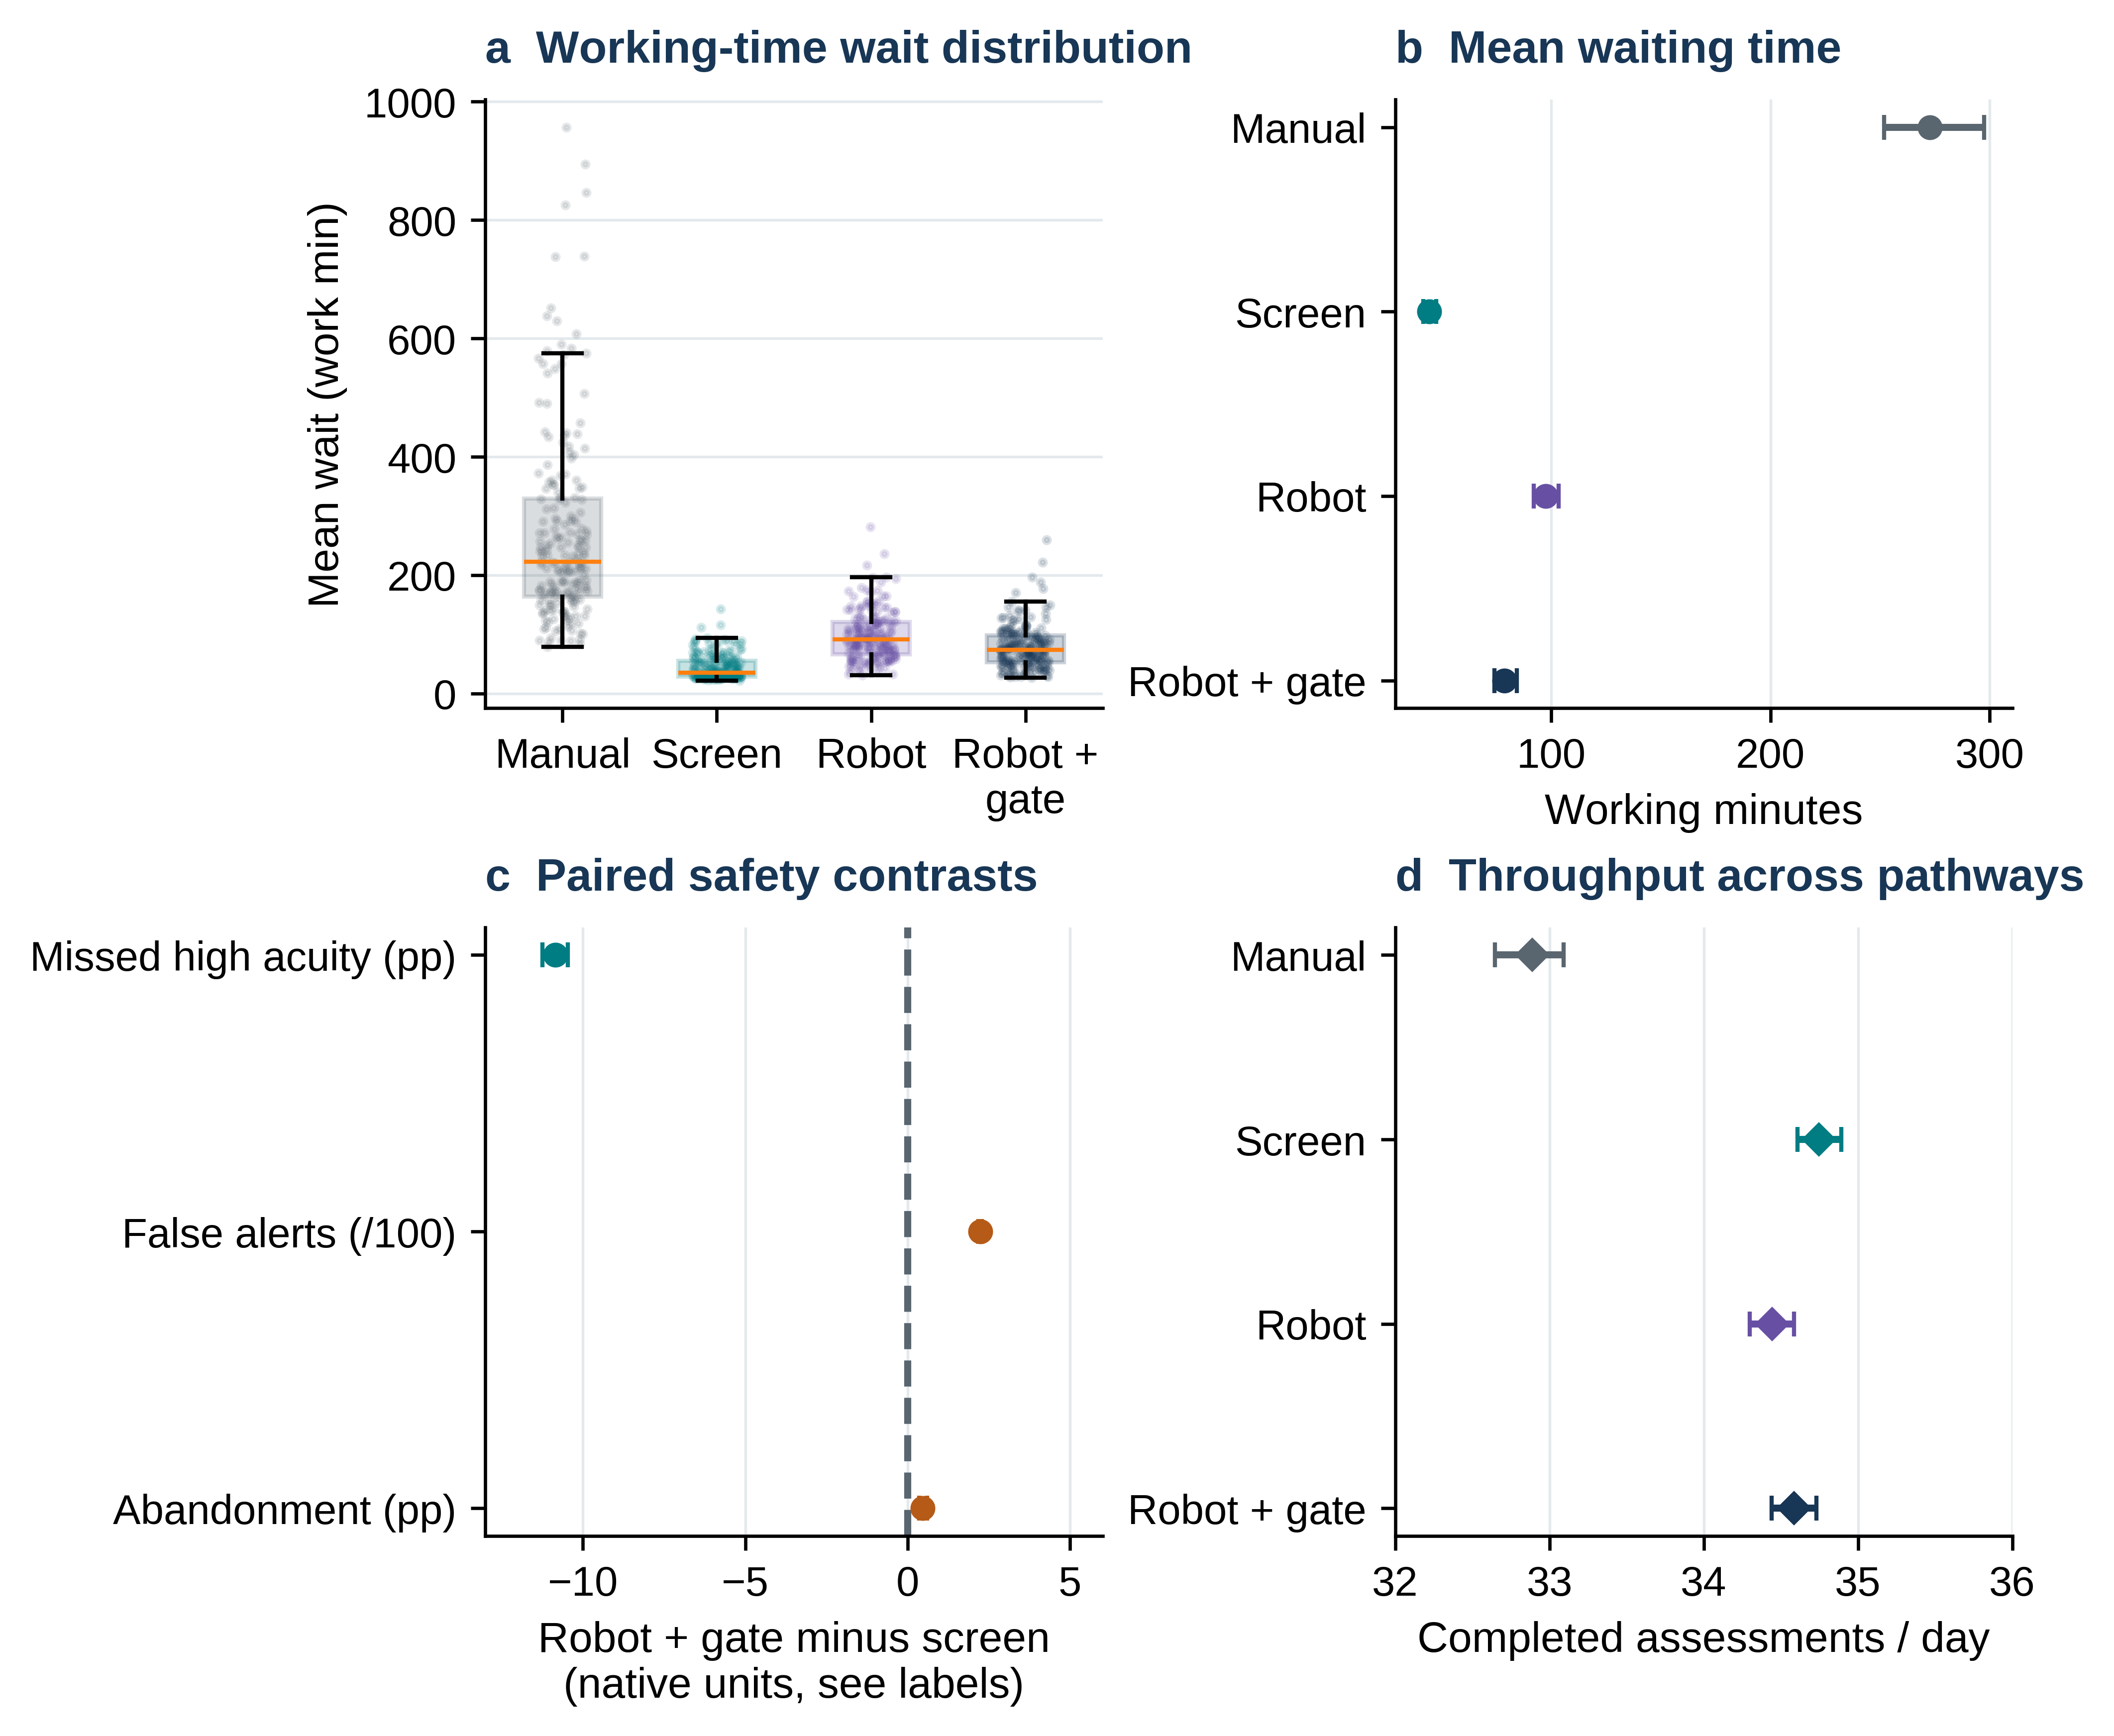
Figure 3. Clinic intake outcomes after a five-day warm-up. a, Distributions of within-replication mean waits across 200 paired replications; boxes indicate interquartile ranges and points individual replication outputs. b, Mean wait with 95% BCa intervals. c, Paired safety differences (the native units differ across rows and are shown explicitly) with 95% BCa intervals. d, Mean assessments per working day with 95% BCa intervals; axis is expanded to resolve small differences and is not a zero-origin bar plot. Waiting is measured in continuous working-minute time.
Table 2 | Primary human-gated pathway differences versus matched screen
Scale | Endpoint | Unit | Mean contrast (95% BCa interval) | Interpretation
Patient | Response | pp | +6.29 (6.09 to 6.50) | Benefit
Patient | Remission | pp | +2.20 (2.09 to 2.31) | Benefit
Patient | Completion | pp | -5.42 (-5.69 to -5.17) | Burden / access
Patient | PHQ-9 change | points | -0.39 (-0.41 to -0.38) | Benefit
Patient | Review work | minutes/person | +4.38 (4.35 to 4.40) | Burden / access
Patient | Physical near misses | /100 persons | +0.55 (0.51 to 0.58) | Burden / access
Service | Waiting time | working minutes | +34.41 (30.69 to 39.02) | Burden / access
Service | Missed high-acuity cases | pp | -10.85 (-11.25 to -10.47) | Benefit
Service | False alerts | /100 arrivals | +2.23 (2.18 to 2.28) | Burden / access
Service | Throughput | assessments/day | -0.16 (-0.21 to -0.13) | Capacity
Paired replication is the sampling unit (n=200); 10,000 BCa bootstrap resamples. Positive response/remission and negative PHQ-9 change/missed cases favor robot; greater burden or waiting and lower completion favor screen. Simulation P values hit the 100,000-draw sign-flip resolution floor and are summarized as P<0.0001 (Holm-adjusted), not exact probabilities.

Assumption stress tests and break-even regions
Sensitivity analyses next removed hypothesized benefits or moved parameters toward adverse-but-declared ranges. With a neutral assumption set, the response contrast became −1.38 points and completion remained inferior; with skeptical assumptions, response was −8.83 points, completion −26.16 points and service waiting increased by 205.66 minutes. Figure 4a makes those joint reversals visible; Table 3 reports the corresponding model-internal confidence intervals.
The two-way patient response grid and service waiting grid (Fig. 4b–c) show that engagement, reliability and review duration have separate roles. In the service grid, zero-margin waiting non-worsening was confined to no modeled day-level downtime with short review times, and stricter confidence-bound criteria narrowed the region further. The 250-draw nested scenario ensemble (Fig. 4d) is an illustrative range stress test, not a posterior probability of success.
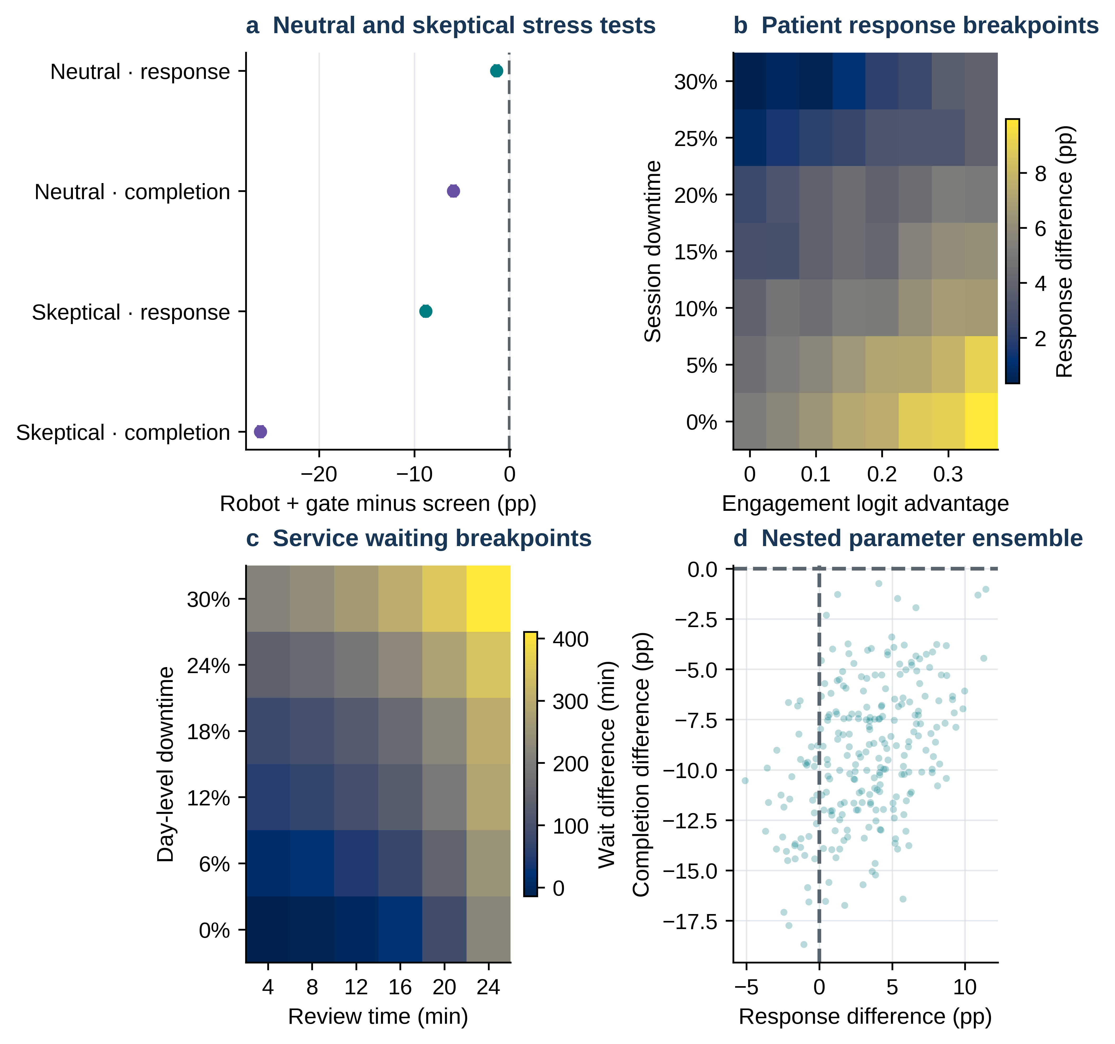
Figure 4. Sensitivity analyses. a, Human-gated robot minus screen contrasts under neutral and skeptical parameter settings, with 95% BCa intervals. b, Response difference over engagement-logit advantage and session downtime. c, Mean wait difference over review time and day-level downtime. d, Joint scenario-draw response and completion contrasts across 250 illustrative parameter sets; scenario proportions are descriptive of the selected ranges, not probabilities of real deployment outcomes.
Table 3 | Neutral and skeptical scenario contrasts
Assumption set | Model | Outcome | Robot + gate minus screen (95% BCa interval)
Neutral | Patient | response percent | -1.38 (-1.57 to -1.18)
Neutral | Patient | completion percent | -5.91 (-6.15 to -5.66)
Neutral | Patient | mean clinician review minutes | +4.56 (4.53 to 4.58)
Neutral | Service | mean wait minutes | +0.92 (0.89 to 0.94)
Neutral | Service | false alerts per 100 arrivals | +0.00 (0.00 to 0.00)
Skeptical | Patient | response percent | -8.83 (-9.02 to -8.63)
Skeptical | Patient | completion percent | -26.16 (-26.42 to -25.90)
Skeptical | Patient | mean clinician review minutes | +9.64 (9.61 to 9.68)
Skeptical | Service | mean wait minutes | +205.66 (195.18 to 221.17)
Skeptical | Service | false alerts per 100 arrivals | +4.99 (4.90 to 5.07)
n=200 paired replications per scenario; these contrasts are from separate scenario-specific random streams, not a continuation of the primary replication series. Parameters and units are fully specified in Supplementary Data 1–2 and the repository.

Global interaction-aware sensitivity
The full variance-based analysis was repeated with 1,024 scrambled Sobol base vectors, 12 patient and 11 service varied inputs, matched common-random-number streams within each design row, and 350 row-bootstrap resamples. Relative to the earlier 128-point screening design, the summed patient-response first-order indices fell within the theoretical bound (ΣS1=0.737). Figure 5 compares total-order contributions and exploratory second-order interactions. Response was most sensitive to the assumed embodiment symptom increment (ST=0.36, 95% design-row interval 0.33–0.40), completion to the embodiment-related dropout increment (ST=0.64), and service waiting to demand (ST=0.46).
Residual small S1>ST inconsistencies persist for some near-zero indices, illustrating finite-sample numerical uncertainty; no indices were forcibly truncated, normalized or treated as exact variance shares. Pairwise interactions were exploratory: none of the patient-response S2 intervals excluded zero; one of 55 service-wait pairwise intervals excluded zero before multiplicity adjustment, so isolated interaction claims would be premature. The sensitivity results apply only to independently uniform input ranges and cannot identify real-world parameter importance without calibration and dependence modeling.
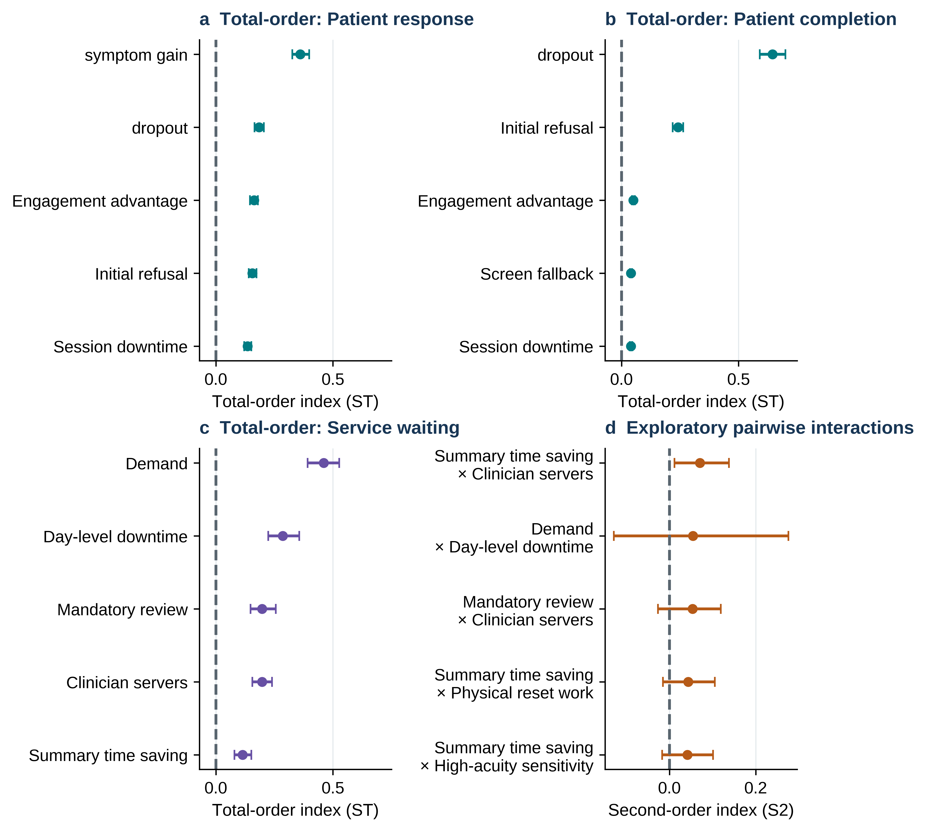
Figure 5. Variance-based global sensitivity audit with 1,024 base design rows. a–c, Largest total-order Sobol estimates and 95% row-bootstrap intervals for patient response, patient completion and clinic waiting, respectively. d, Five exploratory pairwise second-order estimates for clinic waiting with 95% intervals; these comparisons are not multiplicity adjusted. Inputs were independently uniform across declared stress ranges; estimates and intervals concern only the simulation model. S1 and S2 are retained unaltered in the machine-readable repository, including finite-design violations.
Table 4 | Leading total-order Sobol sensitivity indices
Scale | Output contrast | Parameter | ST | 95% row-bootstrap interval
Patient | response difference pp | Embodiment symptom increment | 0.360 | 0.327 to 0.398
Patient | response difference pp | Embodiment dropout increment | 0.184 | 0.165 to 0.205
Patient | response difference pp | Engagement advantage | 0.164 | 0.146 to 0.179
Patient | completion difference pp | Embodiment dropout increment | 0.645 | 0.591 to 0.700
Patient | completion difference pp | Initial refusal | 0.241 | 0.219 to 0.263
Service | mean wait difference minutes | Demand | 0.461 | 0.391 to 0.527
Service | mean wait difference minutes | Day-level downtime | 0.285 | 0.224 to 0.356
Service | mean wait difference minutes | Mandatory review | 0.197 | 0.148 to 0.256
Service | mean wait difference minutes | Clinician servers | 0.197 | 0.155 to 0.239
1,024 base points; two inner stochastic evaluations per parameter vector. Index ranges are model-conditional Monte Carlo diagnostics, not confidence intervals for causal effects or posterior parameter uncertainty. Full S1, ST, S2, denominator diagnostics and design outputs are deposited in the repository.

Alternative estimands, capacity and mechanism diagnostics
The final analyses address two distinct alternatives: endpoint definition and implementation composition. The independently seeded attrition module found a +6.23-point response difference under last-observation-carried-forward, +5.53 under baseline-observation-carried-forward and +10.21 among completers. These values differ slightly from the +6.29-point primary LOCF contrast because the modules used separately seeded synthetic replication streams; they are not duplicate evaluations on identical participants. Figure 6a summarizes these differences, and Supplementary Table S1 retains all estimand intervals.
Similarly, the independently seeded capacity module estimated a +36.40-minute mean-wait difference at three robot intake stations, compared with +34.41 minutes in the primary three-station model; differences stem from Monte Carlo stream choice, not changed configured capacity. Increasing robot stations to five left an approximately +36-minute penalty (Fig. 6b). One-block substitutions identified different drivers of modeled response and completion (Fig. 6c), but are neither additive nor causal mediation. Warm-up choice did not reverse queue ordering (Fig. 6d). The corresponding data are retained as Supplementary Tables S2–S3 and source CSVs.
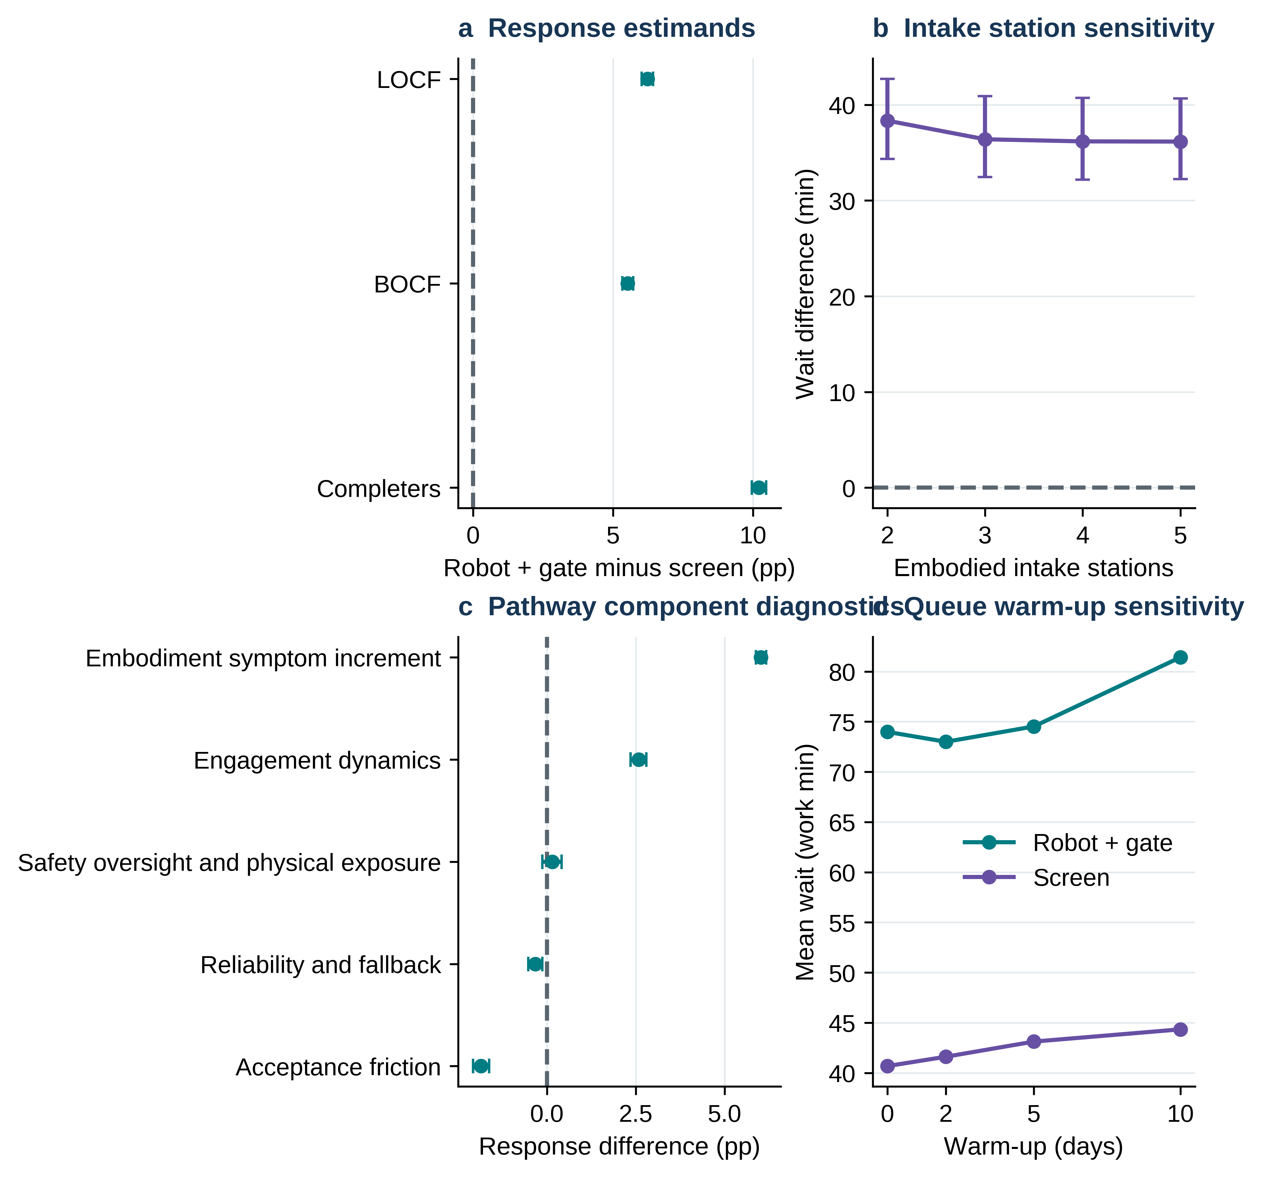
Figure 6. Structural and estimand diagnostics. a, Response contrasts under last-observation-carried-forward (LOCF), baseline-observation-carried-forward (BOCF) and completer-only definitions. b, Paired mean-wait differences as robot intake stations vary; the three-station point uses an independent Monte Carlo stream from the primary estimate. c, One-block pathway parameter substitutions into the screen model (diagnostic, not additive or causal). d, Warm-up comparison; queue backlogs may pass between nominal working days. Error bars in a–c are 95% BCa intervals where shown.

Discussion
The complementary simulations demonstrate a decision-scale separation: a modeled patient or detection advantage can coexist with worse retention, human workload, false alerts, physical exposure, and service access. The principal implication is not that a specific robot is effective or unsafe. It is that empirical evaluation should require both incremental patient benefit against a content-matched screen and prespecified operational acceptability, including completion, waiting, verification labor, fallback, and physical-safety workload.
The neutral and skeptical analyses materially sharpen that interpretation. Once the assumed engagement and symptom increments were removed, the patient response advantage disappeared while completion, review, and physical exposure remained unfavorable. Under skeptical but still declared-range assumptions, the deterioration was larger and the service queue became markedly unstable. The base case should therefore be read as one internally coherent hypothesis, not as the expected performance of physical AI.
The result is consistent with, but more operationally qualified than, the human-robot interaction literature. Physical copresence can strengthen behavioral and attitudinal responses relative to screen display [8,9], and the recent matched iCBT study found improved alliance, adherence, and satisfaction without a significant mood advantage [5]. Our framework formalizes the next question: whether such an interaction dividend remains valuable after refusal, downtime, oversight, and service consequences are counted. In the base assumptions, the answer differed by outcome and scale.
The broader health evidence also supports cautious interpretation. Reviews across mental health, older adults, and dementia report promising feasibility and selected psychosocial effects, but heterogeneous interventions, small samples, mixed pooled estimates, and limited long-term evidence remain common [2,3,10-12]. A month-long home study in autism illustrates the feasibility of sustained autonomous interaction in a selected setting [13], but it does not resolve comparative efficacy, workflow, or generalizability in psychiatric services. Simulation can therefore organize hypotheses and identify measurements; it cannot substitute for clinical evaluation.
Implementation science provides the appropriate bridge from efficacy to deployment. Digital psychiatry reviews emphasize that the intervention, users, clinical context, and implementation process jointly determine real-world value [14,15], while the NASSS framework highlights nonadoption, abandonment, scale-up, spread, and sustainability as distinct failure modes [16]. The present dual-gate standard operationalizes part of that agenda by treating completion, clinician review, waiting, fallback, and physical work as co-primary deployment concerns rather than post hoc inconveniences.
The component analysis further limits causal language. The human-gated robot and screen were content-matched but not intervention-identical: their contrast combined embodiment, engagement dynamics, acceptance friction, downtime, fallback, detection sensitivity, review rules, and physical exposure. Favorable response and unfavorable completion arose from different assumption blocks. Empirical studies seeking component effects should use factorial, sequential, or adaptive designs and report human-AI interaction, workflow integration, error handling, and protocol deviations in line with DECIDE-AI and CONSORT-AI principles [22,23].
Differential attrition is central because the pathway with better modeled symptom thresholds also completed less often. Baseline-observation-carried-forward and completer-only analyses preserved the response direction but changed its magnitude. An empirical trial should prospectively define treatment-policy, while-on-treatment, and hypothetical estimands; collect outcomes after disengagement where feasible; and use missing-data methods appropriate to the causal question rather than rely on last observation carried forward.
Increasing the global design from 128 to 1,024 base points and synchronizing latent streams improved estimator stability but did not make the indices empirical. Response and completion were most sensitive to different patient-model assumptions, while queue waiting depended on jointly varying demand, reliability and clinician work. Some S1 versus ST inequalities remained for effects near zero, and bootstrap intervals for interactions were often wide. A further simulation budget expansion, independent scramble replication and explicitly modeled parameter dependence are needed before assigning robust causal importance to pairwise interactions [36–38].
The two contexts must not be portrayed as a dynamically linked digital twin: the 12-week model counts participant-level review over a longitudinal horizon, whereas the clinic model assigns clinician work to a one-day assessment. Thus +4.38 longitudinal review minutes per participant cannot be converted to clinic staffing without specifying panel size, contact frequency, time horizon and service coverage. For example, for a panel of M participants, required clinician hours per 12-week period would be 4.38×M/60; average weekly FTE then depends on paid weekly hours and whether that additional labor falls on the same clinician pool. This algebra is illustrative; no staffing estimate was inferred from unavailable clinic volumes.
In the intake simulation, time is indexed in consecutive 420-minute productive working-day blocks, with unfinished service and waiting workloads carried into later blocks. It does not insert overnight closures or explicit shift endings, and the original excess-work measure is a daily workload-capacity proxy rather than observed clock-time overtime. Likewise “utilization” is scheduled service minutes relative to nominal daily clinician capacity rather than direct time-weighted occupancy. These restrictions complicate extrapolation to a clinic with overtime policies, appointment calendars, breaks and overnight delays.
The service model suggests that the waiting penalty is not explained solely by fewer robot stations, because increasing intake capacity produced little improvement while clinician review remained fixed. Nevertheless, this is one finite-capacity clinic configuration. The manual pathway is nominally at its intake-capacity boundary, the abandonment function is stylized, and scheduling, no-shows, downstream treatment capacity, staff learning, maintenance logistics, costs, and equity effects are not represented. Site-specific calibration and face validation are required before operational use.
All parameters are illustrative. The framework cannot estimate clinical efficacy, real-world safety incidence, cost-effectiveness, regulatory acceptability, or generalizability. Threshold outcomes amplify small distributional shifts; high-risk episodes and physical near-misses are synthetic constructs; the individual and service models are not dynamically coupled; and the broad parameter draws are not a probability distribution over plausible deployments. Narrow bootstrap intervals and small Monte Carlo P values reflect repeated computation under fixed assumptions, not empirical certainty.
The central contribution is a falsifiable dual-gate evaluation and a transparent experimental agenda, not evidence that physical AI is effective or harmful. A credible next phase will collect site-specific symptom/engagement and operational logs; elicit uncertain robot-specific effects from patients, clinicians, operations, privacy and human-factors experts; externally face-validate the conceptual architecture; and prespecify noninferiority margins and calibration targets [32–35]. Until those steps, the numerical break-even thresholds remain research hypotheses.

Methods

Design, units and modeling contexts
Two models share pathway names and burden categories but are intentionally uncoupled. The longitudinal model evaluates 12 weeks of synthetic outpatient interaction and follow-up. The discrete-event model evaluates a finite-capacity clinic intake assessment and clinician triage. No real patient observations or medical records entered either model. The estimand is the expectation of each complete robot pathway minus a functionally matched screen under fixed, transparent parameter values. The comparison is bundled across hardware, engagement, acceptance, reliability, alerting and oversight; it is not an isolated causal embodiment effect.

Parameter selection and calibration status
All 47 documented patient-model inputs and structural assumptions and all 33 service-model inputs and assumptions have a defined functional role, unit or scale, pathway value, optional neutral/skeptical value, stress range, ordering rationale and evidence class. For an exact machine-readable row-by-row account, see Supplementary Data 1 and 2; these are data tables rather than separate Supplementary Methods. The full formulas, event order, distributional assumptions, horizon and functional definitions necessary for replication are specified below and implemented in the associated Python code.
PHQ-9 scale bounds and response/remission definitions are supported by measurement literature [20,21,31]; attrition and engagement direction classes by digital intervention evidence [27–30]; possible embodiment mechanisms by physical copresence and robot reviews [2,3,5,8,9,39]; and queue/alert-workflow categories by simulation and alarm research [17–19,40]. Those sources do not calibrate the numeric robot-specific effects, trust-update coefficients, crisis intercepts, or alert rates. These remain explicit hypothetical assumptions; parameter-dictionary references were restricted to appropriate conceptual or scale anchors and do not imply extraction of a coefficient from a cited study.
Neutral and skeptical parameter sets remove hypothesized benefit or place burdens near adverse declared bounds. Uniform input distributions used for Sobol sensitivity are independent by construction and are not posterior estimates. Neither empirical calibration, structured stakeholder elicitation nor independent face validation has been completed. A prospective multi-stakeholder elicitation and external face-validation protocol is supplied with the repository, and any calibrated analysis must be rerun with correlated parameter distributions where justified [32–35].

Patient-level mathematical and operational specification

State and baseline
For participant i, pathway a and week t=1,…,12, the state is PHQ-9 Y, active indicator Z, past engagement E, trust U, and cumulative risk, alerts, downtime, fallback, review and near-miss counts. Shared baseline draws: Y(i,0)=clip[Normal(15.5,3.2),10,24]; acceptance A~Beta(2.4,1.9); privacy P~Beta(2.1,2.4); support S~Normal(0,1); responsiveness R~Normal(0,0.13) PHQ-9 units/week. Initial trust U(i,a,0)=0.08 H(a)+0.12 A(i)−0.10 P(i), with H the verification indicator. Initial refusal F~Bernoulli(rho(a)); Z(i,a,0)=1−F.

Availability and engagement
While active, downtime D(i,a,t)~Bernoulli(d(a)), and conditional fallback B(i,a,t)~Bernoulli(f(a)); a session is available when D=0 or B=1. Engagement logit equals alpha(a)+1.05(A−0.5)−gamma_P(a)(P−0.5)+0.34 E(previous)+0.13 S+U(previous)−delta(a)(t−1)−0.025 max[Y(previous)−15,0]. Realized engagement requires both a successful Bernoulli draw and availability; fallback preserves content but removes the embodiment symptom increment.

Symptoms and clinical events
Baseline week-specific trend b(i)=0.24+0.022 max[Y(i,0)−14,0]. Intervention increment Q(i,a,t)=E(i,a,t)[beta_content(a)+beta_emb(a)(1−B(i,a,t))]. Active symptoms evolve as Y(i,a,t)=clip{Y(previous)−[b(i)+Q(i,a,t)+R(i)]+epsilon,0,27}, epsilon~Normal(0,0.62). Worsening W=Y(new)−Y(previous). Crisis logit=−10.2+0.27Y(new)+0.42max(W,0). Alerts occur with sensitivity Se(a) in crisis weeks and false-alert probability FPR(a) otherwise. None of these coefficients is derived from observed clinical data.

Oversight, trust and safety
False-alert escalation probabilities are 0.12 under human verification and 0.72 otherwise. Clinician review initializes at pathway-specific routine audit minutes and adds review minutes for every alert. Trust changes +0.025 for a true alert, −0.040 for an escalated false alert, and −0.075 for a missed crisis, clipped to [−0.5,0.5]. A physical near-miss is Bernoulli(h(a)) only for available, nonfallback embodied sessions; it is a synthetic noninjury placeholder.

Dropout and endpoints
For active participants, p_drop=clip[0.010+0.030(1−E)+0.016P+kappa(a)+0.010 I(W>1.5)−0.008E,0.002,0.12]. Dropout is Bernoulli(p_drop), with absorbing inactive state. Completion requires activity through week 12; response is ≥50% PHQ-9 reduction, remission Y≤4. Primary missingness handling is last observation carried forward after attrition; BOCF and completer-only results are alternative estimands rather than evidence of missing-data validity.

Clinic discrete-event mathematical and operational specification

Arrivals, time axis and resources
In each replication, five warm-up days precede 35 observed days; one day is L=420 productive working minutes. Daily arrivals N(d)~Poisson(lambda); within-day timestamps are sorted Uniform(0,L) shifted by dL. Low/medium/high acuity probabilities are 0.60/0.30/0.10. Intake, fallback and clinician resources each maintain a heap of next-available working-minute times. Start=max(arrival,minimum resource availability), finish=start+duration, and the resource heap is updated. A FIFO queue is never reset at day boundaries: an arrival near minute 420 may wait into the next 420-minute block. The time axis compresses overnight/nonworking periods, rather than assuming real-time work during nights. No explicit end-of-shift overtime operation is modeled.

Intake, downtime and rework
For each model day, a common outage uniform determines whether the digital pathway uses its available fallback resource. Primary intake duration=max(4,mu_intake+sigma_intake×standard normal) plus any routine reset minutes; fallback duration=max(4,mu_fallback+4×standard normal). Digital incompleteness is a Bernoulli event with probability q(a) and consumes extra rework duration on the fallback resource. Reset work is not an incident or injury rate.

Detection, clinician activity and abandonment
An alert occurs with sensitivity Se(a) among high-acuity arrivals and false-alert rate FPR(a) otherwise. Baseline clinician assessment minutes are 38,52,72 for low,medium,high acuity. Final clinician duration=max(base−summary_saving(a),25)+I(digital)×review_minutes(a)+I(alert)×[6H(a)+10(1−H(a))]. Predicted wait=max(intake_finish, earliest_clinician_availability)−arrival; abandonment risk=min{0.25,logistic[−5.2+0.010max(predicted_wait−120,0)]}. Abandoned arrivals never enter clinician service; completed waiting time=clinician_start−arrival.

Boundary, denominators and outputs
Observed arrivals are classified by their arrival day after warm-up, even when downstream clinician completion occurs beyond the nominal observation boundary. Therefore “completed per observed day” is an observed-arrival-cohort throughput ratio, not a censored clock-time completion count. Arrivals=completed+abandoned exactly. Mean and 90th-percentile waits are computed among completed arrivals. False alerts use all observed arrivals as denominator; missed high-acuity cases use observed high-acuity arrivals. Clinician workload-to-capacity is assigned clinician service minutes for the observed arrival cohort to that cohort’s arrival day, divided by nominal 420×clinician-server minutes; reported excess above capacity is a workload proxy, not directly simulated calendar overtime. Intakes and fallback work are analogously attributed to arrival day. A full site scheduling model would have to add shifts, overnight closures, unfinished-work censored analyses, appointment/no-show logic and staff breaks.

Primary statistical analysis and module-specific streams
The independent simulation replication (not an individual record or arrival) is the uncertainty unit. Arms within each patient replication share a baseline cohort; service pathways within each queue replication share demand, acuity and latent event draws. Contrasts were resampled as intact pairs for two-sided 95% BCa bootstrap mean intervals (10,000 resamples for primary endpoints; 5,000 arm means; 3,000 selected diagnostic grids). The base-case analysis used n=200 paired replications. Simulation MCSE equals the standard deviation of paired replication contrasts divided by √200. The alternative two-sided paired sign-flip randomization test used 100,000 draws and a plus-one correction; Holm adjustment was applied across seven prespecified outcomes per comparator and model, with nominal alpha=.05. At the Monte Carlo floor, the smallest unadjusted P is 1/100,001=0.0000099999 and the smallest seven-test adjusted P is approximately 0.000070; both are reported as P<0.0001, not as estimates of extreme real-world tail probability. Paired t tests and standardized dz were concordance diagnostics [24–26].
The original primary, attrition, capacity, ablation, and scenario modules intentionally use separate deterministic analysis-label seeds. Repeating nominally identical configurations in different modules therefore generates slightly different Monte Carlo means and intervals. All differences retain their unaltered original output files; this distinction is explicit in Results and Supplementary Table S4. No significance claim is based on treating those independently sampled outputs as exact replicates.

Sensitivity estimators and quality control
The patient grid varied engagement-logit advantage 0–0.35 and session downtime 0–30%, and the service grid day downtime 0–30% and review time 4–24 min. A separate 250-draw multivariate scenario ensemble used five inner stochastic replications per scenario. Neutral/skeptical tests each used 200 paired replications. Sobol global analysis used 12 varied patient and 11 service parameters with independently Uniform inputs over registered stress ranges. A scrambled 2d-dimensional Sobol sequence defined two N=1,024 matrices A and B, their d AB matrices and d BA matrices (N×[2d+2] model evaluations per scale). Within each design row, each A/B/AB/BA evaluation shared identical synthetic-cohort and event seeds; for service demand, a maximum-rate Poisson stream was Bernoulli-thinned with fixed per-arrival uniforms so differing arrival rates preserved CRN nesting. Each parameter vector was averaged over two independent matched stochastic replications (350 synthetic participants per arm, or 18 observed service days following warm-up).
First-order S1 was estimated by the Saltelli covariance estimator mean[Y_B×(Y_ABi−Y_A)]/Var(Y); total-order ST by Jansen’s squared-difference estimator mean[(Y_A−Y_ABi)^2]/[2Var(Y)]. Pairwise S2 used the Saltelli BA/AB cross-product correction with first-order terms subtracted. Row bootstrap intervals used 350 resamples, maintaining matrix-row alignment. All raw estimates are retained, even if finite-design effects yield S1<0, S1>ST, ΣS1>1 or uninformative S2 intervals. Interpretation concentrates on stable total-order ranking, while individual S1 violations near zero and unadjusted pairwise interactions are declared exploratory. The full input matrices, outputs, estimator diagnostics and code are deposited. The 1,024-point rerun uses different numerical random streams from the earlier 128-point audit and therefore replaces—not silently augments—the earlier global estimates [36–38].

Software, reporting, ethical and AI-use disclosures
Python, NumPy, pandas, SciPy, Matplotlib and python-docx were used; exact versions are pinned in requirements-lock.txt. The full code, design matrices, synthetic data, tests, figure-generation scripts and SHA-256 manifest are provided in the accompanying reproducibility repository. Tests verify deterministic stream matching, range and impossibility constraints, queue accounting, model outputs, and figure-editable text. The reporting approach follows STRESS and ISPOR-SMDM model-transparency guidance [18,19]. No real human data, tissue or participant interactions were used, so no human research ethics approval or consent was required for the computational work described here; authors must confirm this characterization under their institution’s policies.
Use of AI-assisted tools: OpenAI ChatGPT was used in preparing draft editorial text, reviewing code and developing reproducibility artifacts. All scientific interpretations, source accuracy, analysis outputs and final text require author verification; the human authors retain responsibility for the submission. [AUTHOR VERIFICATION REQUIRED: verify this description against actual use.]

Data availability
Synthetic simulation inputs and machine-readable outputs, including complete Saltelli design/output matrices and parameter dictionaries, are contained in the accompanying repository. [AUTHOR INPUT REQUIRED: insert public repository name, persistent release URL and DOI after deposit; no DOI has yet been assigned.]

Code availability
Complete Python simulation, validation, sensitivity and plotting scripts are included in the accompanying versioned repository, with environment specifications and an end-to-end reproduction workflow. [AUTHOR INPUT REQUIRED: choose and confirm an authorized open-source license, release tag and archived DOI.]

Acknowledgements
[AUTHOR INPUT REQUIRED: acknowledgements and funding source/grant information, or an affirmative statement that no external funding was received.]

Author contributions
[AUTHOR INPUT REQUIRED: identify every author by initials and specify CRediT contributions.]

Competing interests
[AUTHOR INPUT REQUIRED: declare every author’s financial and non-financial competing interests, or state explicitly if none.]

References
1. Fiske A, Henningsen P, Buyx A. Your Robot Therapist Will See You Now: Ethical Implications of Embodied Artificial Intelligence in Psychiatry, Psychology, and Psychotherapy. J Med Internet Res. 2019;21(5):e13216. doi:10.2196/13216.
2. Guemghar I, Pires de Oliveira Padilha P, Abdel-Baki A, Jutras-Aswad D, Paquette J, Pomey MP. Social Robot Interventions in Mental Health Care and Their Outcomes, Barriers, and Facilitators: Scoping Review. JMIR Ment Health. 2022;9(4):e36094. doi:10.2196/36094.
3. Kling M, Haeussl A, Dalkner N, et al. Social robots in adult psychiatry: a summary of utilisation and impact. Front Psychiatry. 2025;16:1506776. doi:10.3389/fpsyt.2025.1506776.
4. Jung HW, Park JY, Holoubek T, Kim WJ, Park J. Socially Assistive Robots in Mental Healthcare: Principles and Conceptual Framework for User-Centered Design. Int J Soc Robot. 2025;17:2827-2851. doi:10.1007/s12369-025-01323-5.
5. Konijn EA, Peeper G, Portegies T, Garnefski N, Kraaij V, Struijs S. Examining the Potential of Social Robots to Increase Adherence in Internet-based CBT. Int J Soc Robot. 2026;18(6):83. doi:10.1007/s12369-026-01417-8.
6. Deng E, Mutlu B, Mataric MJ. Embodiment in Socially Interactive Robots. Found Trends Robot. 2019;7(4):251-356. doi:10.1561/2300000056.
7. Rabbitt SM, Kazdin AE, Scassellati B. Integrating socially assistive robotics into mental healthcare interventions: applications and recommendations for expanded use. Clin Psychol Rev. 2015;35:35-46. doi:10.1016/j.cpr.2014.07.001.
8. Li J. The benefit of being physically present: A survey of experimental works comparing copresent robots, telepresent robots and virtual agents. Int J Hum Comput Stud. 2015;77:23-37. doi:10.1016/j.ijhcs.2015.01.001.
9. Bainbridge WA, Hart JW, Kim ES, Scassellati B. The Benefits of Interactions with Physically Present Robots over Video-Displayed Agents. Int J Soc Robot. 2011;3(1):41-52. doi:10.1007/s12369-010-0082-7.
10. Pu L, Moyle W, Jones C, Todorovic M. The Effectiveness of Social Robots for Older Adults: A Systematic Review and Meta-Analysis of Randomized Controlled Studies. Gerontologist. 2019;59(1):e37-e51. doi:10.1093/geront/gny046.
11. Yu C, Sommerlad A, Sakure L, Livingston G. Socially assistive robots for people with dementia: Systematic review and meta-analysis of feasibility, acceptability and the effect on cognition, neuropsychiatric symptoms and quality of life. Ageing Res Rev. 2022;78:101633. doi:10.1016/j.arr.2022.101633.
12. Nichol B, McCready J, Erfani G, et al. Exploring the impact of socially assistive robots on health and wellbeing across the lifespan: An umbrella review and meta-analysis. Int J Nurs Stud. 2024;153:104730. doi:10.1016/j.ijnurstu.2024.104730.
13. Scassellati B, Boccanfuso L, Huang CM, et al. Improving social skills in children with ASD using a long-term, in-home social robot. Sci Robot. 2018;3(21):eaat7544. doi:10.1126/scirobotics.aat7544.
14. Torous J, Bucci S, Bell IH, et al. The growing field of digital psychiatry: current evidence and the future of apps, social media, chatbots, and virtual reality. World Psychiatry. 2021;20(3):318-335. doi:10.1002/wps.20883.
15. Torous J, Linardon J, Goldberg SB, et al. The evolving field of digital mental health: current evidence and implementation issues for smartphone apps, generative artificial intelligence, and virtual reality. World Psychiatry. 2025;24(2):156-174. doi:10.1002/wps.21299.
16. Greenhalgh T, Wherton J, Papoutsi C, et al. Beyond Adoption: A New Framework for Theorizing and Evaluating Nonadoption, Abandonment, and Challenges to the Scale-Up, Spread, and Sustainability of Health and Care Technologies. J Med Internet Res. 2017;19(11):e367. doi:10.2196/jmir.8775.
17. Kim B, Elstein Y, Shiner B, Konrad R, Pomerantz AS, Watts BV. Use of discrete event simulation to improve a mental health clinic. Gen Hosp Psychiatry. 2013;35(6):668-670. doi:10.1016/j.genhosppsych.2013.06.004.
18. Monks T, Currie CSM, Onggo BS, Robinson S, Kunc M, Taylor SJE. Strengthening the reporting of empirical simulation studies: Introducing the STRESS guidelines. J Simul. 2019;13(1):55-67. doi:10.1080/17477778.2018.1442155.
19. Eddy DM, Hollingworth W, Caro JJ, Tsevat J, McDonald KM, Wong JB. Model transparency and validation: a report of the ISPOR-SMDM Modeling Good Research Practices Task Force-7. Med Decis Making. 2012;32(5):733-743. doi:10.1177/0272989X12454579.
20. Kroenke K, Spitzer RL, Williams JBW. The PHQ-9: Validity of a Brief Depression Severity Measure. J Gen Intern Med. 2001;16(9):606-613. doi:10.1046/j.1525-1497.2001.016009606.x.
21. Coley RY, Boggs JM, Beck A, et al. Defining Success in Measurement-Based Care for Depression: A Comparison of Common Metrics. Psychiatr Serv. 2020;71(4):312-318. doi:10.1176/appi.ps.201900295.
22. Vasey B, Nagendran M, Campbell B, et al. Reporting guideline for the early-stage clinical evaluation of decision support systems driven by artificial intelligence: DECIDE-AI. Nat Med. 2022;28(5):924-933. doi:10.1038/s41591-022-01772-9.
23. Liu X, Cruz Rivera S, Moher D, Calvert MJ, Denniston AK; SPIRIT-AI and CONSORT-AI Working Group. Reporting guidelines for clinical trial reports for interventions involving artificial intelligence: the CONSORT-AI extension. Nat Med. 2020;26(9):1364-1374. doi:10.1038/s41591-020-1034-x.
24. Morris TP, White IR, Crowther MJ. Using simulation studies to evaluate statistical methods. Stat Med. 2019;38(11):2074-2102. doi:10.1002/sim.8086.
25. Efron B, Tibshirani RJ. An Introduction to the Bootstrap. New York: Chapman & Hall; 1993.
26. Desharnais B, Camirand-Lemyre F, Mireault P, Skinner CD. Determination of confidence intervals in non-normal data: application of the bootstrap to cocaine concentration in femoral blood. J Anal Toxicol. 2015;39(2):113-117. doi:10.1093/jat/bku127.
27. van Ballegooijen W, Cuijpers P, van Straten A, et al. Adherence to Internet-based and face-to-face cognitive behavioural therapy for depression: a meta-analysis. PLoS One. 2014;9(7):e100674. doi:10.1371/journal.pone.0100674.
28. Torous J, Lipschitz J, Ng M, Firth J. Dropout rates in clinical trials of smartphone apps for depressive symptoms: a systematic review and meta-analysis. J Affect Disord. 2020;263:413-419. doi:10.1016/j.jad.2019.11.167.
29. Linardon J, Fuller-Tyszkiewicz M. Attrition and adherence in smartphone-delivered interventions for mental health problems: a systematic and meta-analytic review. J Consult Clin Psychol. 2020;88(1):1-13. doi:10.1037/ccp0000459.
30. Baumel A, Muench F, Edan S, Kane JM. Objective User Engagement With Mental Health Apps: Systematic Search and Panel-Based Usage Analysis. J Med Internet Res. 2019;21(9):e14567. doi:10.2196/14567.
31. Lowe B, Unutzer J, Callahan CM, Perkins AJ, Kroenke K. Monitoring depression treatment outcomes with the Patient Health Questionnaire-9. Med Care. 2004;42(12):1194-1201. doi:10.1097/00005650-200412000-00006.
32. Briggs AH, Weinstein MC, Fenwick EAL, Karnon J, Sculpher MJ, Paltiel AD. Model parameter estimation and uncertainty analysis: a report of the ISPOR-SMDM Modeling Good Research Practices Task Force Working Group-6. Med Decis Making. 2012;32(5):722-732. doi:10.1177/0272989X12458348.
33. Sargent RG. Verification and validation of simulation models. J Simul. 2013;7(1):12-24. doi:10.1057/jos.2012.20.
34. Bojke L, Soares M, Claxton K, Colson A, Fox A. Developing a reference protocol for structured expert elicitation in health-care decision-making: a mixed-methods study. Health Technol Assess. 2021;25(37):1-124. doi:10.3310/hta25370.
35. Soares M, Colson A, Bojke L, et al. Recommendations on the Use of Structured Expert Elicitation Protocols for Healthcare Decision Making: A Good Practices Report of an ISPOR Task Force. Value Health. 2024;27(11):1469-1478. doi:10.1016/j.jval.2024.07.027.
36. Sobol IM. Global sensitivity indices for nonlinear mathematical models and their Monte Carlo estimates. Math Comput Simul. 2001;55(1-3):271-280. doi:10.1016/S0378-4754(00)00270-6.
37. Saltelli A, Annoni P, Azzini I, Campolongo F, Ratto M, Tarantola S. Variance based sensitivity analysis of model output: design and estimator for the total sensitivity index. Comput Phys Commun. 2010;181(2):259-270. doi:10.1016/j.cpc.2009.09.018.
38. Pianosi F, Beven K, Freer J, et al. Sensitivity analysis of environmental models: a systematic review with practical workflow. Environ Model Softw. 2016;79:214-232. doi:10.1016/j.envsoft.2016.02.008.
39. Huang R, Li H, Suomi R, Li C, Peltoniemi T. Intelligent Physical Robots in Health Care: Systematic Literature Review. J Med Internet Res. 2023;25:e39786. doi:10.2196/39786.
40. Cvach M. Monitor alarm fatigue: an integrative review. Biomed Instrum Technol. 2012;46(4):268-277. doi:10.2345/0899-8205-46.4.268.

