Reimagining Psychiatric Care with Physical AI through Multiscale Modeling of Benefit Burden and Breakeven Conditions
[AUTHOR INPUT REQUIRED: author names, affiliations, ORCID IDs, corresponding author email]
Article | Original research

Abstract
Physical artificial intelligence (AI) could support psychiatric care, where value depends on engagement, safety oversight, and service capacity. We developed an assumption-driven multiscale framework spanning 12-week outpatient monitoring and psychiatric intake, comparing embodied pathways with a functionally matched screen. Across 200 paired replications, human-gated embodiment increased modeled response by 6.29 percentage points and reduced missed high-acuity cases by 10.85 points. These gains accompanied a 5.42-point reduction in completion, 4.38 additional review minutes per participant, and 34.41 additional working minutes of waiting. Neutral and skeptical scenarios identified conditions that reversed the response advantage. Global variance-based sensitivity localized assumptions governing symptom response, attrition, demand, and reliability. By integrating patient outcomes with clinician workload and access, the framework offers a dual-gate evaluation strategy and concrete targets for prospective trials and implementation studies. Estimates depend on specified model inputs and require empirical calibration.
Keywords: physical AI; digital psychiatry; socially assistive robots; microsimulation; discrete-event simulation; global sensitivity; patient safety

Introduction
Digital psychiatry is expanding beyond software interfaces to devices that perceive, communicate, and act within the care environment. Physically embodied AI may support structured skills practice, patient coaching, assessments, and repeated contact between clinical visits [1–7,14,15]. Experimental human–robot interaction studies have found differences in social presence, engagement, and task behavior when a robot shares a physical space with the user [8,9]. These mechanisms create a timely clinical question: when does a physical interface offer enough additional patient value to justify the maintenance, supervision, and workflow demands of embodiment? Answering it requires a comparator delivering equivalent intervention content and outcomes extending beyond symptom improvement.
The evidence base now provides stronger clinical motivation for this question. In a 2026 randomized trial involving 153 LGBTQ+ young people with self-harm ideation, access to a socially assistive robot alongside safety planning improved emotion-regulation difficulties and selected secondary symptoms over 13 weeks; a between-group effect on self-harm was not established [41]. A 2026 meta-analysis of 34 randomized care-robot trials across populations identified a pooled improvement in neuropsychiatric symptoms, with broad prediction intervals and low or very low certainty for the assessed domains [42]. Earlier mental-health syntheses similarly show varied interventions and outcome measures [2,3,10–12]. A content-matched comparison of robot-supported internet-based cognitive behavioral therapy reported gains in alliance, adherence, and satisfaction without a significant mood advantage [5]. Together, these studies elevate the importance of direct screen comparisons, retention, measurement fidelity, and implementation outcomes.
Engagement determines how frequently a psychiatric digital intervention can deliver its intended content, and attrition changes the interpretation of measured response. Meta-analyses of digital mental-health interventions and real-world app use document substantial variability in adherence and sustained use [27–30]. At the same time, monitoring and escalation consume clinician attention: a recent systematic review found that the cognitive effects of clinical AI depend on the task and oversight design [43], while a clinical alert study demonstrated how concentrated alert exposure can create disproportionate burden [47]. Robots also introduce downtime, fallback, sanitation, reset work, and physical proximity [2,39]. In an intake service operating near capacity, these seemingly modest increments can propagate through queues to waiting and abandonment [17]. A useful evaluation therefore needs to follow benefits and costs through the care pathway.
Recent technical and evaluation research reinforces this system-level view. A 2026 preprint describing robot-supported cognitive behavioral therapy exercises identified the interaction between on-device functions, web interfaces, and longitudinal deployment as an engineering priority [44]. Separate 2026 preprints proposed clinically grounded evaluation taxonomies and clinician-validated safety assessment for mental-health AI [45,46]. In implementation science, the NASSS framework connects adoption, abandonment, and sustainability to the wider care system [16]. Established simulation and decision-modeling guidance provides tools for testing uncertainty, documenting parameter provenance, checking model behavior, and investigating interacting drivers before selecting designs for prospective study [18,19,32–38]. These strands motivate a framework in which patient outcomes and operational consequences are examined together.
We developed an openly specified, reproducible stress-testing framework with two complementary clinical settings: longitudinal psychiatric monitoring and the intake process of a capacity-constrained clinic. Across four pathways, it quantifies symptom thresholds, completion, risk detection, false alerts, verification labor, reliability, physical exposure, and access. Neutral and skeptical scenarios expose dependence on favorable assumptions, while global sensitivity and break-even analyses identify the design variables with greatest leverage. The central contribution is a dual-gate evaluation criterion: incremental patient benefit over a matched screen must be accompanied by operational acceptability. Figure 1 presents the two model contexts and their common decision framework; Table 1 summarizes the comparisons.
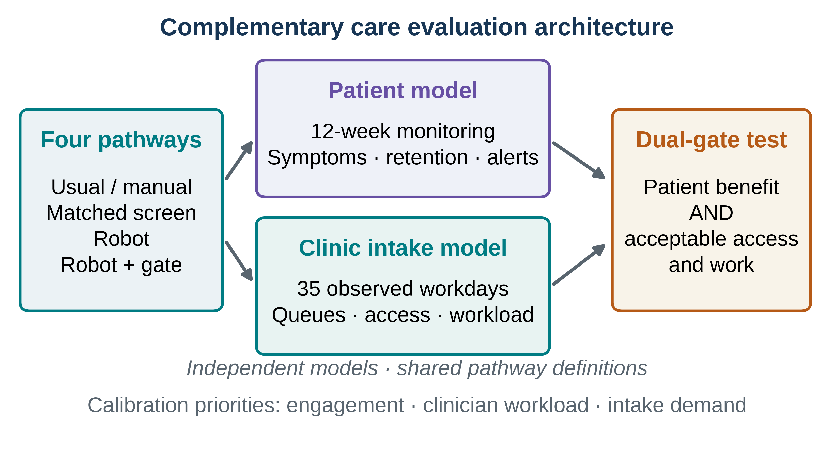
Figure 1. Complementary care contexts and the dual-gate assessment. The longitudinal pathway models 12-week symptom monitoring, engagement, and safety oversight; the clinic pathway models intake, triage, queues, and clinician work. Both feed a shared evaluation of patient benefit and operational acceptability. The contexts are evaluated independently and share pathway definitions.
Table 1 | Comparison pathways and contexts
Pathway | Longitudinal monitoring | Clinic intake | Incremental question
Usual/manual | Measurement-based usual care | Manual assessment | Contextual comparator
Matched screen | Screen agent delivering matched intervention content | Digital kiosk with clinician review | Primary reference
Embodied robot | Same digital content plus physical interface | Robot intake with faults and fallback | Bundled effects of embodiment, reliability and workflow
Robot + human gate | Robot with mandatory risk-relevant review | Robot with mandatory clinician checks | Detection gain versus oversight and access costs
Intervention content is matched in the patient model. Pathway-specific acceptance, engagement, reliability, risk detection, and oversight determine the complete modeled contrast and are documented separately in the parameter dictionaries.

Results

Patient-level symptom benefits and retention constraints
Across 200 repeated patient trials with 1,200 modeled participants per pathway and 200 paired intake replications, deterministic checks confirmed common baseline cohorts, matched service demand, and exact accounting of each arrival. These checks support the internal consistency of the comparisons presented below. The patient analysis first examines symptom change alongside continued participation; the intake analysis then follows safety decisions through clinical workload and service access.
At 12 weeks, response reached 26.94% (95% BCa interval 26.78–27.11) under the human-gated robot pathway and 20.65% (20.49–20.80) under the screen, a 6.29-percentage-point advantage. Completion moved in the opposite direction: 68.00% (67.81–68.19) with the gated robot and 73.43% (73.24–73.62) with the screen. Figure 2a–c connects symptom trajectories, endpoint frequencies, and paired contrasts. The separation between response and completion reveals why outcome measurement and retention must be assessed jointly in a future trial [20,21,27–29].
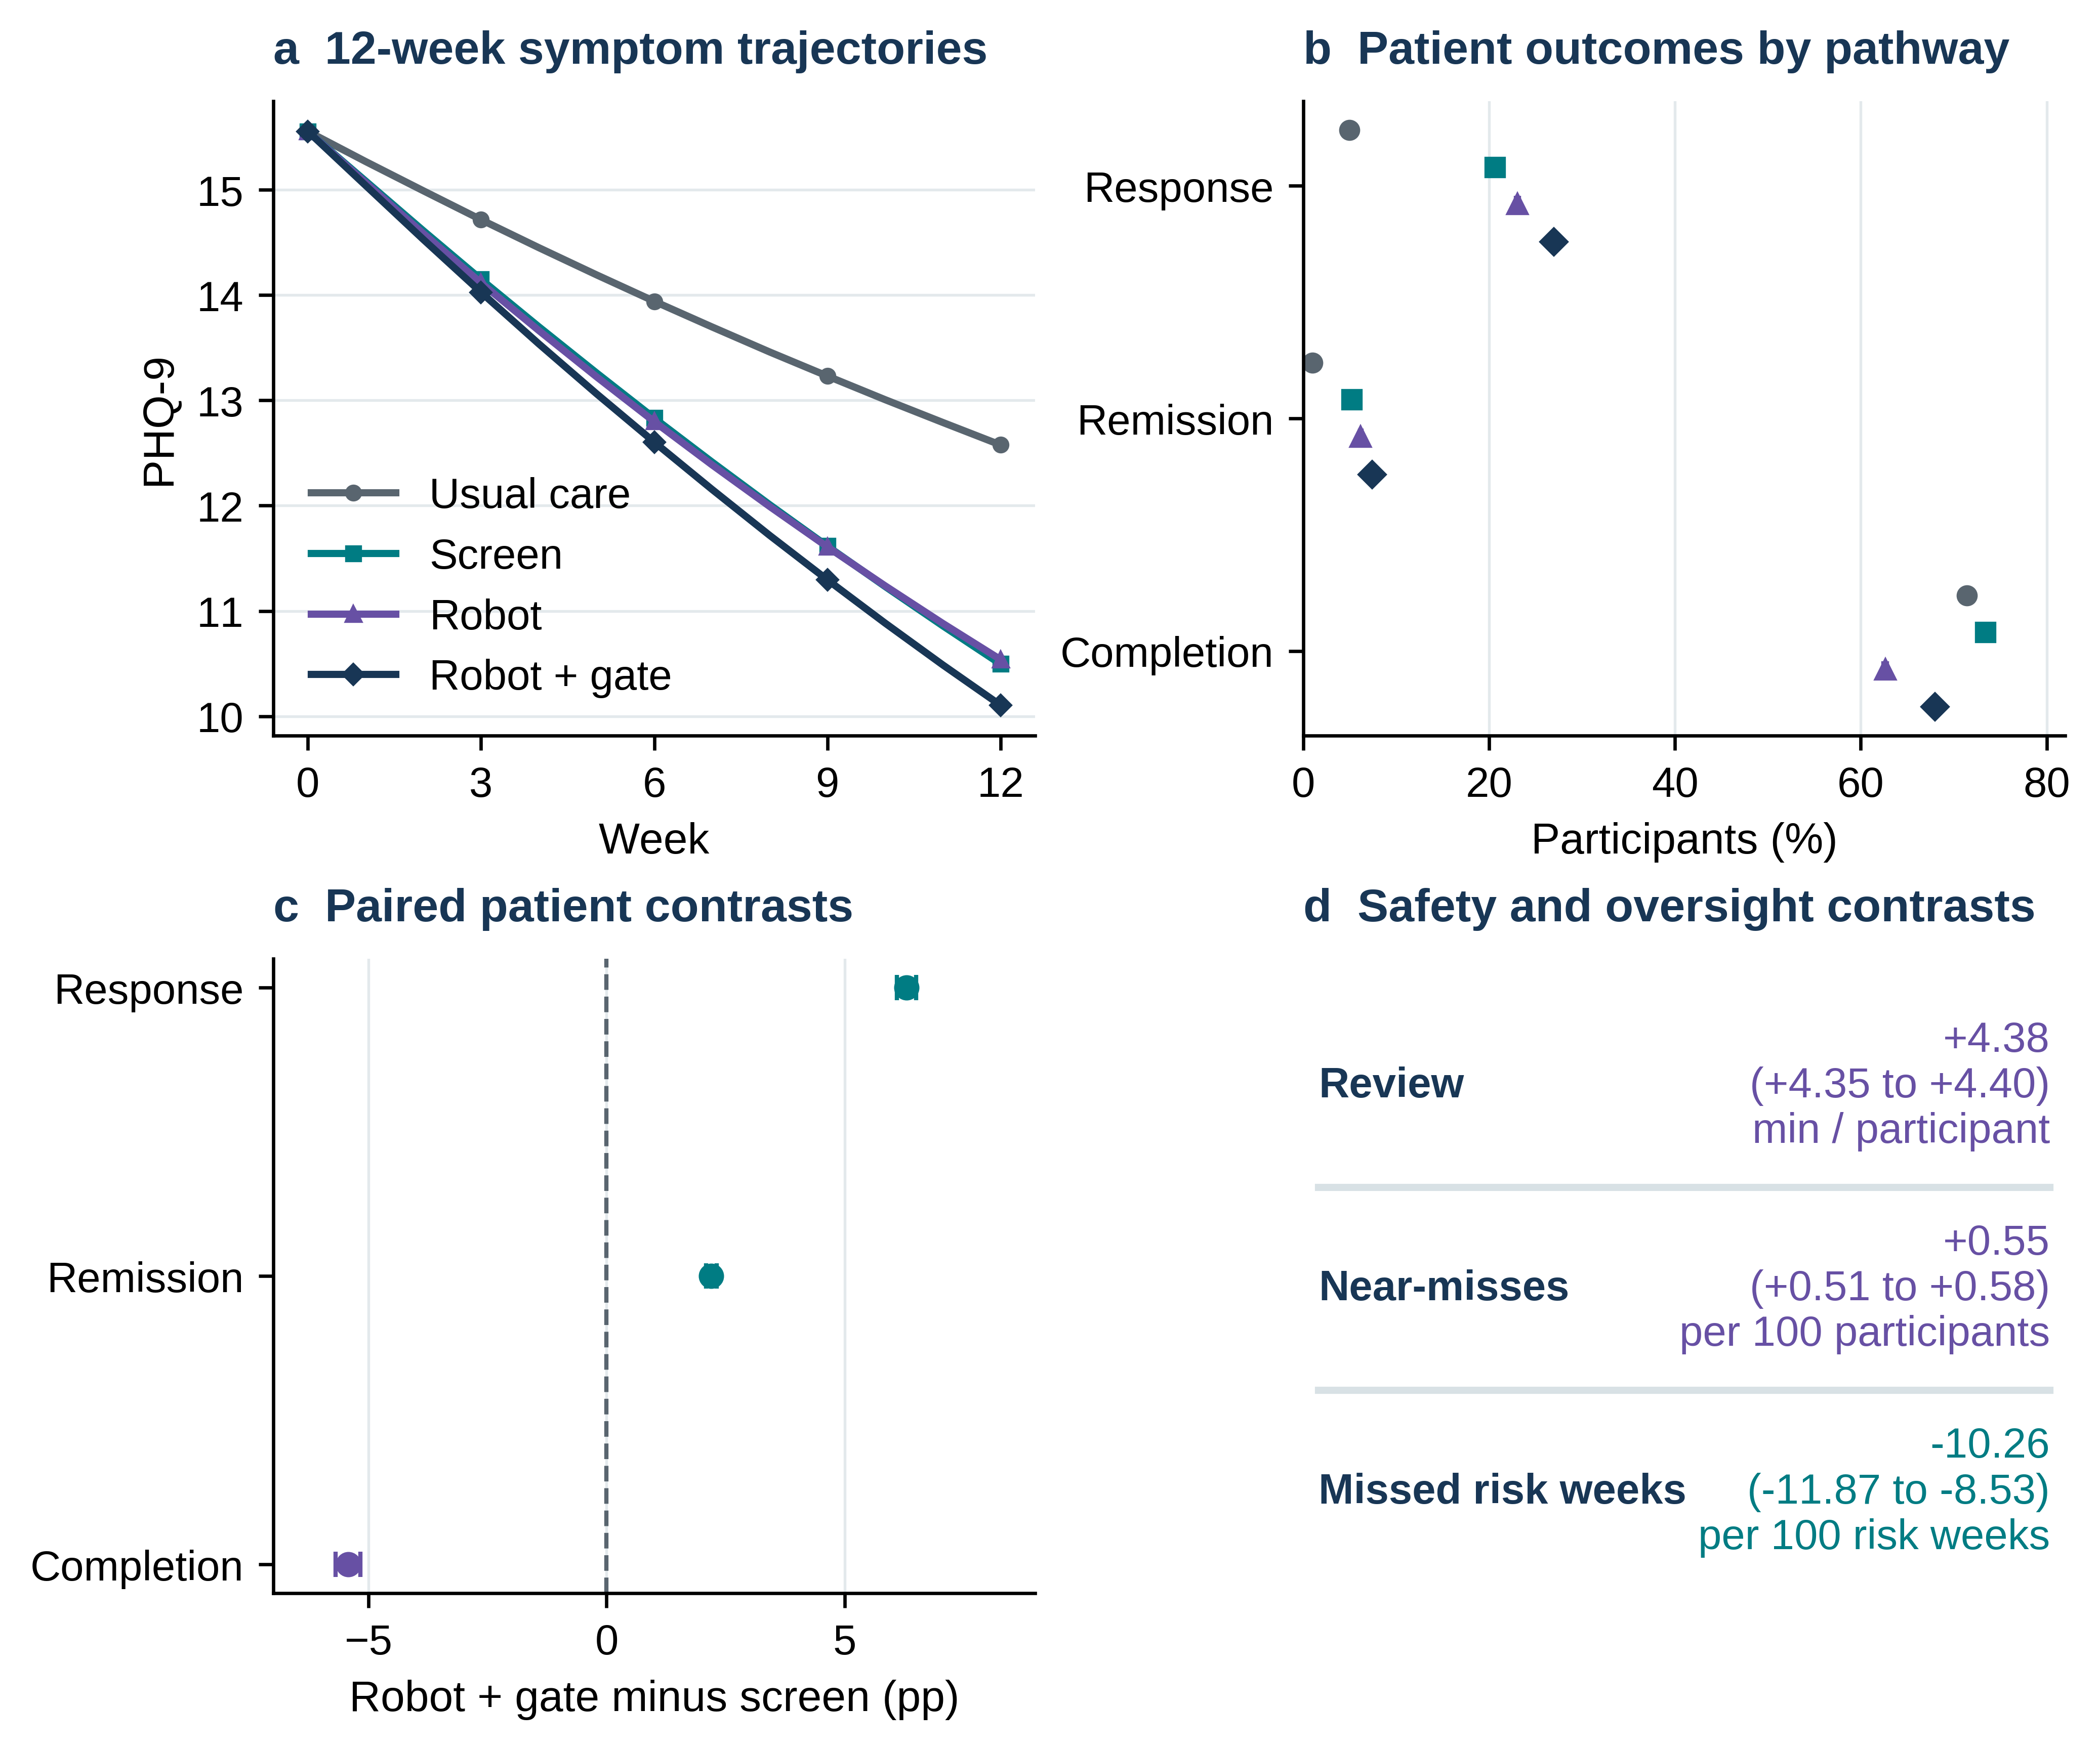
Figure 2. Patient outcomes and oversight burden across 12-week monitoring. a, Mean last-observation-carried-forward PHQ-9 over 12 weeks; b, response, remission, and completion by pathway; c, human-gated robot versus screen differences in response, remission, and completion; d, differences in clinician review time, physical near-misses, and missed high-risk weeks. Points and intervals show means and two-sided 95% BCa bootstrap intervals over 200 independent replications. Units are displayed in each panel. These intervals describe precision under the specified model.
The same pathway increased remission by 2.20 (95% BCa interval 2.09–2.31) percentage points, while completion fell by 5.42 (5.17–5.69) points. Risk-related oversight changed in parallel: review work rose by 4.38 (4.35–4.40) minutes per participant, physical near-misses by 0.55 (0.51–0.58) per 100 participants, and missed high-risk weeks fell by 10.26 (8.53–11.87) per 100 high-risk weeks (Fig. 2d; Table 2). These combined outcomes define the patient-side trade-off: improvement in selected clinical thresholds arrived alongside additional staff work and reduced longitudinal completion. We next examine whether the same oversight principle remains workable within an intake queue.

Service-level detection gains and capacity consequences
Clinic intake produced a related tension between detection and access. The human-gated robot reduced missed high-acuity cases by 10.85 (95% BCa interval 10.47–11.25) percentage points relative to the screen, accompanied by 2.23 (2.18–2.28) additional false alerts per 100 arrivals. Mean waiting increased from 44.34 (41.64–47.53) to 78.75 (74.19–84.40) working minutes, a paired difference of 34.41 (30.69–39.02) minutes. Throughput remained near 35 assessments per working day. Figure 3 shows the full waiting-time distribution, mean contrasts, alert and detection outcomes, and throughput; Table 2 places the patient and service comparisons on a common benefit–burden ledger. This pattern makes operational feasibility a clinical-access question, especially when arrivals approach available capacity [17,43].
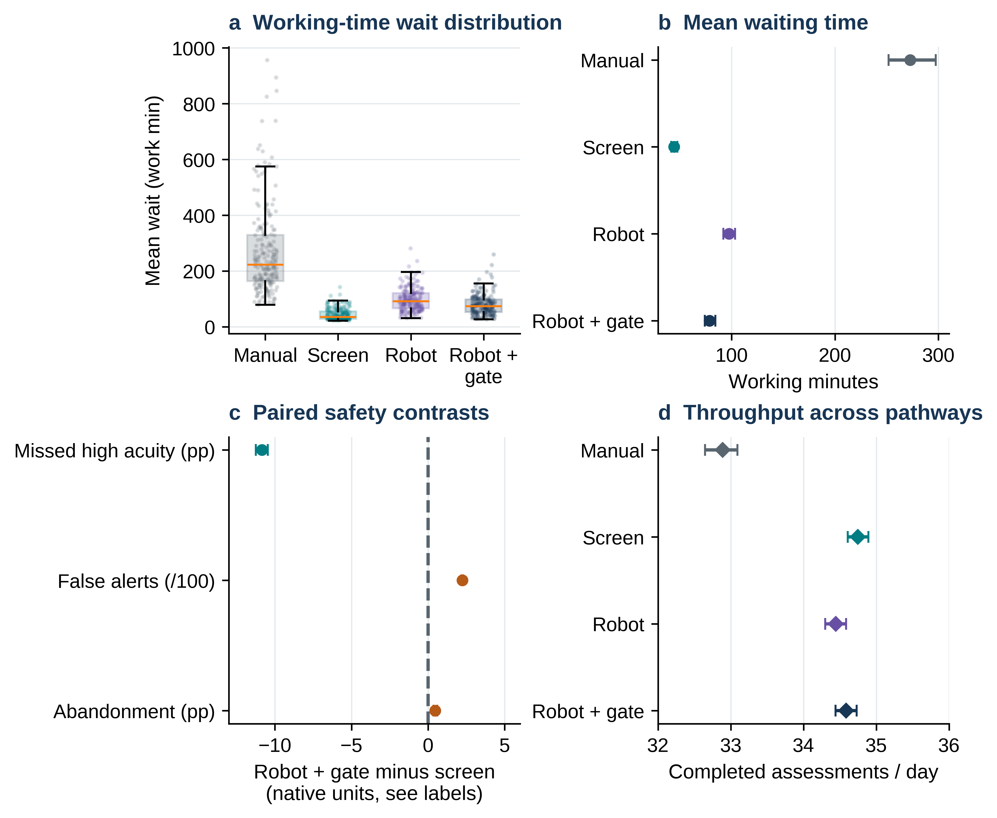
Figure 3. Clinic intake access and safety across 200 paired replications. a, Distribution of replication-level mean waiting time, with observed points and box plots; b, mean waiting time and 95% BCa intervals by pathway; c, paired robot-versus-screen differences in missed high-acuity cases, false alerts, and abandonment, with each native unit labeled; d, assessments per observed working day with an expanded, explicitly labeled axis to show small changes. Waiting time uses the continuous working-minute queue clock.
Table 2 | Primary human-gated pathway differences versus matched screen
Scale | Endpoint | Unit | Mean contrast (95% BCa interval) | Interpretation
Patient | Response | pp | +6.29 (6.09 to 6.50) | Benefit
Patient | Remission | pp | +2.20 (2.09 to 2.31) | Benefit
Patient | Completion | pp | -5.42 (-5.69 to -5.17) | Burden / access
Patient | PHQ-9 change | points | -0.39 (-0.41 to -0.38) | Benefit
Patient | Review work | minutes/person | +4.38 (4.35 to 4.40) | Burden / access
Patient | Physical near misses | /100 persons | +0.55 (0.51 to 0.58) | Burden / access
Service | Waiting time | working minutes | +34.41 (30.69 to 39.02) | Burden / access
Service | Missed high-acuity cases | pp | -10.85 (-11.25 to -10.47) | Benefit
Service | False alerts | /100 arrivals | +2.23 (2.18 to 2.28) | Burden / access
Service | Throughput | assessments/day | -0.16 (-0.21 to -0.13) | Capacity
The unit of uncertainty is the paired replication (n=200). Differences are reported with two-sided 95% BCa bootstrap intervals from 10,000 resamples; each positive or negative sign is interpreted according to the endpoint. The seven-outcome Holm-adjusted sign-flip tests reached P<0.0001 at the 100,000-draw resolution floor. Precision pertains to the defined model and parameter values.

Conditions that preserve clinical gain and service feasibility
The base-case separation led to a direct test of its assumptions. When the hypothesized robot-specific engagement and symptom benefits were removed, the human-gated response difference shifted to −1.38 percentage points and completion remained 5.91 points lower. Under the skeptical parameter set, response fell by 8.83 points, completion by 26.16 points, and mean intake waiting rose by 205.66 working minutes (Table 3; Fig. 4a). The direction changes identify critical empirical quantities for early trials, particularly any true incremental symptom benefit and the propensity to refuse or discontinue robot-supported care.
The two-parameter surfaces sharpened these observations. Patient response depended jointly on the assumed engagement advantage and session downtime (Fig. 4b), while service waiting was highly sensitive to downtime and mandatory review minutes (Fig. 4c). In the tested grid, mean waiting was no worse than the screen only at zero modeled day-level downtime and short review durations; the interval-based criterion narrowed that region. The 250-scenario ensemble (Fig. 4d) visualizes how response and completion can move in different directions across specified parameter combinations. These analyses provide design targets for reliability engineering, review-workflow optimization, and prospective calibration.
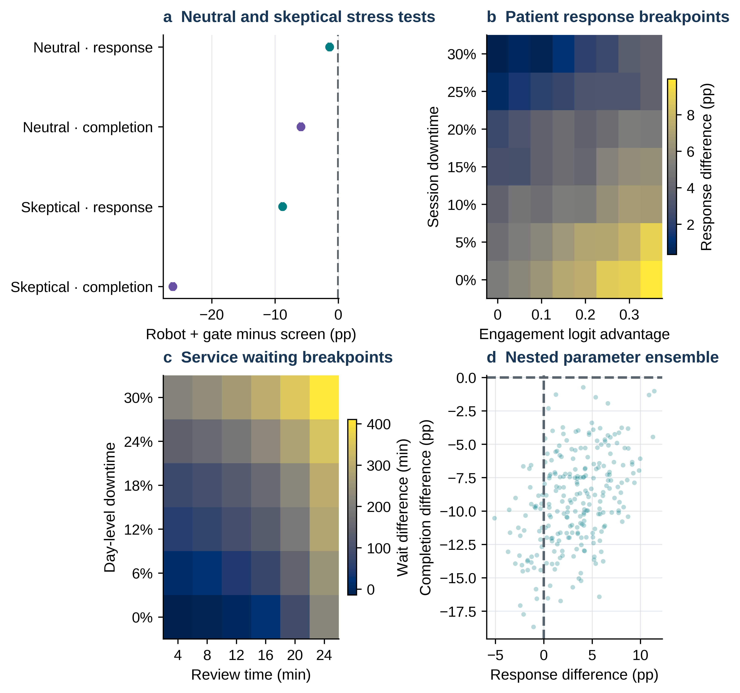
Figure 4. Neutral and skeptical scenarios and break-even regions. a, Paired response and completion differences between human-gated robot and matched screen under neutral and skeptical parameters; b, patient response over engagement-logit advantage and session downtime; c, intake waiting difference over review duration and day-level downtime; d, joint response and completion differences across 250 varied parameter scenarios. Intervals in panel a are 95% BCa intervals. Color bars define numerical scales; scenario frequencies describe the chosen stress ranges.
Table 3 | Neutral and skeptical scenario contrasts
Assumption set | Model | Outcome | Robot + gate minus screen (95% BCa interval)
Neutral | Patient | response percent | -1.38 (-1.57 to -1.18)
Neutral | Patient | completion percent | -5.91 (-6.15 to -5.66)
Neutral | Patient | mean clinician review minutes | +4.56 (4.53 to 4.58)
Neutral | Service | mean wait minutes | +0.92 (0.89 to 0.94)
Neutral | Service | false alerts per 100 arrivals | +0.00 (0.00 to 0.00)
Skeptical | Patient | response percent | -8.83 (-9.02 to -8.63)
Skeptical | Patient | completion percent | -26.16 (-26.42 to -25.90)
Skeptical | Patient | mean clinician review minutes | +9.64 (9.61 to 9.68)
Skeptical | Service | mean wait minutes | +205.66 (195.18 to 221.17)
Skeptical | Service | false alerts per 100 arrivals | +4.99 (4.90 to 5.07)
Each scenario used 200 paired replications with separate deterministic seed streams. The complete parameter substitutions, units, and ranges appear in Supplementary Data 1–2 and the code release.

Global sensitivity identifies the most consequential model assumptions
To examine interactions among inputs, we evaluated 1,024 scrambled Sobol base vectors with common latent streams matched within each matrix row. The dominant total-order contributions (ST) were the embodiment symptom increment for patient response (ST=0.360; 95% row-bootstrap interval 0.327–0.398), embodiment-related dropout for completion (ST=0.645), and daily demand for service waiting (ST=0.461). Figure 5a–c shows these drivers and their uncertainty; Table 4 gives the leading estimates. Their different rankings explain why a single engagement or reliability metric cannot summarize readiness across patient care and clinic operations.
Second-order estimates explored whether input pairs amplify one another. Uncertainty remained substantial: the patient-response interaction intervals crossed zero, and one of 55 service-waiting intervals excluded zero before multiplicity adjustment (Fig. 5d). Several small first-order estimates retained finite-sample inconsistencies with their total-order counterparts. The main inference is therefore a ranking of influential input groups, supported by the total-order analysis; individual pairwise interactions remain hypotheses for larger designs and calibrated models [36–38].
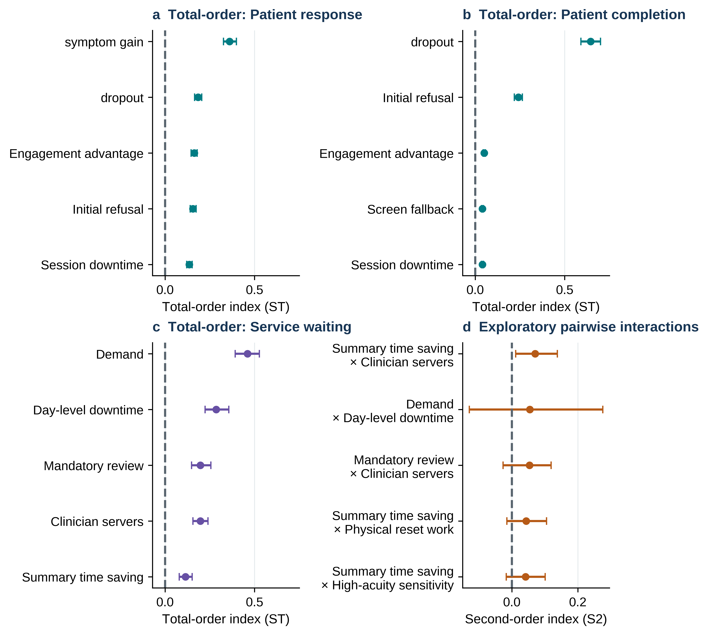
Figure 5. Global input importance and interaction diagnostics. a–c, Leading total-order Sobol indices (ST) and 95% row-bootstrap intervals for patient response, patient completion, and service waiting; d, selected second-order interaction estimates for waiting time with corresponding intervals. The design used 1,024 base points, matched common random numbers, and independently uniform stress ranges. Pairwise estimates are exploratory and unadjusted for multiplicity.
Table 4 | Leading total-order Sobol sensitivity indices
Scale | Output contrast | Parameter | ST | 95% row-bootstrap interval
Patient | response difference pp | Embodiment symptom increment | 0.360 | 0.327 to 0.398
Patient | response difference pp | Embodiment dropout increment | 0.184 | 0.165 to 0.205
Patient | response difference pp | Engagement advantage | 0.164 | 0.146 to 0.179
Patient | completion difference pp | Embodiment dropout increment | 0.645 | 0.591 to 0.700
Patient | completion difference pp | Initial refusal | 0.241 | 0.219 to 0.263
Service | mean wait difference minutes | Demand | 0.461 | 0.391 to 0.527
Service | mean wait difference minutes | Day-level downtime | 0.285 | 0.224 to 0.356
Service | mean wait difference minutes | Mandatory review | 0.197 | 0.148 to 0.256
Service | mean wait difference minutes | Clinician servers | 0.197 | 0.155 to 0.239
Sobol indices are variance-based diagnostics over the specified independently uniform input ranges. Intervals were obtained from 350 resamples of aligned design rows. The full first-, total-, and pairwise second-order estimates, matrices, and estimator checks are available with the code.

Robustness to endpoint definition and implementation design
The final analyses tested how endpoint definitions and pathway components influence interpretation. A separately seeded attrition analysis estimated a 6.23-point response advantage under last-observation-carried-forward, 5.53 points under baseline-observation-carried-forward, and 10.21 points among completers (Fig. 6a; Supplementary Table S1). Their common direction supports the scenario-specific response pattern, while the magnitude depends on how outcomes after disengagement are handled. These estimates also demonstrate the value of follow-up measurement in future trials [21,27–29].
On the clinic side, increasing robot intake stations from three to five left the mean waiting penalty near 36 minutes (Fig. 6b), directing attention toward clinician-stage work as a likely bottleneck within this model. Single-block parameter substitutions (Fig. 6c) separately identified acceptance, engagement, safety oversight, and reliability contributions to patient response. Warm-up duration changed absolute waiting estimates without reversing the screen-versus-robot ordering (Fig. 6d). The capacity and attrition modules use independently seeded replications, which account for their small numeric differences from the primary contrasts (Supplementary Tables S2–S4).
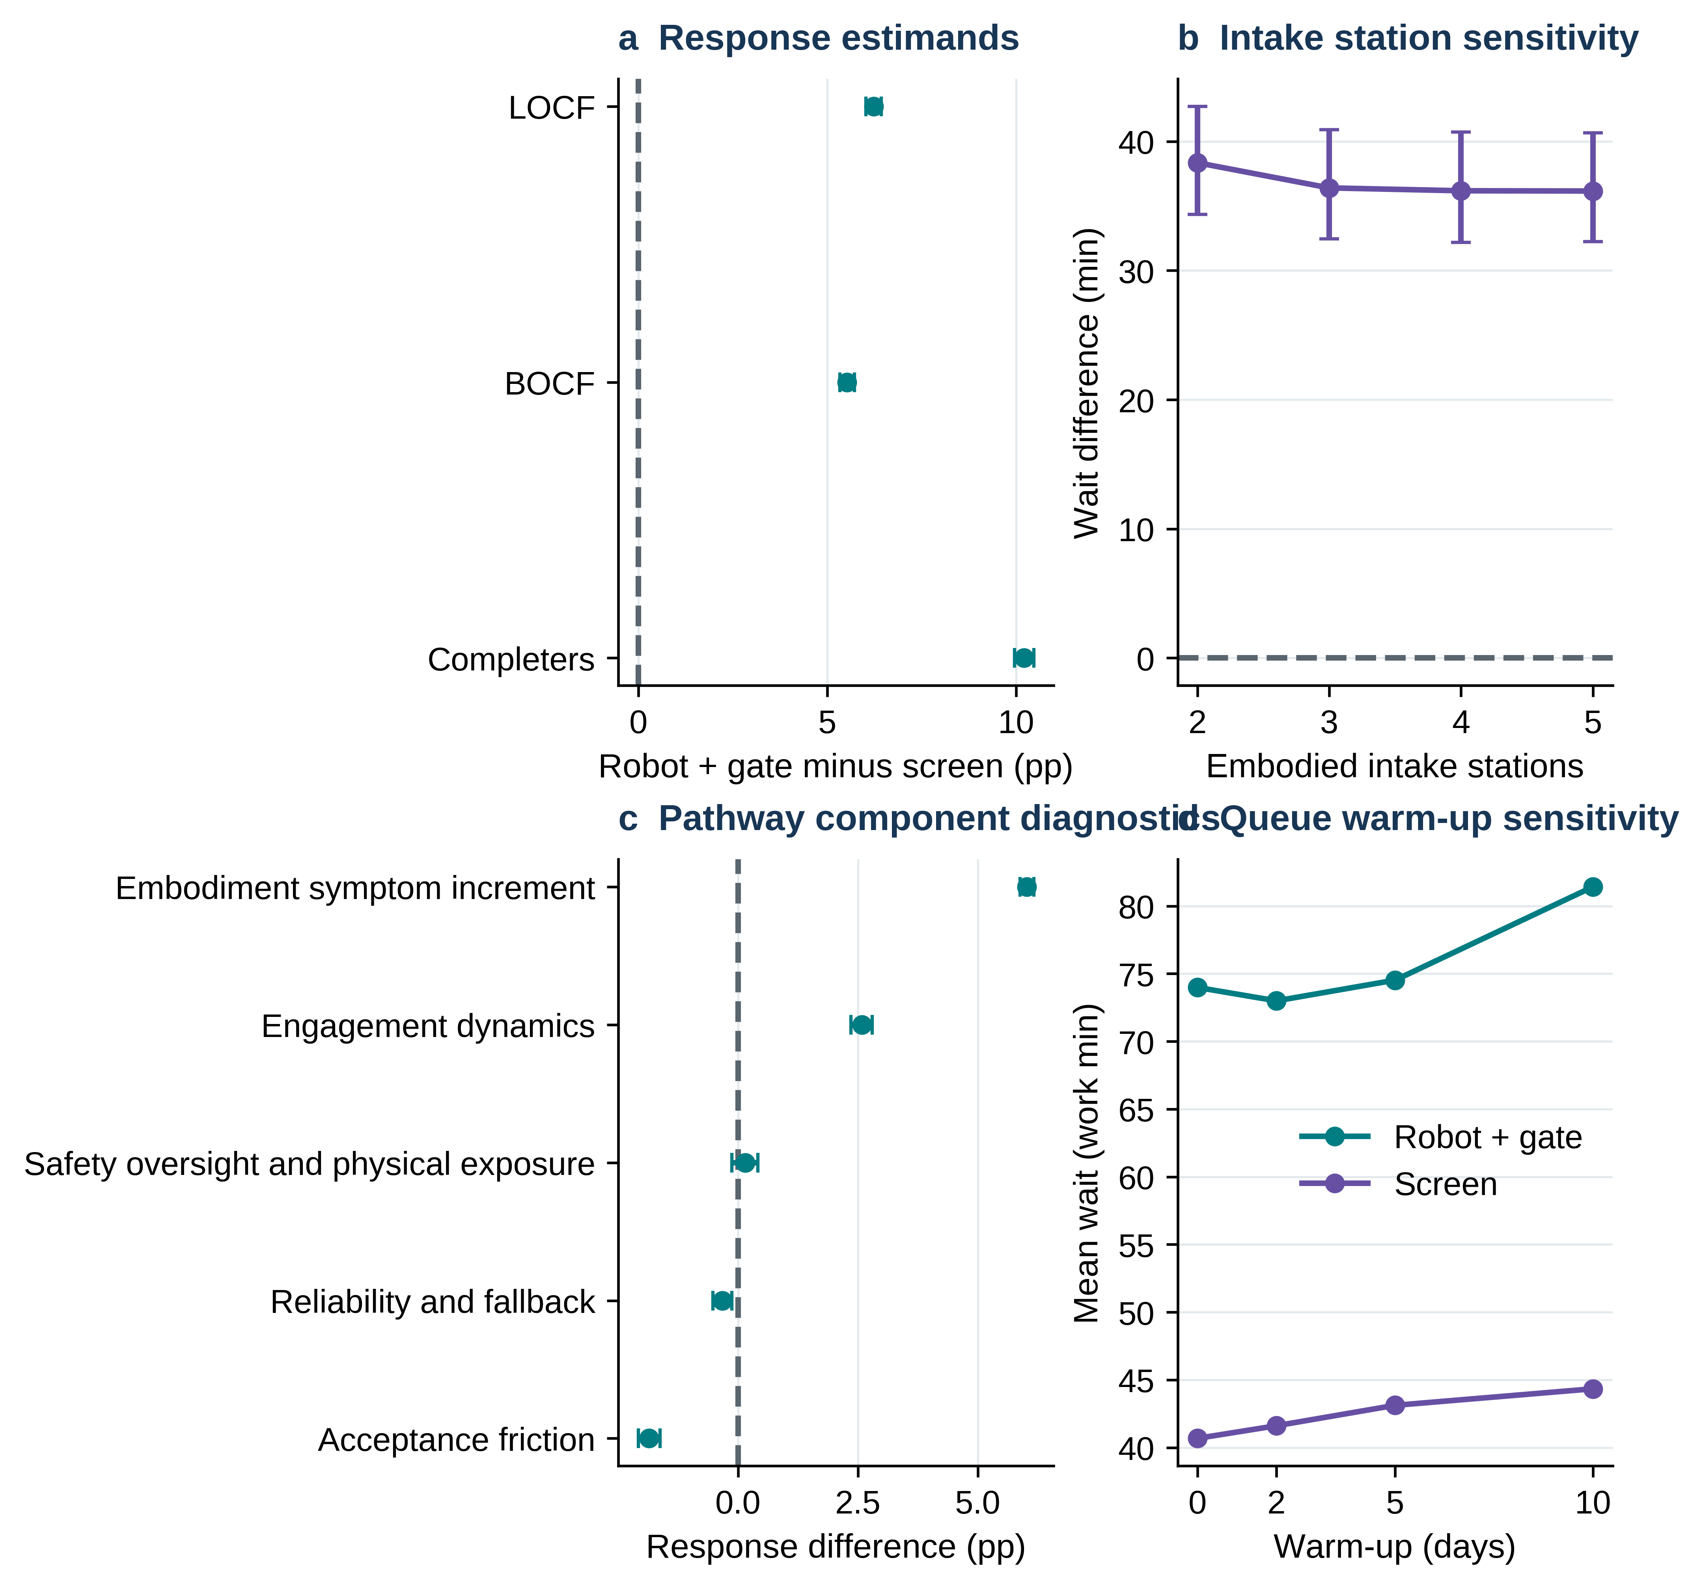
Figure 6. Estimand and implementation sensitivity. a, Response differences under last-observation-carried-forward (LOCF), baseline-observation-carried-forward (BOCF), and completer-only definitions; b, mean waiting differences as the number of robot intake stations varies; c, single-block parameter substitutions into the screen comparator; d, queue warm-up sensitivity. Points are modeled contrasts; available error bars are 95% BCa intervals. The three-station sensitivity run uses an independent seed stream from the base-case result.

Discussion
The key translational challenge for physical AI in psychiatry is to turn engaging interactions into sustainable clinical pathways. In the base-case comparisons, greater modeled response and detection occurred together with lower completion, greater review work, more false alerts, physical exposure, and longer intake queues. These findings motivate a dual-gate evaluation: a physically embodied system should demonstrate incremental patient benefit over functionally matched software while meeting prespecified standards for retention, staff workload, safety, and access. The framework offers measurable criteria for deciding which candidates deserve costly clinical evaluation and which operational components require redesign.
This agenda is timely because clinical evidence for socially assistive robots is advancing faster than deployment criteria. The 2026 randomized Purrble trial demonstrated a clinically relevant emotion-regulation signal in a specific population [41]. A contemporaneous meta-analysis spanning 34 trials found heterogeneous effects and wide prediction intervals, highlighting the importance of fit between intervention, population, and outcome [42]. Our screen-matched, two-context framework complements such studies by identifying the operational measurements that can be built into the next generation of pragmatic trials. It also provides a way to translate uncertain therapeutic advantages into engineering and service-design targets before scale-up.
The first design implication concerns the source of patient benefit. Physical copresence can influence social responding and task engagement [8,9], and a matched cognitive behavioral therapy comparison reported higher alliance and adherence for a robot-supported interface [5]. In our parameterized pathways, response depended most strongly on the hypothesized symptom increment, whereas completion was driven primarily by dropout and initial refusal. This separation identifies acceptance and continued use as clinical-design endpoints in their own right. Prospective studies can establish the incremental contribution of physical presence through factorial or sequential pathway comparisons, with engagement, content exposure, and staff contact measured explicitly [22,23].
The second implication concerns access. Within the intake model, a substantial improvement in high-acuity detection was accompanied by a longer wait even though throughput changed little. Queueing makes that combination plausible when an additional review step is imposed on a finite clinician pool [17]. A local validation study should therefore measure actual service-time distributions, staff availability, queue carry-over, abandonment, and the consequences of false alerts alongside diagnostic performance. These variables connect patient safety directly to service access and can inform decisions about staffing, review thresholds, and backup workflows.
Human oversight deserves particular attention. A 2026 systematic review found that clinical AI changes cognitive workload differently across documentation, decision support, and alert-driven applications [43]. A study of interruptive clinical alerts illustrates how burden can accumulate unevenly among clinicians [47]. Recent preprint evidence from deployed mental-health coaching proposes a tiered oversight architecture with prevention, real-time monitoring, and sampling-based clinical review [48]. The current models make review time and false-alert burden visible; future evaluations can compare graded escalation policies, audit sampling, and selective human verification while retaining appropriate clinical safeguards.
The third implication is methodological. Patient response improved under the base assumptions and reversed when assumed benefit was removed. This sensitivity is actionable: empirical calibration should prioritize embodiment-specific symptom increments, initial acceptance, sustained engagement, attrition, downtime, and review duration. The variance-based analysis adds a multivariable ranking and detects potential joint effects; the broad uncertainty around pairwise interactions argues for careful confirmatory designs. Expert elicitation, patient and clinician participation, face validation, and externally observed service data would sharpen these ranges and support more realistic dependent parameter distributions [32–35].
A clinically useful evaluation also needs an explicit target population and estimand. Response among all enrolled participants, response among completers, and response under alternative missing-data assumptions answer different questions [20,21]. Here, the response contrast was directionally stable across the tested definitions but varied in magnitude. Future trials should measure outcomes after discontinuation when feasible, prespecify missing-data strategies, and report patient burden, consent preferences, privacy concerns, and clinician workload alongside symptom endpoints [22,23,27–30]. These outcomes will be especially important for populations with high disengagement risk.
The two model settings illuminate distinct stages of care. The patient model follows 12 weeks of longitudinal contact; the service model follows a single intake assessment moving through limited resources. Both share pathway definitions, enabling a common operational vocabulary. A direct staffing bridge would require panel size, contact frequency, staffing roles, and shift arrangements. For example, an incremental 4.38 review minutes per participant corresponds algebraically to 4.38M/60 additional clinician hours over the modeled 12-week horizon for a panel of M participants, before assigning those hours to schedules or full-time equivalents. This provides a starting point for site-specific resource planning.
Recent preprints in mental-health AI evaluation emphasize clinically meaningful tasks, transparent safety benchmarks, and participation by practitioners and service users [45,46]. Work on robot-supported behavioral exercises similarly draws attention to the integration of physical interaction with cloud software and home deployment [44]. These themes align with the present contribution: clinical relevance depends on the full sociotechnical pathway, including treatment content, physical interaction, human governance, and the capacity of the receiving service. The proposed dual gate can be registered prospectively with clinically meaningful margins for response, completion, and waiting time.
Several design boundaries govern interpretation. Model parameters were selected to span explicit, literature-informed or illustrative ranges and remain to be calibrated in psychiatric settings. The two settings are evaluated independently, and the service model compresses nonworking time into consecutive 420-minute work blocks. Its excess-work measure represents workload relative to nominal capacity; it does not simulate clock-time overtime. Real clinics also have scheduling, cancellations, no-shows, staff learning, heterogeneous patient needs, maintenance logistics, and downstream treatment capacity. These aspects should be added as site data become available.
The primary numerical results estimate the behavior of the specified pathways under fixed model assumptions. Bootstrap intervals and randomization tests quantify internal computational separation, while scenario and global analyses probe assumptions and nonlinear response. None of the reported contrasts can yet be interpreted as a clinical treatment effect, measured safety incidence, or a forecast for a particular institution. The full code and input provenance make it possible to replace assumptions with empirical estimates and repeat each analysis transparently.
A practical validation program can build directly on the identified drivers. Initial work should combine structured elicitation from patients, psychiatrists, nurses, privacy specialists, human-factors researchers, and service managers with device reliability tests and retrospective clinic-flow measurements [32–35]. Independent face validation can examine event order, high-acuity escalation, dropout logic, and capacity constraints. A prospective screen-matched evaluation can then define clinical and operational noninferiority margins, collect post-disengagement outcomes, and assess usability, equity, costs, and physical safety under normal staffing conditions [22,23].
Physical AI offers a meaningful opportunity to extend psychiatric care, particularly where sustained engagement and timely risk escalation matter. This work contributes a reproducible framework for judging that opportunity across patient benefit, retention, safety, and health-system capacity. Its central proposition is testable: successful deployment requires a clinically relevant incremental benefit together with operational performance that the service and its patients can sustain.

Methods

Design, units and modeling contexts
We evaluated four care pathways in two complementary settings: 12-week outpatient symptom monitoring and a finite-capacity psychiatric intake service. A 5,000-participant-per-pathway reference run supported the patient-level audit; repeated-trial inference used 200 trials with 1,200 participants per arm. The patient model represents longitudinal contact and the service model represents intake assessment. Both share the screen comparator and categories of reliability, oversight, and burden. They are independently run models, with a common interpretation at the deployment decision stage. Analyses estimate the complete pathway difference relative to a functionally matched screen for specified parameter values; effects may arise from embodiment, acceptance, engagement, reliability, alerting, and clinical review.

Parameter selection and calibration status
The patient parameter documentation contains 47 inputs, coefficients, and structural assumptions; the service documentation contains 33. Every entry records its unit, functional role, pathway configuration, alternative parameterizations, range and rationale, evidence class, and calibration status. Supplementary Data 1–2 provide the full machine-readable dictionaries, while the equations, event logic, distributional assumptions, and outcome definitions required to reproduce the study appear in the Methods below and in the executable code.
PHQ-9 scoring and response definitions were anchored to measurement literature [20,21,31]. Evidence from digital intervention adherence guided the direction and breadth of engagement and attrition stress ranges [27–30]. Robot and copresence research informed the mechanisms selected for embodiment, fallback, and acceptance [2,3,5,8,9,39,44]. Queueing, clinical alert, and workload studies informed operational categories and stress assumptions [17–19,40,43,47]. Numerical robot-specific symptom increments, trust-update coefficients, crisis intercepts, and alert rates were specified transparently for exploratory evaluation. Published studies were used as conceptual or scale anchors only where they supported the particular parameter.
Neutral assumptions remove hypothesized robot-specific advantages, and skeptical configurations shift specified burdens toward adverse values within the documented ranges. The Sobol design treats varied inputs as independent uniform stress distributions. Empirical calibration, multi-stakeholder elicitation, and independent face validation constitute a planned next phase; a protocol and elicitation templates accompany the repository [32–35]. Subsequent analyses can incorporate empirical distributions and parameter dependence once those inputs are available.

Patient-level mathematical and operational specification

State and baseline
For participant i, pathway a and week t=1,…,12, the state is PHQ-9 Y, active indicator Z, past engagement E, trust U, and cumulative risk, alerts, downtime, fallback, review and near-miss counts. Shared baseline draws: Y(i,0)=clip[Normal(15.5,3.2),10,24]; acceptance A~Beta(2.4,1.9); privacy P~Beta(2.1,2.4); support S~Normal(0,1); responsiveness R~Normal(0,0.13) PHQ-9 units/week. Initial trust U(i,a,0)=0.08 H(a)+0.12 A(i)−0.10 P(i), with H the verification indicator. Initial refusal F~Bernoulli(rho(a)); Z(i,a,0)=1−F.

Availability and engagement
While active, downtime D(i,a,t)~Bernoulli(d(a)), and conditional fallback B(i,a,t)~Bernoulli(f(a)); a session is available when D=0 or B=1. Engagement logit equals alpha(a)+1.05(A−0.5)−gamma_P(a)(P−0.5)+0.34 E(previous)+0.13 S+U(previous)−delta(a)(t−1)−0.025 max[Y(previous)−15,0]. Realized engagement requires both a successful Bernoulli draw and availability; fallback preserves content but removes the embodiment symptom increment.

Symptoms and clinical events
Baseline week-specific trend b(i)=0.24+0.022 max[Y(i,0)−14,0]. Intervention increment Q(i,a,t)=E(i,a,t)[beta_content(a)+beta_emb(a)(1−B(i,a,t))]. Active symptoms evolve as Y(i,a,t)=clip{Y(previous)−[b(i)+Q(i,a,t)+R(i)]+epsilon,0,27}, epsilon~Normal(0,0.62). Worsening W=Y(new)−Y(previous). Crisis logit=−10.2+0.27Y(new)+0.42max(W,0). Alerts occur with sensitivity Se(a) in crisis weeks and false-alert probability FPR(a) otherwise. None of these coefficients is derived from observed clinical data.

Oversight, trust and safety
False-alert escalation probabilities are 0.12 under human verification and 0.72 otherwise. Clinician review initializes at pathway-specific routine audit minutes and adds review minutes for every alert. Trust changes +0.025 for a true alert, −0.040 for an escalated false alert, and −0.075 for a missed crisis, clipped to [−0.5,0.5]. A physical near-miss is Bernoulli(h(a)) only for available, nonfallback embodied sessions; it is a synthetic noninjury placeholder.

Dropout and endpoints
For active participants, p_drop=clip[0.010+0.030(1−E)+0.016P+kappa(a)+0.010 I(W>1.5)−0.008E,0.002,0.12]. Dropout is Bernoulli(p_drop) and the inactive state is absorbing. Completion requires activity through week 12; response is at least 50% PHQ-9 reduction and remission is Y≤4. Last observation carried forward is the primary descriptive endpoint convention after attrition; baseline observation carried forward and completer-only calculations probe sensitivity to this convention.

Clinic discrete-event mathematical and operational specification

Arrivals, time axis and resources
In each replication, five warm-up days precede 35 observed days; a nominal day has L=420 productive working minutes. Daily arrivals follow N(d)~Poisson(lambda), with within-day timestamps sorted Uniform(0,L) and shifted by dL. Low, medium, and high acuity occur with probabilities 0.60, 0.30, and 0.10. Intake, fallback, and clinician resources maintain heaps of next-available working-minute times. Service starts at max(arrival, first available resource time), finishes after the assigned duration, and updates the heap. FIFO workloads carry across day boundaries on a continuous productive-minute clock that compresses nights and closures. The model has no explicit overtime-shift process.

Intake, downtime and rework
For each model day, a common outage uniform determines whether a digital pathway routes arrivals to fallback resources. Primary intake duration is max(4,mu_intake+sigma_intake×standard normal) plus any routine reset minutes; fallback duration is max(4,mu_fallback+4×standard normal). Digital incompleteness is drawn Bernoulli(q(a)) and consumes additional rework time on a fallback resource. Reset minutes are recorded as operational work associated with embodiment.

Detection, clinician activity and abandonment
Alerts are generated with sensitivity Se(a) among high-acuity arrivals and false-alert probability FPR(a) otherwise. Baseline clinician assessment takes 38, 52, or 72 minutes for low, medium, or high acuity. Final clinician duration=max(base−summary_saving(a),25)+I(digital)×review_minutes(a)+I(alert)×[6H(a)+10(1−H(a))]. Predicted wait=max(intake_finish, earliest_clinician_availability)−arrival; abandonment risk=min{0.25,logistic[−5.2+0.010max(predicted_wait−120,0)]}. Abandoned arrivals exit before clinician service; for completed arrivals, waiting time=clinician_start−arrival.

Boundary, denominators and outputs
Arrivals are assigned to the observed cohort according to their arrival day after warm-up, even when clinician completion falls beyond the nominal observation window. Completed assessments per observed day therefore divide observed-cohort completions by 35 days. Arrivals=completed+abandoned exactly. Waiting means and 90th percentiles use completed arrivals; false alerts use all observed arrivals and missed high-acuity cases use high-acuity observed arrivals. Clinician workload-to-capacity divides clinician service minutes assigned to an arrival day by 420×the number of clinician servers; excess over one is a workload proxy. Intake and fallback work are attributed in the same manner. Real-calendar validation will require staff shifts, scheduled overtime, closures, breaks, and no-show processes.

Primary statistical analysis and module-specific streams
The independent replication is the unit for uncertainty analysis. Patient pathways within a replication share baseline patient draws; service pathways share demand, acuity, and latent event streams. Paired contrasts were bootstrapped by intact replication identifier, using two-sided 95% bias-corrected and accelerated (BCa) intervals: 10,000 resamples for primary contrasts, 5,000 for arm means, and 3,000 for selected diagnostics. The base study contained 200 replications per model; Monte Carlo standard errors equal the standard deviation of paired differences divided by √200. Two-sided paired sign-flip tests used 100,000 random sign assignments, a plus-one correction, and Holm adjustment across seven outcomes per model and comparator (nominal alpha=0.05). The minimum adjusted P at this draw budget is approximately 0.000070, reported as P<0.0001. Paired t tests and Cohen dz were concordance diagnostics [24–26].
Primary, attrition, capacity, pathway-component, and scenario analyses use independent deterministic seed streams identified by analysis label. Consequently, repeated configurations in distinct modules have ordinary Monte Carlo differences in their estimated means and intervals; Supplementary Table S4 reconciles them. Each module preserves within-replication pairing, and the unmodified analysis outputs remain available for comparison.

Sensitivity estimators and quality control
The patient grid varied engagement-logit advantage 0–0.35 and session downtime 0–30%, and the service grid day downtime 0–30% and review time 4–24 min. A separate 250-draw multivariate scenario ensemble used five inner stochastic replications per scenario. Neutral/skeptical tests each used 200 paired replications. Sobol global analysis used 12 varied patient and 11 service parameters with independently Uniform inputs over registered stress ranges. A scrambled 2d-dimensional Sobol sequence defined two N=1,024 matrices A and B, their d AB matrices and d BA matrices (N×[2d+2] model evaluations per scale). Within each design row, each A/B/AB/BA evaluation shared identical synthetic-cohort and event seeds; for service demand, a maximum-rate Poisson stream was Bernoulli-thinned with fixed per-arrival uniforms so differing arrival rates preserved CRN nesting. Each parameter vector was averaged over two independent matched stochastic replications (350 synthetic participants per arm, or 18 observed service days following warm-up).
The Saltelli covariance estimator gives S1=mean[Y_B×(Y_ABi−Y_A)]/Var(Y), and the Jansen squared-difference estimator gives ST=mean[(Y_A−Y_ABi)^2]/[2Var(Y)]. Pairwise S2 uses cross-matrix terms corrected by first-order estimates. Row-bootstrap intervals resampled 350 aligned matrix rows. Raw estimates, including small finite-design departures from ideal index bounds, are retained in the repository. Interpretation prioritizes stable total-order rankings; the exploratory S2 indices require additional resolution before confirmatory use [36–38].

Software, reporting, ethical and AI-use disclosures
Analyses and figures were generated with Python, NumPy, pandas, SciPy, Matplotlib, and python-docx; versions are recorded in requirements-lock.txt. The repository includes source code, fixed random streams, full design matrices, tabular outputs, tests, plotting scripts, and SHA-256 manifests. Automated checks cover matched streams, range constraints, impossible events, queue accounting, parameter provenance, and editable figure text. Reporting follows STRESS and ISPOR-SMDM principles [18,19]. The study involved computationally generated records and no interactions with human participants; applicability of local institutional research-governance requirements must be confirmed by the authors.
Use of AI-assisted tools: OpenAI ChatGPT assisted editorial drafting, software review, and reproducibility documentation. Human authors are responsible for confirming the accuracy of all sources, interpretations, analyses, disclosures, and the final text. [AUTHOR VERIFICATION REQUIRED: confirm the description against actual use.]

Data availability
The study uses computationally generated patient and service inputs. The complete model outputs, parameter dictionaries, scenario definitions, and global-sensitivity input/output matrices are included in the accompanying release package. [AUTHOR INPUT REQUIRED: provide the permanent publicly accessible archive link and accession/DOI following deposit.]

Code availability
The complete Python code for simulations, paired inference, global sensitivity, validation, and figure regeneration, together with pinned dependencies, tests, and execution instructions, is included in the accompanying release package. [AUTHOR INPUT REQUIRED: authorize the license and provide the release tag and permanent repository DOI.]

Acknowledgements
[AUTHOR INPUT REQUIRED: acknowledgements and funding source/grant information, or an affirmative statement that no external funding was received.]

Author contributions
[AUTHOR INPUT REQUIRED: identify every author by initials and specify CRediT contributions.]

Competing interests
[AUTHOR INPUT REQUIRED: declare every author’s financial and non-financial competing interests, or state explicitly if none.]

References
1. Fiske A, Henningsen P, Buyx A. Your Robot Therapist Will See You Now: Ethical Implications of Embodied Artificial Intelligence in Psychiatry, Psychology, and Psychotherapy. J Med Internet Res. 2019;21(5):e13216. doi:10.2196/13216.
2. Guemghar I, Pires de Oliveira Padilha P, Abdel-Baki A, Jutras-Aswad D, Paquette J, Pomey MP. Social Robot Interventions in Mental Health Care and Their Outcomes, Barriers, and Facilitators: Scoping Review. JMIR Ment Health. 2022;9(4):e36094. doi:10.2196/36094.
3. Kling M, Haeussl A, Dalkner N, et al. Social robots in adult psychiatry: a summary of utilisation and impact. Front Psychiatry. 2025;16:1506776. doi:10.3389/fpsyt.2025.1506776.
4. Jung HW, Park JY, Holoubek T, Kim WJ, Park J. Socially Assistive Robots in Mental Healthcare: Principles and Conceptual Framework for User-Centered Design. Int J Soc Robot. 2025;17:2827-2851. doi:10.1007/s12369-025-01323-5.
5. Konijn EA, Peeper G, Portegies T, Garnefski N, Kraaij V, Struijs S. Examining the Potential of Social Robots to Increase Adherence in Internet-based CBT. Int J Soc Robot. 2026;18(6):83. doi:10.1007/s12369-026-01417-8.
6. Deng E, Mutlu B, Mataric MJ. Embodiment in Socially Interactive Robots. Found Trends Robot. 2019;7(4):251-356. doi:10.1561/2300000056.
7. Rabbitt SM, Kazdin AE, Scassellati B. Integrating socially assistive robotics into mental healthcare interventions: applications and recommendations for expanded use. Clin Psychol Rev. 2015;35:35-46. doi:10.1016/j.cpr.2014.07.001.
8. Li J. The benefit of being physically present: A survey of experimental works comparing copresent robots, telepresent robots and virtual agents. Int J Hum Comput Stud. 2015;77:23-37. doi:10.1016/j.ijhcs.2015.01.001.
9. Bainbridge WA, Hart JW, Kim ES, Scassellati B. The Benefits of Interactions with Physically Present Robots over Video-Displayed Agents. Int J Soc Robot. 2011;3(1):41-52. doi:10.1007/s12369-010-0082-7.
10. Pu L, Moyle W, Jones C, Todorovic M. The Effectiveness of Social Robots for Older Adults: A Systematic Review and Meta-Analysis of Randomized Controlled Studies. Gerontologist. 2019;59(1):e37-e51. doi:10.1093/geront/gny046.
11. Yu C, Sommerlad A, Sakure L, Livingston G. Socially assistive robots for people with dementia: Systematic review and meta-analysis of feasibility, acceptability and the effect on cognition, neuropsychiatric symptoms and quality of life. Ageing Res Rev. 2022;78:101633. doi:10.1016/j.arr.2022.101633.
12. Nichol B, McCready J, Erfani G, et al. Exploring the impact of socially assistive robots on health and wellbeing across the lifespan: An umbrella review and meta-analysis. Int J Nurs Stud. 2024;153:104730. doi:10.1016/j.ijnurstu.2024.104730.
13. Scassellati B, Boccanfuso L, Huang CM, et al. Improving social skills in children with ASD using a long-term, in-home social robot. Sci Robot. 2018;3(21):eaat7544. doi:10.1126/scirobotics.aat7544.
14. Torous J, Bucci S, Bell IH, et al. The growing field of digital psychiatry: current evidence and the future of apps, social media, chatbots, and virtual reality. World Psychiatry. 2021;20(3):318-335. doi:10.1002/wps.20883.
15. Torous J, Linardon J, Goldberg SB, et al. The evolving field of digital mental health: current evidence and implementation issues for smartphone apps, generative artificial intelligence, and virtual reality. World Psychiatry. 2025;24(2):156-174. doi:10.1002/wps.21299.
16. Greenhalgh T, Wherton J, Papoutsi C, et al. Beyond Adoption: A New Framework for Theorizing and Evaluating Nonadoption, Abandonment, and Challenges to the Scale-Up, Spread, and Sustainability of Health and Care Technologies. J Med Internet Res. 2017;19(11):e367. doi:10.2196/jmir.8775.
17. Kim B, Elstein Y, Shiner B, Konrad R, Pomerantz AS, Watts BV. Use of discrete event simulation to improve a mental health clinic. Gen Hosp Psychiatry. 2013;35(6):668-670. doi:10.1016/j.genhosppsych.2013.06.004.
18. Monks T, Currie CSM, Onggo BS, Robinson S, Kunc M, Taylor SJE. Strengthening the reporting of empirical simulation studies: Introducing the STRESS guidelines. J Simul. 2019;13(1):55-67. doi:10.1080/17477778.2018.1442155.
19. Eddy DM, Hollingworth W, Caro JJ, Tsevat J, McDonald KM, Wong JB. Model transparency and validation: a report of the ISPOR-SMDM Modeling Good Research Practices Task Force-7. Med Decis Making. 2012;32(5):733-743. doi:10.1177/0272989X12454579.
20. Kroenke K, Spitzer RL, Williams JBW. The PHQ-9: Validity of a Brief Depression Severity Measure. J Gen Intern Med. 2001;16(9):606-613. doi:10.1046/j.1525-1497.2001.016009606.x.
21. Coley RY, Boggs JM, Beck A, et al. Defining Success in Measurement-Based Care for Depression: A Comparison of Common Metrics. Psychiatr Serv. 2020;71(4):312-318. doi:10.1176/appi.ps.201900295.
22. Vasey B, Nagendran M, Campbell B, et al. Reporting guideline for the early-stage clinical evaluation of decision support systems driven by artificial intelligence: DECIDE-AI. Nat Med. 2022;28(5):924-933. doi:10.1038/s41591-022-01772-9.
23. Liu X, Cruz Rivera S, Moher D, Calvert MJ, Denniston AK; SPIRIT-AI and CONSORT-AI Working Group. Reporting guidelines for clinical trial reports for interventions involving artificial intelligence: the CONSORT-AI extension. Nat Med. 2020;26(9):1364-1374. doi:10.1038/s41591-020-1034-x.
24. Morris TP, White IR, Crowther MJ. Using simulation studies to evaluate statistical methods. Stat Med. 2019;38(11):2074-2102. doi:10.1002/sim.8086.
25. Efron B, Tibshirani RJ. An Introduction to the Bootstrap. New York: Chapman & Hall; 1993.
26. Desharnais B, Camirand-Lemyre F, Mireault P, Skinner CD. Determination of confidence intervals in non-normal data: application of the bootstrap to cocaine concentration in femoral blood. J Anal Toxicol. 2015;39(2):113-117. doi:10.1093/jat/bku127.
27. van Ballegooijen W, Cuijpers P, van Straten A, et al. Adherence to Internet-based and face-to-face cognitive behavioural therapy for depression: a meta-analysis. PLoS One. 2014;9(7):e100674. doi:10.1371/journal.pone.0100674.
28. Torous J, Lipschitz J, Ng M, Firth J. Dropout rates in clinical trials of smartphone apps for depressive symptoms: a systematic review and meta-analysis. J Affect Disord. 2020;263:413-419. doi:10.1016/j.jad.2019.11.167.
29. Linardon J, Fuller-Tyszkiewicz M. Attrition and adherence in smartphone-delivered interventions for mental health problems: a systematic and meta-analytic review. J Consult Clin Psychol. 2020;88(1):1-13. doi:10.1037/ccp0000459.
30. Baumel A, Muench F, Edan S, Kane JM. Objective User Engagement With Mental Health Apps: Systematic Search and Panel-Based Usage Analysis. J Med Internet Res. 2019;21(9):e14567. doi:10.2196/14567.
31. Lowe B, Unutzer J, Callahan CM, Perkins AJ, Kroenke K. Monitoring depression treatment outcomes with the Patient Health Questionnaire-9. Med Care. 2004;42(12):1194-1201. doi:10.1097/00005650-200412000-00006.
32. Briggs AH, Weinstein MC, Fenwick EAL, Karnon J, Sculpher MJ, Paltiel AD. Model parameter estimation and uncertainty analysis: a report of the ISPOR-SMDM Modeling Good Research Practices Task Force Working Group-6. Med Decis Making. 2012;32(5):722-732. doi:10.1177/0272989X12458348.
33. Sargent RG. Verification and validation of simulation models. J Simul. 2013;7(1):12-24. doi:10.1057/jos.2012.20.
34. Bojke L, Soares M, Claxton K, Colson A, Fox A. Developing a reference protocol for structured expert elicitation in health-care decision-making: a mixed-methods study. Health Technol Assess. 2021;25(37):1-124. doi:10.3310/hta25370.
35. Soares M, Colson A, Bojke L, et al. Recommendations on the Use of Structured Expert Elicitation Protocols for Healthcare Decision Making: A Good Practices Report of an ISPOR Task Force. Value Health. 2024;27(11):1469-1478. doi:10.1016/j.jval.2024.07.027.
36. Sobol IM. Global sensitivity indices for nonlinear mathematical models and their Monte Carlo estimates. Math Comput Simul. 2001;55(1-3):271-280. doi:10.1016/S0378-4754(00)00270-6.
37. Saltelli A, Annoni P, Azzini I, Campolongo F, Ratto M, Tarantola S. Variance based sensitivity analysis of model output: design and estimator for the total sensitivity index. Comput Phys Commun. 2010;181(2):259-270. doi:10.1016/j.cpc.2009.09.018.
38. Pianosi F, Beven K, Freer J, et al. Sensitivity analysis of environmental models: a systematic review with practical workflow. Environ Model Softw. 2016;79:214-232. doi:10.1016/j.envsoft.2016.02.008.
39. Huang R, Li H, Suomi R, Li C, Peltoniemi T. Intelligent Physical Robots in Health Care: Systematic Literature Review. J Med Internet Res. 2023;25:e39786. doi:10.2196/39786.
40. Cvach M. Monitor alarm fatigue: an integrative review. Biomed Instrum Technol. 2012;46(4):268-277. doi:10.2345/0899-8205-46.4.268.
41. Williams AJ, Rhodes CA, Cleare S, et al. A socially assistive robot to support mental wellbeing in LGBTQ+ young people at risk of self-harm: a randomized controlled trial. Nat Med. 2026;32:2267–2276. doi:10.1038/s41591-026-04422-6.
42. Kim G, Jeon J. Care Robots as Emerging Health Technologies: Systematic Review and Meta-Analysis of Randomized Controlled Trials. J Med Internet Res. 2026;28:e95232. doi:10.2196/95232.
43. Gong EJ, Bang CS, Lee JJ. Cognitive Workload and Mental Burden in Health Care Professionals Interacting With AI: Systematic Review and Meta-Analysis. J Med Internet Res. 2026;28:e93618. doi:10.2196/93618.
44. Kian M, Ignatova L, Wang J, et al. A Deployable Architecture for Robot-Mediated Tasks (DART): Evaluation in Socially Assistive Robot-Guided Cognitive Behavioral Therapy Exercises. arXiv. 2026;arXiv:2609.12349. Preprint. https://arxiv.org/abs/2609.12349.
45. Arnaout H, Goel A, Schwartz HA, et al. Responsible Evaluation of AI for Mental Health. arXiv. 2026;arXiv:2602.00065. Preprint. https://arxiv.org/abs/2602.00065.
46. Bentley KH, Belli L, Chekroud AM, et al. VERA-MH: Reliability and Validity of an Open-Source AI Safety Evaluation in Mental Health. arXiv. 2026;arXiv:2602.05088. Preprint. https://arxiv.org/abs/2602.05088.
47. Clarke T, Kotarski T, Tobias M. The Burden of a Highly Targeted Alert. Appl Clin Inform. 2025;16(3):732–735. doi:10.1055/a-2573-8067.
48. Scult MA, Havlik JL, Ramotar K, Goh E, Kanagaraj M. Scalable Oversight for AI in Mental Health: Lessons from 350,000 AI Coaching Conversations between Therapy Sessions. arXiv. 2026;arXiv:2609.09533. Preprint. https://arxiv.org/abs/2609.09533.

