Reimagining Psychiatric Care with Physical AI: Multiscale Simulation Stress Tests of Benefit, Burden, and Break-Even Conditions
[Insert author names, degrees, affiliations, ORCID identifiers, and corresponding-author email]
Article type: Original Research - Simulation Study
Short title: Physical AI in psychiatric care
Full parameter, specification, and global-sensitivity revision: 30 July 2026

Abstract
Physical artificial intelligence may increase engagement in psychiatric care, but embodiment also introduces refusal, downtime, physical exposure, and human oversight. We developed an assumption-driven 12-week microsimulation and psychiatric intake discrete-event model comparing embodied pathways with a content-matched screen, and documented every input's unit, role, selection rationale, range, and calibration status. Across 200 paired base-case replications, the human-gated robot increased modeled response by 6.29 percentage points and reduced missed high-acuity cases by 10.85 points, but reduced completion by 5.42 points, added 4.38 review minutes per participant, and increased mean wait by 34.41 working minutes. When all embodiment-specific symptom and engagement advantages were removed, response was -1.38 points and completion remained lower; under skeptical assumptions, response was -8.83 points and service wait increased by 205.66 minutes. Global Sobol analysis identified the embodiment symptom increment as the largest total-order driver of response (ST=0.39) and demand as the largest driver of the waiting contrast (ST=0.62), with broad interaction uncertainty. The model remains uncalibrated and has not undergone formal stakeholder elicitation or external face validation. These synthetic results support a dual empirical requirement: incremental patient benefit and operational acceptability against a matched screen.
Abstract word count: 200
Keywords: physical artificial intelligence; psychiatry; social robotics; microsimulation; discrete-event simulation; implementation science

Introduction
Physical artificial intelligence extends digital psychiatry from software-only interaction to systems that perceive, reason, communicate, and act through a body. Socially assistive robots have been proposed as coaching, companionship, assessment, and structured-intervention interfaces in mental health care [1-7]. Human-robot interaction research also indicates that physical copresence can alter persuasion, trust, personal space, social salience, and task performance relative to screen-displayed agents, although physical presence should not be conflated with embodiment as an isolated mechanism [8,9]. These findings provide a plausible rationale for testing embodied psychiatric interfaces, but they do not establish clinical benefit.
The empirical evidence remains early and heterogeneous. Mental-health reviews describe small studies spanning different diagnoses, age groups, robots, comparators, and outcomes [2,3]. Broader systematic reviews and meta-analyses report feasibility and occasional improvements in engagement, interaction, mood, or depressive symptoms, but pooled effects on clinical and quality-of-life outcomes are inconsistent and frequently limited by bias, heterogeneity, and short follow-up [10-12]. Longitudinal home deployments demonstrate that sustained interaction is technically possible in selected populations [13], while a recent content-matched comparison in internet-based cognitive behavioral therapy found higher alliance, adherence, and satisfaction for a physically present robot without a significant mood advantage [5]. A matched screen is therefore essential, and even that contrast remains a complete pathway comparison when acceptance, reliability, alerting, and human oversight also differ.
Digital mental-health scholarship increasingly emphasizes that efficacy signals alone do not determine adoption, scale-up, or sustained value [14-16]. In a physical system, refusal, incomplete assessments, downtime, fallback, verification, false alerts, sanitation, rework, and physical resets can consume capacity and create nonlinear queue effects. Discrete-event simulation has informed mental-health operations [17], but patient-level engagement and symptom stress tests are rarely evaluated alongside service access and hidden labor. We therefore developed a transparent multiscale framework that moves sequentially from patient trajectories, to clinical thresholds and burden, to service consequences, and finally to break-even and robustness analyses. Table 1 defines the four modeled pathways and the interpretation of their comparisons.
Parameter uncertainty is especially consequential in an early technology area. Digital-intervention reviews document substantial variation in adherence and dropout, and real-world app engagement is often much lower than trial participation [27-30]. These findings support broad stress ranges for uptake, weekly engagement, and attrition, but they do not identify robot-specific coefficients. Similarly, physical-robot reviews identify heterogeneous technical, organizational, and user antecedents [2,39], while alarm research warns that false-alert burden can change human response and workflow [40]. We therefore distinguish empirical scale anchors, literature-informed directions, operational stress ranges, and explicit placeholders rather than presenting all inputs as equally evidenced.
Good modeling practice requires parameter provenance, separation of stochastic and parameter uncertainty, conceptual and operational validation, and sensitivity methods that can detect nonlinear interactions [19,31-38]. The present revision consequently adds complete equations and queue rules; exhaustive parameter dictionaries; neutral and skeptical scenarios; and variance-based first-, total-, and second-order Sobol indices. Formal empirical calibration, structured multi-stakeholder elicitation, and independent face validation remain prospective activities and are not claimed as completed.

Table 1. Modeled pathways and the incremental comparison.
Pathway | Modeled role | Interpretation
Usual care or manual | Human-delivered baseline | Contextual comparator; no embodiment-specific exposure
Content-matched screen | Same modeled digital content without a body | Primary reference for the bundled robot-pathway contrast
Embodied robot | Physical interface with realistic faults | Embodiment plus acceptance, downtime, alert, and physical-burden assumptions
Robot plus human gate | Physical interface with mandatory verification | Higher modeled detection and fallback plus additional routine review work

Results

Computational verification and analytic sequence
The audited v4.1 outputs were retained without rerunning the simulations for this narrative revision. In the underlying full rerun, deterministic execution completed, all automated tests passed, shared-cohort and shared-demand checks passed, and queue flow accounting reconciled arrivals with completions and abandonment. Numerical CSV and PNG outputs reproduced exactly; SVG and DOCX artifacts were scientifically equivalent but not byte-identical because generated identifiers and package metadata changed between builds.
With model integrity established, the results are presented in the order implied by the multiscale question: symptom trajectories first, then threshold outcomes and retention, then patient-level safety and labor, followed by service access and detection, and finally sensitivity, break-even, and component analyses.

Patient trajectories, threshold outcomes, and retention
The first question was whether the pathways separated over time at the symptom scale. Mean last-observation-carried-forward PHQ-9 declined in all pathways, with the screen and robot trajectories separating from usual care and the human-gated pathway showing the lowest modeled week-12 mean (Fig. 1). The intervals in this display quantify uncertainty in expected simulation output under fixed assumptions, not uncertainty in an empirical clinical effect.
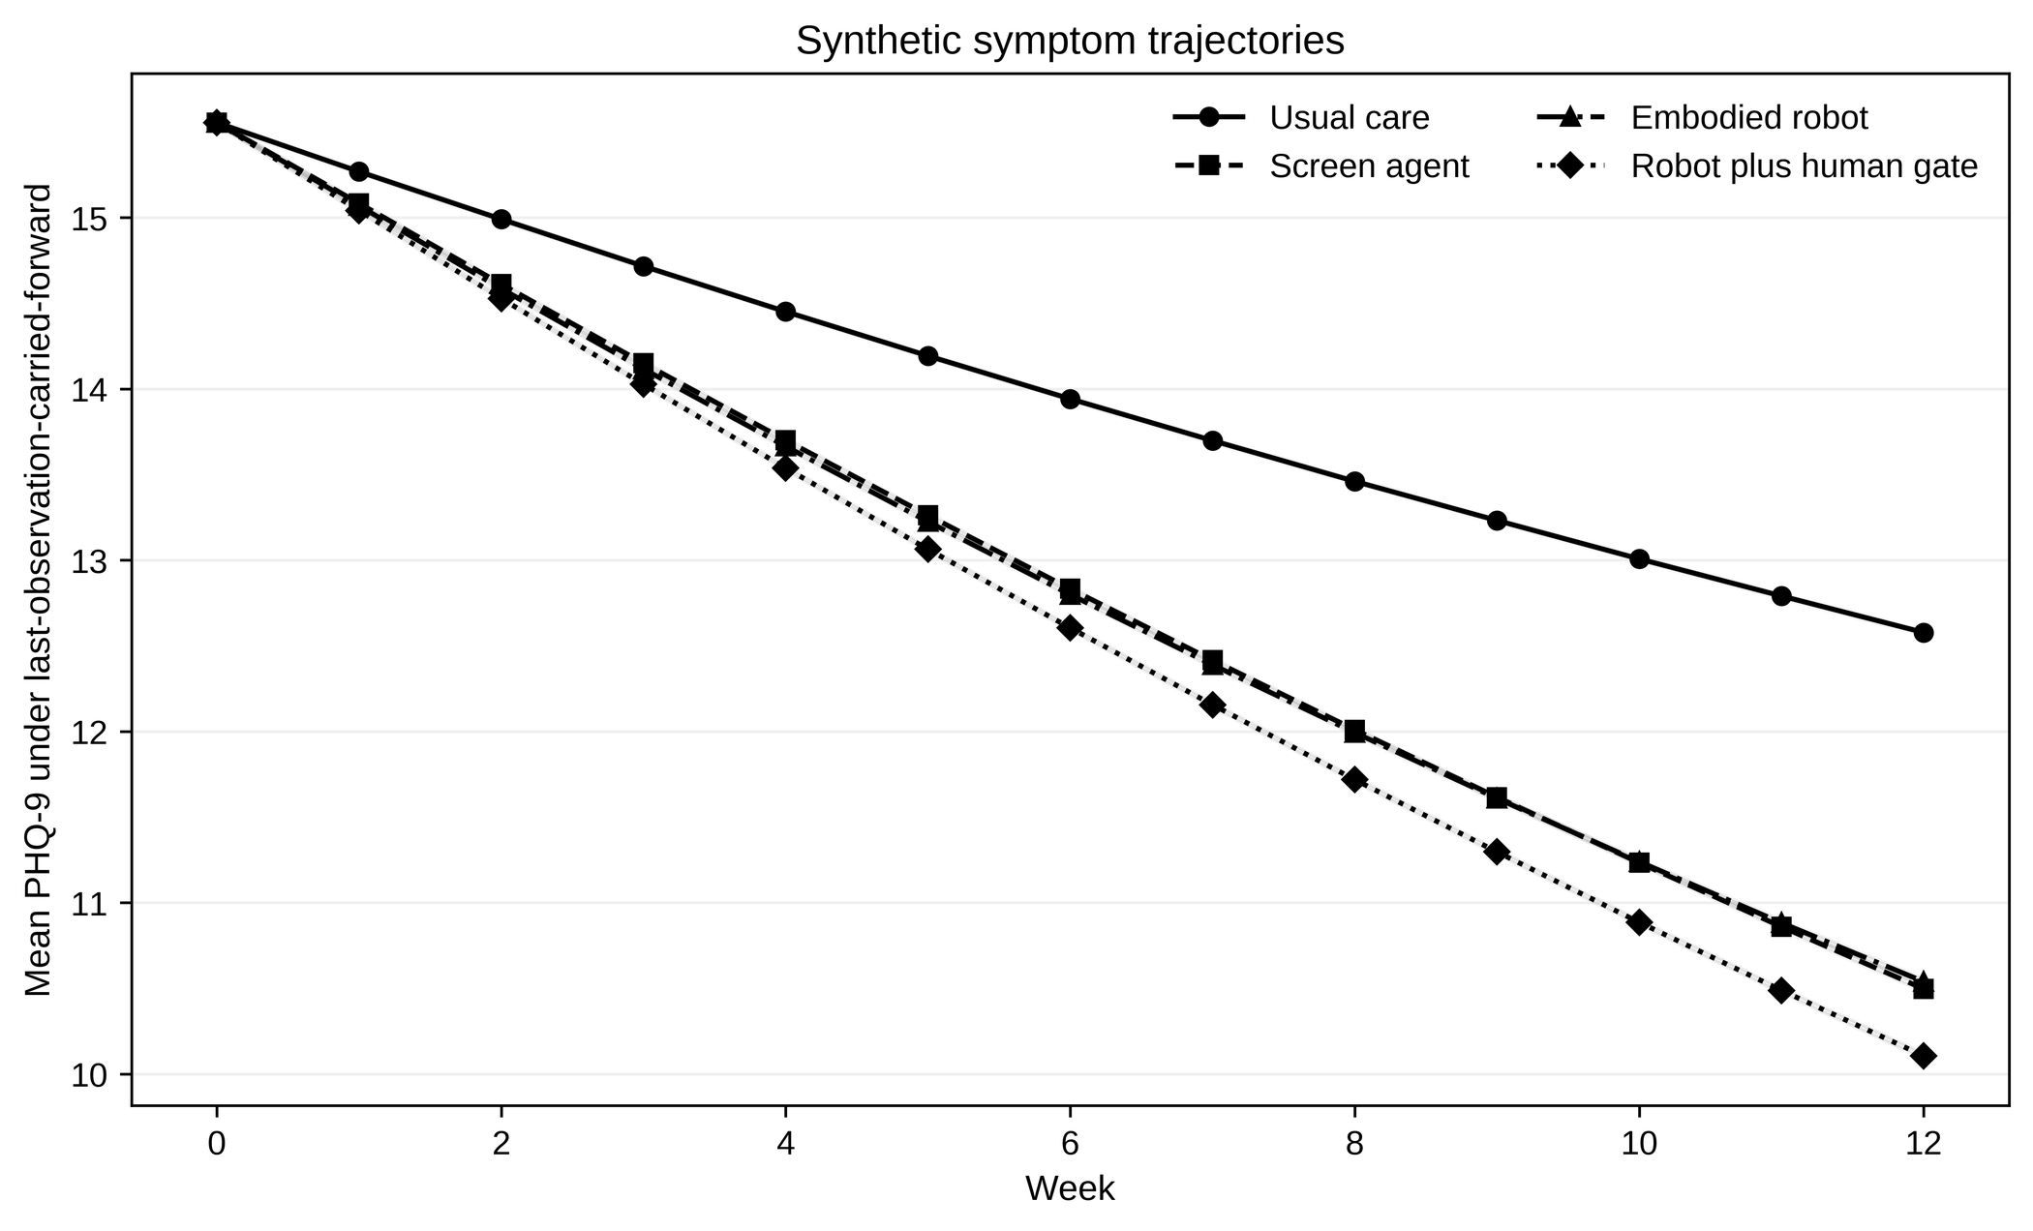
Figure 1. Synthetic symptom trajectories. Mean last-observation-carried-forward PHQ-9 across 12 weeks for four pathways. Lines use distinct markers and line styles; shaded bands are 95% BCa bootstrap intervals for the mean across 200 independent repeated synthetic trials. The intervals describe model-output uncertainty under fixed assumptions.
The trajectory separation translated into higher modeled response and remission, but not into retention non-worsening. Across 200 repeated trials with 1,200 participants per arm, response was 20.65% (95% BCa interval 20.49-20.80) for the screen and 26.94% (26.78-27.11) for the human-gated robot. Completion was 73.43% (73.24-73.62) and 68.00% (67.81-68.19), respectively. Figure 2 shows the complete arm-level distributions and makes the benefit-retention divergence visible.
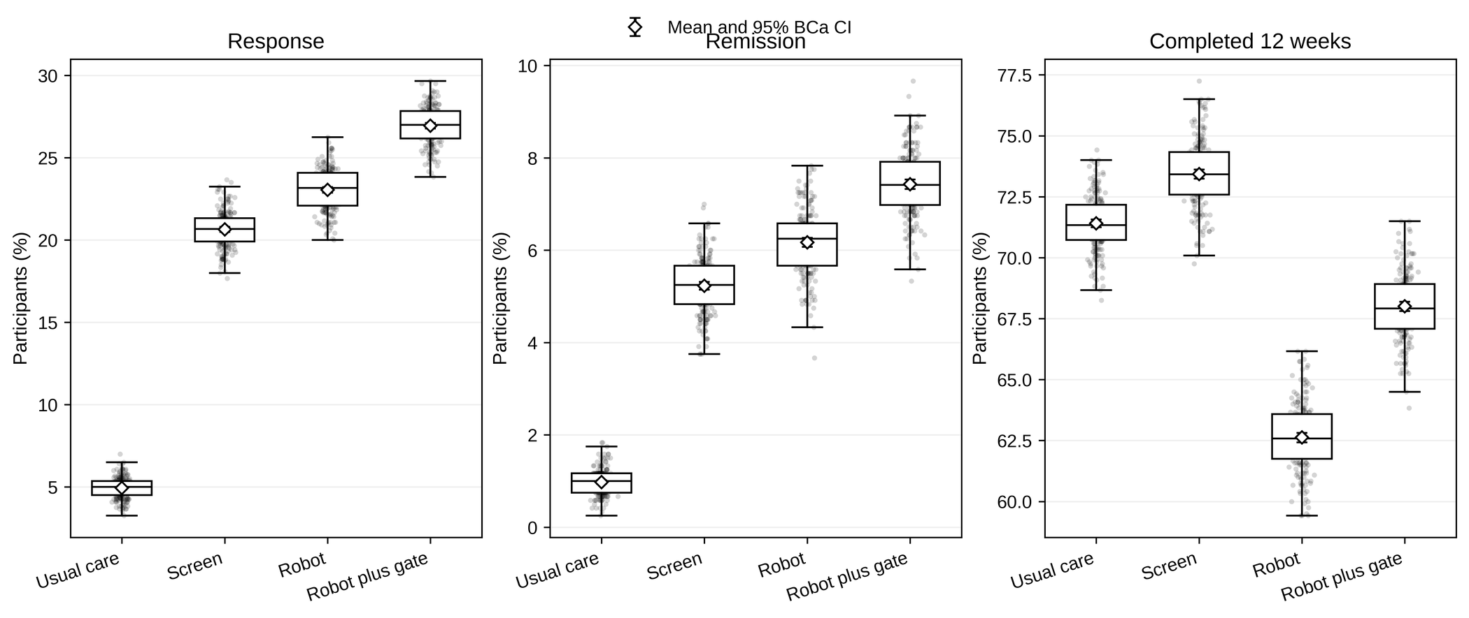
Figure 2. Patient-level outcomes. Replication distributions for response, remission, and 12-week completion. Box plots show medians and interquartile ranges, points show individual replication means, and diamonds with error bars show means and 95% BCa bootstrap intervals. The human-gated pathway improves modeled symptom thresholds while completion remains below the screen comparator.
Paired contrasts then isolated the complete robot-pathway differences against the content-matched screen. The human-gated pathway increased response by +6.29 (6.09 to 6.50) percentage points, increased remission by +2.20 (2.09 to 2.31) points, and improved mean PHQ-9 change by -0.39 (-0.41 to -0.38) points, while reducing completion by -5.42 (-5.69 to -5.17) points (Fig. 3). The two-sided sign-flip Monte Carlo P value was 0.000010 for each contrast and the Holm-adjusted value was 0.000070; these values demonstrate model-internal separation, not clinical significance.
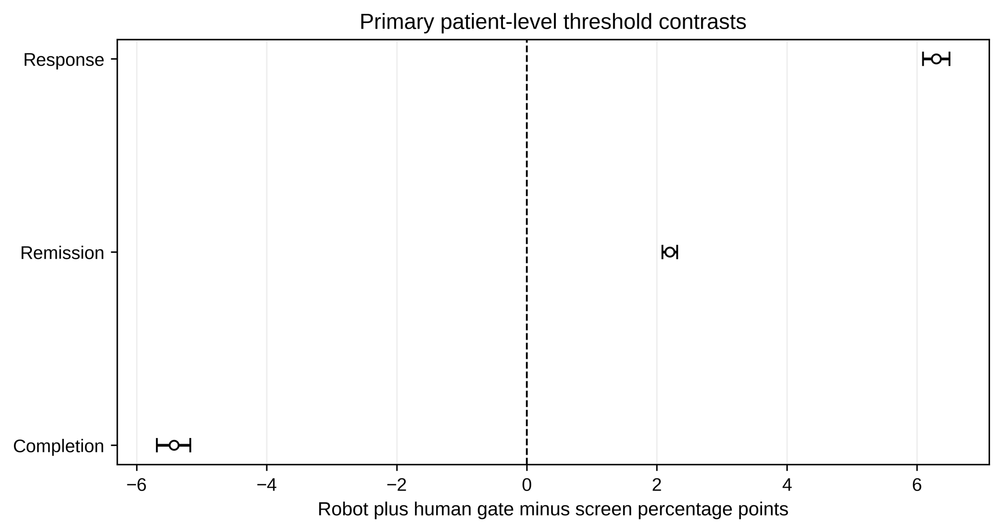
Figure 3. Primary patient-level threshold contrasts. Mean paired differences between the human-gated robot and the screen across 200 repeated trials. Error bars are 95% BCa bootstrap intervals obtained by resampling intact paired replication identifiers. Positive values favor the robot for response and remission; negative values favor the screen for completion.

Patient-level safety burden and hidden labor
The next transition was from symptom benefit to safety and workload. The human-gated pathway reduced expected missed high-risk weeks by 10.26 per 100 high-risk weeks, but added +4.38 (4.35 to 4.40) review minutes per participant and +0.55 (0.51 to 0.58) physical near-misses per 100 participants. Figure 4 places these favorable and unfavorable outcomes on a common patient-level burden map. The 2.5th-97.5th percentile range of single-replication missed-high-risk contrasts crossed zero (-30.8 to 14.3), despite a mean interval excluding zero.
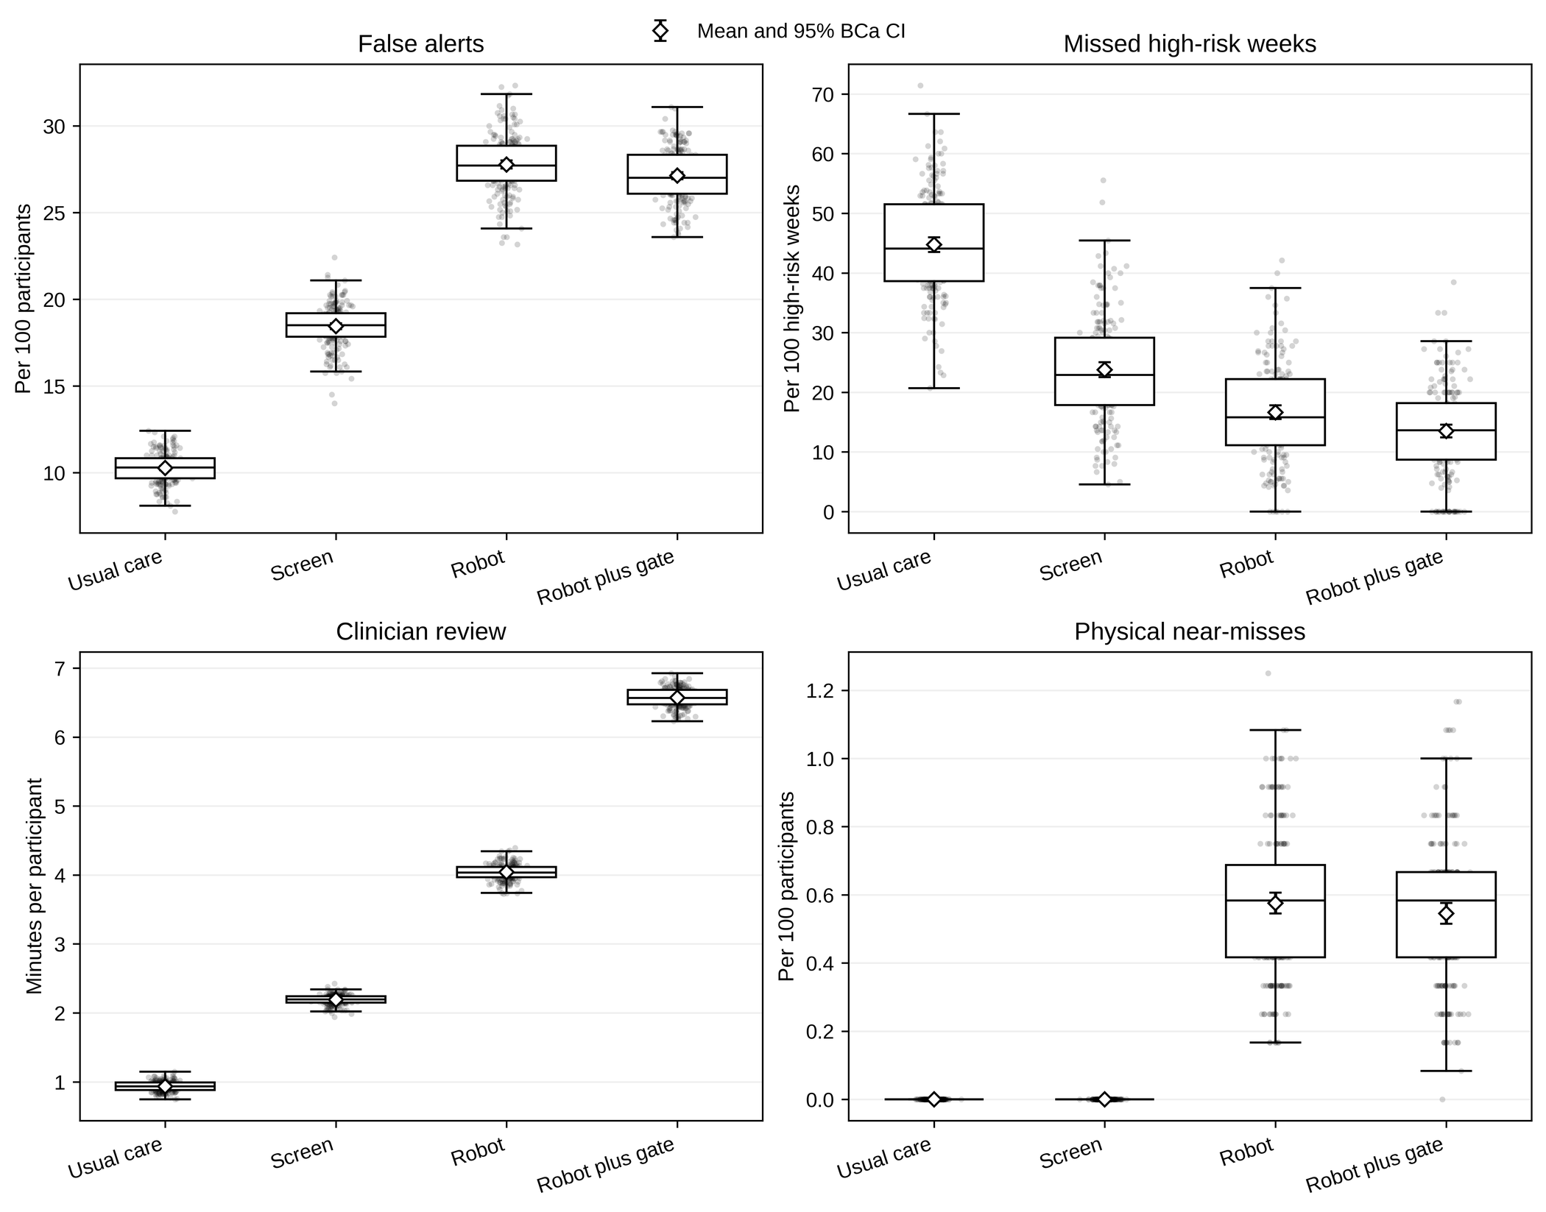
Figure 4. Patient-level safety and hidden labor. Replication distributions for false alerts, missed high-risk weeks, clinician review time, and physical near-misses. Box plots and points display the full replication distribution; diamonds and error bars show means and 95% BCa intervals. Nonembodied pathways are structurally unable to generate physical near-misses.

Service access, throughput, and detection trade-offs
Because patient-level gains can be offset by service congestion, the analysis next moved to the discrete-event model. Mean wait was 44.34 working minutes (95% BCa interval 41.64-47.53) for the screen and 78.75 minutes (74.19-84.40) for the human-gated robot. The paired difference was +34.41 (30.69 to 39.02) minutes. Figure 5 shows that the penalty was not an artifact of a small number of extreme replications; the distribution shifted broadly upward.
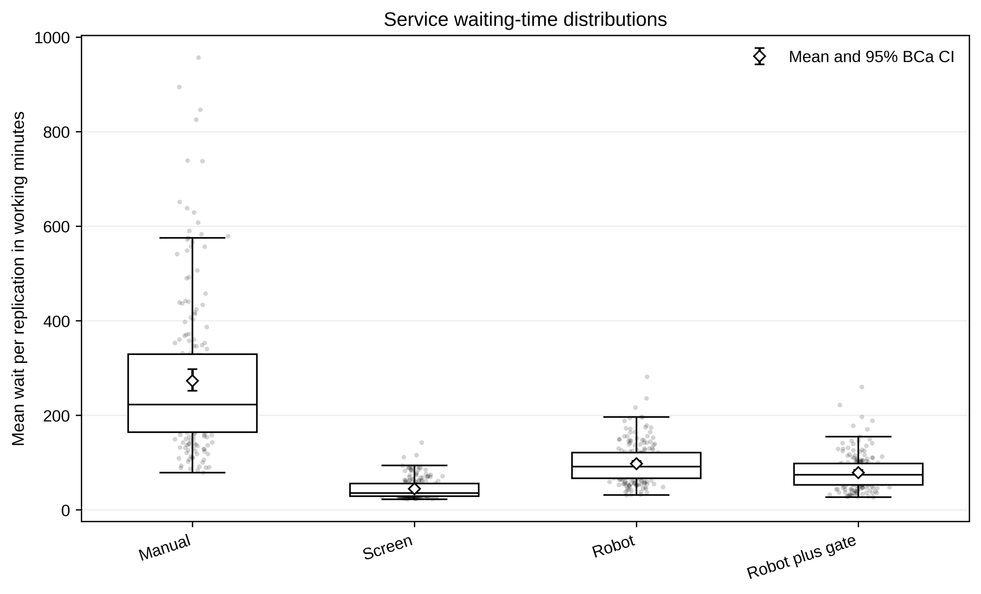
Figure 5. Service waiting-time distributions. Mean working-time waits over 200 paired discrete-event replications after a five-day warm-up. Box plots and points show replication distributions; diamonds and error bars show means and 95% BCa intervals.
The access penalty accompanied a detection-workload trade-off. The human-gated pathway reduced missed high-acuity cases by 10.85 percentage points, while increasing false alerts by 2.23 per 100 arrivals, abandonment by 0.46 points, and clinician utilization by 1.61 points (Fig. 6). Each two-sided sign-flip Monte Carlo P value was 0.000010 and each Holm-adjusted value was 0.000070.
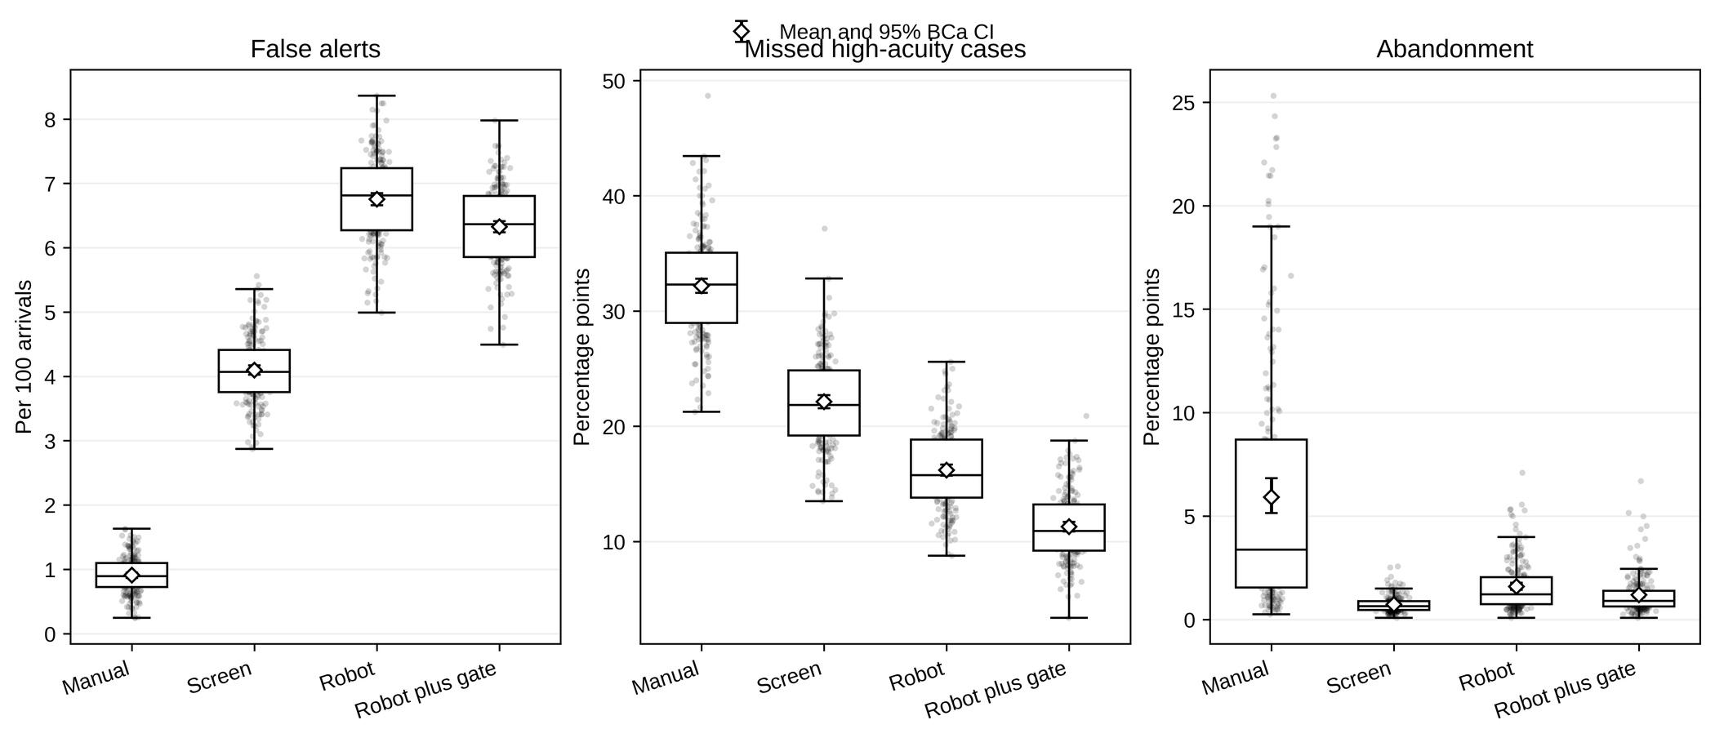
Figure 6. Service safety and access outcomes. Replication distributions for false alerts, missed high-acuity cases, and abandonment. Box plots and points show paired-replication outputs; diamonds and error bars show means and 95% BCa intervals. Improved modeled detection is accompanied by additional false alerts and operational burden.
Average throughput appeared similar across the screen and robot pathways, with a human-gated contrast of -0.160 (-0.207 to -0.126) assessments per working day. Figure 7 shows why throughput alone is an incomplete operational endpoint: nearly unchanged completions coexisted with much longer waits and higher abandonment.

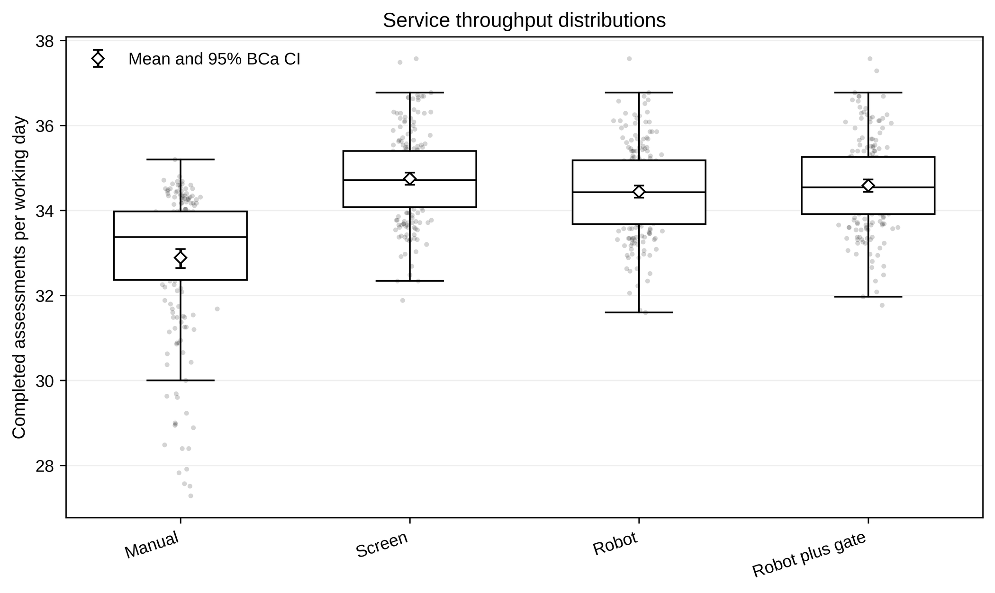
Figure 7. Service throughput distributions. Completed assessments per working day. Box plots and points show 200 replication outputs; diamonds and error bars show means and 95% BCa intervals. Similar throughput conceals large differences in waiting, abandonment, detection, and workload.
The paired service contrasts are assembled in Figure 8, which provides the bridge from individual operational endpoints to the cross-scale synthesis. The large positive wait contrast and small negative throughput contrast demonstrate that capacity stress can be expressed more strongly in delay than in completed volume.
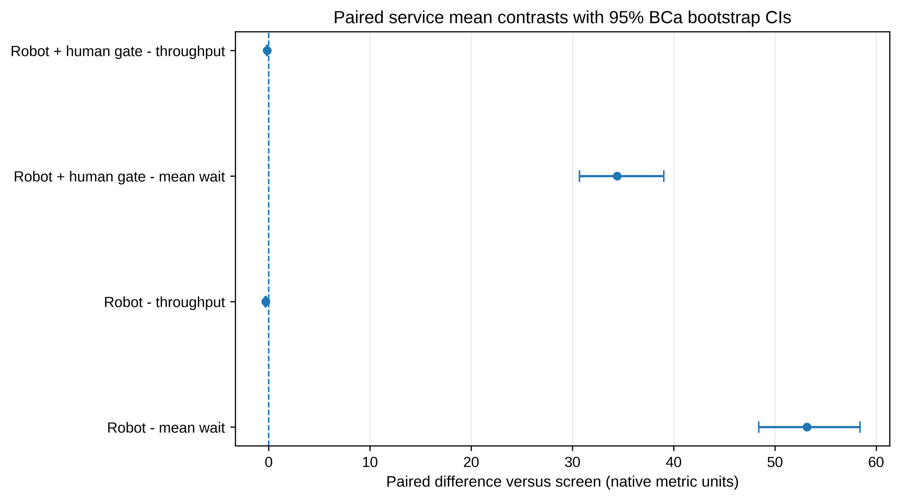
Figure 8. Paired service-level contrasts. Mean paired differences versus the screen under common arrival, acuity, and latent random streams. Error bars are 95% BCa bootstrap intervals. Native metric units are retained because waiting time and throughput are operationally distinct quantities.
Table 2 consolidates the primary human-gated pathway contrasts after the patient and service results have been presented separately. The table makes the dual-gate conclusion explicit: modeled response, remission, and detection favored the robot pathway, whereas completion, review time, waiting, false alerts, and physical exposure did not.
Table 2. Primary human-gated pathway contrasts versus the content-matched screen.
Scale | Outcome | Mean difference (95% BCa interval) | Unit | Holm-adjusted sign-flip P | Interpretation
Patient | Response | +6.29 (6.09 to 6.50) | percentage points | 0.000070 | Favors robot pathway
Patient | Remission | +2.20 (2.09 to 2.31) | percentage points | 0.000070 | Favors robot pathway
Patient | Completion | -5.42 (-5.69 to -5.17) | percentage points | 0.000070 | Favors screen
Patient | Mean PHQ-9 change | -0.39 (-0.41 to -0.38) | score points | 0.000070 | Negative favors robot pathway
Patient | Review time | +4.38 (4.35 to 4.40) | minutes per participant | 0.000070 | Higher hidden labor
Patient | Physical near-misses | +0.55 (0.51 to 0.58) | per 100 participants | 0.000070 | Robot-only exposure
Service | Mean wait | +34.41 (30.69 to 39.02) | working minutes | 0.000070 | Favors screen
Service | False alerts | +2.23 (2.18 to 2.28) | per 100 arrivals | 0.000070 | Higher alert burden
Service | Missed high-acuity cases | -10.85 (-11.25 to -10.47) | percentage points | 0.000070 | Negative favors robot pathway

Sensitivity, break-even, and reviewer-motivated analyses
After establishing the base-case divergence, the analysis proceeded through four robustness questions: whether patient benefit survived engagement and downtime variation; whether conclusions persisted across multivariable scenarios; whether service non-worsening could be recovered through engineering changes; and whether the findings depended on attrition estimands or bundled parameter assumptions. Table 3 summarizes the sequence before the detailed displays.
Table 3. Roadmap of robustness questions and findings.
Question | Analysis | Finding | Interpretation
Patient benefit under operating variation | Engagement-by-downtime grid | Response benefit varied, but no tested cell produced a completion gain | Clinical threshold benefit did not imply retention non-worsening
Multivariable parameter uncertainty | 250 draws with five inner replications | Response positive in 83.2%; completion negative in 100% | Proportions apply only to selected stress-test ranges
Operational break-even | Downtime-by-review grid and warm-up diagnostic | Wait non-worsening was confined to low review time and zero downtime; ordering survived warm-up choices | Engineering reliability and oversight duration are joint constraints
Reviewer-motivated alternatives | Attrition estimands, 2-5 intake stations, and one-block substitution | Response direction persisted; wait penalty remained about 36.4-36.2 min; components drove different outcomes | Magnitude and attribution require explicit estimands and component designs

Because the complete robot-screen contrast changes several implementation blocks at once, Table 4 lists the underlying parameter differences before the sensitivity and decomposition results are interpreted. This table is descriptive: it defines the modeled pathways and does not imply that the parameter values are empirically calibrated.
Table 4. Parameter blocks differentiating the screen and human-gated patient pathways.
Block | Parameter | Screen | Robot plus human gate
Engagement | engagement_intercept | 0.42 | 0.68
Engagement | weekly_decay | 0.025 | 0.016
Embodiment symptom effect | embodiment_effect | 0.0 | 0.08
Acceptance friction | initial_refusal | 0.025 | 0.065
Acceptance friction | privacy_penalty | 0.25 | 0.34
Acceptance friction | discomfort_dropout | 0.0 | 0.005
Reliability and fallback | downtime | 0.025 | 0.1
Reliability and fallback | fallback_screen_probability | 0.0 | 0.6
Detection and oversight | crisis_sensitivity | 0.76 | 0.86
Detection and oversight | false_alert_probability | 0.018 | 0.028
Detection and oversight | review_minutes_per_alert | 6.0 | 9.0
Detection and oversight | routine_audit_minutes | 1.0 | 4.0
Detection and oversight | human_verification | True | True
Physical exposure | physical_near_miss_per_active_week | 0.0 | 0.0006

The first detailed stress test varied engagement advantage and session-level downtime. Figure 9 shows that response benefit was most favorable when engagement advantage was high and downtime low. The surface also shows why a single base-case contrast is insufficient: the same conceptual pathway can occupy materially different regions of performance as reliability and engagement change.
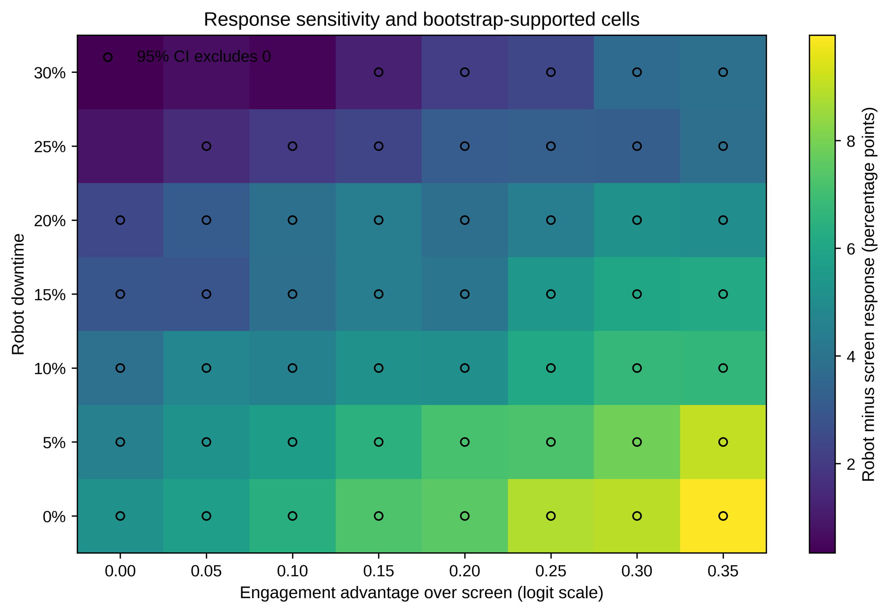
Figure 9. Patient-level response sensitivity. Mean response difference between the human-gated robot and screen as engagement-logit advantage and downtime vary. Open circles mark cells whose 95% bootstrap interval excludes zero in the favorable direction.
The second stress test varied multiple parameters jointly. Across 250 broad scenarios averaged over five first-order replications per draw, response favored the human-gated pathway in 83.2% (scenario-resampling interval 78.0-87.6), whereas completion was lower and review burden higher in 100% of scenarios. Favorable mean PHQ-9 change occurred in 59.2%. Figure 10 displays the response-completion trade-off, and Table 5 reports the full scenario-stability summary. These proportions are diagnostics over selected ranges, not posterior probabilities.
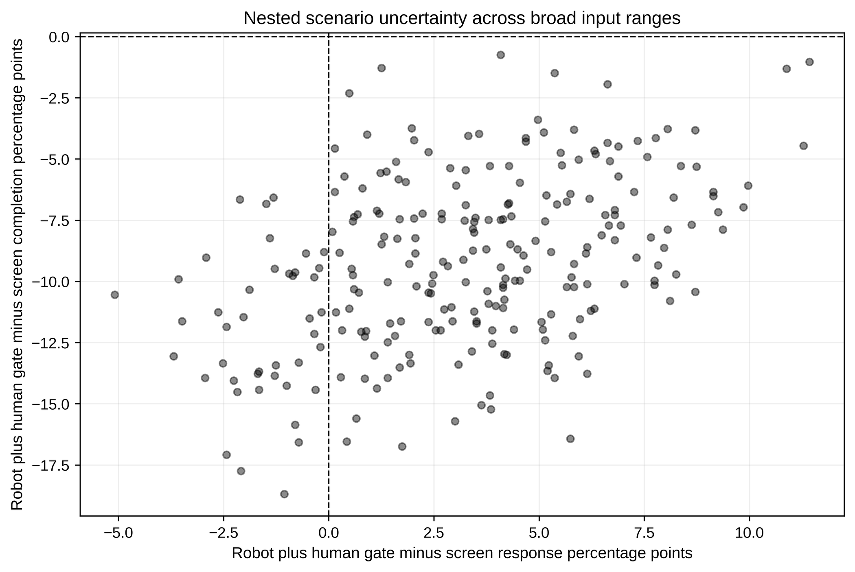
Figure 10. Nested parameter-scenario uncertainty. Joint response and completion contrasts across 250 broad illustrative parameter draws, each averaged over five first-order replications. The scenario ranges are stress tests and not posterior distributions.
Table 5. Nested scenario-ensemble stability.
Diagnostic | Scenario draws (%) | Resampling interval (%) | Draws | Inner replications
Response favors robot | 83.2 | 78.0-87.6 | 250 | 5
Completion favors screen | 100.0 | 100.0-100.0 | 250 | 5
Mean PHQ-9 change favors robot | 59.2 | 53.2-65.2 | 250 | 5
Review burden higher for robot | 100.0 | 100.0-100.0 | 250 | 5
Physical exposure higher for robot | 100.0 | 100.0-100.0 | 250 | 5

The third stress test asked where service waiting could reach a strict zero-margin non-worsening condition. Figure 11 shows that favorable or nonpositive wait differences were confined to zero modeled day-level downtime and short review durations. Requiring the upper 95% bootstrap bound to be nonpositive further narrowed the feasible region, illustrating that reliability and human review cannot be optimized independently.
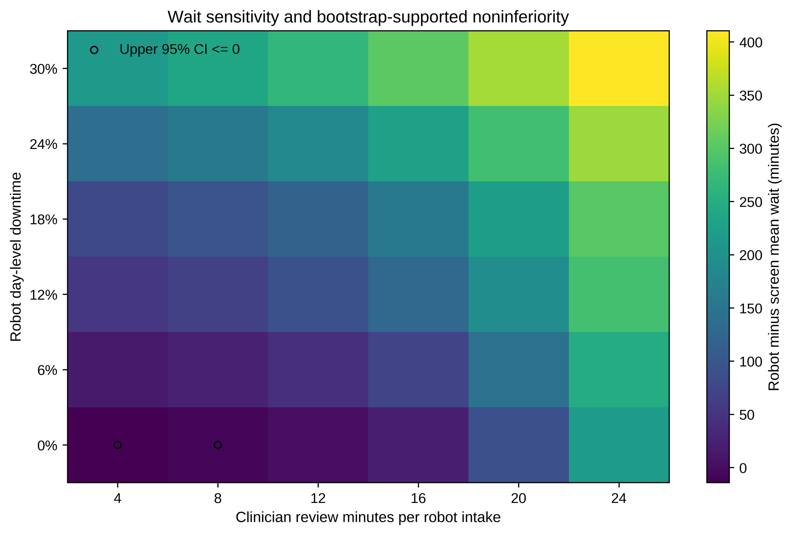
Figure 11. Service break-even sensitivity. Difference in mean wait between the human-gated robot and screen as downtime and review time vary. Negative values favor the robot; open circles mark cells whose upper 95% bootstrap bound is nonpositive.
A queue warm-up diagnostic then tested whether the base ordering was a transient initialization artifact. Across zero, two, five, and ten warm-up days, the screen remained faster than the human-gated pathway (Fig. 12). Warm-up changed the absolute estimates modestly but did not reverse the comparison.
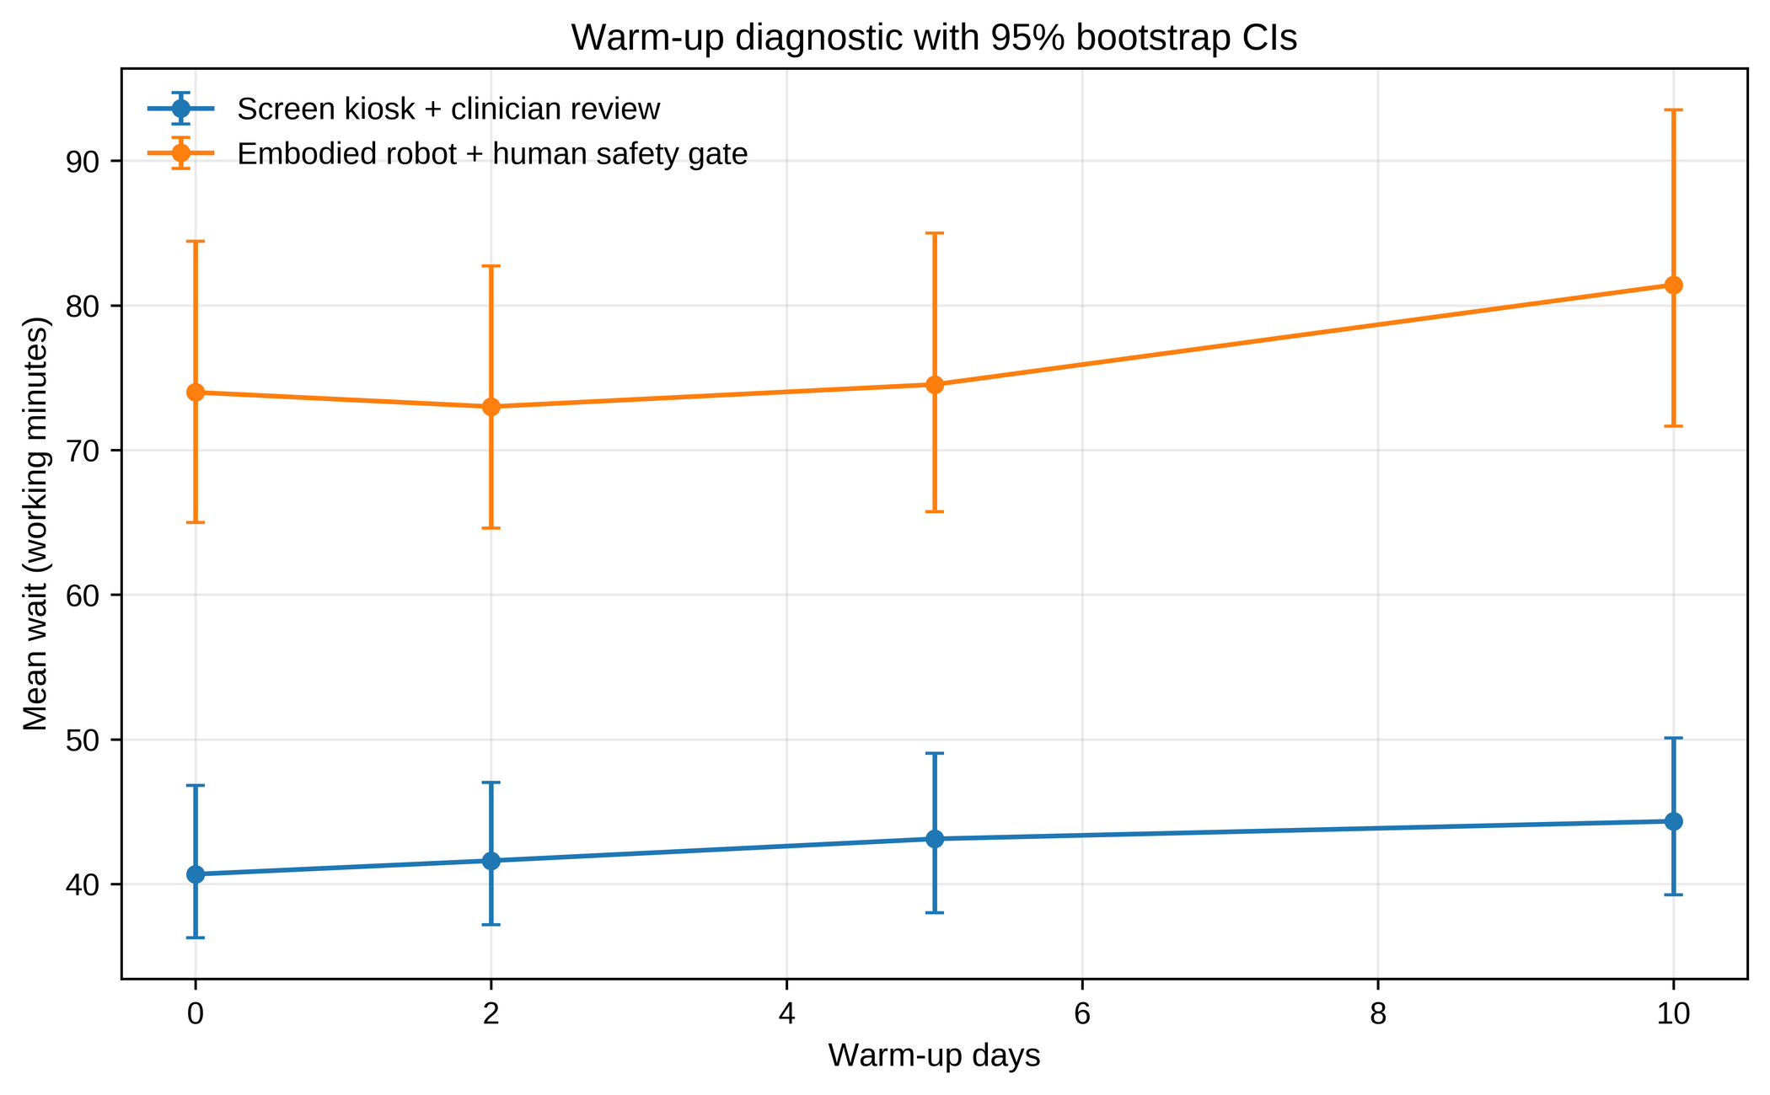
Figure 12. Queue warm-up diagnostic. Mean waiting time with zero, two, five, and ten warm-up days. Error bars are 95% BCa intervals. Warm-up choice does not reverse pathway ordering.
The fourth group of analyses addressed reviewer-motivated alternatives. Differential attrition was examined first because the pathway with better modeled symptom thresholds also completed less often. The response contrast was 6.23 points under last observation carried forward, 5.53 under baseline observation carried forward, and 10.21 among completers. Figure 13 shows the estimand dependence across response and remission, and Table 6 provides the numerical intervals.
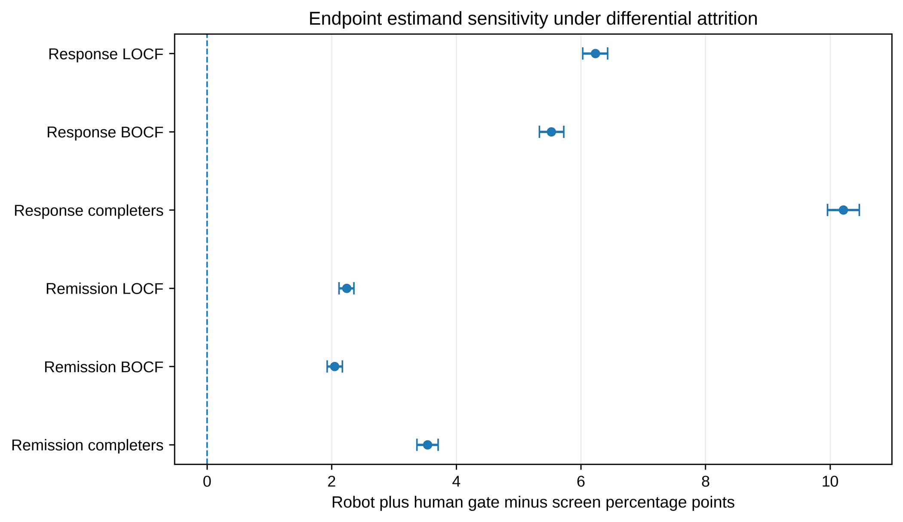
Figure 13. Endpoint estimand sensitivity. Robot-screen response and remission contrasts under last observation carried forward, baseline observation carried forward, and completer-only estimands. Error bars are 95% BCa intervals across 200 repeated trials.
Table 6. Endpoint estimand sensitivity for the human-gated robot minus screen contrast.
Estimand | Mean difference | 95% BCa interval | Replications
Response under LOCF, percentage points | 6.23 | 6.03 to 6.43 | 200
Response under BOCF, percentage points | 5.53 | 5.33 to 5.73 | 200
Response among completers, percentage points | 10.21 | 9.96 to 10.47 | 200
Remission under LOCF, percentage points | 2.24 | 2.12 to 2.36 | 200
Remission under BOCF, percentage points | 2.05 | 1.93 to 2.17 | 200
Remission among completers, percentage points | 3.54 | 3.37 to 3.71 | 200
Mean PHQ-9 change under LOCF | -0.40 | -0.41 to -0.38 | 200
Mean PHQ-9 change under BOCF | -0.25 | -0.27 to -0.23 | 200
Mean PHQ-9 change among completers | -0.84 | -0.85 to -0.82 | 200

Service capacity was then varied to test whether the waiting penalty was caused only by fewer embodied intake stations. Increasing the human-gated pathway from two to five stations did not remove the penalty: the mean difference was 36.40 minutes with three stations, 36.18 with four, and 36.16 with five. Figure 14 shows the near-plateau, and Table 7 reports the wait and throughput contrasts. Within this configuration, clinician-stage duration and review burden dominated the intake-station count.
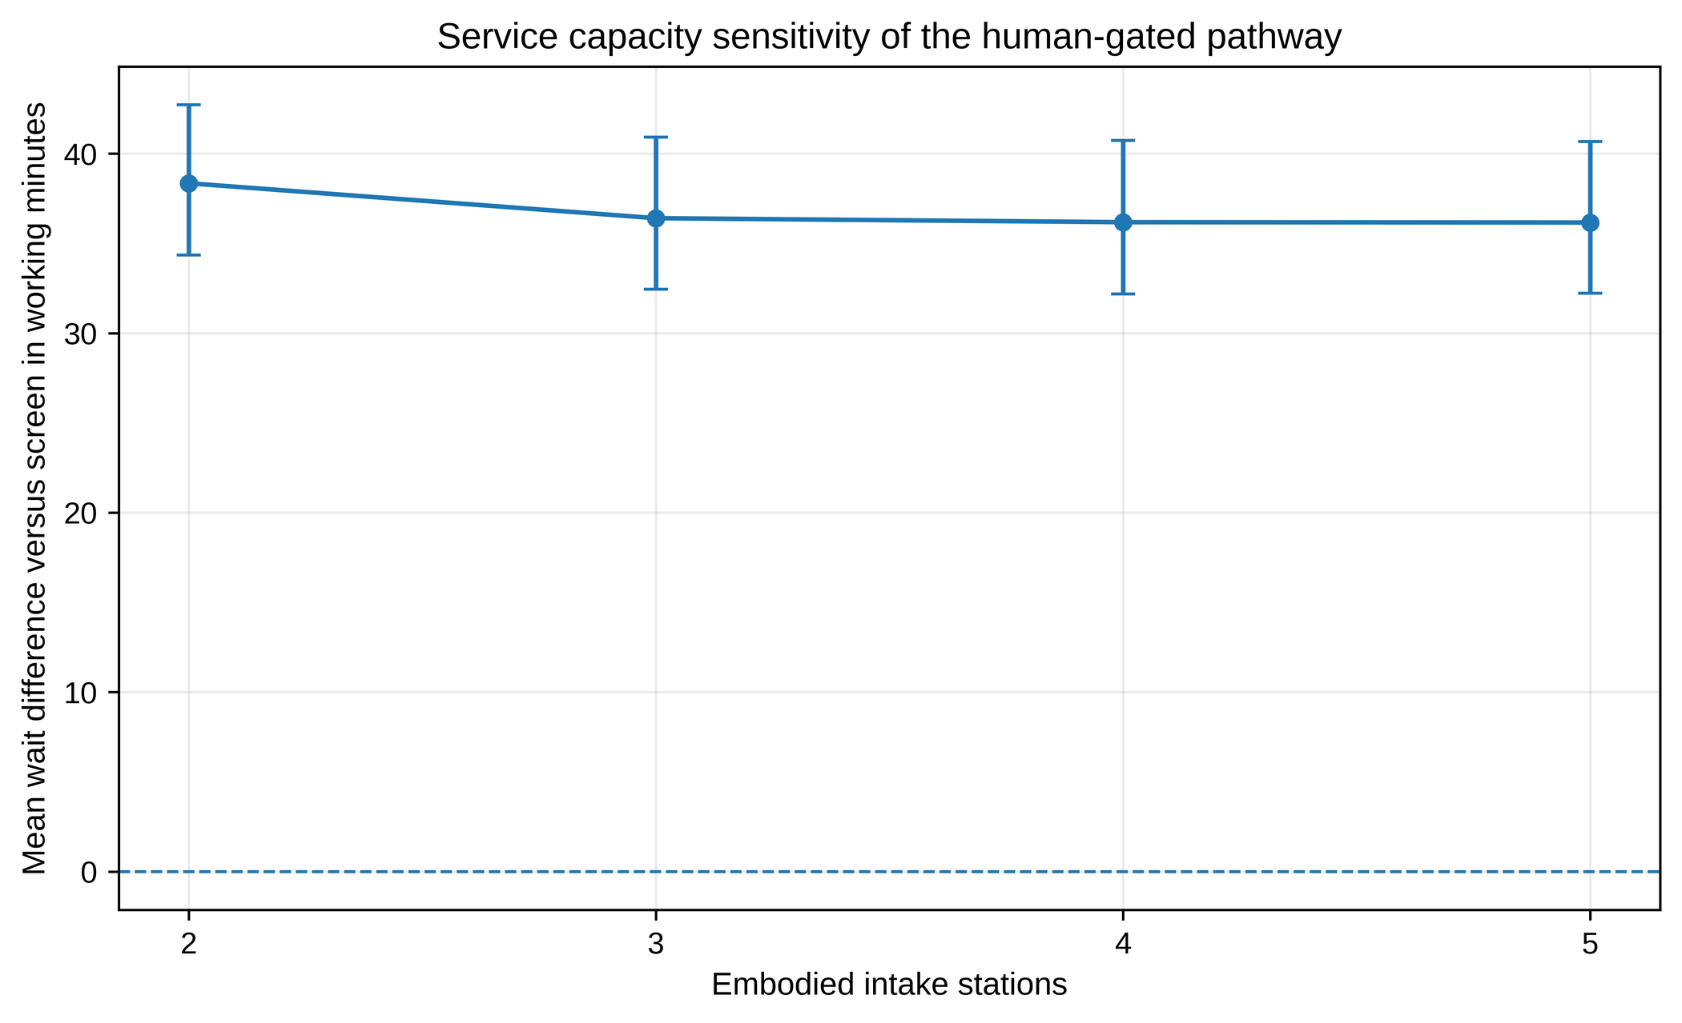
Figure 14. Service capacity sensitivity. Mean wait difference between the human-gated robot and screen as the number of embodied intake stations varies. Error bars are 95% BCa intervals across 200 paired replications.
Table 7. Service capacity sensitivity.
Embodied intake stations | Mean wait difference, min | 95% BCa interval | Throughput difference/day | 95% BCa interval
2 | 38.34 | 34.35 to 42.71 | -0.178 | -0.222 to -0.144
3 | 36.40 | 32.44 to 40.92 | -0.178 | -0.220 to -0.144
4 | 36.18 | 32.18 to 40.73 | -0.178 | -0.224 to -0.143
5 | 36.16 | 32.23 to 40.67 | -0.178 | -0.221 to -0.145

Finally, the pathway bundle was decomposed one block at a time. Substituting only the modeled embodiment symptom increment increased response by 6.02 points with essentially no completion change, whereas substituting only acceptance-friction assumptions reduced response by 1.85 points and completion by 7.13 points. Safety oversight and physical exposure generated most of the additional review and near-miss burden. Figure 15 shows the directional pattern and Table 8 gives the numerical decomposition. This diagnostic is not additive, causal mediation, or attribution of a biological embodiment effect.
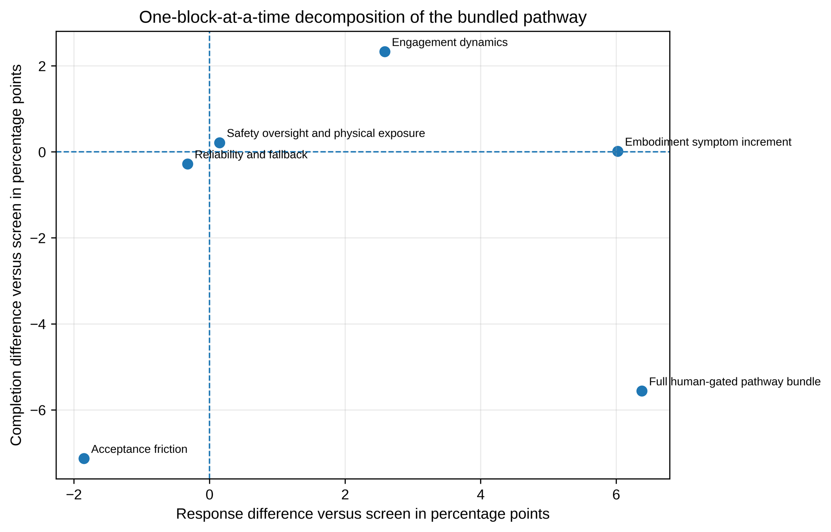
Figure 15. Pathway bundle decomposition. One-block-at-a-time substitution of human-gated robot parameter blocks into the screen pathway. The analysis is diagnostic and not an additive or causal attribution.
Table 8. One-block-at-a-time pathway decomposition.
Parameter block substituted into screen | Response difference, points | Completion difference, points | Review difference, min
Embodiment symptom increment only | 6.02 | 0.01 | -0.00
Engagement dynamics only | 2.59 | 2.33 | 0.01
Acceptance friction only | -1.85 | -7.13 | -0.10
Reliability and fallback only | -0.32 | -0.28 | -0.01
Safety oversight and physical exposure only | 0.15 | 0.21 | 4.56
Full human-gated pathway bundle | 6.38 | -5.56 | 4.36

The component decomposition led directly to two deliberately less favorable assumption sets. The neutral set removed the robot's engagement and symptom advantages and equalized most digital performance parameters while retaining physical reset, refusal, dropout, and review burdens. The skeptical set combined a negative engagement differential, no embodiment symptom increment, poorer reliability, higher refusal/dropout, longer review, and heavier service burden. Table 9 shows that the base-case benefit was not structurally guaranteed: under neutral assumptions the patient response contrast became negative, and under skeptical assumptions both patient and operational outcomes deteriorated substantially.
Table 9. Results under neutral and skeptical assumptions versus the content-matched screen.
Scale | Outcome | Assumption set | Mean difference (95% BCa interval)
Patient | Response, percentage points | Neutral | -1.38 (-1.57 to -1.18)
Patient | Response, percentage points | Skeptical | -8.83 (-9.02 to -8.63)
Patient | Completion, percentage points | Neutral | -5.91 (-6.15 to -5.66)
Patient | Completion, percentage points | Skeptical | -26.16 (-26.42 to -25.90)
Patient | Review time, min/participant | Neutral | +4.56 (4.53 to 4.58)
Patient | Review time, min/participant | Skeptical | +9.64 (9.61 to 9.68)
Service | Mean wait, working minutes | Neutral | +0.92 (0.89 to 0.94)
Service | Mean wait, working minutes | Skeptical | +205.66 (195.18 to 221.17)
Service | Abandonment, percentage points | Neutral | +0.00 (0.00 to 0.00)
Service | Abandonment, percentage points | Skeptical | +4.39 (4.01 to 4.80)
Service | False alerts per 100 arrivals | Neutral | +0.00 (0.00 to 0.00)
Service | False alerts per 100 arrivals | Skeptical | +4.99 (4.90 to 5.07)
Service | Missed high-acuity, percentage points | Neutral | +0.00 (0.00 to 0.00)
Service | Missed high-acuity, percentage points | Skeptical | -2.17 (-2.34 to -2.01)

Because one-at-a-time grids can miss nonlinear interactions, we next varied 12 patient-model and 11 service-model inputs simultaneously over the documented ranges. Scrambled Sobol designs used 128 base points, first- and total-order indices, every pairwise second-order index, two stochastic paired evaluations per parameter vector, and bootstrap diagnostic intervals. Figure 16 moves from the scenario result to the global structure of patient-level response uncertainty. The embodiment symptom increment had the largest total-order index, followed by engagement advantage, embodiment-related dropout, downtime, and refusal. For completion, embodiment-related dropout and initial refusal dominated. Pairwise response-interaction intervals were broad and crossed zero, so no individual response interaction was treated as established.
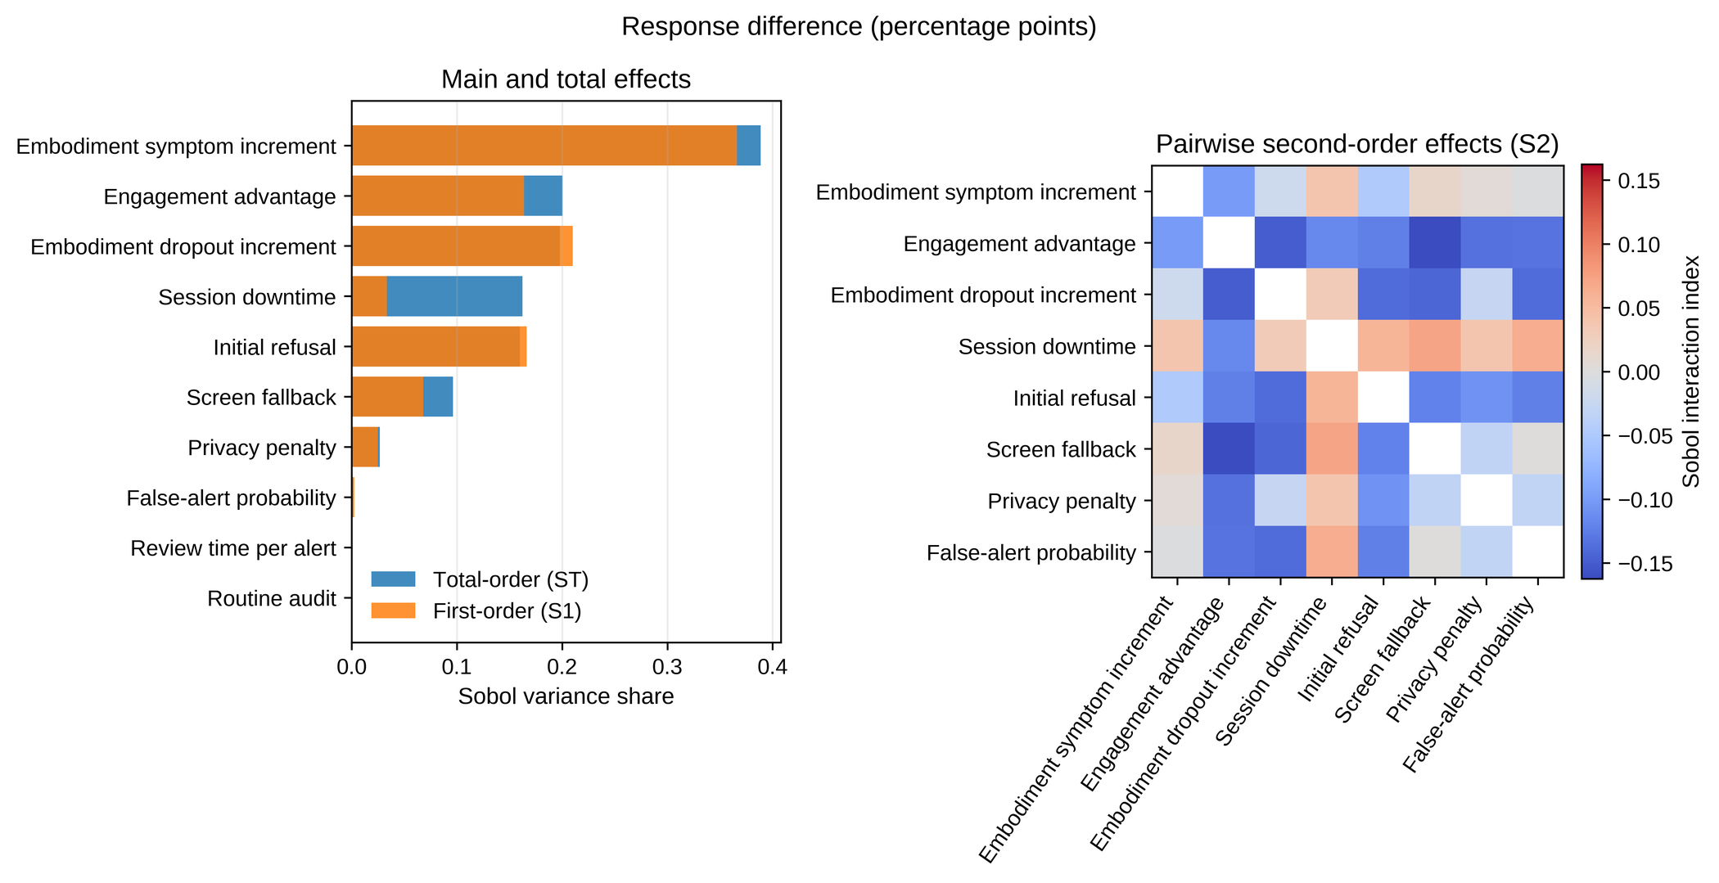
Figure 16. Global interaction-aware sensitivity of the patient response contrast. Left: first-order and total-order Sobol indices for the ten largest contributors to variance in the human-gated robot minus screen response contrast over the declared independent Uniform ranges. Right: pairwise second-order indices among leading factors. Indices are simulation diagnostics; negative estimates and values above one can occur with finite noisy designs. Bootstrap intervals, reported in machine-readable outputs, govern interpretation.
Figure 17 then applies the same variance decomposition to the service waiting contrast. Demand was the largest total-order driver, followed by day-level downtime, clinician capacity, mandatory review, and robot intake duration. The demand-by-downtime interaction was the only leading waiting-time interaction whose bootstrap interval excluded zero; most other pairwise intervals were too wide for firm ranking. This progression from neutral/skeptical scenarios to global sensitivity identifies which measurements would most reduce decision uncertainty and which combinations must be calibrated jointly.
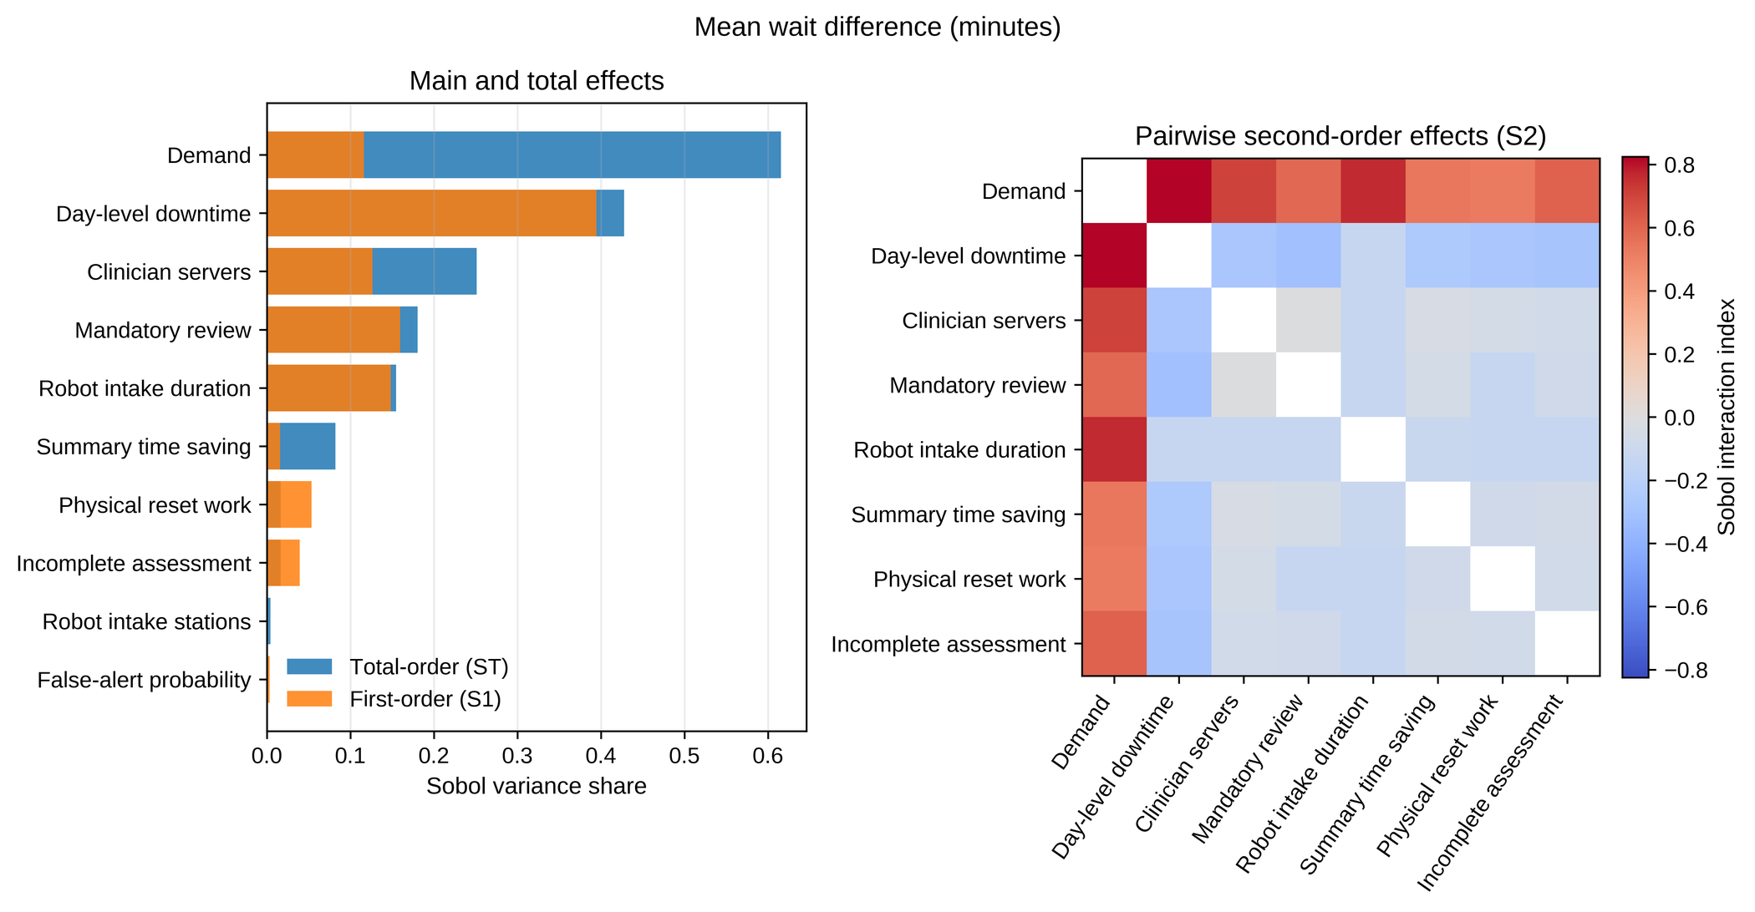
Figure 17. Global interaction-aware sensitivity of the service waiting contrast. Left: first-order and total-order Sobol indices for leading contributors to variance in the human-gated robot minus screen mean-wait contrast. Right: pairwise second-order indices among leading factors. The analysis assumes independent Uniform input ranges and is not a posterior distribution. Wide interaction intervals are interpreted as inconclusive.
Table 10. Leading global Sobol sensitivity indices.
Outcome | Parameter | First-order S1 | Total-order ST (bootstrap interval)
Patient response | Embodiment symptom increment | 0.37 | 0.39 (0.30 to 0.49)
Patient response | Engagement advantage | 0.16 | 0.20 (0.15 to 0.27)
Patient response | Embodiment dropout increment | 0.21 | 0.20 (0.15 to 0.25)
Patient response | Session downtime | 0.03 | 0.16 (0.11 to 0.24)
Patient completion | Embodiment dropout increment | 0.84 | 0.65 (0.50 to 0.81)
Patient completion | Initial refusal | 0.36 | 0.28 (0.21 to 0.37)
Patient completion | Engagement advantage | 0.08 | 0.05 (0.04 to 0.07)
Patient completion | Session downtime | 0.05 | 0.04 (0.03 to 0.06)
Service mean wait | Demand | 0.12 | 0.62 (0.42 to 0.89)
Service mean wait | Day-level downtime | 0.39 | 0.43 (0.11 to 0.93)
Service mean wait | Clinician servers | 0.13 | 0.25 (0.12 to 0.42)
Service mean wait | Mandatory review | 0.16 | 0.18 (0.09 to 0.32)
Clinician utilization | Mandatory review | 0.53 | 0.48 (0.37 to 0.57)
Clinician utilization | Summary time saving | 0.29 | 0.25 (0.20 to 0.32)
Clinician utilization | Demand | -0.01 | 0.18 (0.11 to 0.27)
Clinician utilization | Clinician servers | 0.06 | 0.13 (0.06 to 0.20)

Discussion
This simulation demonstrates a multiscale separation: a modeled patient or detection advantage can coexist with worse retention, human workload, false alerts, physical exposure, and service access. The principal implication is not that a specific robot is effective or unsafe. It is that empirical evaluation should require both incremental patient benefit against a content-matched screen and prespecified operational acceptability, including completion, waiting, verification labor, fallback, and physical-safety workload.
The neutral and skeptical analyses materially sharpen that interpretation. Once the assumed engagement and symptom increments were removed, the patient response advantage disappeared while completion, review, and physical exposure remained unfavorable. Under skeptical but still declared-range assumptions, the deterioration was larger and the service queue became markedly unstable. The base case should therefore be read as one internally coherent hypothesis, not as the expected performance of physical AI.
The global sensitivity analysis also changes the emphasis from isolated parameter sweeps to joint uncertainty. Patient response variance was driven primarily by the embodiment symptom increment, engagement, dropout friction, downtime, and refusal; service waiting was governed by demand, downtime, clinician capacity, review time, and intake duration. These rankings identify empirical priorities, while the wide second-order intervals show that the current design is adequate for screening but not precise interaction estimation. Larger designs should follow calibration, when parameter distributions and dependencies are better justified [36-38].
The result is consistent with, but more operationally qualified than, the human-robot interaction literature. Physical copresence can strengthen behavioral and attitudinal responses relative to screen display [8,9], and the recent matched iCBT study found improved alliance, adherence, and satisfaction without a significant mood advantage [5]. Our framework formalizes the next question: whether such an interaction dividend remains valuable after refusal, downtime, oversight, and service consequences are counted. In the base assumptions, the answer differed by outcome and scale.
The broader health evidence also supports cautious interpretation. Reviews across mental health, older adults, and dementia report promising feasibility and selected psychosocial effects, but heterogeneous interventions, small samples, mixed pooled estimates, and limited long-term evidence remain common [2,3,10-12]. A month-long home study in autism illustrates the feasibility of sustained autonomous interaction in a selected setting [13], but it does not resolve comparative efficacy, workflow, or generalizability in psychiatric services. Simulation can therefore organize hypotheses and identify measurements; it cannot substitute for clinical evaluation.
Implementation science provides the appropriate bridge from efficacy to deployment. Digital psychiatry reviews emphasize that the intervention, users, clinical context, and implementation process jointly determine real-world value [14,15], while the NASSS framework highlights nonadoption, abandonment, scale-up, spread, and sustainability as distinct failure modes [16]. The present dual-gate standard operationalizes part of that agenda by treating completion, clinician review, waiting, fallback, and physical work as co-primary deployment concerns rather than post hoc inconveniences.
The component analysis further limits causal language. The human-gated robot and screen were content-matched but not intervention-identical: their contrast combined embodiment, engagement dynamics, acceptance friction, downtime, fallback, detection sensitivity, review rules, and physical exposure. Favorable response and unfavorable completion arose from different assumption blocks. Empirical studies seeking component effects should use factorial, sequential, or adaptive designs and report human-AI interaction, workflow integration, error handling, and protocol deviations in line with DECIDE-AI and CONSORT-AI principles [22,23].
Differential attrition is central because the pathway with better modeled symptom thresholds also completed less often. Baseline-observation-carried-forward and completer-only analyses preserved the response direction but changed its magnitude. An empirical trial should prospectively define treatment-policy, while-on-treatment, and hypothetical estimands; collect outcomes after disengagement where feasible; and use missing-data methods appropriate to the causal question rather than rely on last observation carried forward.
The service model suggests that the waiting penalty is not explained solely by fewer robot stations, because increasing intake capacity produced little improvement while clinician review remained fixed. Nevertheless, this is one finite-capacity clinic configuration. The manual pathway is nominally at its intake-capacity boundary, the abandonment function is stylized, and scheduling, no-shows, downstream treatment capacity, staff learning, maintenance logistics, costs, and equity effects are not represented. Site-specific calibration and face validation are required before operational use.
All parameters are illustrative. The framework cannot estimate clinical efficacy, real-world safety incidence, cost-effectiveness, regulatory acceptability, or generalizability. Threshold outcomes amplify small distributional shifts; high-risk episodes and physical near-misses are synthetic constructs; the individual and service models are not dynamically coupled; and the broad parameter draws are not a probability distribution over plausible deployments. Narrow bootstrap intervals and small Monte Carlo P values reflect repeated computation under fixed assumptions, not empirical certainty.
The contribution is therefore methodological and hypothesis-generating: a single reproducible sequence connects patient trajectories, threshold outcomes, retention, hidden labor, queue performance, break-even conditions, assumption stress tests, and interaction-aware global sensitivity. The model has not yet been empirically calibrated, externally validated, or formally face-validated by patients, clinicians, operations staff, human-factors specialists, and robotics engineers. A structured elicitation and face-validation protocol is supplied, following health-care expert-elicitation and simulation-validation guidance [33-35]. Completion of that protocol, followed by re-estimation of ranges and correlated uncertainty distributions, is required before decision use.

Methods

Study design and interpretation
We constructed an individual microsimulation and a service-level discrete-event simulation. The models share pathway definitions and burden categories but are not dynamically coupled. No patient records, human-subject data, or empirical clinical outcome data were used. Parameters are transparent illustrative assumptions selected to expose trade-offs and generate falsifiable targets. Table 1 summarizes the pathways, and Table 4 identifies the parameter blocks that distinguish the content-matched screen from the human-gated patient pathway.
The primary reference was a screen pathway delivering the same modeled digital content. The primary estimand was the expected paired difference between each complete robot pathway and the screen under the fixed data-generating process. Because the pathways differ in multiple implementation parameters, this estimand is a bundled pathway contrast and not a causal effect of physical embodiment alone.

Parameter selection, provenance, and validation status
Every parameter was assigned a name, symbol, unit, functional role, pathway value, neutral and skeptical value where applicable, global range, selection rationale, ordering rationale, evidence class, and calibration status. We used four evidence categories: empirically established scale or endpoint anchors; literature-informed direction or broad range class; operational face-validity stress assumptions; and explicit placeholders. PHQ-9 bounds and endpoints were scale anchored [20,21,31]. Engagement and attrition ranges were informed by digital-intervention adherence and real-world use literature [27-30], while robot-specific differences were kept as hypotheses because the current literature is too heterogeneous to estimate a common coefficient [2,3,39].
Range size was chosen according to functional scale. Probabilities were bounded in [0,1] and generally spanned low-to-adverse operating conditions; durations covered rapid through documentation-intensive workflows; logit coefficients were kept modest enough to avoid deterministic behavior; and symptom increments were constrained so the maximal 12-week contribution remained small relative to the PHQ-9 scale. When one pathway value exceeded another, the ordering encoded a specific mechanism: physical copresence for engagement, additional hardware/environmental failure modes for downtime, sensing sensitivity for detection, and mandatory verification/reset for workload. Neutral scenarios removed hypothesized robot benefit; skeptical scenarios moved burden parameters toward adverse ends of the declared ranges.
No local patient or service dataset was available for empirical calibration. No structured multi-stakeholder elicitation or independent face-validation workshop was performed. Accordingly, literature supports the plausibility and direction of selected ranges but not the exact joint distribution. Tables 11-14 report the complete inputs, and Table 15 separates completed verification from unresolved calibration and validation. A prospective protocol based on structured health-care elicitation and simulation-validation guidance is provided in the repository [32-35].

Individual microsimulation
The individual model followed synthetic participants for 12 weeks across usual measurement-based care, a screen-based agent, an embodied social robot, and an embodied robot with mandatory human review for risk-relevant alerts. A 5,000-participant-per-arm base cohort supported patient-level audit output. The uncertainty experiment used 200 independent repeated trials with 1,200 participants per arm. Within each replication, all pathways reused the same baseline-cohort seed while pathway event streams were independent.
Baseline PHQ-9, technology acceptance, privacy concern, social support, and treatment responsiveness were drawn from bounded or parametric distributions. Weekly engagement, refusal, dropout, symptom change, downtime, fallback, alerts, high-risk episodes, review minutes, and physical near-misses followed prespecified transition rules. Response was at least a 50% PHQ-9 reduction and remission was PHQ-9 of 4 or less [20,21]; completion required remaining active through week 12. The primary symptom analysis carried the last observation forward after dropout.
For participant i, pathway a, and week t, engagement followed: logit Pr(E_iat=1) = alpha_a + 1.05(A_i-0.5) - gamma_P,a(P_i-0.5) + 0.34 E_i,a,t-1 + 0.13 S_i + U_i,a,t-1 - delta_a(t-1) - 0.025 max(Y_i,a,t-1-15,0). Engagement was realized only when the session was available; conditional fallback preserved content but removed the embodiment increment.
Weekly symptoms followed Y_iat = clip{Y_i,a,t-1 - [0.24 + 0.022 max(Y_i0-14,0) + E_iat(beta_content,a + beta_emb,a(1-B_iat)) + R_i] + epsilon_iat, 0, 27}, with epsilon_iat ~ Normal(0,0.62). Crisis probability followed logit Pr(C_iat=1) = -10.2 + 0.27Y_iat + 0.42max(Y_iat-Y_i,a,t-1,0). Alerts used pathway sensitivity in crisis weeks and the false-alert probability otherwise.
Weekly dropout was clip{0.010 + 0.030(1-E_iat) + 0.016P_i + kappa_a + 0.010I(worsening>1.5) - 0.008E_iat, 0.002, 0.12}. Trust increased by 0.025 after a true alert and decreased by 0.040 after an escalated false alert and 0.075 after a missed crisis. Physical near-misses were Bernoulli events restricted to available nonfallback embodied sessions. The complete state-update order and all symbols are reproduced in the repository model specification.
Table 11. Pathway-specific individual-model parameters, ranges, roles, and provenance.
Parameter (unit) | Base, neutral, skeptical, and global range | Functional role | Selection, ordering, evidence, and calibration status
engagement_intercept (logit units) | Base: usual_care=-0.05; screen_agent=0.42; embodied_robot=0.63; robot_hitl=0.68 | Neutral: robot=0.42 | Skeptical: robot=0.31999999999999995 | Global: Not varied in v4.3 global analysis | Pathway-specific baseline log-odds of engaging in an available weekly session. | Base ordering encodes the hypothesis that copresence can increase salience; the global range spans a skeptical disadvantage (-0.10) to a modest advantage (+0.35) relative to screen. Ordering: Robot > screen > usual in the base case; neutral sets robot equal to screen and skeptical reverses the ordering. Evidence: Literature-informed direction; illustrative magnitude; Guemghar et al. 2022; Kling et al. 2025; Huang et al. 2023. Status: Illustrative; requires empirical calibration
content_effect (PHQ-9 points per engaged week) | Base: usual_care=0.0; screen_agent=0.32; embodied_robot=0.32; robot_hitl=0.32 | Neutral: robot=screen=0.32 | Skeptical: robot=screen=0.32 | Global: Not varied in v4.3 global analysis | Incremental symptom improvement from functionally matched digital content. | 0.32 per engaged week yields a maximum 3.84-point 12-week content contribution before dropout/noise, below a 5-point PHQ-9 response benchmark and within the scale's observed treatment-change range. It is not a treatment-effect estimate. Ordering: Identical for screen and robot by design so the primary comparator is content matched. Evidence: Scale-anchored but uncalibrated; Kroenke et al. 2001; Lowe et al. 2004. Status: Illustrative; requires empirical calibration
embodiment_effect (PHQ-9 points per engaged embodied week) | Base: usual_care=0.0; screen_agent=0.0; embodied_robot=0.08; robot_hitl=0.08 | Neutral: robot=0 | Skeptical: robot=0 | Global: 0 to 0.12 PHQ-9 points per engaged week | Additional symptom increment assigned only to an engaged, non-fallback embodied session. | The base value 0.08 implies at most 0.96 points over 12 fully engaged weeks. The global range 0-0.12 includes no embodiment effect and a modest upper stress bound; evidence does not justify a larger clinical increment. Ordering: Zero for nonembodied pathways; neutral and skeptical scenarios set it to zero. Evidence: Hypothesis-generating assumption; Guemghar et al. 2022; Kling et al. 2025; Huang et al. 2023. Status: Illustrative; requires empirical calibration
weekly_decay (logit units/week) | Base: usual_care=0.035; screen_agent=0.025; embodied_robot=0.018; robot_hitl=0.016 | Neutral: robot=screen=0.025 | Skeptical: robot=0.035 | Global: Not varied in v4.3 global analysis | Linear loss of engagement log-odds with elapsed week (novelty/effort decay). | Values generate gradual rather than abrupt decline over 12 weeks and are directionally consistent with digital attrition. They are not fitted survival parameters. Ordering: Base robot decay is lower than screen to encode slower novelty loss; neutral equalizes it; skeptical makes robot decay faster. Evidence: Literature-informed direction; illustrative magnitude; van Ballegooijen et al. 2014; Torous et al. 2020; Linardon and Fuller-Tyszkiewicz 2020. Status: Illustrative; requires empirical calibration
downtime (probability/session) | Base: usual_care=0.0; screen_agent=0.025; embodied_robot=0.1; robot_hitl=0.1 | Neutral: robot=0.05 | Skeptical: robot=0.20 | Global: 0.02 to 0.2 probability/session | Probability that the pathway is unavailable in a weekly session; fallback may preserve content delivery. | Base values distinguish software availability from physical-device maintenance. The 0.02-0.20 global range spans high reliability through one-in-five session disruption, appropriate for stress testing rather than forecasting. Ordering: Robot > screen in the base case because physical systems add hardware, mobility, and environmental failure modes. Evidence: Implementation-informed stress range; Guemghar et al. 2022; Kling et al. 2025; Huang et al. 2023. Status: Illustrative; requires empirical calibration
initial_refusal (probability before first use) | Base: usual_care=0.0; screen_agent=0.025; embodied_robot=0.08; robot_hitl=0.065 | Neutral: robot=0.05 | Skeptical: robot=0.15 | Global: 0.025 to 0.15 probability | Immediate noninitiation and therefore noncompletion. | The 2.5%-15% range separates ordinary digital noninitiation from additional physical/privacy discomfort; digital intervention attrition literature supports treating uptake and completion as material uncertainties, not these exact values. Ordering: Robot > screen because a physical device may be more salient or intrusive; human gating slightly reduces base robot refusal. Evidence: Literature-informed range class; uncalibrated values; van Ballegooijen et al. 2014; Torous et al. 2020; Linardon and Fuller-Tyszkiewicz 2020. Status: Illustrative; requires empirical calibration
privacy_penalty (engagement-logit coefficient) | Base: usual_care=0.1; screen_agent=0.25; embodied_robot=0.42; robot_hitl=0.34 | Neutral: robot=0.25 | Skeptical: robot=0.55 | Global: 0.2 to 0.55 logit coefficient | Modifies engagement according to centered privacy concern. | The 0.20-0.55 range keeps the maximum effect modest on the logit scale while permitting meaningful heterogeneity. It is a behavioral coefficient, not a measured odds ratio. Ordering: Base robot > screen because embodied sensing/coproximity may increase privacy salience; neutral equalizes them. Evidence: Face-validity assumption; Torous et al. 2021; Greenhalgh et al. 2017. Status: Illustrative; requires empirical calibration
discomfort_dropout (absolute weekly dropout probability) | Base: usual_care=0.0; screen_agent=0.0; embodied_robot=0.008; robot_hitl=0.005 | Neutral: robot=0.005 | Skeptical: robot=0.020 | Global: 0 to 0.02 probability/week | Embodiment-specific additive dropout risk. | The 0-0.02 range adds up to two percentage points per active week, large enough to challenge retention but bounded below the model's 12% weekly cap. Digital attrition reviews motivate the scale of concern, not a robot-specific estimate. Ordering: Zero for nonembodied pathways; higher in skeptical scenario. Evidence: Literature-informed stress range; not robot-calibrated; van Ballegooijen et al. 2014; Torous et al. 2020; Linardon and Fuller-Tyszkiewicz 2020. Status: Illustrative; requires empirical calibration
crisis_sensitivity (probability) | Base: usual_care=0.55; screen_agent=0.76; embodied_robot=0.84; robot_hitl=0.86 | Neutral: robot=0.82 | Skeptical: robot=0.78 | Global: 0.7 to 0.95 probability | Probability of an alert in a simulated crisis week. | The 0.70-0.95 global range represents poor-to-strong detection while excluding impossible perfection. No specific device has been validated against this synthetic endpoint. Ordering: Base robot pathways exceed screen to encode richer sensing; skeptical reduces this to the screen-like region. Evidence: Diagnostic stress assumption; Briggs et al. 2012; Eddy et al. 2012. Status: Illustrative; requires empirical calibration
false_alert_probability (probability per active noncrisis week) | Base: usual_care=0.01; screen_agent=0.018; embodied_robot=0.03; robot_hitl=0.028 | Neutral: robot=0.030 | Skeptical: robot=0.060 | Global: 0.015 to 0.06 probability/week | Generates alerts in weeks without a crisis and therefore workload/trust burden. | The 0.015-0.06 range spans approximately 0.18-0.72 expected raw false alerts per fully active participant-year before dropout; it is a workload stress range, not empirical specificity. Ordering: Robot > screen because higher sensitivity and additional sensors can create more alerts; human review changes escalation, not raw-alert generation. Evidence: Safety-workflow stress assumption; Guemghar et al. 2022; Kling et al. 2025; Huang et al. 2023. Status: Illustrative; requires empirical calibration
review_minutes_per_alert (minutes/alert) | Base: usual_care=8.0; screen_agent=6.0; embodied_robot=7.0; robot_hitl=9.0 | Neutral: robot=9 | Skeptical: robot=12 | Global: 4 to 15 minutes | Adds clinician verification work for every alert. | The 4-15 minute global range spans rapid disposition through documentation-intensive review and directly supports break-even analysis. Ordering: Human-gated robot is highest in the base case because mandatory verification is more intensive than routine screen review. Evidence: Operational face-validity range; Sargent 2013; Monks et al. 2019. Status: Illustrative; requires empirical calibration
routine_audit_minutes (minutes/participant) | Base: usual_care=0.0; screen_agent=1.0; embodied_robot=2.0; robot_hitl=4.0 | Neutral: robot=4 | Skeptical: robot=6 | Global: 0 to 6 minutes/participant | Fixed per-participant oversight burden independent of alerts. | 0-6 minutes brackets no audit through a short documented check; base values preserve an explicit hidden-labor gradient. Ordering: Human gate > ungated robot > screen > usual. Evidence: Operational face-validity range; Sargent 2013; Monks et al. 2019. Status: Illustrative; requires empirical calibration
physical_near_miss_per_active_week (probability per active nonfallback week) | Base: usual_care=0.0; screen_agent=0.0; embodied_robot=0.0007; robot_hitl=0.0006 | Neutral: robot=0.0006 | Skeptical: robot=0.0012 | Global: 0 to 0.0015 probability/active week | Generates noninjury physical near-miss counts only when the robot is physically active. | 0-0.0015 is deliberately rare (up to 1.8 per 100 fully active participants over 12 weeks) but nonzero. It is a placeholder requiring incident data and safety-case elicitation. Ordering: Exactly zero for nonembodied pathways; slightly lower with human gating in the base case. Evidence: Explicit placeholder; Guemghar et al. 2022; Kling et al. 2025; Huang et al. 2023. Status: Illustrative; requires empirical calibration
human_verification (Boolean) | Base: usual_care=True; screen_agent=True; embodied_robot=False; robot_hitl=True | Neutral: robot=True | Skeptical: robot=True | Global: Not varied in v4.3 global analysis | Changes false-escalation probability, alert review, and initial trust. | Represents a categorical workflow design, not a probability. It is retained in neutral and skeptical cases because the target pathway is human gated. Ordering: True for usual, screen, and gated robot; false only for ungated robot. Evidence: Structural workflow assumption; Torous et al. 2021; Greenhalgh et al. 2017. Status: Illustrative; requires empirical calibration
fallback_screen_probability (probability conditional on downtime) | Base: usual_care=0.0; screen_agent=0.0; embodied_robot=0.15; robot_hitl=0.6 | Neutral: robot=0.60 | Skeptical: robot=0.30 | Global: 0 to 0.9 probability when down | Preserves content, but not embodiment increment, when the physical system is down. | The 0-0.90 global range spans no contingency through highly reliable fallback and allows interaction with downtime to be estimated. Ordering: Highest for the human-gated robot because the workflow explicitly includes supervised fallback. Evidence: Operational stress range; Sargent 2013; Monks et al. 2019. Status: Illustrative; requires empirical calibration

Table 12. Shared individual-model distributions, coefficients, endpoints, and provenance.
Parameter (unit) | Base value or distribution | Functional role | Selection, evidence, and calibration status
weeks (weeks) | Base: 12 | Neutral: 12 | Skeptical: 12 | Global: Not varied in v4.3 global analysis | Simulation horizon and completion endpoint. | A 12-week horizon is common enough to represent an acute digital intervention while remaining short enough for weekly engagement dynamics. It is a structural design choice rather than an estimate. Ordering: Held constant across pathways to isolate pathway differences. Evidence: Structural assumption; van Ballegooijen et al. 2014; Torous et al. 2020; Linardon and Fuller-Tyszkiewicz 2020. Status: Illustrative; requires empirical calibration
baseline_phq9 (PHQ-9 points (0-27)) | Base: truncated Normal(15.5, 3.2), clipped 10-24 | Neutral: same | Skeptical: same | Global: Not varied in v4.3 global analysis | Initial symptom severity and driver of subsequent improvement and crisis risk. | Centers the synthetic cohort in the moderate-to-moderately severe range and avoids floor/ceiling extremes. The scale and thresholds are empirically established; the distribution is not calibrated to a specific clinic. Ordering: Shared exactly between pathways within replication. Evidence: Empirical scale anchor; illustrative distribution; Kroenke et al. 2001; Lowe et al. 2004. Status: Illustrative; requires empirical calibration
technology_acceptance (unit interval) | Base: Beta(2.4, 1.9) | Neutral: same | Skeptical: same | Global: Not varied in v4.3 global analysis | Patient heterogeneity entering engagement and initial trust. | A right-of-center beta distribution creates heterogeneous but generally permissive acceptance. Shape parameters were selected for face validity and should be replaced with survey data. Ordering: Shared between pathways; pathway intercepts and refusal probabilities express interface differences. Evidence: Face-validity assumption; Torous et al. 2021; Greenhalgh et al. 2017. Status: Illustrative; requires empirical calibration
privacy_concern (unit interval) | Base: Beta(2.1, 2.4) | Neutral: same | Skeptical: same | Global: Not varied in v4.3 global analysis | Patient heterogeneity entering engagement, trust, and dropout. | A broad, mildly left-of-center beta distribution represents mixed privacy concern. It is intentionally not tied to a single instrument. Ordering: Higher pathway privacy coefficients penalize physical systems more strongly because sensors and copresence can increase salience of privacy concerns. Evidence: Face-validity assumption; Torous et al. 2021; Greenhalgh et al. 2017. Status: Illustrative; requires empirical calibration
social_support (standardized latent score) | Base: Normal(0, 1) | Neutral: same | Skeptical: same | Global: Not varied in v4.3 global analysis | Heterogeneity term in weekly engagement. | Standard normal scaling makes the coefficient interpretable per SD and avoids claiming use of a specific instrument. Ordering: Shared across pathways. Evidence: Structural latent-variable assumption; Torous et al. 2021; Greenhalgh et al. 2017. Status: Illustrative; requires empirical calibration
treatment_responsiveness (PHQ-9 points/week) | Base: Normal(0, 0.13) | Neutral: same | Skeptical: same | Global: Not varied in v4.3 global analysis | Persistent individual deviation in weekly symptom response. | Small mean-zero heterogeneity prevents identical trajectories without dominating pathway effects; not empirically calibrated. Ordering: Shared across pathways within the cohort. Evidence: Face-validity assumption; Briggs et al. 2012; Eddy et al. 2012. Status: Illustrative; requires empirical calibration
trust_verification_bonus (trust score) | Base: 0.08 | Neutral: same | Skeptical: same | Global: Not varied in v4.3 global analysis | Initial trust increment when human verification is visible. | Small positive offset selected to encode transparency; uncalibrated. Ordering: Shared across pathways unless the role explicitly depends on a pathway parameter. Evidence: Structural or scale-anchored assumption; Kroenke et al. 2001; Lowe et al. 2004; van Ballegooijen et al. 2014; Torous et al. 2020; Linardon and Fuller-Tyszkiewicz 2020. Status: Illustrative; requires empirical calibration
trust_acceptance_coefficient (trust per acceptance unit) | Base: 0.12 | Neutral: same | Skeptical: same | Global: Not varied in v4.3 global analysis | Initial trust effect of technology acceptance. | Keeps patient-level trust heterogeneity bounded. Ordering: Shared across pathways unless the role explicitly depends on a pathway parameter. Evidence: Structural or scale-anchored assumption; Kroenke et al. 2001; Lowe et al. 2004; van Ballegooijen et al. 2014; Torous et al. 2020; Linardon and Fuller-Tyszkiewicz 2020. Status: Illustrative; requires empirical calibration
trust_privacy_coefficient (trust per privacy unit) | Base: -0.10 | Neutral: same | Skeptical: same | Global: Not varied in v4.3 global analysis | Initial trust effect of privacy concern. | Direction follows implementation theory; magnitude is illustrative. Ordering: Shared across pathways unless the role explicitly depends on a pathway parameter. Evidence: Structural or scale-anchored assumption; Kroenke et al. 2001; Lowe et al. 2004; van Ballegooijen et al. 2014; Torous et al. 2020; Linardon and Fuller-Tyszkiewicz 2020. Status: Illustrative; requires empirical calibration
engagement_acceptance_coefficient (logit per acceptance unit) | Base: 1.05 | Neutral: same | Skeptical: same | Global: Not varied in v4.3 global analysis | Largest patient-level engagement covariate. | Makes acceptance materially influential without determining engagement alone. Ordering: Shared across pathways unless the role explicitly depends on a pathway parameter. Evidence: Structural or scale-anchored assumption; Kroenke et al. 2001; Lowe et al. 2004; van Ballegooijen et al. 2014; Torous et al. 2020; Linardon and Fuller-Tyszkiewicz 2020. Status: Illustrative; requires empirical calibration
engagement_prior_use_coefficient (logit) | Base: 0.34 | Neutral: same | Skeptical: same | Global: Not varied in v4.3 global analysis | State dependence after prior engagement. | Encodes habit/persistence; uncalibrated. Ordering: Shared across pathways unless the role explicitly depends on a pathway parameter. Evidence: Structural or scale-anchored assumption; Kroenke et al. 2001; Lowe et al. 2004; van Ballegooijen et al. 2014; Torous et al. 2020; Linardon and Fuller-Tyszkiewicz 2020. Status: Illustrative; requires empirical calibration
engagement_social_support_coefficient (logit per SD) | Base: 0.13 | Neutral: same | Skeptical: same | Global: Not varied in v4.3 global analysis | Social-support contribution to engagement. | Small positive contextual effect. Ordering: Shared across pathways unless the role explicitly depends on a pathway parameter. Evidence: Structural or scale-anchored assumption; Kroenke et al. 2001; Lowe et al. 2004; van Ballegooijen et al. 2014; Torous et al. 2020; Linardon and Fuller-Tyszkiewicz 2020. Status: Illustrative; requires empirical calibration
engagement_symptom_penalty (logit per PHQ-9 point above 15) | Base: -0.025 | Neutral: same | Skeptical: same | Global: Not varied in v4.3 global analysis | Reduces engagement at higher symptom burden. | Modest burden effect; avoids deterministic disengagement. Ordering: Shared across pathways unless the role explicitly depends on a pathway parameter. Evidence: Structural or scale-anchored assumption; Kroenke et al. 2001; Lowe et al. 2004; van Ballegooijen et al. 2014; Torous et al. 2020; Linardon and Fuller-Tyszkiewicz 2020. Status: Illustrative; requires empirical calibration
base_weekly_improvement_intercept (PHQ-9 points/week) | Base: 0.24 | Neutral: same | Skeptical: same | Global: Not varied in v4.3 global analysis | Usual-care/regression-to-mean component. | Generates clinically plausible declining trajectories; not calibrated. Ordering: Shared across pathways unless the role explicitly depends on a pathway parameter. Evidence: Structural or scale-anchored assumption; Kroenke et al. 2001; Lowe et al. 2004; van Ballegooijen et al. 2014; Torous et al. 2020; Linardon and Fuller-Tyszkiewicz 2020. Status: Illustrative; requires empirical calibration
base_weekly_improvement_severity_slope (PHQ-9 points/week per baseline point above 14) | Base: 0.022 | Neutral: same | Skeptical: same | Global: Not varied in v4.3 global analysis | Allows greater absolute improvement at higher baseline severity. | Avoids identical changes across baseline severity. Ordering: Shared across pathways unless the role explicitly depends on a pathway parameter. Evidence: Structural or scale-anchored assumption; Kroenke et al. 2001; Lowe et al. 2004; van Ballegooijen et al. 2014; Torous et al. 2020; Linardon and Fuller-Tyszkiewicz 2020. Status: Illustrative; requires empirical calibration
symptom_noise_sd (PHQ-9 points/week) | Base: 0.62 | Neutral: same | Skeptical: same | Global: Not varied in v4.3 global analysis | Independent weekly symptom noise. | Selected to produce overlap across finite synthetic trials while retaining stable mean contrasts. Ordering: Shared across pathways unless the role explicitly depends on a pathway parameter. Evidence: Structural or scale-anchored assumption; Kroenke et al. 2001; Lowe et al. 2004; van Ballegooijen et al. 2014; Torous et al. 2020; Linardon and Fuller-Tyszkiewicz 2020. Status: Illustrative; requires empirical calibration
crisis_logit_intercept (logit) | Base: -10.2 | Neutral: same | Skeptical: same | Global: Not varied in v4.3 global analysis | Sets rare baseline crisis-week probability. | Explicit stylization; requires clinical event-rate calibration. Ordering: Shared across pathways unless the role explicitly depends on a pathway parameter. Evidence: Structural or scale-anchored assumption; Kroenke et al. 2001; Lowe et al. 2004; van Ballegooijen et al. 2014; Torous et al. 2020; Linardon and Fuller-Tyszkiewicz 2020. Status: Illustrative; requires empirical calibration
crisis_current_phq_coefficient (logit per PHQ-9 point) | Base: 0.27 | Neutral: same | Skeptical: same | Global: Not varied in v4.3 global analysis | Raises crisis risk with current severity. | Direction clinically plausible; magnitude uncalibrated. Ordering: Shared across pathways unless the role explicitly depends on a pathway parameter. Evidence: Structural or scale-anchored assumption; Kroenke et al. 2001; Lowe et al. 2004; van Ballegooijen et al. 2014; Torous et al. 2020; Linardon and Fuller-Tyszkiewicz 2020. Status: Illustrative; requires empirical calibration
crisis_worsening_coefficient (logit per worsening point) | Base: 0.42 | Neutral: same | Skeptical: same | Global: Not varied in v4.3 global analysis | Raises crisis risk after symptom worsening. | Direction clinically plausible; magnitude uncalibrated. Ordering: Shared across pathways unless the role explicitly depends on a pathway parameter. Evidence: Structural or scale-anchored assumption; Kroenke et al. 2001; Lowe et al. 2004; van Ballegooijen et al. 2014; Torous et al. 2020; Linardon and Fuller-Tyszkiewicz 2020. Status: Illustrative; requires empirical calibration
verified_false_escalation_probability (probability/false alert) | Base: 0.12 | Neutral: same | Skeptical: same | Global: Not varied in v4.3 global analysis | False alerts escalated despite verification. | Represents substantial suppression by human review; uncalibrated. Ordering: Shared across pathways unless the role explicitly depends on a pathway parameter. Evidence: Structural or scale-anchored assumption; Kroenke et al. 2001; Lowe et al. 2004; van Ballegooijen et al. 2014; Torous et al. 2020; Linardon and Fuller-Tyszkiewicz 2020. Status: Illustrative; requires empirical calibration
unverified_false_escalation_probability (probability/false alert) | Base: 0.72 | Neutral: same | Skeptical: same | Global: Not varied in v4.3 global analysis | False alerts escalated without verification. | Creates a strong gating contrast for stress testing. Ordering: Shared across pathways unless the role explicitly depends on a pathway parameter. Evidence: Structural or scale-anchored assumption; Kroenke et al. 2001; Lowe et al. 2004; van Ballegooijen et al. 2014; Torous et al. 2020; Linardon and Fuller-Tyszkiewicz 2020. Status: Illustrative; requires empirical calibration
trust_true_alert_increment (trust units/event) | Base: +0.025 | Neutral: same | Skeptical: same | Global: Not varied in v4.3 global analysis | Trust update after true alert. | Small positive update. Ordering: Shared across pathways unless the role explicitly depends on a pathway parameter. Evidence: Structural or scale-anchored assumption; Kroenke et al. 2001; Lowe et al. 2004; van Ballegooijen et al. 2014; Torous et al. 2020; Linardon and Fuller-Tyszkiewicz 2020. Status: Illustrative; requires empirical calibration
trust_false_escalation_decrement (trust units/event) | Base: -0.040 | Neutral: same | Skeptical: same | Global: Not varied in v4.3 global analysis | Trust update after false escalation. | Negative reliability penalty. Ordering: Shared across pathways unless the role explicitly depends on a pathway parameter. Evidence: Structural or scale-anchored assumption; Kroenke et al. 2001; Lowe et al. 2004; van Ballegooijen et al. 2014; Torous et al. 2020; Linardon and Fuller-Tyszkiewicz 2020. Status: Illustrative; requires empirical calibration
trust_missed_crisis_decrement (trust units/event) | Base: -0.075 | Neutral: same | Skeptical: same | Global: Not varied in v4.3 global analysis | Trust update after missed crisis. | Largest trust penalty because it is the most consequential failure. Ordering: Shared across pathways unless the role explicitly depends on a pathway parameter. Evidence: Structural or scale-anchored assumption; Kroenke et al. 2001; Lowe et al. 2004; van Ballegooijen et al. 2014; Torous et al. 2020; Linardon and Fuller-Tyszkiewicz 2020. Status: Illustrative; requires empirical calibration
dropout_intercept (weekly probability) | Base: 0.010 | Neutral: same | Skeptical: same | Global: Not varied in v4.3 global analysis | Baseline dropout risk. | Combined with other terms to yield attrition in the range observed in digital interventions. Ordering: Shared across pathways unless the role explicitly depends on a pathway parameter. Evidence: Structural or scale-anchored assumption; Kroenke et al. 2001; Lowe et al. 2004; van Ballegooijen et al. 2014; Torous et al. 2020; Linardon and Fuller-Tyszkiewicz 2020. Status: Illustrative; requires empirical calibration
dropout_nonengagement_increment (weekly probability) | Base: 0.030 | Neutral: same | Skeptical: same | Global: Not varied in v4.3 global analysis | Penalty after nonengagement. | Largest modifiable weekly dropout increment. Ordering: Shared across pathways unless the role explicitly depends on a pathway parameter. Evidence: Structural or scale-anchored assumption; Kroenke et al. 2001; Lowe et al. 2004; van Ballegooijen et al. 2014; Torous et al. 2020; Linardon and Fuller-Tyszkiewicz 2020. Status: Illustrative; requires empirical calibration
dropout_privacy_coefficient (weekly probability per privacy unit) | Base: 0.016 | Neutral: same | Skeptical: same | Global: Not varied in v4.3 global analysis | Privacy-related attrition. | Small patient-level effect. Ordering: Shared across pathways unless the role explicitly depends on a pathway parameter. Evidence: Structural or scale-anchored assumption; Kroenke et al. 2001; Lowe et al. 2004; van Ballegooijen et al. 2014; Torous et al. 2020; Linardon and Fuller-Tyszkiewicz 2020. Status: Illustrative; requires empirical calibration
dropout_worsening_increment (weekly probability) | Base: 0.010 | Neutral: same | Skeptical: same | Global: Not varied in v4.3 global analysis | Penalty when PHQ-9 worsens by >1.5. | Small symptom-frustration effect. Ordering: Shared across pathways unless the role explicitly depends on a pathway parameter. Evidence: Structural or scale-anchored assumption; Kroenke et al. 2001; Lowe et al. 2004; van Ballegooijen et al. 2014; Torous et al. 2020; Linardon and Fuller-Tyszkiewicz 2020. Status: Illustrative; requires empirical calibration
dropout_engagement_decrement (weekly probability) | Base: -0.008 | Neutral: same | Skeptical: same | Global: Not varied in v4.3 global analysis | Protective effect of engagement. | Offsets part of the baseline/nonengagement risk. Ordering: Shared across pathways unless the role explicitly depends on a pathway parameter. Evidence: Structural or scale-anchored assumption; Kroenke et al. 2001; Lowe et al. 2004; van Ballegooijen et al. 2014; Torous et al. 2020; Linardon and Fuller-Tyszkiewicz 2020. Status: Illustrative; requires empirical calibration
dropout_probability_bounds (weekly probability) | Base: 0.002-0.12 | Neutral: same | Skeptical: same | Global: Not varied in v4.3 global analysis | Prevents zero or implausibly extreme weekly dropout. | Numerical/face-validity constraint. Ordering: Shared across pathways unless the role explicitly depends on a pathway parameter. Evidence: Structural or scale-anchored assumption; Kroenke et al. 2001; Lowe et al. 2004; van Ballegooijen et al. 2014; Torous et al. 2020; Linardon and Fuller-Tyszkiewicz 2020. Status: Illustrative; requires empirical calibration
response_threshold (binary endpoint) | Base: >=50% reduction | Neutral: same | Skeptical: same | Global: Not varied in v4.3 global analysis | Defines response. | Established depression-response convention. Ordering: Shared across pathways unless the role explicitly depends on a pathway parameter. Evidence: Structural or scale-anchored assumption; Kroenke et al. 2001; Lowe et al. 2004; van Ballegooijen et al. 2014; Torous et al. 2020; Linardon and Fuller-Tyszkiewicz 2020. Status: Illustrative; requires empirical calibration
remission_threshold (binary endpoint) | Base: PHQ-9 <=4 | Neutral: same | Skeptical: same | Global: Not varied in v4.3 global analysis | Defines remission. | Established PHQ-9 convention. Ordering: Shared across pathways unless the role explicitly depends on a pathway parameter. Evidence: Structural or scale-anchored assumption; Kroenke et al. 2001; Lowe et al. 2004; van Ballegooijen et al. 2014; Torous et al. 2020; Linardon and Fuller-Tyszkiewicz 2020. Status: Illustrative; requires empirical calibration

Service discrete-event simulation
The service model compared manual intake, a screen kiosk with clinician review, an embodied robot with realistic faults, and an embodied robot with a human safety gate. Each replication simulated a five-working-day warm-up followed by 35 observed working days; 200 paired replications were used. All pathways within a replication received identical arrival times, acuity labels, outage uniforms, and latent service and event variates.
Outcomes included mean and 90th-percentile waiting time, throughput, abandonment, false alerts, missed high-acuity cases, failover, rework, clinician utilization, overtime, and routine physical reset workload. Arrival accounting required arrivals to equal completions plus abandonment. The manual pathway has nominal intake capacity of approximately 35 arrivals per day and was retained as a deliberately capacity-constrained contextual benchmark rather than the primary comparator.
Daily counts were Poisson(lambda), arrival times were ordered Uniform(0,420), and acuity probabilities were 0.60/0.30/0.10 for low/medium/high. Every resource used FIFO scheduling: start = max(arrival, earliest server availability), finish = start + duration. Primary intake duration was max(4, Normal(mu_intake,a, sigma_intake,a)) plus physical reset time; day-level downtime redirected the pathway to fallback; incomplete digital assessments added rework on the fallback server.
Clinician base durations were 38, 52, and 72 minutes by acuity. Final clinician time was max(base - summary saving, 25) + routine digital review + alert handling, where an alert added 6 minutes with human verification and 10 minutes without it. Predicted-wait abandonment was min{0.25, logistic[-5.2 + 0.010max(wait-120,0)]}. Completed waiting time was clinician start minus arrival. These equations, queue events, and output denominators constitute the complete operational specification.
Table 13. Pathway-specific service-model parameters, ranges, roles, and provenance.
Parameter (unit) | Base, neutral, skeptical, and global range | Functional role | Selection, ordering, evidence, and calibration status
arrivals_per_day (arrivals/working day) | Base: manual=35.0; screen=35.0; robot=35.0; robot_hitl=35.0 | Neutral: 35 | Skeptical: 35 | Global: 25 to 45 arrivals/working day | Poisson demand intensity shared across pathways in each paired replication. | Base demand of 35/day places the clinic near capacity so nonlinear queues can emerge; the 25-45 global range spans underload through overload. It must be replaced with site-specific arrival data. Ordering: Shared across pathways; varied globally because load interacts with capacity parameters. Evidence: Operational stress range; Sargent 2013; Monks et al. 2019. Status: Illustrative; requires local operational calibration
days (observed working days) | Base: manual=35; screen=35; robot=35; robot_hitl=35 | Neutral: 35 | Skeptical: 35 | Global: Not varied in v4.3 global analysis | Length of observed service simulation. | Thirty-five observed days balances computational precision and a multiweek operational horizon. Ordering: Shared across pathways. Evidence: Structural assumption; Sargent 2013; Monks et al. 2019. Status: Illustrative; requires local operational calibration
warmup_days (working days) | Base: manual=5; screen=5; robot=5; robot_hitl=5 | Neutral: 5 | Skeptical: 5 | Global: Not varied in v4.3 global analysis | Removes initial empty-system transient. | Five days was prespecified and tested against 0, 2, and 10 days; ordering was unchanged. Ordering: Shared across pathways. Evidence: Validated structural assumption; Sargent 2013; Monks et al. 2019. Status: Warm-up sensitivity completed; local validation still required
intake_servers (parallel servers) | Base: manual=2; screen=4; robot=2; robot_hitl=3 | Neutral: robot=4 | Skeptical: robot=2 | Global: 2 to 5 servers | Number of simultaneous intake resources. | Base counts instantiate plausible staffing/device configurations; the robot global range 2-5 tests whether adding devices resolves congestion. Ordering: Screen has more parallel kiosks than robots in the base case because software terminals are assumed easier to provision. Evidence: Operational stress assumption; Sargent 2013; Monks et al. 2019. Status: Illustrative; requires local operational calibration
intake_minutes_mean (minutes) | Base: manual=24.0; screen=14.0; robot=13.0; robot_hitl=13.0 | Neutral: robot=14 | Skeptical: robot=16 | Global: 10 to 18 minutes | Mean primary intake duration before reset/rework. | The robot range 10-18 minutes brackets faster structured capture through slower physical interaction; manual is longer at 24 minutes. Local time-and-motion data are required. Ordering: Automation is assumed faster than manual; neutral makes robot equal to screen. Evidence: Operational face-validity range; Sargent 2013; Monks et al. 2019. Status: Illustrative; requires local operational calibration
intake_minutes_sd (minutes) | Base: manual=5.0; screen=4.0; robot=4.0; robot_hitl=4.0 | Neutral: robot=4 | Skeptical: robot=5 | Global: Not varied in v4.3 global analysis | Normal service-time dispersion, truncated at 4 minutes. | 4-5 minutes provides moderate heterogeneity without creating negative durations; not fitted to observations. Ordering: Manual has slightly greater dispersion than automated pathways. Evidence: Operational face-validity assumption; Sargent 2013; Monks et al. 2019. Status: Illustrative; requires local operational calibration
human_fallback_servers (servers) | Base: manual=0; screen=1; robot=1; robot_hitl=1 | Neutral: robot=1 | Skeptical: robot=1 | Global: Not varied in v4.3 global analysis | Capacity for downtime fallback and incomplete-assessment rework. | One server makes fallback finite and potentially congestible. Ordering: Zero for manual because manual is itself the baseline; one for digital pathways. Evidence: Structural workflow assumption; Sargent 2013; Monks et al. 2019. Status: Illustrative; requires local operational calibration
human_fallback_minutes_mean (minutes) | Base: manual=0.0; screen=20.0; robot=20.0; robot_hitl=20.0 | Neutral: robot=20 | Skeptical: robot=20 | Global: Not varied in v4.3 global analysis | Mean duration of fallback intake, with SD fixed at 4 minutes and 4-minute minimum. | Intermediate between automated and manual intake; requires local time-and-motion data. Ordering: Shared by digital pathways. Evidence: Operational face-validity assumption; Sargent 2013; Monks et al. 2019. Status: Illustrative; requires local operational calibration
downtime_day_probability (probability/day) | Base: manual=0.0; screen=0.02; robot=0.1; robot_hitl=0.07 | Neutral: robot=0.02 | Skeptical: robot=0.15 | Global: 0 to 0.2 probability/day | Probability that an entire pathway uses fallback on a given day. | The 0-0.20 global range spans highly reliable operation through one day in five disrupted; it is intentionally broader than the base case for stress testing. Ordering: Robot > screen in the base case because physical hardware/environment adds failure modes; neutral equalizes them. Evidence: Implementation-informed stress range; Guemghar et al. 2022; Kling et al. 2025; Huang et al. 2023. Status: Illustrative; requires local operational calibration
incomplete_probability (probability/arrival) | Base: manual=0.03; screen=0.12; robot=0.08; robot_hitl=0.07 | Neutral: robot=0.12 | Skeptical: robot=0.15 | Global: 0.03 to 0.15 probability/arrival | Triggers fallback rework after incomplete digital intake. | 3%-15% brackets low rework through substantial input failure. Values are not observed rates. Ordering: Base robot < screen because multimodal sensing is hypothesized to improve completion; neutral equalizes and skeptical reverses advantage. Evidence: Workflow stress assumption; Guemghar et al. 2022; Kling et al. 2025; Huang et al. 2023. Status: Illustrative; requires local operational calibration
incomplete_rework_minutes (minutes/case) | Base: manual=8.0; screen=12.0; robot=10.0; robot_hitl=10.0 | Neutral: robot=12 | Skeptical: robot=15 | Global: Not varied in v4.3 global analysis | Additional fallback-service time for incomplete assessments. | 8-15 minutes represents a partial repeat rather than a full new intake. Ordering: Higher under skeptical assumptions. Evidence: Operational face-validity assumption; Sargent 2013; Monks et al. 2019. Status: Illustrative; requires local operational calibration
clinician_servers (parallel clinicians) | Base: manual=5; screen=5; robot=5; robot_hitl=5 | Neutral: 5 | Skeptical: 5 | Global: 4 to 7 servers | Capacity of the downstream clinician stage. | Five clinicians creates near-capacity behavior at 35 arrivals/day; the global range 4-7 tests interaction with demand and review burden. Ordering: Shared across pathways within a parameter vector. Evidence: Operational stress range; Sargent 2013; Monks et al. 2019. Status: Illustrative; requires local operational calibration
clinician_summary_saving_minutes (minutes/arrival) | Base: manual=0.0; screen=5.0; robot=6.0; robot_hitl=7.0 | Neutral: robot=5 | Skeptical: robot=3 | Global: 2 to 10 minutes/arrival | Reduces acuity-specific base clinician time before the 25-minute floor. | 2-10 minutes spans weak through substantial documentation support. It is not an observed productivity estimate. Ordering: Base gated robot > screen because richer structured capture is hypothesized; neutral equalizes and skeptical reduces saving. Evidence: Productivity stress assumption; Torous et al. 2021; Greenhalgh et al. 2017. Status: Illustrative; requires local operational calibration
clinician_review_minutes (minutes/arrival) | Base: manual=0.0; screen=6.0; robot=7.0; robot_hitl=9.0 | Neutral: robot=6 | Skeptical: robot=12 | Global: 4 to 15 minutes/arrival | Mandatory review added for every digital intake. | 4-15 minutes spans brief verification through detailed review and directly affects queue break-even. Ordering: Base human-gated robot > screen because verification obligations are greater; neutral equalizes them. Evidence: Operational face-validity range; Sargent 2013; Monks et al. 2019. Status: Illustrative; requires local operational calibration
false_alert_probability (probability/non-high-acuity arrival) | Base: manual=0.01; screen=0.045; robot=0.075; robot_hitl=0.07 | Neutral: robot=0.045 | Skeptical: robot=0.10 | Global: 0.03 to 0.12 probability/non-high-acuity arrival | Generates non-high-acuity alerts and alert-handling time. | 3%-12% global range is a broad burden stress test. It should be calibrated from prospective confusion matrices and workflow logs. Ordering: Base robot > screen to reflect more sensitive multimodal detection. Evidence: Diagnostic stress assumption; Briggs et al. 2012; Eddy et al. 2012. Status: Illustrative; requires local operational calibration
high_acuity_detection_sensitivity (probability/high-acuity arrival) | Base: manual=0.68; screen=0.78; robot=0.84; robot_hitl=0.89 | Neutral: robot=0.78 | Skeptical: robot=0.80 | Global: 0.7 to 0.95 probability | Probability of detecting a high-acuity case. | 70%-95% global range spans weak through strong discrimination without assuming perfection; no specific device is represented. Ordering: Base gated robot > ungated robot > screen > manual; neutral equalizes robot and screen. Evidence: Diagnostic stress assumption; Briggs et al. 2012; Eddy et al. 2012. Status: Illustrative; requires local operational calibration
physical_reset_minutes (minutes/nonfallback intake) | Base: manual=0.0; screen=0.0; robot=3.0; robot_hitl=3.0 | Neutral: robot=1 | Skeptical: robot=5 | Global: 0 to 6 minutes/intake | Adds routine physical reset/sanitation work and occupies intake capacity. | 0-6 minutes spans no physical overhead through substantial reset work. This is routine work, not an adverse-event rate. Ordering: Exactly zero for manual/screen and positive only for embodied pathways. Evidence: Physical-workflow stress range; Guemghar et al. 2022; Kling et al. 2025; Huang et al. 2023. Status: Illustrative; requires local operational calibration
robot_or_kiosk (Boolean) | Base: manual=False; screen=True; robot=True; robot_hitl=True | Neutral: robot=True | Skeptical: robot=True | Global: Not varied in v4.3 global analysis | Activates incomplete assessments, reset work, and routine review. | Structural pathway flag. Ordering: False only for manual. Evidence: Structural assumption; Sargent 2013; Monks et al. 2019. Status: Illustrative; requires local operational calibration
human_verification (Boolean) | Base: manual=True; screen=True; robot=False; robot_hitl=True | Neutral: robot=True | Skeptical: robot=True | Global: Not varied in v4.3 global analysis | Determines whether an alert adds 6 or 10 clinician minutes. | Categorical workflow design. Ordering: False only for ungated robot. Evidence: Structural workflow assumption; Torous et al. 2021; Greenhalgh et al. 2017. Status: Illustrative; requires local operational calibration

Table 14. Shared service-process assumptions, coefficients, and provenance.
Parameter (unit) | Base value or rule | Functional role | Selection, evidence, and calibration status
workday_minutes (minutes/day) | Base: 420 | Neutral: 420 | Skeptical: 420 | Global: Not varied in v4.3 global analysis | Defines productive daily capacity. | Represents seven productive hours after breaks/administrative time. It is a transparent operational convention, not measured at a site. Ordering: Shared across pathways. Evidence: Operational convention; Sargent 2013; Monks et al. 2019. Status: Illustrative; requires local operational calibration
arrival_process (stochastic process) | Base: Poisson(lambda) counts; Uniform(0,420) ordered arrival times | Neutral: same | Skeptical: same | Global: Not varied in v4.3 global analysis | Generates daily arrivals and within-day timing. | Standard transparent arrival-process approximation; requires goodness-of-fit against local data. Ordering: Shared across pathways. Evidence: Structural or face-validity assumption; Sargent 2013; Monks et al. 2019. Status: Illustrative; requires local operational calibration
acuity_mix (categorical probabilities) | Base: 60% low, 30% medium, 10% high | Neutral: same | Skeptical: same | Global: Not varied in v4.3 global analysis | Determines clinician service time and high-acuity detection denominator. | Illustrative outpatient mix; requires local triage data. Ordering: Shared across pathways. Evidence: Structural or face-validity assumption; Sargent 2013; Monks et al. 2019. Status: Illustrative; requires local operational calibration
base_clinician_minutes (minutes/arrival) | Base: low=38; medium=52; high=72 | Neutral: same | Skeptical: same | Global: Not varied in v4.3 global analysis | Acuity-specific clinician work before summary savings/review. | Ordered durations preserve clinical complexity; values require time-and-motion calibration. Ordering: Shared across pathways. Evidence: Structural or face-validity assumption; Sargent 2013; Monks et al. 2019. Status: Illustrative; requires local operational calibration
minimum_clinician_minutes (minutes/arrival) | Base: 25 | Neutral: same | Skeptical: same | Global: Not varied in v4.3 global analysis | Lower bound after summary savings. | Prevents implausibly short clinician encounters. Ordering: Shared across pathways. Evidence: Structural or face-validity assumption; Sargent 2013; Monks et al. 2019. Status: Illustrative; requires local operational calibration
alert_minutes_with_verification (minutes/alert) | Base: 6 | Neutral: same | Skeptical: same | Global: Not varied in v4.3 global analysis | Additional handling after an alert in verified pathways. | Short documented escalation assumption. Ordering: Shared across pathways. Evidence: Structural or face-validity assumption; Sargent 2013; Monks et al. 2019. Status: Illustrative; requires local operational calibration
alert_minutes_without_verification (minutes/alert) | Base: 10 | Neutral: same | Skeptical: same | Global: Not varied in v4.3 global analysis | Additional handling after an alert without a gate. | Higher because unfiltered escalation is assumed less efficient. Ordering: Shared across pathways. Evidence: Structural or face-validity assumption; Sargent 2013; Monks et al. 2019. Status: Illustrative; requires local operational calibration
service_time_minimum (minutes) | Base: 4 | Neutral: same | Skeptical: same | Global: Not varied in v4.3 global analysis | Lower bound for primary/fallback service draws. | Numerical and face-validity constraint. Ordering: Shared across pathways. Evidence: Structural or face-validity assumption; Sargent 2013; Monks et al. 2019. Status: Illustrative; requires local operational calibration
fallback_service_sd (minutes) | Base: 4 | Neutral: same | Skeptical: same | Global: Not varied in v4.3 global analysis | Dispersion of fallback duration. | Moderate uncalibrated heterogeneity. Ordering: Shared across pathways. Evidence: Structural or face-validity assumption; Sargent 2013; Monks et al. 2019. Status: Illustrative; requires local operational calibration
abandonment_logit_intercept (logit) | Base: -5.2 | Neutral: same | Skeptical: same | Global: Not varied in v4.3 global analysis | Sets low baseline abandonment. | Chosen so abandonment rises mainly after long waits; requires empirical waiting/abandonment data. Ordering: Shared across pathways. Evidence: Structural or face-validity assumption; Sargent 2013; Monks et al. 2019. Status: Illustrative; requires local operational calibration
abandonment_wait_slope (logit per minute above 120) | Base: 0.010 | Neutral: same | Skeptical: same | Global: Not varied in v4.3 global analysis | Raises abandonment with predicted wait beyond 120 minutes. | Stylized monotonic relationship, not a fitted hazard. Ordering: Shared across pathways. Evidence: Structural or face-validity assumption; Sargent 2013; Monks et al. 2019. Status: Illustrative; requires local operational calibration
abandonment_wait_threshold (minutes) | Base: 120 | Neutral: same | Skeptical: same | Global: Not varied in v4.3 global analysis | Delay before wait-sensitive abandonment increases. | Face-validity threshold for severe delay. Ordering: Shared across pathways. Evidence: Structural or face-validity assumption; Sargent 2013; Monks et al. 2019. Status: Illustrative; requires local operational calibration
abandonment_probability_cap (probability/arrival) | Base: 0.25 | Neutral: same | Skeptical: same | Global: Not varied in v4.3 global analysis | Bounds abandonment. | Prevents extreme extrapolation under unstable queues. Ordering: Shared across pathways. Evidence: Structural or face-validity assumption; Sargent 2013; Monks et al. 2019. Status: Illustrative; requires local operational calibration
queue_discipline (operational rule) | Base: FIFO at intake, fallback, and clinician resources | Neutral: same | Skeptical: same | Global: Not varied in v4.3 global analysis | Schedules starts at max(arrival, next server availability). | Transparent default; priority triage is omitted and should be tested for local use. Ordering: Shared across pathways. Evidence: Structural or face-validity assumption; Sargent 2013; Monks et al. 2019. Status: Illustrative; requires local operational calibration

Statistical analysis and reproducibility
The independent simulation replication was the uncertainty unit. Paired nonparametric resampling selected intact replication identifiers. Primary mean contrasts used two-sided 95% bias-corrected and accelerated bootstrap intervals with 10,000 resamples. Arm-level endpoints used 5,000 resamples, and weekly trajectories and grid cells used 3,000. All seeds were deterministically derived from analysis labels [24-26].
Each primary paired contrast was evaluated using a two-sided paired sign-flip randomization test with 100,000 Monte Carlo draws and a plus-one correction. The nominal alpha level was 0.05. Paired t tests were concordance analyses. Holm adjustment controlled family-wise error across seven declared outcomes within each comparator and model. Cohen dz summarized standardized paired separation, and the standard deviation of replication contrasts divided by the square root of 200 provided the Monte Carlo standard error of the mean.
Confidence intervals quantify precision of expected outputs under fixed model assumptions. Empirical 2.5th-97.5th percentile ranges describe variation across individual synthetic replications. Neither quantity incorporates empirical parameter uncertainty, structural uncertainty, clinical sampling uncertainty, or external validity.

Sensitivity and reviewer-motivated analyses
The original individual grid varied the robot engagement-logit advantage from 0.00 to 0.35 and session-level downtime from 0% to 30%. The service grid varied day-level downtime from 0% to 30% and clinician review from 4 to 24 minutes. A revised 250-draw scenario ensemble varied engagement, downtime, embodiment effect, refusal, dropout, false-alert probability, risk sensitivity, review time, and fallback, with five first-order replications averaged within each parameter draw.
Post-review analyses compared last-observation-carried-forward, baseline-observation-carried-forward, and completer-only symptom estimands; varied the human-gated pathway from two to five intake stations; and replaced one parameter block at a time in the screen configuration with the corresponding robot-pathway values. The one-block analysis is a diagnostic decomposition, not an additive attribution or causal mediation analysis.
Neutral and skeptical scenarios were prespecified transparent parameter sets. Neutral removed all assumed engagement and embodiment-specific symptom benefits while retaining physical and review burdens. Skeptical set engagement below screen, embodiment symptom effect to zero, and burden/reliability parameters near adverse ends of the documented ranges. Each scenario used 200 paired replications and 10,000-resample BCa intervals.
Global sensitivity used independent Uniform distributions over 12 individual and 11 service inputs. A scrambled Sobol A/B design contained 128 base vectors; cross-sampled matrices supported first-order S1, total-order ST, and all pairwise second-order S2 estimators [36-38]. Each vector averaged two paired stochastic evaluations (350 participants per arm for the individual model; 18 observed service days after warm-up). Two hundred row-bootstrap samples supplied diagnostic intervals. Total-order indices include all interactions involving a parameter; S2 estimates quantify specific pairwise interactions. Finite noisy designs can yield negative estimates or values above one, so bootstrap separation and ranking stability were emphasized rather than truncation.
Table 15. Verification, calibration, elicitation, and validation status.
Domain | Status in v4.3 | Evidence or deliverable | Required next action
Code verification | Complete | Deterministic reruns, tests, range/impossible-event checks, shared streams, flow accounting | Maintain continuous integration
Internal output validation | Complete for declared model | Warm-up, estimand, capacity, scenario, and global sensitivity analyses | Repeat after any calibration
Empirical calibration | Not completed | No local patient, device, or clinic dataset was supplied | Fit uptake, engagement, symptoms, reliability, alerts, durations, and queues to empirical data
Structured multi-stakeholder elicitation | Not completed | Prospective protocol and CSV template supplied | Recruit patients, clinicians, operations, safety/human factors, robotics, privacy, and methods stakeholders
Independent face validation | Not completed | Conceptual, trace, extreme-condition, and output-validation plan supplied | Conduct and document workshops before decision use
External validation | Not completed | No held-out site or deployment data | Evaluate calibrated predictions against independent settings

Software, verification, and reporting
The simulations were implemented in Python 3.13 using NumPy, pandas, SciPy, Matplotlib, and python-docx. The repository records fixed seeds, dependency constraints, model parameters, intermediate data, figures, tests, and SHA-256 manifests. Automated checks cover deterministic reruns, shared cohorts and demand streams, ranges, impossible events, queue flow, interval fields, editable SVG text, figure fonts, and manuscript-result reconciliation. The framework follows STRESS and model-transparency principles [18,19]. The command python run_all.py regenerates the primary simulations, reviewer analyses, neutral/skeptical scenarios, global sensitivity analysis, parameter documentation, journal figures, manuscript files, validation checks, and checksums.

Ethics and use of artificial intelligence
Ethics approval and participant consent were not applicable because the study used only synthetic data and computer simulations.
[Authors to verify and edit before submission] During repository and manuscript revision, OpenAI ChatGPT was used for editorial restructuring, code review, literature-search support, and generation of draft text. All analyses were executed from the repository, numerical outputs were checked against generated files, and the authors take responsibility for the final manuscript.

Data Availability
All synthetic datasets and machine-readable outputs generated for this study are included in the accompanying repository. Before submission, replace this sentence with the name, persistent URL, version, and DOI of the deposited release.

Code Availability
All custom Python code required to reproduce the simulations, analyses, tables, and figures is included in the accompanying repository. Running python run_all.py regenerates the complete workflow. Before submission, deposit the tagged release in a DOI-minting repository, select an open-source license, and insert the persistent citation here.

Acknowledgements
[Insert acknowledgements.] [Insert funding statement here; state either the funder and grant information or that the study received no funding.]

Author contributions
[Insert a CRediT statement naming every author by initials and describing individual contributions.]

Competing interests
[Insert a declaration for every author. If none: All authors declare no financial or non-financial competing interests.]

References
1. Fiske A, Henningsen P, Buyx A. Your Robot Therapist Will See You Now: Ethical Implications of Embodied Artificial Intelligence in Psychiatry, Psychology, and Psychotherapy. J Med Internet Res. 2019;21(5):e13216. doi:10.2196/13216.
2. Guemghar I, Pires de Oliveira Padilha P, Abdel-Baki A, Jutras-Aswad D, Paquette J, Pomey MP. Social Robot Interventions in Mental Health Care and Their Outcomes, Barriers, and Facilitators: Scoping Review. JMIR Ment Health. 2022;9(4):e36094. doi:10.2196/36094.
3. Kling M, Haeussl A, Dalkner N, et al. Social robots in adult psychiatry: a summary of utilisation and impact. Front Psychiatry. 2025;16:1506776. doi:10.3389/fpsyt.2025.1506776.
4. Jung HW, Park JY, Holoubek T, Kim WJ, Park J. Socially Assistive Robots in Mental Healthcare: Principles and Conceptual Framework for User-Centered Design. Int J Soc Robot. 2025;17:2827-2851. doi:10.1007/s12369-025-01323-5.
5. Konijn EA, Peeper G, Portegies T, Garnefski N, Kraaij V, Struijs S. Examining the Potential of Social Robots to Increase Adherence in Internet-based CBT. Int J Soc Robot. 2026;18(6):83. doi:10.1007/s12369-026-01417-8.
6. Deng E, Mutlu B, Mataric MJ. Embodiment in Socially Interactive Robots. Found Trends Robot. 2019;7(4):251-356. doi:10.1561/2300000056.
7. Rabbitt SM, Kazdin AE, Scassellati B. Integrating socially assistive robotics into mental healthcare interventions: applications and recommendations for expanded use. Clin Psychol Rev. 2015;35:35-46. doi:10.1016/j.cpr.2014.07.001.
8. Li J. The benefit of being physically present: A survey of experimental works comparing copresent robots, telepresent robots and virtual agents. Int J Hum Comput Stud. 2015;77:23-37. doi:10.1016/j.ijhcs.2015.01.001.
9. Bainbridge WA, Hart JW, Kim ES, Scassellati B. The Benefits of Interactions with Physically Present Robots over Video-Displayed Agents. Int J Soc Robot. 2011;3(1):41-52. doi:10.1007/s12369-010-0082-7.
10. Pu L, Moyle W, Jones C, Todorovic M. The Effectiveness of Social Robots for Older Adults: A Systematic Review and Meta-Analysis of Randomized Controlled Studies. Gerontologist. 2019;59(1):e37-e51. doi:10.1093/geront/gny046.
11. Yu C, Sommerlad A, Sakure L, Livingston G. Socially assistive robots for people with dementia: Systematic review and meta-analysis of feasibility, acceptability and the effect on cognition, neuropsychiatric symptoms and quality of life. Ageing Res Rev. 2022;78:101633. doi:10.1016/j.arr.2022.101633.
12. Nichol B, McCready J, Erfani G, et al. Exploring the impact of socially assistive robots on health and wellbeing across the lifespan: An umbrella review and meta-analysis. Int J Nurs Stud. 2024;153:104730. doi:10.1016/j.ijnurstu.2024.104730.
13. Scassellati B, Boccanfuso L, Huang CM, et al. Improving social skills in children with ASD using a long-term, in-home social robot. Sci Robot. 2018;3(21):eaat7544. doi:10.1126/scirobotics.aat7544.
14. Torous J, Bucci S, Bell IH, et al. The growing field of digital psychiatry: current evidence and the future of apps, social media, chatbots, and virtual reality. World Psychiatry. 2021;20(3):318-335. doi:10.1002/wps.20883.
15. Torous J, Linardon J, Goldberg SB, et al. The evolving field of digital mental health: current evidence and implementation issues for smartphone apps, generative artificial intelligence, and virtual reality. World Psychiatry. 2025;24(2):156-174. doi:10.1002/wps.21299.
16. Greenhalgh T, Wherton J, Papoutsi C, et al. Beyond Adoption: A New Framework for Theorizing and Evaluating Nonadoption, Abandonment, and Challenges to the Scale-Up, Spread, and Sustainability of Health and Care Technologies. J Med Internet Res. 2017;19(11):e367. doi:10.2196/jmir.8775.
17. Kim B, Elstein Y, Shiner B, Konrad R, Pomerantz AS, Watts BV. Use of discrete event simulation to improve a mental health clinic. Gen Hosp Psychiatry. 2013;35(6):668-670. doi:10.1016/j.genhosppsych.2013.06.004.
18. Monks T, Currie CSM, Onggo BS, Robinson S, Kunc M, Taylor SJE. Strengthening the reporting of empirical simulation studies: Introducing the STRESS guidelines. J Simul. 2019;13(1):55-67. doi:10.1080/17477778.2018.1442155.
19. Eddy DM, Hollingworth W, Caro JJ, Tsevat J, McDonald KM, Wong JB. Model transparency and validation: a report of the ISPOR-SMDM Modeling Good Research Practices Task Force-7. Med Decis Making. 2012;32(5):733-743. doi:10.1177/0272989X12454579.
20. Kroenke K, Spitzer RL, Williams JBW. The PHQ-9: Validity of a Brief Depression Severity Measure. J Gen Intern Med. 2001;16(9):606-613. doi:10.1046/j.1525-1497.2001.016009606.x.
21. Coley RY, Boggs JM, Beck A, et al. Defining Success in Measurement-Based Care for Depression: A Comparison of Common Metrics. Psychiatr Serv. 2020;71(4):312-318. doi:10.1176/appi.ps.201900295.
22. Vasey B, Nagendran M, Campbell B, et al. Reporting guideline for the early-stage clinical evaluation of decision support systems driven by artificial intelligence: DECIDE-AI. Nat Med. 2022;28(5):924-933. doi:10.1038/s41591-022-01772-9.
23. Liu X, Cruz Rivera S, Moher D, Calvert MJ, Denniston AK; SPIRIT-AI and CONSORT-AI Working Group. Reporting guidelines for clinical trial reports for interventions involving artificial intelligence: the CONSORT-AI extension. Nat Med. 2020;26(9):1364-1374. doi:10.1038/s41591-020-1034-x.
24. Morris TP, White IR, Crowther MJ. Using simulation studies to evaluate statistical methods. Stat Med. 2019;38(11):2074-2102. doi:10.1002/sim.8086.
25. Efron B, Tibshirani RJ. An Introduction to the Bootstrap. New York: Chapman & Hall; 1993.
26. Desharnais B, Camirand-Lemyre F, Mireault P, Skinner CD. Determination of confidence intervals in non-normal data: application of the bootstrap to cocaine concentration in femoral blood. J Anal Toxicol. 2015;39(2):113-117. doi:10.1093/jat/bku127.
27. van Ballegooijen W, Cuijpers P, van Straten A, et al. Adherence to Internet-based and face-to-face cognitive behavioural therapy for depression: a meta-analysis. PLoS One. 2014;9(7):e100674. doi:10.1371/journal.pone.0100674.
28. Torous J, Lipschitz J, Ng M, Firth J. Dropout rates in clinical trials of smartphone apps for depressive symptoms: a systematic review and meta-analysis. J Affect Disord. 2020;263:413-419. doi:10.1016/j.jad.2019.11.167.
29. Linardon J, Fuller-Tyszkiewicz M. Attrition and adherence in smartphone-delivered interventions for mental health problems: a systematic and meta-analytic review. J Consult Clin Psychol. 2020;88(1):1-13. doi:10.1037/ccp0000459.
30. Baumel A, Muench F, Edan S, Kane JM. Objective User Engagement With Mental Health Apps: Systematic Search and Panel-Based Usage Analysis. J Med Internet Res. 2019;21(9):e14567. doi:10.2196/14567.
31. Lowe B, Unutzer J, Callahan CM, Perkins AJ, Kroenke K. Monitoring depression treatment outcomes with the Patient Health Questionnaire-9. Med Care. 2004;42(12):1194-1201. doi:10.1097/00005650-200412000-00006.
32. Briggs AH, Weinstein MC, Fenwick EAL, Karnon J, Sculpher MJ, Paltiel AD. Model parameter estimation and uncertainty analysis: a report of the ISPOR-SMDM Modeling Good Research Practices Task Force Working Group-6. Med Decis Making. 2012;32(5):722-732. doi:10.1177/0272989X12458348.
33. Sargent RG. Verification and validation of simulation models. J Simul. 2013;7(1):12-24. doi:10.1057/jos.2012.20.
34. Bojke L, Soares M, Claxton K, Colson A, Fox A. Developing a reference protocol for structured expert elicitation in health-care decision-making: a mixed-methods study. Health Technol Assess. 2021;25(37):1-124. doi:10.3310/hta25370.
35. Soares M, Colson A, Bojke L, et al. Recommendations on the Use of Structured Expert Elicitation Protocols for Healthcare Decision Making: A Good Practices Report of an ISPOR Task Force. Value Health. 2024;27(11):1469-1478. doi:10.1016/j.jval.2024.07.027.
36. Sobol IM. Global sensitivity indices for nonlinear mathematical models and their Monte Carlo estimates. Math Comput Simul. 2001;55(1-3):271-280. doi:10.1016/S0378-4754(00)00270-6.
37. Saltelli A, Annoni P, Azzini I, Campolongo F, Ratto M, Tarantola S. Variance based sensitivity analysis of model output: design and estimator for the total sensitivity index. Comput Phys Commun. 2010;181(2):259-270. doi:10.1016/j.cpc.2009.09.018.
38. Pianosi F, Beven K, Freer J, et al. Sensitivity analysis of environmental models: a systematic review with practical workflow. Environ Model Softw. 2016;79:214-232. doi:10.1016/j.envsoft.2016.02.008.
39. Huang R, Li H, Suomi R, Li C, Peltoniemi T. Intelligent Physical Robots in Health Care: Systematic Literature Review. J Med Internet Res. 2023;25:e39786. doi:10.2196/39786.
40. Cvach M. Monitor alarm fatigue: an integrative review. Biomed Instrum Technol. 2012;46(4):268-277. doi:10.2345/0899-8205-46.4.268.

