Duration: 60 min | Primary School | Grade: 3 | Lesson 8


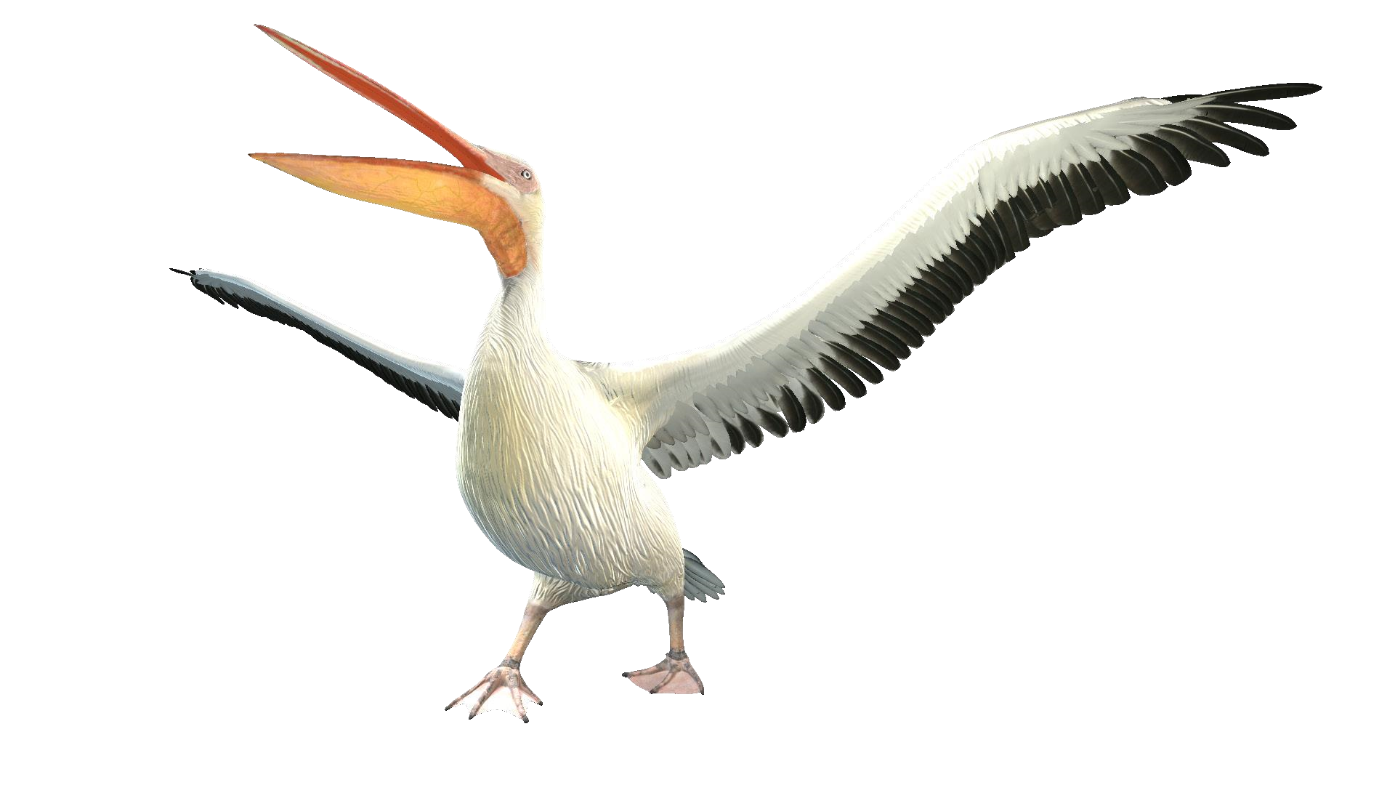

Animals and their habitat
s

Magnets
are
common items
in our
daily
lives.
Playing around
with some
magnets,
we
can
see some
basic
features:
•
Magnets exert
force
on
each
other,
as
well
as
on
certain
metals.
•
This
force
is
strongest
when they
are
touching, but also
acts
at
a
distance.
•
Magnets
can
either
attract
or
repel
each
other,
depending on how they
are
held.
•
Know how
to
determine
the
direction
of
a
permanent magnetic
field.
•
Know
that a
current
-
carrying wire
creates
a
magnetic
field.
•
Know
how
to
determine
the
direction
of
the
magnetic
field
produced
by
a
current
-
carrying wire.
Magnetic
Domains,
Magnetic Poles, Magnetism, Right
-
Hand
Rule
OBJECTIVES
VOCABULARY
LESSON OVERVIEW

Vocabulary: Animals


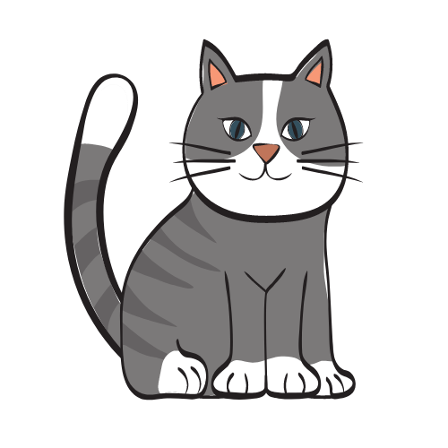

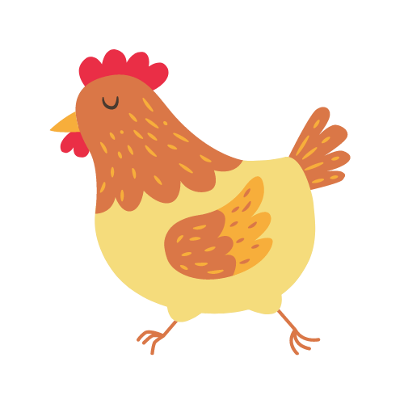

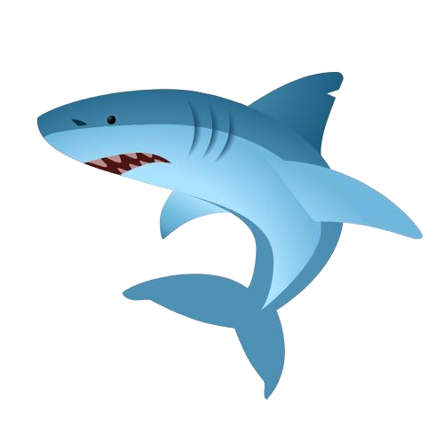

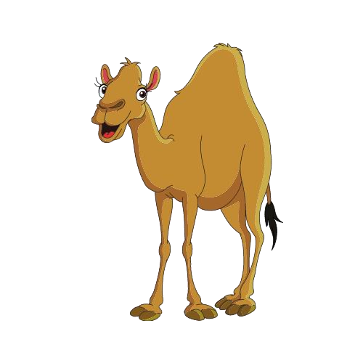

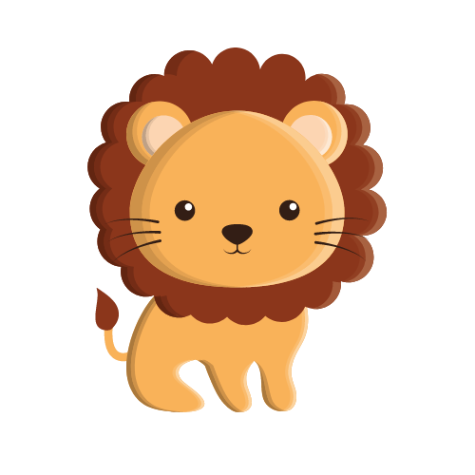



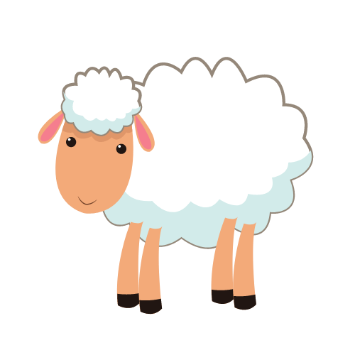



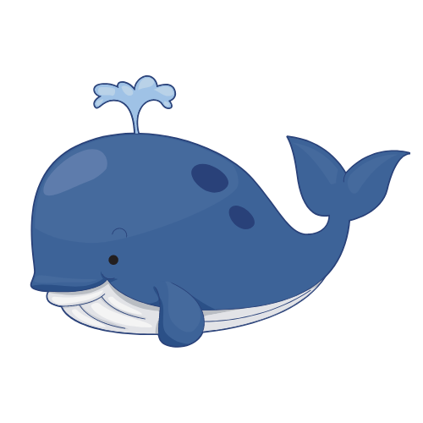


Dialogue: At the Zoo

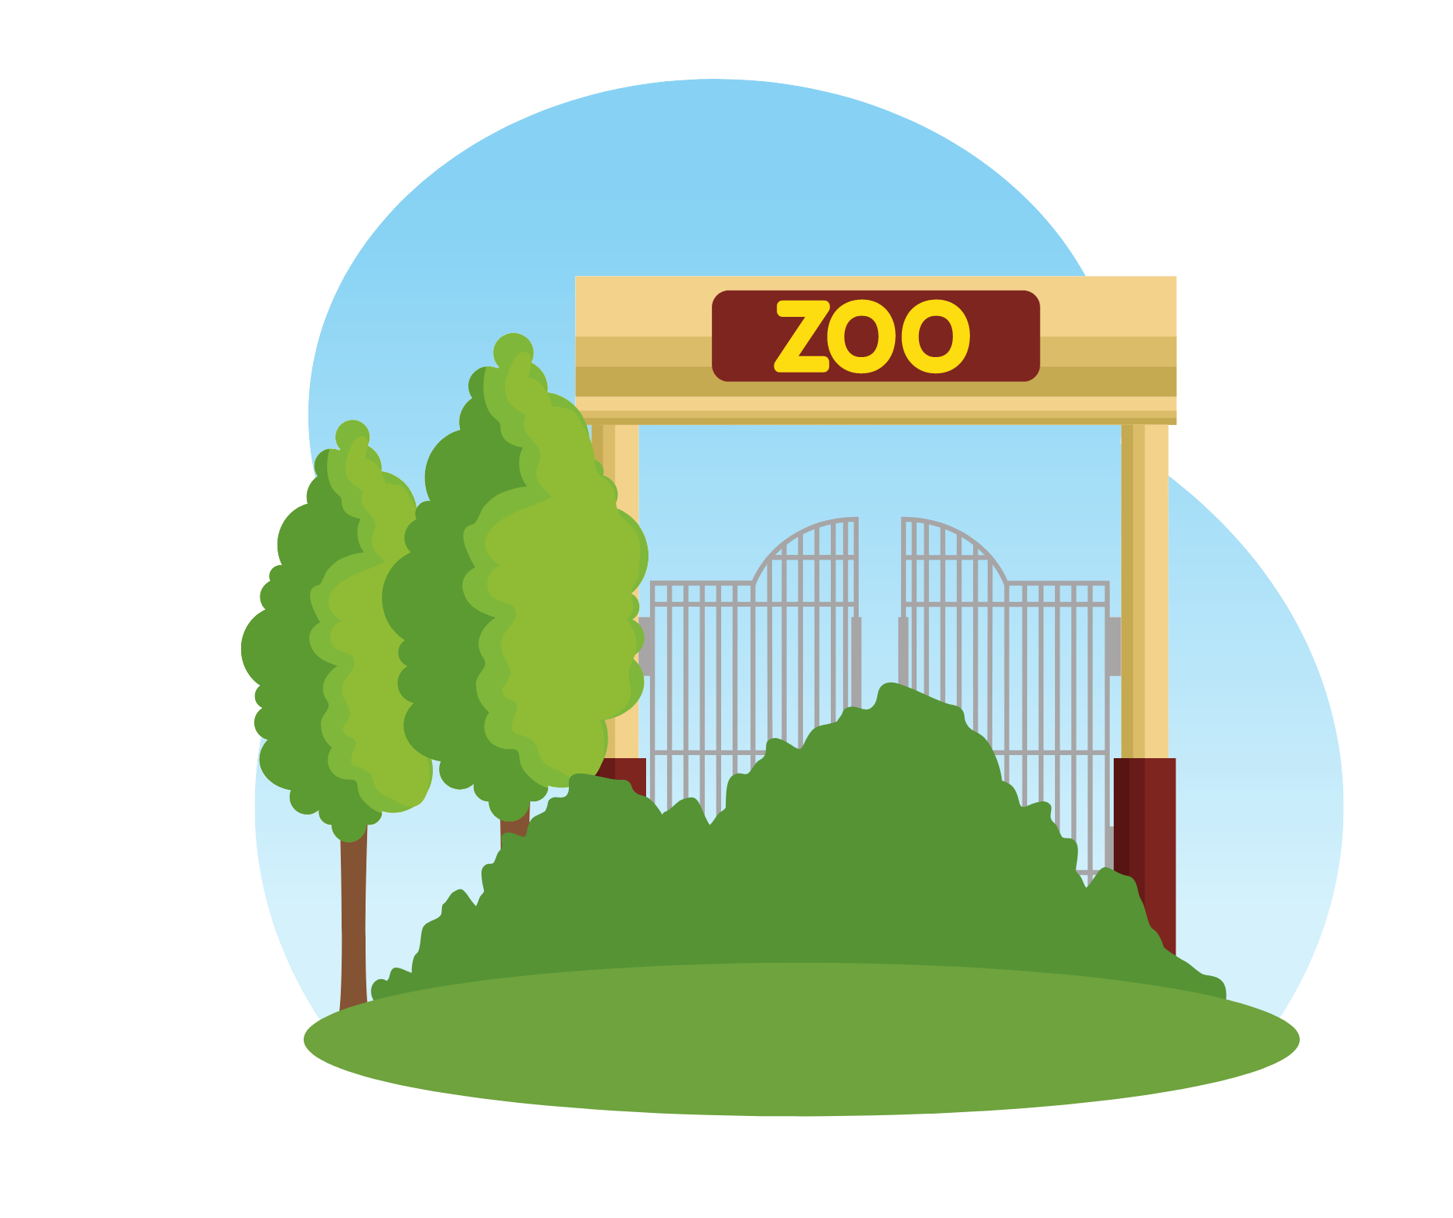

ZOO KEEPER
STUDENT
AT THE ZOO
Tip:
An = A,E,I,O,U
A =
NOT
A,E,I,O,U
A
An


Tip: An = A,E,I,O,U
What Animal is that?
STUDENT
It’s a/an ________
ZOO KEEPER
A =
NOT
A,E,I,O,U

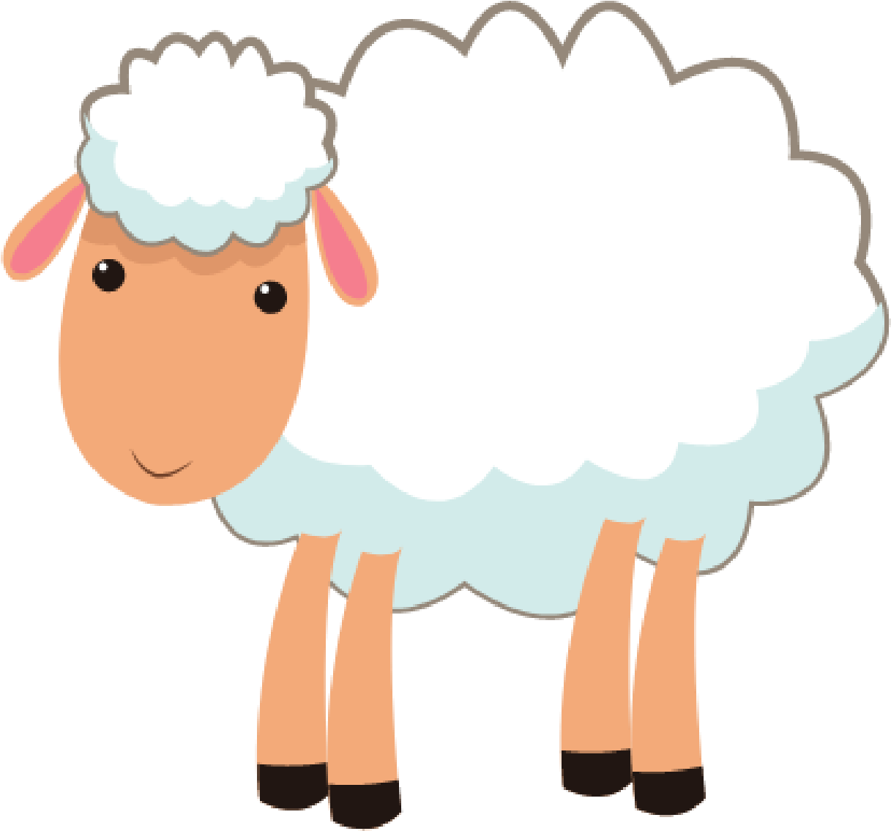
10
min
Dialogue: Practice
What Animal is that?
It’s a/an ________


10
min
Vocabulary: Animals
What Animal is this?
It is a/an ________
Tip:
An = A,E,I,O,U
A =
NOT
A,E,I,O,U
10
min
Vocabulary: Animals
What Animal is this?
It is a/an ________

