**Project-2**

**Group members:**

Amina Ghulam Mustafa (GL) (221400056)

Tooba Munir (221400097)

Zoya Khalid (221400094)

**Section:** B

**Problem Name:** Inefficient Cooking Guidance in “All Recipes App”

**Domain:** Culinary Technology

**Scope:**

Designed for everyone, from beginners to experienced cooks, the app offers easy navigation with multilingual support and video guides. The voice-enabled interface ensures inclusivity, making it accessible for all users. Enhanced search features simplify recipe exploration, creating a user-friendly experience for diverse cooking needs.

**List of potential users for the "All Recipes App":**

Cooking Enthusiasts, Beginner Cooks, Experienced Chefs, Multilingual Users, Visual Learners, Illiterate Users, Busy Professionals, Health-conscious Individuals, Parents, and Home Entertainers.

* **Functional Requirement #1:**



The system should implement a secure login mechanism for users to access personalized features.

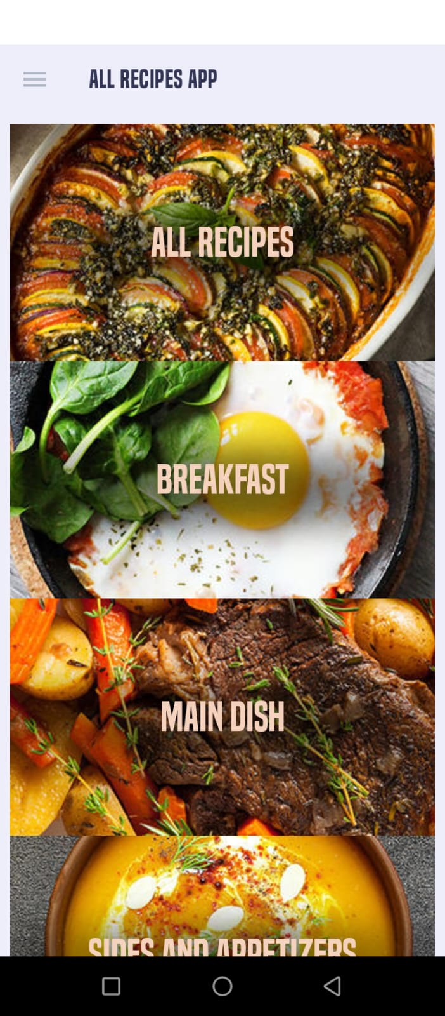

**Pain point:**

Lacking the ability to create accounts or log in, limiting personalized experiences.

**Plan to address the identified pain point:**

To address this, implement a secure and user-friendly login/signup feature to enhance user engagement.

* **Functional Requirement #2:**

The system should allow users to input multiple ingredients with auto-suggestions and provide filters for relevance, popularity in search results.

**Pain Point:**





The current search functionality does not efficiently filter recipes based on specific ingredients, leading to user frustration.

**Plan to address the identified pain point:**



Introduce a dual-search option with a prominent search bar, allowing users to search by ingredients or recipe names/categories.

* **Functional Requirement #3:**

The system shall feature an integration of video content for each recipe, enabling users to play, pause, and navigate through instructional videos.

**Pain Point:**

Users prefer visual instructions, and the absence of videos makes it harder to understand the cooking process.

**Plan to address the identified pain point:**

Integrate video support to offer step-by-step visual instructions for recipes, enhancing user understanding and learning experience.

* **Functional Requirement #4:**

The app shall allow users to dynamically select preferred languages, translating all content.

**Pain Point:**

The app is currently available only in English, limiting accessibility for users who may prefer or understand a different language.

**Plan to address the identified pain point:**

Implement multi-language support to cater to a wider audience. Users should be able to select their preferred language, making the app more user-friendly.

* **Functional Requirement #5:**

The system should allow users to categorize recipes as Beginner, Intermediate, or Expert.

**Pain Point:**

Users with varying cooking skills find it challenging to identify recipes that match their expertise level.

**Plan to address the identified pain point:**

Categorize recipes into skill levels (beginner, intermediate, expert). Users can filter recipes based on their proficiency, ensuring they choose recipes that match their cooking skills.

* **Functional Requirement #6:**

The system shall implement a voice-enabled interface, allowing illiterate users to navigate the app using voice commands for essential functionalities.

**Pain Point:**

Illiterate users face challenges navigating the app, and the absence of a voice option further hinders their interaction.

**Plan to address the identified pain point:**

Implement a voice-enabled feature to assist illiterate users, allowing them to navigate and interact with the app through voice commands for a more inclusive experience.

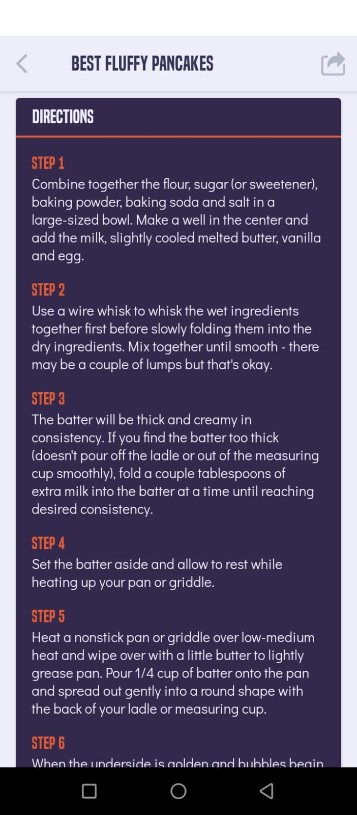

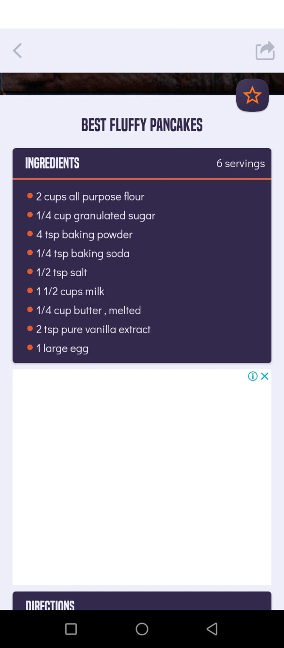

After scroll down

* **Functional Requirement #7:**

Allow users to access ingredient quantities within the recipe instructions to streamline the cooking experience.

**Pain Point:**

The current recipe app design creates inconvenience as users constantly scroll between ingredient lists and instructions, leading to difficulty in remembering quantities. This disrupts the cooking flow, causing cognitive stress and increasing the likelihood of mistakes.

**Plan to address the identified pain point:**

Integrate ingredient quantities with recipe instructions for a streamlined cooking experience, accommodating all user levels. This enhances usability by eliminating the need for constant scrolling and improves overall user engagement.