Task 1

**Islamic University of Technology**

**RDBMS**

**CSE 4508**

**Lab Report 9**

Name : Amina

Student ID : 200041155

Section : 1

Lab Group : 1B (Shifted from 1A)

Date of Performance : 15/11/23

Date of Submission : 15/11/23

Differences between a PL/SQLprocedure and a function:

A procedure or function acts like a concise program, consisting of optional declaration, execution, and exception-handling parts.

* A procedure functions as a subprogram with a specific task. It requires specifications like its name, parameters, local variables, and a BEGIN-END block enclosing its code and exception-handling.
* In comparison, a function, structured like a procedure, is designed to calculate and provide a return value. The key difference is that functions give an output.

Task 2 - A

Here, I created two sequences, one for generating primary keys for Members table another for Employees table.

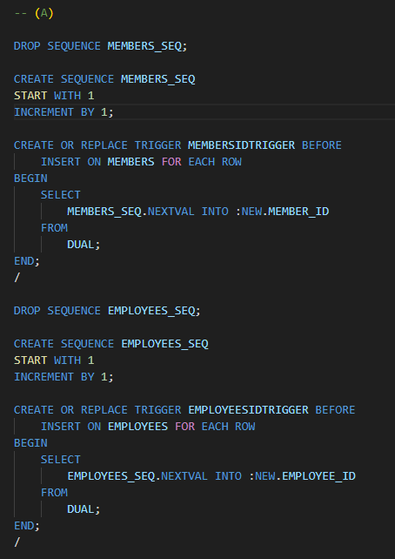

Task 2 - B

Here, I made a trigger updateDiscountTrigger which takes purchase id and member id and calls a function updateMemberDiscount. The function calculates the bill and current discount. Then I calculated new discount modify the column.

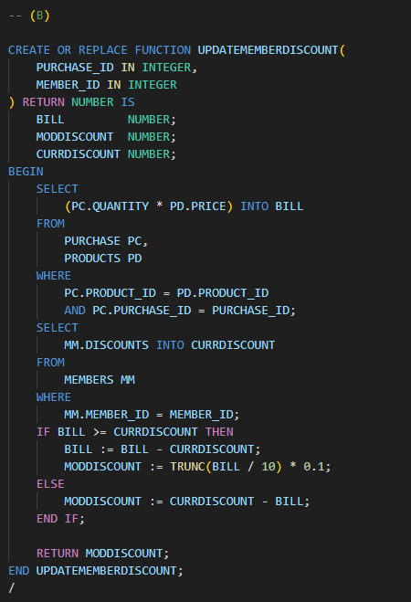

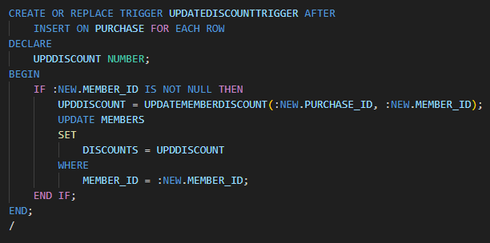

Task 2 - C

Initially, a joint table combining member, product, and purchase data was created and grouped by member ID. Each member ID had multiple rows with different products. The total cost for each member was calculated by multiplying the product price and quantity, summing them for each member.

Next, the member who spent the maximum was identified, and their ID and name were extracted. From the records of this top-spending member, the data was grouped by product ID. The total quantity of each particular product was determined. Finally, the top two products with the highest quantities were identified.

