# **Overview**

* **About our team** – A brief team information such as
  + **Members and their roles –**
  + Umbeteyeva Amina – 204109, [204109@astanait.edu.kz](mailto:204109@astanait.edu.kz), creating server using node.js (express) and creating package.json;
  + Sadykova Aiym – 204087, [204087@astanait.edu.kz](mailto:204087@astanait.edu.kz), working on html and css;
  + Biksitova Alina – 204076, [204076@astanait.edu.kz](mailto:204076@astanait.edu.kz), working on html and css;
  + Zhumakhan Saya – 204146, [204146@astanait.edu.kz](mailto:204146@astanait.edu.kz), working on script.js;
  + Sekenova Kamila – 204107, [204107@astanait.edu.kz](mailto:204107@astanait.edu.kz), working on script.js;
  + Akhmetova Aruzhan- 204122, [204122@astanait.edu.kz](mailto:204122@astanait.edu.kz), working on script.js;
  + **Communication strategy** – meeting and brainstorming every day since 14 of march;
* **Motivation** – This project summarizes our knowledge that we gained throughout this course;
* **High-level project scope** – new website, but some elements were taken from internet
* **Target audience/market** – This website is targeted at our WEB technologies course instructor aka best teacher Aldiyar Salkenov;

# **Project goals and team interests**

**Project goals**

* Developing our coding skills
* Building website for people who are interested in football

**Team interests**

* Understand HTML tags and CSS by building a football-related website
* Understand JavaScript and node.js by building a football-related website
* Establish a solid understanding of website design principles
* Improve team working skills by collaborating with different members of the group

# **Phases**

* Phase 1 – Basic football-related website (that gets inputs: team members and scores) with HTML
* Phase 2 – Add styles to improve the appearance and thus draw wider audience
* Phase 3 – Writing JavaScript code that calculates the score of match and displays team members in console
* Phase 4 – Building server on node js using express
* Phase 5 – Creating documentation for our website by using “npm init” (package.json)

# **Content structure**

**Site map**

Diagram that shows hierarchical structure of the website pages:

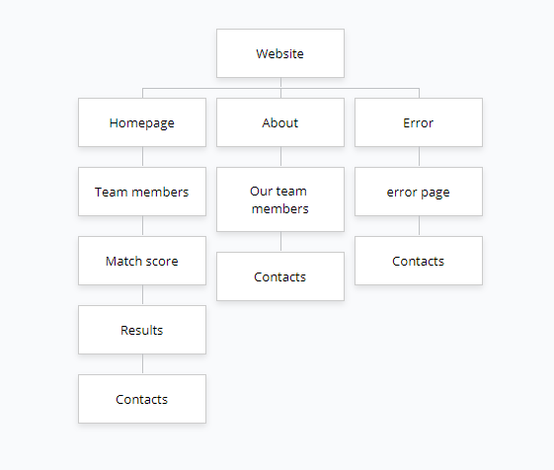

**Content types**

Website is for people, who enjoy watching and playing football. Site can be helpful during football game between friends or colleagues. For example, before starting a game they can write players names in Team boxes and write scores of each team.

**Design**

For our about page we used each members photo.

We created an information and office part, where person who visited site can find additional information, a phone number that he can immediately call by pressing and email address that he can write by pressing on it.

**Functionality**

On our site person should enter 11 football players name for each team and write their scores, site will randomly show possible score list, also displays the players in the console.

**Hosting**

We used Github pages to host our website. First, we created new repository, called Final-exam and added ReadMe file. After that, we uploaded files, including index.html, about.html, error.html, public folder that includes static files such as style.css, app.js, script.js and all images that we used, and package.json.

**Accessibility**

Accessible only on local device, due to reason that we used localhost:3000.

Our website benefit everyone, not just those with disabilities. On an accessible website, the user is put at the center of the experience. Text is more readable. Content is better organized. The design is clean and simple. This website will show you how to make your site accessible, and make it better for all, by using the latest web technology.

**Deadlines**

In order to be more organized and finish the project on time, we decided to make deadlines for our phases:

* Phase 1 – March 15 19:00
* Phase 2 – March 17, 21:00
* Phase 3 – March 18, 17:00
* Phase 4 – March 18, 23:00
* Phase 5 – March 19, 02:00

# **Summary**

This project involves building a website that calculates scores of two teams, with requirements, such as not more than 11 players in each team and 7 is a maximum score that one team can get.

Obviously, the most difficult part was combining work on a project and preparation for other exams in such a short time. Every day after our exams we gathered to do our project. Thanks to our unity and to each other, we were able to get together and finish our work on time.

In total, we did the project in 4 days, and during that time we learned to understand and listen to each other.

Of course, each and one of us improved our coding skills, received valuable knowledge on this course.