University of Chenab, Gujrat
Department of Computer Science
Master of Software Engineering (MSSE)
Assignment 03
Security Vulnerability Analysis Using OWASP ZAP
Course: Software Testing and Quality Assurance (Spring 2026)
Submitted to: Dr. Nadeem Q. Mehmood
Submitted by: Amina Shahbaz
Roll No: MSSE012515005
Date: June 14, 2026

1. Introduction
Web application security testing is a critical component of modern software quality assurance practices. Identifying and mitigating security vulnerabilities before deployment protects users, data integrity, and organizational reputation. OWASP ZAP (Zed Attack Proxy) is an open-source, industry-standard security testing tool developed and maintained by the Open Web Application Security Project (OWASP). It is widely used by security professionals and developers to perform automated and manual security assessments on web applications.

This report documents the security testing performed on a static web application titled the Chenab Reading Room – Library Management System. The website was built as part of the assignment and consists of four interconnected pages: Home, Catalogue, My Account (Login), and Contact Us. OWASP ZAP version 2.17.0 was used to scan the locally hosted website running on http://localhost:8000. The scan identified seven distinct alerts across multiple risk categories. This report analyzes each vulnerability in terms of its origin, risk classification, and recommended mitigation strategy.

2. Website Overview
The Chenab Reading Room is a Library Management System website developed using HTML, CSS, and JavaScript. The application contains four pages, each serving a distinct purpose:
- Home Page (index.html): Displays the library welcome screen, navigation links, a notice board, and quick-access cards to major features.
- Catalogue Page (catalogue.html): Provides a book search form (title/category), a featured titles table, and a reader review/comment section.
- My Account / Login Page (profile.html): Contains a member login form with username and password fields, a borrowed books table, and a profile update form.
- Contact Us Page (contact.html): A contact form allowing visitors to send messages to library staff, along with location and contact details.

The site was served locally using Python's built-in HTTP server (python -m http.server 8000) and scanned via OWASP ZAP's Automated Scan feature with both Traditional Spider and AJAX Spider enabled using Firefox.

2.1 Website Screenshots
The following figures illustrate the four pages of the web application as they appeared during testing.

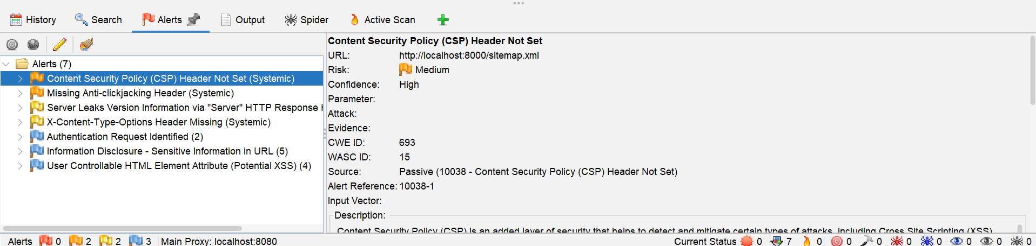
Figure 1: ZAP Alerts Overview – 7 Vulnerabilities Identified After Automated Scan
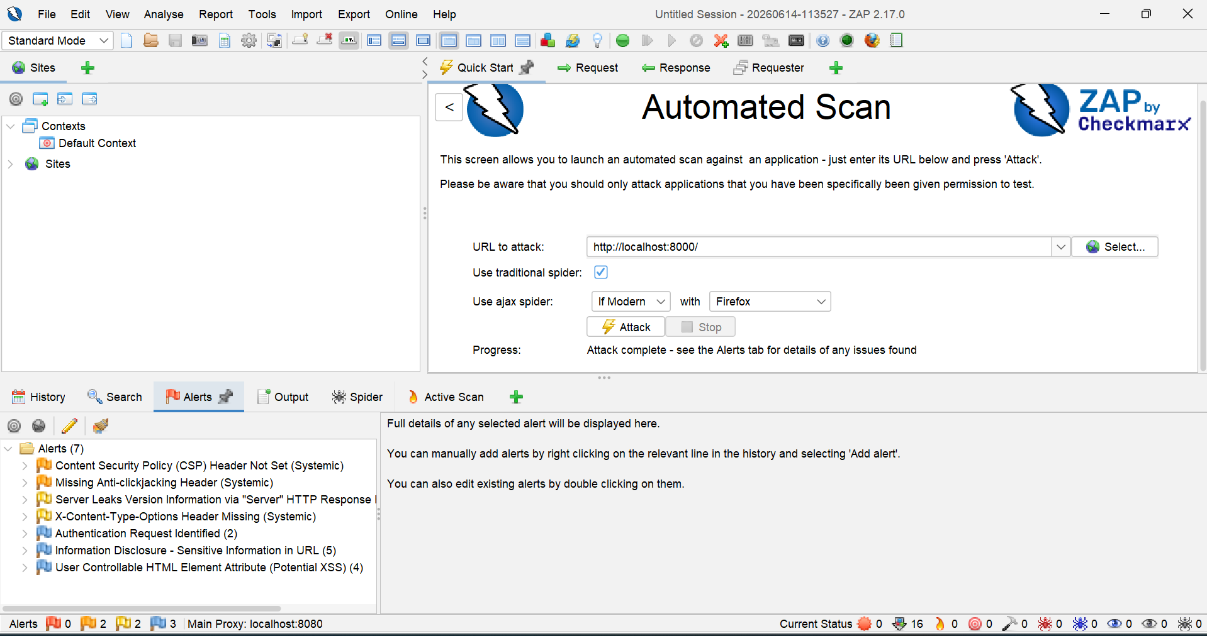
Figure 2: ZAP Automated Scan Panel Showing Scan Completion and Alert Categories

3. Testing Methodology
The following steps were followed to perform security testing on the web application:
- Step 1 – Environment Setup: The website files were placed in a local directory and served using the command python -m http.server 8000. This made the application accessible at http://localhost:8000.
- Step 2 – OWASP ZAP Launch: OWASP ZAP version 2.17.0 was launched in Standard Mode. The tool was configured to use the local proxy at localhost:8080.
- Step 3 – Automated Scan Configuration: The Automated Scan dialog was opened by clicking the Quick Start option. The target URL http://localhost:8000 was entered. Both Traditional Spider (for static link discovery) and AJAX Spider with Firefox (for dynamic JavaScript-rendered content) were enabled.
- Step 4 – Scan Execution: The Attack button was clicked to initiate the scan. ZAP crawled all pages and performed passive and active checks. The scan completed successfully with the progress status reading "Attack complete – see the Alerts tab for details."
- Step 5 – Alert Analysis: The Alerts tab was examined. Seven alerts were identified across four risk categories: Medium (2), Low (2), and Informational (3). Each alert was selected individually to view full details including URL, CWE ID, WASC ID, description, and recommended solution.

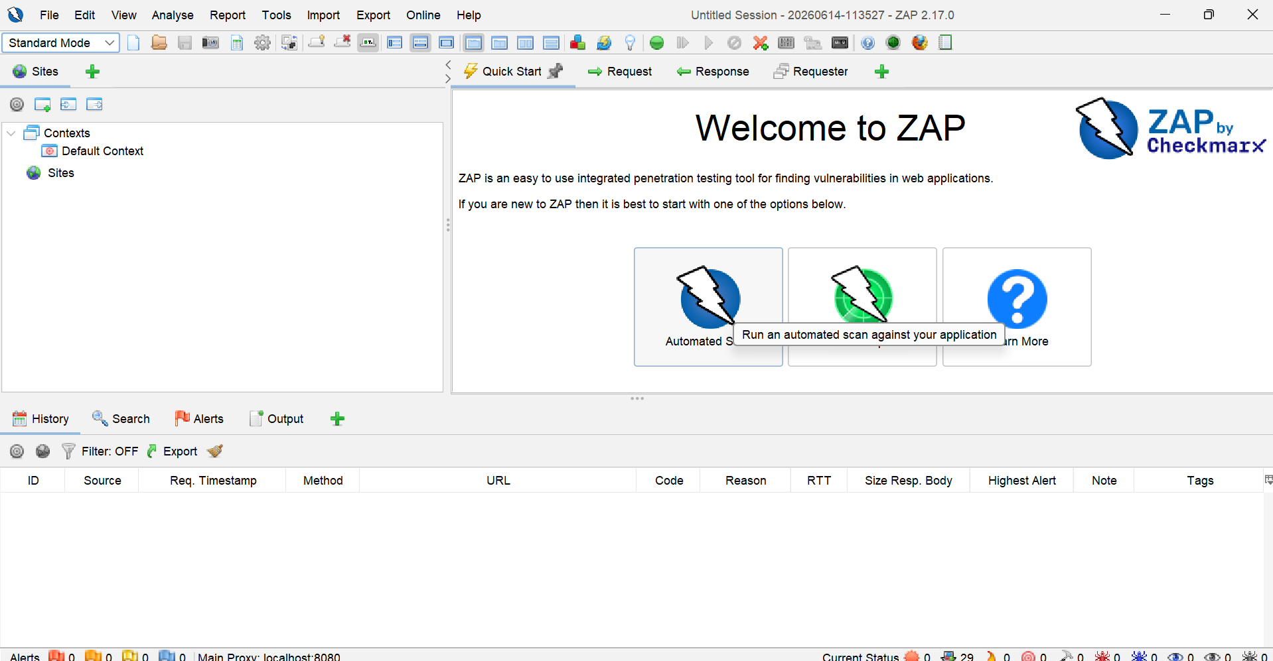
Figure 3: OWASP ZAP 2.17.0 – Welcome Screen and Tool Interface
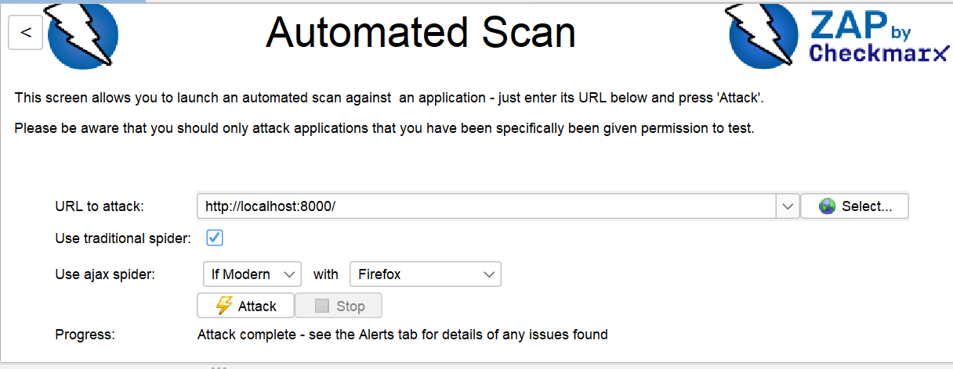
Figure 4: Automated Scan Configuration – Target URL Set to http://localhost:8000
4. Vulnerability Analysis
OWASP ZAP identified a total of seven alerts during the automated security scan. The following table provides a summary of all identified vulnerabilities along with their risk classifications and CWE/WASC identifiers.

# | Vulnerability | Risk Level | CWE ID | WASC ID | Detection Source
1 | Content Security Policy (CSP) Header Not Set | Medium | 693 | 15 | Passive (10038)
2 | Missing Anti-clickjacking Header | Medium | 693 | 15 | Passive (10020)
3 | Server Leaks Version Information via HTTP Response Header | Low | 497 | 13 | Passive (10036)
4 | X-Content-Type-Options Header Missing | Low | 693 | 15 | Passive (10021)
5 | Authentication Request Identified | Informational | — | — | Passive (10111)
6 | Information Disclosure – Sensitive Information in URL | Informational | 598 | 13 | Passive (10024)
7 | User Controllable HTML Element Attribute (Potential XSS) | Informational | 20 | 20 | Passive (10031)
Table 1: Summary of Vulnerabilities Identified by OWASP ZAP

4.1 Content Security Policy (CSP) Header Not Set
Origin of the Security Issue:
The web server response did not include a Content-Security-Policy (CSP) HTTP header. CSP is a browser-side security mechanism that instructs the browser about which sources of content (scripts, styles, images, etc.) are considered trustworthy. When CSP is absent, the browser applies no restrictions, making the application vulnerable to Cross-Site Scripting (XSS) and data injection attacks. The issue was detected on the URL http://localhost:8000/sitemap.xml with CWE ID 693 and WASC ID 15. ZAP detected this via Passive Scan rule 10038.
Security Level: Medium
Proposed Fix:
Add a Content-Security-Policy header to all HTTP responses. For example, the server should include a header such as: Content-Security-Policy: default-src 'self'. This restricts all content to be loaded only from the same origin. For production environments, the policy should be carefully crafted to allow only trusted external CDN sources.


Figure 5: ZAP Alert Detail – Content Security Policy (CSP) Header Not Set (Risk: Medium)

4.2 Missing Anti-clickjacking Header
Origin of the Security Issue:
The application did not include either the X-Frame-Options HTTP response header or a Content-Security-Policy frame-ancestors directive. Without this protection, an attacker can embed the web application in an invisible iframe on a malicious website and trick users into clicking on hidden interface elements – an attack known as clickjacking. ZAP flagged this issue at http://localhost:8000/ with CWE ID 693, WASC ID 15, and Parameter x-frame-options.
Security Level: Medium
Proposed Fix:
Add the X-Frame-Options: DENY header to all HTTP responses to prevent the site from being rendered inside an iframe. Alternatively, include frame-ancestors 'none' in the Content-Security-Policy header, which achieves the same result in modern browsers.

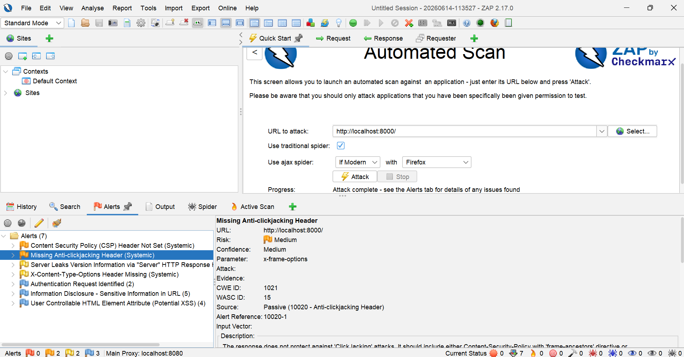
Figure 6: ZAP Alert Detail – Missing Anti-clickjacking Header (Risk: Medium, CWE: 693)

4.3 Server Leaks Version Information via HTTP Response Header
Origin of the Security Issue:
The HTTP response headers included a Server field that disclosed the exact version of the web server being used. ZAP captured the evidence: Server: SimpleHTTP/0.6 Python/3.11.1. This information allows an attacker to identify the specific server software and version, and then look up known exploits or vulnerabilities targeting that version (CWE ID 497, WASC ID 13). The vulnerability was flagged with High confidence via Passive Scan rule 10036.
Security Level: Low
Proposed Fix:
Configure the web server to suppress or genericize the Server response header. In production environments using frameworks such as Nginx or Apache, the server_tokens directive (Nginx) or ServerTokens directive (Apache) can be set to suppress version disclosure. For development servers, switching from Python's SimpleHTTP to a production-grade server eliminates this issue.

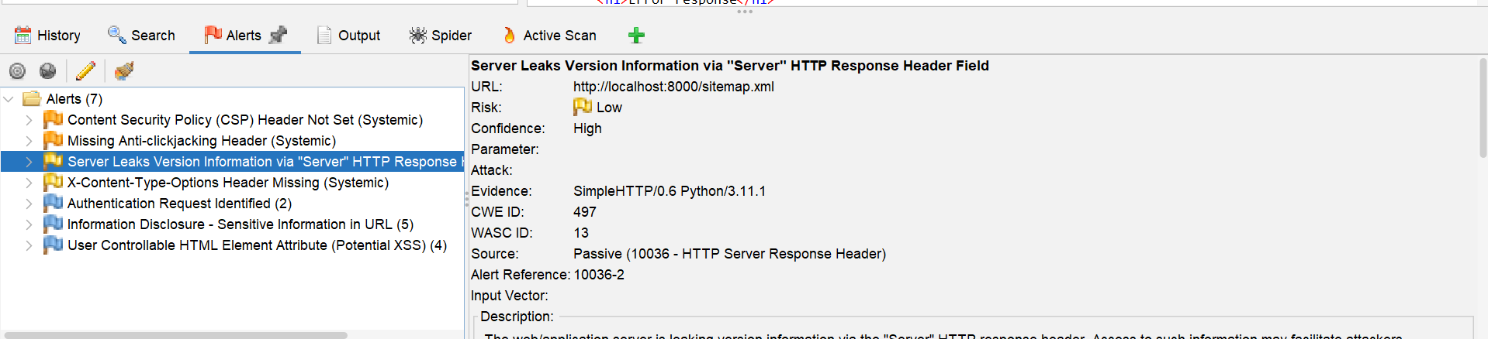
Figure 7: ZAP Alert Detail – Server Version Leakage (Evidence: SimpleHTTP/0.6 Python/3.11.1)

4.4 X-Content-Type-Options Header Missing
Origin of the Security Issue:
The application did not include the X-Content-Type-Options: nosniff HTTP header in its responses. Without this header, older browsers (notably Internet Explorer and certain versions of Chrome) may attempt to "MIME sniff" the content type of a response, potentially interpreting a malicious file as executable content. The issue was detected on the URL http://localhost:8000/style.css with CWE ID 693 and WASC ID 15 via Passive Scan rule 10021.
Security Level: Low
Proposed Fix:
Add the response header X-Content-Type-Options: nosniff to all HTTP responses. This instructs the browser to strictly follow the declared Content-Type and not perform MIME type sniffing. This is a simple one-line server configuration change.

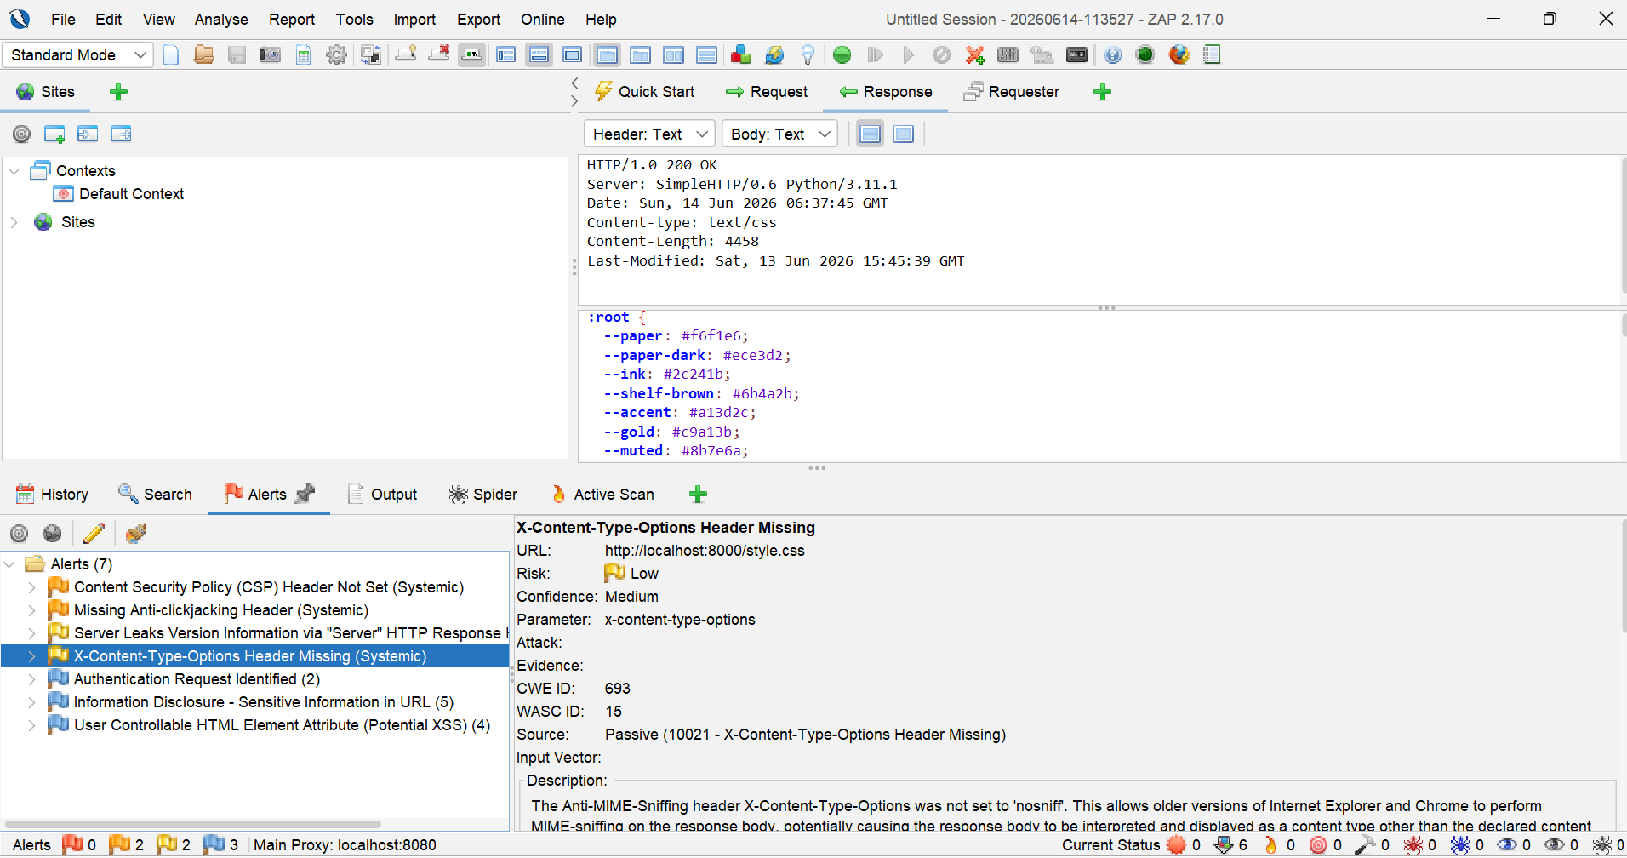
Figure 8: ZAP Alert Detail – X-Content-Type-Options Header Missing (CWE: 693)

4.5 Authentication Request Identified
Origin of the Security Issue:
OWASP ZAP identified the login form on the My Account page (profile.html) as an authentication endpoint. ZAP detected the presence of a username and password parameter in the URL http://localhost:8000/profile.html?password=ZAP&username=ZAP during its scan. Although classified as Informational (not an active exploit), this finding indicates that the application uses client-side authentication without server-side verification or secure token management. ZAP's evidence field captured the keyword "password" (Passive Scan 10111).
Security Level: Informational
Proposed Fix:
In production, authentication should be implemented server-side using a secure framework. Credentials must never be passed in URL query strings. POST requests with HTTPS should be used for all login forms. Additionally, implementing session tokens, CSRF protection, and account lockout mechanisms are recommended best practices.

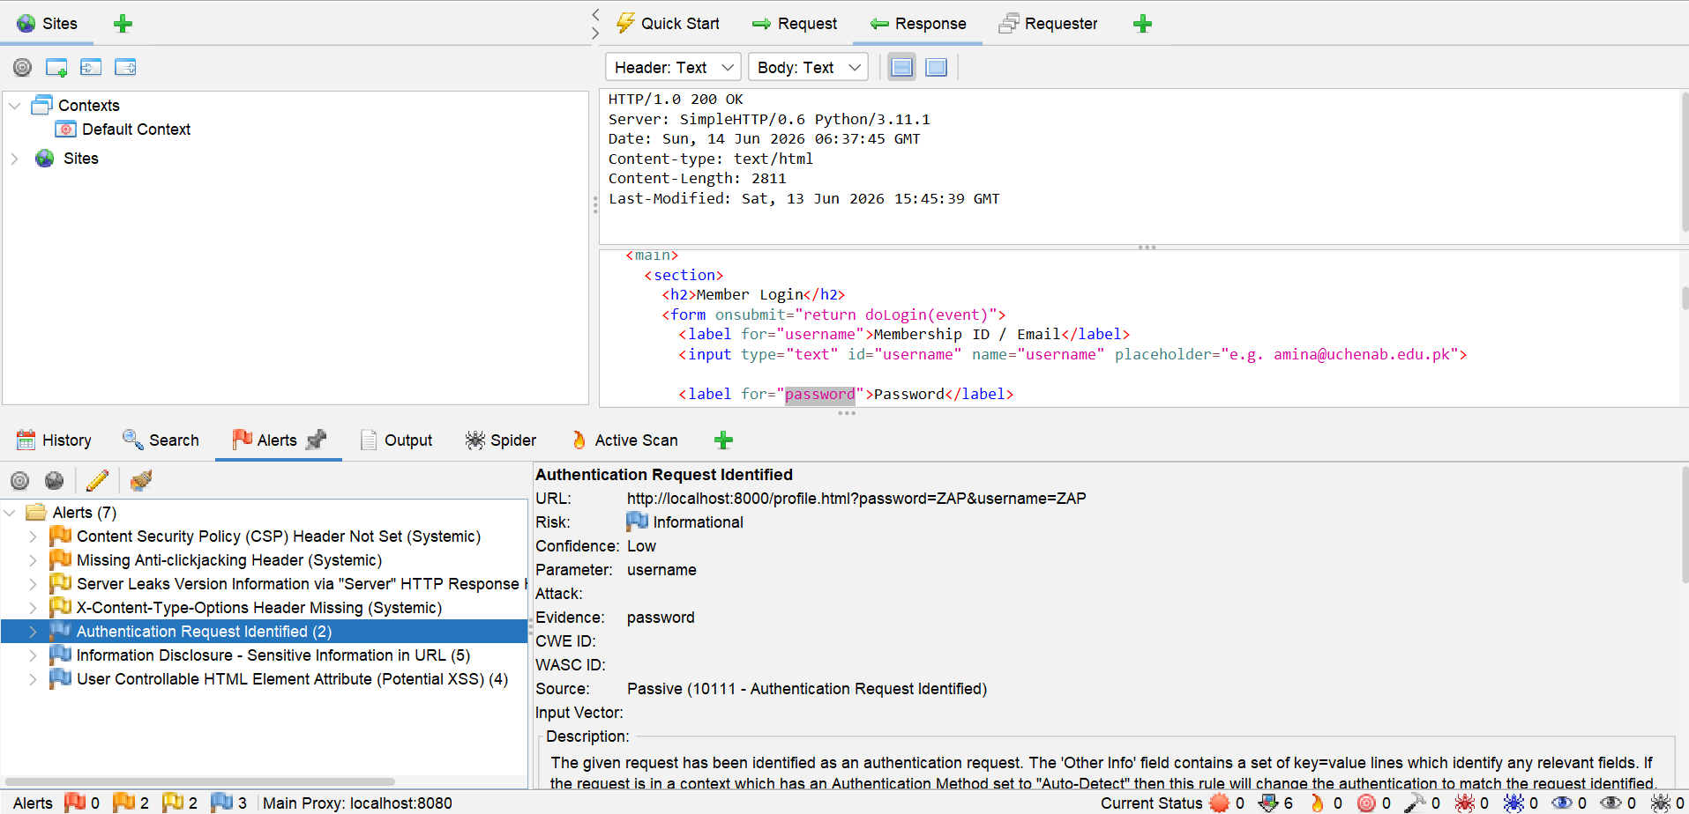
Figure 9: ZAP Alert – Authentication Request Identified on Login Form (Informational)

4.6 Information Disclosure – Sensitive Information in URL
Origin of the Security Issue:
ZAP detected that sensitive parameter values, specifically the word "password", appeared in the URL during the scan: http://localhost:8000/profile.html?password=ZAP&username=ZAP. Passing sensitive credentials in URLs is dangerous because URLs are commonly stored in browser history, server access logs, proxy logs, and referrer headers, all of which may be accessible to unauthorized parties. CWE ID 598 and WASC ID 13 apply. Confidence was Medium.
Security Level: Informational
Proposed Fix:
All sensitive data including usernames, passwords, tokens, and session identifiers must be transmitted in the HTTP request body (via POST) rather than in the URL query string. HTTPS must be enforced to encrypt the transmission. Server-side logging should be configured to redact sensitive parameter values.

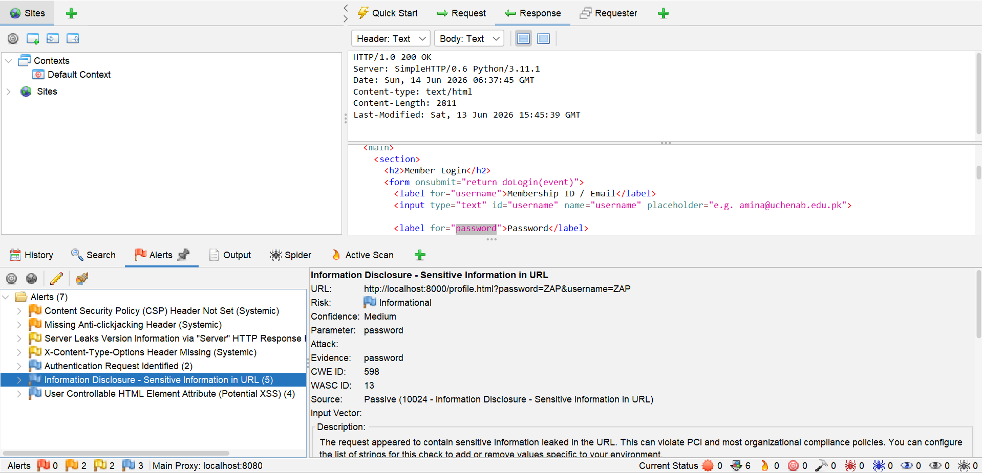
Figure 10: ZAP Alert – Sensitive Information Disclosure in URL (CWE: 598)

4.7 User Controllable HTML Element Attribute (Potential XSS)
Origin of the Security Issue:
ZAP flagged a potential Cross-Site Scripting (XSS) risk on the Catalogue page. The URL http://localhost:8000/catalogue.html?category=cs&q=ZAP shows that the query parameters q (search term) and category are reflected back into the HTML page without server-side sanitization. In the existing JavaScript implementation, these values are inserted directly into the DOM via innerHTML, which could allow a malicious user to inject arbitrary HTML or JavaScript code. CWE ID 20 (Improper Input Validation) and WASC ID 20 apply. ZAP detected this via Passive Scan rule 10031.
Security Level: Informational (with potential for Medium/High if exploited)
Proposed Fix:
All user-supplied input must be sanitized and encoded before being inserted into the DOM. The use of innerHTML should be replaced with safer DOM manipulation methods such as textContent or innerText. On the server side, output encoding libraries should be used to escape HTML special characters. A strong Content Security Policy header would also limit the damage of any successful XSS attack.

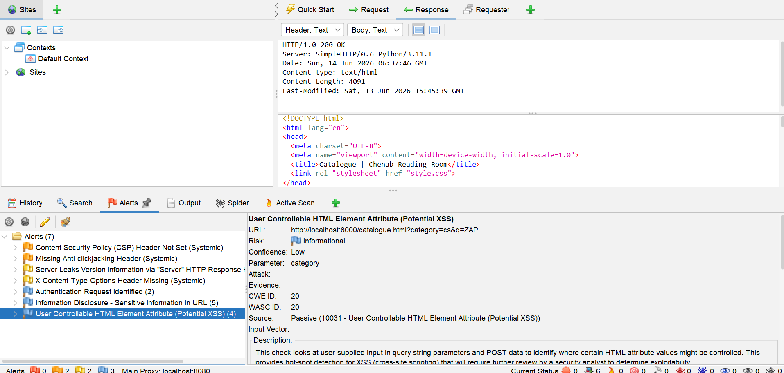
Figure 11: ZAP Alert – User Controllable HTML Attribute / Potential XSS (CWE: 20)

5. OWASP ZAP Generated Report
In addition to the manual analysis above, OWASP ZAP was used to automatically generate a comprehensive HTML-based scan report. This report, generated by ZAP's reporting engine (Checkmarx Scanning Report), provides a complete listing of all alerts including full descriptions, evidence, solutions, and affected URLs. The figure below shows a preview of the ZAP-generated report.
Figure 12: OWASP ZAP Auto-Generated Scan Report (HTML Format) – Full Alert Listing

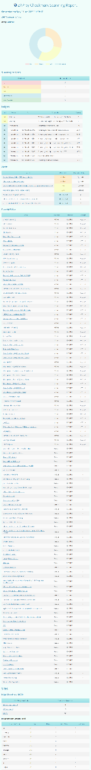
6. Report Summary
The security assessment of the Chenab Reading Room Library Management System website using OWASP ZAP version 2.17.0 revealed a total of seven security alerts. The application did not exhibit any High-risk vulnerabilities, which indicates a reasonable baseline security posture for a development/testing environment. However, several configuration-level issues were identified that would require remediation before the application could be considered ready for production deployment.

Risk Level | Number of Issues | Overall Assessment
High | 0 | No high-risk issues found
Medium | 2 | Header misconfigurations present
Low | 2 | Version/MIME leakage detected
Informational | 3 | Auth exposure, URL info, XSS risk flagged
Table 2: Risk-Level Summary of All Identified Vulnerabilities

Key Findings:
- The two Medium-risk issues (CSP header not set and missing anti-clickjacking header) are the most critical findings and should be addressed immediately in any production deployment by configuring appropriate HTTP response headers.
- The two Low-risk issues (server version disclosure and missing X-Content-Type-Options) represent information leakage and MIME-sniffing risks that are easily resolved through server configuration changes.
- The three Informational alerts highlight design-level concerns: the presence of a login form without secure server-side authentication, sensitive parameters in URL query strings, and user-controlled input being reflected in the DOM without sanitization (potential XSS).
- None of the vulnerabilities identified were of High or Critical severity, suggesting that the basic architecture of the website is sound. The issues found are primarily related to missing security headers and unsafe input handling patterns that are common in development environments.

Overall Security Status: Moderate – Remediation Required Before Production Deployment.
It is recommended that all identified issues be resolved before the application is deployed on a public server. The most impactful and straightforward remediations are the addition of security headers (CSP, X-Frame-Options, X-Content-Type-Options) and the migration of authentication to a server-side framework with HTTPS enforcement.

7. Conclusion
This assignment provided hands-on experience with OWASP ZAP, one of the most widely used open-source tools for web application security testing. By creating a multi-page Library Management System website and scanning it with ZAP's automated scan feature, seven security alerts were discovered and analyzed. The exercise demonstrated how even a simple, static web application can expose security misconfigurations and information disclosure risks when deployed without proper server-side hardening.
The findings reinforce the importance of integrating security testing into the software development lifecycle (SDLC) at an early stage, rather than treating it as an afterthought. Tools such as OWASP ZAP enable developers to proactively identify and fix vulnerabilities before they can be exploited in production environments.

References
[1] OWASP Foundation. (2024). OWASP ZAP – Zed Attack Proxy. https://www.zaproxy.org
[2] OWASP Foundation. (2023). Content Security Policy Cheat Sheet. https://cheatsheetseries.owasp.org/cheatsheets/Content_Security_Policy_Cheat_Sheet.html
[3] MITRE Corporation. (2024). CWE-693: Protection Mechanism Failure. https://cwe.mitre.org/data/definitions/693.html
[4] MITRE Corporation. (2024). CWE-598: Information Exposure Through Query Strings in GET Request. https://cwe.mitre.org/data/definitions/598.html
[5] Mozilla Developer Network. (2024). HTTP Headers – Security Reference. https://developer.mozilla.org/en-US/docs/Web/HTTP/Headers

