Name : Amina Ahmed Mahmoud

B.N: 222

Topic: Database

Date: 26/5/2020

Github pages publish website:

Application Brief:-

Database, also called electronic database, any collection of data, or information, that is specially organized for rapid search and retrieval by a computer. Databases are structured to facilitate the storage, retrieval, modification, and deletion of data in conjunction with various data-processing operations. A database management system (DBMS) extracts information from the database in response to queries.

A brief treatment of databases follows. For full treatment, see computer science: Information systems and databases; information processing.

A database is stored as a file or a set of files. The information in these files may be broken down into records, each of which consists of one or more fields. Fields are the basic units of data storage, and each field typically contains information pertaining to one aspect or attribute of the entity described by the database. Records are also organized into tables that include information about relationships between its various fields. Although database is applied loosely to any collection of information in computer files, a database in the strict sense provides cross-referencing capabilities.

Applications of database:-

Database applications are software programs designed to collect, manage and disseminate information efficiently. Many home and small business owners create simple databases such as customer contact and mailing lists with easy to use software such as Microsoft "Access" and "FileMaker Pro." "Oracle," "SQL Server," and "FoxPro" are examples of advanced database applications with programming languages that can be used to build custom business solutions in networked environments.

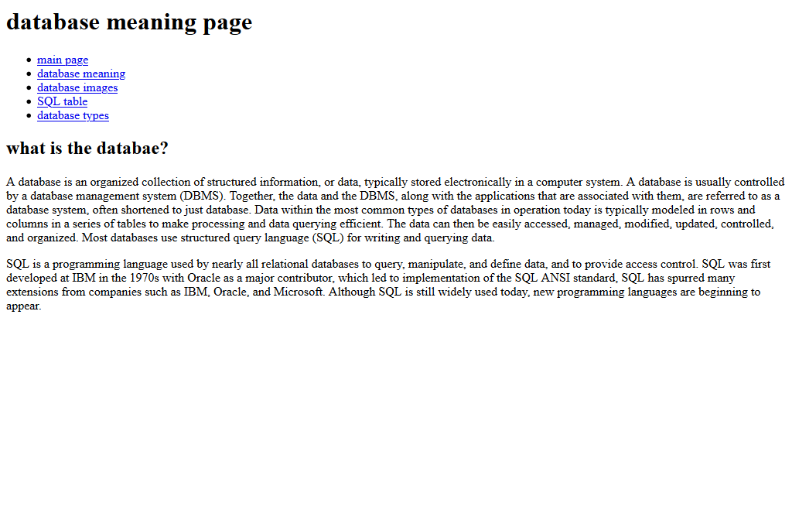Section of screenshots:-

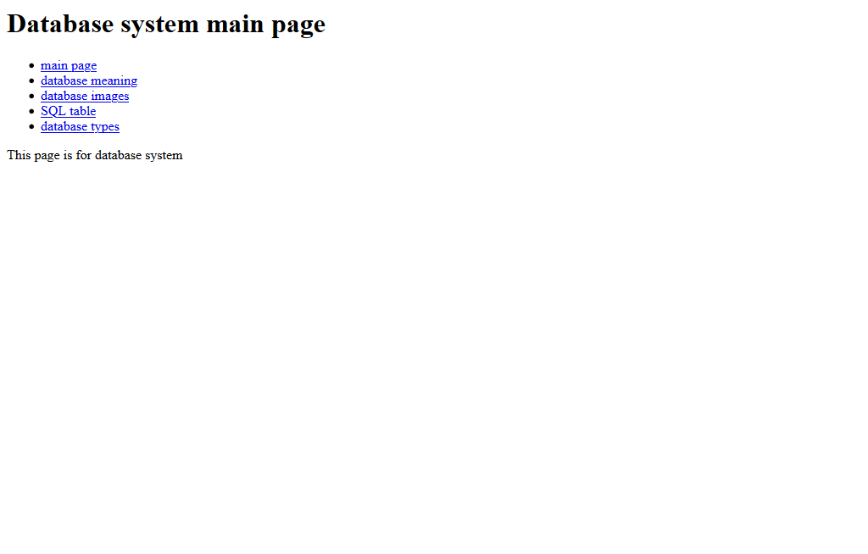

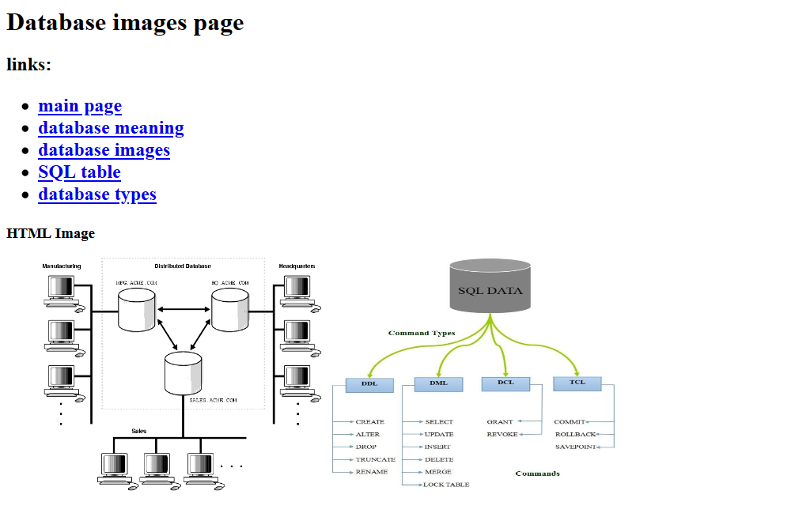

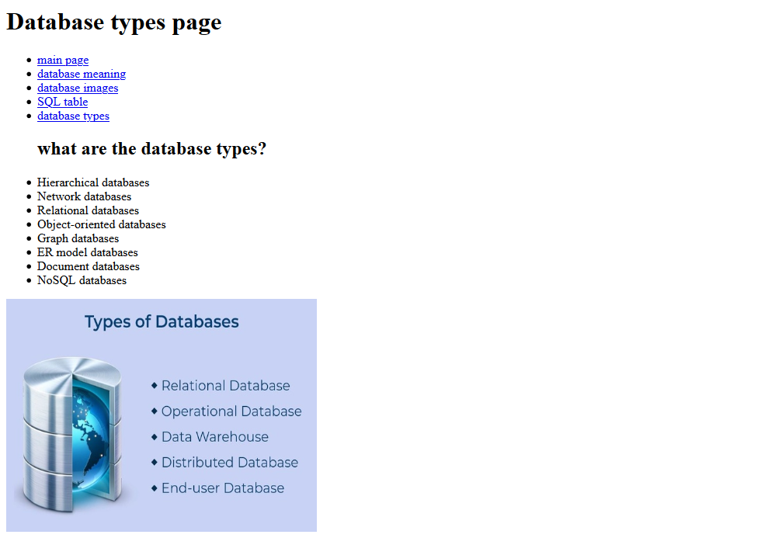 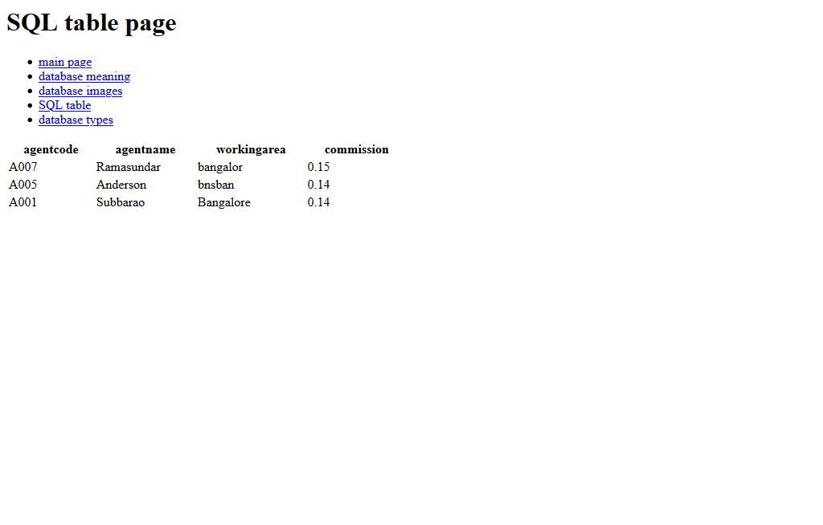

Section of code:-

