

National Textile University
Department of Computer Science
Subject: Mobile Application Development

Submitted to: Sir Rehan

Submitted by: Amina

Reg. number: 23-NTU-CS-1136

Lab no.: Lab3

Semester: 6 th

Task 1: Custom Cards and Icon Layouts
Objective: Master the Card widget's visual properties and child arrangement.
• Activity: Create three Card widgets with varying color properties and
elevation values.
• Requirement: Each card must contain a Row or Column of multiple Icon
widgets with different sizes and colors.
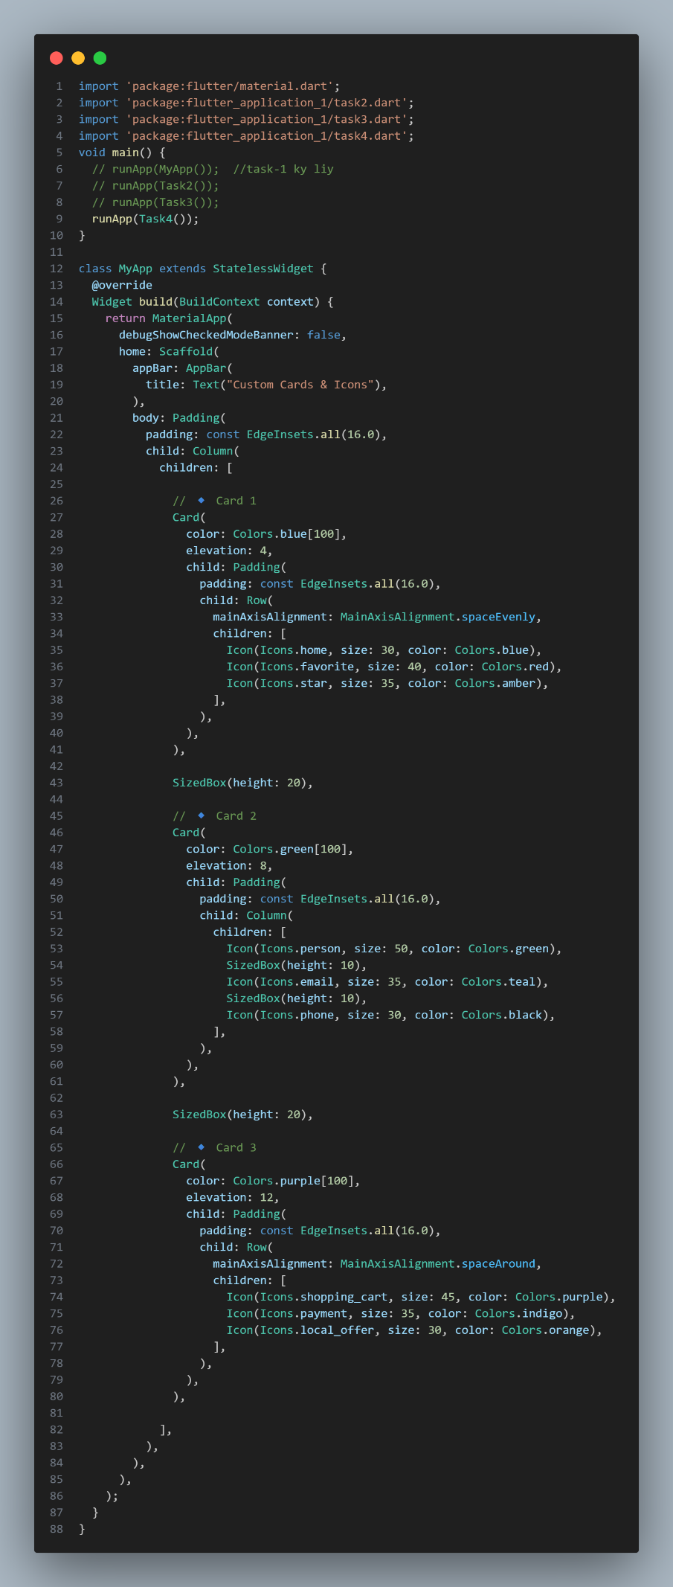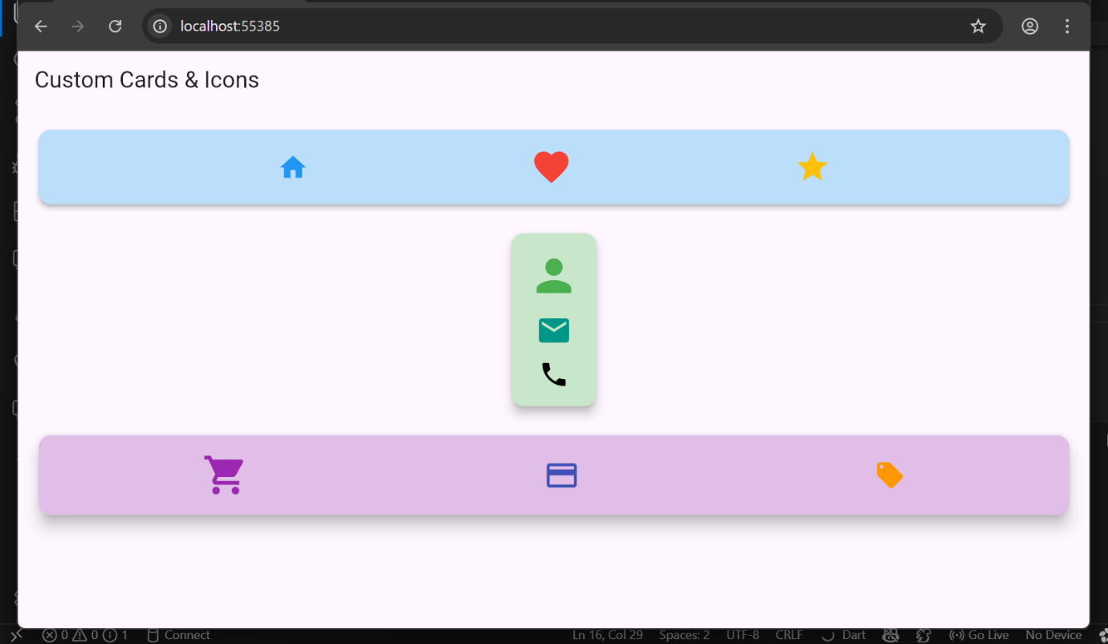

Task 2: Margin and Padding Implementation
Objective: Differentiate between internal (Padding) and external (Margin)
spacing.
• Activity: Create a Container with a background color and implement the
following:
o All sides: Use padding: EdgeInsets.all(20.0).
o Symmetric: Use margin: EdgeInsets.symmetric(vertical: 50.0,
horizontal: 10.0).
o Specific sides: Use EdgeInsets.only(left: 10) to add space only to the
left.

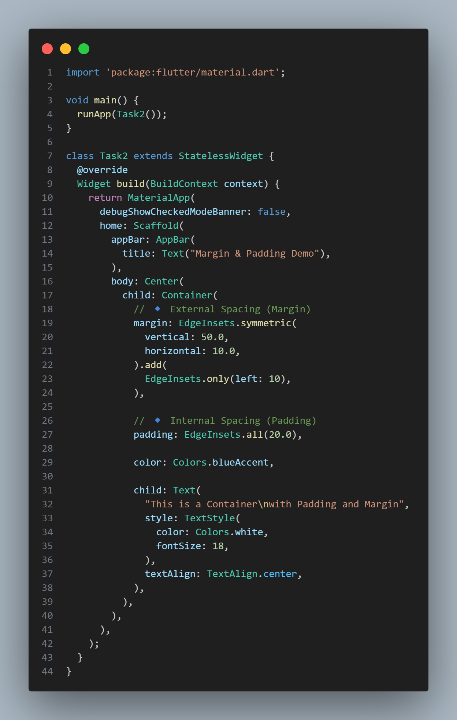
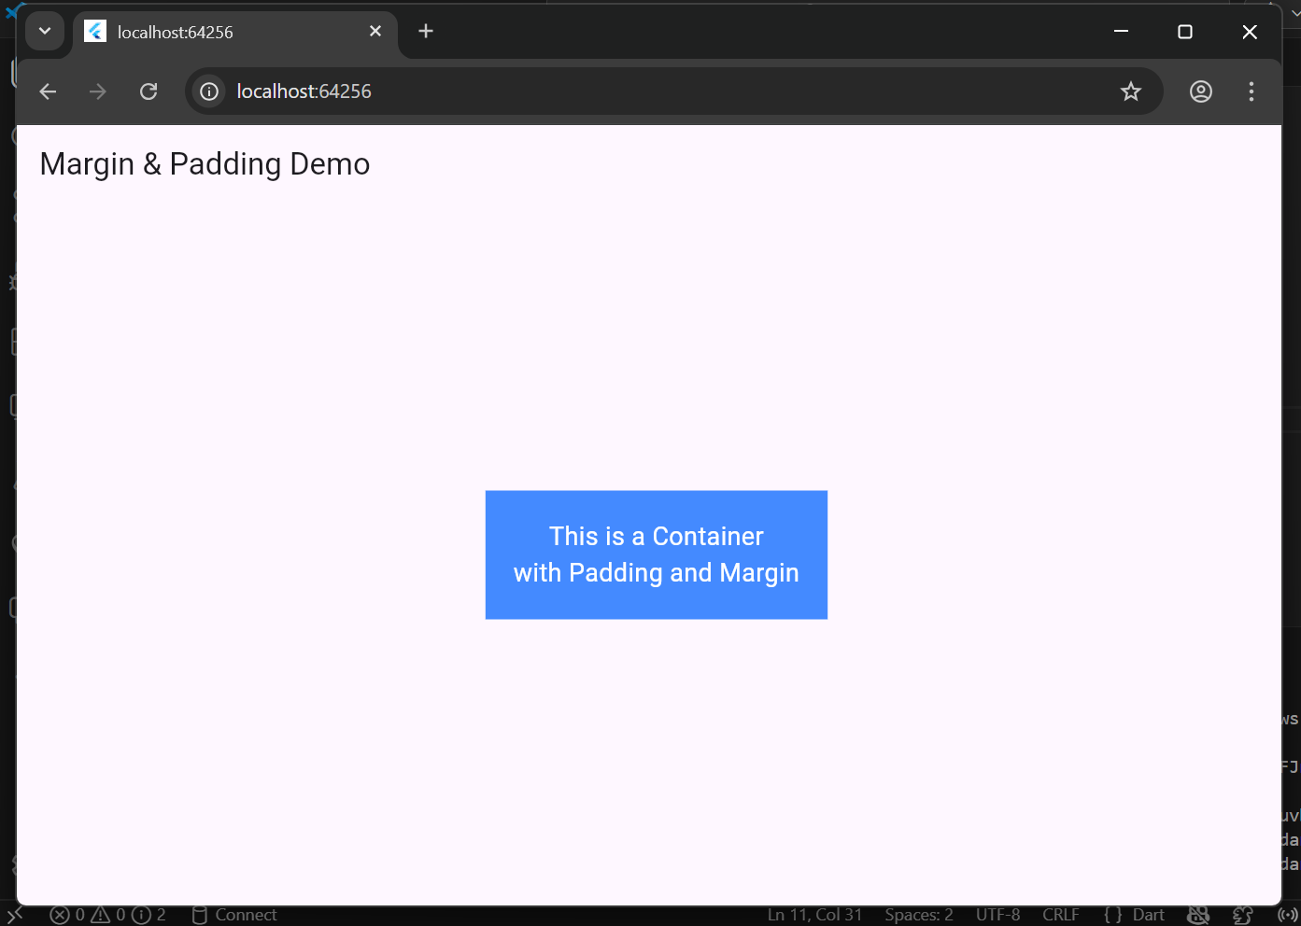
Task 3: Profile UI with CircleAvatar
Objective: Implement user identity visuals in different UI areas.
• Activity:
1. Place a CircleAvatar in the body that loads a profile image via
NetworkImage.
2. Place a second CircleAvatar within the AppBar (typically in the actions
or leading property) using AssetImage for a local file.
• Requirement: Ensure the avatar correctly represents a user profile or
initials if the image fails to load.
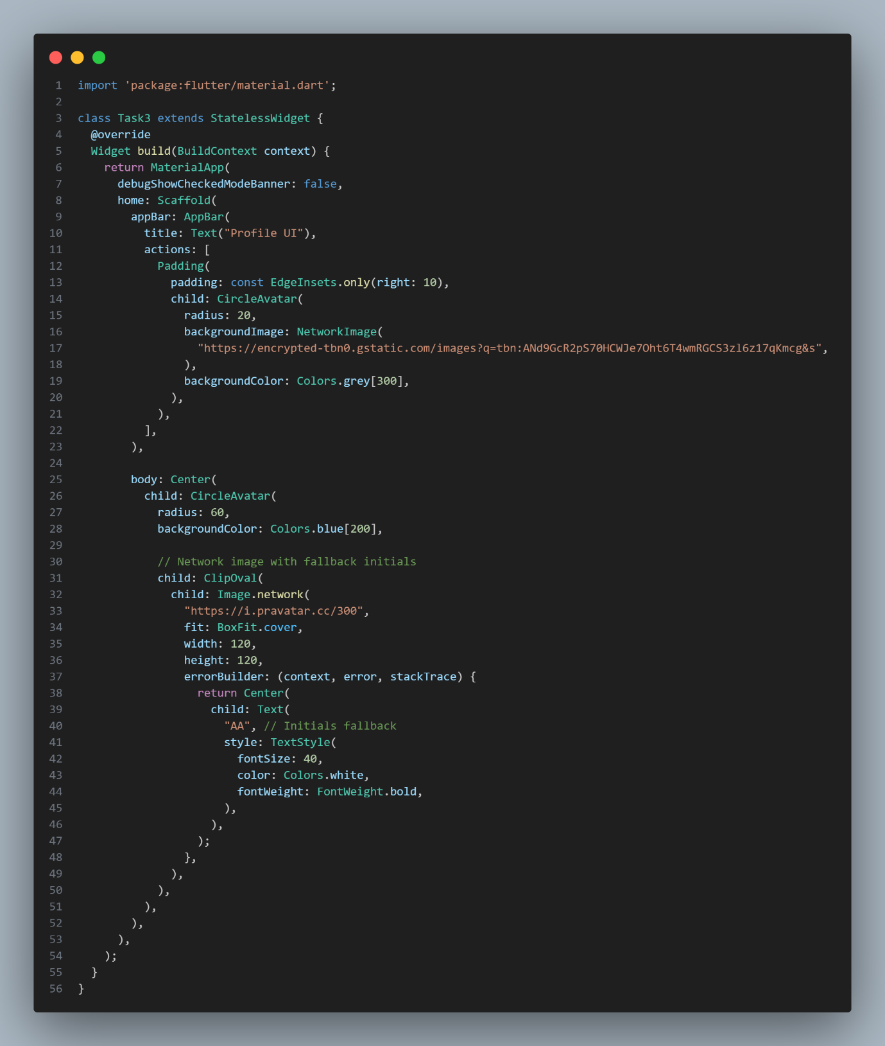
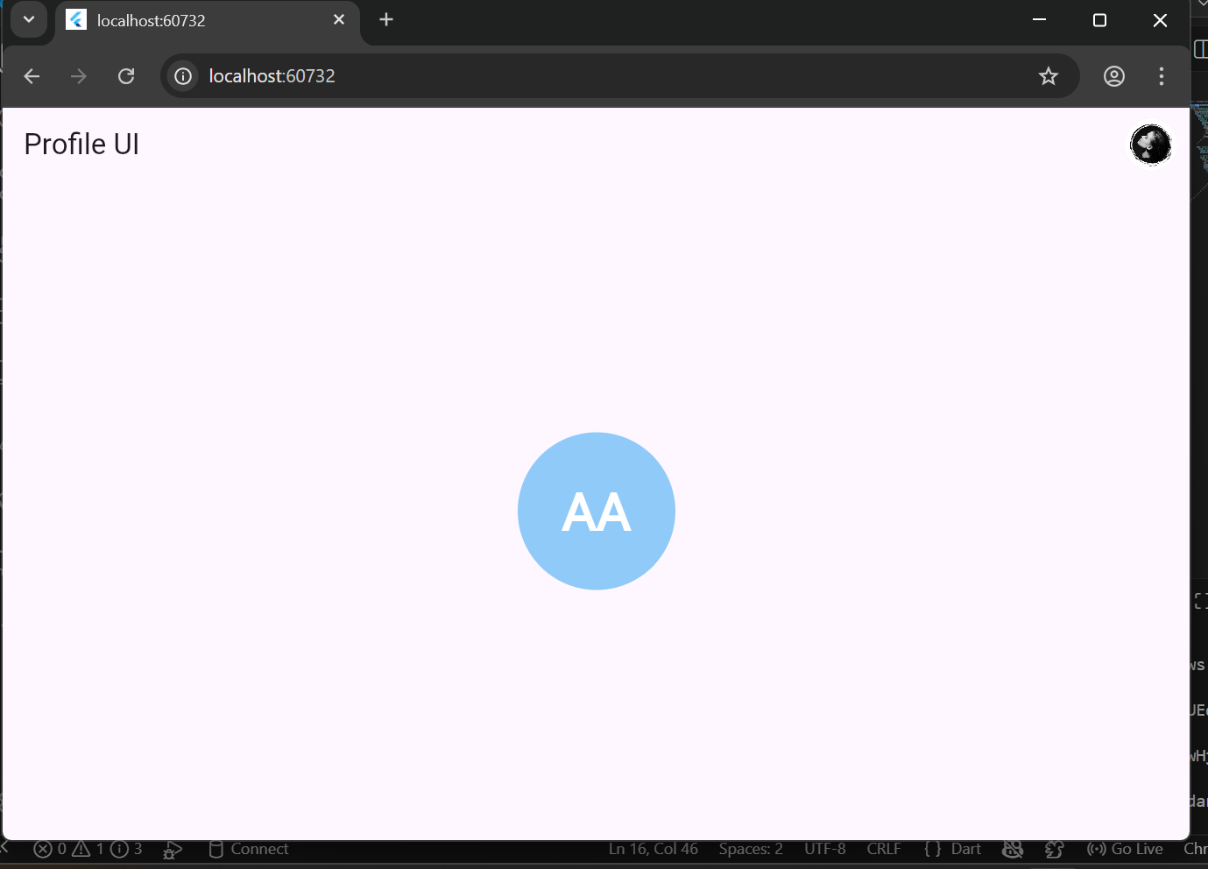
Task 4: Information Grouping with Card & ListTile
Objective: Use ListTile to create structured, repeatable UI elements.
• Activity:
1. Create a Card with rounded corners and an elevation shadow.
2. Inside the Card, nest a ListTile.
• Requirement:
o Leading: Use an Icon or CircleAvatar.
o Title: Contact name.
o Subtitle: Registration No.
o Variations: Create a second version with a different color scheme and
a trailing icon.
