

National Textile University
Department of Computer Science
Subject: Mobile Application Development

Submitted to: Sir Rehan

Submitted by: Amina

Reg. number: 23-NTU-CS-1136

Lab Evaluation

Semester: 6 th

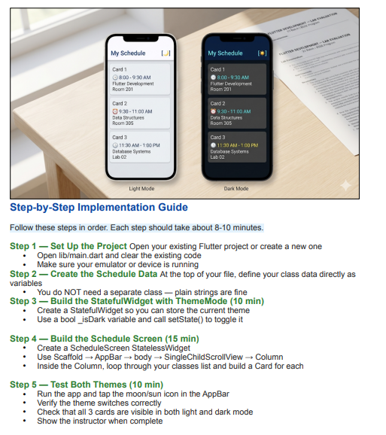

Code:
import 'package:flutter/material.dart';

void main() {
runApp(const MyApp());
}

final List<Map<String, String>> scheduleData = [
{
'time': '8:00 - 9:30 AM',
'subject': 'Flutter Development',
'room': 'Room 201',
},
{'time': '9:30 - 11:00 AM', 'subject': 'Data Structures', 'room': 'Room 305'},
{
'time': '11:30 AM - 1:00 PM',
'subject': 'Database Systems',
'room': 'Lab 02',
},
{
'time': '2:00 - 3:30 PM',
'subject': 'Software Engineering',
'room': 'Room 102',
},
];

class MyApp extends StatefulWidget {
const MyApp({super.key});

@override
State<MyApp> createState() => _MyAppState();
}

class _MyAppState extends State<MyApp> {
// Tracks whether dark mode is active
bool _isDark = false;

void _toggleTheme() {
setState(() {
_isDark = !_isDark;
});
}

@override
Widget build(BuildContext context) {
return MaterialApp(
title: 'My Schedule',
debugShowCheckedModeBanner: false,
themeMode: _isDark ? ThemeMode.dark : ThemeMode.light,
theme: ThemeData(
useMaterial3: true,
colorScheme: ColorScheme.fromSeed(
seedColor: const Color(0xFF1565C0),
brightness: Brightness.light,
),
),
darkTheme: ThemeData(
useMaterial3: true,
colorScheme: ColorScheme.fromSeed(
seedColor: const Color(0xFF1565C0),
brightness: Brightness.dark,
),
),
home: ScheduleScreen(isDark: _isDark, onToggleTheme: _toggleTheme),
);
}
}

// ─── Schedule Screen
class ScheduleScreen extends StatelessWidget {
final bool isDark;
final VoidCallback onToggleTheme;

const ScheduleScreen({
super.key,
required this.isDark,
required this.onToggleTheme,
});

@override
Widget build(BuildContext context) {
return Scaffold(
appBar: AppBar(
title: const Text(
'My Schedule',
style: TextStyle(fontWeight: FontWeight.bold),
),
actions: [
IconButton(
icon: Icon(isDark ? Icons.wb_sunny : Icons.star),
tooltip: isDark ? 'Switch to Light Mode' : 'Switch to Dark Mode',
onPressed: onToggleTheme,
),
],
),
body: SingleChildScrollView(
// Padding around all content
padding: const EdgeInsets.all(16.0),
child: Column(
crossAxisAlignment: CrossAxisAlignment.start,
children: [

...scheduleData.asMap().entries.map((entry) {
final int index = entry.key;
final Map<String, String> classInfo = entry.value;
return Column(
children: [
ScheduleCard(
cardNumber: index + 1,
time: classInfo['time']!,
subject: classInfo['subject']!,
room: classInfo['room']!,
),
if (index < scheduleData.length - 1)
const SizedBox(height: 12),
],
);
}),
],
),
),
);
}
}

// ─── Schedule Card Widget
class ScheduleCard extends StatelessWidget {
final int cardNumber;
final String time;
final String subject;
final String room;

const ScheduleCard({
super.key,
required this.cardNumber,
required this.time,
required this.subject,
required this.room,
});

@override
Widget build(BuildContext context) {
final colorScheme = Theme.of(context).colorScheme;

return Card(
elevation: 2,
shape: RoundedRectangleBorder(borderRadius: BorderRadius.circular(12)),
child: Padding(
padding: const EdgeInsets.all(16.0),
child: Column(
crossAxisAlignment: CrossAxisAlignment.start,
children: [

Text(
'Card $cardNumber',
style: Theme.of(context).textTheme.labelMedium?.copyWith(
color: colorScheme.onSurfaceVariant,
),
),
const SizedBox(height: 8),
Row(
children: [
const Text('⏰ ', style: TextStyle(fontSize: 18)),
Text(
time,
style: Theme.of(context).textTheme.bodyLarge?.copyWith(
color: colorScheme.primary,
fontWeight: FontWeight.normal,
),
),
],
),
const SizedBox(height: 5),

Text(subject, style: Theme.of(context).textTheme.bodyMedium),
const SizedBox(height: 2),

Text(
room,
style: Theme.of(context).textTheme.bodyMedium?.copyWith(
color: colorScheme.onSurfaceVariant,
),
),
],
),
),
);
}
}

Terminal:

