

National Textile University
Department of Computer Science
Subject: Mobile Application Development

Submitted to: Sir Rehan

Submitted by: Amina

Reg. number: 23-NTU-CS-1136

Lab no.: Lab7

Semester: 6 th

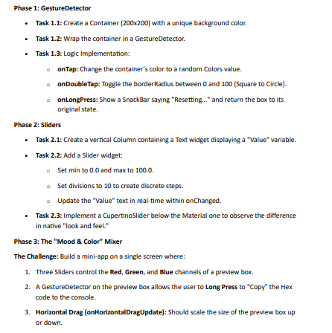

Code:
import 'dart:math';
import 'package:flutter/cupertino.dart';
import 'package:flutter/material.dart';

void main() {
runApp(const MyApp());
}

class MyApp extends StatelessWidget {
const MyApp({super.key});

@override
Widget build(BuildContext context) {
return const MaterialApp(
debugShowCheckedModeBanner: false,
home: GestureSliderApp(),
);
}
}

class GestureSliderApp extends StatefulWidget {
const GestureSliderApp({super.key});

@override
State<GestureSliderApp> createState() => _GestureSliderAppState();
}

class _GestureSliderAppState extends State<GestureSliderApp> {

// ---------------- Phase 1 ----------------
Color boxColor = Colors.blue;
double borderRadius = 0;

final Color initialColor = Colors.blue;
final double initialRadius = 0;

// ---------------- Phase 2 ----------------
double sliderValue = 50;

// ---------------- Phase 3 ----------------
double red = 100;
double green = 100;
double blue = 100;
double boxSize = 150;

// Generate random color
Color getRandomColor() {
return Color.fromARGB(
255,
Random().nextInt(256),
Random().nextInt(256),
Random().nextInt(256),
);
}

// Convert RGB to HEX
String getHexColor() {
return '#'
'${red.toInt().toRadixString(16).padLeft(2, '0')}'
'${green.toInt().toRadixString(16).padLeft(2, '0')}'
'${blue.toInt().toRadixString(16).padLeft(2, '0')}'
.toUpperCase();
}

@override
Widget build(BuildContext context) {

Color mixedColor = Color.fromRGBO(
red.toInt(),
green.toInt(),
blue.toInt(),
1,
);

return Scaffold(
appBar: AppBar(title: const Text("Gesture + Slider App")),
body: SingleChildScrollView(
child: Column(
children: [

// ================= Phase 1 =================
const SizedBox(height: 20),

GestureDetector(
onTap: () {
setState(() {
boxColor = getRandomColor();
});
},

onDoubleTap: () {
setState(() {
borderRadius = borderRadius == 0 ? 100 : 0;
});
},

onLongPress: () {
ScaffoldMessenger.of(context).showSnackBar(
const SnackBar(content: Text("Resetting...")),
);

setState(() {
boxColor = initialColor;
borderRadius = initialRadius;
});
},

child: Container(
width: 200,
height: 200,
decoration: BoxDecoration(
color: boxColor,
borderRadius: BorderRadius.circular(borderRadius),
),
),
),

const SizedBox(height: 40),

// ================= Phase 2 =================
Text("Value: ${sliderValue.toInt()}",
style: const TextStyle(fontSize: 18)),

Slider(
min: 0,
max: 100,
divisions: 10,
value: sliderValue,
label: sliderValue.toString(),
onChanged: (value) {
setState(() {
sliderValue = value;
});
},
),

CupertinoSlider(
min: 0,
max: 100,
value: sliderValue,
onChanged: (value) {
setState(() {
sliderValue = value;
});
},
),

const SizedBox(height: 40),

// ================= Phase 3 =================
const Text("Mood & Color Mixer",
style: TextStyle(fontSize: 20, fontWeight: FontWeight.bold)),

const SizedBox(height: 20),

// RGB Sliders
buildSlider("Red", red, (val) {
setState(() => red = val);
}),

buildSlider("Green", green, (val) {
setState(() => green = val);
}),

buildSlider("Blue", blue, (val) {
setState(() => blue = val);
}),

const SizedBox(height: 20),

// Preview Box with GestureDetector
GestureDetector(
onLongPress: () {
print("HEX: ${getHexColor()}");
ScaffoldMessenger.of(context).showSnackBar(
SnackBar(content: Text("Copied: ${getHexColor()}")),
);
},

onHorizontalDragUpdate: (details) {
setState(() {
boxSize += details.delta.dx;
boxSize = boxSize.clamp(50, 300);
});
},

child: Container(
width: boxSize,
height: boxSize,
color: mixedColor,
alignment: Alignment.center,
child: Text(
getHexColor(),
style: const TextStyle(color: Colors.white),
),
),
),

const SizedBox(height: 40),
],
),
),
);
}

// Reusable slider widget
Widget buildSlider(String label, double value, Function(double) onChanged) {
return Column(
children: [
Text("$label: ${value.toInt()}"),
Slider(
min: 0,
max: 255,
value: value,
onChanged: onChanged,
),
],
);
}
}

