

National Textile University
Department of Computer Science
Subject: Mobile Application Development

Submitted to: Sir Rehan

Submitted by: Amina

Reg. number: 23-NTU-CS-1136

Lab no.: Lab8

Semester: 6 th

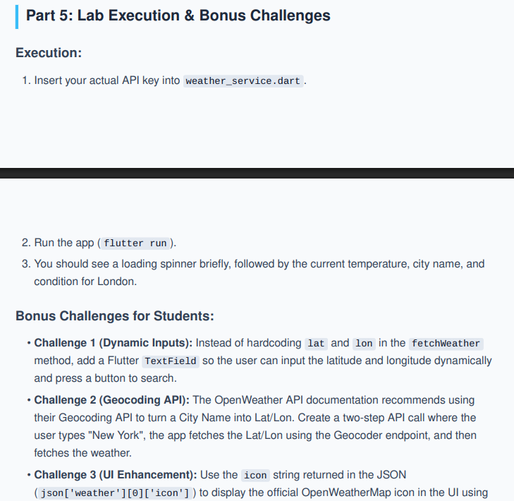

Main.Dart
import 'package:flutter/material.dart';
import 'weatherModel.dart';
import 'modelService.dart';

void main() {
runApp(const WeatherApp());
}

class WeatherApp extends StatelessWidget {
const WeatherApp({super.key});

@override
Widget build(BuildContext context) {
return MaterialApp(
debugShowCheckedModeBanner: false,
theme: ThemeData(
colorScheme: ColorScheme.fromSeed(seedColor: Colors.blue),
useMaterial3: true,
),
home: const WeatherScreen(),
);
}
}

class WeatherScreen extends StatefulWidget {
const WeatherScreen({super.key});

@override
State<WeatherScreen> createState() => _WeatherScreenState();
}

class _WeatherScreenState extends State<WeatherScreen> {
final WeatherService _service = WeatherService();

late Future<Weather> _weatherFuture;

final TextEditingController latController = TextEditingController();
final TextEditingController lonController = TextEditingController();
final TextEditingController cityController = TextEditingController();

@override
void initState() {
super.initState();
_weatherFuture = _service.fetchWeather(51.5074, -0.1278);
}

void _getWeatherByCoords() {
final lat = double.tryParse(latController.text) ?? 0;
final lon = double.tryParse(lonController.text) ?? 0;

setState(() {
_weatherFuture = _service.fetchWeather(lat, lon);
});
}

void _getWeatherByCity() {
setState(() {
_weatherFuture = _service.fetchWeatherByCity(cityController.text);
});
}

@override
Widget build(BuildContext context) {
return Scaffold(
appBar: AppBar(
title: const Text("SkyCast Weather"),
centerTitle: true,
backgroundColor: Theme.of(context).colorScheme.inversePrimary,
),
body: SingleChildScrollView(
padding: const EdgeInsets.all(16),
child: Column(
crossAxisAlignment: CrossAxisAlignment.stretch,
children: [
// 🔹 Input Section
Card(
elevation: 4,
shape: RoundedRectangleBorder(borderRadius: BorderRadius.circular(16)),
child: Padding(
padding: const EdgeInsets.all(16),
child: Column(
children: [
const Text(
"Search Weather",
style: TextStyle(fontSize: 18, fontWeight: FontWeight.bold),
),
const SizedBox(height: 16),
TextField(
controller: cityController,
decoration: InputDecoration(
labelText: "Enter City Name",
prefixIcon: const Icon(Icons.location_city),
border: OutlineInputBorder(borderRadius: BorderRadius.circular(12)),
),
),
const SizedBox(height: 12),
ElevatedButton.icon(
onPressed: _getWeatherByCity,
icon: const Icon(Icons.search),
label: const Text("Search by City"),
style: ElevatedButton.styleFrom(
minimumSize: const Size(double.infinity, 50),
shape: RoundedRectangleBorder(borderRadius: BorderRadius.circular(12)),
),
),
const Padding(
padding: EdgeInsets.symmetric(vertical: 16),
child: Row(
children: [
Expanded(child: Divider()),
Padding(
padding: EdgeInsets.symmetric(horizontal: 8),
child: Text("OR"),
),
Expanded(child: Divider()),
],
),
),
Row(
children: [
Expanded(
child: TextField(
controller: latController,
keyboardType: TextInputType.number,
decoration: InputDecoration(
labelText: "Latitude",
border: OutlineInputBorder(borderRadius: BorderRadius.circular(12)),
),
),
),
const SizedBox(width: 12),
Expanded(
child: TextField(
controller: lonController,
keyboardType: TextInputType.number,
decoration: InputDecoration(
labelText: "Longitude",
border: OutlineInputBorder(borderRadius: BorderRadius.circular(12)),
),
),
),
],
),
const SizedBox(height: 12),
OutlinedButton.icon(
onPressed: _getWeatherByCoords,
icon: const Icon(Icons.my_location),
label: const Text("Search by Coords"),
style: OutlinedButton.styleFrom(
minimumSize: const Size(double.infinity, 50),
shape: RoundedRectangleBorder(borderRadius: BorderRadius.circular(12)),
),
),
],
),
),
),

const SizedBox(height: 24),

// 🔹 Weather Result Section
FutureBuilder<Weather>(
future: _weatherFuture,
builder: (context, snapshot) {
if (snapshot.connectionState == ConnectionState.waiting) {
return const Center(child: CircularProgressIndicator());
}

if (snapshot.hasError) {
return Card(
color: Colors.red.shade50,
child: Padding(
padding: const EdgeInsets.all(16),
child: Text(
"Error: ${snapshot.error}",
style: const TextStyle(color: Colors.red),
textAlign: TextAlign.center,
),
),
);
}

if (snapshot.hasData) {
final weather = snapshot.data!;

return Card(
elevation: 6,
shape: RoundedRectangleBorder(borderRadius: BorderRadius.circular(20)),
child: Container(
padding: const EdgeInsets.all(24),
decoration: BoxDecoration(
borderRadius: BorderRadius.circular(20),
gradient: LinearGradient(
colors: [Colors.blue.shade300, Colors.blue.shade700],
begin: Alignment.topLeft,
end: Alignment.bottomRight,
),
),
child: Column(
children: [
Text(
weather.cityName,
style: const TextStyle(
fontSize: 32,
fontWeight: FontWeight.bold,
color: Colors.white,
),
),
const SizedBox(height: 8),
Image.network(
'https://openweathermap.org/img/wn/${weather.icon}@4x.png',
scale: 0.8,
),
Text(
"${weather.temperature.toStringAsFixed(1)}°C",
style: const TextStyle(
fontSize: 48,
fontWeight: FontWeight.w300,
color: Colors.white,
),
),
const SizedBox(height: 8),
Text(
weather.description.toUpperCase(),
style: const TextStyle(
fontSize: 18,
letterSpacing: 1.2,
color: Colors.white70,
),
),
],
),
),
);
}

return const SizedBox();
},
),
],
),
),
);
}
}

Weather.dart
class Weather {
final String cityName;
final double temperature;
final String description;
final String icon;

Weather({
required this.cityName,
required this.temperature,
required this.description,
required this.icon,
});

factory Weather.fromJson(Map<String, dynamic> json) {
return Weather(
cityName: json['name'],
temperature: json['main']['temp'].toDouble(),
description: json['weather'][0]['description'],
icon: json['weather'][0]['icon'],
);
}
}

Service.dart:
import 'dart:convert';
import 'package:http/http.dart' as http;
import 'weatherModel.dart';

class WeatherService {
static const String apiKey = '6064ab1d463b4e02ab3f8586059aaacd';

// 🔹 Fetch by lat/lon (Challenge 1)
Future<Weather> fetchWeather(double lat, double lon) async {
final url = Uri.parse(
'https://api.openweathermap.org/data/2.5/weather?lat=$lat&lon=$lon&appid=$apiKey&units=metric'
);

final response = await http.get(url);

if (response.statusCode == 200) {
return Weather.fromJson(jsonDecode(response.body));
} else {
throw Exception('Failed to load weather');
}
}

// 🔹 Fetch by city (Challenge 2)
Future<Weather> fetchWeatherByCity(String city) async {
final geoUrl = Uri.parse(
'https://api.openweathermap.org/geo/1.0/direct?q=$city&limit=1&appid=$apiKey'
);

final geoResponse = await http.get(geoUrl);

if (geoResponse.statusCode == 200) {
final geoData = jsonDecode(geoResponse.body);

if (geoData is List && geoData.isNotEmpty) {
final lat = geoData[0]['lat'];
final lon = geoData[0]['lon'];

return fetchWeather(lat, lon);
} else {
throw Exception('City not found');
}
} else {
throw Exception('City not found');
}
}
}

