

National Textile University
Department of Computer Science
Subject: Mobile Application Development

Submitted to: Sir Rehan

Submitted by: Amina

Reg. number: 23-NTU-CS-1136

Lab no.: Lab6

Semester: 6 th

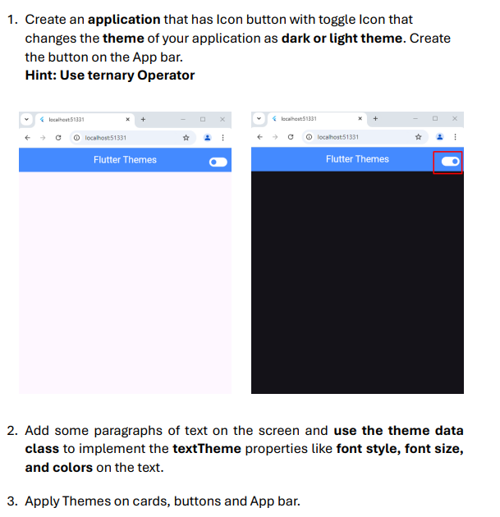
import 'package:flutter/material.dart';

void main() {
runApp(const MyApp());
}

class MyApp extends StatefulWidget {
const MyApp({super.key});

@override
State<MyApp> createState() => _MyAppState();
}

class _MyAppState extends State<MyApp> {
bool _isDarkMode = false;

void _toggleTheme() {
setState(() {
_isDarkMode = !_isDarkMode;
});
}

@override
Widget build(BuildContext context) {
return MaterialApp(
title: 'Flutter Themes Demo',
debugShowCheckedModeBanner: false,
theme: ThemeData(
brightness: Brightness.light,
primarySwatch: Colors.blue,
primaryColor: Colors.blue,
scaffoldBackgroundColor: Colors.grey[50],
appBarTheme: const AppBarTheme(
backgroundColor: Colors.blue,
foregroundColor: Colors.white,
elevation: 4,
centerTitle: true,
),
textTheme: const TextTheme(
headlineLarge: TextStyle(fontSize: 32, fontWeight: FontWeight.bold, color: Colors.blue),
headlineMedium: TextStyle(fontSize: 24, fontWeight: FontWeight.w600),
bodyLarge: TextStyle(fontSize: 16, color: Colors.black87),
),
elevatedButtonTheme: ElevatedButtonThemeData(
style: ElevatedButton.styleFrom(
backgroundColor: Colors.blue,
foregroundColor: Colors.white,
padding: const EdgeInsets.symmetric(horizontal: 24, vertical: 12),
shape: RoundedRectangleBorder(borderRadius: BorderRadius.circular(8)),
),
),
cardTheme: CardThemeData(
elevation: 4,
shape: RoundedRectangleBorder(borderRadius: BorderRadius.circular(12)),
color: Colors.white,
),
floatingActionButtonTheme: const FloatingActionButtonThemeData(
backgroundColor: Colors.blue,
foregroundColor: Colors.white,
),
),
darkTheme: ThemeData(
brightness: Brightness.dark,
primarySwatch: Colors.teal,
primaryColor: Colors.teal,
scaffoldBackgroundColor: Colors.grey[900],
appBarTheme: const AppBarTheme(
backgroundColor: Colors.teal,
foregroundColor: Colors.white,
elevation: 4,
centerTitle: true,
),
textTheme: const TextTheme(
headlineLarge: TextStyle(fontSize: 32, fontWeight: FontWeight.bold, color: Colors.tealAccent),
headlineMedium: TextStyle(fontSize: 24, fontWeight: FontWeight.w600, color: Colors.white),
bodyLarge: TextStyle(fontSize: 16, color: Colors.white70),
),
elevatedButtonTheme: ElevatedButtonThemeData(
style: ElevatedButton.styleFrom(
backgroundColor: Colors.teal,
foregroundColor: Colors.white,
padding: const EdgeInsets.symmetric(horizontal: 24, vertical: 12),
shape: RoundedRectangleBorder(borderRadius: BorderRadius.circular(8)),
),
),
cardTheme: CardThemeData(
elevation: 4,
shape: RoundedRectangleBorder(borderRadius: BorderRadius.circular(12)),
color: Colors.grey[800],
),
floatingActionButtonTheme: const FloatingActionButtonThemeData(
backgroundColor: Colors.teal,
foregroundColor: Colors.white,
),
),
themeMode: _isDarkMode ? ThemeMode.dark : ThemeMode.light,
home: MyHomePage(toggleTheme: _toggleTheme, isDarkMode: _isDarkMode),
);
}
}

class MyHomePage extends StatelessWidget {
final VoidCallback toggleTheme;
final bool isDarkMode;

const MyHomePage({super.key, required this.toggleTheme, required this.isDarkMode});

@override
Widget build(BuildContext context) {
final theme = Theme.of(context);

return Scaffold(
appBar: AppBar(
title: const Text('Flutter Themes'),
actions: [
IconButton(
icon: Icon(isDarkMode ? Icons.light_mode : Icons.dark_mode),
onPressed: toggleTheme,
),
],
),
body: Center(
child: SingleChildScrollView(
padding: const EdgeInsets.all(20),
child: Column(
mainAxisAlignment: MainAxisAlignment.center,
children: [
// Main title
Text(
'Flutter Themes',
style: theme.textTheme.headlineLarge,
),
const SizedBox(height: 10),
Text(
isDarkMode ? 'Dark Mode Active' : 'Light Mode Active',
style: theme.textTheme.headlineMedium?.copyWith(
color: isDarkMode ? Colors.tealAccent : Colors.blue,
),
),
const SizedBox(height: 30),

// Card with theme demonstration
Card(
child: Padding(
padding: const EdgeInsets.all(20),
child: Column(
children: [
Text(
'Theme Features',
style: theme.textTheme.titleLarge?.copyWith(
fontWeight: FontWeight.bold,
),
),
const SizedBox(height: 15),
Text(
'This card automatically adapts to the current theme',
style: theme.textTheme.bodyLarge,
textAlign: TextAlign.center,
),
const SizedBox(height: 20),

// Different text styles
Text('Headline Large', style: theme.textTheme.headlineLarge),
Text('Headline Medium', style: theme.textTheme.headlineMedium),
Text('Body Large', style: theme.textTheme.bodyLarge),
],
),
),
),
const SizedBox(height: 20),

// Buttons
ElevatedButton(
onPressed: () {},
child: const Text('Elevated Button'),
),
const SizedBox(height: 10),

OutlinedButton(
onPressed: () {},
style: OutlinedButton.styleFrom(
foregroundColor: isDarkMode ? Colors.tealAccent : Colors.blue,
side: BorderSide(color: isDarkMode ? Colors.tealAccent : Colors.blue),
padding: const EdgeInsets.symmetric(horizontal: 24, vertical: 12),
),
child: const Text('Outlined Button'),
),
const SizedBox(height: 10),

TextButton(
onPressed: () {},
style: TextButton.styleFrom(
foregroundColor: isDarkMode ? Colors.tealAccent : Colors.blue,
),
child: const Text('Text Button'),
),
const SizedBox(height: 30),

// Theme information
Container(
padding: const EdgeInsets.all(15),
decoration: BoxDecoration(
color: theme.cardColor,
borderRadius: BorderRadius.circular(8),
border: Border.all(color: theme.dividerColor),
),
child: Column(
children: [
Text(
'Current Theme Properties',
style: theme.textTheme.titleMedium?.copyWith(
fontWeight: FontWeight.bold,
),
),
const SizedBox(height: 10),
_buildThemeInfoRow('Primary Color', theme.primaryColor.toString(), theme),
_buildThemeInfoRow('Background', theme.scaffoldBackgroundColor.toString(), theme),
_buildThemeInfoRow('Brightness', theme.brightness.toString(), theme),
],
),
),
],
),
),
),
floatingActionButton: FloatingActionButton(
onPressed: () {
ScaffoldMessenger.of(context).showSnackBar(
SnackBar(
content: Text('Theme: ${isDarkMode ? 'Dark' : 'Light'}'),
duration: const Duration(seconds: 1),
),
);
},
child: const Icon(Icons.info),
),
);
}

Widget _buildThemeInfoRow(String label, String value, ThemeData theme) {
return Padding(
padding: const EdgeInsets.symmetric(vertical: 4),
child: Row(
mainAxisAlignment: MainAxisAlignment.spaceBetween,
children: [
Text(label, style: theme.textTheme.bodyLarge),
Container(
padding: const EdgeInsets.symmetric(horizontal: 8, vertical: 2),
decoration: BoxDecoration(
color: theme.primaryColor.withOpacity(0.1),
borderRadius: BorderRadius.circular(4),
),
child: Text(
value.split('(').first,
style: theme.textTheme.bodySmall?.copyWith(
color: theme.primaryColor,
fontWeight: FontWeight.bold,
),
),
),
],
),
);
}
}

