1.1 Logical Scheme
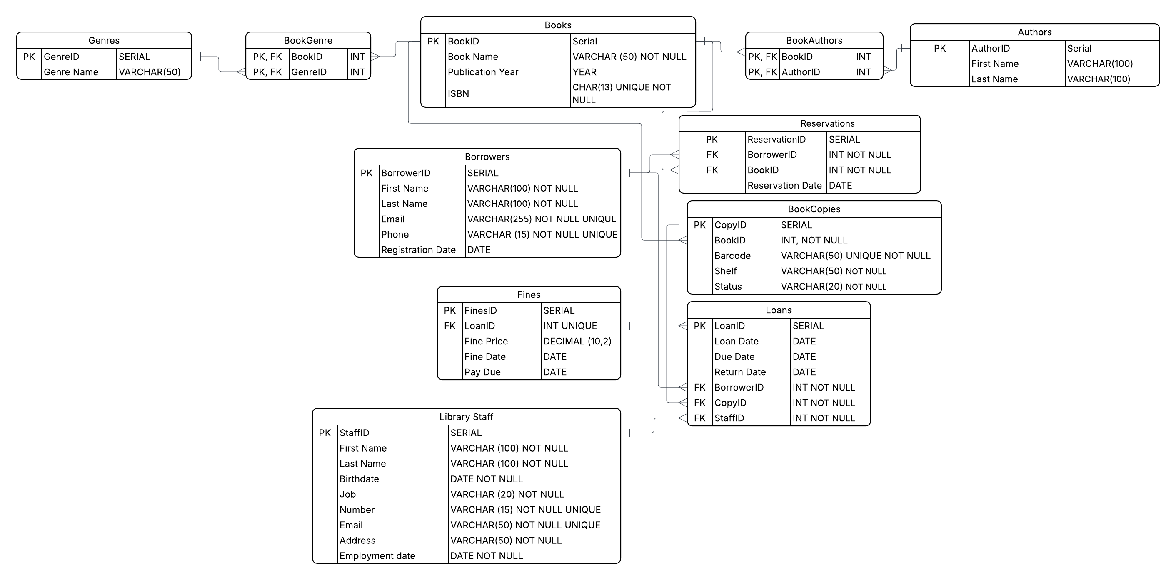

1.2 Objects
Books
This table stores the core information for every book title in the library catalog.
Table Name | Field Name | Field Description | Data Type / Constraints
Books | BookID | Unique indentifier for the book title | SERIAL, PK
 | Book Name | Title of the book | VARCHAR(50), NOT NULL
 | Publication Year | The year the book was released | YEAR
 | ISBN | Numeric commercial book identifier | CHAR(13) UNIQUE NOT NULL

One to many with BookCopies: one book title can have multiple physical copies
Many to many with Authors and Genres using bridge tables

Example with data
BookID | Book Name | Publication Year | ISBN
1 | The Great Gatsby | 1925 | 9780743273565
Authors
This table stores information about the creators of the books in the library system.
Table Name | Field Name | Field Description | Data Type / Constraints
Authors | AuthorID | Unique identifier for the author | SERIAL, PK
 | First Name | Author’s first name | VARCHAR(50), NOT NULL
 | Last Name | Author’s last name | VARCHAR(50), NOT NULL

Many to many with Books through the BookAuthors bridge table: one author can write many books, and one book can have multiple authors

Example with data
AuthorID | First Name | Last Name
105 | Scott | Fitzgerald

BookAuthors
This table resolves the many to many relationship between book and authors.
Table Name | Field Name | Field Description | Data Type / Constraints
BookAuthors | BookID | Reference to the book | INT, PK, FK
 | AuthorID | Reference to the author | INT, PK, FK

Uses a composite primary key to ensure a specific author isn’t linked to the same book twice

Example with data
BookID | AuthorID
1 | 105

Genres
A lookup table, like a dictionary, of all literary categories available in the library.
Table Name | Field Name | Field Description | Data Type / Constraints
Genres | GenreID | Unique identifier for the genre | SERIAL, PK
 | Genre Name | The name of the category | VARCHAR(50), NOT NULL, UNIQUE

Many to many with Books through the BookGenre bridge table

Example with data
GenreID | Genre Name
5 | Science Fiction
6 | Classic Literature

BookGenre
This junction table resolves the many to many relationship between books and their literary genres
Table Name | Field Name | Field Description | Data Type / Constraints
BookGenre | BookID | Reference to the book title | INT, PK, FK
 | GenreID | Reference to the genre category | INT, PK, FK

Also uses a composite primary key to ensure a book is never assigned to the same genre more than once

Example with data
BookID | GenreID
1 | 6

Library Staff
This table contains comprehensive profiles for library employees.
Table Name | Field Name | Field Description | Data Type / Constraints
Library Staff | StaffID | Unique identifier for the staff member | SERIAL, PK
 | First Name | Staff member’s first name | VARCHAR(100), NOT NULL
 | Last Name | Staff member’s last name | VARCHAR(100), NOT NULL
 | Birthdate | Employee’s date of birth | DATE, NOT NULL
 | Job | Specific job title or role | VARCHAR(20), NOT NULL
 | Number | Contact phone number | VARCHAR(15), NOT NULL, UNIQUE
 | Email | Professional email address | VARCHAR(50), NOT NULL, UNIQUE
 | Address | Residential address | VARCHAR(50), NOT NULL
 | Employment date | Date the staff member started working | DATE, NOT NULL

One to many with Loans - one staff member can be responsible for authorizing and processing many different loan transactions.
Example with data
StaffID | First Name | Last Name | Birthdate | Job | Number | Email | Address | Employment date
50 | Jane | Smith | 1985-05-15 | Librarian | +77777777777 | j.smith@gmail.com | 123 Maple St | 2026-01-10

Borrowers
This table stores the information and contact details for all registered library members(borrowers)
Table Name | Field Name | Field Description | Data Type / Constraints
Borrowers | BorrowerID | Unique identifier for the member | SERIAL, PK
 | First Name | Member’s first name | VARCHAR(100), NOT NULL
 | Last Name | Member’s last name | VARCHAR(100), NOT NULL
 | Email | Professional email address | VARCHAR(255), NOT NULL, UNIQUE
 | Number | Contact phone number | VARCHAR(15), NOT NULL, UNIQUE
 | Registration Date | Date the member joined | DATE, NOT NULL

One to many with Reservations - a borrower can place multiple holds on books
One to many with Loans - a borrower can check out multiple books over time

Example with data
BorrowerID | First Name | Last Name | Email | Number | Registration date
10 | John | Doe | j.doe@gmail.com | +77777777776 | 2026-03-13

BookCopies
This table tracks the individual physical items owned by the library
Table Name | Field Name | Field Description | Data Type / Constraints
BookCopies | CopyID | Unique identifier for the physical unit | SERIAL, PK
 | BookID | Reference to the book title | INT, FK, NOT NULL
 | Barcode | Scannable code for the book | VARCHAR(50), UNIQUE, NOT NULL
 | Shelf | Physical location in the library | VARCHAR(50), NOT NULL
 | Status | Book availability | VARCHAR(20), NOT NULL

Many to one with Books - connects a specific copy to its general title information
One to many with Loans - tracks which specific copy was taken by a borrower

Example with data
CopyID | BookID | Barcode | Shelf | Status
1001 | 1 | BC1001GATSBY | A-01-01 | Available

Loans
This table is for library transactions, recording when a book copy is checked out and returned
Table Name | Field Name | Field Description | Data Type / Constraints
Loans | LoanID | Unique identifier for the transaction | SERIAL, PK
 | Loan Date | Date the book was borrowed | DATE, NOT NULL
 | Due Date | Date the book is due for return | DATE, NOT NULL
 | Return Date | Actual date the book was return | DATE
 | BorrowerID | Reference to the member | INT, FK, NOT NULL
 | CopyID | Reference to the physical copy | INT, FK, NOT NULL
 | StaffID | Reference to the staff member | INT, FK, NOT NULL

Acts as a junction connecting Borrowers, BookCopies and Library staff
Parent table to Fines.

Example with data
LoanID | Loan Date | Due Date | Return Date | BorrowerID | CopyID | StaffID
501 | 2026-01-01 | 2026-01-15 | 2026-01-14 | 10 | 1001 | 50

Fines
This table tracks financial penalties for overdue loans.
Table Name | Field Name | Field Description | Data Type / Constraints
Fines | FinesID | Unique identifier for the fine | SERIAL, PK
 | LoanID | Reference to the specific loan | INT, FK, UNIQUE
 | Fine Price | The monetary amount of the fine | DECIMAL(10,2)
 | Fine Date | Date the fine was issued | DATE
 | Pay Due | The deadline for the fine payment | DATE

This
Example with data
FinesID | LoanID | Fine Price | Fine Date | Pay Due
1 | 501 | 15.00 | 2026-01-09 | 2026-01-24

Reservations
This table manages “holds” placed by borrowers on specific book titles.
Table Name | Field Name | Field Description | Data Type / Constraints
Reservations | ReservationID | Unique identifier for the hold | SERIAL, PK
 | BorrowerID | Reference to the member waiting | INT, FK, NOT NULL
 | BookID | Reference to the book title | INT, FK, NOT NULL
 | Reservation Date | Date the reservation was made | DATE

Linked to Borrowers and Books. Unlike Loans, this links to the general BookID rather than a specific copy.

Example with data
ReservationID | BorrowerID | BookID | Reservation Date
101 | 10 | 1 | 2026-01-01

