WEBSITE FOR GOVT TECNICAL AND VOACTIONAL CENTER MIRAZADAR
Khyber Pakhtunkhwa Board of Technical & Commerce Education
DIPLOMA OF INFORMATION TECHNOLOGY
FINAL PROJECT
For D.I.T - 2nd Semester

Supervised By:
Sana Ullah jan
Submitted by:
Name Roll No:

Semester: 2nd
GTVC (BOYS) MIRZADHER

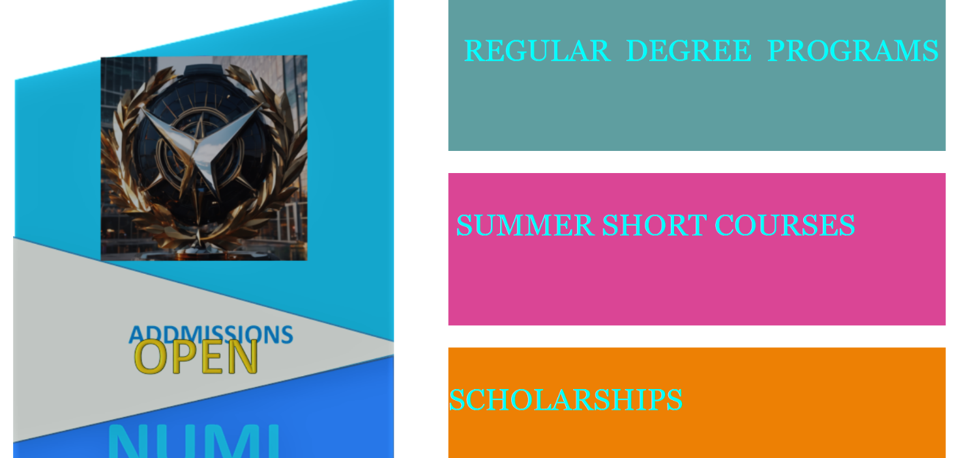


REGULAR DEGREE PROGRAMS
