Introduction and project motivation
To make a good project of interest I decided to choose World Bank Findex Survey data to use the knowledge on real microdata and make comprehensive analysis and provide economic interpretation.
The Global Findex is the world’s most comprehensive database on digital and financial inclusion. I chose my home country as my analysis target.

Research Questions
- Are there distinct groups of individuals with different financial usage behavior?
- How does digital financial behavior distinguish between those who are financially included?

Data
The analysis is based on microdata from the World Bank Global Findex Database (2025 edition). The dataset contains individual-level survey responses related to account ownership, digital payments and demographic characteristics.
The project focuses on Kazakhstan data. It consists of 1000 rows and more than 100 variables but after filtering the data we have in total 1000 rows of data with 44 variables most of them are binary.

Methodology
To reduce the dimensionality of the data and identify key dimensions, Principal Component Analysis (PCA) was used. Based on the results of PCA analysis, unsupervised clustering methods (k-means and hierarchical clustering) are used to group individuals with similar financial behavior patterns.

Project Structure
- Data cleaning and preprocessing
  - Removal of empty observations
  - Transformation of the variable values
  - Removal of highly correlated attributes
- Principal component analysis
  - Identification of variables relevant for clustering
  - The variable contributions for PC1 and PC2
  - Visualization of PCA results
- Classification
  - Determination of the optimal number of clusters (Elbow and Silhouette methods)
  - Visualization of clusters using the k-means algorithm
  - Visualization of clusters using hierarchical clustering
  - Economic interpretation of the identified groups
- Demographics
  - Analysis of demographic differences across clusters

Data cleaning and preprocessing
Removal of empty observations. Empty observations and variables with a very high share of missing values were removed. Variables with more than 70% missing value were excluded from the analysis, as they do not provide sufficient information. Responses such as “Don’t know” and “Refused” were treated as missing values, as they do not reflect actual financial behavior and cannot be meaningfully interpreted in clustering.
Transformation of the variable values. The raw survey data contain many variables with different formats, missing responses, and special answer categories such as “Don’t know” or “Refused”. Binary variables were harmonized to represent clear “yes/no” or 0/1 outcomes, while ordinal variables were converted to ordered numerical scales reflecting increasing or decreasing intensity (for example, frequency of digital payments).
Removal of highly correlated attributes. Finally, variables with very high pairwise correlations (above 70%) were removed to avoid redundancy. This step ensures that highly similar attributes do not disproportionately influence the analysis and allows each remaining variable to contribute unique information.

Principal Component Analysis
Identification of variables relevant for clustering. Demographic and nominal variables were not included in the analysis to obtain results based only on behavioral patterns and not demographic attributes and age, education etc.
After preprocessing, Principal Component Analysis (PCA) was applied to reduce the dimensionality of the dataset and to identify the main underlying patterns in financial behavior.
The variable contributions for PC1 and PC2.
The top 10 variables for Principal Component 1
Variable | Definition | PC1 contribution (%)
fin20 | Applied for a loan using a mobile phone (yes/no) | 30,7
borrowed | The respondent, personally or together with someone else, borrowed money in the past year, including from a bank or similar financial institution, via a mobile money account, from family or friends, or from an informal savings group, or for any other reason (yes/no) | 30,3
fin22a | Borrowed from a formal bank or similar financial institution (yes/no) | 30,4
fin10 | Has a credit card (yes/no) | 28,3
receive_wages | Received a wage payment (yes/no) | 25,3
account_mob | Has a mobile money account (yes/no) | 24,5
fin22b | Borrowed from friends or family (yes/no) | 22,5
internet_use | Using the internet within the past three months (yes/no) | 21,1
domestic_remittances | Made or received a domestic remittance payment (yes/no) | 20,9
fin19 | Made regular payments to insurance agent or company | 20,4

The top 10 variables for Principal Component 2
Variable | Definition | PC2 contribution (%)
fin6 | Frequency of money deposited into accounts | -37,0
account | Has an account (yes/no) | -35,7
fin25e1 | Use a mobile phone or card to pay for household cleaning supplies (yes/no) | 32,8
fin26b | Used a mobile phone or the internet to buy something online (yes/no) | 32,2
fin8 | Store money in account (yes/no) | 31,0
fin2 | Has a debit card (yes/no) | -29,0
fin26a | Used a mobile phone or computer to make a bill payment | 28,2
fin9b | Check account balance using a mobile phone or the internet (yes/no) | 27,9
fin25e3 | Frequency of digital instore merchant payments (frequency) | -20,1
fin4 | Opened first account to receive a wage or salary payment or money from the government (yes/no) | 15,2

PC1 = “Financial engagement and borrowing behavior”
Individuals with high PC1 scores demonstrate active financial engagement and intensive borrowing behavior. They are more likely to:
- use loan products, including formal and digital loans
- borrow money from financial institutions or via mobile banking and other
- own credit cards and mobile accounts
- receive wages and make domestic remittance or insurance payments
PC2 = “Digital transaction usage vs basic account ownership”
Individuals with high PC2 scores are characterized by active digital transaction usage rather than passive account ownership. They are more likely to:
- actively use digital payment methods;
- purchase goods online;
- use cards and mobile-based accounts for transactions;
- participate in receiving pension payments through digital or account-based channels.
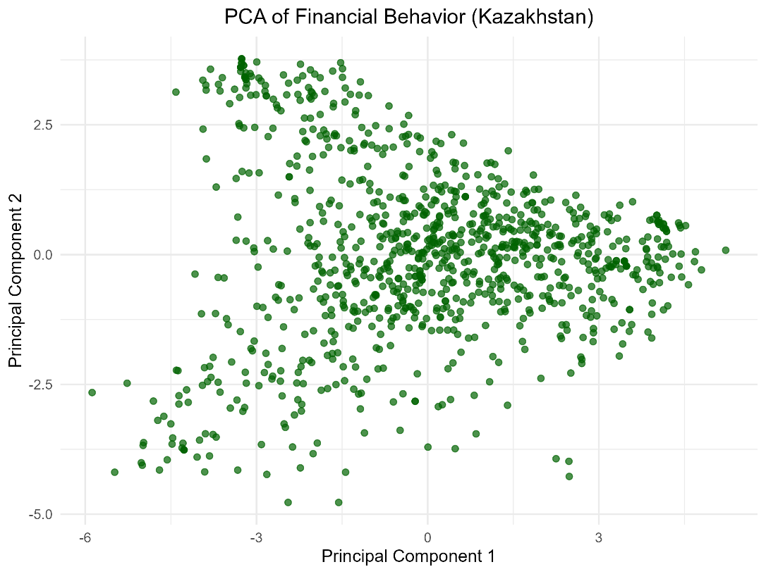

Classification
Determination of the optimal number of clusters (Elbow and Silhouette methods).
The Elbow method indicates that the optimal number of clusters is k = 2. However, this solution leads to a very trivial interpretation, separating individuals into financially included and financially excluded groups. As this binary distinction does not provide sufficient insight, the two-cluster solution is not used for further analysis.
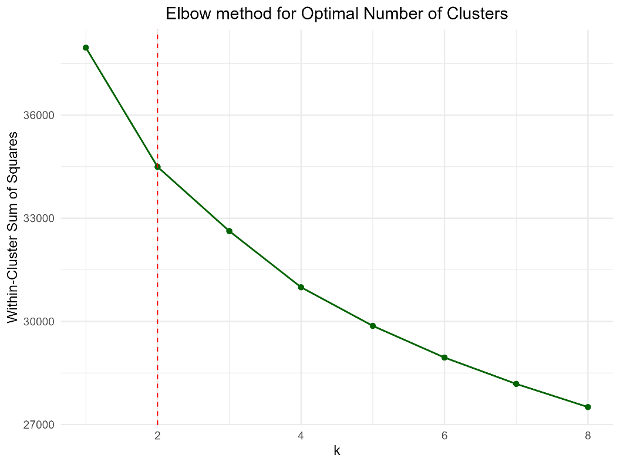
The Silhouette method was also applied to assess cluster quality. The highest average silhouette widths were observed for k = 2 and k = 6, suggesting that both solutions provide relatively well-separated clusters.
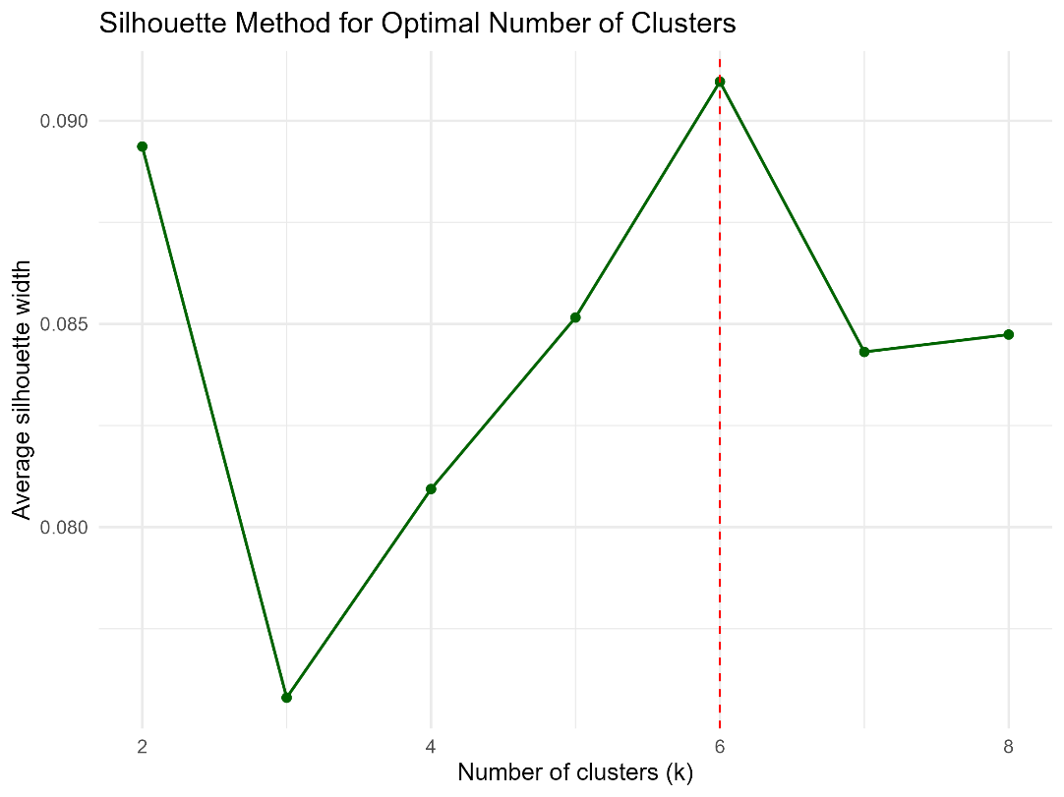
Despite these results, the analysis focuses on k = 3 and k = 4 clusters. These configurations offer a better balance between statistical validity and interpretability, allowing for a more meaningful economic interpretation
Visualization of clusters using the k-means and hierarchical clustering algorithms
K-means | Hierarchical clustering
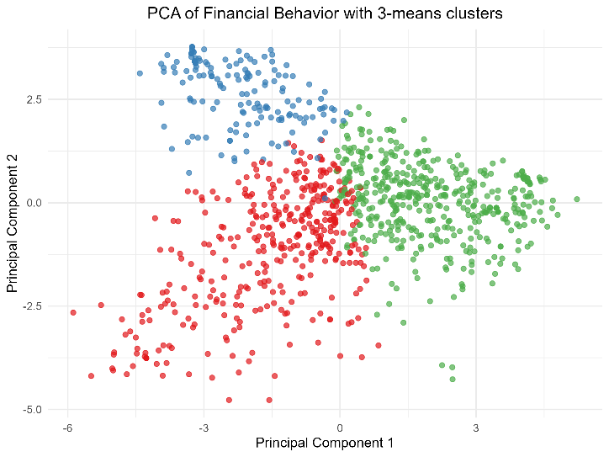 | 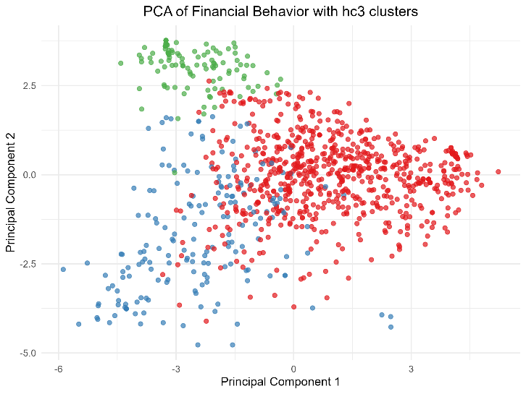
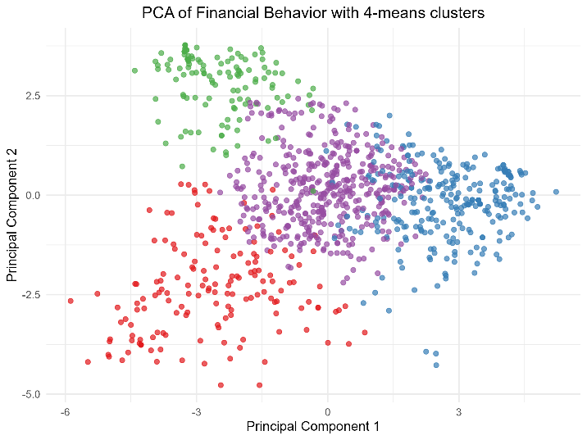 | 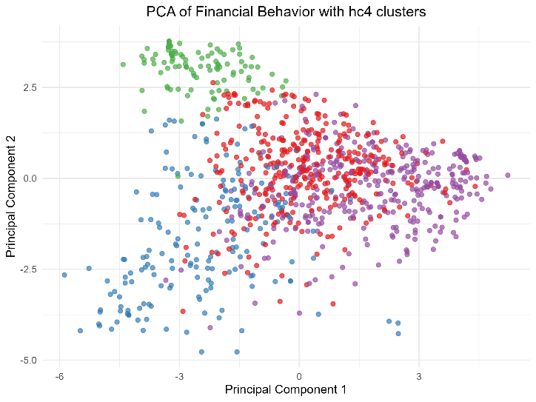

Economic interpretation of the identified groups for k-means algorithm
 | Cluster1 | Cluster2 | Cluster3
Has a debit card | 0,85 | 0,89 | 0,06
Has an account | 1,00 | 1,00 | 0,35
Used a mobile phone or the internet to buy something online | 0,34 | 0,78 | 0,34
Borrowed | 0,44 | 0,96 | 0,35
Applied for a loan using a mobile phone | 0,07 | 0,64 | 0,07
Has a mobile money account | 0,16 | 0,72 | 0,38
Borrowed from a formal bank or similar financial institution | 0,04 | 0,57 | 0,53
Has a credit card | 0,01 | 0,53 | 0,01
Frequency of money sent or taken out of accounts (1 – frequently, 4 – rarely) | 1,99 | 1,49 | 1,90
Received a wage payment | 0,34 | 0,84 | 0,45

Cluster 1 — “Basic account holders with limited digital engagement”
This cluster is characterized by high ownership of basic financial products, such as bank accounts and debit cards, but relatively low engagement with digital and advanced financial services.
Main characteristics:
- All individuals have a bank account (100%) and most have a debit card (85%).
- However, usage of digital financial services is limited: only 34% used the internet or a mobile phone for online purchases, and very few applied for loans via mobile phones (7%).
- Borrowing behavior is moderate (44%), but borrowing from formal financial institutions is rare (4%).
- Credit card ownership is almost nonexistent (1%).
- Wage receipt is relatively low (34%).
This cluster represents individuals who are financially included at a basic level, but remain largely traditional users of financial services, with limited adoption of digital tools and formal credit.
Cluster 2 — “Digitally and financially active users”
The second shows consistently high values across almost all indicators, suggesting a group that is both financially sophisticated and digitally engaged.
Main characteristics:
- All individuals have bank accounts (100%), and most have debit cards (89%).
- Digital activity is very high: 78% made online purchases and 64% applied for loans using mobile phones.
- Borrowing is intense (96%), with a substantial share borrowing from formal institutions (57%).
- Ownership of mobile money accounts (72%) and credit cards (53%) is common.
- This cluster has the highest share of individuals receiving wages (84%).
- Money is moved through accounts relatively frequently (mean = 1.49, where 1 is frequent).
This cluster can be described as highly financially included and digitally advanced, representing individuals who actively use a wide range of financial products, including digital payments and formal credit.
Cluster 3 — “Partially included and irregular users”
The third cluster displays mixed characteristics, with lower ownership of traditional banking products but moderate engagement with some financial services.
Main characteristics:
- Only 35% have a bank account and very few own debit or credit cards.
- Digital purchasing is limited (34%), like in the first cluster.
- Borrowing exists (35%), and notably, borrowing from formal institutions (53%) is higher than in Cluster 1.
- Mobile money account ownership is relatively moderate (38%).
- Wage receipt is moderate (45%).
- Frequency of account use is lower than in the second cluster (mean = 1.90).
This cluster represents individuals who are partially financially included, possibly relying on specific financial services (such as formal loans or mobile money) without broad access to traditional banking infrastructure.

4.Demographics

