

**Name: Aminah Tariq**

**Roll no: SP24-BSE-011**

**Course name: Object oriented programming**

**Teacher name: M. Shahid Bhatti**

**Assignment no: 02**

**Due Date: 22-11-2024**

**JAVA FX STUDENT FORM**

**Person Class:**

Attributes:

1. Name
2. Father name
3. Cnic
4. Date of birth
5. Gender
6. City

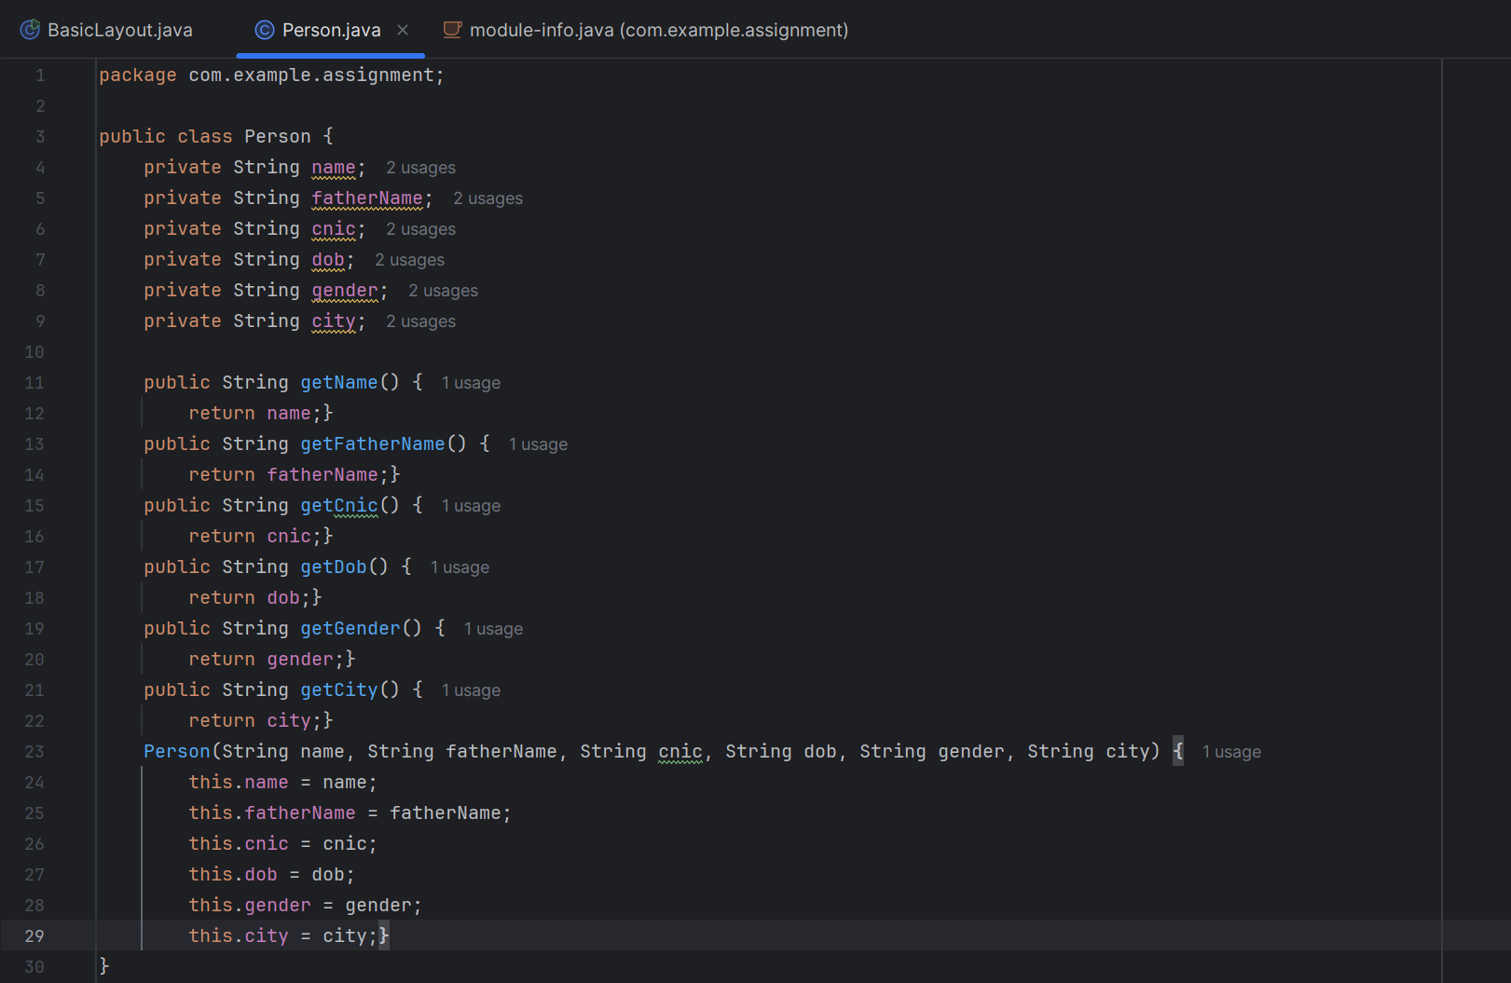

**Banner Class:**

Class includes java fx code and a person class arraylist to store the input taken from the gui, function displaystudents() is used to display all records saved in the arraylist

Different color codes are taken from the web for the design purpose.

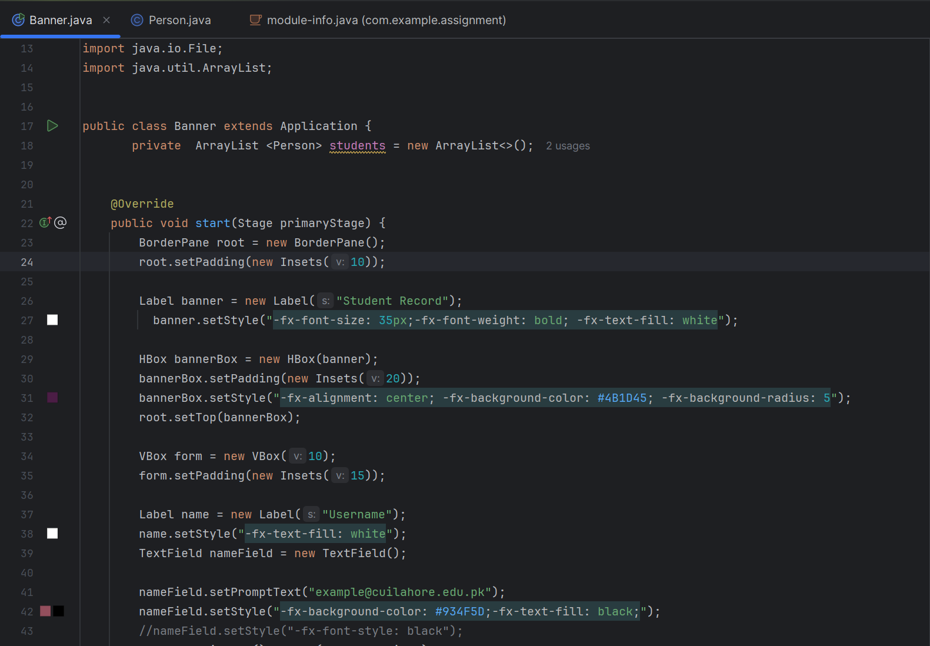

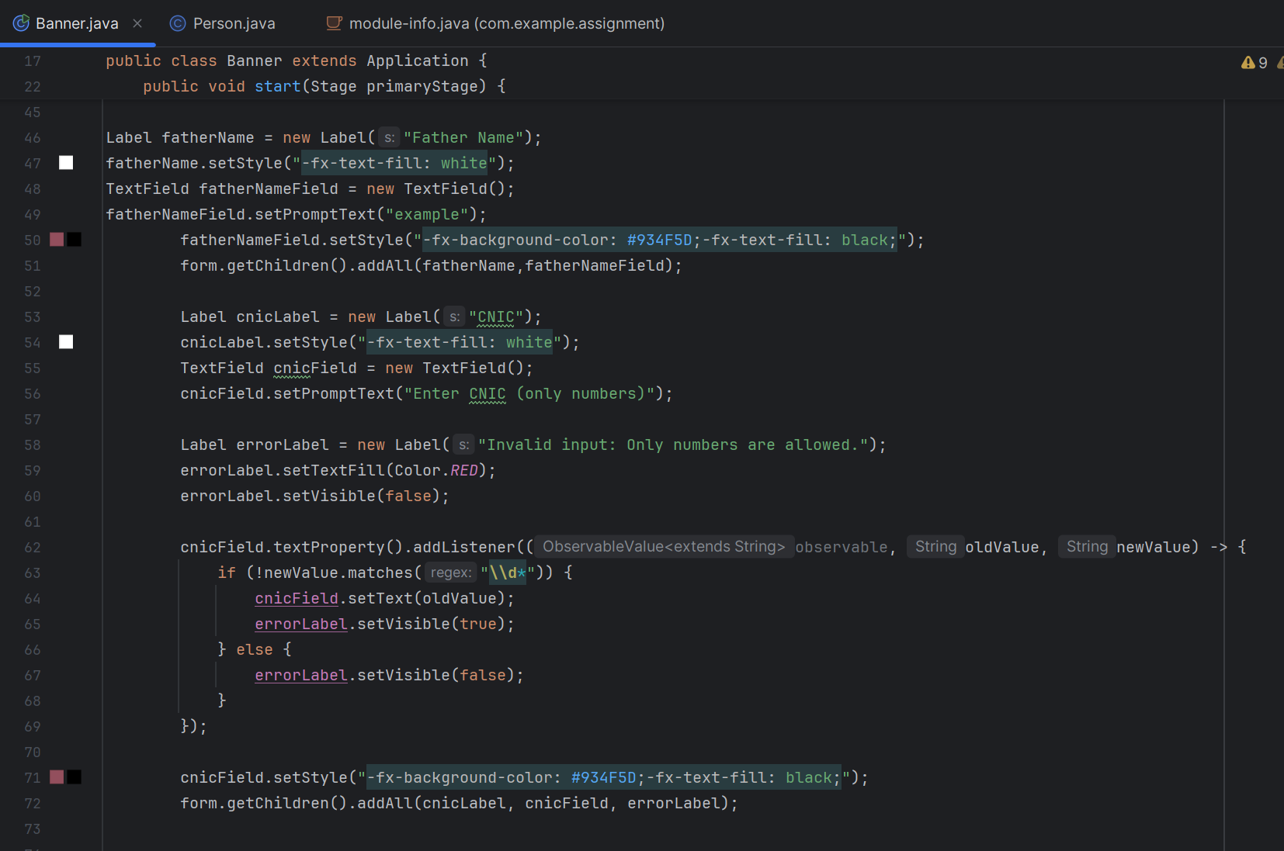

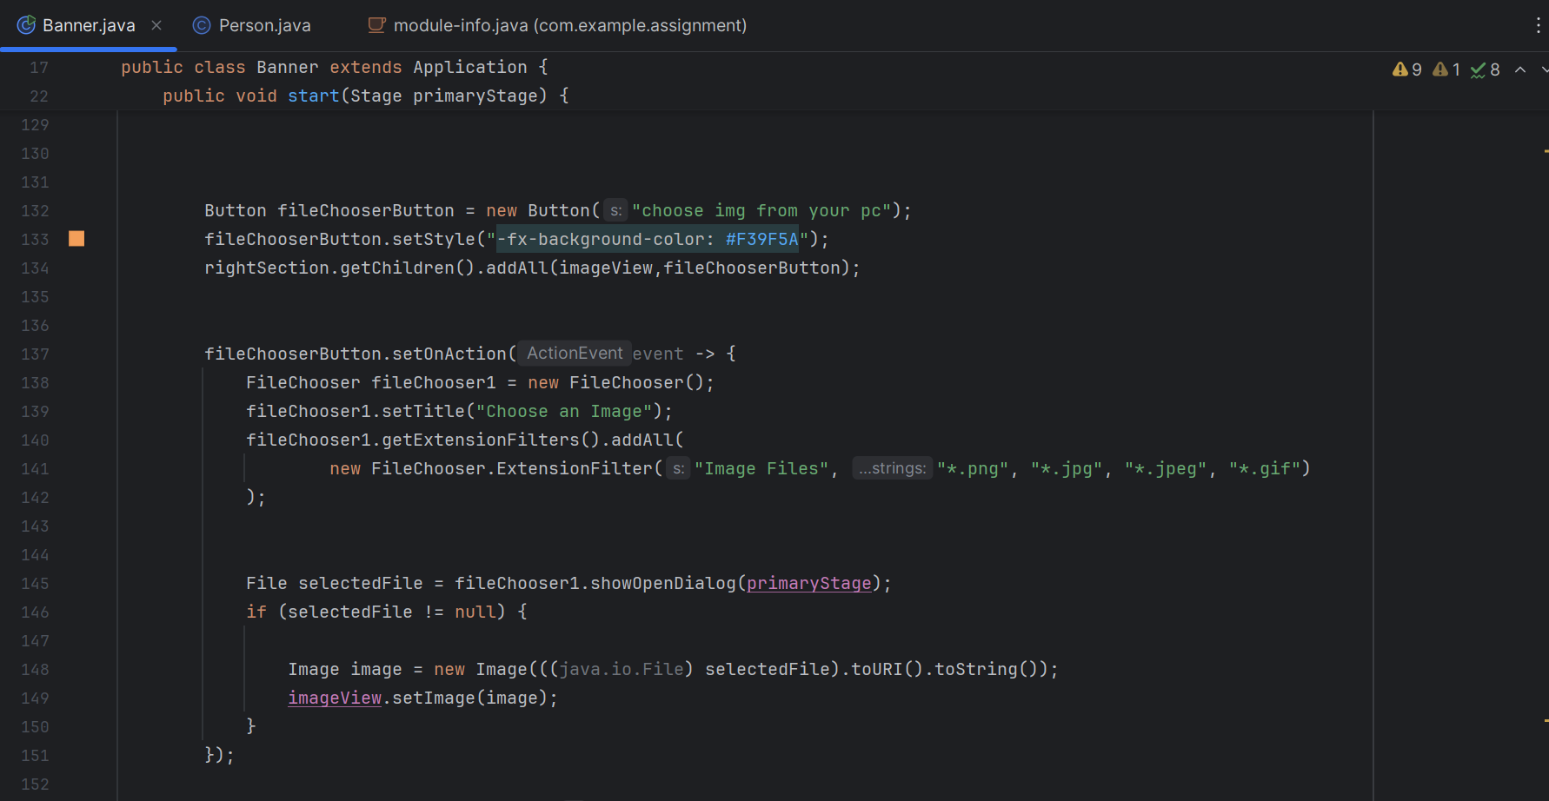

File chooser button:

This button allows us to chose an image file from our system to be displayed on the form

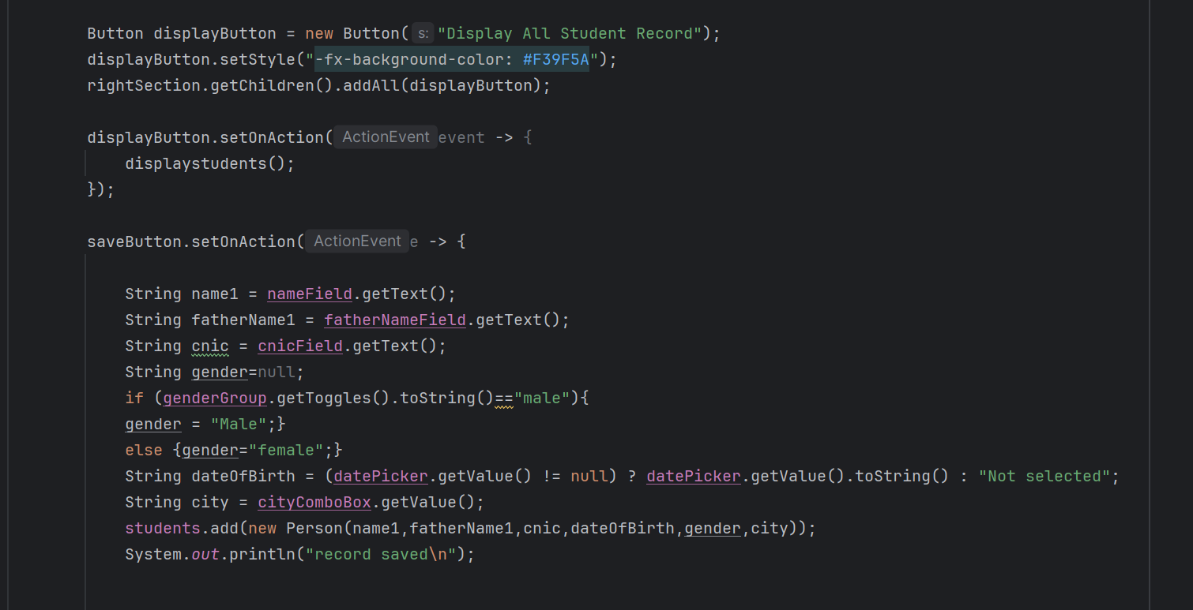

Display button:

It is used to display all of the records that are saved from the form in the arraylist

Saved button:

It is used to save the record in the arraylist

OUTPUT:

When code is compiled this is how record form is displayed on the screen

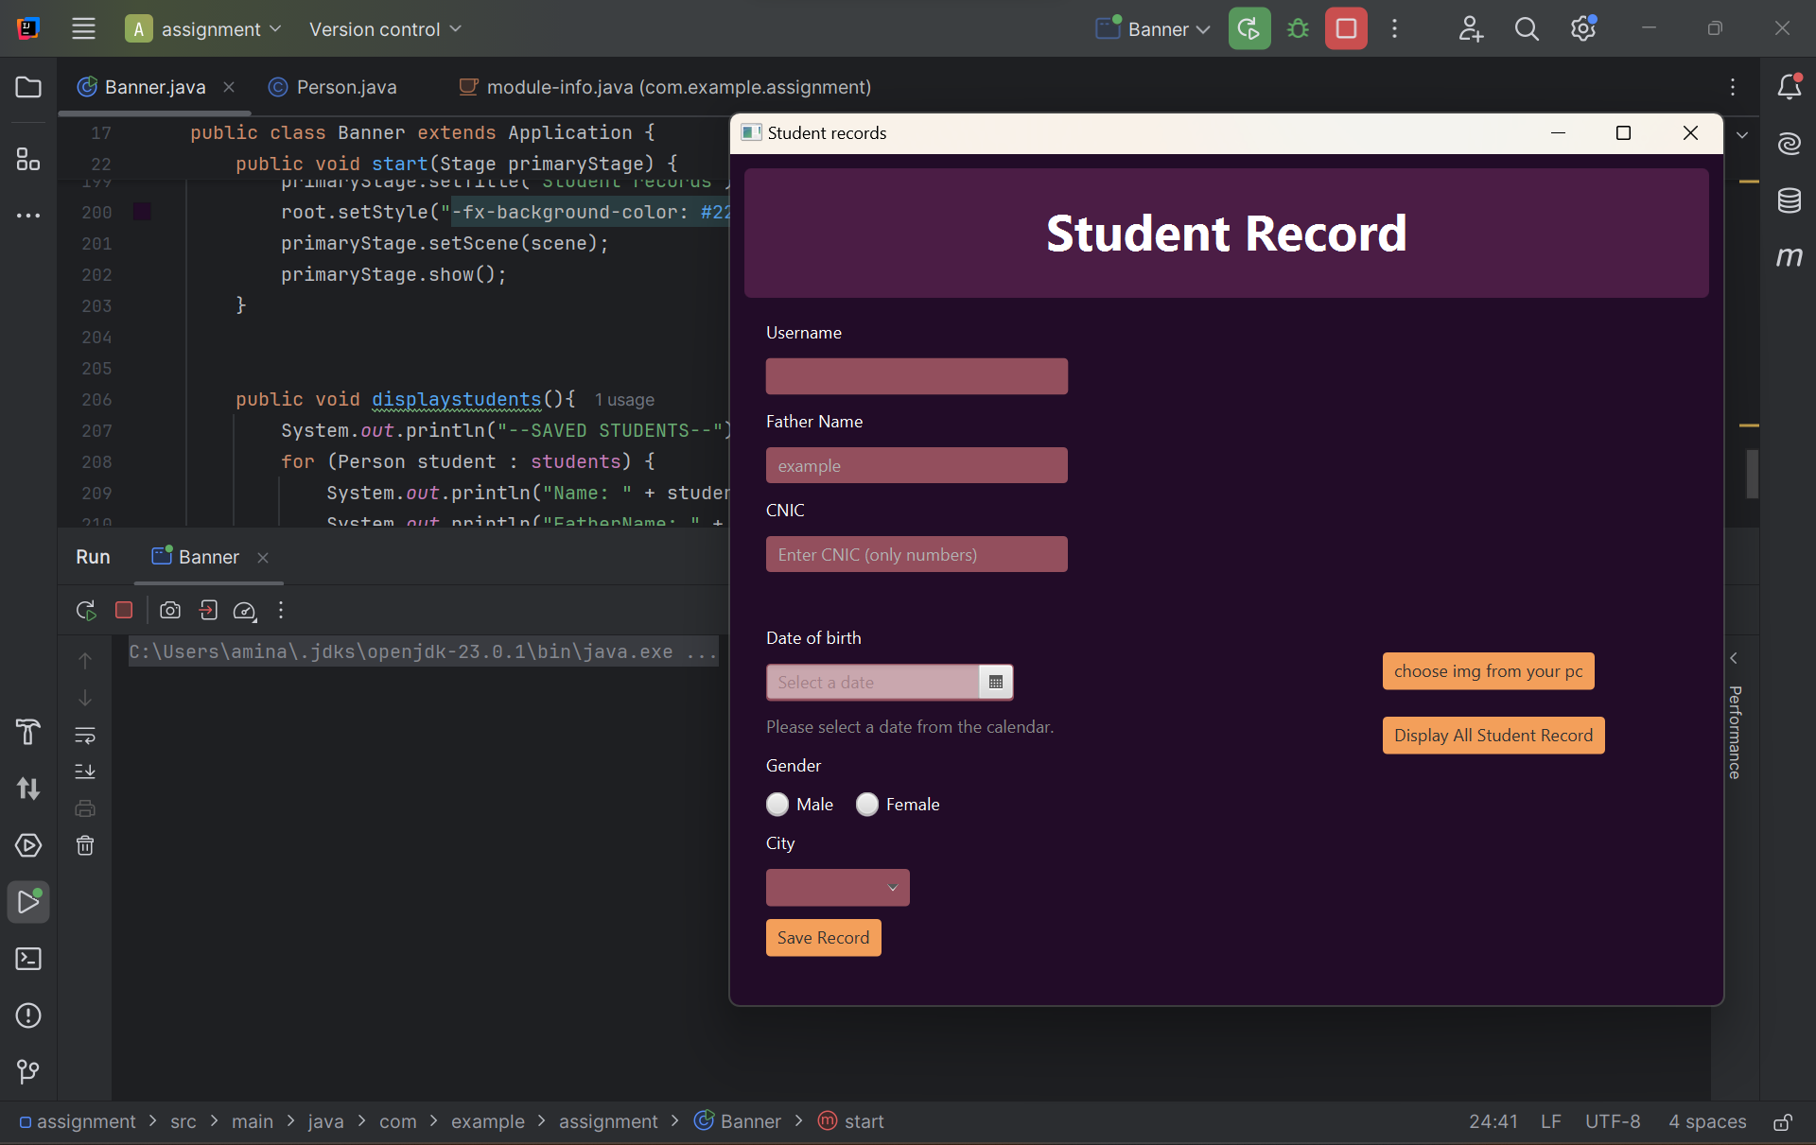

When a record is entered and saved in the array list

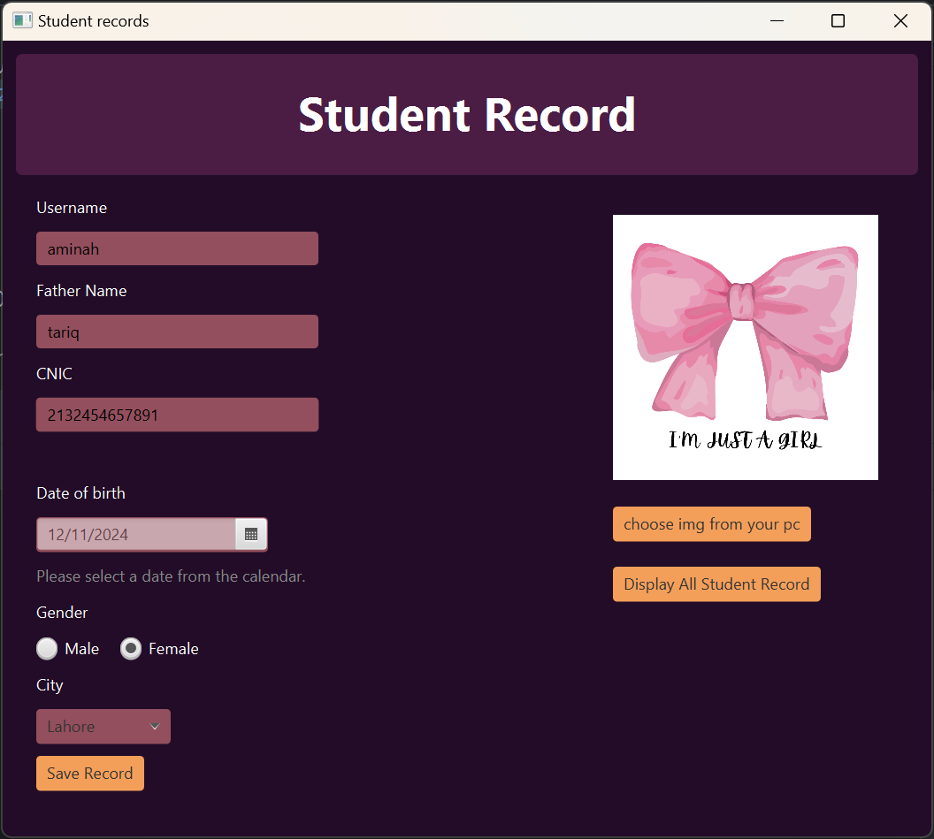

When the record is saved by the “save record button”



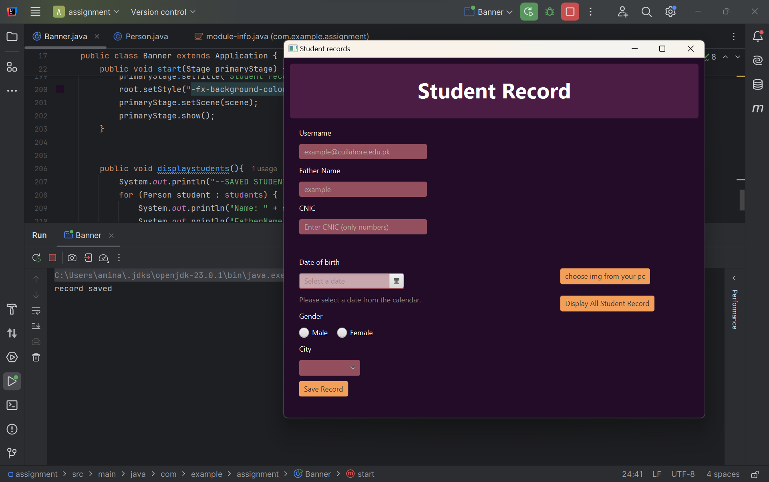When record is saved and displayed by the “display all records button 