

|  |  |
| --- | --- |
|  |  |
| Names: | **Registration numbers:** |
| Aminah Tariq  Adina Zafar  Ayesha Arshad | Sp24-bse-011-B  Sp24-bse-006-B  Sp24-bse-019-B |
| Assignment number: | 3 |
| Course instructor: | Prof Shahid Bhatti |
| Due Date: | 12-12-2024 |

**CLASSES:**

This diagram illustrates the core structure and relationships between the classes in the project. Each class represents a specific functionality or component of the Blood Management System

E**ntity Classes**: These represent core objects like donors, donations, and users. They define the attributes and methods related to these entities.

**Service Classes**: Handle the business logic, such as processing donations, managing donor information, and retrieving donation history.

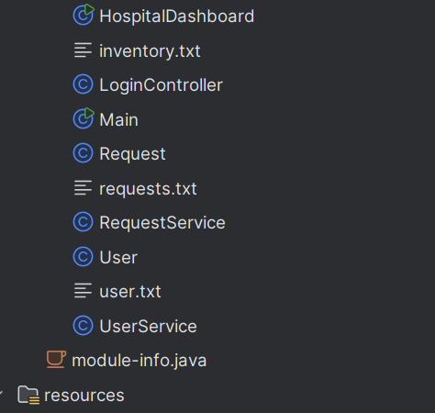**Controller Classes**: Manage the interaction between the GUI and backend, acting as a bridge to facilitate user actions and system responses.**Utility Classes**: Provide helper functions like file handling and data processing to support the main operations. 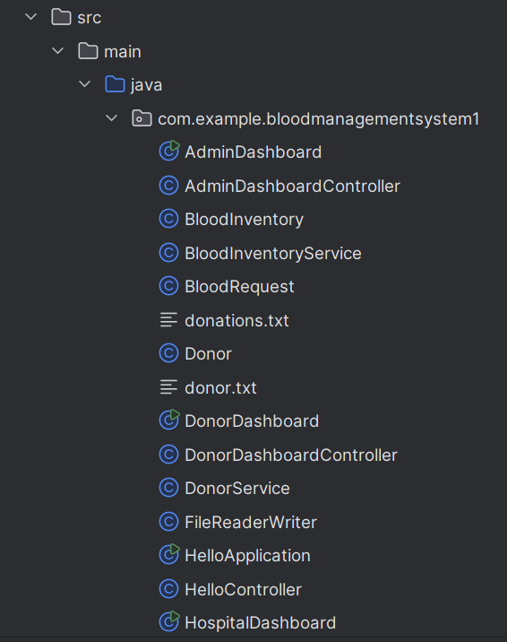

**BLOOD BANK SYSTEM**

**Login Page :**

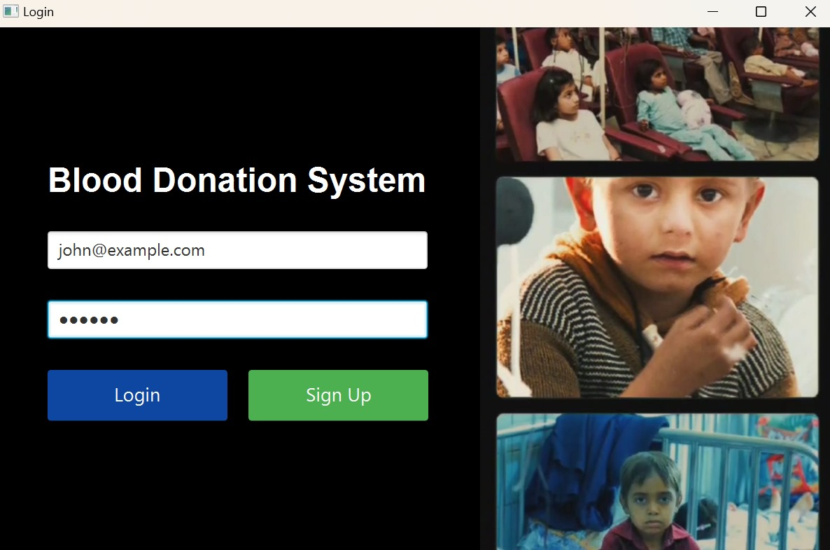

here, john is a donor who signed up as donor and thus has his data saved at donor.txt file and thus can now log in into the blood bank system

And you can also signup into the sytem if u are not already loggedin

The signup credentials are asfollows:

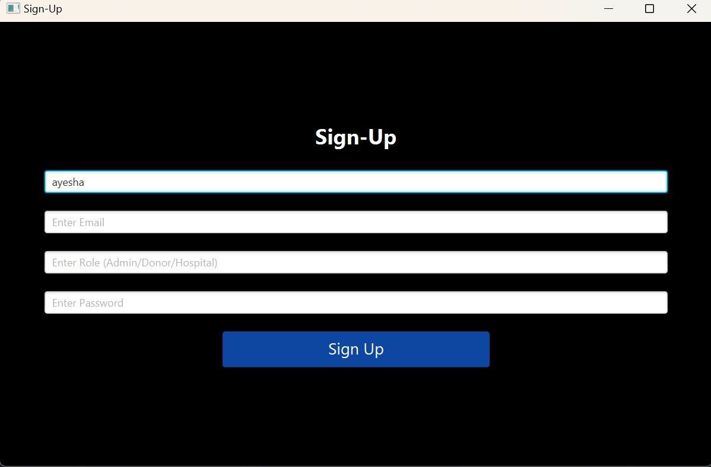

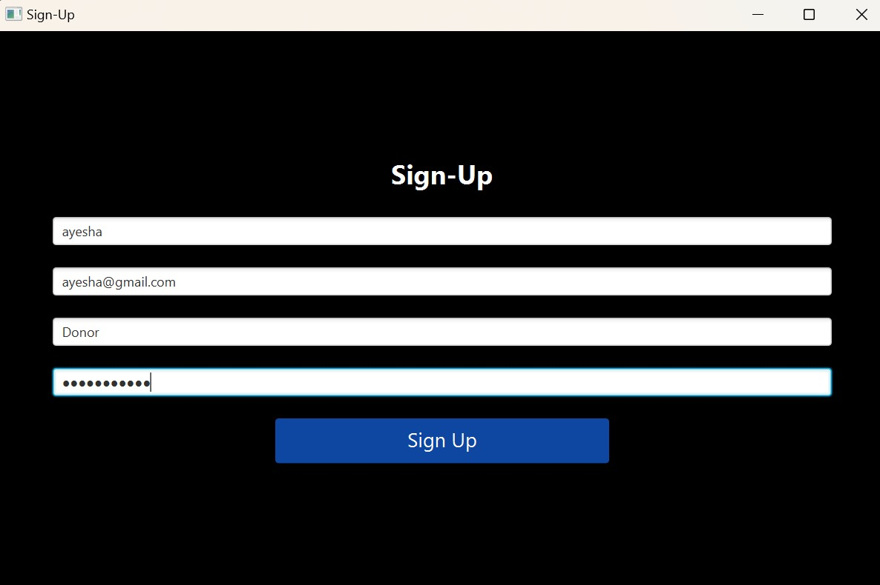

**Donor Login**

The Donor Login interface is designed to allow donors to securely enter their details and contribute to the blood management system.

**Key Features:**

**Personal Information Input:** Captures donor's name, age, and contact details.

Blood Group Selection: Allows donors to specify their blood group.

**Donation Details:**

**Date and Time:** Records the exact date and time of donation.

**Bottles Donated:** Tracks the quantity of blood donated.

This ensures that the system maintains accurate and up-to-date records of all donations.

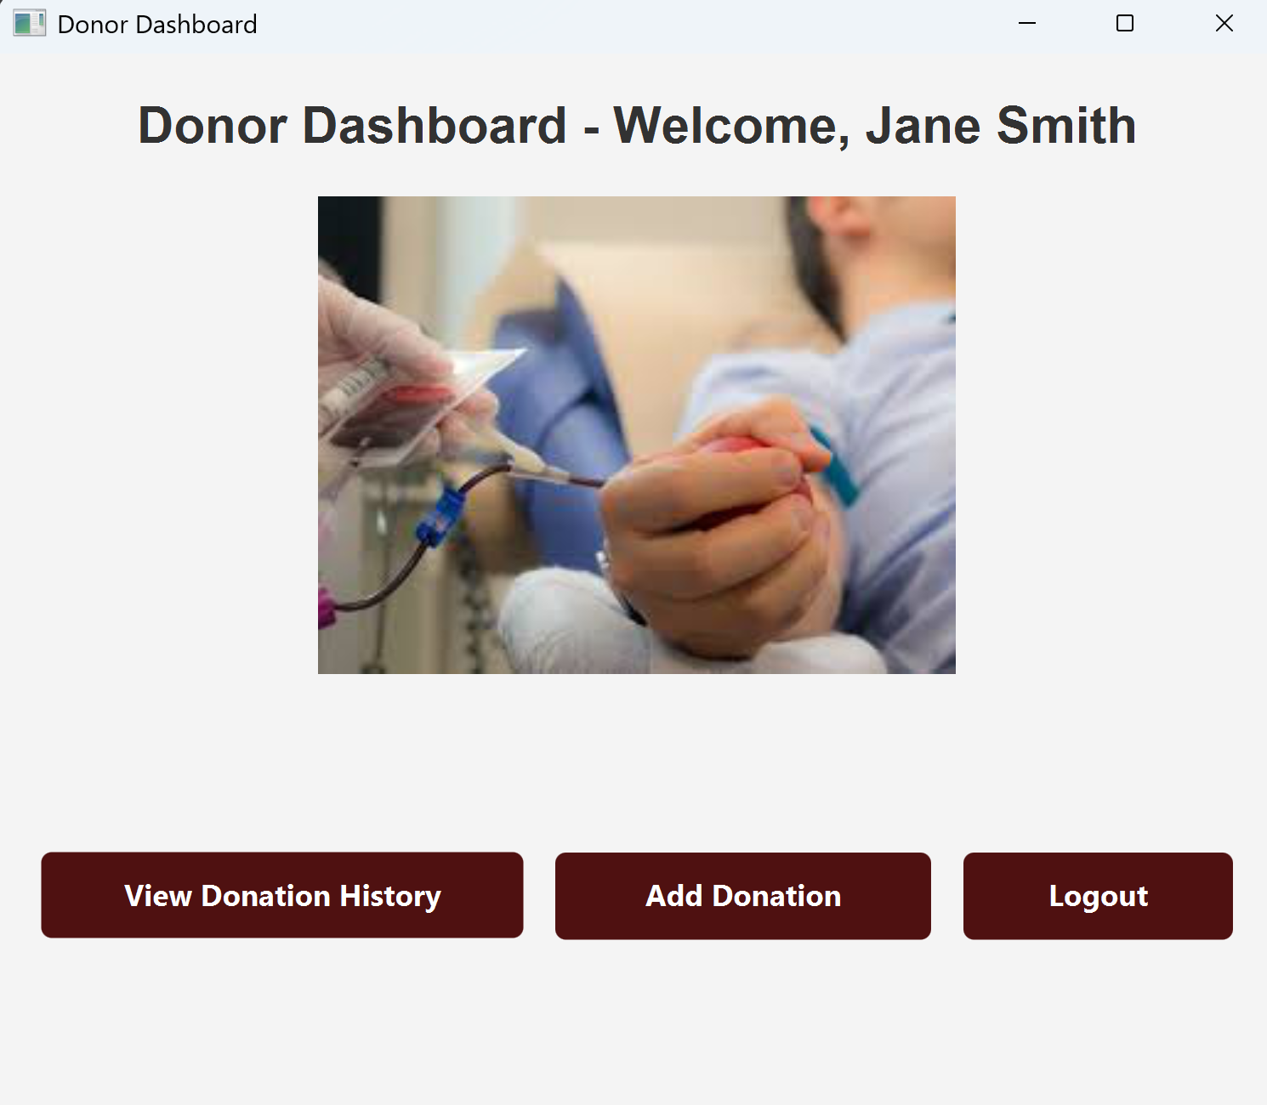

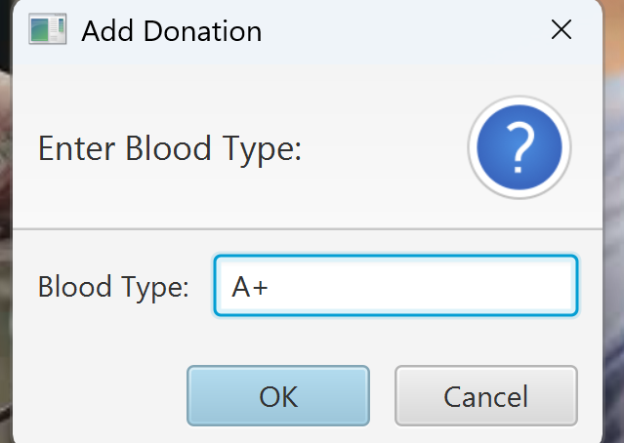

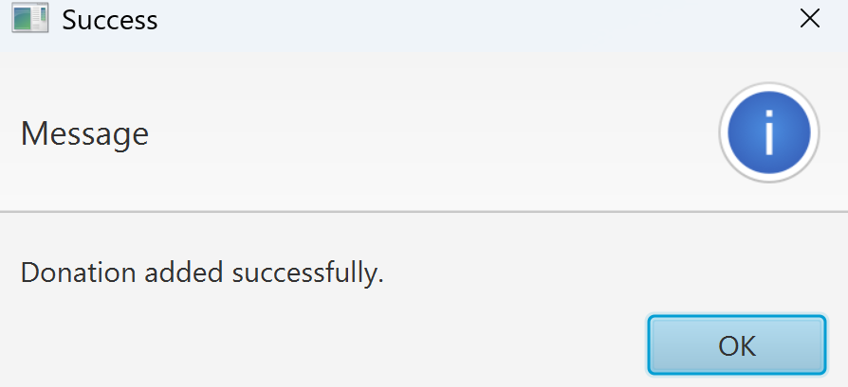

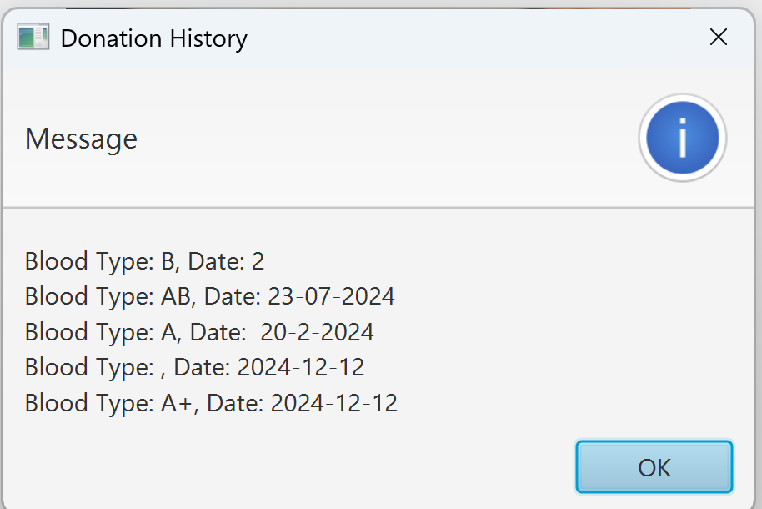

**Admin Login**

The Admin Login is intended for system administrators who oversee the entire blood donation process.

**Key Features:**

**Comprehensive Access**: Enables the admin to view the complete history of donations, including donor details and blood group statistics.

**Data Management:** Facilitates monitoring and updating of stored data for efficient blood stock tracking.

**System Oversight:** Ensures proper functioning of the system by managing any discrepancies in data.

The admin interface provides a centralized hub for effective system management.

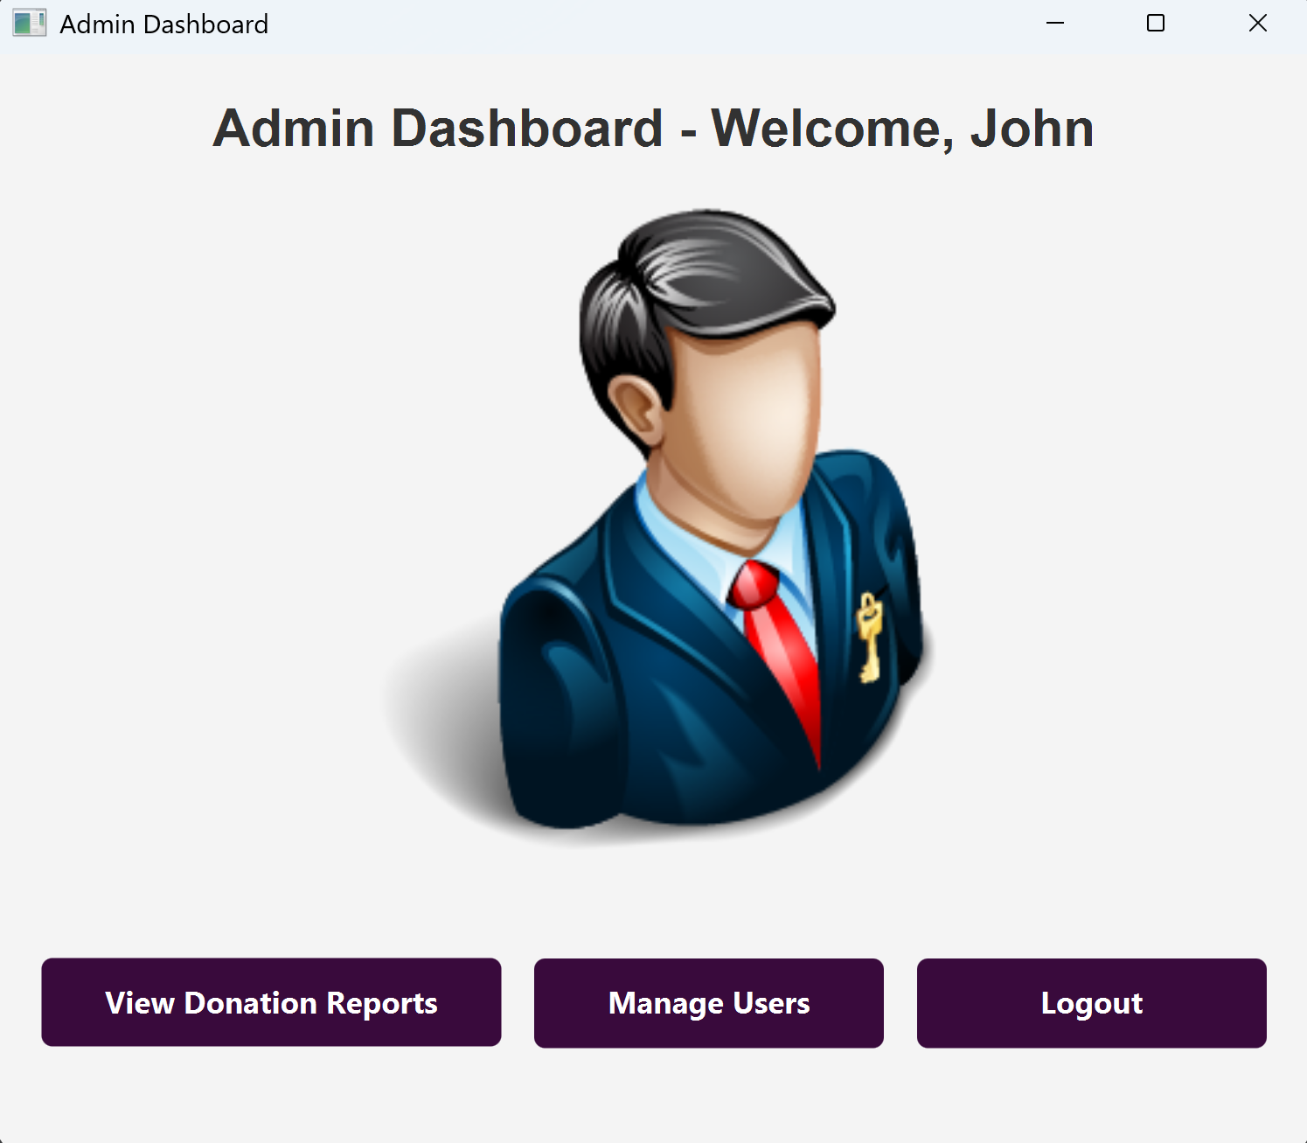

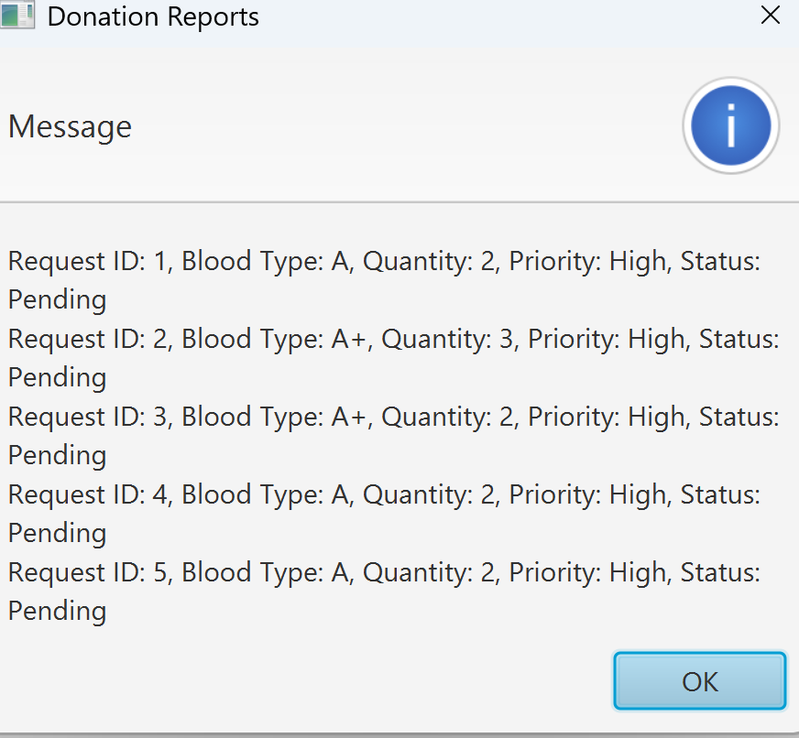

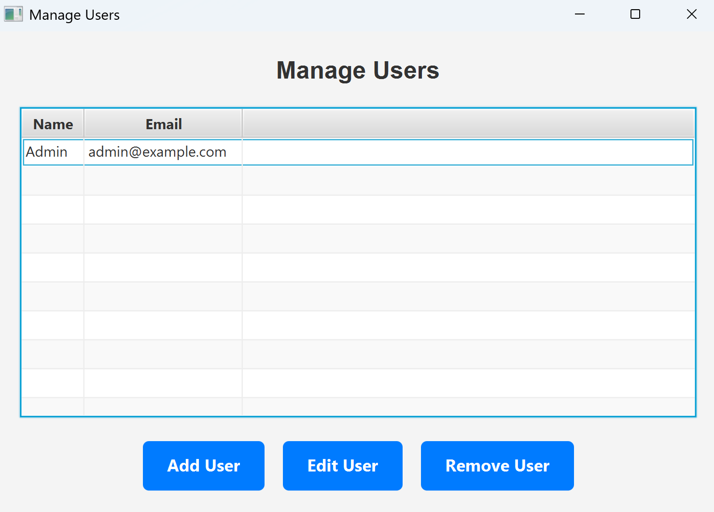

**Hospital Login**

The Hospital Login interface is tailored for hospitals to manage users and blood donation data.

**Key Features:**

**User Management:** Allows hospitals to view and manage donor and admin profiles.

**History Access:** Provides hospitals with access to historical data of donations and available blood stocks.

**Data Monitoring:** Ensures accurate tracking and availability of blood for emergencies and routine usage.

This login type empowers hospitals to collaborate seamlessly with the system, ensuring efficient blood usage.

Each login type is represented with a tailored interface and dedicated functionalities, enhancing the system's usability and efficiency. With clear role-based access control, the login system ensures security and precision in managing the blood donation process.

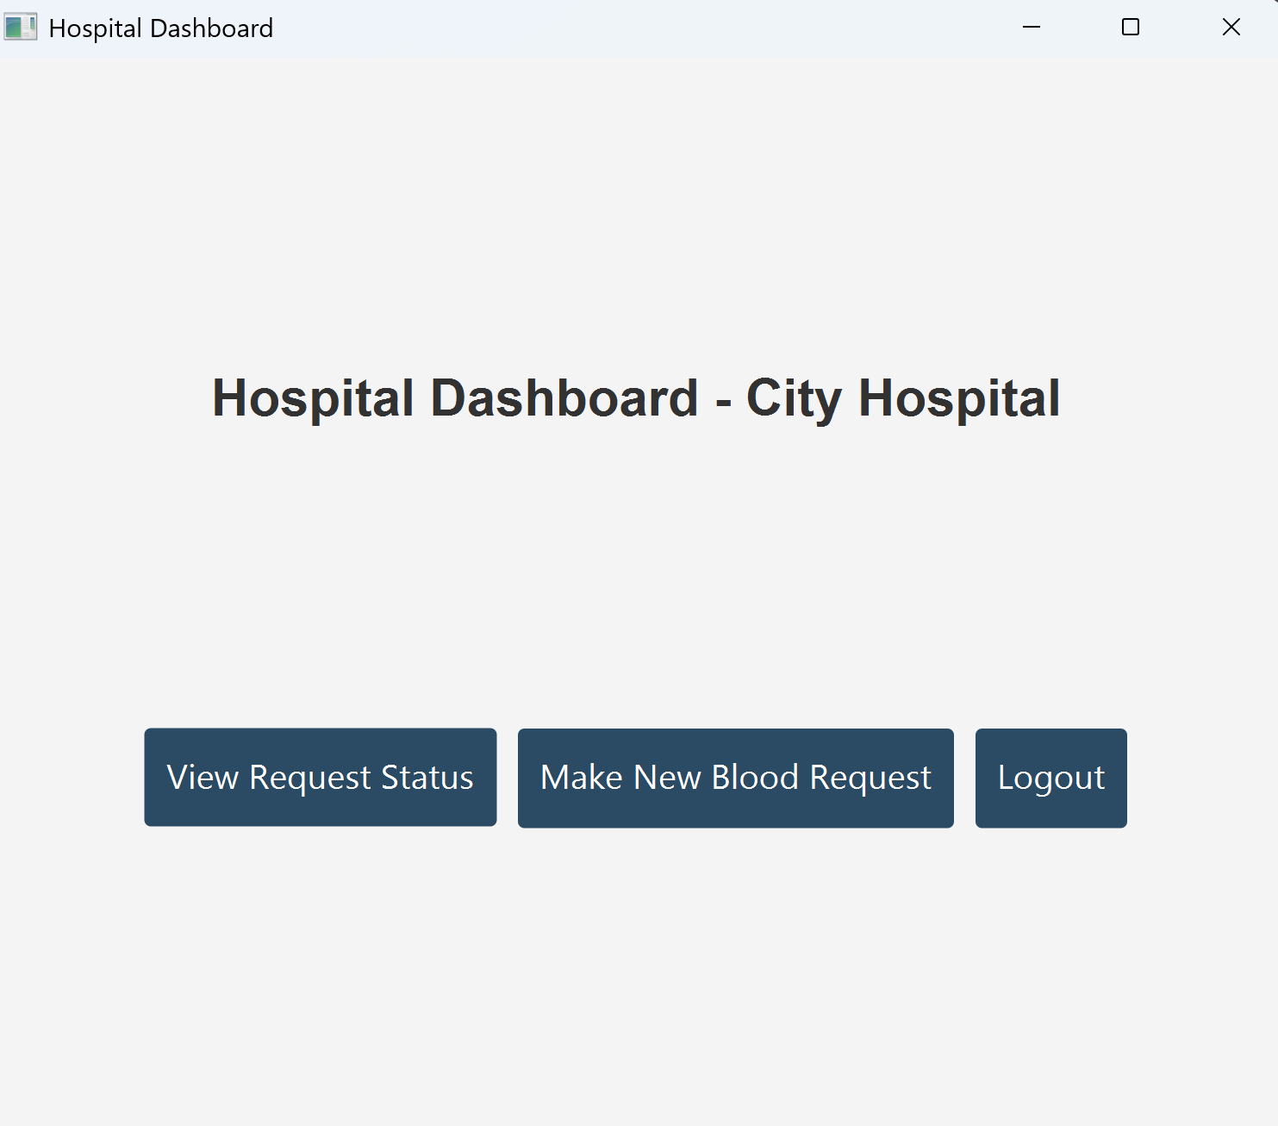

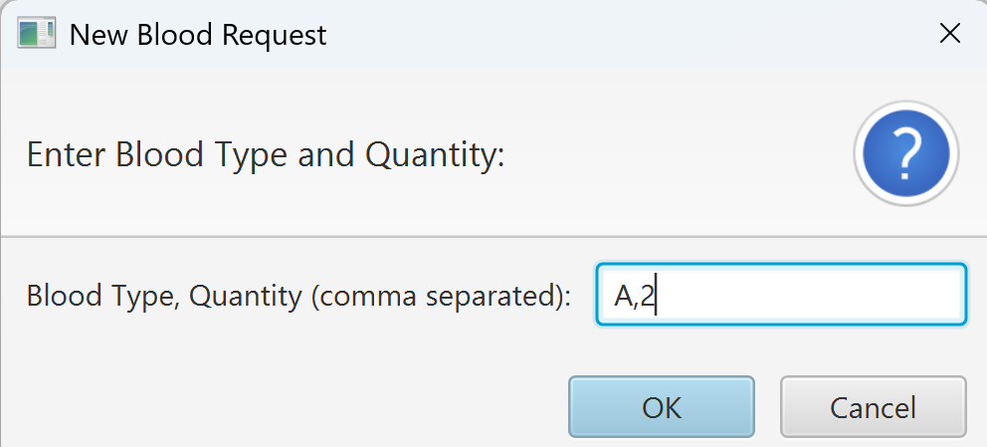

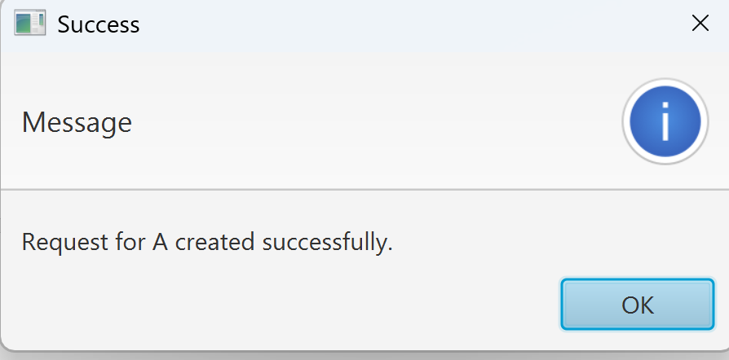

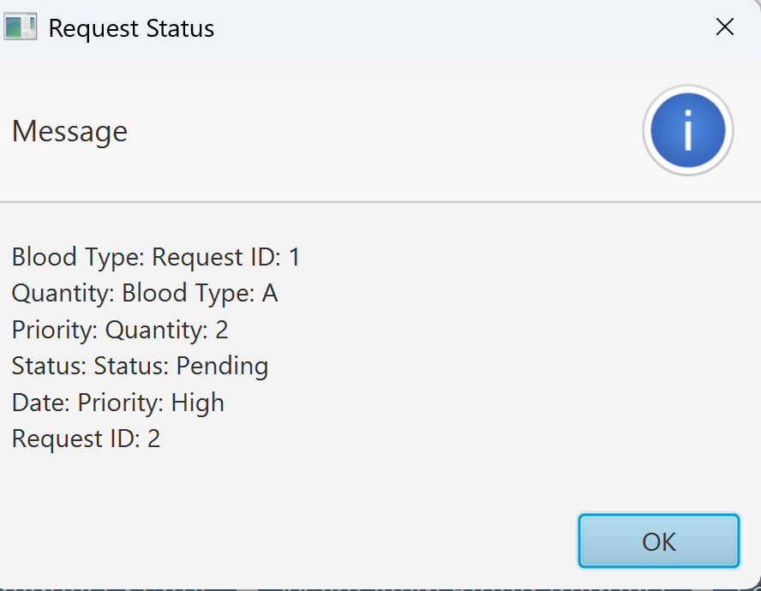

Donor Text File (donor.txt)

This file maintains a record of all donors in the system. Each time a new donor is added through the Add User button, their details are appended to this file.

Data Stored:

Donor ID

Name

Age

Contact Information

Blood Group

Last Donation Date

The file allows seamless access to donor data for operations like fetching donor history or managing their information.

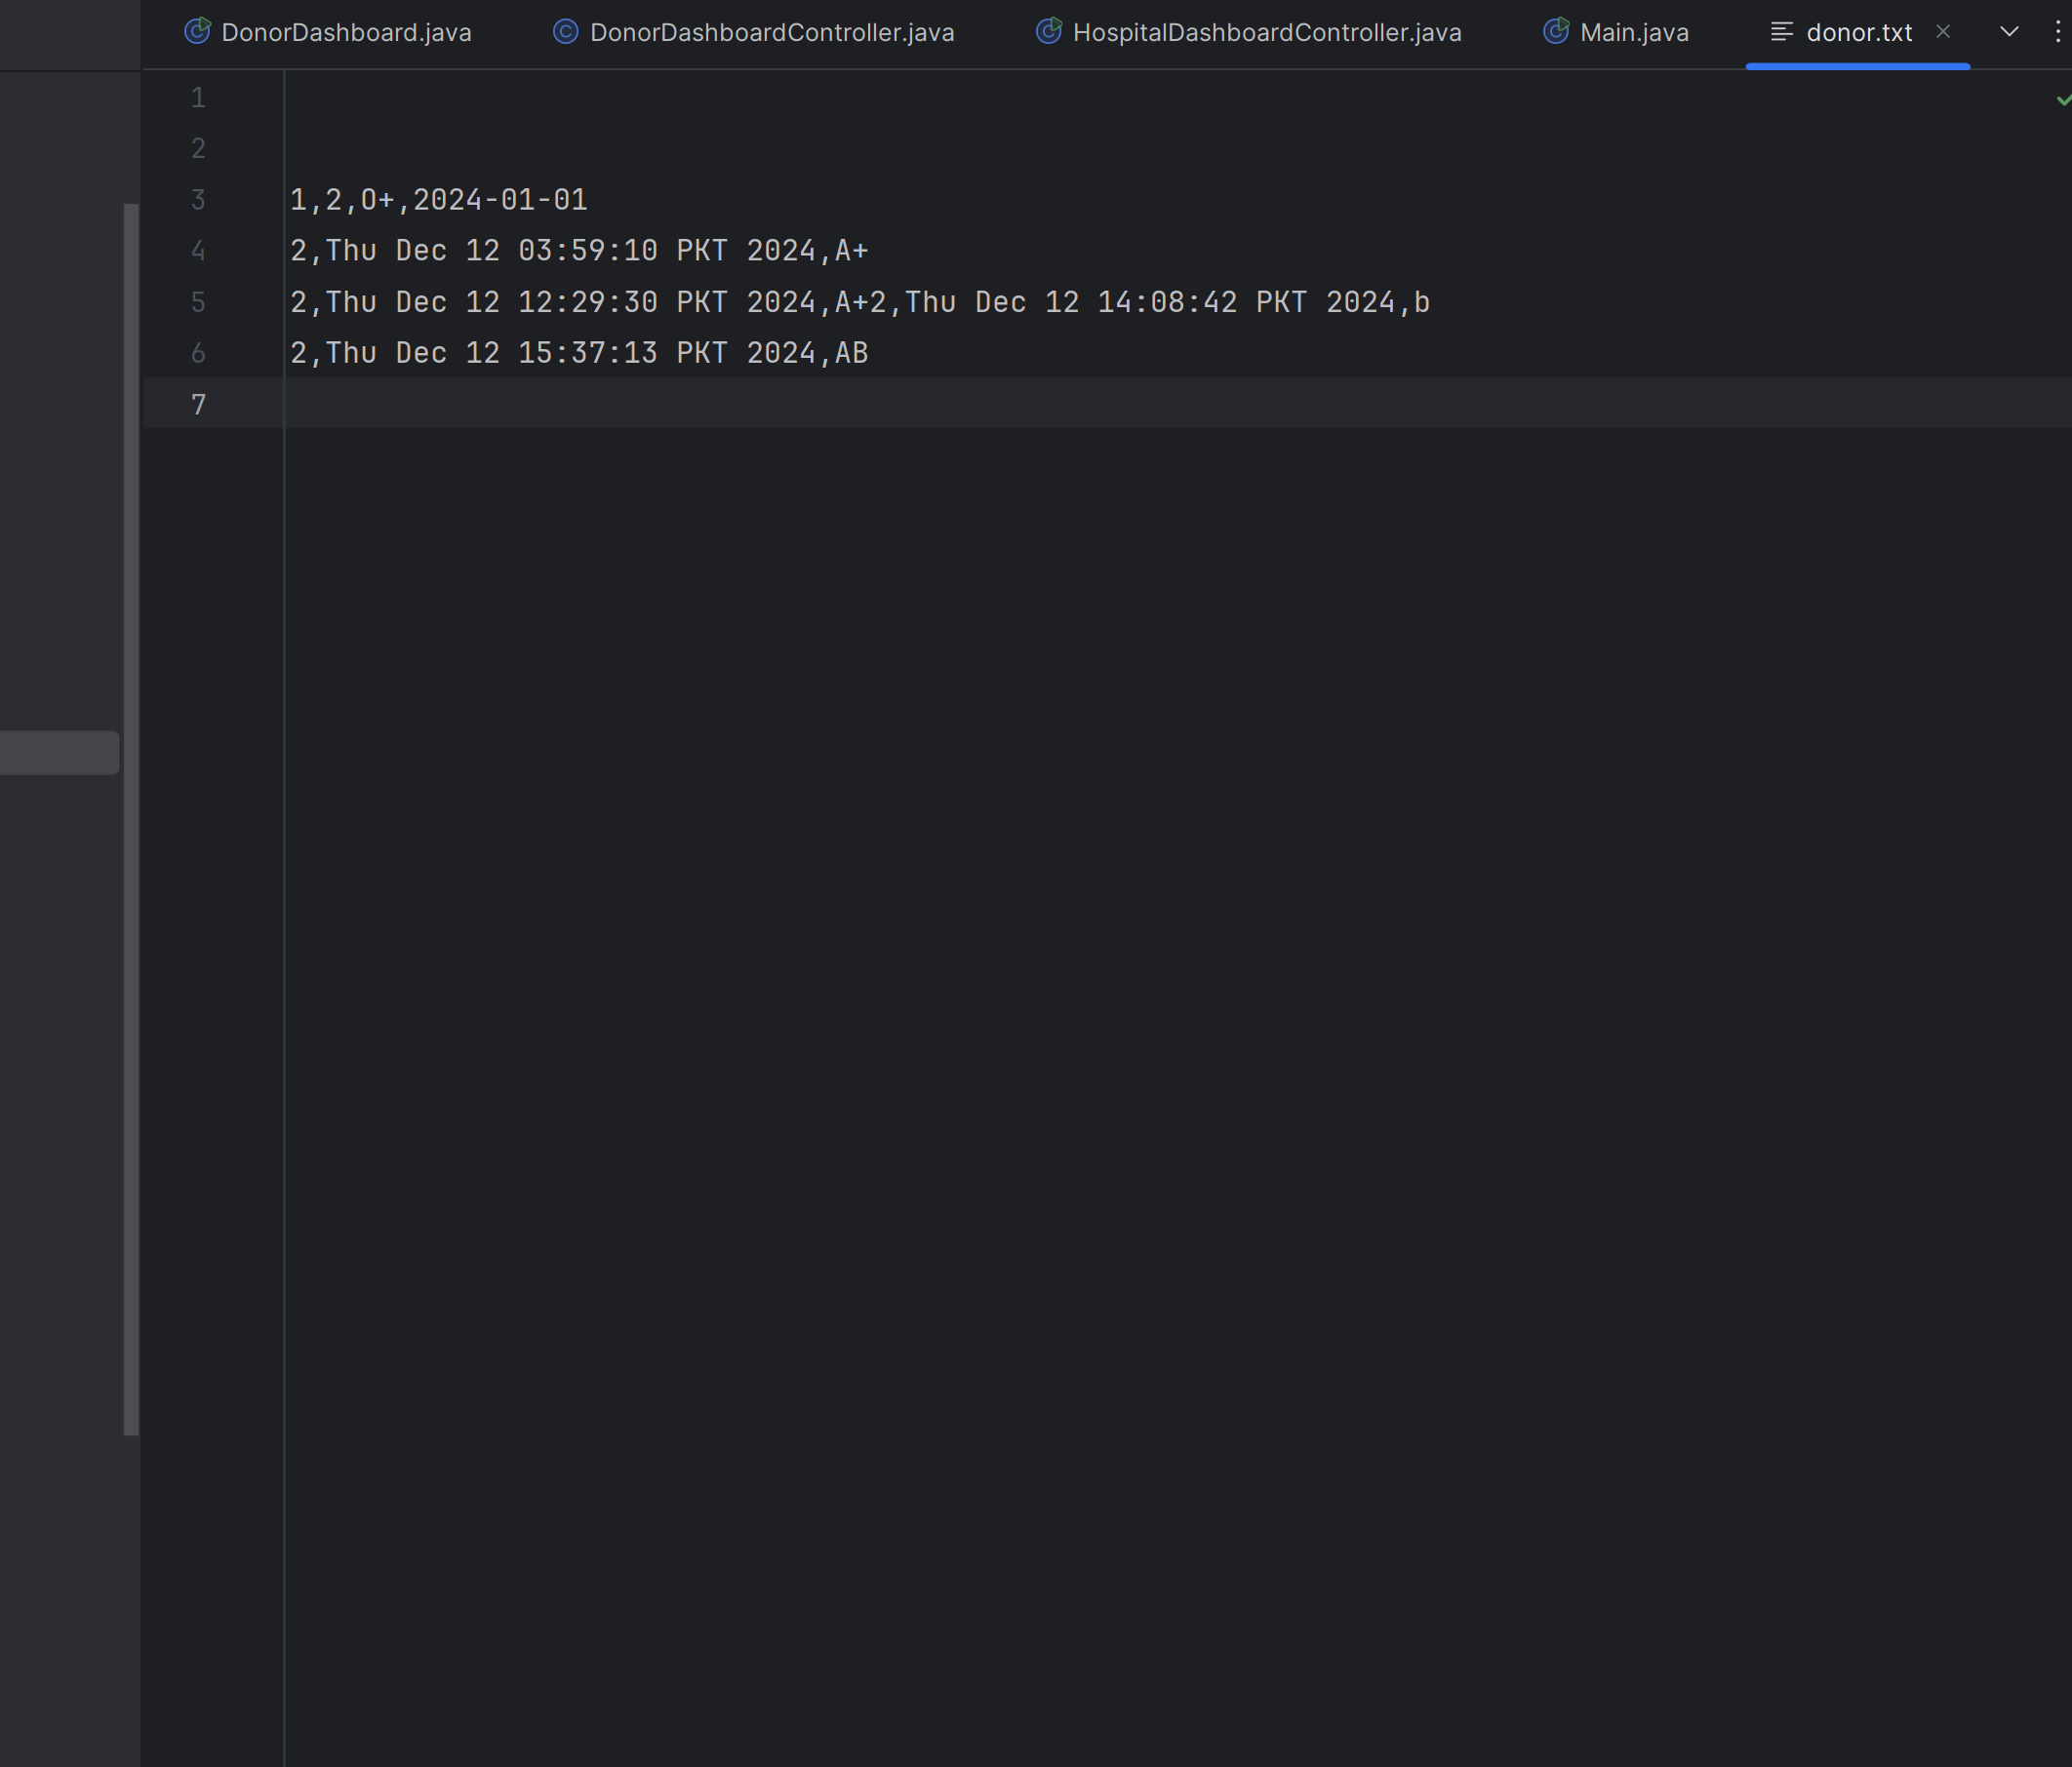

Donations File (donations.txt)

This file maintains a comprehensive record of all blood donations made by donors. Each donation entry is appended to the file upon completing the donation process via the Add Donations button.

Data Stored:

Donor ID

Blood Group

Number of Bottles Donated

Date and Time of Donation

Purpose:

To track the history of blood donations.

To generate detailed reports for inventory management and donor contributions.

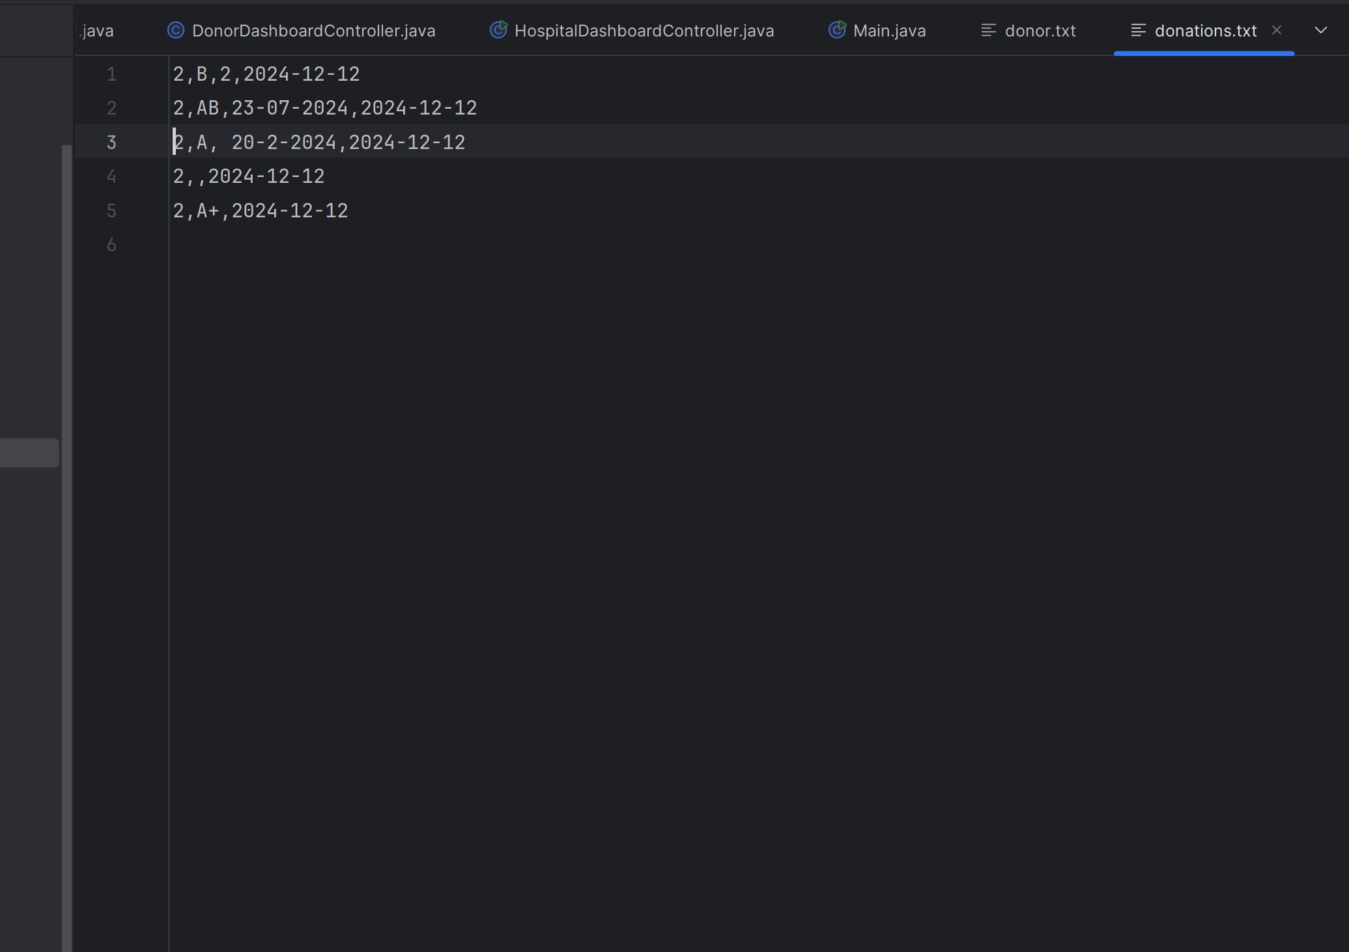

User File (user.txt)

This file handles the user data for all system users, including donors, admin staff, and hospital representatives. The Add Users and Manage Users buttons interact with this file.

Data Stored:

User ID

Name

Role (Donor, Admin, Hospital)

Contact Details

Credentials (encrypted passwords for security)

Purpose:

To manage system users effectively.

To provide secure login functionality for different roles.

