Getting Started Guide

**Load File Utility (LFU)**

**Opening the application**

Double-click the LFU.exe shortcut on your desktop:



The user interface is displayed:

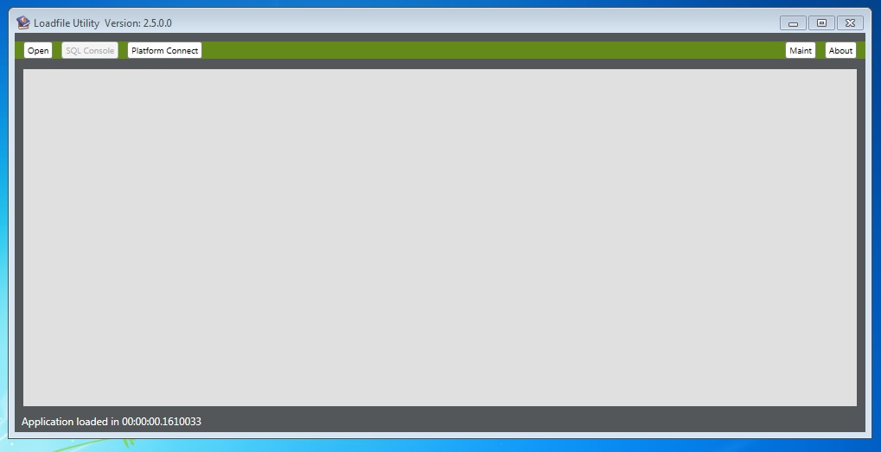

**Control Descriptions:**

***Open*** – This button is for importing the load files into the application.

***Platform Connect***: This section is for connecting the application to Law platform.

***Maint***: In this section users can have access to temporary databases built from load files.

***About***: A help button and configuration file is located in this part.

**Opening a load file**

Click on the Open button and select a flat file.

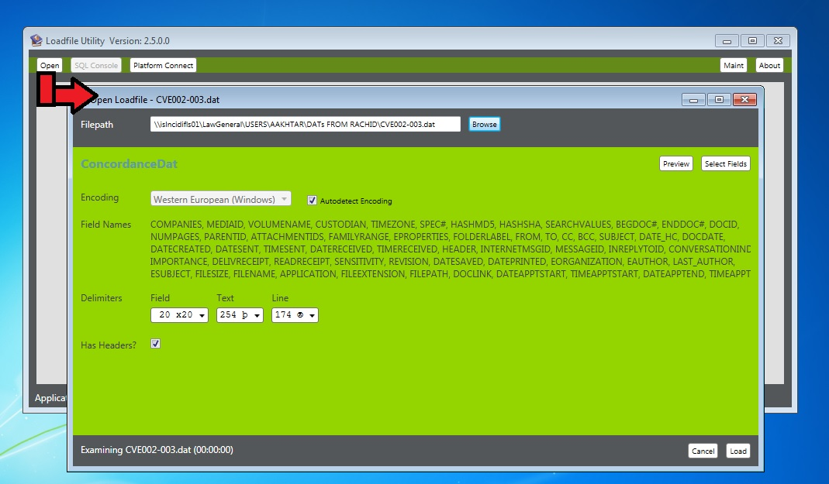

In this section, the load file can be imported completely or partially. Uses can skip importing unnecessary columns by clicking on Select Fields button.

Preview section is built for looking at first few rows of the load file before loading the whole file into the application.

**Paging**

On the top of each tab the paging buttons are located. Users can pick how many rows should be visible in each page. After changing the number in the size text box and pressing the Tab we can see the rows in the data grid. However showing many rows are not recommended, it is possible to see all the rows in the load file here. The default value for each page is 500 rows each page.

**\\islncidifls01\LawGeneral\USERS\AAKHTAR\Dev\Projects\LoadfileUtility_2016\06-07-16\LoadfileUtility_2.5\Doc\Paging.jpg**

Note: When we update a column using the SQL console or buttons, the change applies on all rows regardless of number of visible rows in each page. For example if we see the first 500 rows, and we update a column, we will update the whole 100,000 rows of the file.

With next and previous buttons we can go through all the rows in a load file page by page.

**SQL Console**

Since the flat file is loaded into a SQL table, users can run SQL Commands on the load files using SQL Console. One of the most interesting part of the application is having an intelliSense in the SQL console! As you can see in the example, the SQL command box would suggest the reserved keywords as well as the name of the tables built from the load file names.

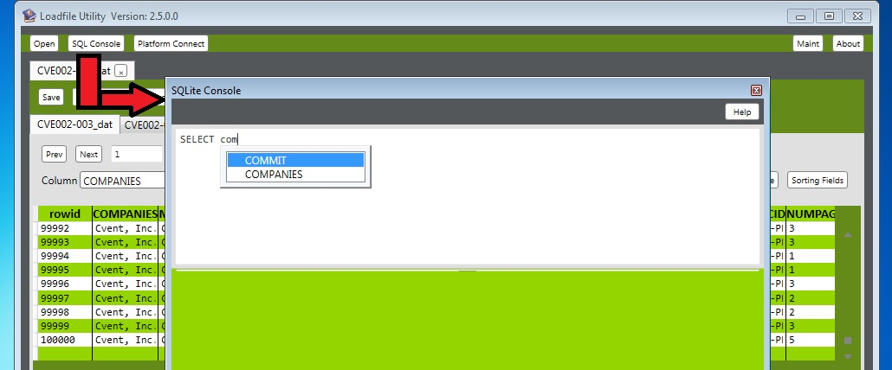

Users may save the result of their queries in a separate file.

**Drop**

A column can be removed using the drop button. Users should select the right column that should be removed from the combo box and press the drop button to remove the column from the data grid. After removing the column data grid is refreshed automatically and users can see the result immediately.

\\islncidifls01\LawGeneral\USERS\AAKHTAR\Dev\Projects\LoadfileUtility_2016\06-07-16\LoadfileUtility_2.5\Doc\Drop.jpg

**Add**

After pressing add button, a window for adding more empty columns will pop-up. Users can type the column name and press enter to add it to the list of columns. After All columns are added, user can go ahead and press Ok.

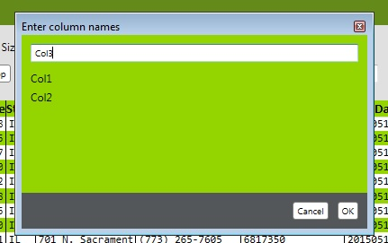

All extra columns will appear in the data grid.

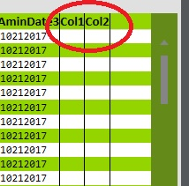

**Sort/Refresh**

The Sort/Refresh button refreshes the view and it shows the changes that we made in back end. After updating the load file press this button to see the result in the data grid.

**Index**

As you might have noticed we imported the data into a SQL database and now we are working with the database through the user interface. Index button creates an index on a column and makes filtering and sorting on that column much smoother. For using the Index button, select a column that you want to build an index on it in the combo box and press Index.

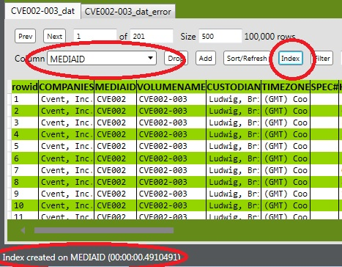

In the toolbar users are notified by a complete index message.

**Filter**

Filtering on a selected column with a specific value in the textbox is possible. For example in the below image we can see that “Sacrament” term is applied on the Towed to Address column:

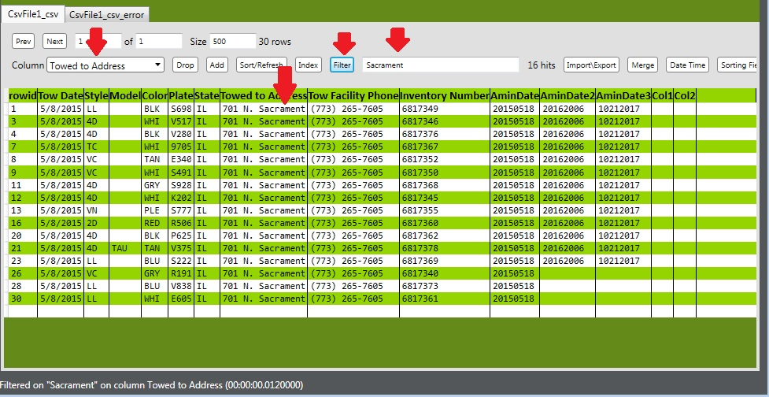

In the previous example the rows with the designated values in the address column are shown.

**Merge**

When we have two columns and we want to merge these two columns with a delimiter to another column, we use this feature.

After pressing Merge button user will be prompted with below window:

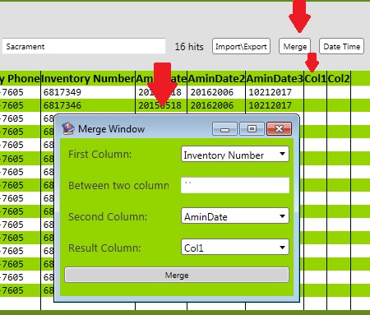

In this window, users should set First Column value and a delimiter and Second Column value. At the end the result column should be selected. After this process we can see the result in Col1 as below:

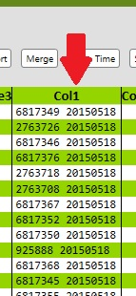

**Date Time**

The Date Time convertor is an advanced feature added recently to the application. With this feature we can transform the format of the date and time to other formats. For example, if we have a field that stores date in this format: “MM/dd/YYYY” and we need to convert it to “YYYY/dd/MM”, we use this feature of the application.

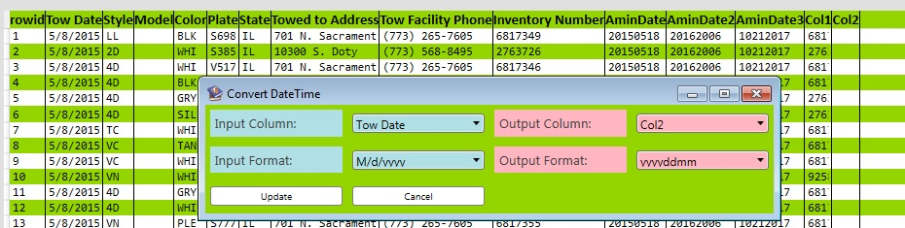

**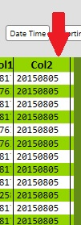**

In the above images, we see that we have Tow Date column and date is in this format:

“M/d/yyyy”. And, we need the same field in this format: “yyyyddMM”. After pressing the Date Time button, we can set other settings in the other window and update the data. After updating the data we should use refresh button to see the result in the data grid.

**Sorting Fields**

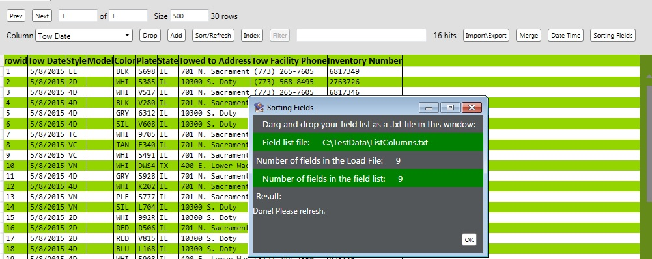When we have a load file and we want to rearrange the fields according to a list that represents the column arrangements, we use this feature.

In the above image we see that the field’s arrangement is as this:

Tow Date, Style, Model, Color, Plate, State, Towed to Address, Tow Facility Phone, Inventory Number

If we want to rearrange the fields we drag and drop a list of fields into the Field window.

Since list of headers is in a text file I didn’t use screenshot for this part.This is an example of the field list:

Tow Date

Style

Model

Color

State

Towed to Address

Tow Facility Phone

Inventory Number

Plate

After the process is done and we refreshed the view, we can see that the field arrangement is sorted by the field list.

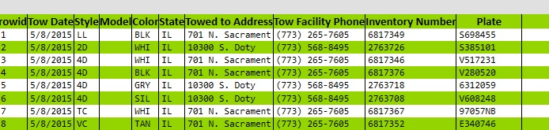

The Plate field moved to the end of the list after all fields.

Note: The number of fields in the list should match the number of fields in the load file. In the previous example the number of fields in the list is equal the number of fields in the load file equal 9.

**Editing LFU.exe.config**

One of the advanced concepts for technical users is editing the configuration file. Load File Utility is located in this path on all Laptops as well as virtual machines:

C:\Program Files (x86)\Loadfile Utility

The LFU.exe.config file is located in the application’s path. Users can open this file using Textpad or other text file editors and adjust some basic settings.

One of the important variables in 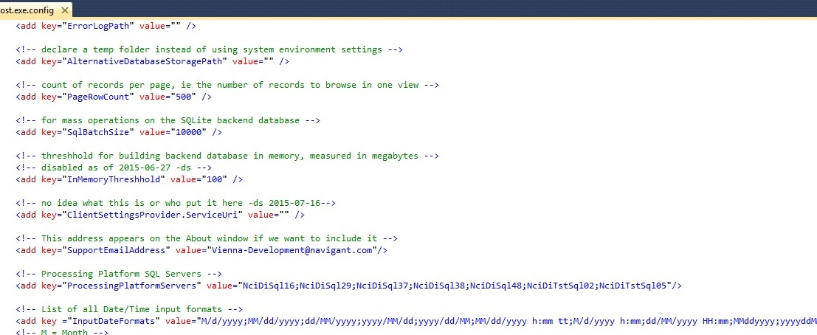the file is InputDateFormats. Sometimes the loadfiles have some date/time fields that is not part of the available date/time list in the application. Users may add the new date format by adding a semicolon at the end of other date formats and restart the application.

Another example is Page Row Count. This variable is number of rows in each page which is 500 by default. Users can edit this variable and see that number of rows showed in each page matches this number.

Note: Please don’t edit the variables that you are not sure what they are. Changing these variables irresponsibly can cause slowness or even crashing the application.