* Over view:

In this project I try to create a program that use random number and seven_segment , LCD , ATMEGA 32 , Key pad, LED .

* Details :

In this program we should suggest a number in a countdown timer before the time becomes zero,

After we suggest the number :

* correct:

the timer stop and the Yellow LED become turn off (zero) then the Green Led will turn on, and the LCD shows “Bomb defused “ message.

* Wrong :

we can try again continuously , the Yellow LED are still on (one), the time decreases .

If your suggest Lower than the real number : LCD shows this message : “Guess Greater “.

If your suggest Greater than the real number : LCD show this message : “ Guess Lower “.

* IF the time becomes zero (0):

The LCD shows the message as this content “ Bomb Exploded “, the Red LED will turn on .

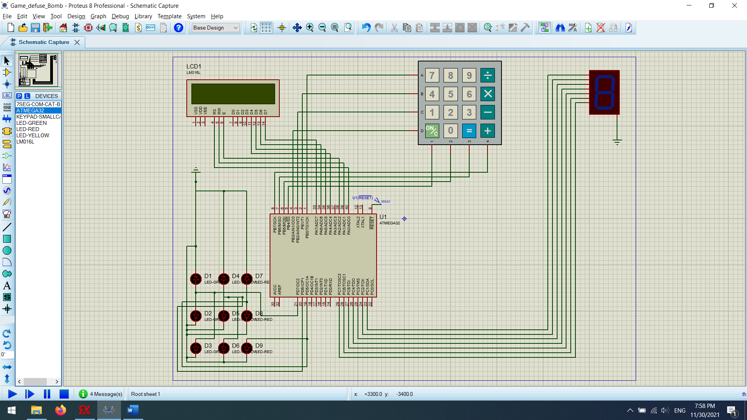

#include <io.h>

#include <mega32.h>

#include <delay.h>

#include <alcd.h>

#include <stdio.h>

#include <stdlib.h>

#include <math.h>

char scan[4]={0XFE,0XFD,0XFB,0XF7};

char key;

int row , col;

char keypad [4][4] = { {'7','8','9','/'},

{'4','5','6','*'},

{'1','2','3','-'},

{'c','0','=','+'}};

char K;

char Seven_Segment(char Data){

switch (Data){

case 0: K=0x7E;return K; break;

case 1: K=0x0C;return K; break;

case 2: K=0xB6; return K;break;

case 3: K=0x9E; return K;break;

case 4: K=0xCC; return K;break;

case 5: K=0xDA; return K;break;

case 6: K=0xFA; return K;break;

case 7: K=0x0E; return K;break;

case 8: K=0xFE; return K;break;

case 9: K=0xDE; return K;break;

default: K=0x00; return K;break;

}

}

void key_pad(){

char rands = '7';

char Data=9;

int j = 0;

while(1){

j++;

PORTC = Seven_Segment(Data);

if(j%1000==0){

Data--;

}

if (Data == 0){

PORTC = Seven_Segment(Data);

PORTD = 0X00;

PORTD.5 = 1;

lcd_clear();

lcd_gotoxy(2,1);

lcd_puts(" Bomb Exploded ");

delay_ms(2500);

break;

}

for(row=0; row <=3; row++){

PORTB = scan[row];

col = 5;

if(PINB.4 ==0){

col = 0;

}

if(PINB.5 ==0){

col = 1;

}

if(PINB.6 ==0){

col = 2;

}

if(PINB.7 ==0){

col = 3;

}

if(col != 5){

//while (PINB.4 == 0);

//while (PINB.5 == 0);

//while (PINB.6 == 0);

//while (PINB.7 == 0);

delay_ms(250);

key = keypad[row][col];

if(key=='c' || key== '=' || key == '+' || key=='-' || key=='/' || key=='*' ){

lcd_init(16);

lcd_clear();

}

else{

if(key != 'c'){

lcd_clear();

lcd_gotoxy(0,0);

lcd_putchar(key);

}

if(key > rands){

lcd_gotoxy(0,1);

lcd_puts("Guess Lower");

}

else if(key < rands){

lcd_gotoxy(0,1);

lcd_puts("Guess Greater");

}

else{

lcd_gotoxy(2,1);

lcd_puts("Bomb Defused");

PORTD = 0X00;

PORTD.7 = 1;

delay_ms(2500);

break;

}

}

}

}

if(PIND.7 == 1){

break;

}

}

}

void main(){

DDRC=0xFF;

DDRB = 0x0F;

PORTC=0x00;

DDRD = 0xFF;

PORTD = 0X00;

PORTD.6 = 1;

lcd_init(16);

lcd_clear();

while(1){

key_pad();

PORTD = 0X00;

lcd_clear();

break;

}

}