In the name of God

m.amin.allahrabi

ID:97213002

Report No:5

Seven Segment

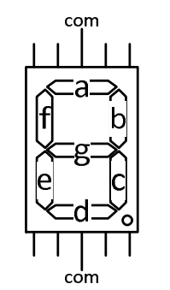

Function and truth table for turning on ( a ) in seven segment:

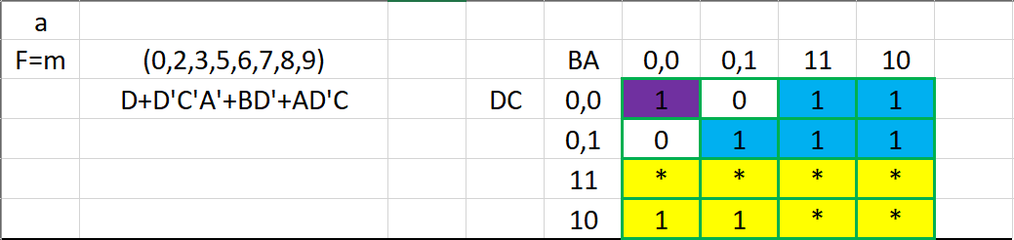

Proteus implement:

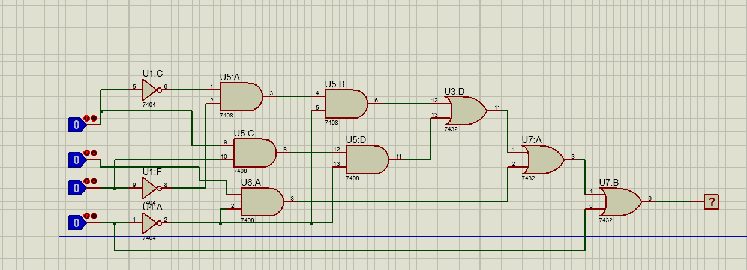

Function and truth table for turning on ( b ) in seven segment:

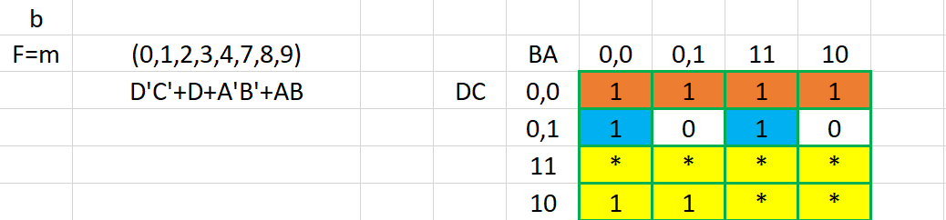

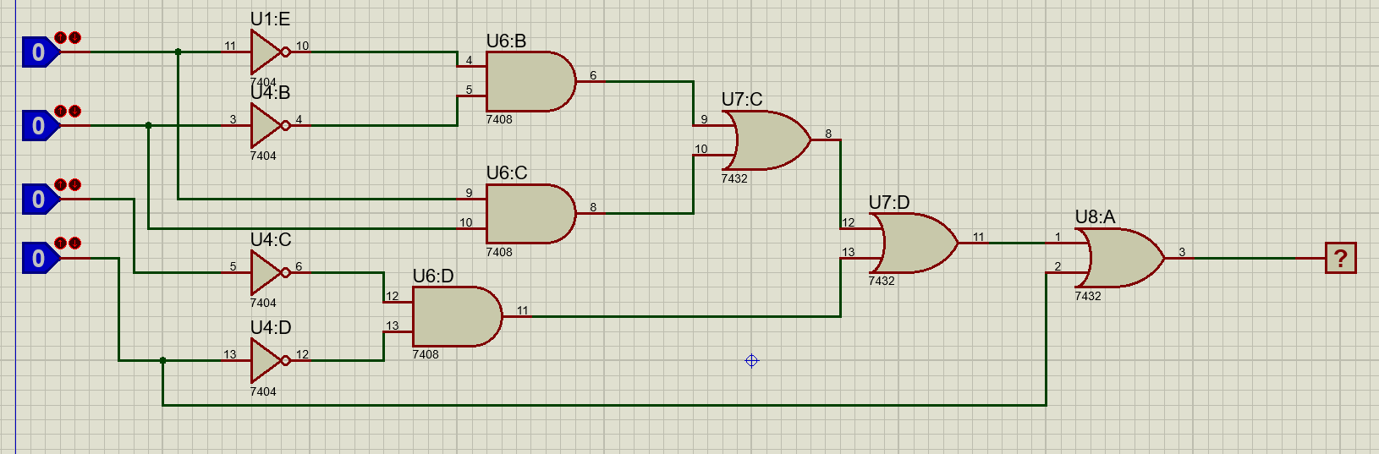

Function and truth table for turning on ( c ) in seven segment:

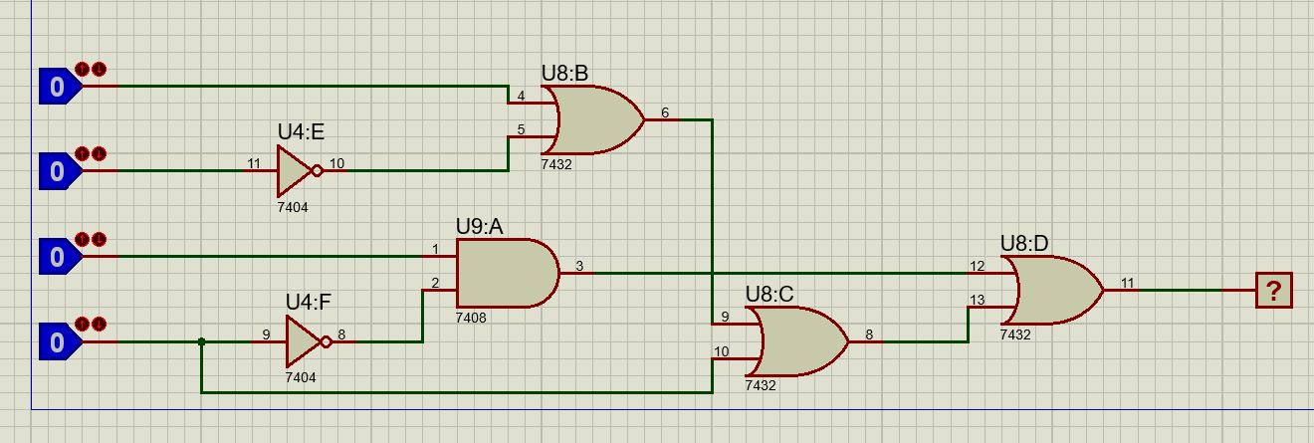

Function and truth table for turning on ( c ) in seven segment:

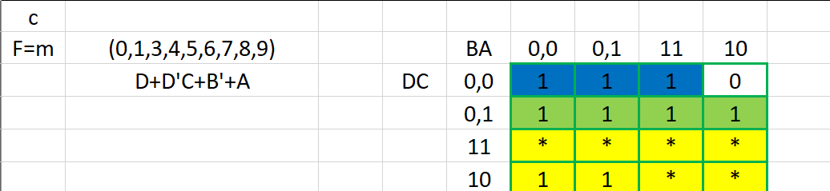

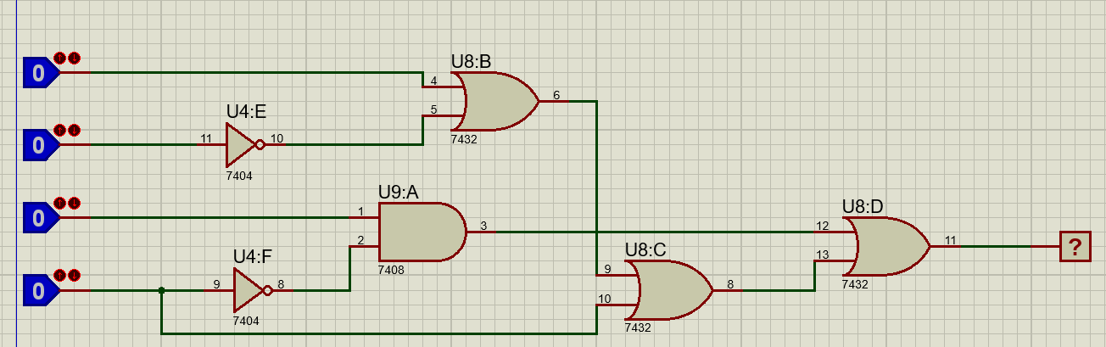

Function and truth table for turning on ( d ) in seven segment:

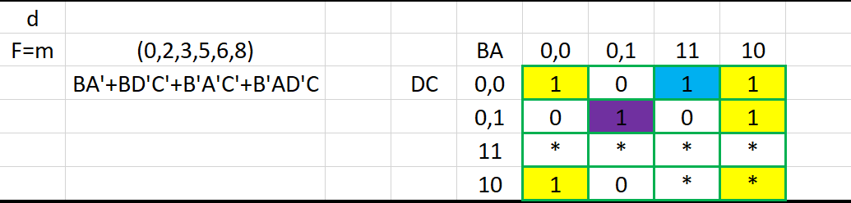

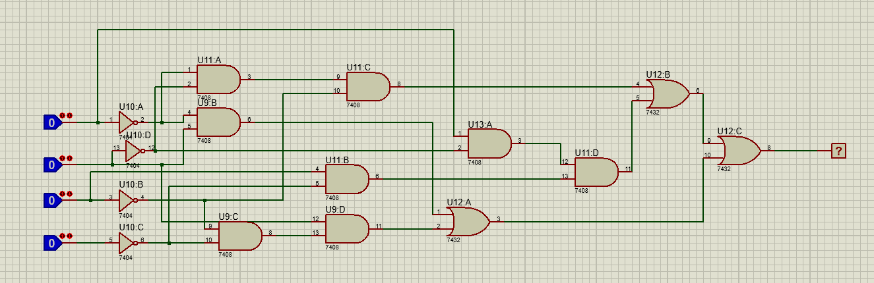

Function and truth table for turning on ( e ) in seven segment:

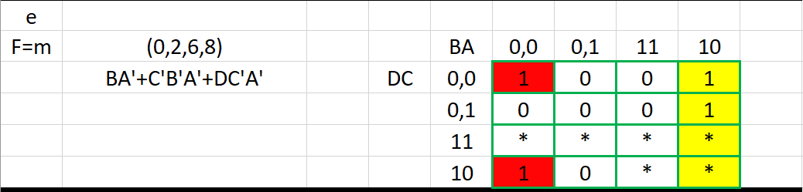

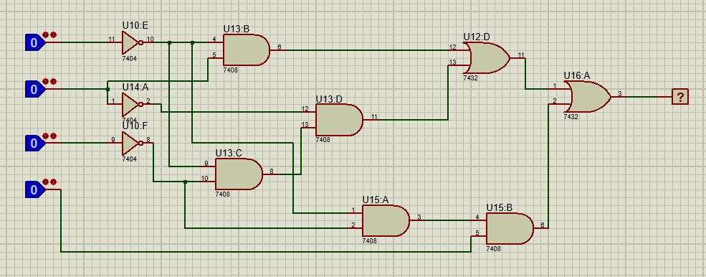

Function and truth table for turning on ( f ) in seven segment:

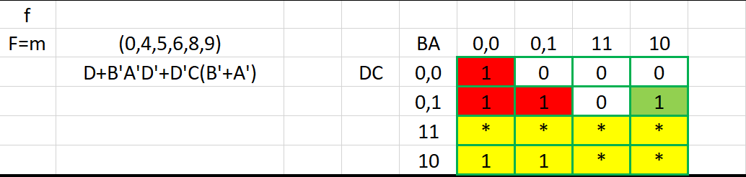

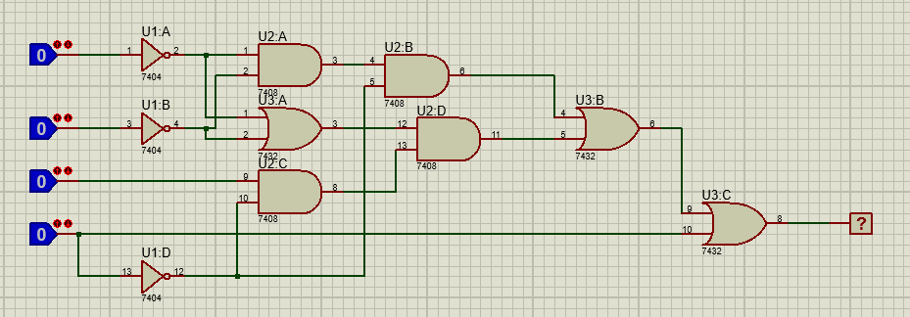

Function and truth table for turning on ( g ) in seven segment:

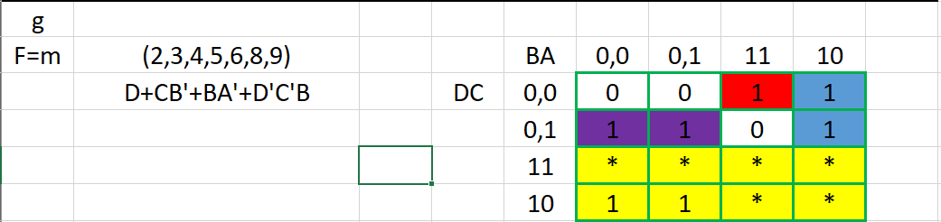

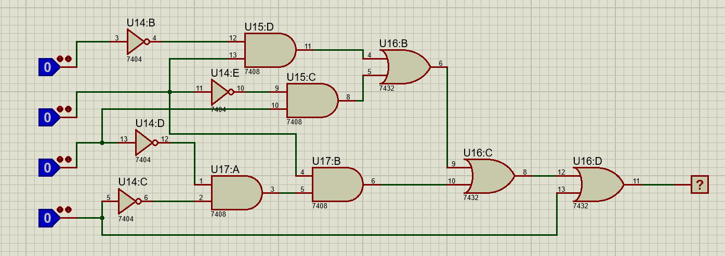

**Github :** [**https://github.com/aminallahrabi/circuit-sevensegment**](https://github.com/aminallahrabi/circuit-sevensegment)