Name: Amina Masood
Roll no: 359
Section: BSAI_3E
Subject: Artificial Intelligence _lab 1
Submitted to: Sir Rasikh Ali
Problem: A scholarship screening prototype must flag incomplete applications. I compared a rule-based checker with a probability threshold.
Assumption: All thresholds (70, 75, 0.70) and probability values are synthetic lab values. No model is trained. “Review” only flags a file for a human.
Question no 1:
Create a timeline of at least five AI milestones (with one AI winter and one modern compute/data milestone).
Year | Event | Significance | Source
1950 | Turing proposes the imitation game | Gave a behaviour-based test for machine intelligence. | Turing (1950), Mind 59(236)
1956 | Dartmouth workshop; term “AI” used | Started AI as a research field (symbolic approach). | McCarthy et al. (1955), Dartmouth proposal
1974–1980 (AI winter) | First AI winter after the Lighthill Report | Systems did not scale, so funding fell. | Lighthill (1973), UK Science Research Council
1980–1982 | R1/XCON expert system at DEC | Rules were useful but brittle and costly. | McDermott (1982), Artificial Intelligence 19(1)
2012 (compute / data) | AlexNet wins ImageNet using GPUs | Big data + GPUs + learning gave a large accuracy jump. | Krizhevsky et al. (2012), NeurIPS 25
Question no 2:
Add two transparent conditions to the rule-based example and test four cases.
I kept score ≥ 70 and documents complete, and added income_verified and attendance ≥ 75 (code: lab1_rules.py).
Case | Input | Expected | Actual | Reason
Case 1 (pass) | score 85, docs complete, income verified, attendance 90 | Review | Review | All conditions satisfied
Case 2 (income fails) | score 85, docs complete, income not verified, attendance 90 | Hold | Hold | Income is not verified
Case 3 (attendance fails) | score 85, docs complete, income verified, attendance 70 | Hold | Hold | Attendance is below 75
Case 4 (boundary) | score 70, docs complete, income verified, attendance 75 | Review | Review | Exact thresholds are accepted

Output of my code:
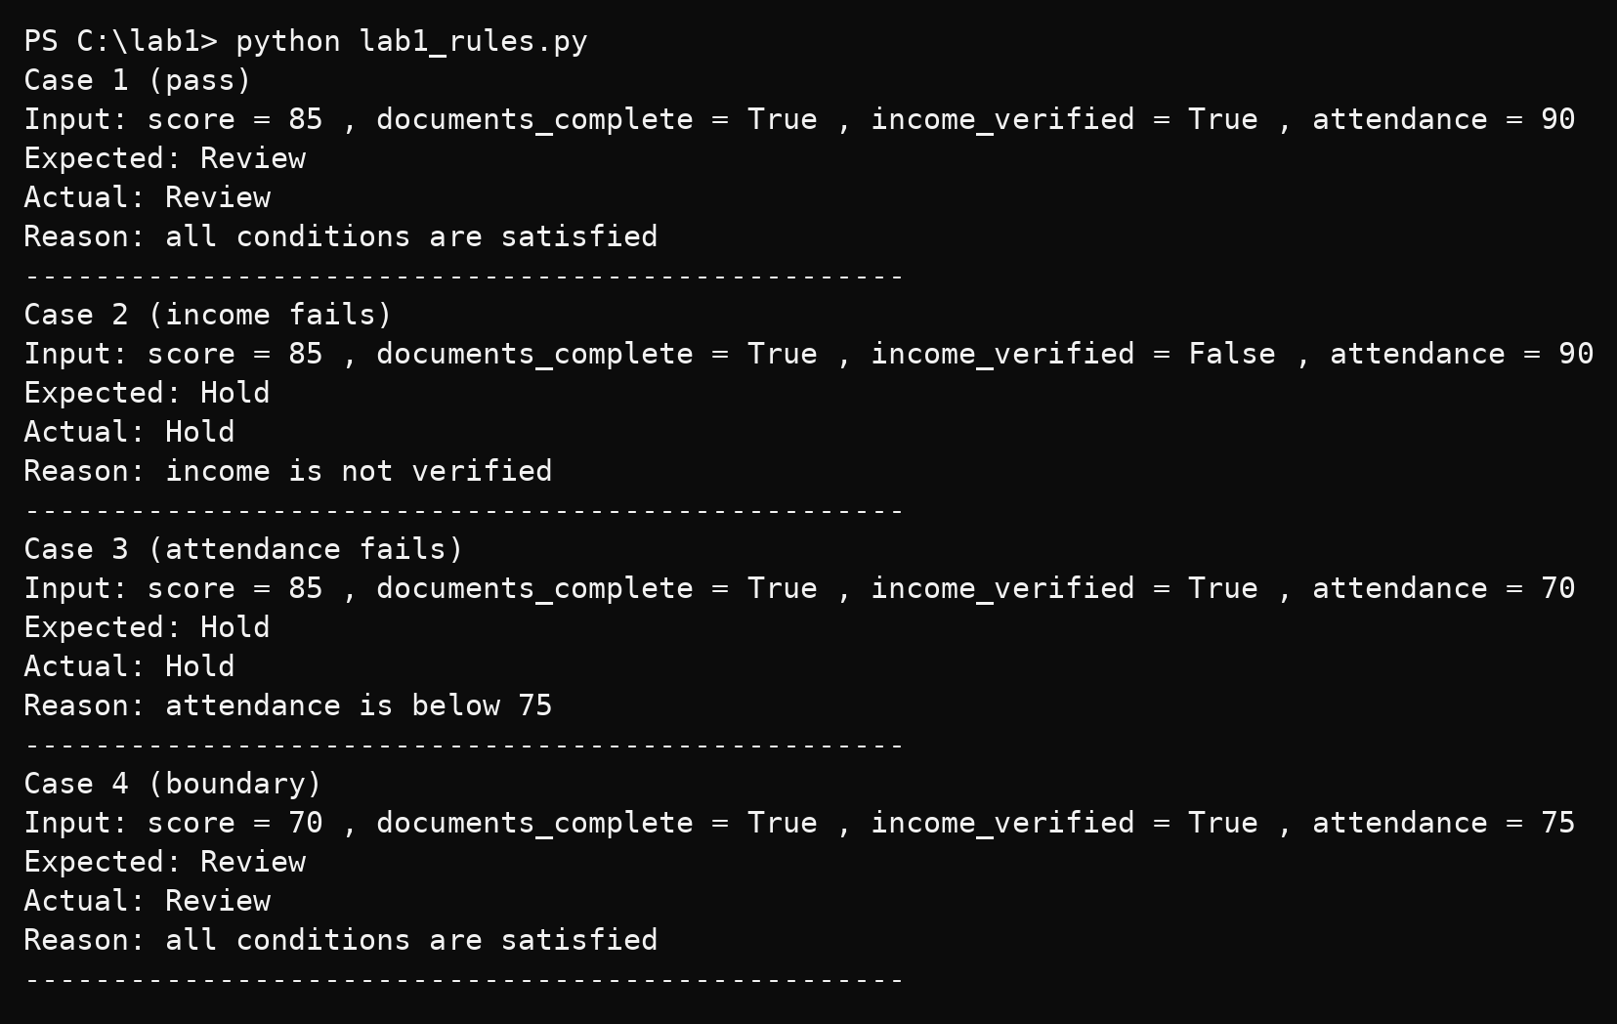
Question no 3:
Compare the rule-based check with the probability threshold
Output of my code:
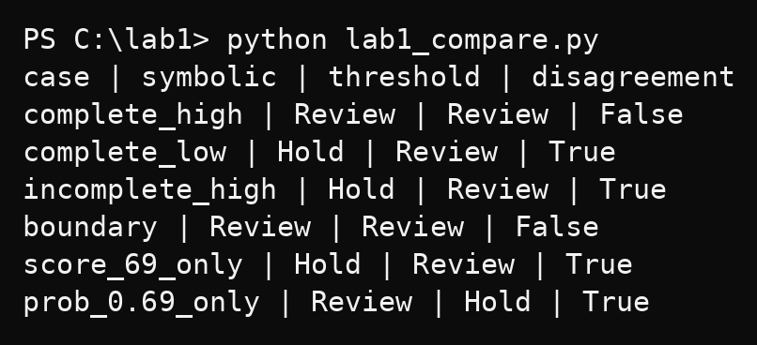

Case | Symbolic | Threshold | Disagree | Reason
complete_high (82, True, 0.81) | Review | Review | False | Both conditions met
complete_low (68, True, 0.74) | Hold | Review | True | Score 68 < 70; threshold never sees the score
incomplete_high (91, False, 0.88) | Hold | Review | True | Documents incomplete; probability ignores it
boundary (70, True, 0.70) | Review | Review | False | Both exactly on threshold

Boundary test: Score 69 alone gives Hold vs Review, and probability 0.69 alone gives Review vs Hold. One step below the boundary flips the result.

