Name: Amina Masood
Roll no: 359
Section: BSAI 3E
Subject: artificial intelligence
Submitted to: Sir Rasikh ali
Question no 1:
Create PEAS specifications for a delivery robot and an LLM-based student-support agent.

Delivery Robot
Component | Entries
Performance | On-time delivery rate; number of collisions per 100 km; deliveries per battery charge
Environment | Sidewalks, crossings and gates; pedestrians, cyclists and vehicles; rain and wet surfaces
Actuators | Drive motors, wheels and brakes; compartment lock; horn and lights
Sensors | Camera and LiDAR; GPS, odometer and IMU; battery level sensor

Trade-off: A higher speed gives faster delivery but reduces safety and battery life, so speed is limited in crowded areas.
Assumptions: The robot follows a mapped campus route and a human operator can take over remotely.

LLM-Based Student-Support Agent
Component | Entries
Performance | Answer accuracy; fraction of queries resolved without a human; response time
Environment | Students chatting with the agent; university handbook, timetable and fee documents; LMS and student records
Actuators | Text replies; escalation tickets to staff; approved reminders
Sensors | Student’s typed message and chat history; tool results; login details of the student

Trade-off: Instant answers are fast but may be outdated, so the agent checks official sources first and escalates when unsure, which is slower but safer.
Assumptions (tools): read-only knowledge base (handbook, FAQs, timetable, fees), read-only access to the logged-in student’s own LMS data, and a ticket tool for escalation. It cannot change grades, make payments or see other students’ records.
Question no 2:
Classify both environments as fully/partially observable and deterministic/stochastic, with justification.
System | Dimension | Label and justification | Example
Delivery robot | Observability | Partially observable: sensors see only what is in range. | Observable: battery level. Hidden: pedestrian behind a parked car.
Delivery robot | Determinism | Stochastic: people and the surface affect the outcome. | Predictable: unlocking the compartment. Uncertain: wheels slipping on wet ground.
Student-support agent | Observability | Partially observable: only text and tool results are seen. | Observable: the student’s message. Hidden: the student’s real intention.
Student-support agent | Determinism | Stochastic: replies can vary and policies change. | Predictable: a created ticket reaches staff. Uncertain: how the student reacts.

Real Environment vs. Simulator
System | Real environment | Simplified simulator
Delivery robot | Partially observable, stochastic | Fully observable and deterministic if the map is fully known and there is no noise or slip
Student-support agent | Partially observable, stochastic | Nearly deterministic with scripted chats, fixed knowledge base and temperature 0

Assumption: These labels hold only if the simulator has no noise and fixed test data.
Question no 3:
Extend the thermostat code so that it remembers the previous mode and does not repeat identical control commands.
Python code
I added a variable previous_mode (starting as None) that stores the last target mode. The function check_result compares the new target with it and returns the old mode, the target and whether to send a command. The original thresholds (below 20 °C HEAT, above 26 °C COOL) and the empty-room OFF priority were kept.
Case | Previous mode | Percept | Target | Outcome
Case 1 | None | 30 °C, occupied | COOL | Command sent
Case 2 | COOL | 30 °C, occupied | COOL | No command
Case 3 | COOL | 26 °C, occupied | IDLE | Command sent
Case 4 | IDLE | 20 °C, occupied | IDLE | No command
Case 5 | IDLE | 15 °C, occupied | HEAT | Command sent
Case 6 | HEAT | 15 °C, empty room | OFF | Command sent
Case 7 | OFF | 30 °C, empty room | OFF | No command

Reflex vs. stateful: a reflex version would send 7 commands; the stateful version sends only 4 (Cases 1, 3, 5, 6). Key cases are shown below: repeated percept (Case 2), exact boundaries (Cases 3 and 4) and empty room (Case 6).
The output of my code for these cases is shown below:
Case 2 output:
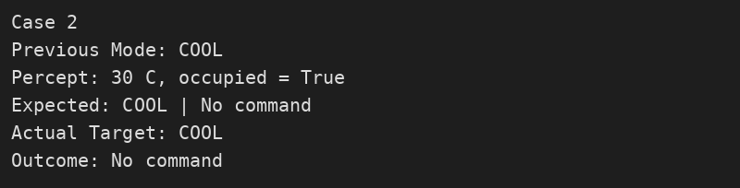
Case 3 output:
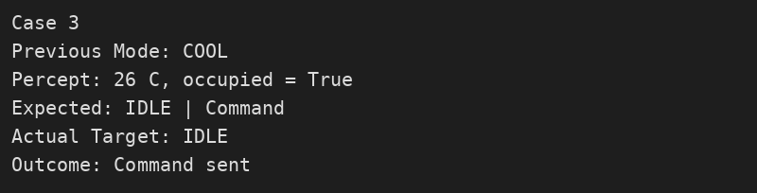
Case 4 output:
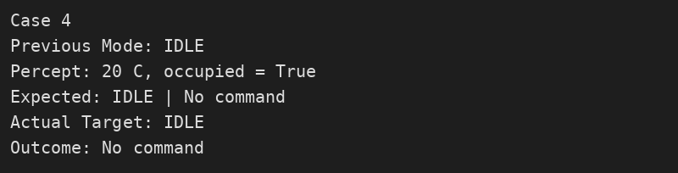
Case 6 output:
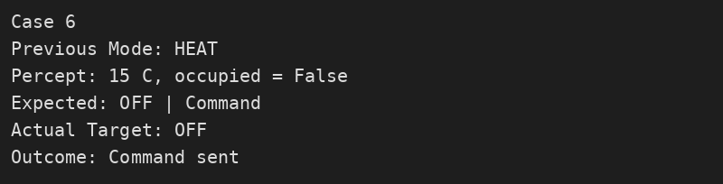
Edge case: percepts 27, 26, 27, 26 °C send a command every time because there is no buffer near the threshold. A small hysteresis band would fix this.
Conclusion: Storing the previous mode makes the agent stateful and avoids repeated identical commands.

