**Display all of the contacts list.**



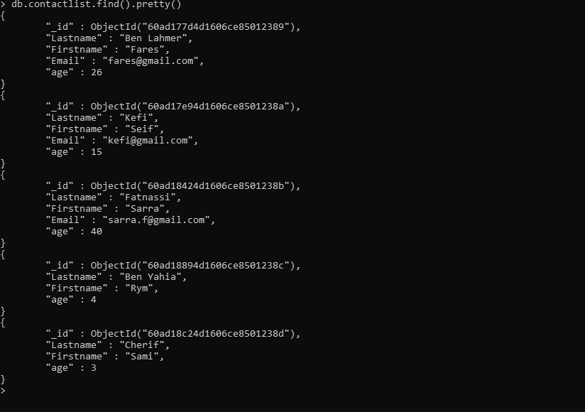

* **Display all the information about only one person using his ID.**



* **Display all the contacts with an age >18.**



* **Display all the contacts with an age>18 and name containing "ah".**



* **Change the contact's first name from"Kefi Seif" to "Kefi Anis".**

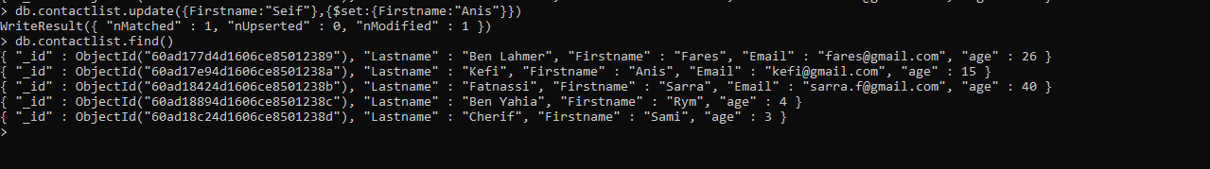

* **Delete the contacts that are aged under <5.**
* **Display all of the contacts list.**

